## MAJOR-1 PROJECT

**SYNOPSIS**

**ON**

**ALGORITHM VISUALIZER**

### Submitted By:

|  |  |  |  |
| --- | --- | --- | --- |
| **Name** | **Roll No** | **Branch** | **SAP ID** |
| Prajjawal Banati | R171217044 | CSE-DevOps | 500060722 |
| Prakhar Aggarwal | R171217045 | CSE-DevOps | 500061466 |
| Priyansh Gupta | R172217039 | CSE-BigData | 500062001 |
| Sajal Sood | R171217051 | CSE-DevOps | 500062540 |

**Under the guidance of** Mrs. Kalpana Rangra Assistant Professor (SG) Department of Cybernetics



### SCHOOL OF COMPUTER SCIENCE

**UNIVERSITY OF PETROLEUM & ENERGY STUDIES**

#### Dehradun – 248007, 2019-2020.

**Approved By**

(Mrs. Kalpana Rangra) (Dr. Monit Kapoor)

#### Project Guide Department Head



**School of Computer Science**

**University of Petroleum & Energy Studies, Dehradun**

# Synopsis Report (2020-2021)

I

## Major

**PROJECT TITLE:** Algorithm Visualizer

#### ABSTRACT

#### We present our findings on the state of the field of algorithm visualization, based on extensive search and analysis of links to hundreds of visualizations. We seek to answer questions such as how content is distributed among topics, who created algorithm visualizations and when, the overall quality of available visualizations, and how visualizations are disseminated. We have built a wiki that currently catalogs over 350 algorithm visualizations, contains the beginnings of an annotated bibliography on algorithm visualization literature, and provides information about researchers and projects. Unfortunately, we found that most existing algorithm visualizations are of low quality, and the content coverage is skewed heavily toward easier topics. There are no effective repositories or organized collections of algorithm visualizations currently available. Thus, the field appears in need of improvement in dissemination of materials, informing potential developers about what is needed, and propagating known best practices for creating new visualizations

#### INTRODUCTION

#### Data structure and algorithm visualizations and animations (hereafter referred to generically as algorithm visualizations) have a long history in computer science education. While the 1981 video “Sorting out Sorting” by Ronald Baeker was the first well-known visualization, ad hoc visualizations existed long before. The first recognized system for creating algorithm animations was BALSA [2] in 1984. Since then, hundreds of algorithm visualizations have been implemented and provided freely to educators, and scores (or hundreds) of papers have been written about them. It is widely perceived that algorithm visualizations can provide a powerful alternative to static written presentations (from textbooks) or verbal descriptions supported by illustrations (from lectures). There has been some debate in the literature as to whether algorithm visualizations are effective in practice. Some studies have shown the classic dismissal that is the downfall of most technological interventions in education: “no significant difference” [6, 9, 11]. Other studies have shown that algorithm visualizations can indeed improve understanding of the fundamental data structures and algorithms that are part of a traditional computer science curriculum [13, 3, 7]. Certainly, many visualizations exist and are widely (and freely) available via the Internet. Unfortunately, the vast majority of those currently available serve no useful pedagogical purpose. So we see that (a) many algorithm visualizations exist, yet relatively few are of true value, and (b) algorithm visualizations can be demonstrated to have pedagogical value, yet it is also quite possible to use them in ways that have no pedagogical effect. These facts seem to imply that creating and deploying effective algorithm visualizations is difficult. There is a small body of literature that investigates how to create pedagogically useful algorithm visualizations (for example, [10, 15]). Yet, there is still much to be done before we are at the point where good quality visualizations on most topics of interest are widely available.

#### LITERATURE REVIEW

Algorithm animation systems have a long history in education.  The first  reference to  algorithm  animation was the famous video ‘Sorting Visualizer Tutorial’ which has been presented by Clement Mihailescu on YouTube. This 30 min video demonstrated the characteristics and operations of nine sorting algorithms, using animation and audio comments. Since then, many researchers have developed  various visualization systems to  depict the behavior of certain algorithms and assist students’ deeper understanding of algorithmic and programming concepts [4, 10, 16, 20, 22]. Nowadays, visualization involves more than the visual  presentation of information  in various  media (such  as animations,  text, static  or dynamic  pictures, diagrams, etc.). Most algorithm visualizations provide an  interactive  environment  that  elicits  active  student participation using informative animations and multiple representations. Additionally, an effective visualization should  not  merely  attract  the  visual  attention  of  the learner but should be designed to promote the cognitive attention and engagement of the learner. In general, there are two main categories of visualization that focus on education: program visualization and algorithm visualization.

**OBJECTIVES**

To create algorithm visualizer for visualizing algorithms graphically

Sub-objectives:

* To implement sorting algorithms
* To implement searching algorithms
* To implement graph algorithms

#### PROBLEM STATEMENT

#### When we start learning to code we may face a lot of issues in understanding  the actual working of the algorithm and visualising it, due to which it may be very frustrating and we may lose the motivation to code, So to make students understand each iteration and make them familiar to the algorithm with the help of animations and could visualize each iteration. So this project aims to create a platform for students to visualize the algorithms. This project will be covering all types of sorting, searching and graph algorithms to make students visualize better about each algorithm.

#### METHODOLOGY

#### 

The model we have used in our project is Agile.

**Sprint-1:- Deploying Sorting Visualizer Unit**

**Goals:-**

* Implement Bubble Sort
* Implement Insertion Sort
* Implement Selection Sort
* Implement Merge Sort
* Implement Quick Sort

**Sprint-2:- Deploying Searching Visualizer Unit**

**Goals:-**

* Implement Linear Search
* Implement Binary Search

**Sprint-3:- Deploying Graph Algorithm Visualizer Unit**

**Goals:-**

* Implement Djakstra’s Algorithm
* Implement BFS Traversal
* Implement DFS Traversal

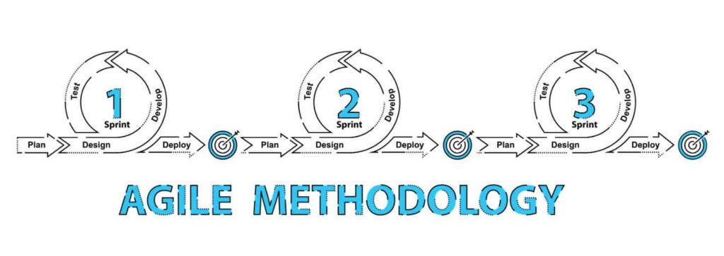

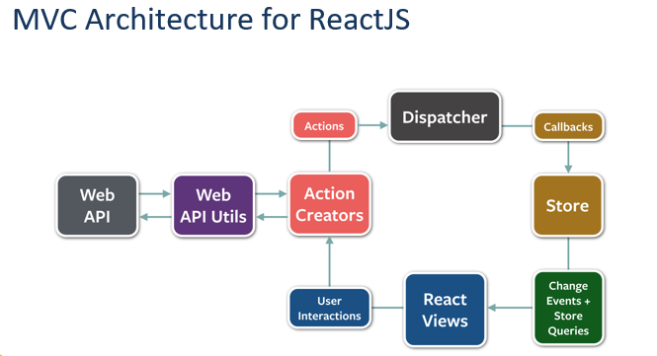

#### SYSTEM REQUIREMENTS

#### Hardware Requirements:-

#### 32/64 bit processor architecture supported by windows.

#### Minimum RAM requirement for proper functioning is 8 GB.

#### Minimum 64 GB free hard disk space depending on edition and configuration, including space required for files.

#### Operating Systems:-

#### Windows (7 and above)

#### Ubuntu (16.04 and above)

#### Software Requirements:-

* Npm(Node Package Manager)
* Create-React-App
* React Developer Tools(Chrome Extension).

#### SCHEDULE (PERT CHART)

#### 

**REFERENCES**

* Available at https://www.youtube.com/watch?v=pFXYym4Wbkc&t=89s [accessed on 14th Sep]
* Available at https://www.youtube.com/watch?v=msttfIHHkak [accessed on 14th Sep]
* Available athttps://citeseerx.ist.psu.edu/viewdoc/download?doi=10.1.1.134.3125&rep=rep1&type=pdf[accessed on 02nd Oct]
* Available at https://github.com/algorithm-visualizer/algorithm-visualizer [accessed on 04th Oct]
* Available athttps://www.geeksforgeeks.org/sorting-algorithm-visualization-merge-sort/[accessed on 04th Oct]