MANGALORE INSTITUTE OF TECHNOLOGY AND ENGINEERING

(An ISO 9001:2015 Certified Institution)

**BADAGA MIJAR, MOODABIDRI – 574225**

**DEPARTMENT OF COMPUTER SCIENCE & ENGINEERING**

(NBA Accredited)



**A**

**PROJECT SYNOPSIS ON**

**CITIZEN CENTRIC PANCHAYATH SYSTEM**

**WITH DIGITAL MANAGEMENT AND AUTOMATION**

**SUBMITTED BY**

**4MT18CS063** **PRAJWALPOOJARY**

**4MT18CS091** **SHRADDHASHETTY**

**4MT18CS114** **VINEETHSERIGAR**

**4MT18CS116** **YASHWITHA**

**Project Guide SHIVAPRASAD T K**

**ASSISTANT PROFESSOR, CS&E**

**TABLE OF CONTENTS**

TITLE 2

1. ABSTRACT 2
2. PROBLEMSTATEMENT 2
3. OBJECTIVEANDSCOPE 3
4. PROJECT DESCRIPTION 3
5. METHODOLOGY 4
6. HARDWARE AND SOFTWARESUPPORT 5
7. POSSIBLEOUTCOMES 5
8. REFERENCES 6

**CITIZEN CENTRIC PANCHAYATH SYSTEM**

**WITH DIGITAL MANAGEMENT AND AUTOMATION**

# **ABSTRACT**

Now a day’s people in the rural areas have to go to panchayath office in their location to know about the benefits from the panchayath. It requires a lot of time and may result in work delay. The data in the office has to be maintained manually. There is no security for the data and faults can be encountered during entering the data mainly which require higher calculations. People also face so many problems in their area. They complain to their respective ward members but they may or may not respond quickly. There are many other problems in the present day panchayath raj system. So, this system provides solutions to all the problems in the current system. It provides online service to the people living in that area. All the services which are done manually are made online in the project with automation. The people can know about their panchayath activities, notifications and all other information related their villages. All the applications and certificates are applied and verified online. The users in the village can complain about their problem and feedback through online. Suggestions are also accepted from the people for the development of their village.

# **PROBLEM STATEMENT**

Design a grama panchayath e-management application that is specially designed to establish a direct communication with grama panchayath.

# **OBJECTIVE AND SCOPE OF THE PROJECT**

**Objectives:**

* Online tax payment can provide contactless, transparent and faster delivery of service.
* The people will come to know about the new schemes which are provided by government officials.
* User can see the development rate at their ward in comparison to other wards.
* The people of the village can easily contact the officials regarding any issues such as availing services, complaints, feedback and application filling.
* Availability of the officials can easily be tracked.
* Status of work done is published in the application.

**Scope:**

* People can request any application, suggestion, and complaint at anywhere and at anytime without

any delay.

* Automation can reduce the human error and standardizes processes.

# **PROJECT DESCRIPTION**

This project is aimed at the developing an E-Gram Panchayath Management System with automation. It is an online based application that can be accessed throughout the internet. This System may be used for monitoring gram panchayath activities. Public can search provided information regarding gram panchayath at any time. The Information about Schemes published by government or any other activities and billing record will be updated by body members and the secure data maintained by only administrator. It is user friendly website, only admin has authority to give access or choose login members. EGPMS is an online based application that aims to provide information keep the Records and Documents like birth certificate, death certificates, residential certificates. User can access the data which are required and only body members have authority to upload the data. It helps for the people in that area to easily complete their work which involves the action of authority of the panchayath people. Even if the officer is not available in the village, he can verify applications online. People can view the distribution of funds which are collected through taxes. The overall distribution of tender funds which is received from the government or through taxes is made visible to the people.

# **METHODOLOGY**

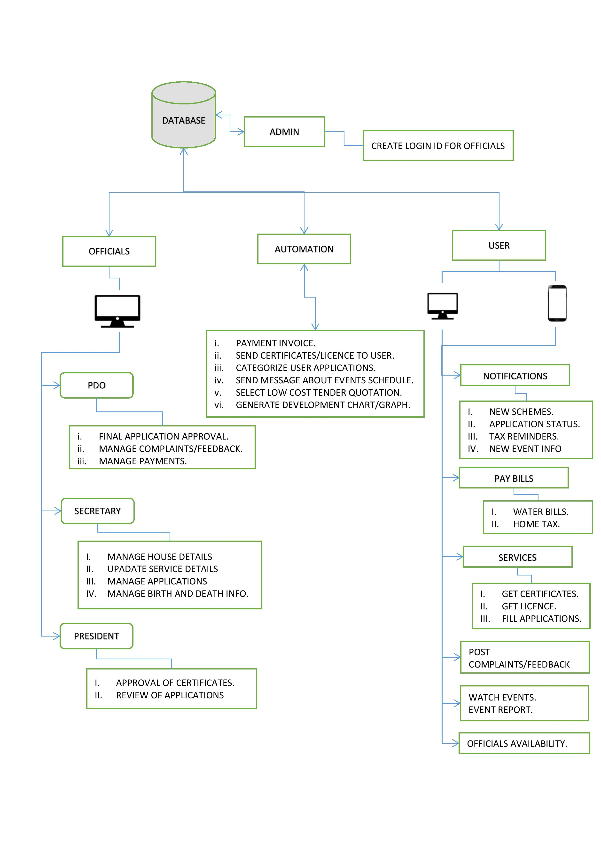

Figure 1: Block Diagram

# **HARDWARE AND SOFTWARE SUPPORT**

**Software Requirement**:

* Frontend development:

Basics: HTML,CSS, JavaScript

Framework: Reactjs, React-Native

* Backend development:

Nodejs : It is opensource cross platform backend JavaScript runtime environment runs on

V8 engine and executes JavaScript code.

* Database:

Mongodb: is a document oriented NoSQL database program. it uses JSON-like document.

* Version Control:

Git

* Package manager:

npm

* Tools:

visual studio code, android studio.

**Hardware requirement:**

* Intel core i5 or higher end processor
* 8GM RAM

# **POSSIBLEOUTCOMES**

* Improving delivery of services to citizens.
* Transparency, Accountability, Efficiency and RTI compliance of Panchayath.

# REFERENCES

* <http://www.warse.org/IJETER/static/pdf/Issue/icacsse2016sp37.pdf>
* <https://panchatantra.kar.nic.in/panchamitra/>
* [https://etownpanchayat.com/Index.aspx#!](https://etownpanchayat.com/Index.aspx%23!)
* <https://rdpr.karnataka.gov.in/english>