BIRLA INSTITUTE OF TECHNOLOGY AND SCIENCE, PILANI



MTech

FIRST SEMESTER 2025 – 2026

LOAN AND CREDIT SYSTEM

CSIWZG628T DISSERTATION BY NAME: RAM KRISHNA

BITS ID: 2021WB86919.

FINAL SEMESTER EVALUATION FORM

Section I
ID No. 2021WB86919.

Name of Student: Ram Krishna
Name of Supervisor: Mohit Shrivastava
Name of the Examiner (s) : Hemanth Devulapally, Dyanesh Dant

Dissertation Title: LOAN AND CREDIT SYSTEM

Section II
- Quantum of work
  - Justifiable as efforts for duration of work (16 weeks) Y/N
  - Work is in line with the commitments made in outline Y/N

Type of work
  - Client assignment Y / N
  - Organization specific task Y / N
  - General study project such as white paper Y / N
  - Any other (kindly elaborate below in a line or two if Y Y / N
Working on a project assigned during MTECH Program.

Nature of work
  - Routine in nature Y/N

  - Involved creativity and rational thinking Y/N

Evaluation methodology
  - Evaluation done based on presentation to supervisor and examiner Y/N
  - Evaluation done through Viva conducted by supervisor and examiner Y/N
  - Student regularly interacted with supervisor and incorporated the suggestions Y/N

  - Brief description on the report submitted, quality of presentation and suggestions given for Y/N

Ram Krishna has covered all the basic aspects of the dissertation, and he has good knowledge of the project.

FINAL semester evaluation matrix:-

Dimension Rank→ | 1 | 2 | 3 | 4 | 5
Student abilities in general
Understanding of the subject of dissertation |  |  |  | ✅
Creative thinking ability to come up with new ideas |  |  |  | ✅
Viva / Seminar presentation
Communication ability |  |  |  | ✅
Organization of material |  |  |  | ✅
Response to review questions |  |  |  | ✅
Cohesive thinking ability |  |  |  | ✅
Report submitted
Report structure and format |  |  |  | ✅
Technical content of the report |  |  |  | ✅
Explanation on the significance of the assignment |  |  | ✅
Analysis of alternative approaches |  |  |  | ✅
Recommendation and suggestions |  |  |  | ✅
Discussion on benefits and limitations |  |  |  | ✅





Examiner 1st Examiner 2nd Supervisor

BIRLA INSTITUTE OF TECHNOLOGY AND SCIENCE, PILANI CERTIFICATE

This is to certify that the Dissertation entitled LOAN AND CREDIT SYSTEM and submitted by Ram Krishna, ID No.2021WB86919 in partial fulfilment of the requirements of dissertation, embodies the work done by him under my supervision.

Name: Mohit Shrivastava Designation: Lead Administrator

Acknowledgements
I would like to express my sincere gratitude to my guide, expert guidance, continuous encouragement, and valuable suggestions were instrumental in the successful completion of this report on the Loan and Credit System.
I am also thankful to the faculty and staff of the Department of MTECH Bits Pilani, for providing the necessary facilities and support throughout this project.
I would like to extend my appreciation to my peers and friends for their support and motivation during this endeavour.

Finally, I am deeply grateful to my family for their unwavering encouragement and understanding throughout my M.Tech journey.

Abstract

The loan and credit system plays a crucial role in the financial ecosystem by facilitating access to funds for individuals, businesses, and institutions. This report presents a comprehensive study of the loan and credit system, exploring its types, mechanisms, and impact on economic growth. It delves into the processes involved in loan evaluation, credit risk assessment, and the regulatory framework governing credit institutions. The report also analyses recent trends, challenges, and technological advancements such as digital lending platforms and credit scoring models. By examining both theoretical concepts and practical applications, this study aims to provide insights into optimizing loan and credit management for improved financial inclusion and risk mitigation. The findings contribute to a better understanding of how an efficient loan and credit system can support sustainable economic development.

Table Contents:

S.  No. | Section Title | Description
1 | Executive Summary | Overview of the report, key objectives, findings, and recommendations.
2 | Introduction | Background, purpose, scope, and methodology of the report.
3 | Overview of Loan and Credit Systems | Definition, importance, types of loans.
4 | System Architecture | Description of system components, design, database structure, and integrations.
5 | Reporting and Analytics | Performance metrics, loan monitoring.
6 | Challenges and Limitations | Technical, operational, and regulatory issues encountered.
7 | Snapshots | Page no.12-15
8 | Future Enhancements / Recommendations | Suggestions for system improvement, innovation, and policy updates.
9 | Conclusion | Summary of findings and closing remarks.
10 | References / Bibliography | Sources and literature consulted in the report.
11 | Appendices | Additional materials such as forms, screenshots, agreements, and glossaries.

List of Symbols & Abbreviations used

Symbol / Abbreviation | Full Form | Description
APR | Annual Percentage Rate | The annual rate charged for borrowing, expressed as a percentage.
ROI | Rate of Interest | The percentage charged by a lender on the principal amount.
NPA | Non-Performing Asset | A loan or advance for which the principal or interest payment is overdue.
API | Application Programming Interface | Used for system integration between credit systems and third-party services.
UI/UX | User Interface / User Experience | Design and usability aspects of the loan or credit system software.
DBMS | Database Management System | System for storing and managing loan and customer data.
CRM | Customer Relationship Management | Software used to manage customer interactions and data.

Chapter 1

Introduction

  - About the Project

A Loan and Credit System is a financial framework designed to manage the processes of lending, borrowing, and credit evaluation between financial institutions and individuals or businesses. It plays a vital role in modern economies by enabling access to funds for personal, commercial, and developmental purposes, while ensuring that lending activities are conducted securely and efficiently.

This system encompasses various components, including loan application, credit assessment, approval, disbursement, repayment tracking, and credit reporting. Financial institutions use it to evaluate the creditworthiness of borrowers, determine appropriate loan terms, and monitor repayment behavior. By maintaining accurate records of loans and credit histories, the system helps reduce risks associated with lending and promotes responsible borrowing.

With the advancement of technology, loan and credit systems have evolved into digital platforms that automate and simplify complex financial processes. Modern systems often integrate with databases, mobile applications, and analytics tools to offer real-time access, improve decision-making, and enhance customer service.

In essence, a Loan and Credit System ensures financial stability and transparency by balancing the needs of lenders and borrowers, supporting economic growth, and fostering trust within the financial sector.

Aims and Objectives

Aims
The primary aim of a Loan and Credit System is to provide an efficient, secure, and automated framework for managing the entire loan lifecycle — from application and approval to disbursement and repayment. It seeks to streamline lending operations, ensure accurate record-keeping, and minimize financial risks for both lenders and borrowers.

Objectives

    - Automate Loan Processes – To reduce manual work by digitizing loan applications, approvals, disbursements, and repayments.

    - Assess Creditworthiness – To evaluate borrower eligibility and reduce the risk of default through accurate credit assessment.

    - Maintain Accurate Records – To keep detailed records of loans, payments, and borrower histories for accountability and transparency.

    - Enhance Customer Service – To provide borrowers with easy access to loan information, repayment schedules, and notifications.

    - Generate Reports and Analytics – To support management decisions with real-time financial reports and performance insights.

    - Ensure Compliance and Security – To adhere to regulatory standards and protect sensitive financial data. Use of usernames, passwords, and sometimes multi-factor authentication (MFA) to verify user identity.

Overview of Loan and Credit Systems

A Loan and Credit System refers to the framework, processes, and technologies used by financial institutions to issue credit, manage loans, assess borrower eligibility, and ensure timely repayment. These systems are central to the functioning of modern banking and financial services, supporting both personal and commercial lending operations.

Purpose and Importance

Loan and credit systems are essential for:
- Providing financial access to individuals and businesses.
- Supporting economic development by enabling investments, education, housing, and entrepreneurship.
- Managing financial risk through structured evaluation, scoring, and repayment systems.

Types of Loans Managed

Loan systems may support multiple loan categories, such as:

- Personal Loans
- Home Loans
- Education Loans
- Building Loans

System Architecture

The Loan and Credit System architecture is designed to facilitate efficient, secure, and scalable processing of loan applications, credit assessment, disbursement, repayment, and monitoring. The architecture integrates multiple components such as user interfaces, business logic, databases, external services, and security modules to provide a seamless loan management experience.

Architectural Components

- User Interface Layer (Client Layer)

  - Web portals and mobile applications where borrowers, loan officers, and administrators interact with the system.
  - Provides features for loan application submission, status tracking, repayment, and reporting.

Application Layer (Business Logic)

  - Handles core loan processing workflows including application validation, credit scoring, approval, and repayment scheduling.
  - Implements business rules, risk management algorithms, and notification services.

Data Layer (Database Management)

  - Stores customer data, loan records, payment histories, credit scores, and audit logs.
  - Supports transaction management and data integrity.

Integration Layer

  - Interfaces with external services such as credit bureaus, payment gateways, regulatory bodies, and third-party verification services.
  - Enables real-time credit checks and secure payment processing.

Reporting and Analytics Module

  - Generates reports for loan performance, risk assessment, and regulatory compliance.
  - Supports dashboards for management decision-making.

  - Setup checklist for project

- Processor: Any Processor above 500 Mhz
- Input Devices: Standard Keyboard and Mouse.
- RAM:: 4gb of RAM or above.
- Output Devices: VGA and High Resolution.
- OS: Windows 7 or Higher

No. of modules

The system after careful analysis has been identified to be presented with the following modules:
- Admin Module.
- User Module
- Security and Authentication.

2. Admin Module

  - Description of Modules

- Admin Module: The Admin Module is for financial institution staff to manage, monitor, and control all aspects of loans and credits.

Key Features:

  - User Management: Admins can create, modify, or deactivate user accounts and assign appropriate roles.

  - Loan Processing: Admins review loan applications, evaluate creditworthiness, and approve or reject requests.

  - Repayment Monitoring: Admins track repayments, manage overdue accounts, and maintain financial records.

  - Reporting: Admins generate reports for decision-making, audits, and regulatory compliance.

  - System Security: Admins enforce access controls, monitor system activity, and ensure data security.

User Module
The User Module is intended for borrowers or clients who access the Loan and Credit System. It enables secure interactions and self-service for loan-related activities.

Key Features:

  - Security and Authentication: Users must log in with valid credentials (username/password) and may use multi- factor authentication (MFA) for enhanced security.

  - Loan Application: Users can submit loan requests and provide necessary personal and financial details.

  - Loan Tracking: Users can check the status of their loan applications, repayment schedules, and outstanding balances.

  - Notifications: Users receive updates regarding approvals, due dates, and payments.

Security and Authentication:
The security and authentication is as follows:

- Login as buyer or seller or administrator.
- Change password.
- Forgot Password
.– Registration for buyer / seller.

Chapter 2 Literature review
Loan and credit systems are foundational components of financial services, enabling institutions to extend funds to borrowers under defined terms and conditions. The effective management of credit risk, loan processing, and repayment monitoring remains critical for both lenders and borrowers. Recent research covers credit scoring models, automation of loan origination, digital financial inclusion, and security/authentication in loan systems. This survey reviews key themes and identifies gaps for the proposed system.

Credit Scoring & Risk Assessment

A substantial body of literature deals with how lenders evaluate borrower creditworthiness.For example, the study by Credit scoring, statistical techniques and evaluation criteria: A review of the literature (Abdou & Pointon, 2011) reviewed over 200 articles and found that both traditional statistical models and newer classification techniques have been applied in credit scoring.
The research A Machine Learning Approach for Micro-Credit Scoring (2019) shows how machine learning methods can improve default prediction in micro-credit settings, though no single model is universally best.

Key insights:

Credit scoring remains crucial for loan decisioning.
Many studies show that more sophisticated models (ML/ensemble) can outperform traditional ones. Challenges include data imbalance, lack of transparency, and generalisability of models.

Automation and Loan Origination Systems

Another major research stream focuses on automating the loan lifecycle — from application to approval and disbursement. The article REVOLUTIONIZING LOAN SYSTEMS THROUGH INTELLIGENT AUTOMATION (Munnangi S., 2024)
outlines how intelligent workflow systems and automated validation can reduce processing times dramatically and minimise errors in loan origination.
Related work on digital loan systems emphasises how automation supports faster turnaround, cost reduction, and improved customer experience.
Key insights:

Automating manual loan processes (application, verification, approval) adds operational efficiency.
Integration of decision support and predictive analytics helps in risk mitigation.Implementation challenges include system design complexity, data integration, compliance monitoring.

2.1.3 Post-Loan Monitoring, Default Risk & Fraud Prevention

Effective loan systems must incorporate mechanisms for tracking repayment, managing defaults, and preventing fraud.

The paper Literature Review on Systematic Management Analysis of National Student Loans in China from the Perspective of Credit Investigation (Zhou, 2022) examines post-loan management of student loans, repayments, and default prevention. Fraud detection in loan systems (though less directly) is highlighted in the bibliometric analysis of fraud detection research. UMM Scientific Journals

Key insights:

Monitoring borrower behavior and repayment status is crucial to reducing non-performing loans.
Fraud detection and predictive monitoring are important but often under-explored in credit-system literature. Systems need robust audit trails, real-time alerts, and analytics for early warning of defaults.

Security, Authentication & Data Governance

While fewer studies focus solely on authentication in loan systems, security remains an enabler for trust and compliance.

Research on credit scoring emphasises the need for transparency and the limitations of black-box models (e.g., problems with interpretability).

Digital loan systems must manage sensitive data, secure authentication, role-based access, and audit logging — though literature specific to loan-system security is less extensive.

Key insights:

Strong security and authentication frameworks are essential for borrower data, system integrity, and regulatory compliance. Explainable models are increasingly demanded to satisfy fairness and transparency regulations.

Gaps and Research Opportunities

From the reviewed literature, the following gaps stand out:

Many credit-scoring models focus on lender side decision-making, but fewer integrate full loan lifecycle (application → approval → monitoring → closure).While automation of origination is well covered, less attention is given to post loan monitoring and analytics within a single system.

Security/authentication in the context of loan systems has limited dedicated research — more work is needed on user- module/admin-module interactions, role-based controls, and audit logging.

Use of alternative data (especially in emerging economies) remains under-explored in many contexts. Explainability, fairness, and regulatory compliance of machine-learning credit systems demand more research.

RESEARCH PAPER II :

Learning DJANGO & SQLLITE: Functional Web Development with DJANGO & SQLLITE Author: Alan C. Mathew et al.
Year: 2024

Technology Used: Django framework + SQLite database

Summary:
This work presents the design, implementation, and evaluation of a web-based application built using Django as the web framework and SQLite as the underlying relational database engine. The authors outline the development of a placement-cell management system for a college setting, whereby the Django framework facilitated rapid development of models, views, templates, and URL routing, while SQLite was chosen for its simplicity, embedded nature and minimal configuration overhead. The project describes features such as user interfaces for students, admin, and companies; CRUD operations for job listings; mock tests and student eligibility tracking; and demonstrates how Django’s Entity-Relationship model maps to SQLite’s tables and queries.

RESEARCH PAPER III :

Learning Developing a frontend application using HTML & CSS :
Author: Ben Shaw, Saurabh Badhwar, Chris Guest & Bharath Chandra K S
Year: 2021 (for Web Development with Django by O’Reilly)
Technology used: Django (web-framework) + SQLite (as one of the supported DB back-ends) + HTML & CSS (for the front-end).

Summary :
This book introduces readers—already familiar with Python—to full-stack web development using the Django framework. It begins by covering setup (Python, Django, development server) and the Model-View-Template (MVT) architecture, and then guides the reader through building a practical project (a “Bookr” application) that uses Django’s ORM, views, templates, user authentication, static files (HTML, CSS), and a database (SQLite among possible options). It emphasizes end-to-end development: defining models and migrations, creating views and templates, styling with CSS, handling user input and authentication, and moving towards deployment. The work is practical, example-driven, and positions SQLite as a lightweight relational database appropriate for development or smaller scale applications. It also reflects on how HTML & CSS integrate with Django’s templating system, enabling a cohesive web front-end tied to a Python back-end. The authors highlight strengths such as rapid development, built-in admin interface, extensive ecosystem, and minimal configuration to get started with SQLite; and they also outline limitations (for example, concurrency and scale concerns with SQLite in high-traffic production).

RESEARCH PAPER IV:

Modern Web-Development using Python Year: 2018 (published December 21)
Author: Fabrizio Romano, Gaston C. Hillar & Arun Ravindran
Technology Used: Python

Summary :

The book Learn Web Development with Python: Get hands-on with Python Programming and Django web development provides a full-stack approach to building web applications using Python and the Django framework. It is targeted at readers who have some basic programming familiarity and wish to transition into web application development. The authors structure the work into two major parts: first covering Python fundamentals (data types, control flow, functions, OOP, decorators, iterators, file I/O, error handling) to reinforce the reader’s foundation; then progressing into Django- centric web development (models, migrations, views, serializers, API endpoints, authentication/permissions, RESTful services, testing, deployment practices).

Chapter 3:
Reporting and Analytics

Reporting and Analytics

Effective Reporting and Analytics are vital components of a Loan and Credit System. They provide insights into loan portfolio performance, risk management, operational efficiency, and regulatory compliance.

Key Reporting Functions:
Loan Portfolio Reports: Summarize loan distribution by type, tenure, amount, and borrower demographics to monitor portfolio health.

Repayment and Delinquency Reports: Track EMI collections, overdue payments, defaults, and recovery

rates.

Operational Reports: Analyze loan processing times, approval rates, and customer service metrics. Financial Reports: Calculate interest income, fees, provisioning, and profitability of loan products. Analytics Capabilities
Trend Analysis: Identify patterns in loan applications, defaults, and repayments over time.

Predictive Modeling: Use historical data and machine learning to forecast loan performance and borrower behavior.

Dashboard Visualizations: Provide real-time, interactive charts and graphs for decision-makers.

- Customizable Reports: Enable users to generate reports based on filters such as date range, loan type, region, and risk category.

Project Requirements:

The following section describes the requirements for the LMS. This is the defining stage of the SDLC. Extensibility is a principle which takes into consideration the future growth during each implementation of the design. It is not possible to design everything in advance in software engineering. Considering this, the extensibility in the design of the product emphasizes properties that helps in modifying or extending the system with minimum effort. Modifiability, maintainability and scalability are the three most important properties of extensibility. Modifiability is the ease with which one can modify a software system. The way in which each functionality is architecturally organized and separated helps in determining the modifiability. If a change in system requires as few changes in each related component as possible, a system is said to have high modifiability. Maintainability is the endeavor required to locate the bugs and errors in an operational software and fix them. In definition, maintainability and modifiability are quite similar. The major distinguishing point between maintainability and modifiability is that the former takes correction of bugs into consideration whereas the latter does not. Scalability is defined as “the system ability to expand in a chosen dimension without any major architectural changes”. Scalability can be quantified by seeing the ease in how a system without any major change in design can add new components and new functionalities. Since I have been working on the frontend development team of the project, I state the quality requirements of the project from frontend perspective:

- The website must be responsive to the web browsers across all the devices.
- Loading indicators are to be added for asynchronous items.
- While scrolling there must not be any shuttering and each view should have a minimum loading speed.
- The system must not crash or freeze in the browser.
- The system should have an uncluttered, simple user interface with readable font size and font.

Chapter 3:

DEVELOPMENT

Technology Description The proposal has to be described in a detailed form to get an overview and an

understanding of the functionalities of the technical approach. This provides the technical description of the characteristics of a proposal.

HTML

HTML, an initialize of Hypertext Markup Language, is the predominant markup language for web pages. It provides a means to describe the structure of text-based information in a document — by denoting certain text as headings, paragraphs, lists, and so on — and to supplement that text with interactive forms, embedded images, and other objects.

Hyper Text Markup Language

Hypertext Markup Language (HTML) the languages of the World Wide Web (WWW), allows users to produces Web pages that include text, graphics and pointer to other Web pages (Hyperlinks).

HTML can be used to display any type of document on the host computer, which can be geographically at a different location. It is a versatile language and can be used on any platform or desktop.

HTML provides tags (special codes) to make the document look attractive. HTML tags are not case-sensitive. Using graphics, fonts, different sizes, color, etc., can enhance the presentation of the document. Anything that is not a tag is part of the document itself.

Attributes

The attributes of an element are name-value pairs, separated by ”=”, and written within the start label of an element, after the element’s name. The value should be enclosed in single or double quotes, although values consisting of certain characters can be left unquoted in HTML (but not XHTML).Leaving attribute values unquoted is considered unsafe. Most elements take any of several common attributes: id, class, style and title. Most also take language-related attributes: language and dir.

Advantages

The advantages include:

- HTML document is small and hence easy to send over the net. It is small because it does not include formatted information.
- HTML is platform independent.
- HTML tags are not case-sensitive.

CSS

Cascading Style Sheets (CSS) is a style sheet language used to describe the presentation and layout of documents written in markup languages such as HTML or XML. CSS separates the content structure from the visual design, allowing developers to control how web pages are displayed across various devices and screen sizes.
It is maintained by the World Wide Web Consortium (W3C) and serves as one of the core technologies of the
World Wide Web, alongside HTML and JavaScript.

Purpose:
The primary purpose of CSS is to enhance the visual appearance and usability of web pages. It enables web developers and designers to:

    - Control layout, colors, fonts, and spacing of web content.

    - Maintain consistency in the design of multiple web pages.

    - Improve user experience by creating responsive and visually appealing interfaces.

Advantages

    - Separation of Content and Design:
CSS keeps the styling separate from the HTML structure, simplifying maintenance and updates.

Reusability:
A single CSS file can be applied across multiple pages, ensuring design consistency.

Cascading Rules:
The “cascading” nature allows styles to be inherited and prioritized based on specificity, source order, and importance.

Responsive Design Support:
CSS allows websites to adjust their layout automatically based on screen size using media queries.

Animations and Transitions:
CSS supports animations and transitions to create smooth interactive effects without JavaScript.

Cross-Platform Compatibility:
Works consistently across modern browsers and devices.

Python

Python is an interpreted, object-oriented, high-level programming language with dynamic semantics. Its high- level built in data structures, combined with dynamic typing and dynamic binding, make it very attractive for Rapid Application Development, as well as for use as a scripting or glue language to connect existing components together. Python’s simple, easy to learn syntax emphasizes readability and therefore reduces the cost of program main tenance. Python supports modules and packages, which encourages program modularity and code reuse. The Python interpreter and the extensive standard library are available in source or binary form without charge for all major platforms, and can be freely distributed.

Often, programmers fall in love with Python because of the increased productivity it provides. Since there is no compilation step, the edit-test-debug cycle is incredibly fast. Debugging Python programs is easy: a bug or bad input will never cause a segmentation fault. Instead, when the interpreter discovers an error, it raises an exception. When the program doesn’t catch the exception, the interpreter prints a stack trace. A source level debugger allows inspection of local and global variables, evaluation of arbitrary expressions, setting breakpoints, stepping through the code a line at a time, and so on. The debugger is written in Python itself, testifying to Python’s introspective power. On the other hand, often the quickest way to debug a program is to add a few print statements to the source: the fast edit-test-debug cycle makes this simple approach very effective.

Advantages

- Large developer community: Python is one of the most popular programming languages in the world.
- Extensive libraries: Python offers a wide range of libraries that can be used across various applications.
- Write less, do more: Python has very concise syntax.This is noticeably true even when compared to other high- level programming languages, such as Java.

- Portability: Portability is another one of Python’s strengths. Portability refers to an application’s ability to run across various operating systems (OS).

SQLite

SQLite is an in-process library that implements a self-contained, serverless, zero-configuration, transactional SQL database engine. It is a popular choice as an embedded database for lo cal/client storage in application software such as web browsers. It is also used in many other applications that need a lightweight, embedded database.

SQLite is ACID-compliant and implements most of the SQL standards, using a dynami cally and weakly typed SQL syntax that does not guarantee domain integrity.

To use SQLite in a C/C++ program, you can use the sqlite3 API, which provides a lightweight, simple, self- contained, high-reliability, full-featured, and SQL database engine. The API is implemented as a library of C functions that can be called from your program. One of the main benefits of using SQLite is that it is very easy to get started with. To create a new database in SQLite, you simply need to create a new file on your filesystem and connect to it using the sqlite3 API.

Advantages

- Ease of use: SQLite is very easy to get started with, as it requires no setup or configuration. You can simply include the library in your project and start using it.
- Embeddability: SQLite is designed to be embedded into other applications. It is a self-contained, serverless database engine, which means you can include it in your application without the need for a separate database server.
- Lightweight: SQLite is a very lightweight database engine, with a small library size (typically less than 1MB). This makes it well-suited for use in applications where the database is embedded directly into the application binary, such as mobile apps.
- Serverless: As mentioned earlier, SQLite is a serverless database engine, which means 12 there is no need to set up and maintain a separate database server process. This makes it easy to deploy and manage, as there are no additional dependencies to worry about.
- Cross-platform: SQLite is available on many platforms, including Linux, macOS, and Windows, making it a good choice for cross-platform development.

Visual Studio Code

Visual Studio Code (VSCode) is the text and source code editor choice used in this project. The benefits of using VSCode are that it is a free open source editor with a built in package manager, cross platform editing and a file system browser with multiple panels.

Additionally, jsLinter can be installed using VSCode’s package manager. There are several highly customizable options but by default, jsLinter looks for syntactical errors and correct them when the file is saved. The code also gets arranged in a coding standardized style such as ESLint, standard JS or Airbnb. This hugely increases maintainability and modifiability of the source code.

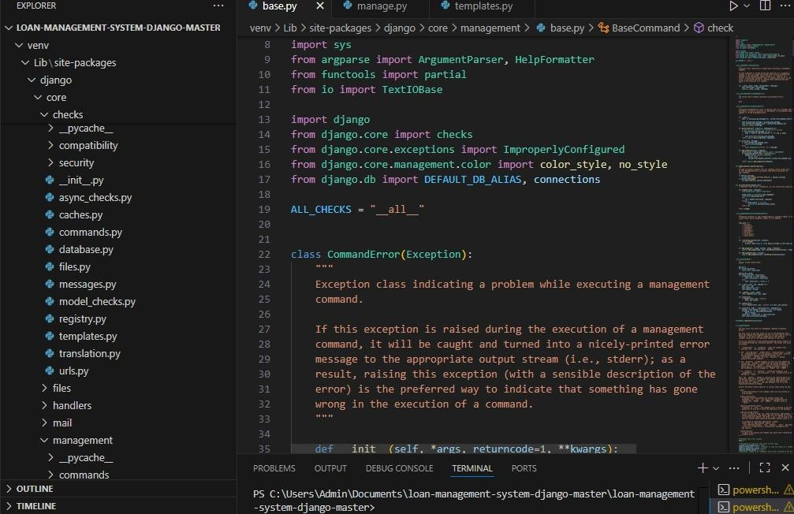

Fig 4.1 Visual Studio Code user interface Additionally.

Chapter 5

System Design

Block Diagram

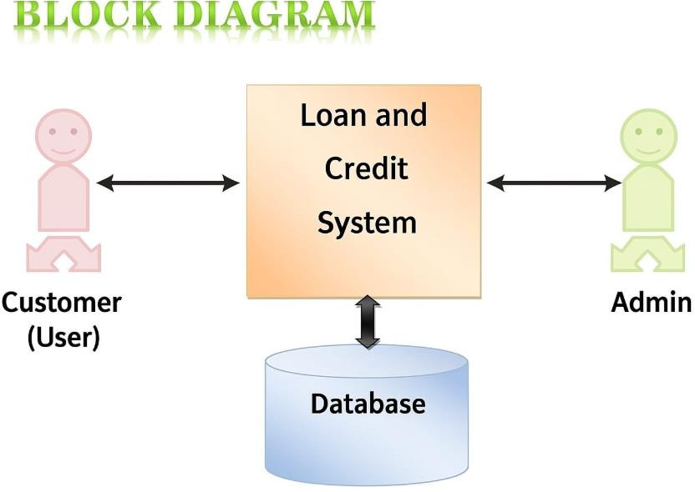

Fig 5.1 Block Diagram

5.2 Client-server model

A client-server model is a distributed communication framework that divides processes between a service provider (server) and a service requester (client). The clients and servers communicate with each other through a network by exchanging response packages or requests.

While using this model, the client side shares data and interacts with the database. All the resources are focused on user experience and the user interface. The server side handles business logic, database interactions and handles calculations. The servers can handle one or many different times at the same time. However, with the rise in demand for applications with complex user interactions and adaptive interfaces rise, the application logic is moving more towards the client. This typically results in a better user experience by avoiding full page reloads after every interaction.

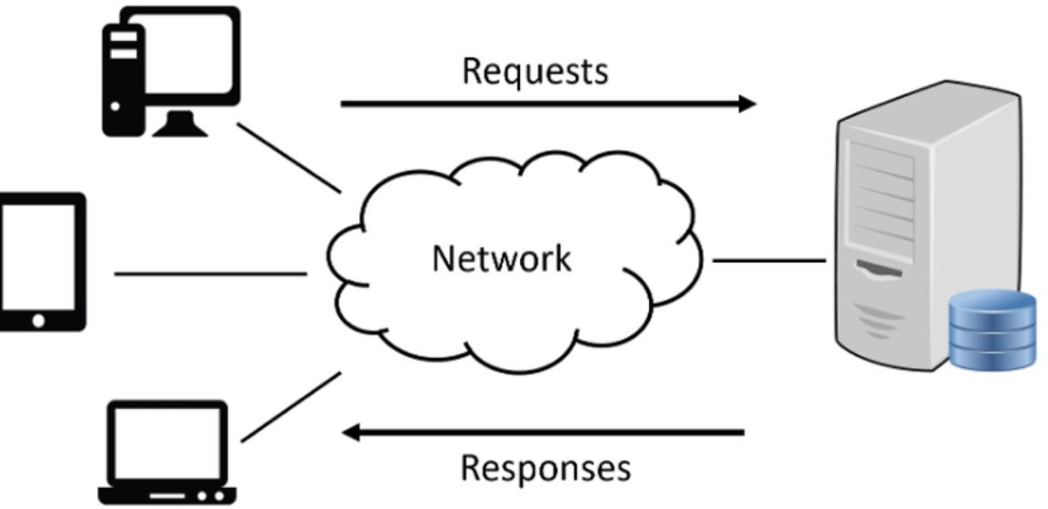

Fig5.2 Client-server model

5.3 Document Object Model

The Document Object Model is a programming interface for HTML and XML document. It interfaces pages to programming languages or scripts. The DOM can be seen as a page representation for programs to modify the style, content and structure of the document. The document is presented as a logical tree structure. There is a node in the end of every branch of the tree. There is an object present in each node. Event handlers can also be attached to the nodes. These events handlers get executed once an event is triggered.

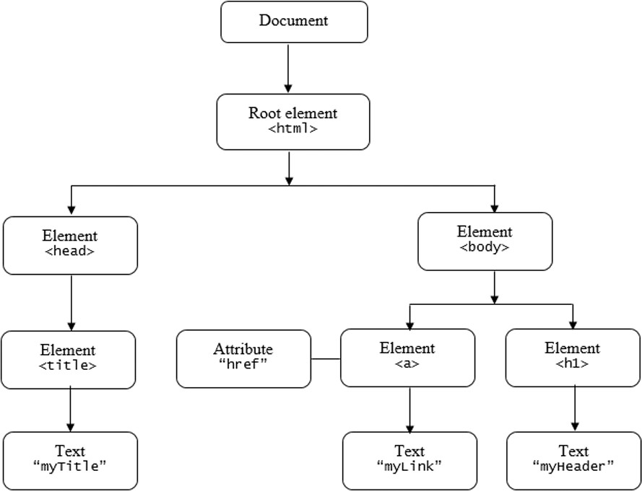 Fig 5.2
The HTML DOM tree of objects

5.3 Use Case Diagram
Use case diagram consists of use cases and actors and shows the interaction between them. The key points are:
- The main purpose is to show the interaction between the use cases and the actor.
- To represent the system requirement from user’s perspective.
- The use cases are the functions that are to be performed in the module.
- It recognizes the internal as well as external factors that influence the system.

Use Case Summary

  - Borrower submits application
  - System verifies credit score
  - Loan officer approves/rejects
  - Funds disbursed upon approval
  - Payments tracked and reported

Activity Diagram for User:

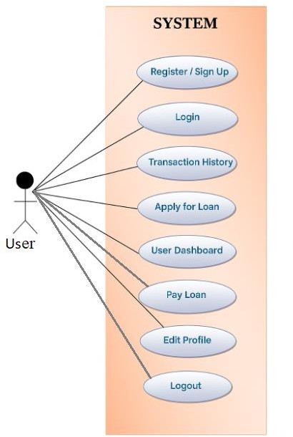

Fig. 5.3 Activity Diagram for User

Activity Diagram
    - Activity Diagram for Admin

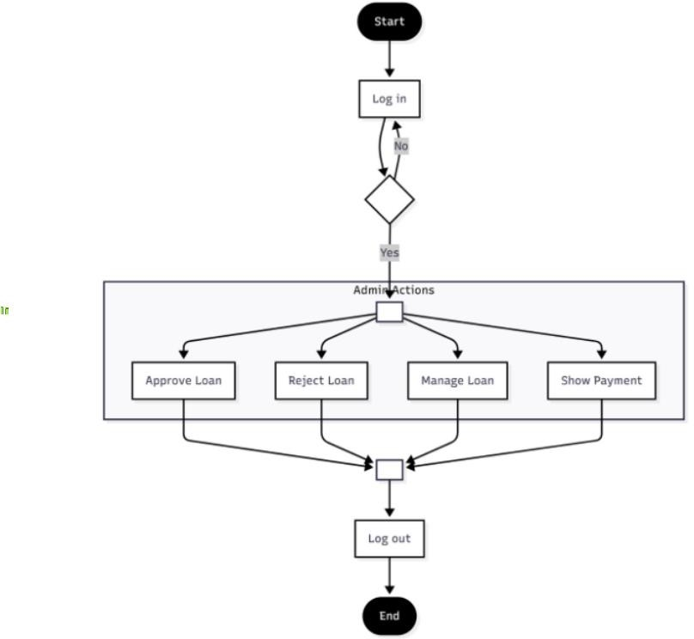

Fig. 5.4 Activity Diagram for Admin

Data Flow Diagram
A Data Flow Diagram (DFD) is a traditional visual representation of the information flows within a system.It can be manual, automated, or a combination of both.It shows how data enters and leaves the system, what changes the information, and where data is stored.

Standard symbols for DFDs are derived from the electric circuit diagram analysis and are shown below:
- Circle: A circle (bubble) shows a process that transforms data inputs into data out puts.
- Data Store: A set of parallel lines shows a place for the collection of data items. A data store indicates that the data is stored which can be used at a later stage or by the other processes in a different order.

- Source or Sink: Source or Sink is an external entity and acts as a source of system inputs or sink of system outputs.

Context Level Data Flow Diagram 5.4.1

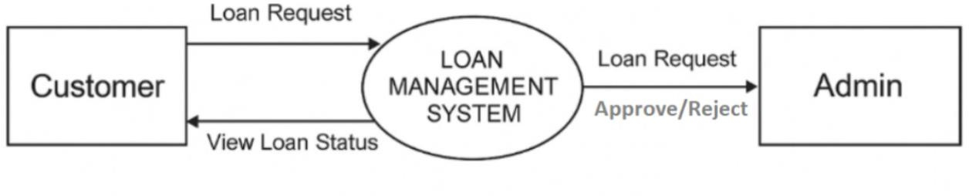

Fig. 5.4 Context Level DFD / 0 Level DFD

5.4.2 1 Level Data Flow Diagram

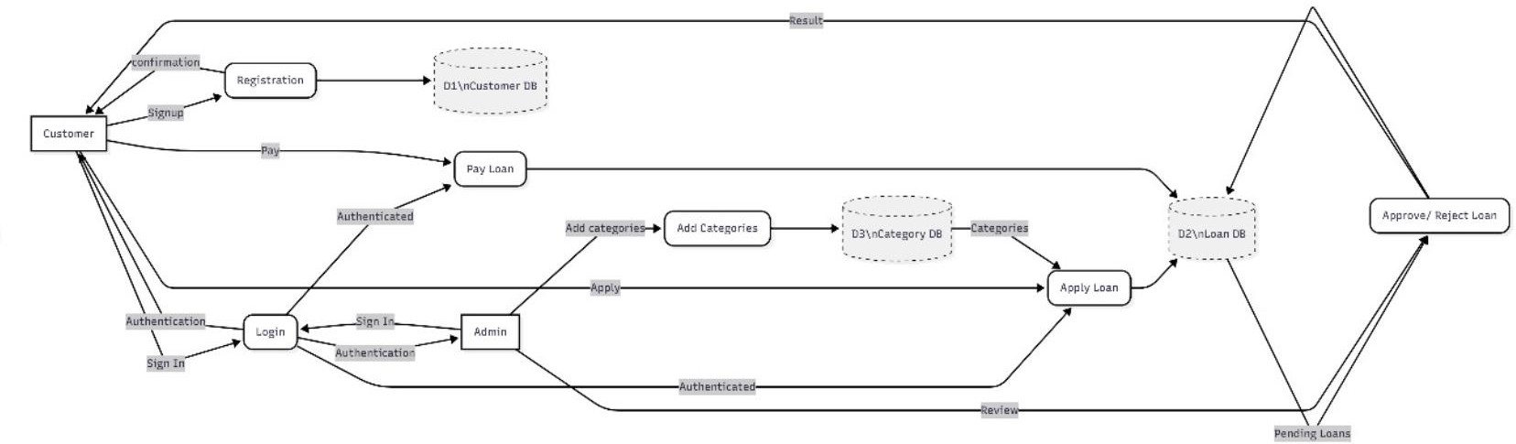

Fig. 5.4 1 Level DFD

5.4.3 FLOWCHART

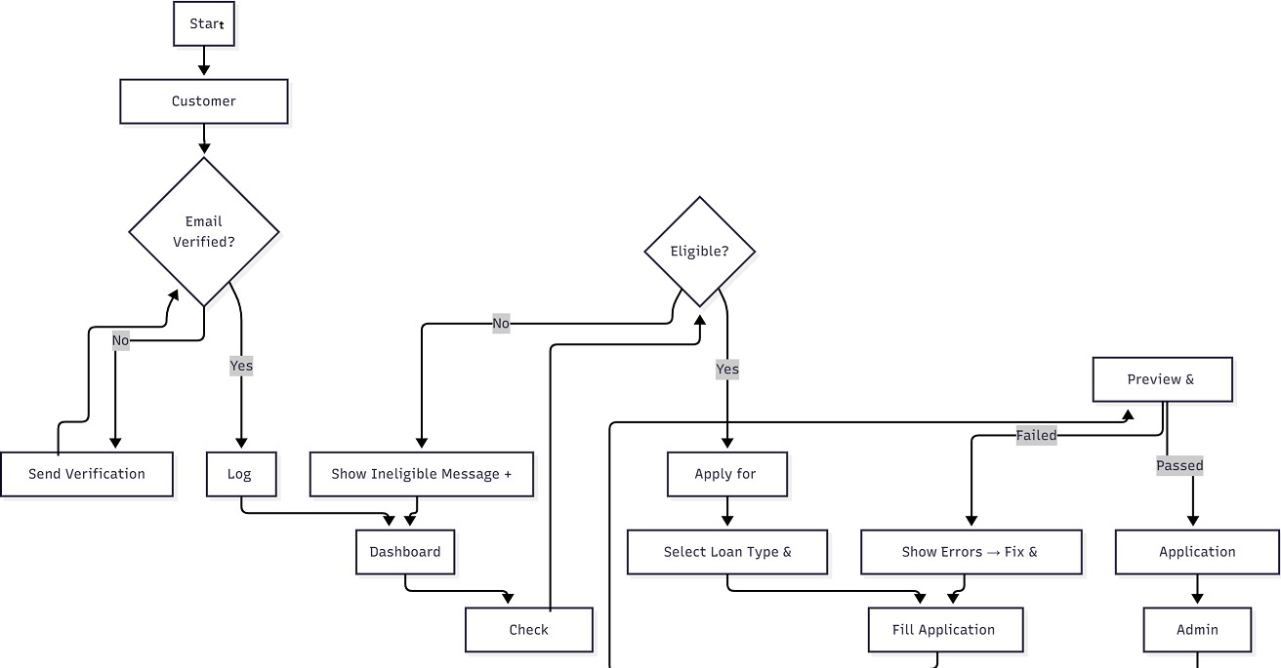

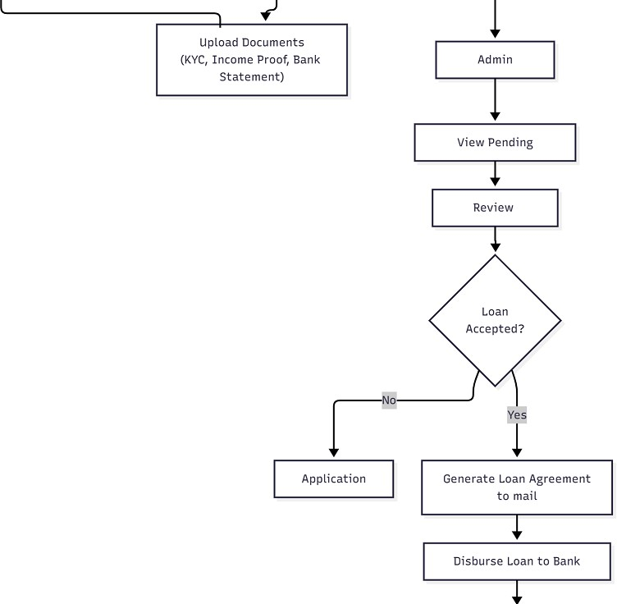

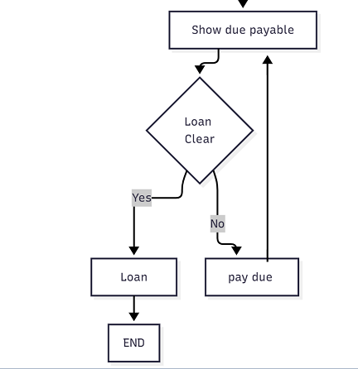

Chapter 6

Implementation and System Testing

6.1.1 System implementation
After all phase have been perfectly done, the system will be implemented to the server and the system can be used.

System implementation involves transforming the designed system into a fully functional application. For the Loan and Credit Management System, this phase focuses on deploying the Python (Django) backend, SQLite database, and HTML/CSS frontend to create a seamless web-based application for managing loan applications, credit evaluation, disbursement, and repayment tracking.
6.1.2. Implementation Strategy
The implementation follows these steps:

Setting Up Development Environment

  - Install Python 3.x, Django framework, and SQLite database.

  - Configure a code editor (e.g., VS Code, PyCharm) and version control (Git).

  - Set up the project structure with Django’s startproject and startapp commands.

Database Implementation

  - Design database models for Users, Loans, Payments, and Credit History.

  - Use Django ORM to create tables automatically in SQLite.

  - Implement database constraints, foreign keys, and validation rules.

Backend Development

  - Create Django views to handle loan applications, approvals, repayment, and reporting.

  - Implement user authentication and role-based access control (Admin, Officer, Customer).

  - Develop business logic for calculating interest, credit scores, and penalties.

Frontend Development

  - Design user-friendly HTML templates using Django templating engine.

  - Apply CSS for styling and layout; optionally use Bootstrap for responsive design.

  - Include interactive forms for loan applications, repayments, and profile management.

Integration

  - Connect frontend forms with backend logic.

  - Ensure seamless communication between database and web interface.

  - Implement notifications (email/SMS) for loan status and repayment reminders.

Testing

  - Unit Testing: Validate individual functions, e.g., credit score calculation.

  - Integration Testing: Ensure modules like loan application and repayment work together.

  - User Acceptance Testing (UAT): Test system with sample users to validate usability.

Deployment

  - Deploy locally on a server or on cloud platforms (Heroku, AWS).

  - Configure static files (CSS, JS) and media uploads.

  - Set up regular database backups and error logging.

System Testing

The goal of the system testing process was to determine all faults in our project. The program was subjected to a set of test inputs and many explanations were made and based on these explanations it will be decided whether the program behaves as expected or not. Our Project went through two levels of testing.

- Unit Testing
- Integration Testing

Unit Testing

Unit testing is commenced when a unit has been created and effectively reviewed .In order to test a single module we need to provide a complete environment i.e. besides the section we would require:

      - The procedures belonging to other units that the unit under test calls.
      - Non local data structures that module accesses.
      - Aprocedure to call the functions of the unit under test with appropriate parameters.

Test for the admin module:

      - Testing admin login form-This form is used for log in of administrator of the system. In this form we enter the username and password if both are correct administration page will open otherwise if any of data is wrong it will get redirected back to the login page and again ask the details.
.• Report Generation- admin can generate report from the main database.

Integration Testing
In the Integration testing we test various combination of the project module by providing the input.

The primary objective is to test the module interfaces in order to confirm that no errors are occurring when one module invokes the other module.

  - Expected Time Schedule

Task / Activity | Week 1-2 | Week 3-4 | Week 5-6 | Week 7-8 | Week 9-  10 | Week 11-  12 | Week 13-  14 | Week 15-  16
1. Requirement Analysis | ██████
2. System Design (Architecture & DB) |  | ██████
3. Environment Setup | ████
4. Database Implementation |  | ████ | ████
5. Backend Development (Django) |  |  | ██████ | ██████
6. Frontend Development (HTML/CSS/JS) |  |  |  | ██████ | ██████
7. Integration (Frontend + Backend + DB) |  |  |  |  | ██████ | ████
8. Testing (Unit & Integration) |  |  |  |  |  | ██████ | ██████
9. User Acceptance Testing (UAT) |  |  |  |  |  |  | ████ | ████
10. Deployment & Documetation |  |  |  |  |  |  |  | ██████

Chapter 7

Coding Snapshots:

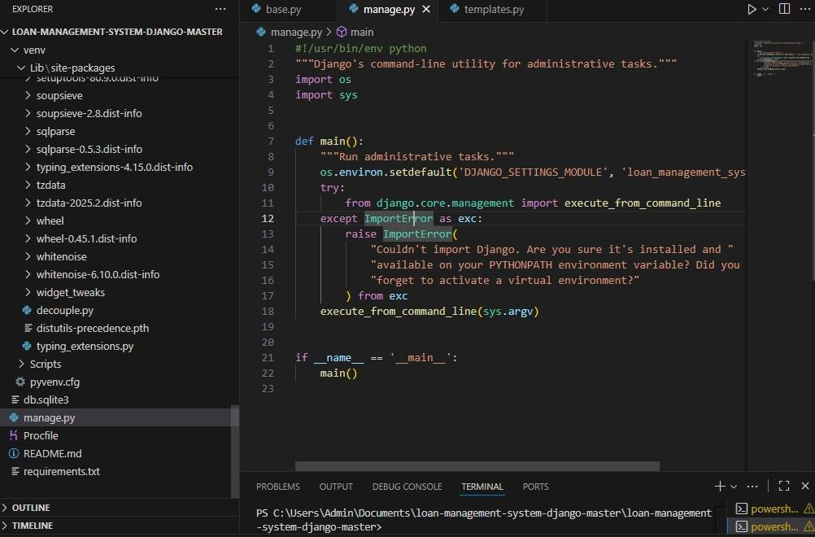

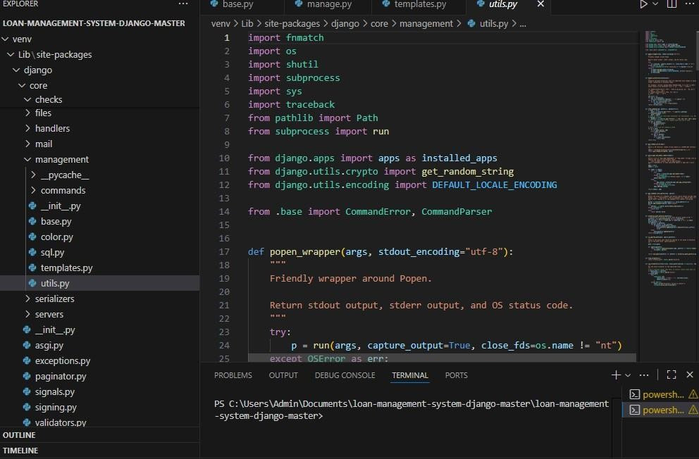

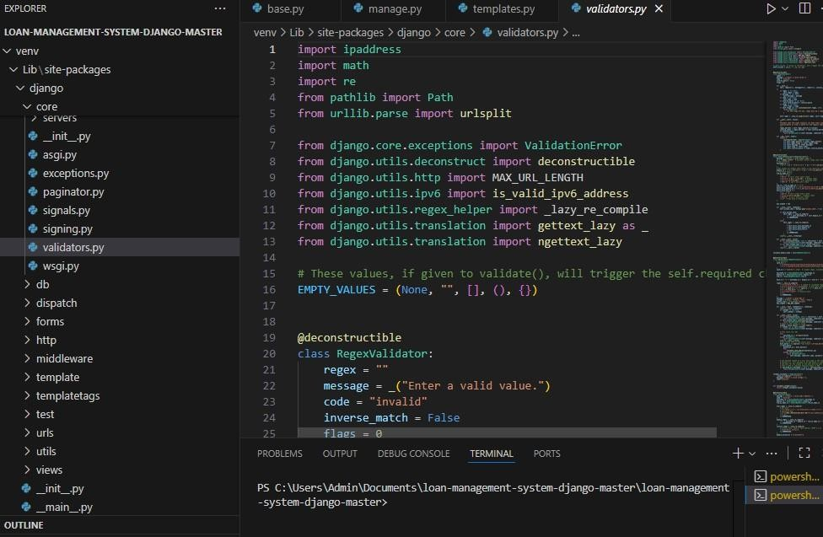

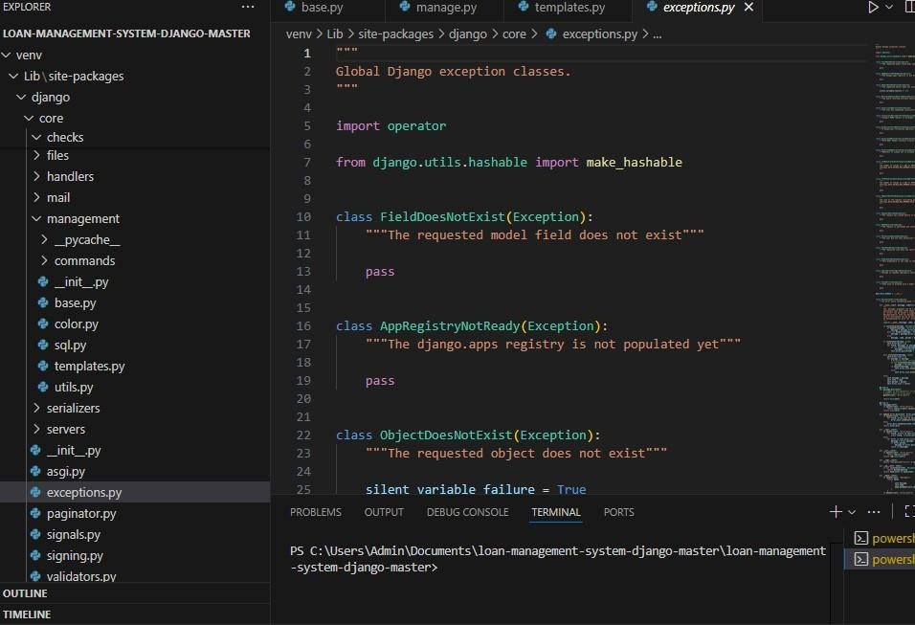

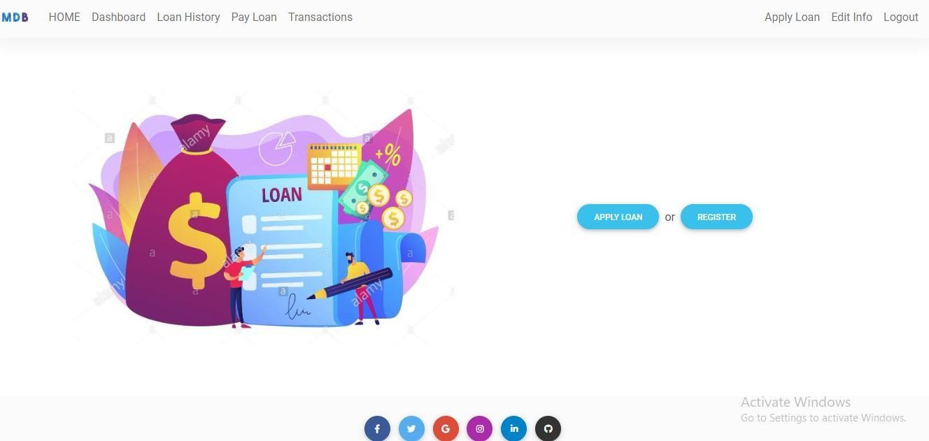

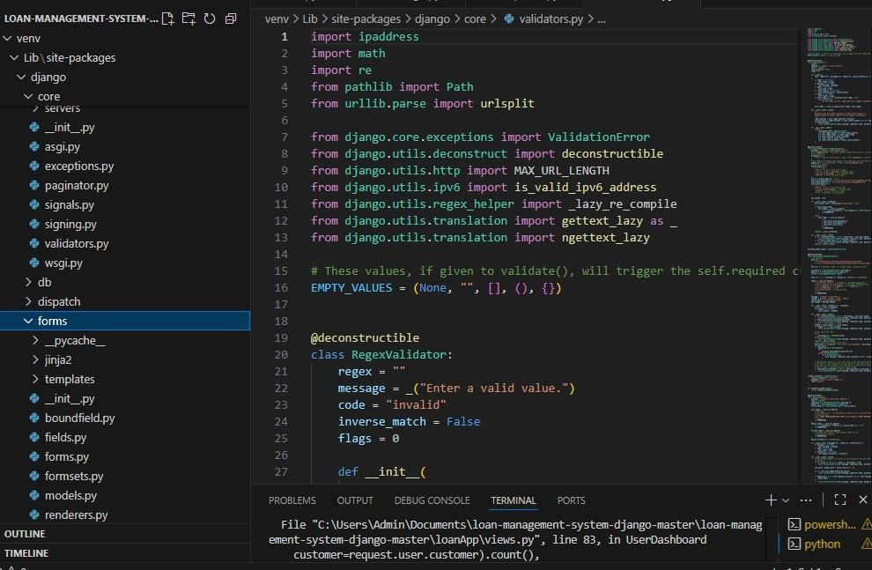

Chapter 8 Output Screens

Chapter 8
Advantages & Limitations

Implementing and managing a Loan and Credit System involves several challenges and limitations that can impact its effectiveness and efficiency. Understanding these issues is crucial for improving system design and operations.

Challenges

      - Data Quality and Availability: Incomplete or inaccurate customer data affects the reliability of credit scoring and risk analysis.
      - Regulatory Compliance: Keeping up with evolving financial regulations (KYC, AML, data privacy) requires continuous system updates and audits.
      - Integration Complexities: Connecting with external systems like credit bureaus, payment gateways, and regulatory bodies often involves technical and compatibility challenges.
      - User Adoption and Training: Ensuring that staff and customers understand and effectively use the system demands comprehensive training and support.
      - Scalability: Handling large volumes of loan applications and transactions without performance degradation can be challenging, especially for growing financial institutions.

8.2 Limitations

- Automation Constraints: Fully automated decision-making may overlook nuanced borrower situations that require human judgment.
- Technology Dependence: System outages or cyberattacks can disrupt loan processing and compromise sensitive data.
- Limited Customization: Off-the-shelf loan system solutions might not cater to unique business rules or product offerings.
- Cost Factors: Developing and maintaining a robust loan system can be expensive, particularly for small lenders.
- Customer Accessibility: Digital loan applications may exclude users with limited internet access or low digital literacy.

8.2 Advantages

- Efficient Loan Processing
  - Automates loan applications, approvals, and disbursement.

  - Reduces manual paperwork and time-consuming processes.

  - Ensures faster decision-making for loan requests.

- Accurate Record Keeping
  - Maintains detailed records of loans, repayments, and customer profiles.

  - Reduces human errors in financial calculations and reporting.

  - Provides easy retrieval of historical loan data for audits or reference.

- Improved Credit Management
  - Tracks credit history, outstanding loans, and repayment schedules.

  - Helps in assessing customer creditworthiness quickly.

  - Minimizes the risk of defaults by alerting for overdue payments.

- Enhanced User Experience
  - Provides customers with easy access to loan status, repayment schedules, and account statements.

  - Reduces the need for frequent visits to the bank or financial institution.

- Data Security and Privacy
  - Sensitive customer information is securely stored and protected.

  - Role-based access ensures only authorized personnel can view or modify data.

- Automation and Reporting
  - Generates automated reports for management on loan portfolio, repayment trends, and financial health.

  - Supports better decision-making and strategic planning.

- Compliance and Audit Support
  - Ensures adherence to banking regulations and policies.

  - Facilitates audits with organized records and traceable transactions.

- Scalability
  - Can handle a growing number of customers, loans, and transactions efficiently.

  - Easily adaptable for future enhancements like integrating mobile payments or online verification.

8.2.2 Benefits
- Informed decision-making for credit policies and risk management.

- Early detection of potential loan defaults.

- Improved operational efficiency and customer satisfaction.
- Enhanced transparency and accountability for stakeholders.

Chapter 9

Future Enhancements / Recommendations

To improve the Loan and Credit System’s efficiency, user experience, and risk management, the following enhancements are recommended:

Advanced Credit Scoring Models

Implement machine learning algorithms to develop more accurate and dynamic credit scoring models that incorporate alternative data (e.g., social behavior, mobile usage) for better risk prediction.

Automation and AI Integration

Introduce AI-driven automation for application processing, fraud detection, and customer support (chatbots), reducing manual workload and improving turnaround time.

Enhanced Security Measures

Adopt biometric authentication, multi-factor authentication (MFA), and advanced encryption standards to safeguard sensitive borrower and transaction data.

Real-time Analytics and Monitoring

Develop real-time dashboards and alert systems to monitor loan performance, defaults, and operational KPIs, enabling proactive management.

Flexible Product Offerings

Allow dynamic configuration of loan products, interest rates, and repayment plans to cater to diverse customer needs and competitive markets.

Integration with Fintech and Open Banking APIs

Facilitate data sharing and collaboration with fintech services and open banking platforms to enrich customer profiles and expand loan services.

Regulatory Compliance Automation

Automate compliance checks and reporting to reduce errors, ensure timely updates, and meet evolving regulatory requirements.

Chapter 9

Conclusion

The Loan and Credit System plays a critical role in modern financial institutions by streamlining loan processing, improving credit risk management, and enhancing customer experience. Through efficient automation, integration with credit bureaus, and robust reporting capabilities, the system supports informed decision-making and regulatory compliance.

Despite certain challenges such as data quality issues, fraud risks, and technological complexities, continuous improvements and adoption of advanced analytics can significantly enhance system performance and reliability. Future enhancements like AI-driven credit scoring, mobile access, and real-time monitoring will further empower lenders to offer competitive, customer-centric loan products.

In summary, a well-designed Loan and Credit System not only accelerates loan disbursement but also strengthens risk control, operational efficiency, and stakeholder trust — ultimately driving sustainable growth in lending operations.

References:

- https://newgensoft.com/in/blog/loan-management-systems.

- https://www.worldbank.org
- Bass, L., Clements, P. & Kazman, R. Software Architecture in Practice. 2nd ed. Boston: Addison Wesley. 2003
- VSCode. 2019. Accessed 2019.9. https://code.visualstudio.com/
- Official documentation of credit bureaus and financial regulations relevant to your region (e.g., FICO, Experian, Equifax).
- Research papers and articles on loan management systems, available via Google Scholar .
- Some You Tube channels.

- https://www.udemy.com/course/python-django-the-full-stack-guide
- Author: Jasmine Finer, Year: 2025 — Jan 18 publication date. Real Python: Django (Python web framework)Get Started With Django: Build a Portfolio App”https://realpython.com/get-started-with- django-1/?
- Author: Nik Piepenbreier,Year: 2020 (published April 2) ,“Python SQLite Tutorial — The Ultimate Guide”
- Author: Erin Glass,Year: 2020 (October 13) , “A Brief Introduction to CSS”

Appendix: Loan and Credit System

2. SAMPLE LOAN APPLICATION FORM

A simple form collecting borrower details, loan amount, tenure, purpose, and supporting documents. Data Dictionary Snapshot
Table | Field | Description
Customers | CustomerID | Unique identifier
Loans | LoanID | Loan record identifier
Payments | PaymentDate | Date of repayment

Check List of Items

Item No. | Item Description
1. | Requirements gathering completed
2. | System architecture designed
3. | Database schema finalized
4. | User interface design completed
5. | Loan application processing module developed
6. | Reporting and analytics module implemented
7. | User roles and access control configured
8. | Testing (unit, integration, system) completed
9. | Post-deployment monitoring plan established

