Agile model is the combination of iterative and incremental models
introduced 1990

agile model divide into incremental part

Agile methods break tasks into smaller iterations

Each iteration is considered as a short time "frame" in the Agile process model, which typically lasts from one to four weeks

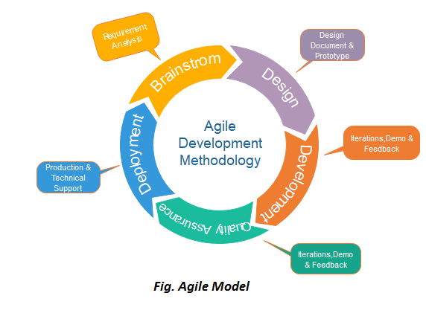
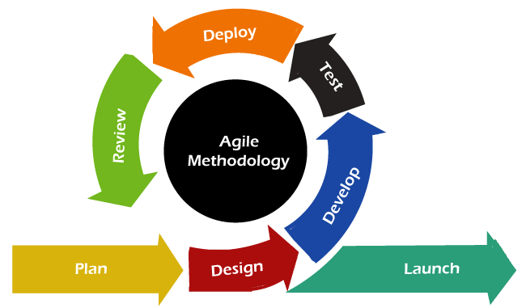

Phases of Agile Model:
Following are the phases in the Agile model are as follows:
- Requirements gathering
- Design the requirements
- Construction/ iteration
- Testing/ Quality assurance
- Deployment
- Feedback

When to use the Agile Model?
- When frequent changes are required.
- When a highly qualified and experienced team is available.
- When a customer is ready to have a meeting with a software team all the time.
- When project size is small.

Advantage(Pros) of Agile Method:
- Frequent Delivery
- Face-to-Face Communication with clients.
- Efficient design and fulfils the business requirement.
- Anytime changes are acceptable.
- It reduces total development time.

Disadvantages(Cons) of Agile Model:
- Due to the shortage of formal documents, it creates confusion and crucial decisions taken throughout various phases can be misinterpreted at any time by different team members.
- Due to the lack of proper documentation, once the project completes and the developers allotted to another project, maintenance of the finished project can become a difficulty.

