**CRIME ANALYSIS ON PROPERTY STOLEN AND RECOVERED**

A Mini Project Report Submitted by

Niveditha G Poojary Nivita Dionna Cardoza (4NM17CS117) (4NM17CS118)

Pavithra S Prajna V

(4NM17CS124) (4NM17CS128)

UNDER THE GUIDANCE OF

Mrs.Savitha Shetty

Assistant Professor Grade II, NMAMIT

Department of Computer Science and Engineering

in partial fulfilment of the requirements for the award of the Degree of

Bachelor of Engineering in

Computer Science & Engineering

From

Visvesvaraya Technological University, Belagavi



DEPARTMENT OF COMPUTER SCIENCE AND ENGINEERING

N.M.A.M. INSTITUTE OF TECHNOLOGY

(An Autonomous Institution under VTU, Belgaum) (AICTE approved, NBA Accredited, ISO

9001:2008 Certified) NITTE -574 110, Udupi District, KARNATAKA.

**May 2020**



**(ISO 9001:2015 Certified), Accredited with ‘A’ Grade by NAAC**

**                 : 08258 - 281039 – 281263, Fax: 08258 – 281265**

**Department of Computer Science and Engineering**

B.E. CSE Program Accredited by NBA, New Delhi from 1-7-2018 to 30-6-2021

**DEPARTMENT OF COMPUTER SCIENCE AND ENGINEERING**

# CERTIFICATE

“Crime analysis on Property stolen and recovered”

is a bonafide work carried out by

Niveditha G Poojary(4NM17CS117) Nivita Dionna Cardoza(4NM17CS118)

Pavithra S(4NM17CS123) Prajna V(4NM17CS128)

in partial fulfilment of the requirements for the award of

Bachelor of Engineering Degree in Computer Science and Engineering

prescribed by Visvesvaraya Technological University,

Belagavi during the year 2018-2019.

It is certified that all corrections/suggestions indicated for Internal Assessment have been incorporated in the report.

The Mini project report has been approved as it satisfies the academic requirements in respect of the project work prescribed for the Bachelor of Engineering Degree.

Signature of Guide Signature of HOD

# **ACKNOWLEDGEMENT**

We believe that our project will be complete only after we thank the people who have contributed to make this project successful.

First and foremost, our sincere thanks to our beloved principal, **Dr. Niranjan N. Chiplunkar** for giving us an opportunity to carry out our project work at our college and providing us with all the needed facilities.

We express our deep sense of gratitude and indebtedness to our guide **Mrs.Savitha Shetty**, Assistant Professor Grade II, Department of Computer Science and Engineering, for his inspiring guidance, constant encouragement, support and suggestions for improvement during the course of our project.

We sincerely thank **Dr. K.R. Udaya Kumar Reddy**, Head of Department of Computer Science and Engineering, Nitte Mahalinga Adyantaya Memorial Institute of Technology, Nitte.

We also thank all those who have supported us throughout the entire duration of our project.

Finally, we thank the staff members of the Department of Computer Science and Engineering and all our friends for their honest opinions and suggestions throughout the course of our project.

Niveditha G Poojary

(4NM17CS117)

Nivita Dionna Cardoza

(4NM17CS118)

Pavithra S

(4NM17CS124)

Prajna V

(4NM17CS128)

**ABSTRACT**

Big Data is a term which is used for the description of huge or large volume of data which cannot be stored or processed using traditional approach within the given time frame. The data could be structured and unstructured. Big data helps users to collect variety of data and analyse large and varied data sets.

Data processing helps us to collect and organize raw data and to get meaningful information.

The Big data analytics tools offer a variety of analytics packages which gives different options to the users to implement.

Big Data is characterized into 4 V’s they are namely:

* ‘Volume’ which is basically measured in terms of the scale of the data. The data that businesses could collect is really massive and it is a critical factor for big data analytics.
* ‘Variety’ which is nothing but the different forms of data that could be used. The variety of data is basically generated from the sources like internet, sensors etc.
* ‘Velocity’ is nothing but the rate at which the heterogeneous data is being generated from various sources. The concept of big data helps us in implementing this.
* ‘Veracity’ means before implanting the data we must know if the data is coming from a valid source and if the data is of any importance. Big data helps us in implanting such an issue.

This project includes detailed yearly data i.e, from 2001 – 20 on the value and type of property stolen and recovered incident to each crime in each states and Union Territories of India .We analyse the data based on the parameters like Burglary property, Criminal breach of trust property, Dacoity property, Robbery property, Theft property, and other heads of property. Analysis of the data is done using Anaconda.

**TABLE OF CONTENTS**

|  |  |
| --- | --- |
| **TITLE** | **PAGE NUMBER** |
| TITLE PAGE | 1 |
| CERTIFICATE | 2 |
| ACKNOWLEDGEMENT | 3 |
| ABSTRACT | 4 |
| CHAPTER 1 INTRODUCTION | 5 |
| CHAPTER 2 SYSTEM ANALYSIS AND REQUIREMENTS | 6 |
| CHAPTER 3 IMPLEMENTATION | 7 |
| CHAPTER 4 RESULTS | 8 |
| CHAPTER 5 CONCLUSION | 12 |
| REFERENCES | 12 |

**CHAPTER 1**

**INTRODUCTION**

Anaconda is a free and open source distribution of the Python and R- programming languages for scientific computing ( [data](https://en.wikipedia.org/wiki/Data_science) science, machine learning application, large-scale data processing, [predictive analytics](https://en.wikipedia.org/wiki/Predictive_analytics), etc.), that aims to simplify package management and deployment. The distribution includes data-science packages suitable for Windows, Linux, and macOS.

Anaconda Navigator is a desktop graphical user interface (GUI) included in the Anaconda distribution. It allows us to launch applications provided in the Anaconda distribution and easily manage conda packages, environments and channels without the use of command-line commands.

The Anaconda distribution comes with applications such as JupyterLab , Jupyter Notebook,Qt Console,Spyder,Glueviz,Orange3, RStudio,Visual Studio Code along with Anaconda Navigator.

**Jupyter Notebook** is a web-based, interactive computing notebook environment. We can edit and run human-readable docs while describing the data analysis. It has the ability to display plots that are the output of running code cells. The IPython kernel is designed to work seamlessly with the matplotlib plotting library to provide this functionality.

Following are uses of Jupyter Notebook-

* Jupyter Notebook allows author visualizations, but also share them and allow interactive changes to the shared code and data set.
* With a Jupyter Notebook, you can view code, execute it, and display the results directly in your web browser.
* Jupyter Notebook code isn’t static; it can be edited and re-run incrementally in real time, with feedback provided directly in the browser.
* Documenting code samples**-** If you have a piece of code and you want to explain line-by-line how it works, with live feedback all along the way, you could embed it in a Jupyter Notebook.
  1. **Objective**

This project is about analysis of property stolen and recovered. Objective of the project is to analyse the vastly generated data using Big Data Analytics.

* 1. **Methodology**

We have initially extracted the property stolen and recovered dataset and saved it as a csv file.This dataset is then linked into Anaconda

Later the analysis of the data is done by writing the python code using Anaconda.

Graph of the analysis is done using Jupyter Notebook.

**CHAPTER 2**

**SYSTEM ANALYSIS AND REQUIREMENTS**

**2.1 Functional Requirements**

A functional requirement defines a function of a system or its component. A function is described as a set of inputs, the behaviour and outputs. Functional requirements may be calculations, technical details, data manipulation and processing and other specific functionality that define what a system is supposed to accomplish. Functional requirements are made up of business features and technical requirements for support of particular features.

**2.1.1 Hardware Requirements**

* Intel i3 or above processor
* 4 GB or 8 GB RAM

**2.1.2 Software Requirements**

* Anaconda
* Jupyter Notebook

**2.2 Non-functional Requirements**

The non-functional requirements have the capabilities that are offered by the framework. They are also known as quality requirements. It specifies the criteria that can be used to judge the operation of a system, rather than specific behaviour. Non-functional requirements address features of a system that are not isolated to the ability of the user application administrator to carry out a particular operation within the system.

**CHAPTER 3**

**IMPLEMENTATION**

We have included the snapshot of the Property stolen and recovered dataset. In this file we have mainly 8 fields. The different fields are:

1. Area name
2. Year
3. Group name
4. Sub group
5. Cases property recovered
6. Cases property stolen
7. Value of property recovered
8. Value of property stolen

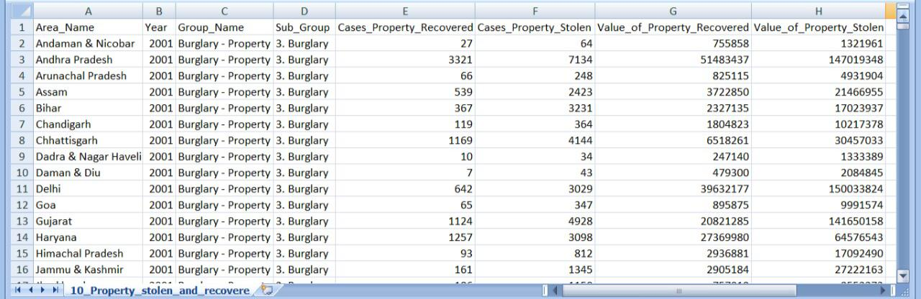

**CHAPTER 4**

**RESULT**

1:To find the total number of property stolen in given states

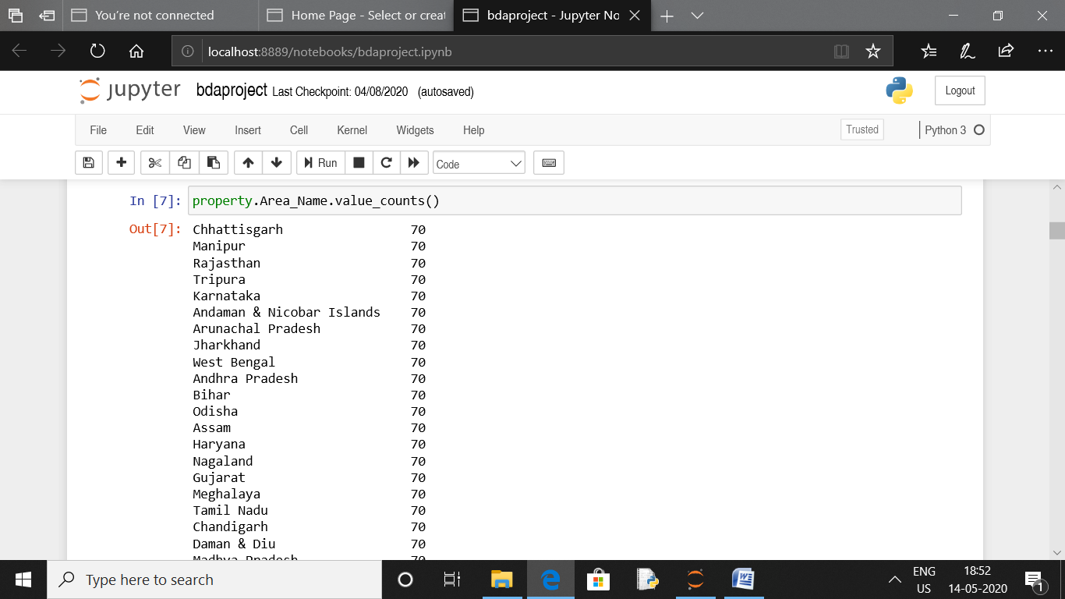

2:To find the number of stolen property in year 2001 to 2010

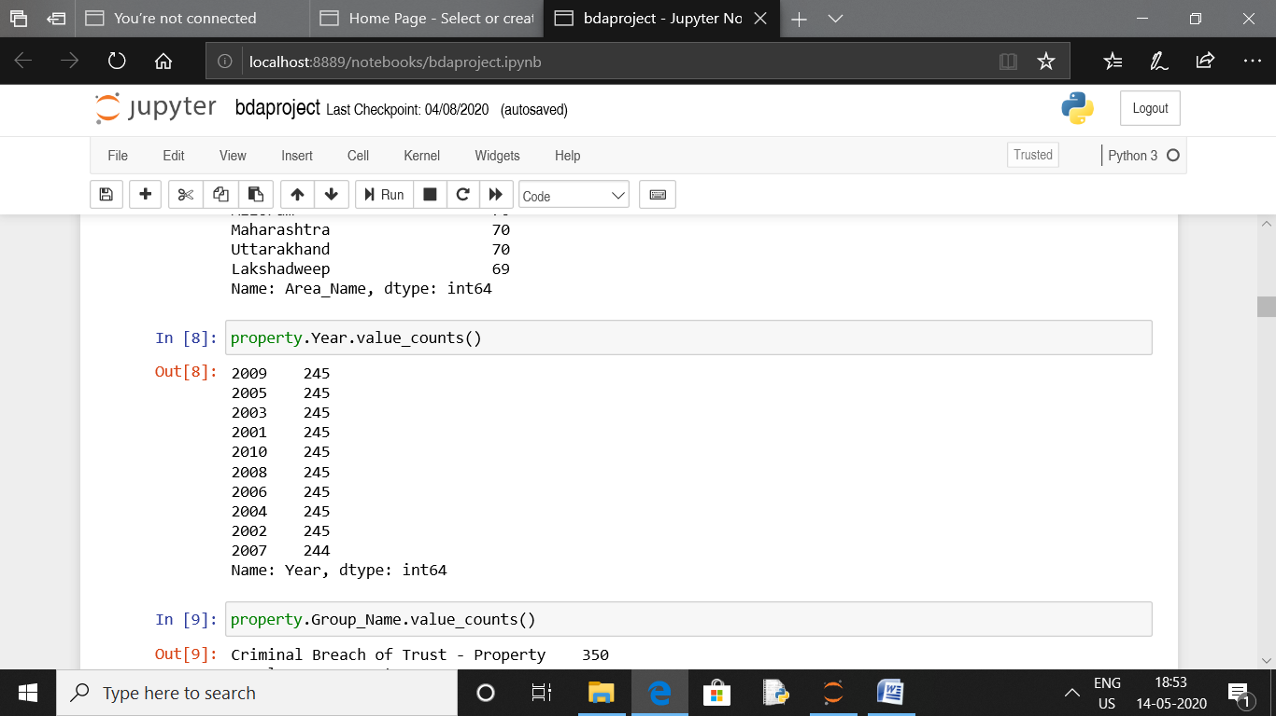

3:To find number of stolen property under each group

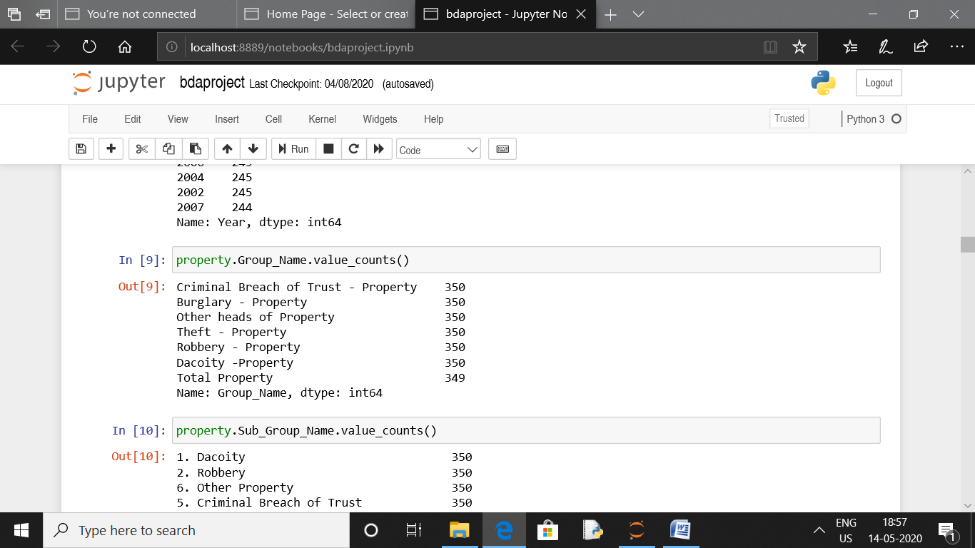

4:To calculate total number of property stolen and recovered

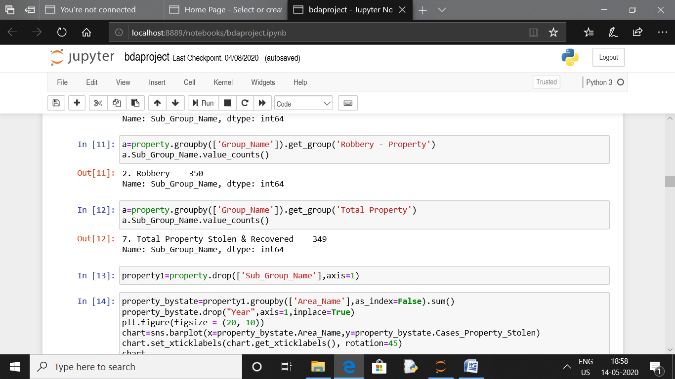

5:Analysing how many cases of properties are stolen in every state

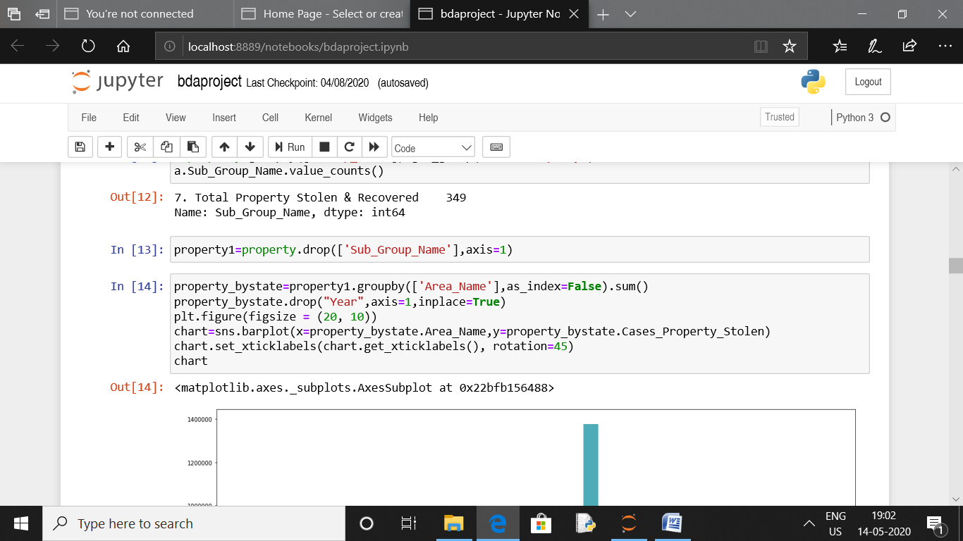

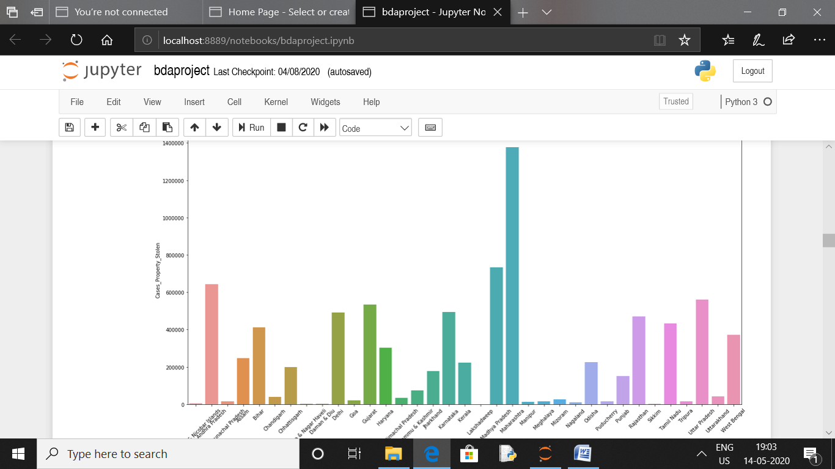

6:Analyse the cases of property stolen in every year

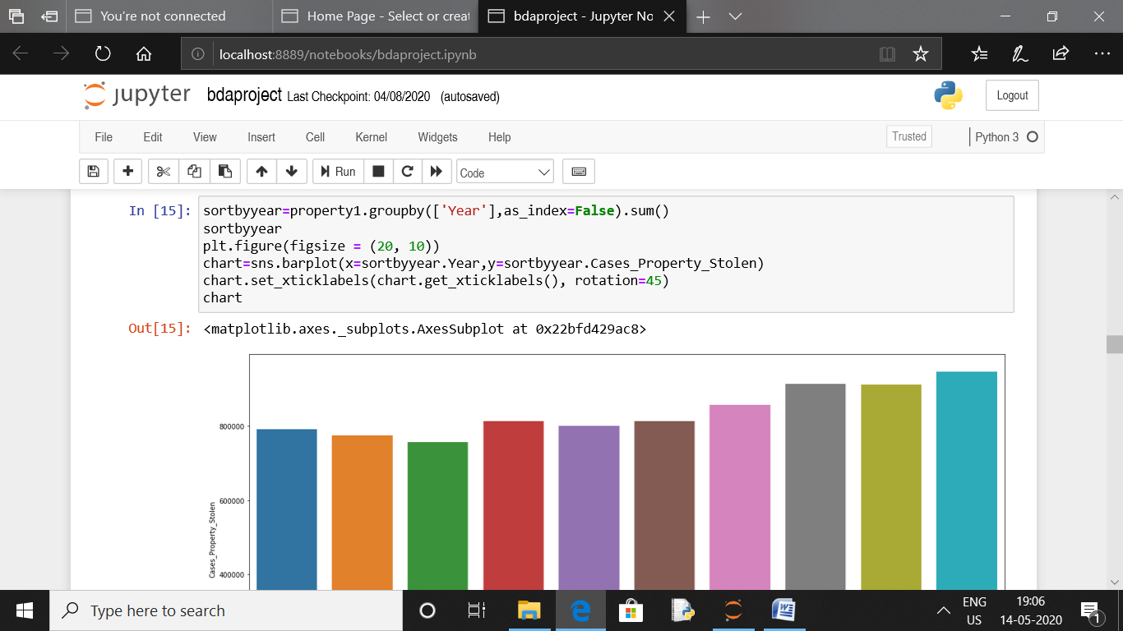

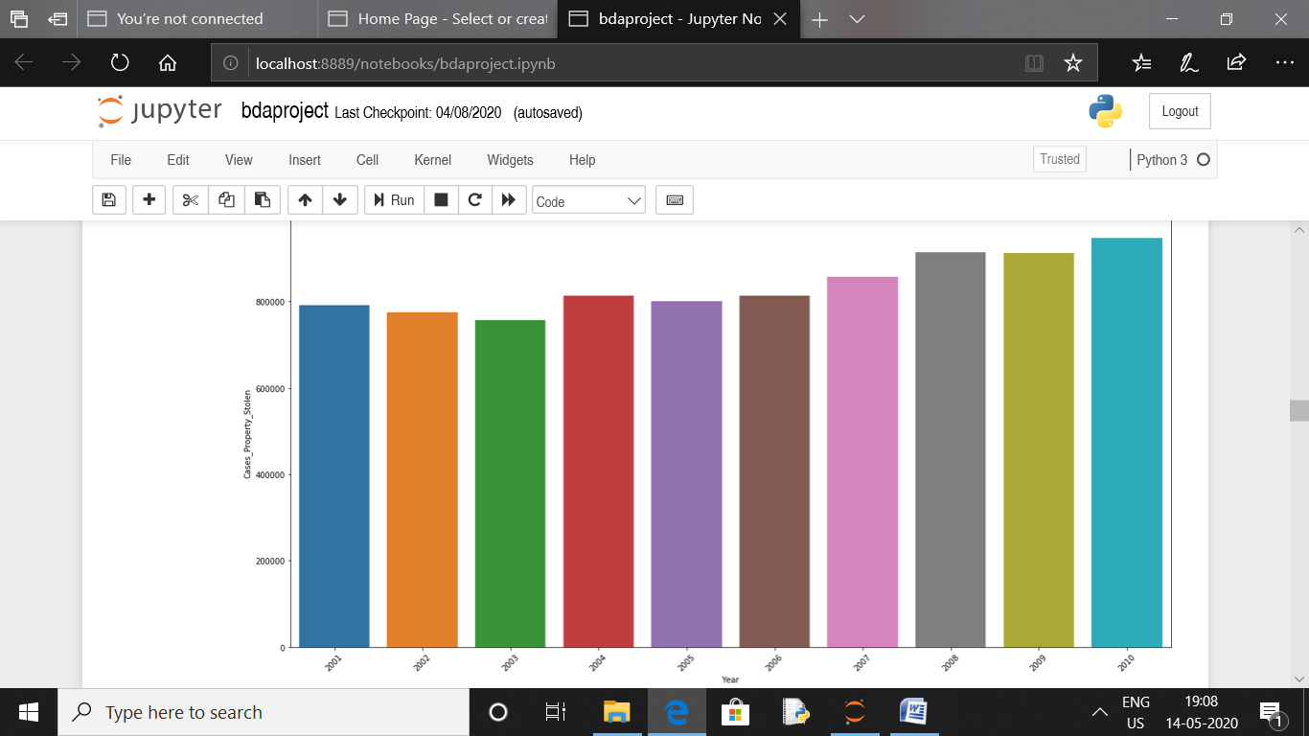

7.Analyse the values of property stolen in every year

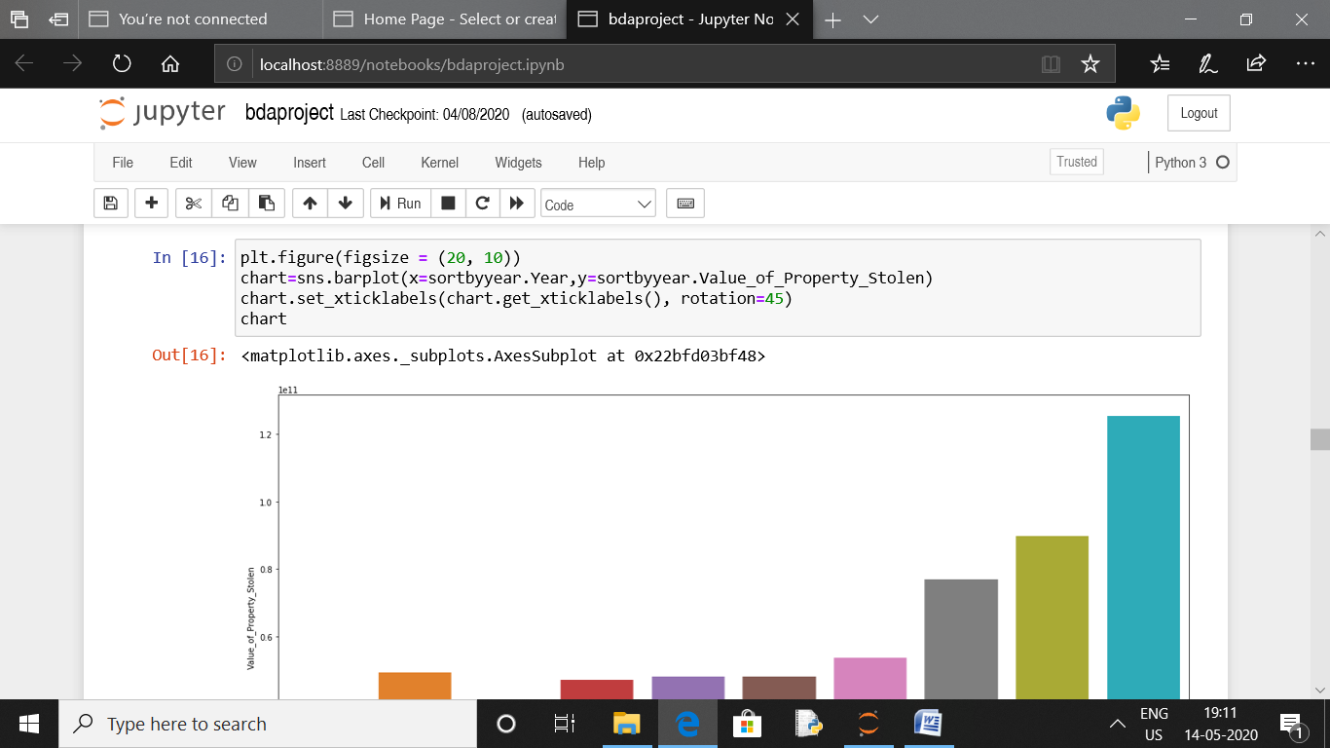

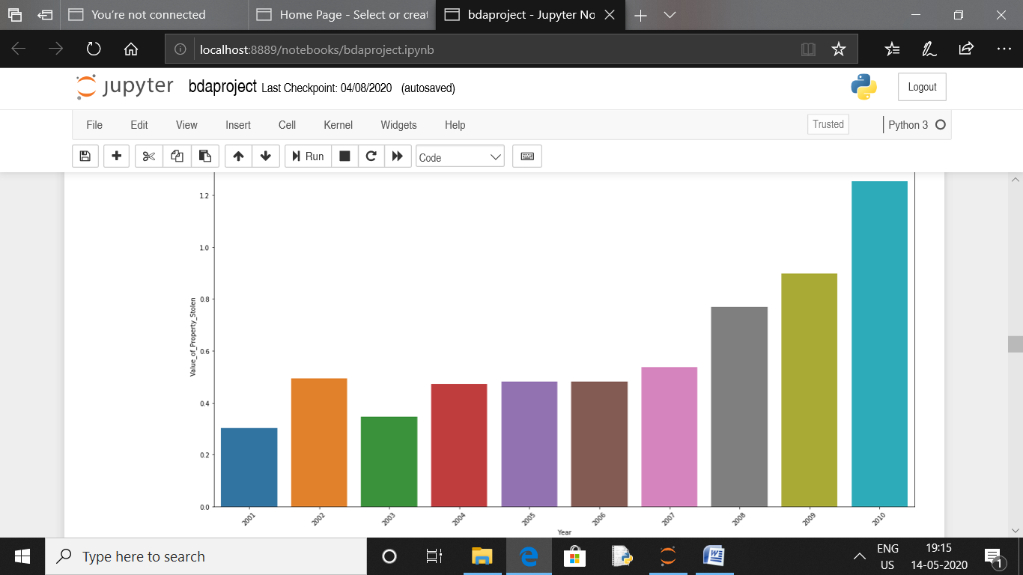

8: Analyse the values of property stolen in all states

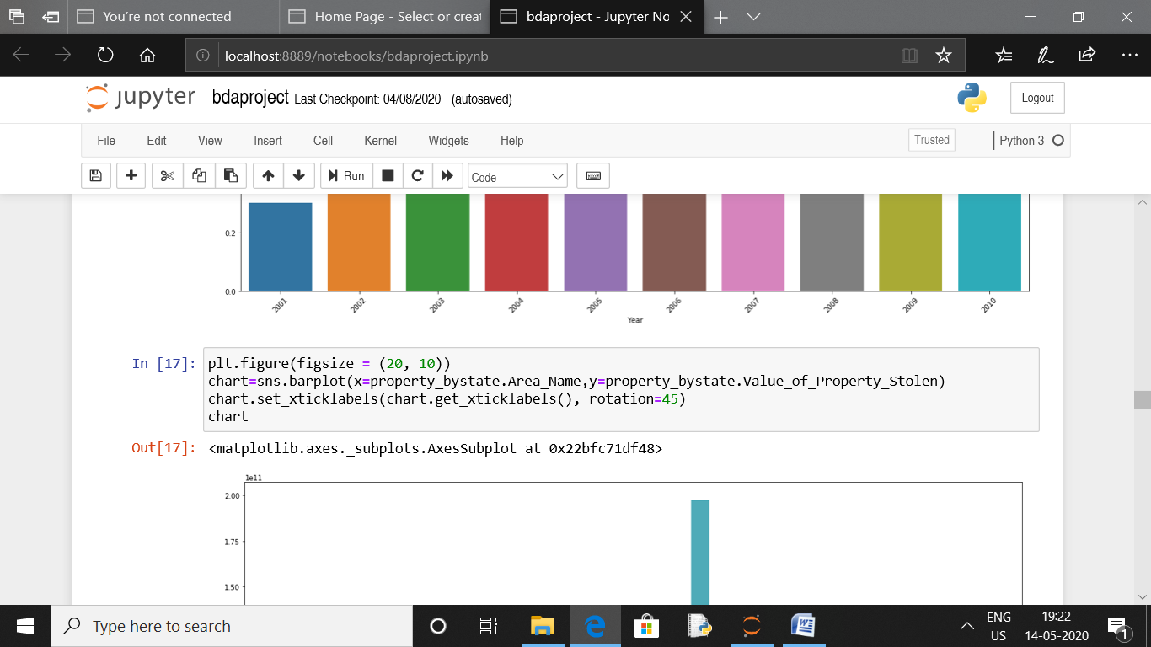

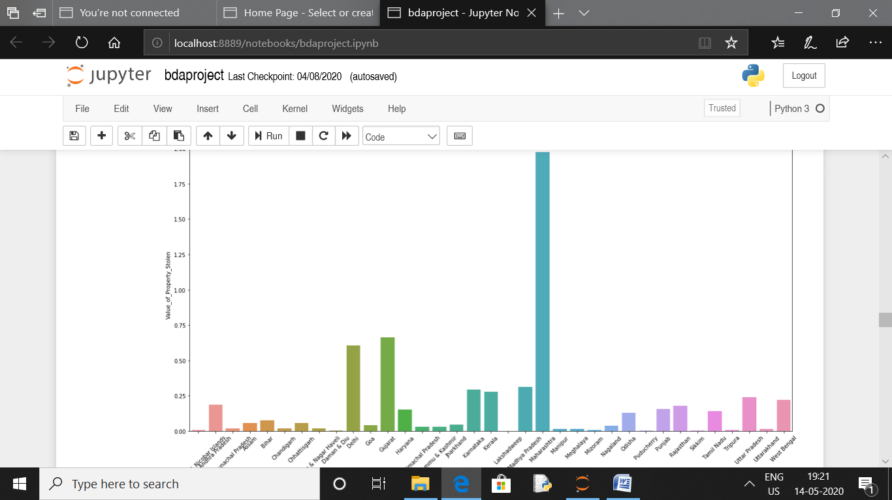

9:To find robbery property stolen

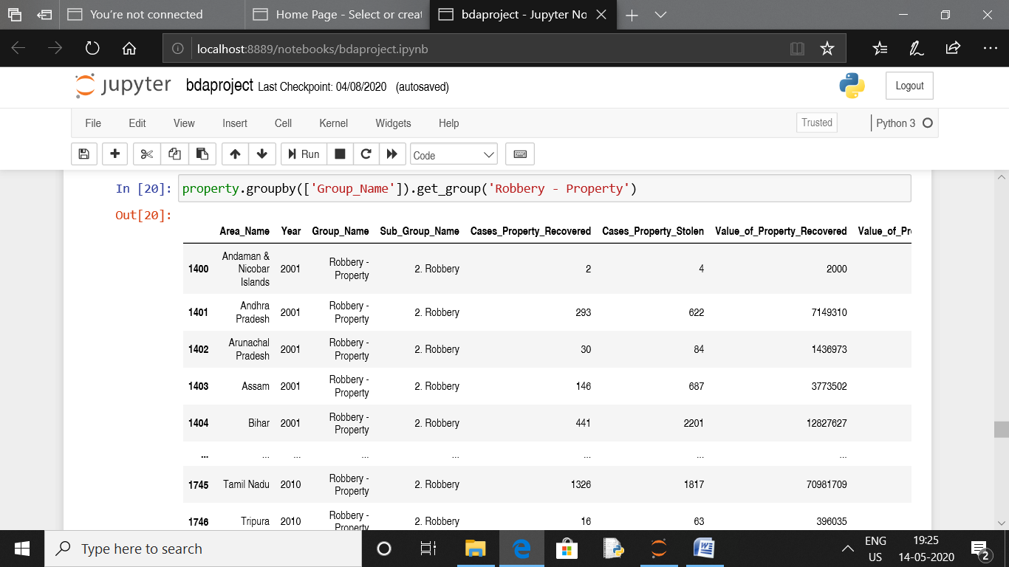

10:Analysing total number of property stolen and recovered

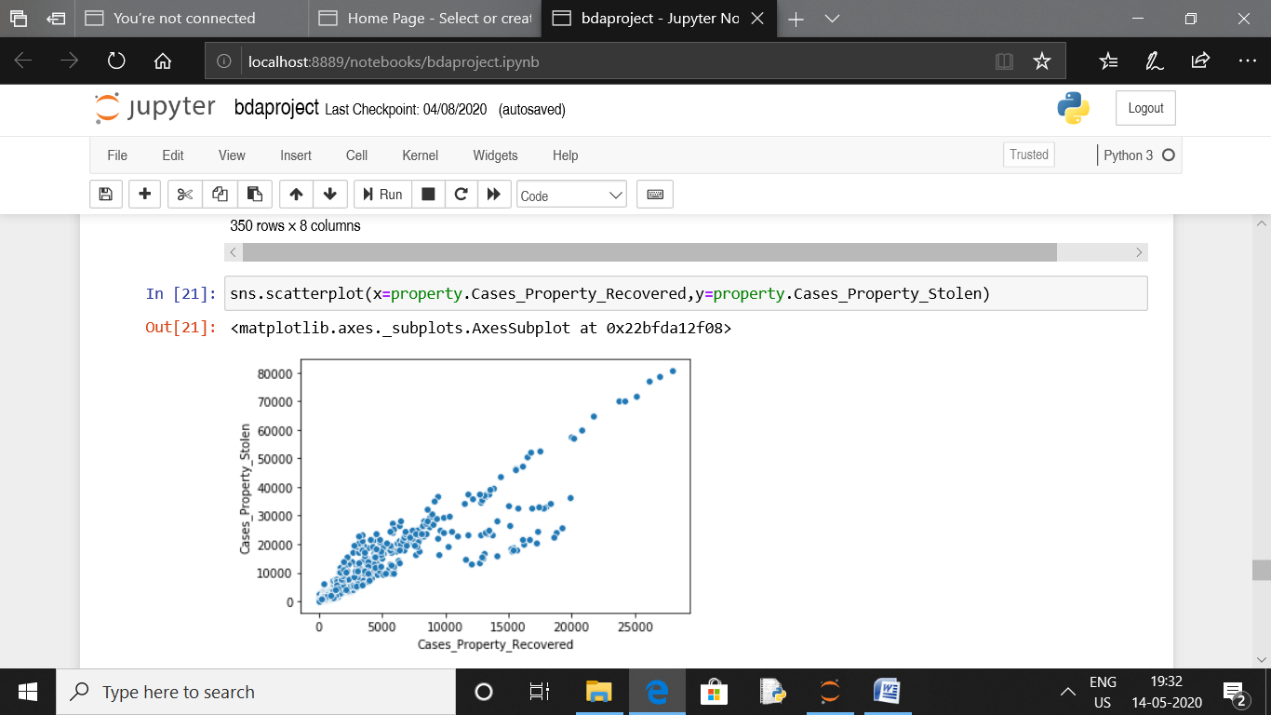

**CHAPTER 5**

**CONCLUSION**

* Using Jupyter and python ,we have analysed the property stolen and recovered dataset.
* If DBMS would have been used ,querying on this unstructured data would not have been possible.
* It helps improve understandability to the user by using big data analysis approach

**REFERENCES**

Referred to this site <https://www.kaggle.com/pratyush12300/crimes-in-india-property-stolen-and-recovered>