**Lab-2: To demonstrate configuration of IP-Address to the router and explore ping commands**

1. Topology

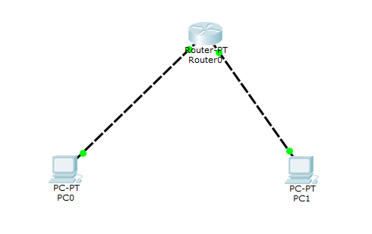

1. Simulation

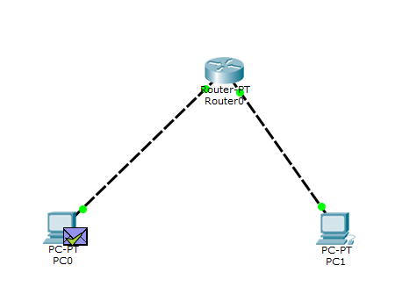

1. Ping Command

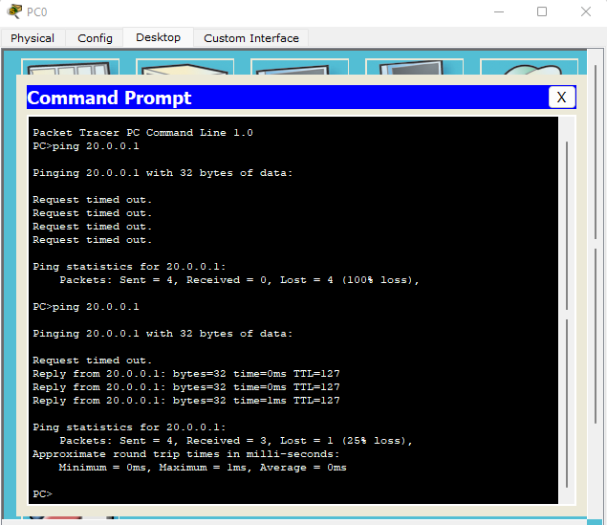

1. Configuration

