# Data Analyst Report

## 1. Sales Overview

### Objective:

To gain a comprehensive understanding of the overall sales performance, trends, and patterns over time.

### Analysis:

Total Sales Distribution by Month:

* March: 0.1%
* April: 36.7%
* May: 33.4%
* June: 29.8%

The data indicates a substantial increase in sales during April, followed by a gradual decline in May and June. Sales in March were minimal.

### Visualizations:

### Total Sales Distribution by Month

- The pie chart illustrates the monthly sales distribution, highlighting the peak sales period in April.



## 2. Product Analysis

### Objective:

To analyze the distribution of product categories, sizes, and quantities sold to identify the most popular products.

### Analysis:

Distribution of Orders by Size:

The most popular sizes are L, M, and XL.

Sizes 3XL to 6XL have significantly fewer orders.

### Visualizations:

1. Distribution of Orders by Size

- The pie chart displays the number of orders for each size, helping to identify which sizes are most and least popular among customers. In this most ordered size is Medium size with 17.26% after that Large is being ordered with 16.89%.

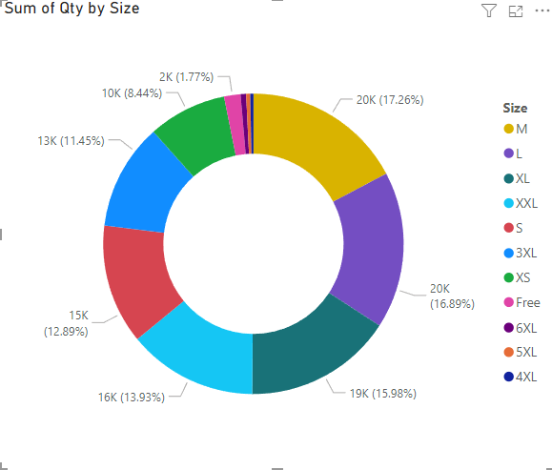

2. Distribution of Orders by Category

- The bar chart displays the number of orders for each category, helping to identify which categories are most and least popular among customers. 47049 people ordered T-shirts after that shirts were ordered with several 46713 people. Watches are the least choice by people.

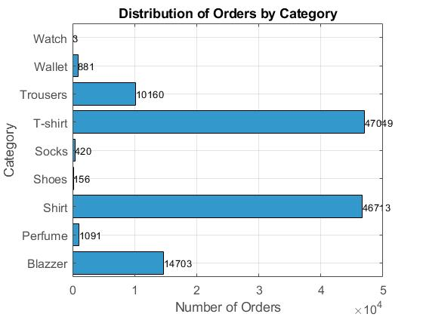

## 3. Fulfilment Analysis

### Objective:

To examine the fulfillment methods used and their effectiveness in delivering orders.

### Analysis:

- The effectiveness of fulfillment methods can be inferred from the geographical distribution and order satisfaction levels. Additional data on delivery times and customer feedback would provide a more detailed analysis.

### Visualizations:

### Geographical Distribution of Orders

- This visualization helps to understand the reach and efficiency of different fulfilment methods across various regions.

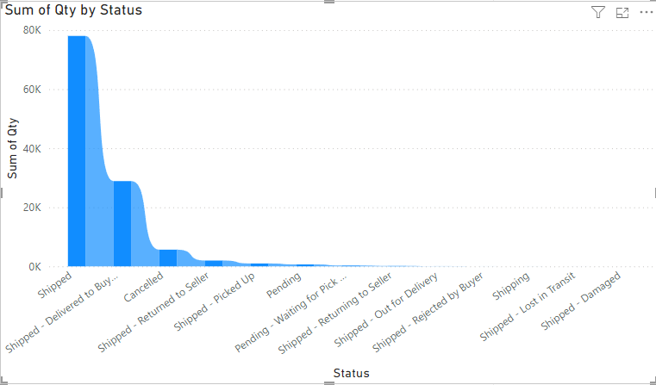

## 4. Customer Segmentation

### Objective:

To segment customers based on their buying behavior, location, and other relevant factors.

### Analysis:

-Segmentation by Location:

- Orders are distributed across various states, with significant concentrations in Maharashtra, Delhi, and Karnataka.

### Visualizations:

Distribution of Orders Over Shipping States

- A treemap shows the number of orders from each state, helping to identify key customer segments geographically. Maharashtra people order most of the products from amazon.

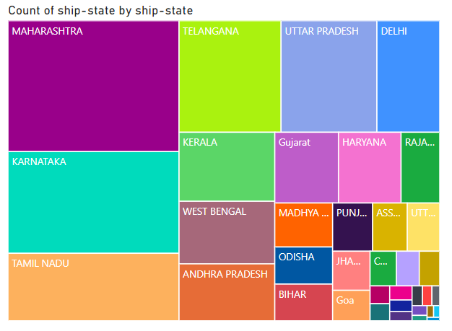

## 5. Geographical Analysis

### Objective:

To explore the geographical distribution of sales, focusing on states and cities.

### Analysis:

Sales Distribution by State:

- States like Maharashtra, Karnataka, and Delhi have higher sales compared to other states.

### Visualizations:

1. Geographical Distribution of Sales

- Detailed maps or charts displaying sales figures across different states and major cities.

## Analysis of Fulfillment Type vs. Order Status

### Description:

The heatmap displays the relationship between fulfillment type (Amazon and Merchant) and various order statuses. Each cell represents the number of orders corresponding to a particular fulfillment type and order status. The color intensity of each cell indicates the volume of orders, with darker shades representing higher counts.

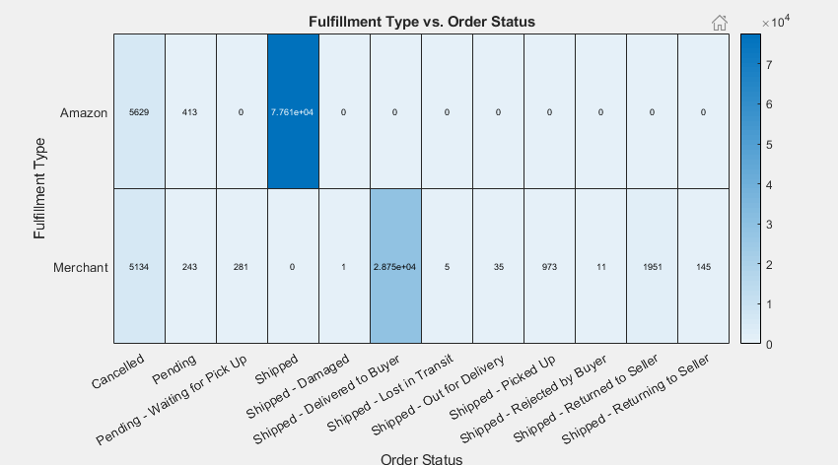

### Key Observations:

* **High Volume of Shipped Orders**:

The largest number of orders falls under the "Shipped" status for both Amazon and Merchant fulfillment types.

Amazon has approximately 27,560 shipped orders, while Merchant has around 28,750 shipped orders. This indicates that a significant portion of orders are successfully processed and dispatched by both fulfillment methods.

* **Pending and Cancelled Orders**:

Both Amazon and Merchant fulfillments have notable counts of "Pending" and "Cancelled" orders.

Amazon shows 5,629 canceled orders and 413 pending orders, whereas Merchant has 5,134 canceled orders and 243 pending orders. This suggests potential issues in order processing or customer decision changes.

* **Other Order Statuses**:

The remaining order statuses (e.g., "Shipped - Delivered to Buyer," "Shipped - Damaged," "Shipped - Returned to Seller") have relatively low counts compared to "Shipped" and "Cancelled."

Merchant fulfillment shows a slightly higher diversity in order statuses compared to Amazon, which has a more streamlined process predominantly ending in shipped orders.

* **No Orders in Some Statuses**:

Certain statuses, such as "Shipped - Lost in Transit" and "Shipped - Picked Up," have very few or no orders recorded for both fulfillment types. This indicates these scenarios are either rare or efficiently managed to prevent such occurrences.

## Distribution of Order Amounts

### Description:

The histogram illustrates the distribution of order amounts in INR. The x-axis denotes the order amounts, while the y-axis indicates the frequency of orders within each amount range.

### Analysis:

- Most orders are within the 200 to 800 INR range.

- There is a significant peak around the 400 to 600 INR range, indicating that this is the most common order value among customers.

- The frequency of orders declines sharply for amounts over 800 INR.

- Very few orders exceed 1200 INR, suggesting that higher-priced items are purchased less frequently.



### Insights:

- The concentration of orders in the lower price range indicates a customer preference for budget-friendly products.

- Marketing strategies could focus on promoting mid-range and higher-priced products to diversify sales distribution and potentially increase the average order value.

- Understanding why higher-priced items are less frequently purchased could offer valuable insights for improving the appeal or pricing strategies for these products.

## 6. Business Insights

### Objective:

To provide actionable insights and recommendations based on the analysis to optimize sales strategies, improve customer satisfaction, and enhance overall business performance.

### Insights:

1. Sales Strategies:

- Focus marketing efforts in April, the month with historically high sales.

- Investigate the low sales in March and develop strategies to boost sales during this period.

2. Inventory Management:

- Maintain higher inventory levels for popular sizes (L, M, XL) to meet demand.

- Adjust production for less popular sizes (3XL to 6XL) to avoid overstock.

3. Customer Service:

- Improve customer service and fulfillment processes in high-sales states to maintain and grow the customer base.

- Consider regional preferences and buying behaviors to tailor marketing campaigns.

4. Geographical Expansion:

- Identify low-sales regions and develop targeted campaigns to increase penetration.

- Utilize high-sales states to launch new products or services, leveraging the established customer base for initial feedback and improvements.

Visualizations:

1. Actionable Insights Dashboard

- A comprehensive dashboard displaying key metrics and insights to aid decision-making.

## Conclusion

This thorough analysis provides a clear understanding of sales performance, product popularity, fulfillment efficiency, and geographical distribution of sales. Leveraging these insights, the company can optimize sales strategies, improve customer satisfaction, and enhance overall business performance.