**OneHealth Application**

**Steps To Navigate from the Home page to the respective calculator page**

**1.Home Page of the application**



Once the user is on the home page ,the user can signin or register by clicking the links given below in the image.

2. **Sign In page**

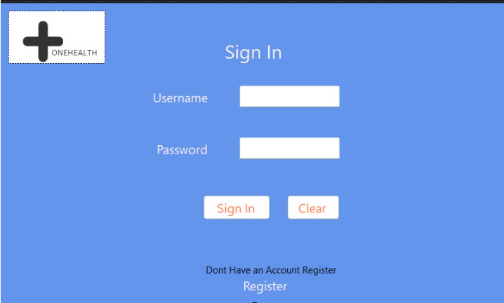

(i)User after clicking the sign in link he/she can enter the username and password known particularly.

(ii)After entering , click on the sign-in button.

(iii)If the user has entered an invalid username or password they can click on the clear button to clear the field.

**3. Sql Database Page**

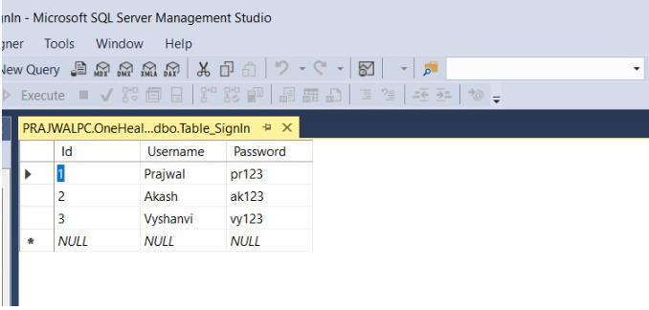

It is the database created in the backend for the users to sign in by adding a username and password**.**

**4. Quote of the day**



It is the quote displayed to the users which boost energy in the users for the rest of the day to stay active

**5. All Calculators page**



This page displays all the 12 calculators and the respective links are given below each image to access.

**6. Ideal Body Weight Calculator Page**

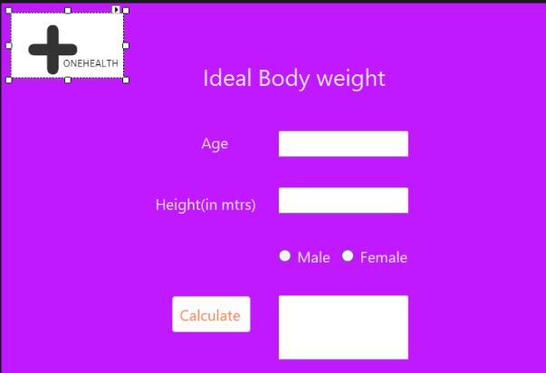

For example, If the user has accessed to Ideal body weight calculator it appears as above. On this page, the user can enter his/her age, height and gender as parameters to calculate their respective Ideal body weight.