EX NO 2

DATE 27-12-22

INPUT FOR EXCHANGING VALUES OF TWO VARIABLES

#Exchanging the values of two variobLes

a=int(input("Enter value of a= "))

b=int(input("Enter value of b= "))

a,b=b,a

print("a,b=",a,b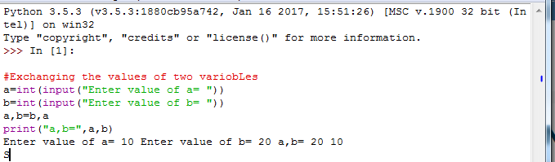

output:

Enter value of a= 2

Enter value of b= 12

a,b= 12 2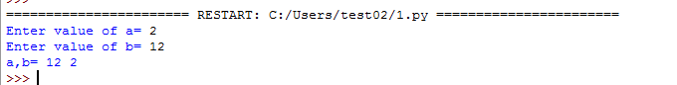

2 exchanging using (“,”) operator

**Program 2:**

#Exchange of the two values using comma operator

a=int(input("Enter the number 1 :"))

b=int(input("Enter the number 2 :"))

print("The values before swapping :",a,b)

a,b=b,a

print("The values after swapping :",a,b)

**Output 2:**

Enter the number 1 :5

Enter the number 2 :2

The values before swapping : 5 2

The values after swapping : 2 5

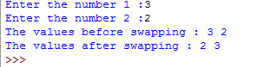

PROGRAM FOR EXCHANGING USING ARITHMETIC OPERATORS

a=int(input("Enter number 1:"))

b=int(input("Enter number 2:"))

print("The values before swapping :",a," ",b)

a=a+b

b=a-b

a=a-b

print("The values after swapping :",a," ",b)

a=int(input("Enter number 1:"))

b=int(input("Enter number 2:"))

OUTPUT



Exchanging numbers using xor gate

a=int(input("Enter number 1:"))

b=int(input("Enter number 2:"))

print("The values before swapping :",a," ",b)

a=a+b

b=a-b

a=a-b

print("The values after swapping :",a," ",b)

OUTPUT

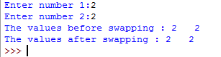

 Circulating the list of values

* using in-Built functions
* n=int(input("Enter the number of values in the list :"))
* l=[]
* for i in range(0,n):
* x=int(input("Enter the value :"))
* l.append(x)
* a=int(input("Enter number of rotation :"))
* for i in range(0,a):
* b=l.pop(0)
* l.append(b)
* print("The circulate list is :",l)

OUTPUT

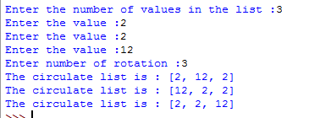

PROGRAM FOR LIST OF VALUES USING SLICING OPERATOR

n=int(input("Enter the number of values in the list :"))

l=[]

for i in range(0,n):

x=int(input("Enter the value :"))

l.append(x)

print("Circulating the list....")

a=int(input("Enter the number of rotation :"))

for i in range(0,a):

l=l[1:]+l[:1]

print("The circulate list is :",l)

OUTPUT

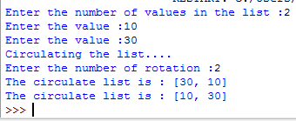

PROGRAM FOR DISTANCE BETWEEN TWO POINTS

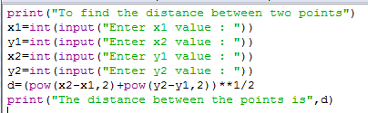

PROGRAM

print("To find the distance between two points")

x1=int(input("Enter x1 value : "))

y1=int(input("Enter x2 value : "))

x2=int(input("Enter y1 value : "))

y2=int(input("Enter y2 value : "))

d=(pow(x2-x1,2)+pow(y2-y1,2))**1/2

print("The distance between the points is",d)

OUTPUT

To find the distance between two points

Enter x1 value : 2

Enter x2 value : 2

Enter y1 value : 22

Enter y2 value : 22

The distance between the points is 400.0

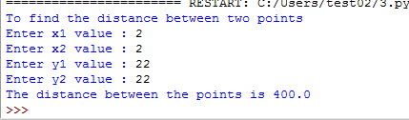

PROGRAM FOR ARITHMETIC CALCULATION

a=int(input("Enter value of a : "))

b=int(input("Enter value of b : "))

print("The ADITTION value is :",a+b)

print("The SUBRACTION value is : ",a-b)

print("The MULTIPLICATION value is : ",a*b)

print("The QUOTIENT value is : ",a/b)

print("The REMAINDER value is : ",a%b)

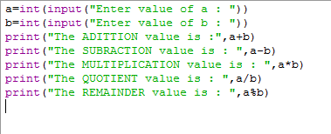

OUTPUT

Enter value of a : 3

Enter value of b : 2

The ADITTION value is : 5

The SUBRACTION value is : 1

The MULTIPLICATION value is : 6

The QUOTIENT value is : 1.5

The REMAINDER value is : 1

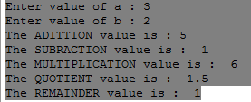

PROGRAM FOR FINDING PRIME OR NOT

n=int(input("Enter number :"))

if n > 1:

for i in range(2, int(n/2)+1):

if (n % i) == 0:

print(num, "is not a prime number")

break

else:

print(n, "is a prime number")

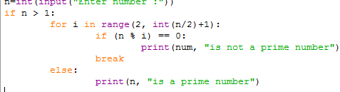

OUTPUT

Enter number :3

3 is a prime number

