**Pizza Sales SQL Queries**

1. **Total pizza Sales and Total Revenue**

**select count(pizza_id) as Total_pizza_Sales, sum(total_price) as Total_Revenue**

**from pizza_sales**

1. **Average Order Value**

**Select sum(total_price)/count(Distinct order_id) as Average_Order_Value**

**from pizza_sales**

1. Total Pizzas Sold

**Select sum(quantity) as Total_Pizzas_Sold**

**from pizza_sales**

1. Total Orders

**Select count(distinct order_id) as Total_Orders_Placed**

**from pizza_sales**

1. Average Number of Pizzas sold per order

**select Cast(sum(quantity)/count(distinct order_id) as decimal(10,2)) as Average_No_Pizza_Per_Order**

**from pizza_sales**

1. Daily trend for total orders

**select DayName(order_date) as Order_Day, count(Distinct order_id)**

**from pizza_sales**

**group by Order_Day**

1. Monthly trend for total orders

**select monthname(order_date) as Month_Name, count(distinct order_id) as Total_Orders**

**from pizza_sales**

**group by Month_Name**

**Order by Total_Orders desc**

1. Percentage of Sales by category

**Select pizza_category, sum(total_price)*100/(select sum(total_price) from pizza_sales) as Percentage_of_Sales**

**from pizza_sales**

**group by pizza_category**

**order by Percentage_of_Sales Desc**

1. **Percentage of sales by pizza_size**

**select pizza_size, cast((sum(total_price)*100) /(select sum(total_price) from pizza_sales) as decimal(10,2)) as Percentage_of_Sales**

**from pizza_sales**

**group by pizza_size**

**order by Percentage_of_Sales desc**

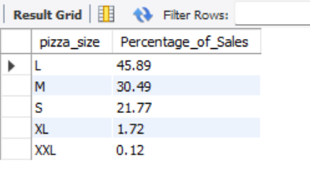

1. **Top 5 Pizzas based on Revenue**

**select pizza_name, sum(total_price) as Total_Revenue**

**from pizza_sales**

**group by pizza_name**

**order by Total_Revenue desc**

**LIMIT 5**

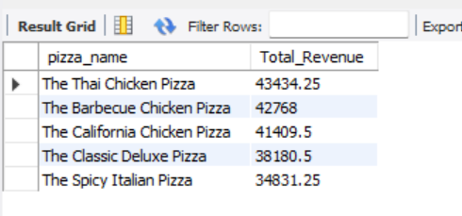

1. **Bottom 5 pizzas based on Revenue**

**select pizza_name, sum(total_price) as Total_Revenue**

**from pizza_sales**

**group by pizza_name**

**order by Total_Revenue ASC**

**LIMIT 5**

1. **Top 5 Pizzas based on Quantity**

**select pizza_name, sum(quantity) as Total_Quantity**

**from pizza_sales**

**group by pizza_name**

**order by Total_Quantity desc**

**LIMIT 5**

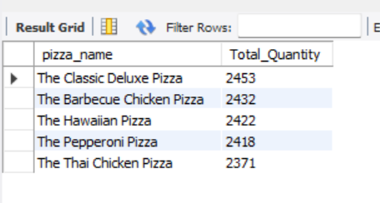

1. **Bottom 5 Pizzas based on Quantity**

**select pizza_name, sum(quantity) as Total_Quantity**

**from pizza_sales**

**group by pizza_name**

**order by Total_Quantity asc**

**LIMIT 5**

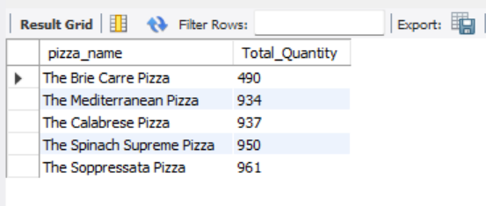

1. **Top 5 pizzas based on total orders**

**select pizza_name, Count(distinct order_id) as Total_Orders**

**from pizza_sales**

**group by pizza_name**

**order by Total_Orders desc**

**LIMIT 5**

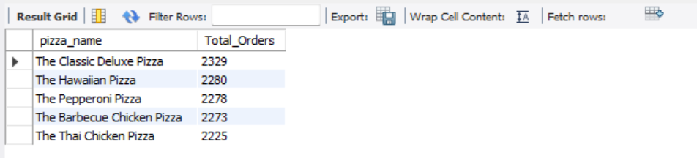

1. **Bottom 5 pizzas based on total orders**

**select pizza_name, Count(distinct order_id) as Total_Orders**

**from pizza_sales**

**group by pizza_name**

**order by Total_Orders asc**

**LIMIT 5**

