ROI BASED IMAGE COMPRESSION USING DWT AND HUFFMAN CODING

|  |  |  |
| --- | --- | --- |
| Abhishek Horate  *Department of Electronics and Communication Engineering*  *JSS Science and Technology University*  Mysuru, India. | Arman Hulkund  *Department of Electronics and Communication Engineering*  *JSS Science and Technology University*  Mysuru, India.  Prajwal Teli  *Department of Electronics and Communication Engineering*  *JSS Science and Technology University*  Mysuru, India. | Ateeb Ur Rahaman  *Department of Electronics and Communication Engineering*  *JSS Science and Technology University*  Mysuru, India. |

**Abstract-This project presents an efficient image compression framework that emphasizes preserving visual quality in regions of interest (ROIs). By combining Haar wavelet transforms and Huff- man encoding, the method compresses RGB images selectively—preserving central cellular regions and applying stronger compression to the rest. The approach significantly reduces file size while maintaining high perceptual quality, evaluated via PSNR, SSIM, and MSE metrics.**

**Keywords—ROI , SSIM, PSNR, MSE, Gaussian, Thresholding, Blending, RGB, Haar, Huffman**

# INTRODUCTION

This project introduces a selective, ROI-aware image compression technique that blends wavelet-based transformation with entropy coding to achieve both efficiency and visual quality. The method primarily relies on the Haar wavelet transform for decomposing each channel of the RGB image into sub-bands, focusing on the LL (low-frequency) component, which retains the majority of the image's energy. The LL sub-band is then quantized and subjected to Huffman encoding for lossless compression, while the high-frequency sub-bands (LH, HL, HH) are discarded to reduce data A key feature of this implementation is the automatic detection of the ROI, particularly focusing on the central, densely textured areas of the image—presumed to contain important visual or structural content. This is achieved using HSV color space transformation and contour-based analysis on the saturation channel, which effectively isolates the central object or cell-like structures in an image. Once detected, a mask is created to protect this region from aggressive compression, preserving its details. To avoid abrupt transitions between compressed and uncompressed areas, a soft blending mask is applied around the ROI, creating a smooth transition zone that enhances visual coherence. The final image is constructed by blending the original ROI with the wavelet-compressed background using this soft mask. This strategy ensures that the visually important sections of the image remain intact, while the background contributes significantly to the compression savings. The reconstructed image is then evaluated using quantitative metrics such as PSNR (Peak Signal-to-Noise Ratio), SSIM (Structural Similarity Index), and MSE (Mean Squared Error), which provide insights into the quality of the compression and the visual fidelity retained.

1**.LITERAATURE SURVEY**

In the first paper the authors proposed Wavelet-based image compression has been extensively used for its multi-resolution capabilities and energy compaction, making it suitable for lossy image compression. Traditional methods like JPEG2000 also support ROI-based preservation, yet they often lack flexibility in real-time region adaptation. Huffman encoding, a form of entropy coding, has been integrated into image compression pipelines for optimal bitstream representation. Recent advances in deep learning also highlight filter pruning and model compression to reduce computational overhead, as seen in History-Based Filter Pruning (HBFP), which prunes redundant filters using training patterns. Inspired by such selective compression, this project adapts a classical yet novel approach for region-aware image quality preservation[1].

The second paper authors introduces ROI-JSCC, a deep joint source-channel coding approach for image transmission that emphasizes regions of interest (ROI) to improve perceived image quality. It integrates ROI embedding, attention-based split processing, and adaptive bandwidth allocation to optimize reconstruction. The model demonstrates superior performance in preserving ROI-specific details while maintaining overall image fidelity under noisy conditions[2].

In the this paper they mainly focused on LoC-LIC proposes a low-complexity learned image compression model using hierarchical feature transforms. By reducing spatial complexity at earlier layers and increasing depth later, it achieves significant reductions in computational load. The model balances rate-distortion performance effectively, supporting deployment on resource-constrained devices[3].

In this paper they introduced historical iamage compression work presents a method to compress deep models using a history-based filter pruning approach, which identifies and eliminates redundant convolutional filters. The pruning decisions are driven by the cumulative importance over training epochs rather than static heuristics. It ensures minimal accuracy loss while significantly reducing model size and inference cost[4].

In this paper they introduced Building on hyperprior models, this paper combines entropy modeling with learned transforms to optimize rate-distortion performance. It introduces channel-wise and context-aware attention mechanisms for improved compression accuracy. Such architectures offer compelling alternatives to traditional codecs, especially for high-resolution image compression tasks[5].

In this paper author proposed a novel method combining Discrete Wavelet Transform (DWT) and Huffman coding for medical image compression. The approach uses wavelet coefficient rounding, a 3×3 window reduction operator, and pivot-based Huffman encoding, ensuring nearly lossless compression with a high PSNR of 54.66 dB and excellent SSIM performance[6].

In this paper authors implemented an enhanced medical image compression approach using Integer Wavelet Transform (IWT) and hybrid Huffman-DCT encoding. Their study showed that integrating spatial redundancy removal techniques improved the compression ratio while preserving clinical image quality[7].

In this method the author examined various lossy and lossless image compression methods and concluded that DWT combined with Huffman or Arithmetic coding provides a good trade-off between compression efficiency and visual fidelity, particularly beneficial for high-resolution images[8].

In this paper authors explored encryption-compression techniques in telemedicine, proposing a method that uses DWT for compression followed by secure encoding. Their results demonstrated that embedding security into the compression pipeline did not degrade image quality, supporting use in secure medical image transmission[9].

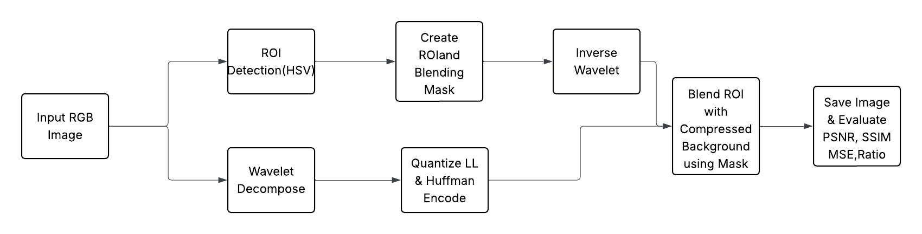This paper gives an extensive review and benchmark of end-to-end image compression techniques based on deep learning, illustrating how they differ from traditional hand-designed pipelines. Unlike the previous codecs like JPEG and JPEG2000, which use fixed transforms and quantization techniques, learned contemporary techniques optimize the entire compression pipeline with neural networks. The survey groups different techniques into architecture design, entropy modeling, and rate control schemes. Hyperprior networks and attention mechanisms are applied by most up-to-date models to better understand the space and learn to compress images based on complexity. These models surpass conventional codecs regarding rate-distortion efficiency according to the benchmark analysis, particularly for low-bitrate, high-resolution images. The article also identifies important challenges like generalization to image types, decoding efficiency, and hardware compatibility and proposes learned compression as a promising area for future standards.[10].

**2 SCOPE OF THE WORK**

The proposed image compression project aims to develop an efficient framework that selectively preserves important parts of an image while applying stronger compression to the background. This technique is especially useful in areas like medical imaging analysis, and surveillance, where certain regions hold critical information. The system automatically identifies the Region of Interest (ROI) using saturation-based contour analysis in the HSV color space, making it adaptable to different types of images. It uses the Haar wavelet transform to break down image data and employs Huffman encoding to compress low-frequency components effectively. Blending masks around the ROI create a smooth visual transition between compressed and uncompressed areas. By maintaining high detail in ROI zones while reducing data in less important regions, the project finds a good balance between compression efficiency and visual quality. This method can scale for RGB images and could also apply to grayscale or multispectral data.

**3.OBJECTIVE**

The main goal of this project is to create an intelligent image compression technique. This technique will keep the visual quality of important areas, known as Regions of Interest (ROI), while compressing less critical background areas. The system will automatically identify these ROI areas using color-based segmentation and contour analysis. This ensures that key visual details stay intact during compression. The aim is to reach a high compression ratio using wavelet transform and Huffman encoding, without losing the integrity and clarity of the ROI. This focused approach is especially helpful in fields like medical imaging and surveillance, where detail in certain areas is vital for interpretation or diagnosis.

**4. METHODOLOGY**

The proposed method combines traditional image processing techniques with smart ROI-based compression. This approach reduces image size while keeping quality in key areas. The steps are outlined below**.**

Fig 1 Block Diagram of Image compression Technique

1. **Image Acquisition:**

* Load RGB images from a dataset folder using the PIL (Python Imaging Library).

1. **ROI Detection:**

* Convert the RGB image to HSV color space with OpenCV.
* Use the saturation (S) channel to find dense regions with:
* Gaussian Blur
* Otsu’s Thresholding
* Contour Extraction
* Select the largest and most circular contour as the ROI. Expand the ROI bounding box by a user-defined margin.

1. **ROI Mask Creation:**

* Create Two masks:
* ROI mask: Identifies the main area to keep. Blending mask: Creates a smooth transition around the ROI for better visual integration.

1. **Wavelet Decomposition:**

* Apply the 2D Haar Wavelet Transform (pywt.dwt2) on each RGB channel.
* Decompose into LL (low-frequency), LH, HL, and HH sub-bands.
* Quantize the LL sub-band and discard the rest.

1. **Huffman Coding:**

* Flatten the quantized LL sub-band values.
* Count the frequency of symbols using collections. Counter.
* Build a Huffman tree and encode the data.
* Compression Bits = length of the encoded Huffman string.

1. **Reconstruction:**

* Decode the Huffman stream to rebuild the LL sub-band.
* Apply the inverse Haar transform (pywt.idwt2) using the LL and fill the other bands with zeros.

1. **ROI Blending:**

* Combine the reconstructed compressed background with the original ROI using the blending mask.
* The final image keeps the ROI with high fidelity and compresses the rest.

1. **Evaluation:**

* Calculate quality metrics between the original and compressed
* Image PSNR (Peak Signal-to-Noise Ratio)
* SSIM (Structural Similarity Index)
* MSE (Mean Squared Error)

**5. RESULT AND DISCUSSION**

The proposed ROI-based image compression technique was tested on a dataset of RGB images with different sizes and content complexity. The system effectively identified central, information-rich areas using saturation-based contour extraction. These areas were kept at full quality, while the surrounding background was compressed using wavelet methods and then encoded with Huffman coding. Each RGB channel was handled separately through the Haar wavelet transform. The low-frequency (LL) coefficients were quantized and encoded to cut down on redundancy. High-frequency components were removed to save space, and a smooth blending mask made sure the transitions between the ROI and compressed areas looked seamlessthe different image samples are taken are give by

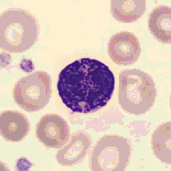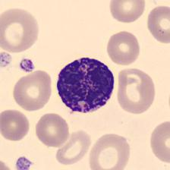

Fig 2 Original compressed Basophil

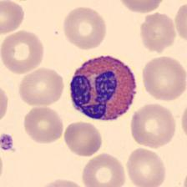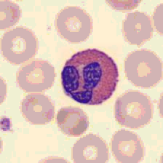

Fig 4 Original compressed

eosinophil

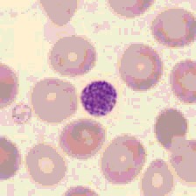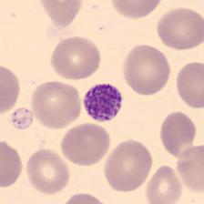

Fig 7 Original Compressed

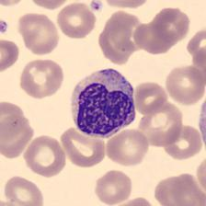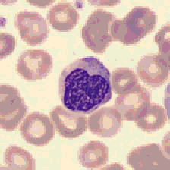 Platelet

 Fig 8 Original Compressed

Fig Original Compressed

**6. FUTURE SCOPE**

In the future, this work can be expanded by adding deep learning-based ROI detection, such as U-Net or YOLO, adaptive quantization methods, and support for multiple ROIs. Real-time implementation on embedded systems or edge devices could also be explored. Additionally, extending the approach to video compression and adding encryption for secure transmission in telemedicine could increase its practical impact.

**7. CONCLUSION**

The proposed ROI-based image compression technique balances compression efficiency with visual quality by preserving important image areas while compressing the background. It uses HSV-based ROI detection, Haar wavelet transform, and Huffman encoding to achieve high compression ratios of 20 to 25 times without losing essential image details. PSNR and SSIM values confirm the visual quality of the reconstructed images. The soft blending transition creates a natural look between compressed and preserved regions, making the approach visually seamless. This lightweight yet effective method works well for applications like medical imaging, satellite imagery, and surveillance.

**8. REFERENCE**

**1.**Utkarsh Prakash Srivastava (NYU) & Toshiaki Fujii (Nagoya University),” Region of Interest Based Medical Image Compression”,

DOI: 10.48550/arXiv.2501.02895

2.Hansung Choi & Daewon Seo, “Region of Interest Guided Deep Joint Source Channel Coding for Image Transmission” (2025),

DOI: 10.48550/arXiv.2506.01269

3.Ayman A. Ameen, Thomas Richter, André Kaup, LoC LIC: “Low Complexity Learned Image Coding Using Hierarchical Feature Transforms” (2025),

DOI: 10.48550/arXiv.2504.21778

4.Ayman A. Ameen, Thomas Richter, André Kaup, “Compact Latent Representation for Image Compression (CLRIC)” (2025),

DOI: 10.48550/arXiv.2502.14937

5.Binglin Li, Jie Liang, Haisheng Fu, Jingning Han, “ROI Based Deep Image Compression with Swin Transformers” (2023),

DOI: 10.1109/ICASSP49357.2023.10094674

6. Shiju Thomas, Addapalli Krishna, Sabeen Govind, Aditya Kumar Sahu, A Novel “Image Compression Method Using Wavelet Coefficients and Huffman Coding (2023)”, DOI: 10.1016/j.jer.2023.08.015

7. V. Anusuya, et al., “Performance Comparison of Wavelet Transforms Based Medical Image Compression “(2023), DOI: 10.54216/JCIM.160201

8.Vlad Ilie Ungureanu, Paul Negirla, Adrian Korodi,”Image Compression Techniques: Classical and ROI Based Approaches Presented in Recent Papers “(2024), DOI: 10.3390/s24030791

9. Ayman A. Ameen, Thomas Richter, André Kaup, “Compact Latent Representation for Image Compression (CLRIC)” (2025),

DOI: 10.48550/arXiv.2502.14937

10. Ayman A. Ameen, Thomas Richter, André Kaup, “Compact Latent Representation for Image Compression (CLRIC)” (2025),

DOI: 10.48550/arXiv.2502.14937