LAB Logbook

Lab 1

Lab 2

Task :1

Test Accuracy: 0.948

Task: 2

O1 = 1.5098

O2 = 1.5098

Lab 3

Test Accuracy: 0.8859000205993652

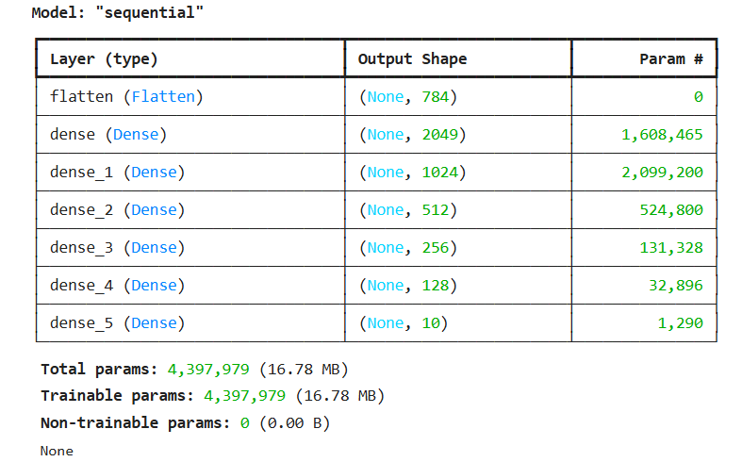

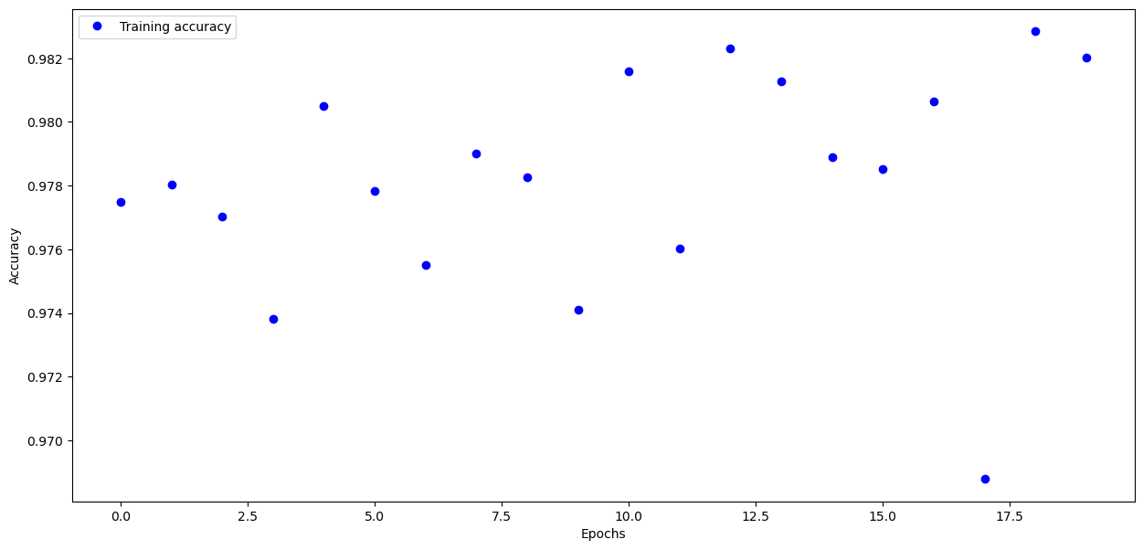

Lab 4

absolute prediction error = -8427.0 $

relative prediction error = -3.797656602073006 %

Lab 5

Optimal number of epochs to train the model: 8/20

Lab 6

Optimal number of epochs for training the model: 2

Lab 7

Lab 8

Mean squared error (mse) : 0.000027354

Mean absolute error (mae): 0.003413985

Lab 9



Lab 10

Lab 11

Lab 12