LAB Logbook

Lab 1

Lab 2

Task :1

Test Accuracy: 0.948

Task: 2

O1 = 1.5098

O2 = 1.5098

Lab 3

Test Accuracy: 0.8859000205993652

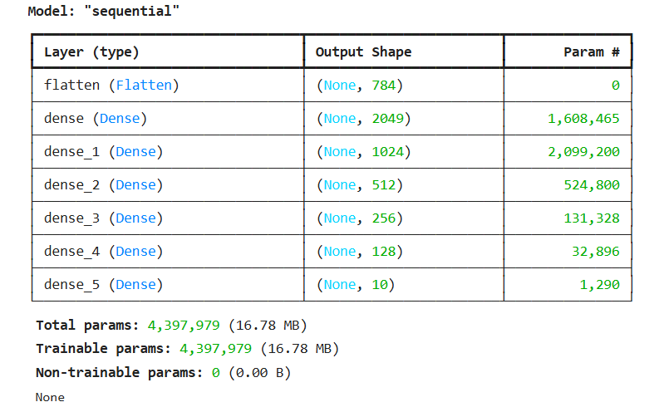

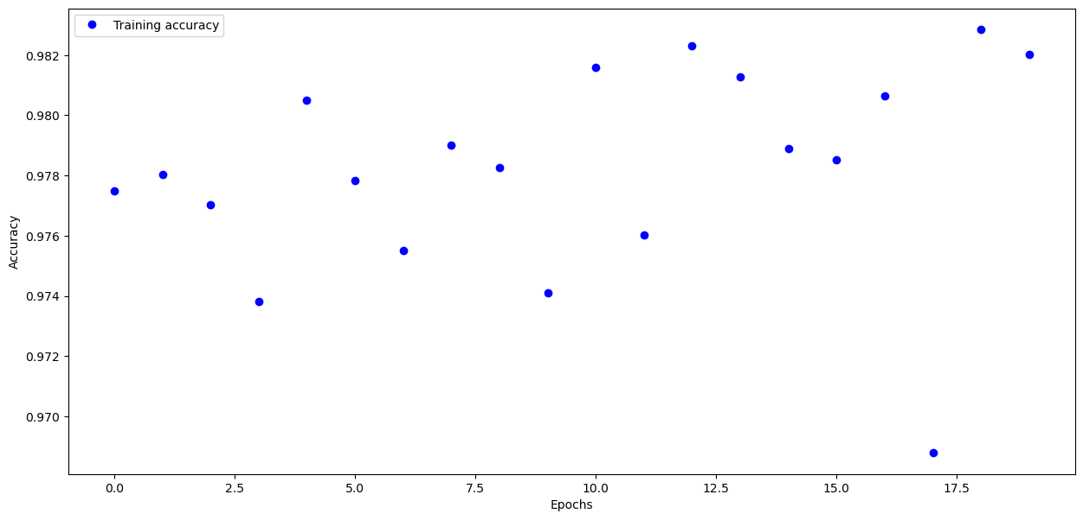

Lab 4

absolute prediction error = -8427.0 $

relative prediction error = -3.797656602073006 %

Lab 5

Lab 6

Lab 7

Lab 8

Lab 9

Lab 10

Lab 11

Lab 12