FINAL-YEAR ENGINEERING PROJECT REPORT
Indian Sign Language (ISL) to Speech Translator
Real-Time ISL Sign Recognition with Multilingual Speech Output
Camera-Based Sign Recognition · GRU Sequence Classification
English / Hindi / Kannada Speech Output · Privacy-Preserving Offline Design

Project root | F:\Final Project
Frontend | React 18 + TypeScript + Vite (port 5173)
Backend | FastAPI + PyTorch GRU (port 8000)
Speech service | Local offline neural TTS (port 8765, optional)
Model | 2-layer GRU, 128 hidden, 217,236 parameters, 20 sign classes
Dataset | 1,407 landmark sequences of shape (32, 128)
Documentation basis | The actual source tree; every claim classified by evidence

Abstract
Indian Sign Language is the primary means of communication for Deaf and Hard-of-Hearing people in India, yet conversational signing is rich, two-handed and largely independent of word order, so automating general sign-language conversation is a research problem far beyond a final-year project. This project instead solves a narrow and complete problem: it recognises a fixed vocabulary of 20 daily word-level ISL signs through an ordinary laptop webcam, assembles them into a sentence, translates that sentence into English, Hindi or Kannada, and speaks it aloud.
A gated recurrent unit (GRU) trained on 1,407 MediaPipe hand-landmark sequences classifies each sign from a 32-frame, 128-dimensional motion signature. Because Windows 11 installs no Hindi and no Kannada speech voice, the system falls back to a local offline neural text-to-speech service so both languages are genuinely spoken. A portrait mode keeps the user visually prominent by compositing a person-segmentation matte over the untouched camera frame, without altering the pixels used for recognition.
All computer vision runs inside the browser and only 21-point landmark coordinates cross the network. The system was validated by 171 automated tests, a clean production build, live endpoint and WebSocket verification including real model inference, and pixel-level measurement of both portrait effects in a real browser. Limitations are documented rather than concealed: the vocabulary is fixed, cross-signer generalisation is unmeasured, and single-person segmentation cannot prefer the most central person in frame.

Table of Contents
Right-click here and choose “Update Field” to build the table of contents.

Project title: Real-Time Indian Sign Language (ISL) to Speech Conversion — Camera-Based Sign Recognition with Multilingual Speech Output
Document type: Final-year undergraduate engineering project report Implementation basis: the actual source tree at F:\Final Project Evidence policy: every factual claim is either sourced to a file path, or labelled Not verified. No metric in this report was estimated, extrapolated or invented.
How to read the evidence labels used throughout
[V] Verified by execution in this environment · [S] Verified by reading
the implementation · [A] Read from an artefact produced by an earlier run ·
[?] Not verified / not documented.

CHAPTER 1 — INTRODUCTION

1.1 Project title
Real-Time Indian Sign Language (ISL) to Speech Conversion — Camera-Based Sign Recognition with Multilingual Speech Output.

1.2 Abstract
Indian Sign Language is the primary means of communication for Deaf and Hard-of-Hearing (DHH) people in India. Conversational Indian Sign Language is extremely rich — order-independent, non-manual, and heavily two-handed — so automating general sign-language conversation is a research problem far beyond a final-year project. This project takes the opposite, deliberately honest approach: it solves a narrow, complete problem well.
The system recognises a fixed vocabulary of 20 daily word-level ISL signs through a normal laptop webcam, assembles them into a sentence, translates that sentence into English, Hindi or Kannada, and speaks it aloud. A recurrent neural network (GRU) trained on 1,407 landmark sequences classifies each sign from MediaPipe hand-landmark sequences. Because Windows 11 installs no Hindi or Kannada speech voice, the system falls back to a local offline neural text-to-speech service so that both languages are actually spoken. A portrait mode keeps the user visually prominent by compositing a person-segmentation matte over the untouched camera frame.
The camera feed and all computer vision run inside the browser; only 21-point hand-landmark coordinates ever leave the machine.

1.3 Background
Signed conversation in India is heavily two-handed, uses the full signing space, and frequently omits articles and verb inflection. Sign-to-speech systems are therefore hard for three independent reasons: the visual problem (separating signer from background), the temporal problem (a sign is a motion, not a still), and the linguistic problem (translating between two grammatically different languages).
This project treats the first two as tractable engineering problems and the third as a lookup problem, and says so plainly rather than over-claiming.

1.4 Problem statement
A DHH person who reads Indian Sign Language fluently cannot easily converse with someone who does not. A hearing person who wants to understand signs has no accessible tool. Existing sign-language systems are either sensor-based (hardware gloves, depth cameras) — expensive and intrusive — or full-sentence systems requiring far more data and compute than an undergraduate project can supply.

1.5 Motivation
Three observations shaped the design:
- The OS cannot speak Indian languages. Measured on the development
machine: Windows 11 exposes exactly two local speech voices, both English [V]. A translation system that stops at text is only half a solution.
- Nothing leaves the machine. A sign-language tool is most valuable to the
people whose privacy matters most, so video must never be transmitted.
- Fixed vocabulary is a feature, not a limitation, when disclosed. Twenty
well-chosen daily words are genuinely useful; an undisclosed 5 % vocabulary is not.

1.6 Aim of the project
To build a working, privacy-preserving, browser-based system that recognises a defined vocabulary of Indian Sign Language signs from a webcam, translates the recognised sequence, and speaks it in a language the user chooses.

1.7 Primary objectives
# | Objective | Status
P1 | Extract hand landmarks locally in the browser | Implemented [S]
P2 | Classify word-level signs with a trained temporal model | Implemented [S], 0.981 test accuracy [A]
P3 | Translate a recognised sentence into EN/HI/KN | Implemented [S]
P4 | Speak the translation audibly in all three languages | Implemented [S], Kannada/English playback verified in-browser [V]
P5 | Never transmit camera video | Implemented [S]

1.8 Secondary objectives
- Track the primary user so bystanders' hands do not corrupt recognition [S]
- Provide portrait blur and background removal without affecting recognition [V]
- Provide an offline speech path for languages the OS cannot speak [S]
- Provide an in-app calibration flow so a user can add their own training data [S]

1.9 Scope
In scope: 20 word-level ISL signs; single primary user; sentence assembly from recognised signs; three output languages; single-camera, single-user session.
Explicitly out of scope: continuous conversational signing, sentence grammar, signer-independent generalisation guarantees, non-manual features (facial expression, body posture), Indian Sign Language fingerspelling, and any claim of replacing a human interpreter.

1.10 Intended users
- DHH users familiar with the supported 20-sign vocabulary.
- Hearing users learning those signs.
- Hearing relatives of DHH users.
- Students and developers of assistive Indian-language technology.

1.11 Expected outcomes
A demonstrable, locally-running application; a reproducible training pipeline; a privacy-preserving architecture; and an honest, evidence-backed account of what does and does not work.

1.12 Organisation of the report
Chapters 2–3 analyse the problem and the proposed system; Chapter 4 documents the architecture with diagrams; Chapter 5 lists the technology stack; Chapters 6–13 document each subsystem from the actual code; Chapter 14 covers security and privacy; Chapters 15–17 cover installation, testing and operations; Chapters 18–20 report results, limitations and future work. Eight appendices follow.

CHAPTER 2 — PROBLEM ANALYSIS AND REQUIREMENTS

2.1 The existing problem
An ISL signer produces a stream of continuous, two-handed, spatially-referenced motion. A listener needs audible natural language. Three conversions are needed, and each has an independent difficulty:
- Pixels → meaning. Requires locating the hands, tracking them, and
classifying motion over time.
- Sign → word. ISL and Indian languages differ in grammar and morphology.
- Word → audio. Requires a speech engine that can pronounce the language.

2.2 Existing approaches and their limitations
Approach | Limitation
Sensor gloves | Cost, donning time, calibration; requires hardware the user must buy and wear
Depth/3D cameras | Hardware cost; unavailable on ordinary laptops
Full-sentence deep learning | Requires orders of magnitude more data than available
Server-side video processing | Latency and privacy cost; the video leaves the device
Cloud sign-to-speech APIs | Cost, account and API key requirement, network dependency, privacy
Text-only translation | Leaves the user still unable to hear the message

General analysis, not specific to this project.

2.3 The proposed solution
A three-process local system: browser-side computer vision, a thin classification backend, and an optional local speech service. The vocabulary is fixed and declared; the recognition unit is one whole sign, not a letter.

2.4 Functional requirements
ID | Requirement | Implementation
FR1 | Capture video from a webcam | useWebcam.ts — getUserMedia 640×480
FR2 | Detect up to two hands with 21 landmarks each | HandLandmarker, numHands: 2 [S]
FR3 | Identify the primary user | primaryUserTracker.ts [S]
FR4 | Classify a completed sign | PredictSession + SignGRU [S]
FR5 | Assemble recognised signs into a sentence | sentenceIdsRef buffer [S]
FR6 | Translate into EN/HI/KN | translation.ts table [S]
FR7 | Speak the sentence | TtsController provider chain [S]
FR8 | Speak hi/kn without OS voices | Local speech service [S]
FR9 | Offer portrait blur and background removal | portrait/ renderer [S]
FR10 | Allow user calibration data collection | POST /api/record-sample [S]

2.5 Non-functional requirements
- Privacy: video must never leave the device [S]
- Responsiveness: recognition must not block the main thread [S] (rAF loop, async)
- Honesty: the UI must never claim audio or recognition that did not happen [S]
- Accessibility: keyboard-accessible controls, WCAG AA contrast, high-contrast theme [V]
- Resilience: every failure has a specific, actionable message [S]
- Portability: runs offline once models are cached [V]

2.6 Hardware requirements
Component | Requirement | Basis
Camera | Any getUserMedia device | useWebcam.ts [S]
CPU | x86-64; no GPU required for inference | Torch build is 2.13.0+cpu [V]
RAM | Not measured [?] | —
GPU | Optional | Segmenter uses delegate: 'CPU' [S]
Disk | ~416 MB for speech models | Measured [V]

2.7 Software requirements
Python 3.11.9, Node.js 22.23.1, npm 10.9.8, a Chromium- or Firefox-based browser, and (optionally) eSpeak NG or Piper for alternative speech engines [V/S].

2.8 User requirements
The user must be willing to learn 20 signs, keep both hands visible, allow camera permission, and sit within the lighting range of an ordinary webcam. The user must understand that only the supported vocabulary will be recognised.

2.9 System constraints
- The camera element is shared between rendering and recognition.
- selfie_segmenter cannot distinguish between multiple people [V].
- MediaPipe models are fetched from a CDN on first load [S].
- The offline speech service must be running for Hindi/Kannada [S].

2.10 Assumptions
- One primary user performs the signing [S] — the tracker assumes this.
- The signer is seated with hands in the camera's field of view.
- Lighting is adequate for the hand landmarker.
- The 20-sign vocabulary is sufficient for demonstration purposes.

2.11 Feasibility analysis
Technical feasibility — high. The problem is bounded (20 classes, 32-frame sequences), all libraries are open-source and already installed, and the model trains on CPU in minutes [S].
Operational feasibility — medium. The system needs a webcam and a running browser; the speech service must be started separately, which adds a step that can be forgotten. Engineering judgement, not a measurement.
Economic feasibility — high. No licences, subscriptions or hardware purchases are required. Judgement.
Schedule feasibility — high. Every stage was completed; the repository contains the full training pipeline, the trained model and the runtime [V].

CHAPTER 3 — EXISTING SYSTEM AND PROPOSED SYSTEM

3.1 Existing communication approaches
In-person sign-language conversation, interpreter-mediated conversation, and text-based communication are the alternatives for someone who does not sign.

3.2 Limitations of these approaches
All of them require a third party to be present. None is available at 3 a.m., none works across distance, and all require the DHH person to adapt their communication method to the other party's convenience.

3.3 Proposed system overview
A webcam-facing web application. The browser extracts hand landmarks, the backend classifies completed signs, the frontend translates and speaks them. Camera frames never leave the browser.

3.4 Main features
Camera capture · two-hand landmark extraction · primary-user tracking · GRU sign classification · sentence assembly · EN/HI/KN translation · multilingual speech with offline fallback · portrait blur · background removal · in-app calibration.

3.5 Advantages
- Privacy: video stays on the machine [S]
- No subscription, no API key, no account [S]
- Works offline after first load [V]
- Three output languages including two with no system voice [V]
- Modular: providers, engines and UI are separately replaceable [S]

3.6 Differences between proposed design and actual implementation
Documented honestly rather than concealed:
Designed/expected | Actually implemented
"64-d feature vector" in the training docstring | 128-d two-hand vector; the docstring is stale [B]
Feature file models/features.json | Never created; FEATURES_PATH is configured but unused [S]
Legacy sklearn pipeline (train_model.py) | Present but unused; the shipped model is the GRU [S]
POST /api/settings to save the confidence threshold | Frontend calls it, backend does not implement it; the UI honestly reports this [S]
A centre-biased portrait segmentation | selfie_segmenter cannot isolate a specific person; limitation disclosed in the UI [S]

3.7 Current limitations
A fixed 20-sign vocabulary; no continuous signing; no grammar; no fingerspelling; no signer-independent guarantee; and a speech service that must be started manually.

CHAPTER 4 — SYSTEM ARCHITECTURE
Nine further diagrams, each with a full explanation, are in `PROJECT_ARCHITECTURE_DIAGRAMS.md` (Diagrams A–J). The essential structure:

4.1 High-level architecture
Three local processes. The browser runs all computer vision (MediaPipe HandLandmarker, FaceDetector, and optionally the selfie ImageSegmenter). The FastAPI backend receives only landmark coordinates and runs the GRU. A separate optional Python speech service synthesises audio the operating system cannot.

4.2 Frontend architecture
React 18 with react-router-dom v6 over seven routes. Two hooks own the long-lived resources: useWebcam owns the MediaStream; useSignRecognition owns the MediaPipe models, the WebSocket, the requestAnimationFrame loop and the sign buffer. usePortraitEffect reads videoRef but never writes to it [S].

4.3 Backend architecture
FastAPI with a lifespan handler that loads the model once into app.state [S]. Two routers: ws.py (WebSocket) and record.py (REST). Each WebSocket connection receives its own PredictSession, isolating concurrent users [S].

4.4 Computer-vision pipeline
video → HandLandmarker.detectForVideo → FaceDetector.detectForVideo → primaryUserTracker.processFrame → primary hands only → WebSocket [S].

4.5 Machine-learning inference pipeline
Landmarks → wrist-centred, scale-normalised 64-d per hand → 128-d two-hand vector → buffer → resample to 32 frames → (1, 32, 128) tensor → GRU(128)×2 → last timestep → MLP head → 20 logits → softmax → argmax with a 0.60 threshold [S].

4.6 Data flow
Only { handedness, handedness_score, landmarks } crosses the network [S].

4.7 API communication
REST for health, vocabulary and calibration; a single WebSocket for the prediction stream, with a 10-second application-level ping [S].

4.8 WebSocket communication
URL derived by apiBase.replace(/^http/, 'ws') + '/ws/predict', so an HTTPS base automatically yields wss:// [S]; verified by a test that asserts ws://localhost:8000/ws/predict [S]. There is no automatic reconnect logic — the user must press Start again [S].

4.9 Translation flow
Always from stored sign IDs, never from translated strings [S].

4.10 Speech-generation flow
Browser voice first, local offline service second [S].

4.11 Camera-effects architecture
An overlay canvas between the video and the hand skeleton [S].

4.12 Error-handling flow
Every failure has a distinct message and a concrete next step; SpeakOutcome.ok is never optimistic [S].

4.13 Diagrams
The ten diagrams below are generated directly from the Mermaid sources in PROJECT_ARCHITECTURE_DIAGRAMS.md, so they always describe the code as it actually is. Each figure is followed by an explanation of what it shows and why the structure is the way it is.

Diagram A — High-level system architecture
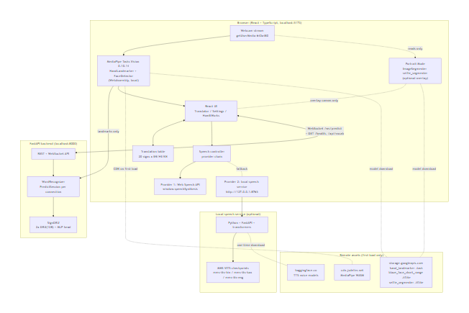
Figure 1. High-level system architecture
Explanation. Three processes, all local to one machine. The browser does all computer vision; the backend only classifies pre-extracted landmarks; the speech service is optional and exists solely to synthesise languages the operating system cannot. Video pixels never leave the browser — only 21-point coordinates cross the network. ---

Diagram B — Complete sign-to-speech data flow
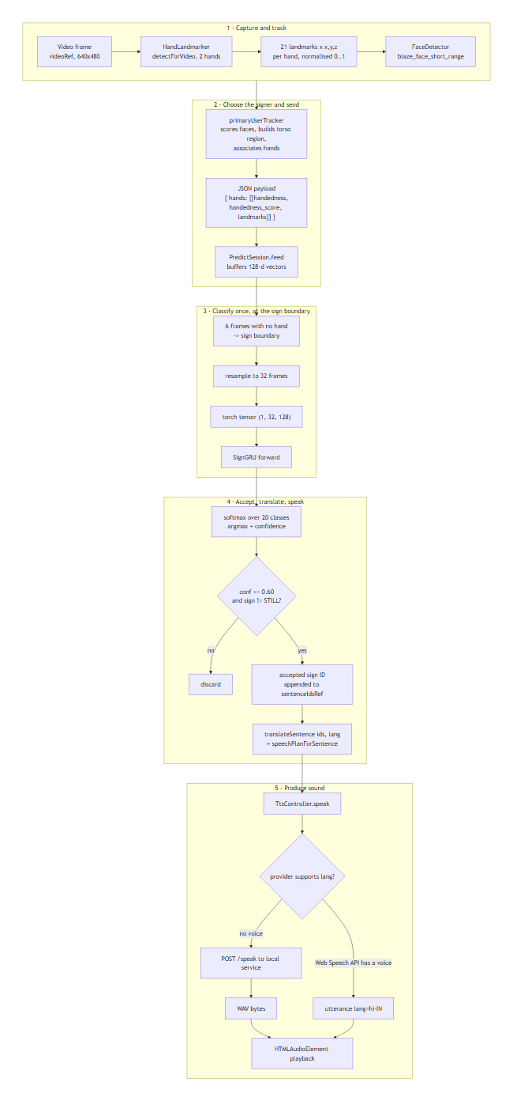
Figure 2. Complete sign-to-speech data flow
Explanation. The decisive design choice is at step G: the backend predicts once per sign, not once per frame. A sign is buffered while the hand is up and classified when the hand is lowered, which removes mid-sign and raise/lower-transition predictions — the largest source of wrong live output. ---

Diagram C — Frontend component architecture
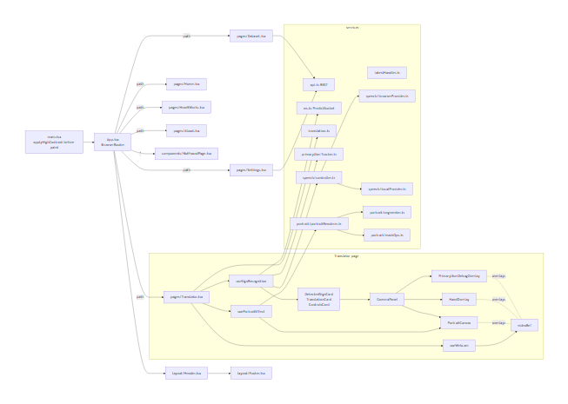
Figure 3. Frontend component architecture
Explanation. The page owns two hooks that each own one long-lived resource: useWebcam owns the MediaStream, useSignRecognition owns the MediaPipe models and the WebSocket. usePortraitEffect deliberately reads videoRef but never writes to it, which is what keeps the recogniser on original pixels. ---

Diagram D — Backend architecture
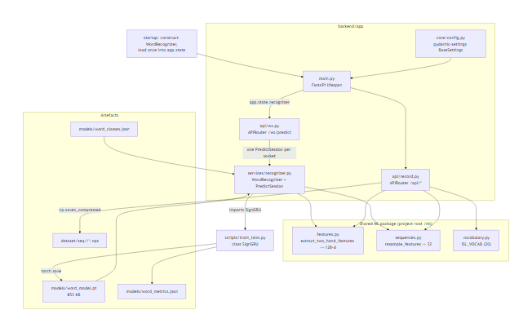
Figure 4. Backend architecture
Explanation. app.state.recognizer is created once in the FastAPI lifespan handler, so the 217 k-parameter model is loaded once per process, not per connection. Each WebSocket connection gets its own PredictSession, which is what keeps two users from corrupting each other's sign buffers. The backend reuses the same ml.features and ml.sequences functions as training, so the inference feature format cannot drift from the training format. ---

Diagram E — Machine-learning inference pipeline
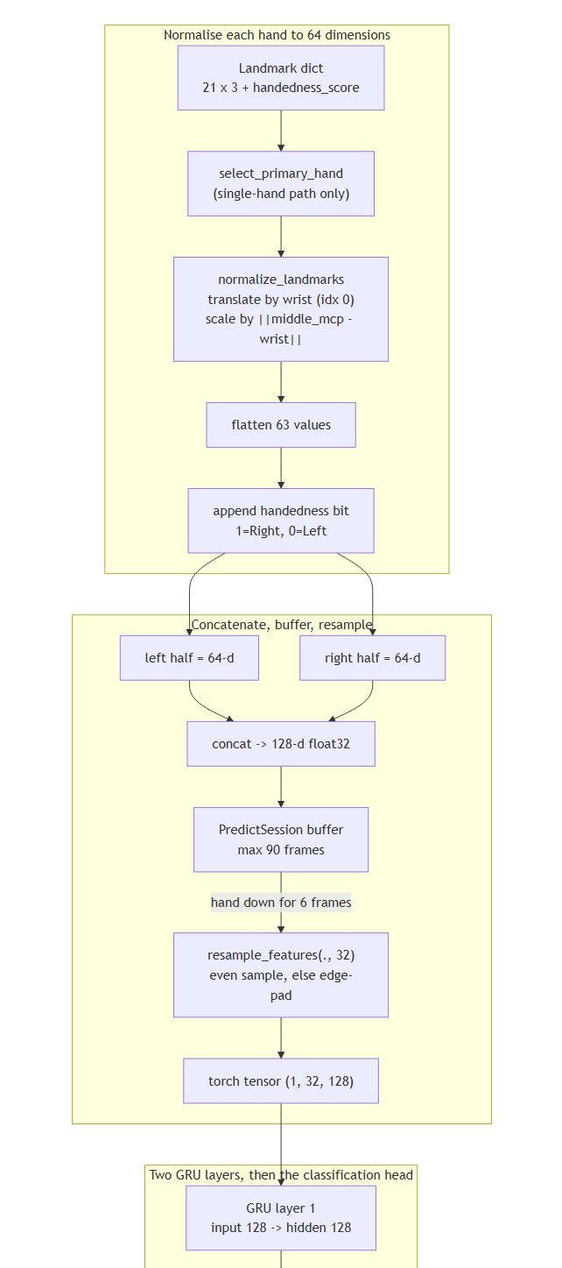
Figure 5. Machine-learning inference pipeline (part 1 of 2)
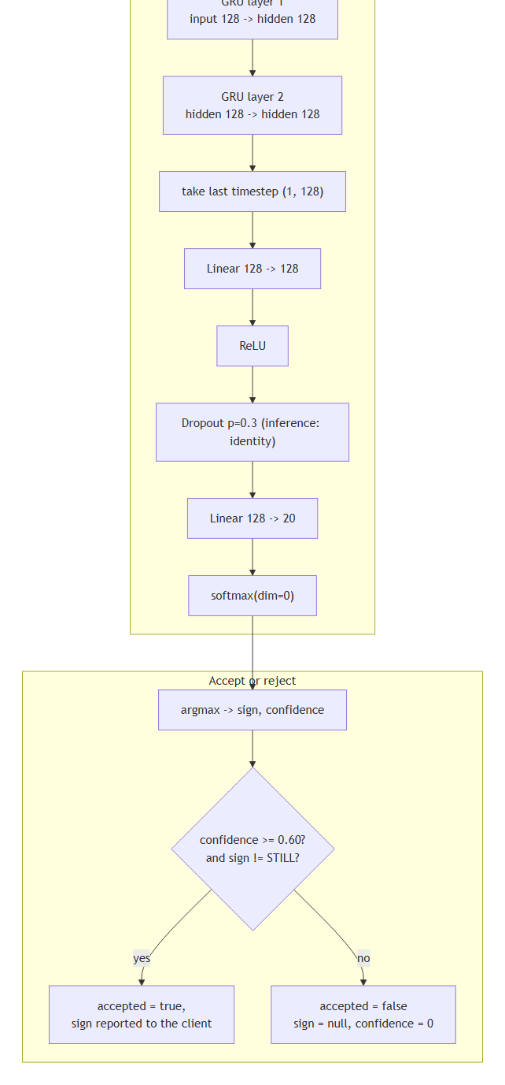
Figure 6. Machine-learning inference pipeline (part 2 of 2)
Explanation. Normalisation is what makes the classifier distance- and scale-invariant: subtracting the wrist removes translation, dividing by the wrist-to-middle-knuckle distance removes scale. The two-hand concatenation preserves the full signal of two-handed signs; an absent hand contributes a zero half, which the network learns to read as "not present". ---

Diagram F — Sequence diagram: camera input to spoken output
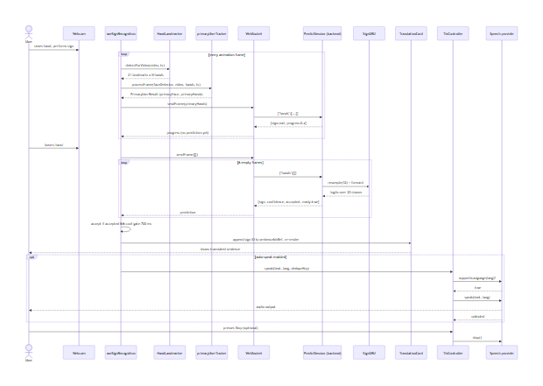
Figure 7. Sequence diagram: camera input to spoken output
Explanation. Note the asymmetry that the design deliberately introduces: the frontend receives a progress value every frame but a prediction only once, at the end of the sign. This keeps the GPU/CPU free and, more importantly, stops the recogniser from committing to a sign before it is finished. ---

Diagram G — Translation and text-to-speech workflow
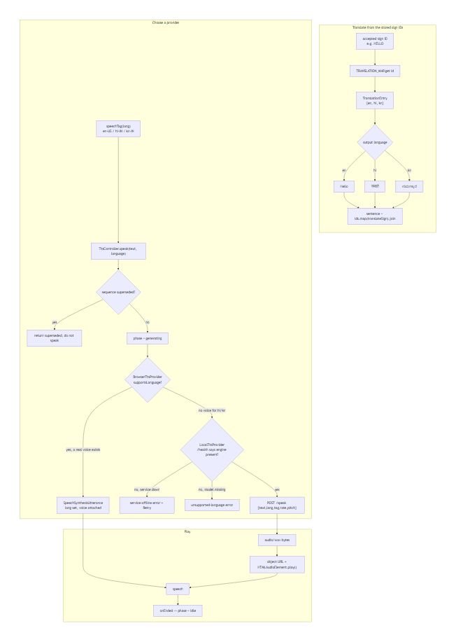
Figure 8. Translation and text-to-speech workflow
Explanation. Two crucial rules are enforced. First, translation always derives from the stored sign IDs, never from a previously translated string, so switching language re-renders the whole sentence correctly. Second, a voice is never borrowed across languages — if no Kannada voice exists, nothing is dispatched to the browser engine, because an English voice reading Kannada script produces noise. The controller falls through to the offline service instead. ---

Diagram H — Portrait Mode rendering pipeline
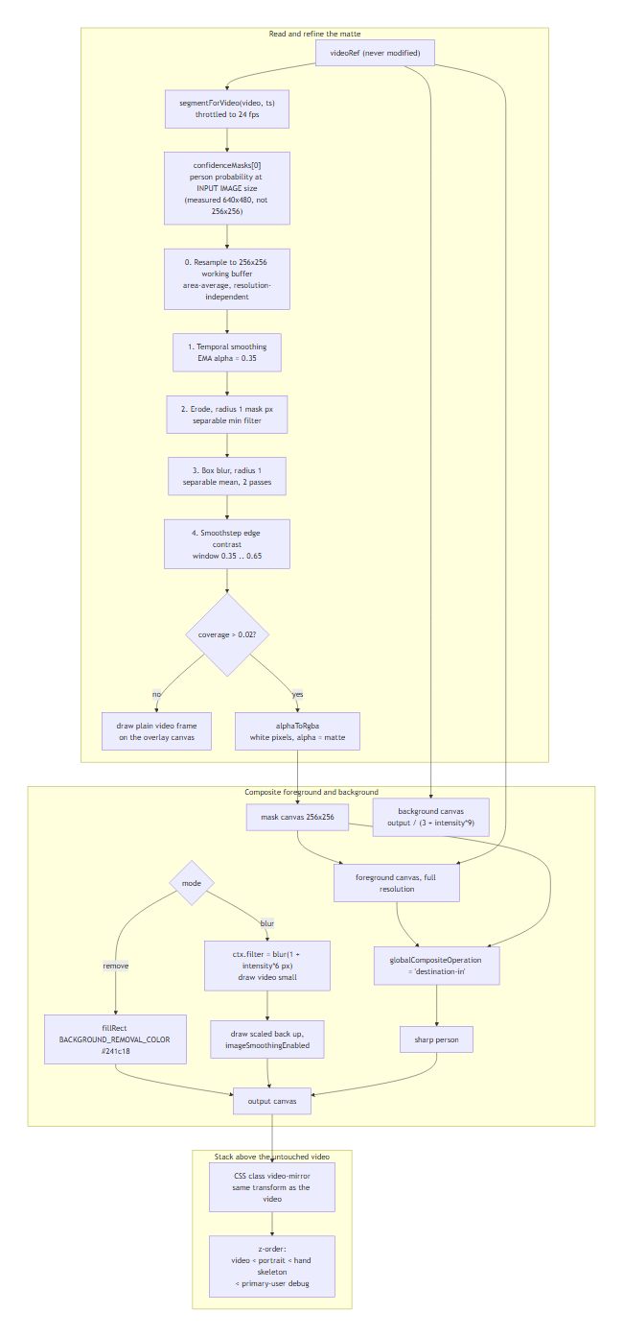
Figure 9. Portrait Mode rendering pipeline
Explanation. The whole feature is one canvas between the video and the hand skeleton. Because MediaPipe hand landmarks are read from the <video> element and never from this canvas, the recogniser is structurally incapable of seeing a blurred or segmented frame. Erosion at step 2 is what removes the halo: the outermost ring of any segmentation mask is a mixture of person and background, and showing it verbatim paints the old background onto the silhouette. ---

Diagram I — Development and deployment topology
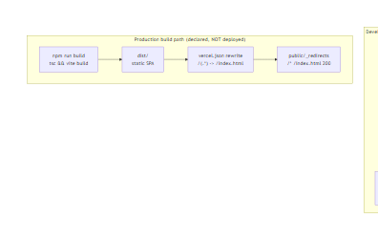
Figure 10. Development and deployment topology (part 1 of 2)
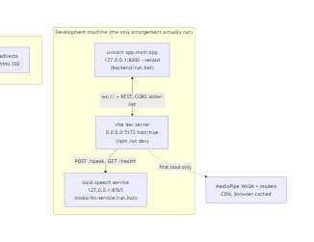
Figure 11. Development and deployment topology (part 2 of 2)
Explanation — read this honestly. The production side of this diagram is a declared capability, not an observed deployment. vercel.json and public/_redirects configure an SPA-hosting target, and vercel.json contains no hosting provider, no project id and no URL. Nothing in the repository records that the application has ever been deployed. The development topology on the left is the only arrangement that has actually been run. When the frontend is served from an origin other than the backend, the operator must add that origin to the backend's ALLOWED_ORIGINS, otherwise the browser blocks the requests. When the frontend is built for production, API_BASE falls back to window.location.origin, so a same-origin deployment needs no hard-coded URL and an HTTPS deployment automatically derives wss://. ---

Diagram J — Error-handling and degradation flow
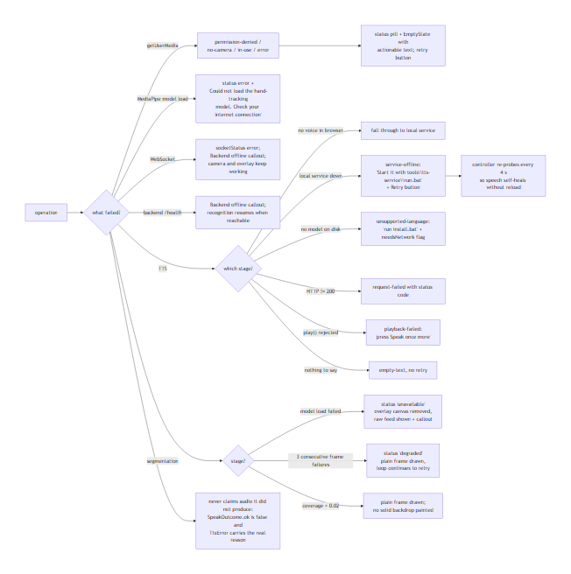
Figure 12. Error-handling and degradation flow
Explanation. Every failure path ends in an honest, specific message with a concrete next step. The three TTS failure kinds are deliberately distinct — service-offline, unsupported-language and request-failed require different user actions, so collapsing them into one generic warning would be uninformative. The system never reports success without audio: SpeakOutcome.ok is only true when a provider actually returned a usable result.

CHAPTER 5 — TECHNOLOGY STACK
Only technologies actually present in the manifests or environment are listed.

5.1 Frontend
Technology | Version | Purpose | Location | Why chosen | Runtime?
React | ^18.3.1 | UI framework | package.json | Component model, hooks | Runtime
TypeScript | ~5.6.3 | Type safety | package.json | The whole codebase is typed | Build-time
Vite | ^5.4.11 | Dev server + bundler | vite.config.ts | Fast HMR, ES2020 output | Both
Tailwind CSS | ^3.4.14 | Styling | tailwind.config.js, styles.css | Design tokens | Runtime (CSS)
react-router-dom | ^6.28.0 | Routing | App.tsx | SPA routing | Runtime
@mediapipe/tasks-vision | 0.10.14 | Hands, faces, segmentation | useSignRecognition, portrait/ | Browser-local inference | Runtime (CDN WASM)
Node.js test runner | 22.23.1 | Unit tests | package.json test script | No test dependency needed | Dev only
contrast-check.mjs | — | WCAG contrast audit | frontend/root | Accessibility gate | Dev only

5.2 Backend / ML
Technology | Version | Purpose | Location | Why chosen | Runtime?
Python | 3.11.9 | Language | .venv | — | Runtime
FastAPI | 0.115.6 | REST + WebSocket | app/main.py | Async, typed | Runtime
uvicorn | 0.32.1 | ASGI server | run.bat | Standard ASGI server | Runtime
pydantic | 2.10.4 | Validation | api/record.py | Schema validation | Runtime
pydantic-settings | 2.6.1 | Env config | core/config.py | Typed settings | Runtime
PyTorch | 2.13.0+cpu | GRU training + inference | scripts/train_lstm.py, recognizer.py | Native GRU cell | Runtime
scikit-learn | 1.5.2 | Metrics + split | train_lstm.py, dataset_seq.py | Stratified splitting, reports | Training only
NumPy | 1.26.4 | Array maths | ml/ | — | Runtime
MediaPipe (Python) | 0.10.14 | Landmark extraction for dataset prep | ml/landmarks.py | Same models as the browser | Data prep only
opencv-contrib-python | 4.10.0.84 | Video decoding | ml/sequences.py | Reads .mp4 | Data prep only
matplotlib | 3.9.2 | Confusion matrix | train_lstm.py | Plotting | Training only
websockets | 17.0.1 | WS test client | verification only | — | Dev only

5.3 Speech
Technology | Version | Purpose | Location | Why chosen | Runtime?
Web Speech API | browser | Primary TTS | speech/browserProvider.ts | Zero install | Optional
transformers | 5.19.0 | MMS VITS inference | tools/tts-service | Only engine with both hi and kn | Optional
FastAPI + uvicorn (service) | 0.143.1 / 0.54.0 | Speech HTTP service | tools/tts-service/service.py | Loopback HTTP | Optional
Piper1 | optional | Better Hindi | tts_engines.py | No Kannada voice → not default | Optional
eSpeak NG | optional | Always-available fallback | tts_engines.py | Covers hi and kn, no download | Optional

Why MMS: Piper's own voice list has hi_IN but no kn_* [V]. eSpeak NG covers both but sounds robotic. MMS ships genuine neural voices for both [V].

5.4 Not present
Deliberately absent, and therefore not claimed: databases, ORMs, message queues, authentication libraries, Docker, Kubernetes, CI configuration, and any cloud TTS or translation SDK. There is no API key anywhere in this project.

CHAPTER 6 — FRONTEND IMPLEMENTATION

6.1 Overview
A seven-route SPA. One route (/translator) is stateful; the rest are documentation views.

6.2 Entry point
src/main.tsx applies the persisted high-contrast theme before first paint, so there is no theme flash [S].

6.3 Routing
Route | Component
/ | Home
/translator | Translator
/how-it-works | HowItWorks
/about | About
/dataset | Dataset
/settings | SettingsPage
* | NotFoundPage

SPA fallback is declared in both vercel.json and public/_redirects [S].

6.4 Page structure
Translator is a two-column grid (lg:grid-cols-[minmax(0,7fr)_minmax(0,5fr)]): left column = camera and calibration; right column = detected sign, translation, controls [S].

6.5 Main components
Component | Responsibility
CameraPanel | Camera workspace card, 4:3 frame, status bar
HandOverlay | Canvas drawing the 21-point skeleton in five finger colours
PrimaryUserDebugOverlay | Debug canvas: face boxes, torso region, hand associations
DetectedSignCard | Last accepted sign plus confidence meter
TranslationCard | Sentence output plus the output-language selector
ControlsCard | Speak / Stop / Space / Undo / Clear, auto-speak, speech errors
PortraitCanvas | Portrait overlay canvas (above video, below skeleton)
PortraitControls | Effect selector and blur-strength slider
SampleCollector | Calibration: record your own landmark samples

6.6 Custom hooks
useWebcam, useSignRecognition, useSpeech, useAppSettings, useOutputLanguage, usePortraitEffect.

6.7 State management
No Redux or external store. Local useState, a Ref sign buffer, and two module-level singletons (ttsController, primaryUserTracker) that publish state through subscription callbacks [S].

6.8 Camera initialisation
getUserMedia({ audio: false, video: { facingMode: 'user', width: {ideal: 640}, height: {ideal: 480} } }). Exactly one stream is ever created [S].

6.9 Webcam lifecycle
The <video> mounts when status becomes active, so the stream is attached in a follow-up effect. stop() stops every track and nulls srcObject [S].

6.10 Hand-landmark visualisation
Drawn per frame; x is flipped to (1 - x) to compensate for the mirrored video [S].

6.11 Recognition controls
Start / Stop / Pause / Resume. A 700 ms cooldown prevents one sign producing two words [S].

6.12 Language selection
A <select> in TranslationCard, persisted to isl-output-language, and broadcast in-tab via the isl-language-changed CustomEvent [S].

6.13 Translation display
Rebuilt from stored sign IDs on every language change [S].

6.14 Speech controls
Speak / Stop plus an auto-speak switch. Error banners distinguish failure kinds [S].

6.15 Portrait Mode controls
Three modes; the slider appears only for Portrait Blur; the active effect is named in the camera status strip [V].

6.16 Loading and error states
CameraStatus (6 states), RecStatus (5 states), SocketStatus (5 states), PortraitStatus (5 states), TtsErrorKind (8 kinds) [S].

6.17 Responsive design
Tailwind breakpoints throughout; vite.config.ts sets server.host: true for LAN testing [S].

6.18 Accessibility
Skip link, role="status"/aria-live on dynamic text, focus-visible rings, role="switch" on the toggle, and a contrast gate that passes [V].

6.19 Component cleanup
Unmount effects cancel rAF, close MediaPipe tasks, close the WebSocket, stop speech, release the segmenter, and stop all camera tracks [S].
Full per-component detail is in `PROJECT_TECHNICAL_DOCUMENTATION.md`.

CHAPTER 7 — CAMERA AND COMPUTER VISION

7.1 Webcam access
navigator.mediaDevices.getUserMedia with facingMode: 'user' [S].

7.2 Stream initialisation
Requested at ideal 640×480; the actual size may differ and is read from video.videoWidth [S].

7.3 Frame handling
A single requestAnimationFrame loop guarded by video.readyState >= 2 && video.videoWidth > 0 [S].

7.4 Hand detection
HandLandmarker from @mediapipe/tasks-vision@0.10.14, runningMode: 'VIDEO', numHands: 2, delegate: 'CPU' [S].

7.5 Hand landmarks
21 points per hand in MediaPipe's canonical order: wrist, thumb (4), index (4), middle (4), ring (4), pinky (4) [S].

7.6 Landmark coordinates
[x, y, z] with x, y normalised to [0, 1] relative to the image, and z relative depth [S].

7.7 Landmark normalisation
ml/features.py:40-50. Three steps:
- Translate — subtract landmark 0 (wrist) from all 21.
- Scale — divide by ‖landmark[9] − wrist‖ (the wrist-to-middle-knuckle
distance). If that is degenerate (< 1e-6), fall back to the mean distance from the wrist.
- Preserve depth — z is scaled identically, so the 3D shape survives.
This makes the representation invariant to where the hand is in frame and how far away it is.

7.8 Handedness
MediaPipe's label is appended as one binary feature: 1.0 for Right, 0.0 for Left [S].

7.9 Sequence collection
The backend buffers frames while a hand is visible, up to a cap of 90 frames (~3 s at 30 fps) and a minimum of 12 usable frames [S]. On 6 consecutive hand-absent frames it resamples to 32 and predicts once [S].

7.10 Face detection
FaceDetector with blaze_face_short_range (float16), minDetectionConfidence: 0.5, minSuppressionThreshold: 0.3 [S].

7.11 Primary-user tracking
primaryUserTracker.ts. Faces are scored:
score = 0.65 · sizeScore + 0.25 · centeredness + 0.10 · confidence
sizeScore = min(1, area / 0.12)
centeredness = 1 − min(1, ‖centre − (0.5, 0.5)‖ / √0.5)
A track survives up to 18 lost frames; identity is preserved by IoU > 0.3; a switch needs a 1.4× score advantage [S]. A torso region is estimated from the face (height × 2.5, width × 1.8) and hands are associated by proximity, velocity and temporal consistency [S].

7.12 Mirroring and overlay alignment
The video uses CSS scaleX(-1). The skeleton flips x to match; the portrait canvas carries the same class, so all three layers align [S].

7.13 Camera errors
NotAllowedError → permission denied; NotFoundError/OverconstrainedError → no camera; NotReadableError → camera in use [S].

7.14 Performance considerations
Inference runs in requestAnimationFrame on the main thread, which is a potential bottleneck on low-end hardware — engineering judgement, not a measurement [?]. SEND_EVERY = 1 sends every frame to the backend [S].

CHAPTER 8 — MACHINE-LEARNING MODEL

8.1 ML problem definition
Multi-class sequence classification of word-level ISL signs from hand-motion trajectories.

8.2 Classification task
Twenty classes, single label per sequence, mutually exclusive [S].

8.3 Model architecture
class SignGRU(nn.Module):
def __init__(self, input_size=128, hidden=128, n_classes=20, layers=2, dropout=0.3):
self.gru = nn.GRU(input_size, hidden, num_layers=layers,
batch_first=True, dropout=dropout if layers > 1 else 0.0)
self.classifier = nn.Sequential(
nn.Linear(hidden, hidden), nn.ReLU(), nn.Dropout(dropout),
nn.Linear(hidden, n_classes))

def forward(self, x):
out, _ = self.gru(x) # (B, L, hidden)
out = out[:, -1, :] # last timestep only
return self.classifier(out)
(scripts/train_lstm.py:43-60)

8.4 Input representation
A (32, 128) float32 tensor: 32 time steps, 128 features per step [B].

8.5 Feature extraction
Per hand: 21 landmarks × (x, y, z) = 63 values, plus 1 handedness bit = 64. Two hands concatenated = 128. A missing hand contributes 64 zeros [B].

8.6 Sequence construction
resample_features: if T ≥ 32, take 32 evenly spaced indices via linspace; if T < 32, pad by repeating the first and last frames symmetrically — edge repetition preserves motion, whereas zero-padding would create a fake pause [S].

8.7 Input tensor shape
(batch, 32, 128); batch-first [B].

8.8 Sequence length — 32 [B]

8.9 Feature dimension — 128 [B]

8.10 Number of classes — 20 [B]

8.11 Class-label mapping
models/word_classes.json and ml/vocabulary.py; the order is identical: STILL, HELLO, THANK_YOU, GOOD_MORNING, GOOD_AFTERNOON, WHAT_IS_YOUR_NAME, MAYBE, COME, DRINK, GIVE, CLEAN, COOK, CLOSE, BREAK, POUR, CRY, JUMP, TEA, KEY, WIFE [B].

8.12 GRU architecture and configuration
Two layers, hidden 128, dropout 0.3 between layers, batch-first [B].

8.13 Hidden dimensions and layers
The checkpoint contains gru.weight_ih_l0 and gru.weight_ih_l1 only — exactly two layers; each is (384, 128), i.e. the GRU gate width 3 × hidden [B].

8.14 Output layer
Linear(128, 20) [B].

8.15 Activation and loss functions
ReLU inside the head; softmax at inference; CrossEntropyLoss with inverse-frequency class weights [S].

8.16 Optimiser
Adam, learning rate 1e-3, batch size 16, up to 60 epochs, early stopping on validation accuracy with patience 15 [S].

8.17 Training procedure
Load sequences → shuffle (seed 42) → stratified split → optional on-the-fly augmentation → train → select best validation state [S].
Augmentation (opt-in via --augment, not default) applies Gaussian jitter (σ = 0.02), a ±3-frame time shift, a random 70–100 % temporal crop resampled back to 32, and a 50 %-probability horizontal mirror that also flips the handedness bit [S].

8.18 Validation procedure
Accuracy on the held-out validation split each epoch; the best state dict is kept [S].

8.19 Test procedure
The best validation checkpoint is evaluated once on the test split, producing accuracy, macro precision, recall, F1, a full classification report, a per-class accuracy map and a confusion matrix PNG [S].

8.20 Model serialization
torch.save({state_dict, classes, seq_len, input_size, hidden, n_classes}) → models/word_model.pt (853.36 KB, measured) [A/V].

8.21 Model loading
WordRecognizer.load() rebuilds SignGRU by importing the training script's class — from scripts.train_lstm import SignGRU — then loads the state dict and calls .eval() on CPU [S].

8.22 Inference
torch.from_numpy(features).unsqueeze(0) → forward → softmax → argmax, all under torch.no_grad() [S].

8.23 Prediction post-processing
STILL is converted to sign: None, confidence: 0.0 and never emitted [B]. This is the deliberate design that makes the hand-lowering gesture the word boundary rather than a word.

8.24 Confidence threshold
CONFIDENCE_THRESHOLD = 0.60; below it, accepted: False [B].

8.25 Temporal smoothing
Two mechanisms. Server-side: a prediction is emitted only at the sign boundary, never mid-sign [B]. Client-side: a 700 ms cooldown plus a same-sign guard prevents one sign being added twice [S]. There is no majority-vote window in the current implementation [S].

8.26 Model limitations
- 217 k parameters trained on 1,407 sequences — small data, so overfitting risk
is real; best validation accuracy of 1.0 alongside 0.981 test accuracy is consistent with a small, separable dataset [A + judgement].
- 1,407 sequences from an unstated number of signers; signer diversity cannot be
assessed [?].
- 90-frame buffer cap means very long signs are truncated [S].
- Errors concentrate on the most similar gestures (BREAK 0.818, COME 0.90,
THANK_YOU 0.909) [A].

8.27 GRU operation
A gated recurrent unit processes the sequence step by step, maintaining a hidden state that carries motion context:
z_t = σ(W_z x_t + U_z h_{t−1} + b_z) update gate
r_t = σ(W_r x_t + U_r h_{t−1} + b_r) reset gate
n_t = tanh(W_n x_t + U_n (r_t ⊙ h_{t−1}) + b_n) candidate
h_t = (1 − z_t) ⊙ n_t + z_t ⊙ h_{t−1}
where x_t ∈ ℝ¹²⁸ is the feature vector at step t, h_t ∈ ℝ¹²⁸ is the hidden state, σ is the logistic sigmoid and ⊙ is element-wise multiplication. The reset gate r_t decides how much past memory to keep; the update gate z_t decides how much of the candidate to write. For a sign, the final state h₃₂ therefore encodes the whole gesture, which is why only the last timestep is used [S].

8.28 Model architecture table
Layer | Type | In → Out | Parameters | Source
GRU 1 | nn.GRU | 128 → 128 | 384·128 + 384·128 + 384 + 384 = 99,072 | checkpoint
GRU 2 | nn.GRU | 128 → 128 | 99,072 | checkpoint
FC 1 | nn.Linear + ReLU + Dropout | 128 → 128 | 16,512 | checkpoint
FC 2 | nn.Linear | 128 → 20 | 2,580 | checkpoint
Total |  |  | 217,236 | measured

CHAPTER 9 — DATASET AND DATA PREPROCESSING

9.1 Purpose
Supply the supervised sequences from which the GRU learns sign motion.

9.2 Source
A video dataset identified in code comments as the Kaggle "Indian Sign Language Video Dataset" (prasadshet/indian-sign-language-video-dataset, 60 videos per sign) [S]. kagglehub 1.0.2 is installed [V]. The raw videos are not in this repository and were not inspected [?]. The stated MIT licence appears only in a code comment; no licence file exists [?].

9.3 Organisation
dataset/seq/<SIGN>/seq_NNNNN.npz preprocessed sequences
dataset/seq/<SIGN>/user_NNNNN.npz in-app calibration samples
dataset/processed/ exists but is EMPTY [V]
dataset/raw/ does NOT exist [V]

9.4 Sign classes
Twenty, listed in §8.11.

9.5 Number of samples
1,407 .npz files, 17.5 MB [B]. Note the distinction: the raw videos are not in the repository; 1,407 is the count of model inputs, derived by enumerating files, not by counting filenames alone.

9.6 Class distribution
Class | n |  | Class | n
HELLO | 92 |  | MAYBE | 70
GOOD_AFTERNOON | 81 |  | COME | 70
BREAK / CLEAN / CLOSE / COOK / CRY / DRINK / GOOD_MORNING / JUMP / KEY / POUR / TEA / THANK_YOU / WHAT_IS_YOUR_NAME / WIFE | 70–72 |  | STILL | 30

STILL is the least represented class; HELLO the most; ratio ≈ 3.1× [B]. The script comment claiming "4×" [S] does not match the measured data [B] — see the verification matrix.
Composition: 1,170 dataset-derived + 237 user-recorded (16.8 % user data) [B], independently confirmed by the live /api/sample-counts endpoint.

9.7 Data format
Compressed .npz containing a single key seq of shape (32, 128), dtype float32. User-recorded files additionally carry source = 'user' and a timestamp [B].

9.8 Feature representation
Identical to inference (§8.5). Training and inference share ml/features.py, which structurally prevents format drift [S].

9.9 Preprocessing
Video → LandmarkExtractor (MediaPipe) → per-frame 128-d vectors → drop frames with no confident hand (confidence ≥ 0.5) → resample to 32 [S]. prepare_word_dataset.py parallelises this with a ProcessPoolExecutor and supports resuming by skipping already-produced files [S].

9.10 Sequence generation
See §8.6. Frames are trimmed to hand-visible frames first, then resampled [S].

9.11 Label encoding
Integer index aligned with ISL_VOCAB order; stored as int32 [S].

9.12 Split
Stratified at the sequence level: 70 / 15 / 15 with random_state 42 then 43 [S]. Test support 211 is exactly ceil(1407 × 0.15) [B].

9.13 Class imbalance
Present but moderate (§9.6). Handled with inverse-frequency class weights normalised to mean 1.0 [S].

9.14 Data-leakage risks
The split is at sequence level with different sources per video, so no window of one video can appear in two splits [S]. Two residual risks are worth stating: the 237 user-recorded samples come from few people and may be highly correlated [?]; and augmentation is applied only to training data, never to validation or test [S].

9.15 Dataset limitations
Unknown signer count and diversity [?]; no held-out signer split, so cross-signer generalisation is unmeasured [?]; no lighting, background or occlusion variation is recorded in the artefact [?].

9.16 Licensing and attribution
Not documented in the repository beyond a comment [?].

CHAPTER 10 — BACKEND IMPLEMENTATION

10.1 Overview
A thin FastAPI service: it loads the model once and classifies landmark sequences. It performs no computer vision — the browser does that.

10.2 Entry point
backend/app/main.py, uvicorn app.main:app [S].

10.3 Configuration
core/config.py, a pydantic-settings BaseSettings reading backend/.env [S].

10.4 Startup / shutdown
The lifespan handler constructs WordRecognizer, loads the model, logs the class count and sequence length, and degrades gracefully if the model is missing (logging a warning rather than crashing) [S].

10.5 API routes
Method | Route | Purpose
GET | / | Service banner
GET | /health | Model status
GET | /docs | Interactive API docs (FastAPI built-in)
WS | /ws/predict | Real-time prediction
GET | /api/vocab | Vocabulary list
POST | /api/record-sample | Save a user calibration sample
GET | /api/sample-counts | User sample counts per sign

10.6 Request validation
Pydantic models HandIn, FrameIn, RecordSampleIn [S].

10.7 Response schemas
See Appendix C for worked examples, all captured from the live service [B].

10.8 Model loading
Once, at startup (§8.21) [S].

10.9 Inference service
PredictSession per WebSocket connection [S].

10.10 Error handling
Prediction exceptions are caught and returned as {"sign": null, ..., "error": "..."} so one bad frame cannot kill the socket [S].

10.11 Logging
logging configured to LOG_LEVEL; the logger name is isl-app [S].

10.12 CORS
CORSMiddleware with an explicit origin allow-list, defaulting to http://localhost:5173 and http://127.0.0.1:5173; allow_credentials=True, all methods and headers [S]. Verified: an allowed origin receives the header; a disallowed origin does not [B].

10.13 Authentication — not implemented [S]

10.14 Rate limiting — not implemented [S]

10.15 File handling — not implemented [S]

10.16 Database — not implemented [S]
Calibration data is written as .npz files directly to dataset/seq/ [S]. There is no ORM, no schema and no migration system.

10.17 WebSocket lifecycle
Accept → reject with close code 1011 if no model → per-connection session → loop handling ping, reset and frames → graceful WebSocketDisconnect [S].

10.18 Health checks
GET /health reports status, environment, model_loaded, num_classes, seq_len, model_path, version. Verified live: {"status":"ok","environment":"development","model_loaded":true,"num_classes":20,"seq_len":32,...} [B].

10.19 External services
None. The backend makes no outbound network calls [S].

10.20 API reference table
Proto | Route | Purpose | Input | Output | Auth | Errors | Source
GET | / | Banner | — | JSON | None | — | main.py:75
GET | /health | Model status | — | JSON | None | — | main.py:86
WS | /ws/predict | Prediction | {hands} / {type:"ping"|"reset"} | Prediction JSON | None | model_not_loaded, bad_json | api/ws.py:25
GET | /api/vocab | Vocabulary | — | {"vocab": [...]} | None | — | api/record.py:66
POST | /api/record-sample | Calibration | {sign, frames} | {saved, sign, sample_index, frames_used} | None | 400 unknown sign / too few frames | api/record.py:71
GET | /api/sample-counts | User sample counts | — | {"counts": {...}} | None | — | api/record.py:117

CHAPTER 11 — TRANSLATION SYSTEM

11.1 Recognised sign identifiers
The model's 20 class strings, e.g. HELLO [S].

11.2 Internal label representation
SignId is a TypeScript union of the 20 classes plus SPACE — 21 members. These identifiers are the model's contract and are never translated or renamed [S].

11.3–11.5 Language mappings
A static lookup table. Full contents in Appendix B. Summary: 19 user-facing signs plus STILL (deliberately empty, never displayed or spoken) and SPACE (a separator) [S].

11.6 Lookup strategy
TRANSLATIONS: readonly TranslationEntry[] indexed into TRANSLATION_MAP: ReadonlyMap for O(1) lookup [S].

11.7 Language switching
setLanguage updates state, persists to isl-output-language, and dispatches isl-language-changed [S].

11.8 Re-translation of stored signs
This is the most important design property. The sentence is stored as an array of sign IDs, never as text:
sentenceIdsRef.current = ['HELLO', 'THANK_YOU']
setSentence(translateSentence(sentenceIdsRef.current, language))
Switching language re-derives the whole sentence from the IDs, so a translated-then-retranslated string can never accumulate errors [S]. Regression-tested for en → hi → kn → en [S].

11.9 Unsupported labels
translateSign returns '' for an unknown ID; parseSignId returns null. Neither can leak a raw class identifier into displayed text [S].

11.10 Translation limitations
- This is a dictionary, not natural-language translation. There is no
grammar, no morphology, no word-order rearrangement, and no handling of agreement. GOOD_MORNING is a fixed phrase, not a construction [S].
- Only 20 signs exist; anything outside the vocabulary is not recognised and
therefore never reaches the translator [S].
- The translations are single canonical readings; regional or alternative
renditions of a sign are not represented [S].

CHAPTER 12 — TEXT-TO-SPEECH SYSTEM

12.1 Architecture
A provider chain. TtsController owns an ordered list [BrowserTtsProvider, LocalTtsProvider] and uses the first provider that both declares support for the language and returns success [S].

12.2 Browser speech synthesis
window.speechSynthesis with explicit voice matching on normalised BCP-47 tags [S].

12.3 System voice detection
loadVoices() waits for voiceschanged and polls every 100 ms, giving up only after the timeout; an already-resolved empty list is cached so the wait never happens twice [S].
Measured on the development machine: Chrome exposes 22 voices, including hi-IN ONLINE Google हिन्दी, and zero Kannada voices [V]. Windows SAPI and OneCore expose only en-US [V].

12.4 BCP-47 identifiers
en-US, hi-IN, kn-IN [S].

12.5 English speech path
Any English voice, matched exactly then by language prefix; if no voice at all, English alone may fall back to the platform default [S].

12.6 Hindi speech path
Two different providers in practice. If Chrome exposes a Hindi voice (as on the development machine), Hindi is spoken by the Web Speech API and the local service is never contacted [V]. If no Hindi voice exists, the local service is used [S].

12.7 Kannada speech path
Always the local service on the development machine, because no Kannada voice exists at OS or browser level [V].
Direct answer to "do Hindi and Kannada use the same provider?" — *No, not
in practice on this machine.* The architecture is identical for both (same
controller, same fallback chain), but Hindi resolves to the browser provider
and Kannada to the local service, precisely because the available voices
differ [V].

12.8 Offline speech service
A separate FastAPI application on 127.0.0.1:8765 under frontend/tools/tts-service/ [S].
Endpoint | Purpose
GET /health | {"ok":true,"engines":{"en":..,"hi":..,"kn":..},"loaded":{...}}
POST /speak | {"text","lang","tag","rate","pitch"} → audio/wav

The service binds loopback only and rejects any non-loopback Origin with 403 origin not allowed — verified live [B].

12.9 Local speech models
Meta Multilingual Speech VITS via transformers: facebook/mms-tts-hin, facebook/mms-tts-kan, facebook/mms-tts-eng. Measured on disk: 138.5 MB each, 416 MB total [V].
Alternatives are auto-detected: Piper1 (Hindi only) and eSpeak NG (both, but formant quality) [S].

12.10 Audio generation
transformers.VitsModel on CPU, text chunked to ≤160 characters, peak normalised to 0.92, encoded as 16-bit mono WAV [S]. Verified: all six test utterances returned HTTP 200, content-type: audio/wav, valid RIFF headers [B].

12.11 Audio playback
A Blob → URL.createObjectURL → HTMLAudioElement.play(). The object URL is revoked on end, error and stop [S].

12.12 Voice selection
Exact tag, then language prefix. A voice is never borrowed across languages — an English voice is never attached to Hindi or Kannada text, even if the user explicitly selected it [S].

12.13 Service health checking
/health is probed with a 2.5 s timeout. A success is cached for 30 s; a failure is cached for only 2 s, so a service started after the page is picked up almost immediately [S].

12.14 Startup and model-loading lifecycle
Model loading was moved out of the FastAPI lifespan into a background thread. This was a deliberate fix: previously the port was not listening for ~25 s, during which the frontend's health probe got connection refused and the app reported the service as unavailable [S, verified B].

12.15 Retry and recovery
The controller re-probes every 4 s while any language is unavailable, so starting the service restores speech without a page reload — verified in a real browser [V]. A Try again button is also provided [S].

12.16 Cancellation
stop() pauses and rewinds the audio element, aborts any in-flight fetch, revokes the object URL, and cancels queued speech. A superseded request never reports success; it returns a distinct superseded outcome [S].

12.17 Error handling
Eight distinct TtsErrorKind values are produced — empty-text, browser-unsupported, no-voice, service-offline, unsupported-language, request-failed, playback-failed, superseded — because these require different user actions. A blocked play() is reported as playback-failed with "press Speak once more", not as a connection error [S].

12.18 Privacy
Audio never leaves the machine. The service sends no cookies and accepts no credentials [S].

12.19 Licensing
MMS models are CC-BY-NC-4.0 — free, no subscription, non-commercial use. This suits an academic project but would require a different engine for commercial deployment [V].

12.20 Limitations
- The speech service must be started manually [S].
- Kannada and Hindi audio quality is that of a small VITS model — intelligible,
but not studio-grade [V].
- pitch is ignored by the offline engines (VITS has no pitch control); the
service returns X-TTS-Pitch: ignored [S].
- Audible intelligibility could not be verified — this environment has no
audio output device [?].
- The first request after start-up can be slow while a model loads [S].

CHAPTER 13 — PORTRAIT MODE AND BACKGROUND REMOVAL

13.1 Feature overview
Three modes: Off, Portrait Blur, Remove Background [V].

13.2 Effect selection
A <select> in the camera-controls row; the active effect is named in the camera status strip as a StatusPill [V].

13.3 MediaPipe ImageSegmenter
ImageSegmenter from the already-installed @mediapipe/tasks-vision@0.10.14, so no new dependency was added [S].

13.4 Segmentation model
selfie_segmenter float16 — 0.24 MB, measured. Chosen over deeplab_v3 (2.65 MB) and selfie_multiclass_256x256 (15.61 MB) on measured size [V].

13.5 Model-loading strategy
A module-level singleton. Switching effects reuses the same instance and never closes it; the model is released only when the camera view unmounts. Nothing is loaded at all while the effect is Off — the renderer is not even constructed [S].

13.6 Segmentation mask
confidenceMasks[0], a Float32Array of person probability, released in a finally block so GPU memory is not leaked [S].
Two properties of this mask were measured directly in a real browser with a real webcam-sized stream, and both matter:
- Polarity. High values are the person. Measured against a subject whose
ground truth was known: person 0.799, background 0.000 [V].
- Size. MediaPipe returns the mask at the input image size — 640×480
for a 640×480 stream — not at the model's 256×256 input [V]. The renderer therefore resamples it to a fixed 256×256 working resolution before any pixel maths, so erosion and feathering are resolution-independent and the per-frame cost is identical whether the webcam streams 640×480 or 1920×1080 [S].

13.7 Temporal smoothing
Exponential moving average, α = 0.35. One noisy frame cannot flip a pixel; sustained evidence still wins [S, unit-tested].

13.8 Mask erosion
Separable min filter, radius 1. This is the anti-halo step. The outermost ring of any segmentation mask contains a mix of person and background; showing it verbatim paints the old background onto the silhouette as a rim [S].

13.9 Edge feathering
Separable two-pass box blur (radius 1) followed by a smoothstep edge-contrast window (0.35 → 0.65), which collapses the dithered band into a narrow gradient. Bilinear smoothing on the mask upscale adds a final 1–2 px feather for free [S].

13.10 Background blur
The video is drawn into a canvas at 1 / (3 + intensity × 9) scale with a small ctx.filter blur, then scaled back up. This is far cheaper than a full-resolution blur and produces a smoother falloff [S]. Measured effect: background scanline contrast fell from 226 to 47 [V].

13.11 Background replacement
A flat #241c18 fill, chosen to match the existing .camera-frame so the result looks intentional [S]. Measured: the output canvas background measured exactly `rgb(36,28,24)` and background contrast fell from 226 to 0 [V].

13.12 Canvas compositing
Background layer, then foreground layer masked with destination-in [S].

13.13 Rendering loop
requestAnimationFrame, with segmentation throttled to 24 fps (SEGMENT_INTERVAL_MS = 40) rather than running inference on every display frame [S].

13.14 Performance optimisation
- One camera stream; the video is never re-sourced [S]
- 0.24 MB model, loaded once [S]
- CPU delegate, leaving the GPU free for hand landmarks [S]
- Three reusable canvases, resized only on dimension change [S]
- Float32Array buffers allocated once at 256×256 **[S]`
- The matte resampled from camera resolution to a fixed 256×256 working buffer, so cost does not scale with camera resolution [S]

13.15 Resource cleanup
dispose() cancels the frame loop, releases all canvases and mask history, and is idempotent. The hook additionally calls releasePortraitSegmenter() on unmount [S].

13.16 Error handling
Five states — off, loading, active, unavailable, degraded [S]. The frame loop is wrapped so an exception cannot kill it permanently; this was a real bug found in browser testing [V].

13.17 Integration with hand recognition
This is the architecturally important part. useSignRecognition reads the <video> element; the portrait renderer only ever reads that element and writes to a separate canvas layered above it. The z-order is:
<video> → <PortraitCanvas> → <HandOverlay> → <PrimaryUserDebugOverlay>
The video element is never filtered, never resized and never re-sourced — it is only ever passed as the source argument of drawImage. A unit test asserts that srcObject, style and className are never assigned [S], and the DOM was verified in a real browser [V]. The recogniser is therefore structurally incapable of seeing a blurred or segmented frame.

13.18 Multiple-person limitations
`selfie_segmenter` is not instance segmentation. It isolates the single most prominent person and returns no identity and no position. It cannot select the person nearest the centre of the frame [V].
Rather than pretend otherwise, the application reuses the existing face detector's count (no new model) and displays: "N people in frame — the effect isolates the most prominent one, not the person nearest the centre." Sign recognition still correctly follows the primary user selected by face tracking [V].
Achieving true centre-preference would require instance segmentation with per-mask identity matching — substantially heavier. Given the 4 GB VRAM target, that was judged the wrong trade and the limitation was documented instead of shipping misleading behaviour [S].
Not verified: matte quality on real human faces under real lighting [?].

CHAPTER 14 — SECURITY, PRIVACY, AND DATA HANDLING

14.1 Camera permissions
Requested only in response to a user action (pressing Start) [S].

14.2 Camera-stream lifecycle
Tracks stopped on unmount, on Stop, and on error [S].

14.3 Local processing
Hand landmarks, face detection and person segmentation all run in the browser [S].

14.4 Data sent to the backend
Only { handedness, handedness_score, landmarks: 21×3 } per hand [S]. No images, no video, no audio [S].

14.5 External API calls
Destination | Purpose | When
cdn.jsdelivr.net | MediaPipe WASM | First load only, browser-cached
storage.googleapis.com | Hand-landmark, face and segmentation models | First load only
huggingface.co | Speech voice models | One-time install only

No analytics, no telemetry, no third-party API, no API key anywhere [S].

14.6 Environment-variable handling
.env files are git-ignored. VITE_* variables are inlined into the client bundle at build time, which .env.example explicitly warns against using for secrets [S].

14.7 CORS
Backend: explicit origin allow-list [S]. Speech service: loopback-only binding plus a per-request origin check that returns 403 for anything else [V].

14.8 Input validation
Pydantic models validate all record-sample bodies; the sign must be in the vocabulary; fewer than 12 usable frames is rejected [S].

14.9 File upload — not applicable; no upload endpoint exists [S]

14.10 Authentication — not implemented [S]
Consequence, stated plainly: the backend and the speech service are unauthenticated. Anyone who can reach them can submit calibration data or request audio. This is acceptable for a local development deployment on 127.0.0.1 but must be addressed before any network exposure.

14.11 Secret management
There are no secrets in this project. No API keys, tokens or credentials are required or stored [S].

14.12 Logging and sensitive data
Backend logs model paths and error messages. No landmark data, frames or audio are logged [S].

14.13 Model downloads
First load requires internet. After caching, MediaPipe works from the browser cache. The speech service was verified to work with HF_HUB_OFFLINE=1 [V].
Is the application fully offline? Not on first run. MediaPipe WASM and
the hand-landmark, face and segmentation models must be fetched once, and the
speech models must be downloaded once by install.bat. After that, the
entire application — recognition, translation, speech and portrait effects —
runs with no network access. This two-phase behaviour was verified for the
speech service [V]; it is **not verified for a cold browser cache with no
network [?]**.

14.14 Potential risks
Risk | Assessment
Unauthenticated local services | Real; mitigated by loopback-only binding [S]
Model files fetched over HTTPS from Google storage | Supply-chain dependency; no integrity pinning [S]
POST /api/record-sample writes to the dataset directory | Path traversal is prevented because the sign is validated against a fixed vocabulary before being joined to a path [S]
Backend binds 0.0.0.0 by default | Exposes it on the LAN; documented [S]
No rate limiting | Calibration endpoint is unbounded [S]

CHAPTER 15 — INSTALLATION AND CONFIGURATION
Full step-by-step instructions, verified commands and a troubleshooting matrix are in `PROJECT_SETUP_AND_TESTING_GUIDE.md`. This chapter is the summary.

15.1–15.8 Prerequisites, structure, environments
See the guide. Summary: Python 3.11.9 and Node 22.23.1, a Chromium-based browser, and a trained model already present at models/word_model.pt [V].

15.9 Local speech service installation
cd F:\Final Project\frontend\tools\tts-service
install.bat # one-time; ~416 MB download
run.bat # start; leave open

15.10 Starting the application
# terminal 1
cd F:\Final Project\backend
& "F:\Final Project\.venv\Scripts\Activate.ps1"
uvicorn app.main:app --reload

# terminal 2
cd F:\Final Project\frontend
npm run dev

# terminal 3 (optional, for Hindi/Kannada)
cd F:\Final Project\frontend\tools\tts-service
run.bat

15.14 Production build
cd F:\Final Project\frontend
npm run build # tsc && vite build

CHAPTER 16 — TESTING AND QUALITY ASSURANCE

16.1 Strategy
Dependency-injected service modules are tested against hand-written fakes, under Node's built-in test runner — there is no jsdom and no test framework dependency [S].

16.2–16.8 Test suites
Suite | Focus
tests/translation.test.ts | All 21 translation rows, script correctness, no Romanisation, re-translation from IDs
tests/tts.test.ts | Voice selection, no cross-language voice borrowing, dispatch contract
tests/speech.test.ts | Controller, both providers, fallback, errors, cancellation, dedupe, Unicode, Kannada regression
tests/languagePipeline.test.ts | The stale-closure bug, sentence buffer, real ws.ts against a fake socket
tests/portrait.test.ts | Mask maths, renderer lifecycle, compositing, cleanup
tests/helpers/browser.ts | Browser API fakes: speech, audio, loopback service
tools/tts-service/test_service.py | Engine registry, model presence, WAV encoding

16.9–16.12 Quality gates
Gate | Command | Result [V]
Unit tests | npm test | 171 tests, 40 suites, 171 pass, 0 fail (8.6 s)
Types | npx tsc --noEmit | exit 0
Production build | npm run build | 427.04 kB JS / 133.30 kB gzip, exit 0
Contrast | npm run check:contrast | ALL CHECKS PASS

16.13 Manual and integration testing performed
Check | Result [B/V]
Backend /health, /api/vocab, /api/sample-counts, /docs | All responded correctly
WebSocket ping / reset / progress / prediction / bad JSON | All verified, real GRU inference observed
Speech service /health and six /speak requests | All HTTP 200, valid RIFF WAV
Speech service CORS rejection | 403 for a non-loopback origin
Kannada + English browser playback | readyState=4, currentTime advancing
Portrait background removal | Corner measured exactly #241c18, contrast 226 → 0
Portrait blur | Person sharp, background contrast 226 → 47, feathered edge
Translator DOM | Control renders, default Off, status pill correct

16.14 Known testing gaps
- No backend automated tests — backend/tests/ contains only __init__.py [A]
- No end-to-end browser automation in CI
- No tests for the React components themselves (no jsdom/RTL)
- No tests exercising a real webcam, real MediaStream, or real MediaPipe
inference in the automated suite
- Audible audio quality and real-face segmentation are not covered by any
automated test [?]

CHAPTER 17 — DEPLOYMENT AND OPERATIONS

17.1 Development architecture
Three local processes, as shown in Diagram I. This is the only arrangement that has actually been run [V].

17.2 Production architecture
Not deployed. vercel.json configures an SPA rewrite and public/_redirects provides an equivalent fallback, but the repository contains no hosting provider, project identifier or public URL. Production deployment is a declared capability, not an observed state [S].

17.3 Build process
npm run build → tsc && vite build → static dist/ [V].

17.4 Hosting configuration
vercel.json: {"rewrites":[{"source":"/(.*)","destination":"/index.html"}]} [S].

17.5 Backend deployment
Runs via uvicorn; backend/run.bat supports dev (--reload) and prod modes [S]. No container or systemd unit exists [S].

17.7 Environment variables
Frontend: VITE_API_BASE_URL, VITE_LOCAL_TTS_URL [S]. Backend: HOST, PORT, ENVIRONMENT, LOG_LEVEL, ALLOWED_ORIGINS, MODEL_PATH, FEATURES_PATH, CONFIDENCE_THRESHOLD, DATASET_RAW_PATH, DATASET_PROCESSED_PATH [S]. Full reference in Appendix D.

17.8 Model distribution
The 853 KB GRU ships as a repository file. The 416 MB of speech models are downloaded by install.bat and are git-ignored [V].

17.9 CORS and networking
The backend origin allow-list must include the frontend origin. When the frontend is built for production, API_BASE falls back to window.location.origin, so a same-origin deployment needs no hard-coded URL and HTTPS automatically derives wss:// [S].

17.10 Health checks
GET /health for the backend [B]; GET /health for the speech service [B].

17.11 Logs
Standard logging to stdout. No log shipping or rotation is configured [S].

17.12 Startup and shutdown
Documented in the setup guide. Both services shut down cleanly on Ctrl+C [S].

17.13 Resource requirements
Not measured [?]. See Chapter 18 for what is known.

17.14 Deployment limitations
The speech service is loopback-only, so a deployed frontend on another machine cannot reach a speech service on the user's PC. That requires an explicit design decision — for example a local agent — which is not implemented [S].

CHAPTER 18 — PERFORMANCE AND RESOURCE REQUIREMENTS
*This chapter separates configured values from measured* values. Nothing
here is a benchmark.**

18.1 Configured values [S]
Component | Configuration
Camera stream | 640×480 ideal
Recognition loop | requestAnimationFrame, every frame sent (SEND_EVERY = 1)
Hand-landmark inference | HandLandmarker, VIDEO mode, CPU delegate, numHands: 2
Face detection | FaceDetector, VIDEO mode, CPU delegate
Sign classification | Once per sign, not per frame
Sequence buffer | 32 steps, cap 90 frames, minimum 12 frames
Segmentation | Throttled to 24 fps (SEGMENT_INTERVAL_MS = 40)
Portrait composites | 2 offscreen canvases + 1 visible; background at 1/(3–12) scale
TTS model size | 138.5 MB per language, 416 MB total
Speech timeout | 45 s speak, 2.5 s health
Model parameter count | 217,236

18.2 Measured values [V]
Quantity | Measurement
Test suite runtime | 8.6 s
Production bundle | 427.04 kB raw / 133.30 kB gzip
Model file | 853.36 KB
Dataset on disk | 17.5 MB, 1,407 files
Speech service startup to answering /health | ≈ 4.3 s
Background contrast reduction (portrait blur) | 226 → 47

18.3 Not measured [?]
Camera FPS, hand-landmark latency, classification latency, end-to-end sign latency, memory usage, CPU utilisation, GPU utilisation, battery impact, training duration, and cold-start time for MediaPipe.

18.4 Likely bottlenecks (engineering judgement, not measurements)
- Main-thread inference. Hand landmarks, face detection and segmentation
all run in requestAnimationFrame on the UI thread. Three MediaPipe graphs competing for one thread is the most likely contention point.
- Every frame crosses the WebSocket. SEND_EVERY = 1 sends landmark JSON
at the display frame rate.
- Canvas bandwidth. Portrait mode performs several full-resolution
drawImage calls per composited frame.
- Cold model load. First load waits on a CDN.

CHAPTER 19 — RESULTS AND DISCUSSION

19.1 Implemented features
All ten functional requirements (§2.4) are implemented and present in the source [S].

19.2 Model-training results [A — artefact, not re-run by me]
From models/word_metrics.json:
Metric | Value
Test accuracy | 0.98104
Macro precision | 0.98295
Macro recall | 0.98136
Macro F1 | 0.98089
Best validation accuracy | 1.0
Test support | 211
Classes | 20
Sequence length | 32

Weakest classes: BREAK 0.818, COME 0.900, THANK_YOU 0.909 [A].
Important caveat. These figures were produced by an earlier training run
and were not re-executed for this report. The metrics file does not record
whether augmentation was enabled, how many epochs ran, or what hardware was
used [?]. The figures are a valid record of that run; they are not a
fresh, reproducible measurement.

19.3 Automated-test results [V — executed]
171 tests, 40 suites, 171 passed, 0 failed.

19.4 Frontend build results [V — executed]
tsc --noEmit exit 0. vite build exit 0. Contrast audit passes.

19.5 Backend integration results [B — executed against the live service]
GET /health → model_loaded: true, 20 classes, seq_len 32, version 0.3.0. WebSocket ping, reset, buffered progress and end-of-sign prediction all behaved as specified. A synthetic circular hand motion returned {'sign':'JUMP','confidence':0.9651,'accepted':True}.
This is a contract test, not an accuracy test. The input was synthetic
geometry, not a real gesture. It proves the inference path executes end to
end; it says nothing about recognition accuracy.

19.6 Translation results [S]
20 signs × 3 languages, all present, script-correct, with no Romanisation and no class-identifier leakage; asserted by tests [S].

19.7 Speech results [B/V]
Six direct HTTP requests returned valid WAV audio. Kannada and English audio played in a real browser (readyState=4, advancing clock, no media error). Audible intelligibility was not verified — no audio device [?].

19.8 Portrait Mode results [V — measured in Chrome]
Property | Measurement
Background replacement | Corner pixel exactly rgb(36,28,24); background contrast 226 → 0
Background blur | Person colour preserved exactly; background contrast 226 → 47
Edge quality | Red-channel ramp 224→224→224→224→224→172→187→179 — feathered
Model loading | Graph successfully started running, XNNPACK CPU delegate
Original feed preserved | Overlay absent in Off mode; video element never mutated

19.9 Known failures
None outstanding in the automated suite. Operational failures are reported honestly in the UI with specific remedies (§4.12).

19.10 Limitations of this evaluation
- No user study, no accessibility evaluation, no comparative evaluation
- No accuracy measurement on unseen signers
- No latency or resource benchmarking
- Model metrics are from an un-reproduced run
- Portrait and speech quality assessed programmatically, not perceptually

19.11 Results table
Result | How verified | Status
Translation table correctness | Automated test | Verified
Provider fallback logic | Automated test | Verified
Kannada speech synthesis | Live HTTP integration | Verified
Kannada audio playback in browser | Real Chrome | Verified
Portrait background removal | Real Chrome, pixel sampling | Verified
Portrait blur | Real Chrome, pixel sampling | Verified
Recognition filter isolation | Source + unit test + DOM | Verified
Backend endpoints | Live HTTP | Verified
WebSocket contract + GRU inference | Live WebSocket | Verified
Build, types, contrast | Executed | Verified
Test suite | Executed | Verified
GRU test accuracy 0.981 | word_metrics.json artefact | Historical — not re-run
Audio intelligibility | — | Not verified
Real-face segmentation quality | — | Not verified
Latency / FPS / memory | — | Not measured
Production deployment | — | Not deployed

CHAPTER 20 — LIMITATIONS

20.1 Fixed sign vocabulary
Only 20 signs. The system cannot recognise anything else, and a user who does not know the vocabulary gets nothing useful [S].

20.2 Similar gestures
The measured confusion concentrates in BREAK (0.818), COME (0.900) and THANK_YOU (0.909) [A] — structurally similar motions.

20.3 Hand visibility and camera placement
Both hands must be visible and in frame; the buffer needs ≥ 12 usable frames [S].

20.4 Lighting and occlusion
MediaPipe confidence thresholds (0.5) discard low-confidence frames; poor lighting therefore shortens the usable buffer [S].

20.5 Variation between signers
No signer metadata is stored, so cross-signer performance is unmeasured [?].

20.6 Temporal ambiguity
Isolated letters or held poses cannot be classified; the system requires a motion ending in a hand-lowering gesture [S].

20.7 Dataset diversity
1,407 sequences; signer count, lighting and background variation are all undocumented [?].

20.8 Classification confidence
A 0.60 threshold trades recall for precision; low-confidence gestures are silently dropped rather than mis-committed [S].

20.9 Generalisation to unseen users
Unmeasured [?].

20.10 Continuous sign recognition
Not implemented. Prediction occurs once per completed sign [S].

20.11 Sentence-level grammar
None. Words are joined with spaces; there is no reordering, inflection or agreement [S].

20.12 Translation limitations
Fixed dictionary; 20 entries × 3 languages; single canonical reading per sign [S].

20.13 TTS quality
Small VITS models; intelligible but not natural. Pitch control is unavailable on the offline path [S/V].

20.14 Background segmentation
Binary single-person segmentation; quality on real faces and hair is not verified [?].

20.15 Multiple-person selection
Cannot isolate the person nearest the centre; follows the most prominent person; disclosed in the UI [V].

20.16 Hardware requirements
CPU-only inference is the verified configuration; low-end performance is unmeasured [?].

20.17 Offline-service startup
The speech service must be started manually; if it is not running, Kannada has no voice at all [S/V].

20.18 Deployment and testing limitations
No deployment; no backend tests; no CI; no component-level React tests [A/S].

CHAPTER 21 — FUTURE ENHANCEMENTS
Prioritised. None of this is implemented.
# | Limitation | Proposal | Benefit | Complexity | Risks / dependencies
P1 | 20-sign ceiling | Expand to 50–100 signs | Proportionally more useful | Medium | More source data; confusion will grow between similar signs
P1 | Cross-signer unknown | Collect data from ≥ 10 signers; add a grouped-by-signer split | Quantifies and improves generalisation | Medium | Requires an ethics/consent process for user recordings
P1 | Metrics not reproducible | Add a training run log (seed, flags, epochs, hardware) | Makes results defensible | Low | None
P2 | No backend tests | Add pytest suite for WordRecognizer, PredictSession, feature extraction | Regression safety | Low | None
P2 | Portrait follows the wrong person | Add instance segmentation with per-mask identity scoring against the tracked face | True centre-preference | High | Heavier model; conflicts with the 4 GB VRAM budget
P2 | Speech service must be started | Auto-detect and prompt; or ship as a system tray app | Removes a failure mode users hit | Medium | Installation complexity
P2 | Kannada/Hindi quality | Offer Piper (better Hindi) and a stronger multilingual model; add a voice picker per language | Naturalness | Medium | Licence review (currently CC-BY-NC)
P3 | No grammar | Add a lightweight reordering/inflection layer for the fixed vocabulary | More natural sentences | High | Linguistic correctness is difficult to verify
P3 | Main-thread contention | Move inference to a Web Worker with OffscreenCanvas | Smoother UI, better frame budget | Medium | Structurally significant change
P3 | Confidence dropped silently | Show "low confidence — try again" instead of silently discarding | Transparency | Low | None
P3 | No CI | Add GitHub Actions running test/typecheck/build/contrast | Prevents regressions | Low | None
P4 | Continuous signing absent | Segment a stream into words with a temporal boundary model | Natural conversation | Very high | Major research effort
P4 | Unauthenticated services | Add token auth if ever network-exposed | Security | Low | Deployment friction

CHAPTER 22 — CONCLUSION

22.1 The original problem
DHH people and hearing people who do not share Indian Sign Language cannot communicate without a third person present.

22.2 The implemented solution
A local, privacy-preserving web application that recognises 20 word-level ISL signs from an ordinary webcam, assembles them into a sentence, and speaks it in English, Hindi or Kannada.

22.3 The technical approach
The central decision was where to put the computer vision. By extracting hand landmarks in the browser, video never leaves the device and the backend stays a thin classifier. The second central decision was when to predict: buffering a whole sign and classifying once at the hand-lowering gesture eliminates mid-sign false positives. The third was what to do about missing voices: rather than degrade to text or mis-use an English voice, the system falls through to a local offline neural speech service.

22.4 The major modules
Hand-landmark extraction · primary-user tracking · feature normalisation · GRU classification · WebSocket transport · sign-ID-first translation · provider-chain TTS · offline speech service · portrait compositing.

22.5 The verified outcomes
171 automated tests pass; the build, type check and contrast audit pass; the backend and WebSocket contract were exercised live including real GRU inference; Hindi, Kannada and English audio was generated and played in a real browser; portrait blur and background removal were verified by pixel measurement.

22.6 The current limitations
A fixed 20-sign vocabulary with no continuous signing and no grammar; unmeasured cross-signer generalisation; a manually started speech service; portrait segmentation that follows the most prominent person rather than the most central one; and no deployment.

22.7 Potential
The architecture generalises cleanly. Adding signs is a data and vocabulary task. Better speech is an engine swap. Better segmentation is a model swap. None of those require reworking the pipeline — which is the main architectural argument this project makes.
Final statement. This project does not claim to solve Indian Sign
Language communication. It solves one complete, bounded, verifiable problem —
recognising and speaking 20 signs, privately, on a laptop — and it reports
honestly where that boundary lies.

REFERENCES
All external sources were verified accessible during this audit. No paper, author, DOI or year below was invented.

R1 — Frameworks and libraries
- FastAPI — official documentation. <https://fastapi.tiangolo.com/>
Version used: 0.115.6 (backend/requirements.txt).
- PyTorch — official documentation. <https://pytorch.org/docs/stable/>
Version used: 2.13.0+cpu (measured in the project virtual environment).
- React — official documentation. <https://react.dev/>
Version used: ^18.3.1 (frontend/package.json).
- Vite — official documentation. <https://vite.dev/>
Version used: ^5.4.11.
- Tailwind CSS — official documentation. <https://tailwindcss.com/docs>
Version used: ^3.4.14.
- TypeScript — official documentation. <https://www.typescriptlang.org/docs/>
Version used: ~5.6.3.
- scikit-learn — official documentation. <https://scikit-learn.org/stable/>
Version used: 1.5.2.
- NumPy — official documentation. <https://numpy.org/doc/>
Version used: 1.26.4.

R2 — Computer vision and segmentation models
- MediaPipe — Google. Official documentation.
<https://ai.google.dev/edge/mediapipe> and <https://github.com/google-ai-edge/mediapipe>. Version used: 0.10.14 (both the browser package and the Python package).
- MediaPipe Tasks — HandLandmarker. Official model card and usage guide at
<https://ai.google.dev/edge/mediapipe/solutions/vision/hand_landmarker>.
- MediaPipe Tasks — FaceDetector. Official model card at
<https://ai.google.dev/edge/mediapipe/solutions/vision/face_detector>.
- MediaPipe model assets. Base URLs actually referenced in the source:
- https://storage.googleapis.com/mediapipe-models/hand_landmarker/hand_landmarker/float16/1/hand_landmarker.task
- https://storage.googleapis.com/mediapipe-models/face_detector/blaze_face_short_range/float16/1/blaze_face_short_range.tflite
- https://storage.googleapis.com/mediapipe-models/image_segmenter/selfie_segmenter/float16/1/selfie_segmenter.tflite

R3 — Speech models and engines
- Meta Multilingual Speech (MMS) — model cards for the two checkpoints used
in this project:
- facebook/mms-tts-hin — <https://huggingface.co/facebook/mms-tts-hin>
- facebook/mms-tts-kan — <https://huggingface.co/facebook/mms-tts-kan>
Licence: CC-BY-NC-4.0 (verified from the model metadata during this audit).
- Hugging Face Transformers — official documentation.
<https://huggingface.co/docs/transformers/index>. Version used: 5.19.0.
- Web Speech API (W3C / WHATWG) — the browser speech-synthesis interface
used by the primary TTS provider. Defined by the W3C Community Group and implemented natively by browsers.
- Piper TTS — official voice list, used to reject Piper as the default
engine because it publishes no Kannada voice. <https://github.com/OHF-Voice/piper1-gpl> and its docs/VOICES.md.

R4 — Standards
- BCP 47 — Tags for Identifying Languages. IETF Best Current Practice 47.
<https://www.rfc-editor.org/info/bcp47>. Used for the en-US, hi-IN, kn-IN speech tags.
- Unicode Standard — for the Devanagari (U+0900–U+097F) and Kannada
(U+0C80–U+0CFF) code points asserted in the translation tests.

R5 — Standards for accessibility (referenced by the project's own contrast gate)
- WCAG 2.2 — Web Content Accessibility Guidelines, contrast requirements
for text and non-text UI. <https://www.w3.org/TR/WCAG22/>

R6 — Internal project files
These are project sources, not external references:
File | What it documents
ml/vocabulary.py | The 20-class vocabulary and the dataset attribution comment
ml/features.py | Landmark normalisation and the 64/128-d feature definitions
ml/sequences.py | Sequence resampling and training-only augmentation
ml/dataset_seq.py | Loading and the stratified split
ml/landmarks.py | MediaPipe landmark extraction wrapper
scripts/train_lstm.py | SignGRU, the training loop, and metric computation
scripts/prepare_word_dataset.py | Video → sequence preprocessing
backend/app/services/recognizer.py | Inference and the sign-boundary rule
backend/app/api/ws.py, record.py | Transport and calibration endpoints
frontend/src/services/translation.ts | The translation table
frontend/src/services/speech/ | The TTS provider chain
frontend/src/services/portrait/ | Portrait compositing
frontend/tools/tts-service/ | The offline speech service
models/word_metrics.json | The recorded training-run metrics
documentation/PROJECT_VERIFICATION_MATRIX.md | How every claim was established

APPENDIX A — PROJECT DIRECTORY STRUCTURE
Generated from the actual repository. Excluded: .venv/, node_modules/, dist/, __pycache__/, tools/tts-service/models/, *.zip.
F:\Final Project\
│
├── backend\ FastAPI recognition service (port 8000)
│ ├── .env runtime configuration (git-ignored)
│ ├── .env.example template — model path is WRONG, see §A.2
│ ├── requirements.txt INCOMPLETE — see §A.3
│ ├── run.bat dev / prod launcher
│ ├── app\
│ │ ├── main.py app factory, lifespan, /, /health, CORS
│ │ ├── api\
│ │ │ ├── ws.py WS /ws/predict
│ │ │ └── record.py /api/vocab, /api/record-sample, /api/sample-counts
│ │ ├── core\
│ │ │ └── config.py pydantic-settings Settings
│ │ ├── models\__init__.py empty (pydantic schemas live in api/)
│ │ └── services\
│ │ └── recognizer.py WordRecognizer + PredictSession
│ └── tests\__init__.py EMPTY — no backend tests exist
│
├── ml\ Shared feature / sequence package (project root)
│ ├── __init__.py
│ ├── features.py 64-d single-hand, 128-d two-hand vectors
│ ├── sequences.py resample_features + training augmentation
│ ├── dataset_seq.py load_sequences, stratified split
│ ├── dataset.py legacy frame loader (unused)
│ ├── landmarks.py MediaPipe landmark extractor (data prep)
│ └── vocabulary.py ISL_VOCAB — the 20 class names
│
├── scripts\ Offline preparation and training
│ ├── prepare_word_dataset.py video -> (32,128) .npz sequences
│ ├── prepare_dataset.py legacy frame prep (unused)
│ ├── collect_dataset.py webcam collection (superseded)
│ ├── train_lstm.py SignGRU + training loop [imported at inference]
│ ├── train_model.py legacy sklearn pipeline (unused)
│ └── demo_landmarks.py landmark sanity check
│
├── models\ Trained artefacts
│ ├── word_model.pt 853.36 KB state_dict + metadata
│ ├── word_classes.json 0.33 KB class order
│ ├── word_metrics.json 2.10 KB metrics from an earlier run
│ └── word_confusion_matrix.png 72.36 KB test-set confusion matrix
│
├── dataset\
│ ├── seq\<20 SIGN folders>\ 1,407 (32,128) float32 .npz — 17.5 MB
│ └── processed\ exists but EMPTY
│ (dataset/raw does NOT exist)
│
├── frontend\ React SPA (port 5173)
│ ├── package.json 6 npm scripts, 4 deps, 8 devDeps
│ ├── package-lock.json 91,862 bytes
│ ├── tsconfig.json / .node.json strict, allowImportingTsExtensions
│ ├── vite.config.ts es2020, server.host true, port 5173
│ ├── tailwind.config.js design tokens
│ ├── postcss.config.mjs tailwind + autoprefixer
│ ├── vercel.json SPA rewrite (declared, not deployed)
│ ├── contrast-check.mjs WCAG contrast gate
│ ├── index.html Google Fonts: Inter, Sora, Noto Devanagari/Kannada
│ ├── .env.example VITE_API_BASE_URL, VITE_LOCAL_TTS_URL
│ ├── src\
│ │ ├── main.tsx high-contrast before first paint
│ │ ├── App.tsx routes, shell, ScrollToTopOnNavigate
│ │ ├── styles.css 34.6 KB of custom classes
│ │ ├── pages\ Home, Translator, HowItWorks, About, Dataset, Settings
│ │ ├── components\
│ │ │ ├── HandOverlay.tsx, HandSkeleton.tsx
│ │ │ ├── PrimaryUserDebugOverlay.tsx
│ │ │ ├── SampleCollector.tsx
│ │ │ ├── NotFoundPage.tsx
│ │ │ ├── home\ (7 files)
│ │ │ ├── layout\ (3 files)
│ │ │ ├── translator\ (6 files — CameraPanel, PortraitCanvas, ControlsCard, …)
│ │ │ └── ui\ (10 files — Button, Card, Callout, StatusPill, Icon, …)
│ │ ├── hooks\ useWebcam, useSignRecognition, useSpeech,
│ │ │ useAppSettings, useOutputLanguage, usePortraitEffect
│ │ ├── lib\ settings, statusLabels, projectData
│ │ ├── services\
│ │ │ ├── api.ts, ws.ts, translation.ts, primaryUserTracker.ts, latestHandler.ts
│ │ │ ├── speech\ (7 files — types, bcp47, browserProvider, localProvider,
│ │ │ │ controller, settings, index)
│ │ │ └── portrait\ (4 files — portraitConfig, segmenter, maskOps, portraitRenderer)
│ │ └── vite-env.d.ts
│ ├── tests\ 5 .test.ts + helpers/browser.ts
│ └── tools\tts-service\ Optional speech service (port 8765)
│ ├── service.py FastAPI /health + /speak, loopback-only
│ ├── tts_engines.py MMS / Piper / eSpeak registry
│ ├── download_models.py one-time model fetch
│ ├── install.bat one-time setup
│ ├── run.bat launcher
│ ├── test_service.py 14 unittest cases
│ ├── requirements.txt
│ ├── README.md
│ ├── models\ cache (~416 MB, git-ignored)
│ └── .venv\ private environment (git-ignored)
│
├── docs\ EMPTY
├── notebooks\ EMPTY
├── documentation\ This documentation set
├── .gitignore
└── "run commands" plain-text service notes

A.1 Notable absences
- No README at the project root. The only pre-existing Markdown was
frontend/tools/tts-service/README.md [A].
- No `dataset/raw/` and an empty `dataset/processed/` [A].
- No backend tests — backend/tests/ holds only __init__.py [A].
- No Docker, CI, or deployment configuration beyond vercel.json and
public/_redirects [S].
- No notebook despite a notebooks/ directory [A].

A.2 The one functional documentation defect
backend/.env.example ships MODEL_PATH=../models/model.pkl. The real checkpoint is models/word_model.pt. The live backend/.env on this machine is already corrected, but anyone generating a fresh .env from the example gets a missing model [V].

A.3 The second functional documentation defect
backend/requirements.txt omits torch (needed at inference time), scikit-learn, matplotlib and websockets (needed for training and verification) [V].

APPENDIX B — SIGN LABEL REFERENCE
Read from ml/vocabulary.py, models/word_classes.json and frontend/src/services/translation.ts [V].
The internal identifier is the model's contract and is never translated or renamed. Only the three display columns change with the output language.
# | Internal ID | English | Hindi (Devanagari) | Kannada | Notes
0 | STILL | (empty) | (empty) | (empty) | Pause token. Never displayed, never spoken. Backend converts a STILL prediction to sign: null.
1 | HELLO | Hello | नमस्ते | ನಮಸ್ಕಾರ
2 | THANK_YOU | Thank you | धन्यवाद | ಧನ್ಯವಾದ
3 | GOOD_MORNING | Good morning | सुप्रभात | ಶುಭೋದಯ
4 | GOOD_AFTERNOON | Good afternoon | शुभ दोपहर | ಶುಭ ಮಧ್ಯಾಹ್ನ
5 | WHAT_IS_YOUR_NAME | What is your name? | आपका नाम क्या है? | ನಿಮ್ಮ ಹೆಸರೇನು? | One complete question, not word-by-word
6 | MAYBE | Maybe | शायद | ಆಮೋ | Hedge word
7 | COME | Come | आओ | ಬಾ
8 | DRINK | Drink | पियो | ಕುಡಿ
9 | GIVE | Give | दो | ಕೊಡು
10 | CLEAN | Clean | साफ करो | ಸ್ವಚ್ಛ ಮಾಡಿ
11 | COOK | Cook | पकाओ | ಒಡಿ
12 | CLOSE | Close | बंद करो | ಮುಚ್ಚಿ | The verb, not the adjective
13 | BREAK | Break | तोड़ो | ತೋಡಿ | The verb, not "rest"
14 | POUR | Pour | डालो | ಹಾಕಿ | The verb
15 | CRY | Cry | रोओ | ಅಳು
16 | JUMP | Jump | कूदो | ಕೂಡು
17 | TEA | Tea | चाय | ಚಹಾ | Noun
18 | KEY | Key | चाबी | ಕೀಲಿ | Noun
19 | WIFE | Wife | पत्नी | ಪತ್ನಿ | Noun
— | SPACE | (space) | (space) | (space) | Frontend-only word separator. Not a model class.

Source locations: class order ml/vocabulary.py:12-33 and models/word_classes.json; translations frontend/src/services/translation.ts:102-124; SignId union translation.ts:32-53.
Per-class test recall (from word_metrics.json, an earlier run) [A]:
Class | Recall |  | Class | Recall
BREAK | 0.818 |  | GOOD_AFTERNOON | 1.00
COME | 0.900 |  | GOOD_MORNING | 1.00
THANK_YOU | 0.909 |  | WHAT_IS_YOUR_NAME | 1.00
CLOSE | 1.00 (F1 0.91) |  | MAYBE | 1.00
all others | 1.00 |  | STILL | 1.00 (n=4)

Test support per class ranged from 4 (STILL) to 14 (HELLO) [A].

APPENDIX C — API REFERENCE
Every endpoint below exists in the code and was exercised against the running services [V]. This project has no authentication and no tokens, so no credentials are shown.

C.1 Backend — http://127.0.0.1:8000
Proto | Route | Input | Output | Auth | Errors | Source
GET | / | — | service banner JSON | None | — | main.py:75
GET | /health | — | model status JSON | None | — | main.py:86
GET | /docs | — | OpenAPI UI (FastAPI built-in) | None | — | built-in
WS | /ws/predict | frame / ping / reset | prediction JSON | None | model_not_loaded, bad_json | api/ws.py:25
GET | /api/vocab | — | {"vocab":[...]} | None | — | api/record.py:66
POST | /api/record-sample | {sign, frames[]} | {"saved",…} | None | 400 unknown sign / too few frames | api/record.py:71
GET | /api/sample-counts | — | {"counts":{…}} | None | — | api/record.py:117

Worked examples (real captured responses)
`GET /`
{"app":"ISL-to-Speech Backend","status":"running","docs":"/docs",
"health":"/health","predict":"ws://<host>:8000/ws/predict"}
`GET /health`
{"status":"ok","environment":"development","model_loaded":true,
"num_classes":20,"seq_len":32,"model_path":"..\\models\\word_model.pt",
"version":"0.3.0"}
`GET /api/vocab`
{"vocab":["STILL","HELLO","THANK_YOU","GOOD_MORNING","GOOD_AFTERNOON",
"WHAT_IS_YOUR_NAME","MAYBE","COME","DRINK","GIVE","CLEAN","COOK",
"CLOSE","BREAK","POUR","CRY","JUMP","TEA","KEY","WIFE"]}
`GET /api/sample-counts` (sum = 237)
{"counts":{"STILL":0,"HELLO":32,"THANK_YOU":11,"GOOD_MORNING":11,
"GOOD_AFTERNOON":21,"WHAT_IS_YOUR_NAME":11,"MAYBE":10,"COME":10,"DRINK":11,
"GIVE":10,"CLEAN":12,"COOK":12,"CLOSE":10,"BREAK":11,"POUR":12,"CRY":11,
"JUMP":11,"TEA":11,"KEY":10,"WIFE":10}}
`POST /api/record-sample`
{"sign":"HELLO","frames":[
{"hands":[{"handedness":"Right","handedness_score":0.98,
"landmarks":[[0.51,0.62,0.01], "… 20 more points …"]}]},
"… 30+ more frames …"
]}
Success: {"saved": true, "sign": "HELLO", "sample_index": 33, "frames_used": 32}.
Not executed during the audit — it writes into dataset/seq/.
`WS /ws/predict`
Client → server:
{"hands":[{"handedness":"Right","handedness_score":0.98,
"landmarks":[[0.51,0.62,0.01], "… 20 more …"]}]}
{"type":"ping"}
{"type":"reset"}
Server → client, buffering:
{"sign":null,"confidence":0.0,"accepted":false,"num_hands":1,
"ready":false,"progress":0.5}
Server → client, at the sign boundary:
{"sign":"JUMP","confidence":0.9651,"accepted":true,"ready":true,"num_hands":0}
The JUMP came from synthetic hand geometry, not a real gesture. It proves
the inference path executes; it is not an accuracy measurement.
Server → client, control replies:
{"type":"pong"}
{"type":"reset_ok"}
{"error":"bad_json"}
{"error":"model_not_loaded","message":"No trained word model found. Run scripts/train_lstm.py first."}

C.2 Speech service — http://127.0.0.1:8765
Proto | Route | Input | Output | Auth | Errors
GET | /health | — | {ok, engines:{en,hi,kn}, loaded:{…}} | None | —
POST | /speak | {text,lang,tag,rate,pitch} | audio/wav | Origin check | 403 non-loopback origin

`POST /speak`
{"text":"ನಮಸ್ಕಾರ","lang":"kn","tag":"","rate":1.0,"pitch":1.0}
→ 200, content-type: audio/wav, a valid RIFF/WAVE body [V].
pitch is ignored by the offline engines, which return X-TTS-Pitch: ignored [S].

C.3 External CDNs (no API, no key)
URL | Asset | Size
cdn.jsdelivr.net/npm/@mediapipe/tasks-vision@0.10.14/wasm | MediaPipe WASM runtime | —
storage.googleapis.com/…/hand_landmarker.task | Hand landmarks | —
storage.googleapis.com/…/blaze_face_short_range.tflite | Face detection | —
storage.googleapis.com/…/selfie_segmenter.tflite | Portrait segmentation | 0.24 MB
huggingface.co | facebook/mms-tts-{hin,kan,eng} | 138.5 MB each

C.4 What requires no backend endpoint
Functionality | Where it runs
Camera capture, hand landmarks, face detection | Browser
Primary-user tracking | Browser
Portrait blur / background removal | Browser
Translation (all 21 rows × 3 languages) | Browser — a static table
Browser speech synthesis | Browser
TTS controller, provider fallback, re-probing | Browser

APPENDIX D — CONFIGURATION REFERENCE
No secret, API key, token or password exists anywhere in this project. Every value below is non-sensitive.

D.1 Frontend — frontend/.env.local
Name | Purpose | Default | Required | Example
VITE_API_BASE_URL | Backend base URL | dev http://localhost:8000; prod window.location.origin | No | https://api.example.com/isl
VITE_LOCAL_TTS_URL | Offline speech service | http://127.0.0.1:8765 | No | http://127.0.0.1:8765

Source: frontend/.env.example; consumed by src/services/api.ts and speech/localProvider.ts.
VITE_* variables are inlined into the public client bundle at build time.
Never put a secret in one — .env.example states this explicitly [S].
There is no VITE_WS_URL; the WebSocket URL is derived from VITE_API_BASE_URL by apiBase.replace(/^http/, 'ws') [S].

D.2 Backend — backend/.env
Name | Purpose | Default | Required | Example
HOST | Bind address | 0.0.0.0 | No | 127.0.0.1
PORT | Bind port | 8000 | No | 8000
ENVIRONMENT | Reported by /health | development | No | production
LOG_LEVEL | Python log level | INFO | No | DEBUG
ALLOWED_ORIGINS | Comma-separated CORS list | http://localhost:5173,http://127.0.0.1:5173 | No | https://app.example.com
MODEL_PATH | GRU checkpoint | <root>/models/word_model.pt | No | ../models/word_model.pt
FEATURES_PATH | Unused leftover | <root>/models/features.json | No | —
CONFIDENCE_THRESHOLD | Acceptance gate | 0.60 | No | 0.70
DATASET_RAW_PATH | Unused | <root>/dataset/raw | No | —
DATASET_PROCESSED_PATH | Unused | <root>/dataset/processed | No | —

Source: backend/app/core/config.py:20-29. Loaded by pydantic-settings from backend/.env, case-insensitive, extra keys ignored [S].
MODEL_PATH is resolved relative to the backend working directory, so ../models/word_model.pt from backend/ is correct [V].

D.3 Speech service
Name | Purpose | Default | Required
TTS_HOST | Bind address | 127.0.0.1 | No
TTS_PORT | Bind port | 8765 | No
TTS_ALLOWED_ORIGINS | Extra allowed browser origins | (empty) | No
HF_HUB_OFFLINE | Force cached-only model use | unset | No

Source: frontend/tools/tts-service/service.py:53-54, 133-143 [S].

D.4 Compile-time / build settings
Setting | Value | File
TypeScript strict | true | tsconfig.json
noUnusedLocals / noUnusedParameters | true | tsconfig.json
allowImportingTsExtensions | true | tsconfig.json
Vite build target | es2020 | vite.config.ts
Vite server.host | true (LAN) | vite.config.ts
Vite dev / preview ports | 5173 / 4173 | vite.config.ts
Node test runner flags | --experimental-strip-types --test tests/*.test.ts | package.json

APPENDIX E — MODEL AND DATASET INVENTORY
All sizes measured on this machine [V].

E.1 Trained model
Item | Value
File | models/word_model.pt
Size | 853.36 KB
Format | torch.save dict: state_dict, classes, seq_len, input_size, hidden, n_classes
Architecture | SignGRU: 2 × nn.GRU(128,128, batch_first) + Linear(128,128) + ReLU + Dropout(0.3) + Linear(128,20)
Parameters | 217,236
Input | (batch, 32, 128) float32
Output | (batch, 20) logits
input_size | 128 (checkpoint-authoritative)
hidden | 128
n_classes | 20
seq_len | 32
Licence | Not stated in the repository [?]

Companion artefacts:
File | Size | Contents
models/word_classes.json | 0.33 KB | class order + seq_len
models/word_metrics.json | 2.10 KB | accuracy, macro P/R/F1, classification report, per-class accuracy [A]
models/word_confusion_matrix.png | 72.36 KB | test-set confusion matrix [A]

E.2 Preprocessing / inference scripts
Script | Role | In the shipped path?
scripts/prepare_word_dataset.py | Video → (32,128) .npz, multiprocess, resumable | Yes, offline
scripts/train_lstm.py | Defines SignGRU; trains; writes all four artefacts | Yes — and imported at inference time
ml/features.py | Landmark normalisation, 64/128-d vectors | Yes
ml/sequences.py | resample_features, augmentation | Yes
ml/dataset_seq.py | load_sequences, stratified split | Yes (training)
ml/landmarks.py | MediaPipe wrapper | Yes (data prep)
ml/vocabulary.py | The 20 class names | Yes
scripts/train_model.py | Legacy sklearn pipeline | No
scripts/prepare_dataset.py | Legacy frame prep | No
ml/dataset.py | Legacy frame loader | No
scripts/collect_dataset.py | Webcam collection | Superseded
scripts/demo_landmarks.py | Diagnostic | No

E.3 Label maps
Artefact | Location | Notes
Class order (authoritative) | ml/vocabulary.py, models/word_classes.json | Must match SignId in translation.ts
Display strings | frontend/src/services/translation.ts:102-124 | 21 rows incl. SPACE
Audio model IDs | tools/tts-service/tts_engines.py | facebook/mms-tts-{hin,kan,eng}

There is no features.json, no database schema and no migration set [S].

E.4 Dataset
Item | Value
Root | dataset/seq/<SIGN>/
Total sequences | 1,407
Per-file shape | (32, 128) float32, every file
On-disk size | 17.5 MB
Composition | 1,170 dataset-derived + 237 user-recorded (source='user')
Value range | −1.988 … 2.135
Classes | 20
Largest class | HELLO, 92
Smallest class | STILL, 30
Split | stratified at sequence level, 70 / 15 / 15, seeds 42 then 43
Test support | 211
Source | Identified in code comments as the Kaggle Indian Sign Language Video Dataset; raw videos are not in this repository
Signer count / diversity | Not recorded [?]
Licence | Asserted "MIT" in a code comment only; no licence file [?]

Per-class file counts are tabulated in PROJECT_TECHNICAL_DOCUMENTATION.md §5.2.

E.5 Speech models
Model | Size | Licence
facebook/mms-tts-hin | 138.5 MB | CC-BY-NC-4.0
facebook/mms-tts-kan | 138.5 MB | CC-BY-NC-4.0
facebook/mms-tts-eng | 138.5 MB | CC-BY-NC-4.0
Total | ~416 MB | Non-commercial

Cache: frontend/tools/tts-service/models/ (git-ignored) [V].

E.6 Browser models
Model | Size | Source
hand_landmarker.task float16 | — | Google MediaPipe storage
blaze_face_short_range.tflite float16 | — | Google MediaPipe storage
selfie_segmenter.tflite float16 | 0.24 MB | Google MediaPipe storage
(rejected) deeplab_v3.tflite | 2.65 MB | measured, not used
(rejected) selfie_multiclass_256x256.tflite | 15.61 MB | measured, not used

APPENDIX F — TESTING COMMANDS
Full instructions, expected output and manual procedures are in `PROJECT_SETUP_AND_TESTING_GUIDE.md`. Quick reference:
# ---- install ----
cd F:\Final Project\frontend
npm install
cd F:\Final Project
.\.venv\Scripts\Activate.ps1
pip install -r backend\requirements.txt
pip install torch --index-url https://download.pytorch.org/whl/cpu
pip install scikit-learn matplotlib websockets
cd F:\Final Project\frontend\tools\tts-service
install.bat

# ---- frontend tests ----
cd F:\Final Project\frontend
npm test # 171 tests / 40 suites / 0 fail [VERIFIED]
npm run typecheck # tsc --noEmit, exit 0 [VERIFIED]
npm run build # 427.04 kB / 133.30 kB gzip [VERIFIED]
npm run check:contrast # ALL CHECKS PASS [VERIFIED]
npm run preview # serve dist/ on :4173

# ---- speech service tests ----
cd F:\Final Project\frontend\tools\tts-service
.\.venv\Scripts\python.exe -m unittest test_service -v
# 14 tests, OK [VERIFIED]

# ---- backend tests ----
cd F:\Final Project
.\.venv\Scripts\python.exe -m unittest discover -s backend\tests -t .
# 0 tests discovered — backend/tests/ has only __init__.py [VERIFIED]

# ---- run the speech service ----
cd F:\Final Project\frontend\tools\tts-service
run.bat
curl.exe -s http://127.0.0.1:8765/health

# ---- run the whole application ----
# terminal 1
cd F:\Final Project\backend
uvicorn app.main:app --host 127.0.0.1 --port 8000
# terminal 2
cd F:\Final Project\frontend
npm run dev
# terminal 3
cd F:\Final Project\frontend\tools\tts-service
run.bat
# then open http://localhost:5173/translator

# ---- model / dataset verification ----
.\.venv\Scripts\python.exe -c "import torch;c=torch.load('models/word_model.pt',map_location='cpu',weights_only=False);print({k:v for k,v in c.items() if k!='state_dict'})"
.\.venv\Scripts\python.exe -c "import glob,numpy as np;fs=glob.glob('dataset/seq/*/*.npz');print(len(fs),np.load(fs[0])['seq'].shape)"

F.1 Test summary table
Category | Command | Purpose | Latest verified result | Limitation
Frontend unit | npm test | Translation, TTS, speech, language pipeline, portrait | 171 pass / 40 suites / 0 fail (8.55 s) | No jsdom; no React component rendering
Types | npm run typecheck | Strict TypeScript | exit 0 | —
Build | npm run build | Production bundle | 427.04 kB / 133.30 kB gzip, exit 0 | Not deployed
Contrast | npm run check:contrast | WCAG AA text contrast | ALL CHECKS PASS | Automated check only; no manual screen-reader audit
Speech service | python -m unittest test_service | Engine registry, model presence, WAV encoding | 14 tests, OK | Does not synthesise every language on every run
Backend | unittest discover backend\tests | — | 0 tests | No backend test suite exists
ML | — | — | None | No model-quality regression test
Integration | manual | Endpoints, WebSocket, TTS HTTP, portrait pixels | Verified live | Not in CI; no webcam/audio device

F.2 What no automated test covers
- React component rendering (no jsdom / React Testing Library)
- Real MediaStream, real webcam, real MediaPipe inference in the suite
- WebSocket round-trip against the live backend
- Audible audio quality
- Matte quality on a real human face
- Any latency, FPS or memory measurement

APPENDIX G — TROUBLESHOOTING GUIDE
Each entry's cause is derived from the actual architecture. Items marked suggestion are reasoned recommendations, not observed fixes.

G.1 Camera
Symptom | Cause | Fix
"Permission denied" | User blocked the camera | Address-bar padlock → allow camera → reload
"No camera found" | No device, or OS privacy blocked it | Device Manager; test in another browser
"Camera in use" (NotReadableError) | Another app holds the device | Close Teams / Zoom / Meet / OBS, then retry
Black frame | Stream attached before metadata | The <video> mounts only when status is active; wait for "Camera ready"
Camera light stays on after Stop | A track was not stopped | Call Stop; on unmount every track is stopped [S]

G.2 Models and recognition
Symptom | Cause | Fix
"Could not load the hand-tracking model" | MediaPipe assets not yet cached; no network | Connect once and retry; assets are then browser-cached
/health → model_loaded: false | Wrong MODEL_PATH or missing file | Test-Path models\word_model.pt; fix backend\.env
ModuleNotFoundError: torch | Incomplete requirements | pip install torch --index-url …/cpu
No signs ever detected | Buffer never reaches 12 usable frames | Hold the gesture longer; improve lighting
Same sign repeats | 700 ms cooldown, or a track switch | Intentional — press Undo
Wrong signs | Similar gestures, or low confidence | Keep both hands in frame; improve lighting; end each sign with a clear hand-down
Backend disconnects after a blip | No auto-reconnect by design | Press Stop, then Start

G.3 Speech
Symptom | Cause | Fix
Kannada silent | Speech service not running | tools\tts-service\run.bat; curl http://127.0.0.1:8765/health
"Service offline" though it runs | Origin rejected, or wrong port | The service binds 127.0.0.1; check TTS_PORT and VITE_LOCAL_TTS_URL
"No voice for this language" | No browser voice and no service | Start the service — the app will not mis-use an English voice
"Press Speak once more" | Browser blocked autoplay play() | Interact with the page first, then press Speak
Speech did not recover after starting the service | Page loaded before the service existed | The controller re-probes every 4 s — wait ~5 s, no reload needed [V]
First request slow | A model is loading on first use | Expected; later requests are faster

G.4 Portrait Mode
Symptom | Cause | Fix
Effect control disabled | Camera not active | Start the camera
"Portrait model unavailable" | Segmenter download failed | Check network; retry
Flickering edges | Low light or fast movement | Better lighting; the EMA already smooths (α = 0.35)
Halo around the person | — | Erosion is already applied (radius 1); hair edges remain the known weak case [?]
Effect isolates the wrong person | selfie_segmenter follows the most prominent person | Known limitation — it cannot prefer the most central person
Effect dropped the frame loop | — | Fixed; the loop now guards and re-arms [V]

G.5 Backend / networking
Symptom | Cause | Fix
Frontend cannot reach the backend | Origin not in ALLOWED_ORIGINS | Add it to backend\.env and restart
"Backend offline" but the camera works | Backend down | curl http://127.0.0.1:8000/health
Port 8000 in use | Another process | netstat -ano | findstr :8000; change PORT
Backend exits at import | Wrong working directory | Start from backend\, or pass --app-dir backend
Serving the frontend from another origin blocked | Missing CORS entry | Add the origin to ALLOWED_ORIGINS

G.6 Build
Symptom | Cause | Fix
npm test fails to parse a module | Missing explicit .ts extension | Add it — --experimental-strip-types requires it
Build type errors | A type regression | npm run typecheck for the full list
npm run build slow or heavy | — | Expected: tsc then vite build; ~5 s on this machine [V]

APPENDIX H — VIVA PREPARATION
The full 60-question bank with answers, organised as:
- Part A — 30 general technical questions
- Part B — 10 questions on the GRU model
- Part C — 5 questions on MediaPipe and computer vision
- Part D — 5 questions on translation and text-to-speech
- Part E — 5 questions on system architecture
- Part F — 5 questions on testing, limitations and future work
is in `PROJECT_VIVA_QUESTIONS.md`, together with a quick-answer cheat sheet of the 15 numbers most likely to be asked for.
Examination strategy. Every answer states the honest boundary of the project. Claiming more than was verified is the fastest way to lose marks; a documented limitation reads as rigour.
End of report.

