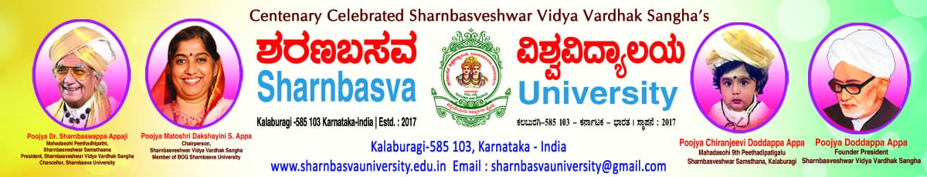

**Faculty of Engineering and Technology (CO-ED)**

**CERTIFICATE**

**Department of**

**This is to certify that Smt / Shri ________________________________**

**bearing University Seat Number ______________ of _____ semester**

**has satisfactorily completed the course of experiment in the laboratory ______________ for B.Tech in the department of ___________________________ prescribed by Sharanbasva University, during the academic year 20 - 20**

**Staff Member Incharge Chairman**

**Examiners :**

**1)**

**2)**

|  |  |  |  |  |  |
| --- | --- | --- | --- | --- | --- |
| S.NO | Name of the program | Page No | Date | Remarks | Signature |
|  |  |  |  |  |  |

INDEX

Course Title: with Code :

USN:

|  |  |  |  |  |  |
| --- | --- | --- | --- | --- | --- |
| S.NO | Name of the program | Page No | Date | Remarks | Signature |
|  |  |  |  |  |  |



**Faculty of Engineering and Technology (CO-ED)**

_________________________________LABORATORY

**RECORD BOOK**

Name _________________________________________

Class ________________________Section ___________

Course/Branch __________________________________

USN _________________________Roll No. __________