Pardhi Prajwal Raosaheb

21CE10040

Assignment - 1

PAVEMENT ASSET MANAGEMENT FOR ROADS, AIRPORTS AND PORTS

**Question-1:**

An agency wish to verify the accuracy of the automated IRI measuring equipment of the vendor (Service provider). The table (see next slide) presents the IRI data (in m/km) the vendor and the reference values established by the on control sections. The agency established the reference IRI values by measuring the profile using Class I profiler (road and level survey) and calculating the IRI based on Quarter Car Simulation.

i. Check if there is a significant difference between the manual measurement by agency and the measurements from sensor data of the vendor equipment.

ii. Check for potential bias, i.e., if the pavement condition is consistently under- or overestimated as a result of the automated data collection process.

iii. If the agency requirement for accuracy for is ±5 percent compared Class I profiler measurement, check if the automated equipment is acceptable or not

Hint: Use paired t-test (95% level of confidence)

|  |  |  |  |  |  |
| --- | --- | --- | --- | --- | --- |
| S.No | IRI_agency | IRI_vendor | S.No | IRI_agency | IRI_vendor |
| 1 | 1.6 | 1.4 | 10 | 4.6 | 4.6 |
| 2 | 6.4 | 6.5 | 11 | 2.4 | 2.6 |
| 3 | 8 | 7.9 | 12 | 5.6 | 5.4 |
| 4 | 3.2 | 3.3 | 13 | 4.1 | 4.1 |
| 5 | 4.1 | 4.4 | 14 | 2 | 2 |
| 6 | 3.4 | 3.7 | 15 | 3.1 | 3.4 |
| 7 | 3.4 | 3.6 | 16 | 4.6 | 4.6 |
| 8 | 2.2 | 2.6 | 17 | 2.8 | 3.1 |
| 9 | 5 | 5 | 18 | 4.9 | 5.1 |
|  |  |  | 19 | 5 | 5.1 |

Solution:

* Paired t-test results:

t-statistic = 2.626128657194452

p-value = 0.01713065198578815

**Equations:**

* **t-statistic**:

​ 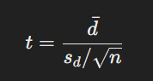

where dˉ is the mean of the differences, sd is the standard deviation of the differences, and n is the number of observations.

* **p-value**: This is obtained from the t-distribution and indicates the probability of observing the data if the null hypothesis is true.
* At a 95% confidence level, there is a significant difference between the agency and vendor measurements.
* Mean bias between vendor and agency IRI: 0.10526315789473686  
    
  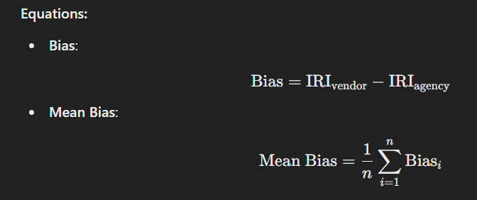
* The vendor tends to overestimate the IRI values.
* Percentage of data within ±5% accuracy: 57.89473684210527%
* The automated equipment does not meet the accuracy requirement.  
  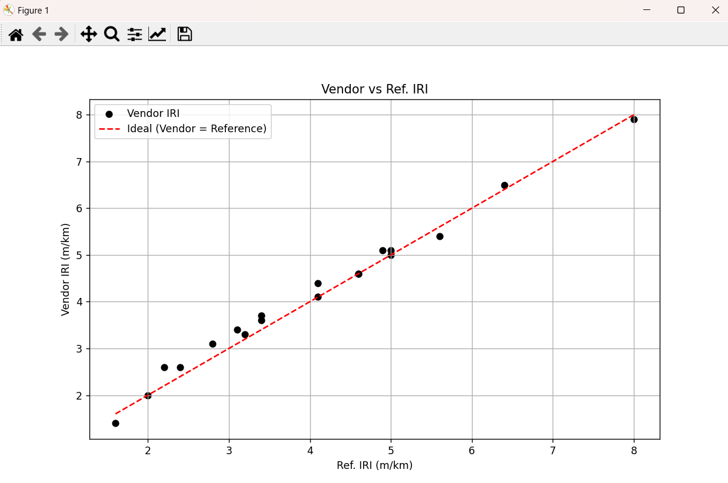

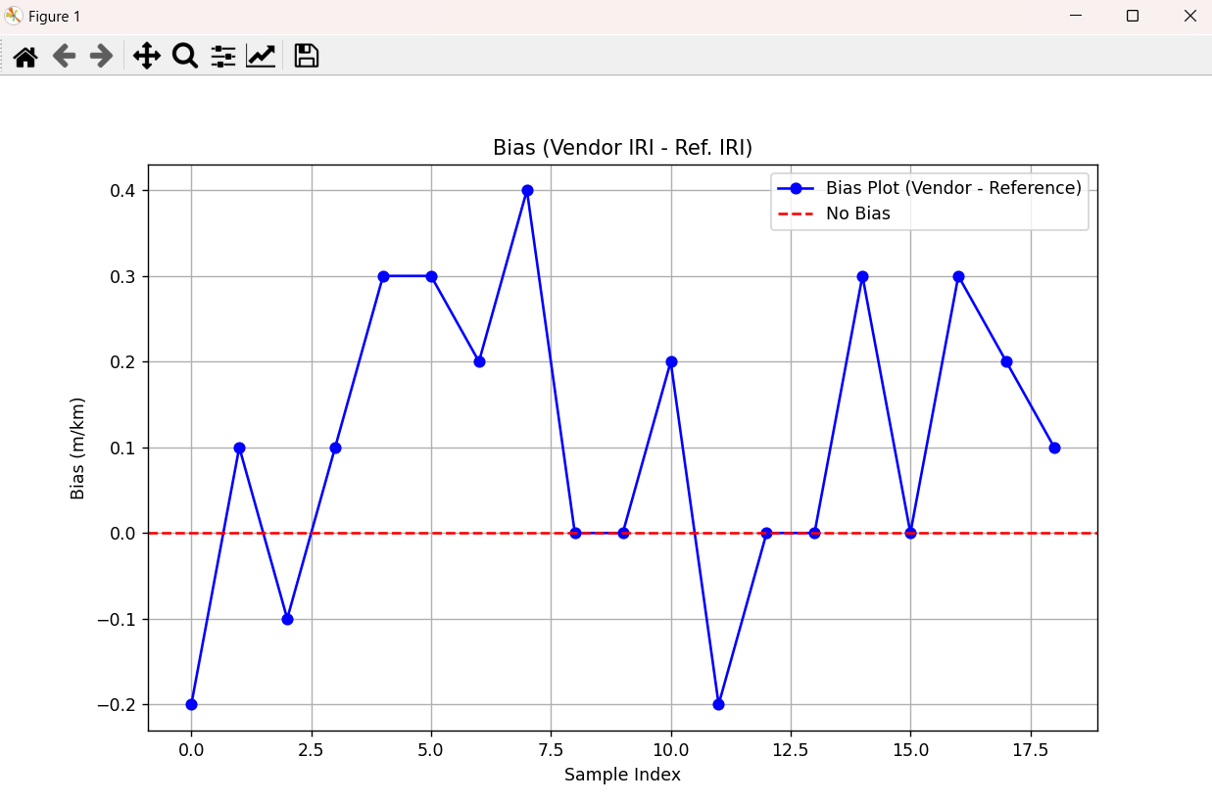

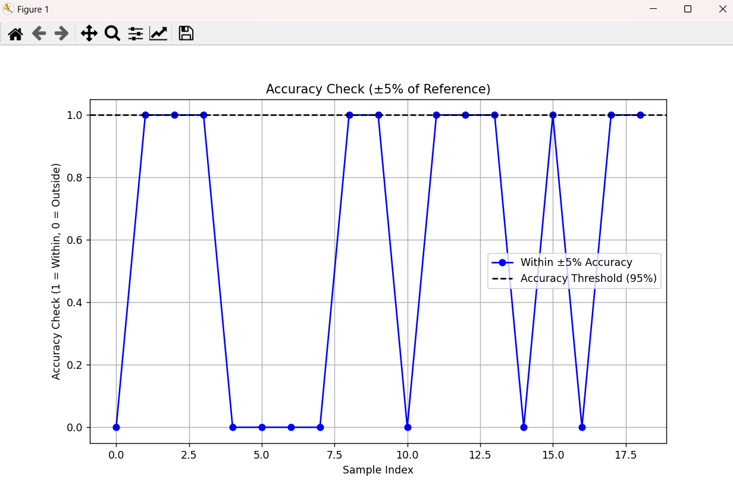

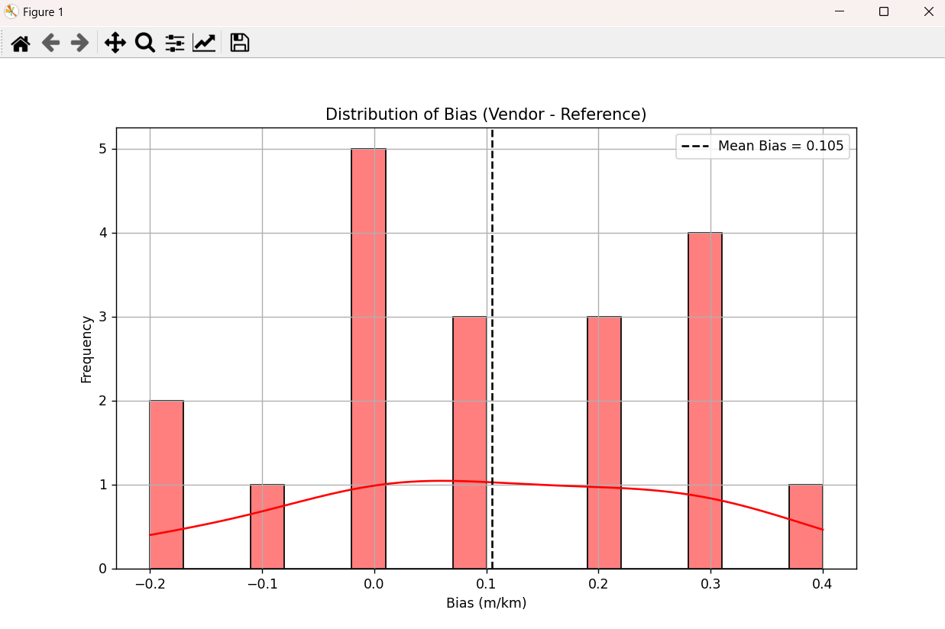

**Question-2:** The rutting data in the table has been collected from field validation testing that involved five repeated runs of the automated senor measurement equipment at a pavement section. If the agency acceptance criterion for the rutting measurement ±1.25 mm standard deviation for 5 runs. Evaluate if the measurement’s method precision meets the acceptance criterion accounting for the sample variation. Assume the data follows a normal distribution.

|  |  |
| --- | --- |
| Section | Rutting (mm) |
| 1 | 10.79 |
| 2 | 13.94 |
| 3 | 12.69 |
| 4 | 8.63 |
| 5 | 11.25 |

**Solution:**

Using python code to find the required value:

* Mean Rutting Measurement: 11.46 mm
* Standard Deviation of Rutting: 2.01 mm
* The measurement method does NOT meet the precision acceptance criterion (Standard deviation > 1.25 mm).  
    
  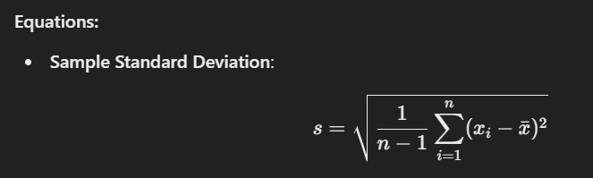  
    
  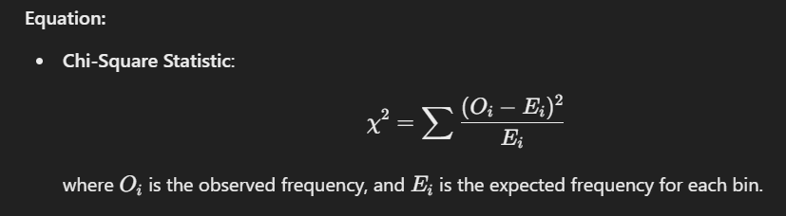

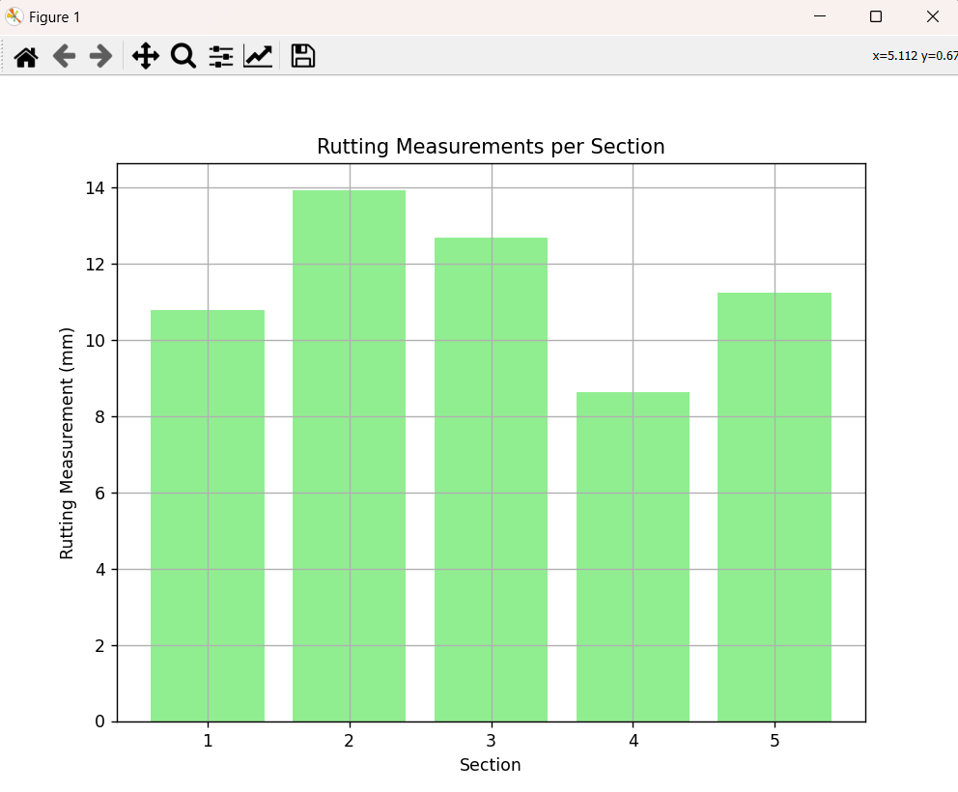

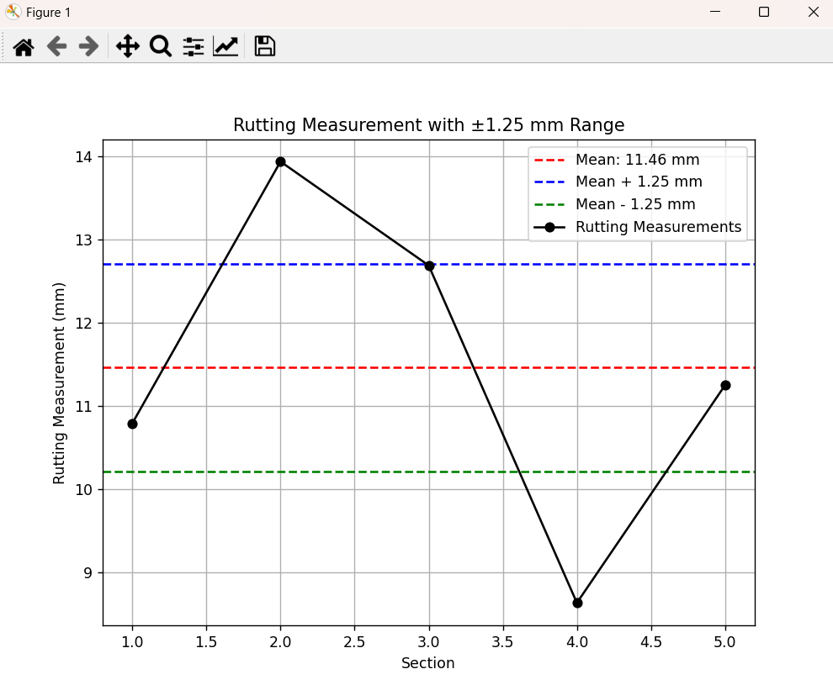

**Code:** [**https://github.com/Prajwal-Pardhi/Pavement-Asset-Management**](https://github.com/Prajwal-Pardhi/Pavement-Asset-Management)