1. Loading all 3 csv files in HDFS.

* 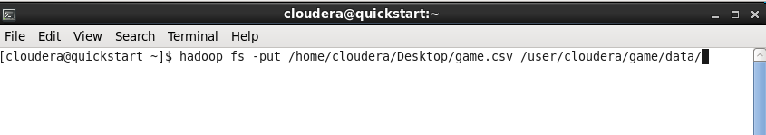Load game.csv
* 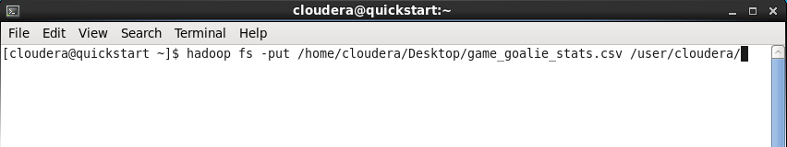Load game_goalie.csv
* Load game_skater.csv

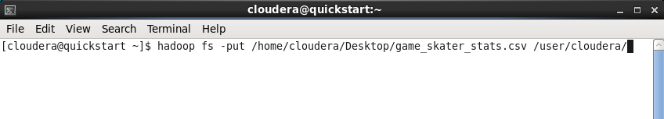

1. 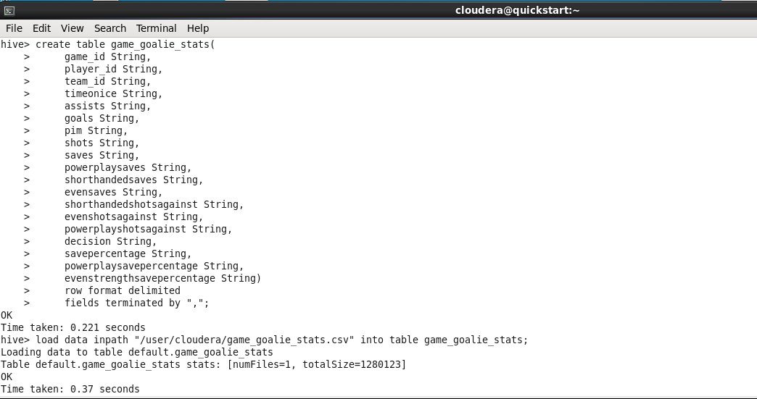Creating tables in hive.

Data is loaded directly into hive using HiveQL.

Internal tables are created and data is loaded into them using ‘LOAD DATA INPATH’

**CLEANING**

Dataframes are created from hive tables.

**CLEANING game_goalie_stats file**

Creating dataframe for game_goalie_stats



Game_goalie_stats Schema

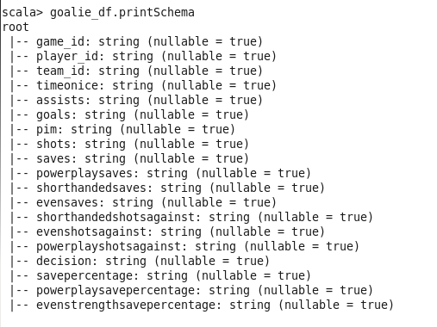

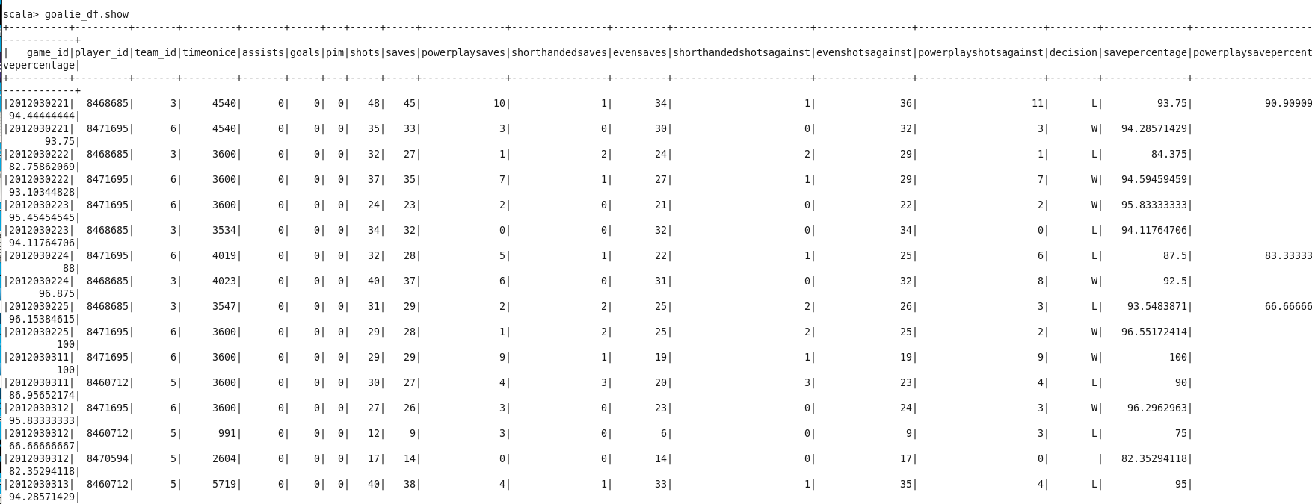goalie_df.show

**Replacing NULL Values**

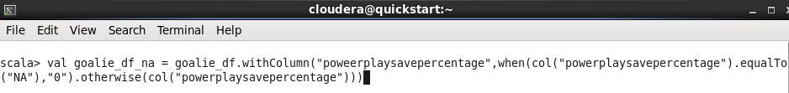

val goalie_df_na = goalie_df.withColumn(“powerplaysavepercentage”,when(col(“powerplaysavepercentage”).equalTo(“NA”),”0”).otherwise(col(“powerplaysavepercentage”)))

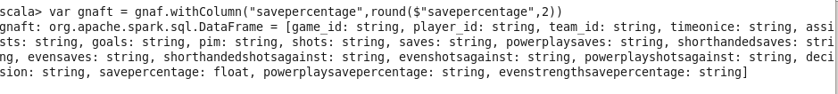**Round off to 2 decimal places**

var gnaft = gnaf.withColumn(“savepercentage”,round($”savepercentage”,2))

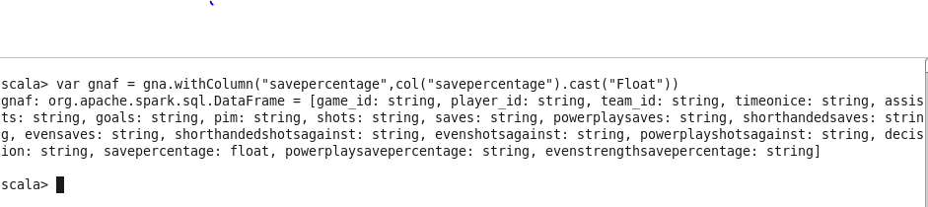**convert Float to Integer**

var gnaf = gna.withColumn(“savepercentage”,col(“savepercentage”).cast(‘Float”))

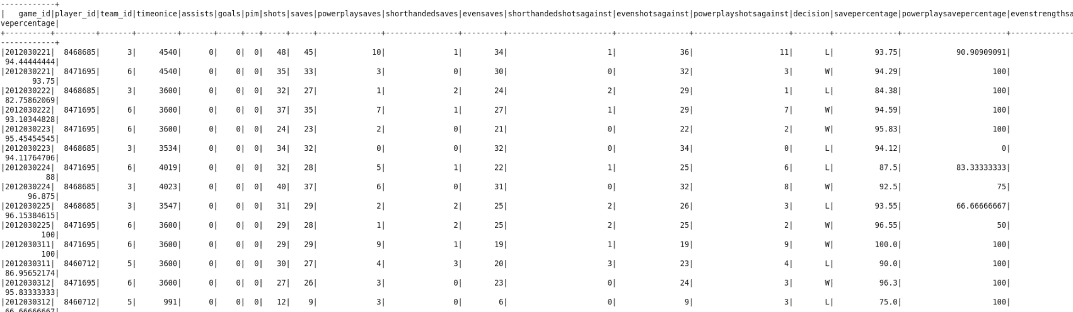game_goalie dataframe show

**CLEANING game.csv**

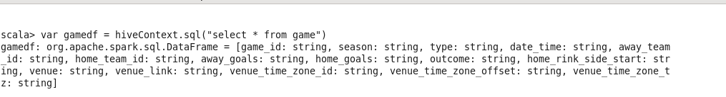Creating dataframe for game.csv

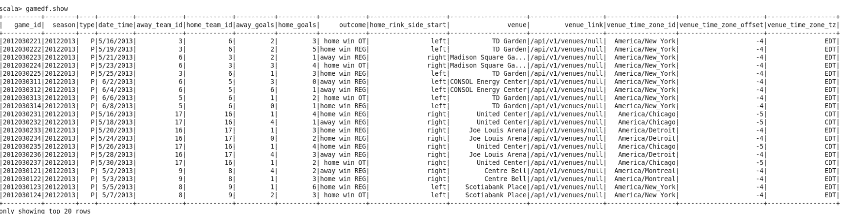Dataframe

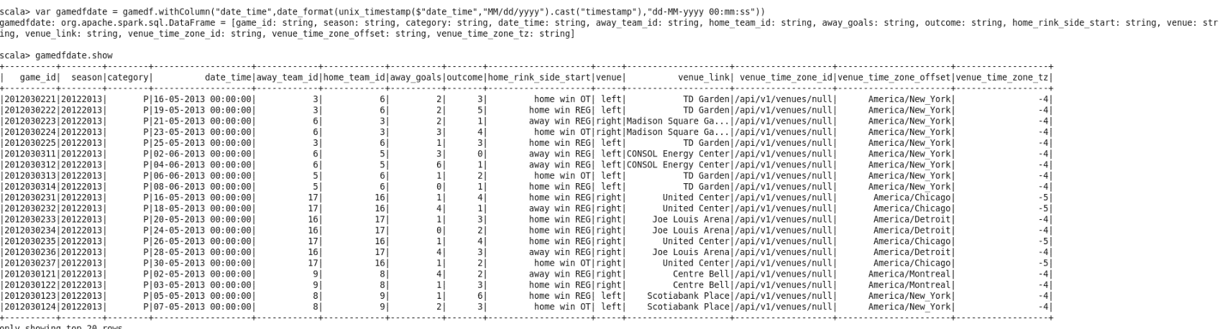Converting date to dd-mm-yyyy hh:mm:ss

var gamedfdate = gamedf.withColumn(“date_time”,date_format(unix_timestamp($”date_time”,”MM/dd/yyyy”).cast(“timestamp”),”dd-MM-yyyy 00:mm:ss”))

**JOINING TABLES**

Dataframes are joined.

Joined dataframes: gamedfdate,gnaft_ftoi,skater

var game_stats = gamedfdate.select(“game_id”,”season”,”type”,”home_team_id”,”venue”,_time_zone_tz”,”venue_time_zone_id”,”outcome”).join(gnaft_ftoi.select(“game_id”,”player_id”,”saverpercentage”,”decision”,seq(“game_id”),”left”)

var game_stats_final = game.stats.join(skater.select(“game_id”,”timeonice”,”goals”,”blocked”,”powerplaytimeonice”,Seq(“game_id”),”right”)

Adding current date and current timestamp to the joined table

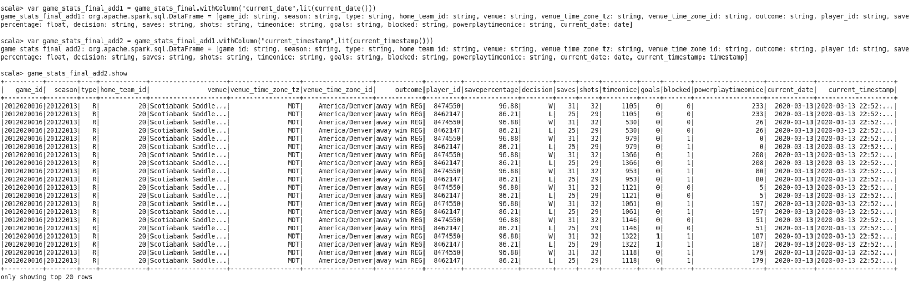

var game_stats_final_add1 =

game_stats_final.withColumn(“current_date,lit(current_date()))

var game_stats_final_add2 = game_stats_final_add1.withColumn(“current_timestamp”,lit(current_timestamp()))

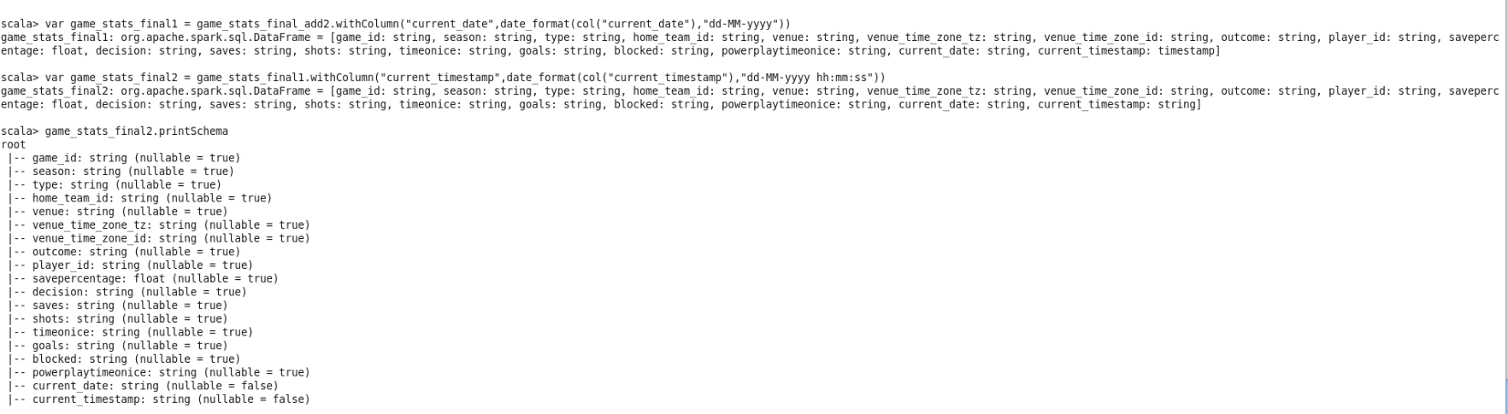Converting current date and current timestamp columns to string

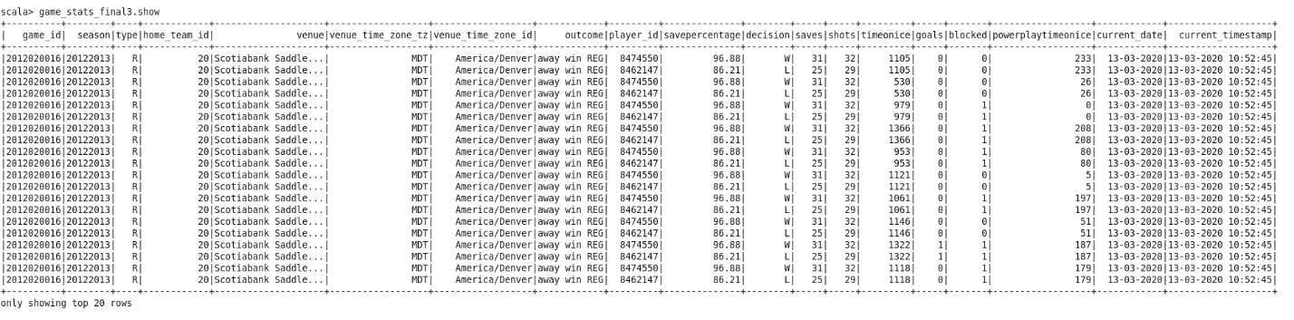Final Table

Loading data into hive

**AGGREGATION**

1. 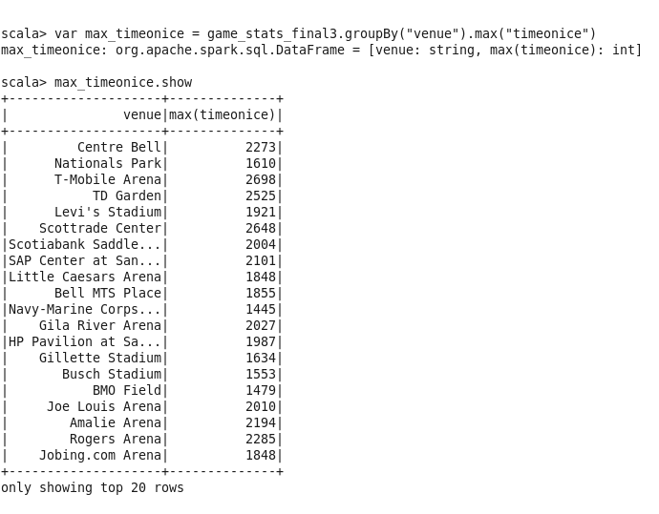Find max of timeonice and group by venue
2. Find min blocked and group by season

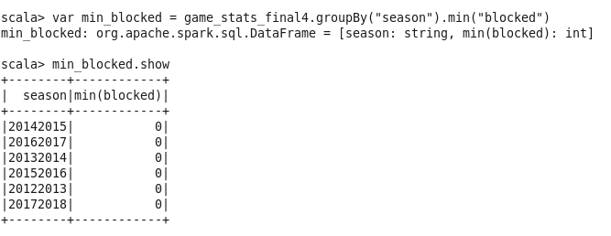

1. Find sum of goals group by player_id

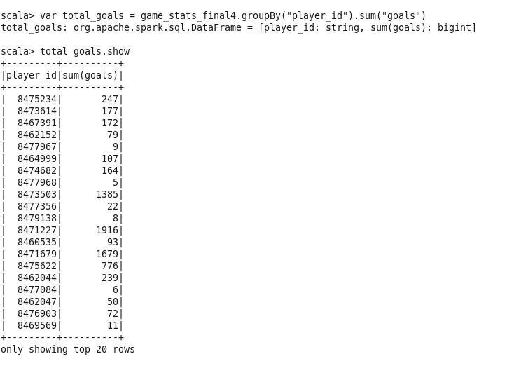

Saving aggregated dataframes to hive

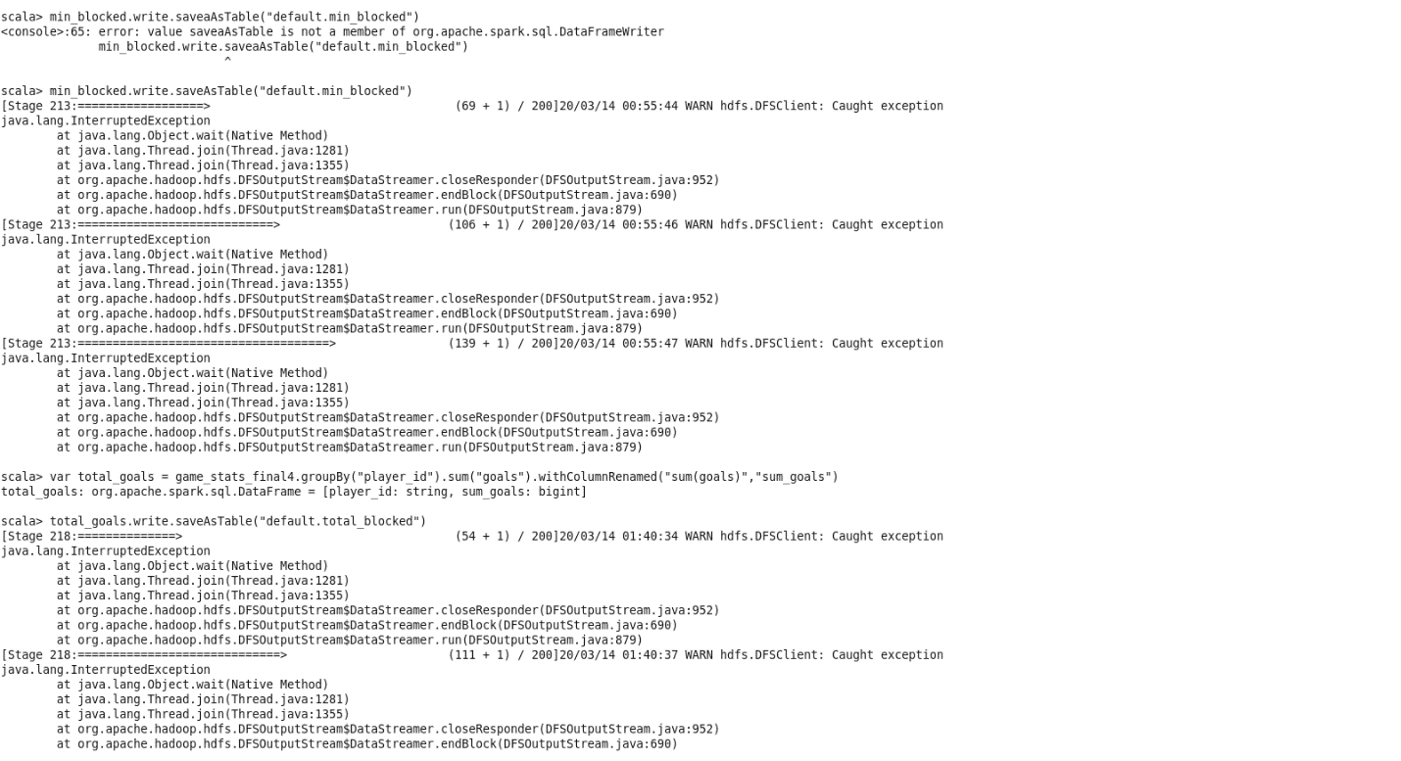

Aggregated Table 1

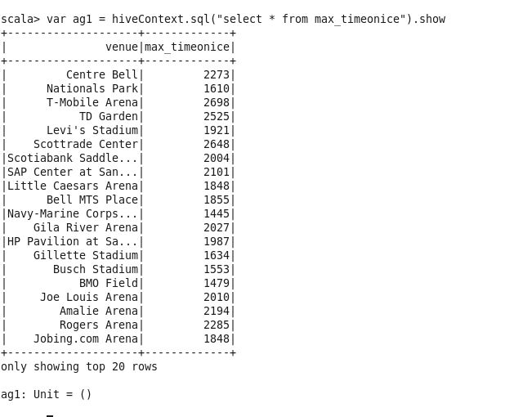

Aggregated Table 2

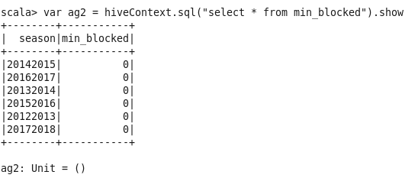

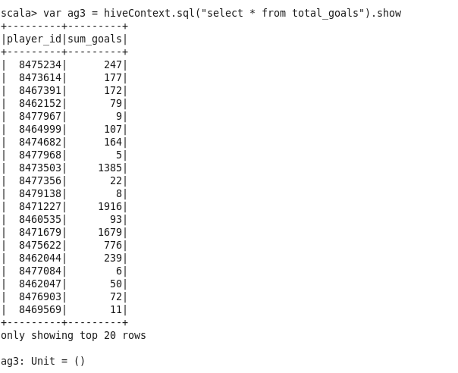Aggregated Table 3

Saving Aggregated Tables into hive

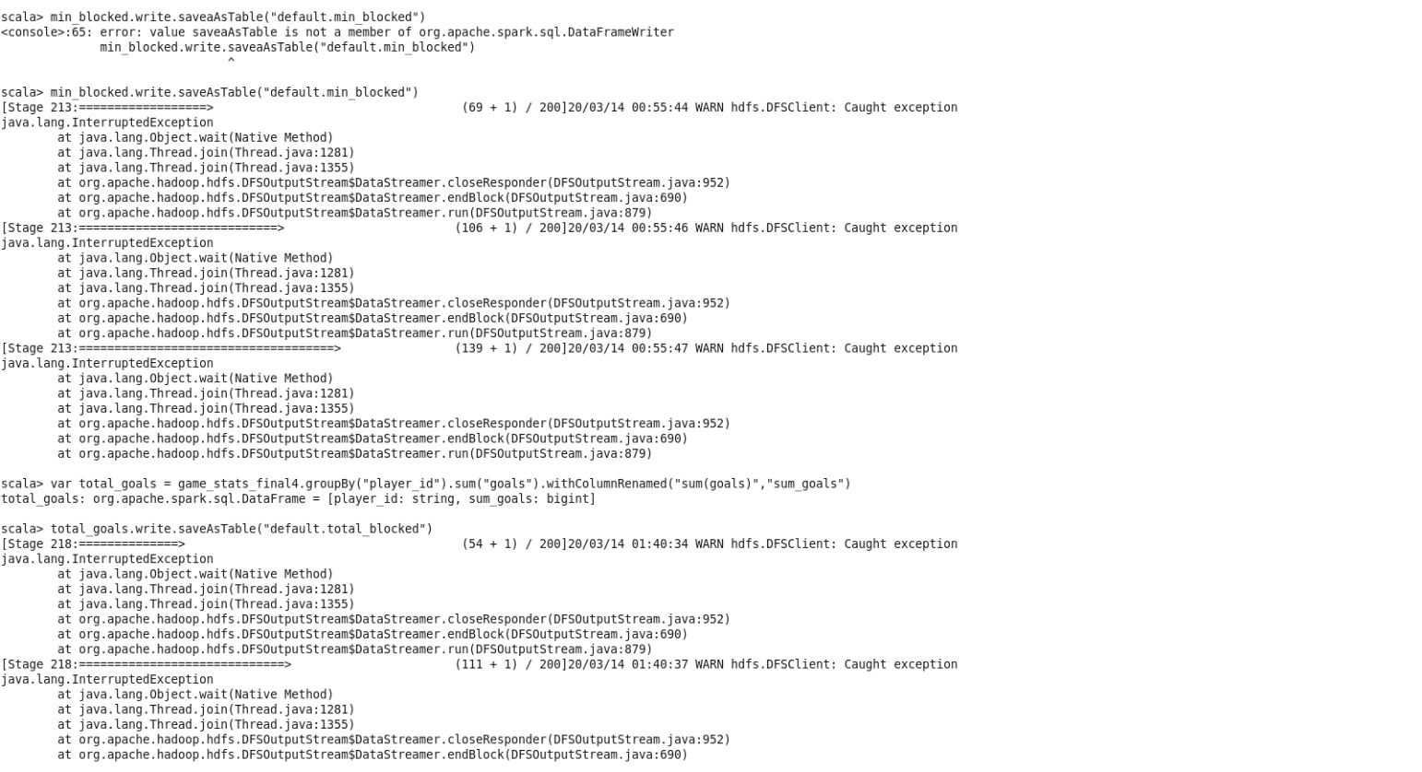

**Final Tables in HIVE:**

**Original Tables:**

game

game_stats

skater

**Cleansed Tables:**

gamefinal

game_stats_final

**Aggregated Tables:**

max_timeonice

min_blocked

total_goals