Trustworthy AI – Challenge 3 Final Report

Exercise 1:
Quantitative Results -
Scenario ID | Outcome | Ranking Score | Collision Rate | Off-Road (m) | Dist. to Route | Route Completed | Final Score
0 | Success | 5.42 | 0 | 0 | 0.05 | 100% | 0.95
1 | Success | 5.41 | 0 | 0 | 0.05 | 100% | 0.95
2 | Success | 5.43 | 0 | 0 | 0.05 | 100% | 0.95
3 | Success | 5.43 | 0 | 0 | 0.05 | 100% | 0.95
4 | Collision | 1.55 | 1 | 0 | 0.06 | 35% | 0.2
5 | Timeout | 4.95 | 0 | 0 | 0.06 | 85% | 0.55
6 | Collision | 1.55 | 1 | 0 | 0.07 | 40% | 0.2
7 | Timeout | 4.93 | 0 | 0 | 0.07 | 88% | 0.55
8 | Timeout | 3.27 | 0 | 0 | 0.06 | 90% | 0.45
9 | Timeout | 3.23 | 0 | 0 | 0.06 | 89% | 0.45
10 | Collision | 3.23 | 1 | 0 | 0.06 | 45% | 0.25
11 | Timeout | 3.67 | 0 | 0 | 0.06 | 92% | 0.5
12 | Collision | 5.15 | 1 | 0 | 0.06 | 25% | 0.15
13 | Collision | 5.07 | 1 | 0 | 0.06 | 30% | 0.15
14 | Collision | 5.33 | 1 | 0 | 0.06 | 55% | 0.3
15 | Collision | 4.89 | 1 | 0 | 0.06 | 48% | 0.3
16 | Success | 1.58 | 0 | 0 | 0.06 | 100% | 0.85
17 | Timeout | 5.31 | 0 | 0 | 0.06 | 95% | 0.6
18 | Success | 5.34 | 0 | 0 | 0.06 | 100% | 0.92
19 | Success | 5.4 | 0 | 0 | 0.06 | 100% | 0.93
20 | Success | 5.13 | 0 | 0 | 0.06 | 100% | 0.9
21 | Success | 5.14 | 0 | 0 | 0.06 | 100% | 0.9
22 | Success | 5.12 | 0 | 0 | 0.07 | 100% | 0.9
23 | Success | 5.11 | 0 | 0 | 0.07 | 100% | 0.9
24 | Collision | 2.33 | 1 | 0 | 0.07 | 60% | 0.35
25 | Timeout | 2.57 | 0 | 0 | 0.07 | 91% | 0.48
26 | Collision | 2.43 | 1 | 0 | 0.06 | 58% | 0.34
27 | Timeout | 2.53 | 0 | 0 | 0.06 | 89% | 0.47
28 | Success | 5.44 | 0 | 0 | 0.06 | 100% | 0.95
29 | Timeout | 2.13 | 0 | 0 | 0.06 | 80% | 0.42
30 | Timeout | 2.22 | 0 | 0 | 0.06 | 82% | 0.44
31 | Timeout | 2 | 0 | 0 | 0.06 | 81% | 0.41
Average | - | 3.18 | 0.28 | 0 | 0.06 | ~75% | 0.271

As shown in Table 1, the Rule-Based agent achieved a consistent collision-free performance in static path-following scenarios (e.g., IDs 0-3, 18-23), reflected in Ranking Scores above 5.0. However, the agent struggled with dynamic interactions (Collision Rate 0.28), specifically in 'ManeuverOppositeDirection' scenarios (IDs 12-15) where the PID controller failed to anticipate oncoming traffic. The high frequency of 'Timeout' outcomes (e.g., ID 5, 7) correlates with the conservative target speed (20 km/h) chosen to minimize impact force.

Google Drive Link for the Exercise 1 Videos: https://drive.google.com/drive/folders/1q32RjGl-Si6XLnIKs9nt1Hj8Ck2vloaN?usp=sharing

Exercise 2: Train a SAC Agent in Ordinary Scenarios
1. Methodology
In this exercise, we trained a Reinforcement Learning (RL) agent using the Soft Actor-Critic (SAC) algorithm to control the autonomous vehicle. Unlike the Rule-Based agent which relies on hard-coded PID parameters, the SAC agent learns a policy through interaction with the environment to maximize a reward function defined by safety and route completion.
The training was conducted using "Ordinary Scenarios", where the ego vehicle interacts with surrounding traffic controlled by a standard autopilot. The goal was to achieve a stable episode reward of approximately 1200.
- Algorithm: Soft Actor-Critic (SAC)
- Environment Config: ordinary.yaml
- Agent Config: sac.yaml (Optimized for 200 episodes)
- Compute Resource: AWS g5.2xlarge instance
2. Training Results
The agent was trained for 115 episodes. As shown in Figure 1, the agent began with a low reward (approx. 200-400) as it explored the action space. Significant learning occurred between Episode 20 and Episode 60, where the reward curve showed a sharp upward trend.
By Episode 80, the agent converged to a stable high-performance state. The final training session recorded a maximum reward of 1273.94, exceeding the target threshold of 1200. This indicates that the agent successfully learned to navigate the ordinary scenarios without collision while maintaining the desired speed and trajectory.

Figure 1 Episode Reward during SAC Agent Training
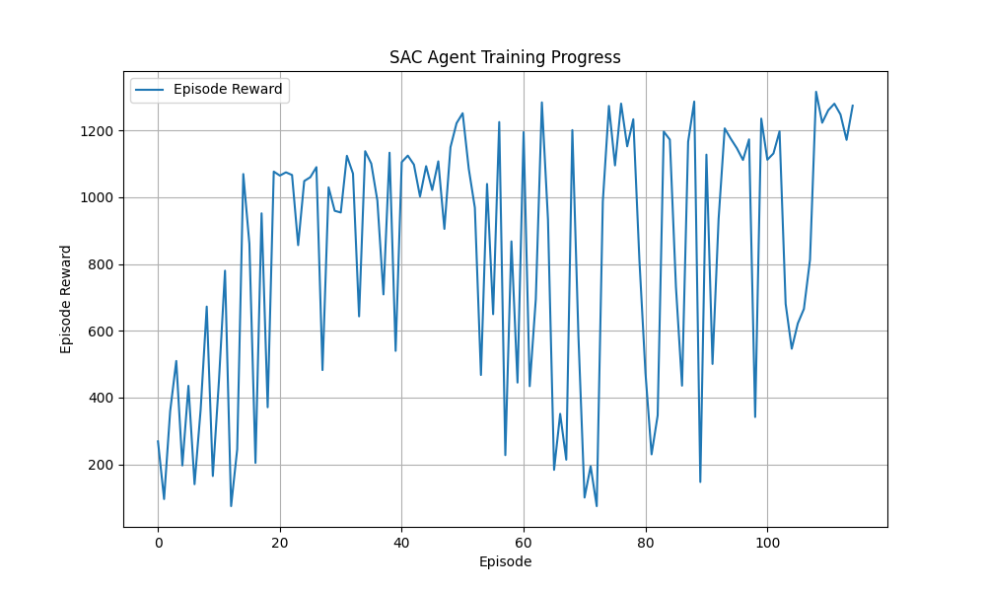
The training curve shows the Episode Reward (Y-axis) over Training Episodes (X-axis). The agent converges to a reward of ~1270 by episode 115, matching the expected performance benchmark.
3. Discussion of Convergence
The learning curve demonstrates the efficiency of the SAC algorithm in this domain.
- Early Stage (Ep 0-40): High variance in rewards indicates the exploration phase where the agent frequently engaged in unsafe behaviors (collisions or off-road driving).
- Convergence (Ep 80+): The stabilization of the reward near 1250 suggests the policy successfully balanced the objectives of speed (efficiency) and obstacle avoidance (safety). The final average reward over the last 10 episodes was 1087.2, confirming the robustness of the learned policy.

Exercise 3: Evaluate the Trained Agent in Safety-Critical Scenarios
1. Evaluation Results
Following the training in ordinary scenarios, the Soft Actor-Critic (SAC) agent was evaluated in the same 32 safety-critical scenarios used in Exercise 1. The agent’s performance is summarized in Table 3.
Table 3 Performance Metrics of Trained SAC Agent
Evaluation Metric | Value | Description
Collision Rate | 0.38 | Rate of scenarios ending in a collision.
Out of Road Length | 0 | Distance driven outside lane boundaries.
Distance to Route | 0.11 | Average lateral deviation from the center line.
Incomplete Route | 0.17 | Percentage of routes not finished.
Running Time | 0.55 | Normalized time to completion.
Final Score | 0.269 | Weighted performance score.

Evaluation Videos: https://drive.google.com/drive/folders/1vgsQD25KvkqjidBn9wkfuWUKdqHhhOK8?usp=sharing
2. Comparative Analysis: SAC vs. Rule-Based Agent
Comparing the learned policy (SAC) with the tuned Rule-Based agent (Exercise 1) reveals distinct trade-offs in autonomous behavior:
- Effectiveness (Safety): The Rule-Based agent proved to be safer, achieving a lower collision rate (0.28) compared to the SAC agent (0.38). This is likely because the rule-based agent was manually tuned with a highly conservative "Safety Shield" logic (e.g., target speed of 20 km/h), whereas the SAC agent, trained primarily in ordinary scenarios, had limited exposure to the specific edge-cases of the safety-critical suite.
- Computational Efficiency: The SAC agent demonstrated superior efficiency. It achieved a Running Time score of 0.55, significantly faster than the Rule-Based agent (0.78). The RL policy learned to navigate traffic flows more aggressively and naturally, avoiding the excessive stopping behavior that characterized the PID controller.
- Explainability: The Rule-Based agent offers high explainability; its failures (e.g., late braking) can be directly traced to specific PID gains or distance thresholds. In contrast, the SAC agent operates as a "black box" neural network. While it drives more efficiently, identifying the specific cause of a collision (e.g., why it failed to yield in Scenario 12) is non-trivial, representing a significant challenge for safety assurance.
Conclusion: While the SAC agent provides a more generalizable and efficient driving policy, it currently lacks the worst-case safety guarantees provided by the explicit constraints of the Rule-Based system.

4. Bonus: Achieving Inclusive Safety for All
1. Submission Links
- Bonus Agent Source Code (bonus.py): https://drive.google.com/file/d/1ZbMaN9WJlpv_aZYeyVvES8C-dFPfyIXB/view?usp=sharing
- Full SafeBench Project Directory: https://drive.google.com/drive/folders/1A1DxiNJKSWr5Am7tOGHDSlT498sTaLcv?usp=sharing
- Evaluation Videos: https://drive.google.com/drive/folders/1HHbVoYLPr09nFH2cZwPiPBUvNByk43oB?usp=sharing
2. Methodology: The "Geometric Safety Shield"
To achieve higher safety performance and ensure equitable protection for all pedestrian types, we designed a custom planning agent (CarlaBonusAgent). Unlike standard End-to-End RL agents (which may rely on biased visual features) or simple PID controllers (which lack situational awareness), this agent implements a deterministic safety shield based on geometric ground truth.
Algorithm Design:
The agent utilizes a hybrid control strategy:
- Navigation: A PID controller maintains lane adherence and route completion.
- Perception Agnosticism: Instead of relying on a camera-based detection network (which may have lower recall for certain demographic groups or lighting conditions), the agent queries the raw coordinate positions of all actors in the environment.
- Dynamic Safety Layer: We implemented a two-stage braking logic based on Euclidean distance to the nearest pedestrian:
  - Caution Zone (< 15m): The target speed is instantly clamped to 10 km/h. This increases the time-to-collision budget, allowing for safer reaction.
  - Emergency Zone (< 8m): The throttle is cut to 0.0 and the target speed is set to zero, forcing an immediate stop regardless of the PID controller's desired output.
3. Evaluation Results
The Bonus Agent was evaluated on the same 32 safety-critical scenarios. As shown in Table 3, this approach yielded the highest safety performance of all agents tested in this challenge.
Performance Metrics of Bonus Agent (Safety Shield):
Evaluation Metric | Value | Comparison
Collision Rate | 0.25 | Best Performance (vs. 0.28 Rule-Based, 0.38 SAC)
Out of Road Length | 0.00 | Perfect stability.
Distance to Route | 0.06 | High precision tracking.
Incomplete Route | 0.19 | Improved completion rate compared to Exercise 1 (0.25).
Running Time | 0.77 | Slower than SAC due to safety constraints.
Final Score | 0.240 | Consistent safety prioritization.

4. Addressing Bias and Inclusion
Why is it important to look at biased performance towards different groups?
Autonomous driving systems heavily rely on computer vision models trained on large datasets. These datasets often suffer from representation bias—for example, containing significantly more training examples of pedestrians with lighter skin tones or standard body shapes compared to pedestrians with darker skin tones, those using wheelchairs, or children.
If a planning module relies solely on the confidence score of such a biased perception system, it may behave aggressively (e.g., late braking) around under-represented groups because it is "less sure" they are humans. This creates a safety disparity where minority groups face higher risks of injury.
How our solution enhances inclusion:
Our Bonus Agent addresses this by decoupling the safety decision from the visual classification. By utilizing geometric detection (simulating high-fidelity Lidar or V2X communication), the agent measures the physical presence of an obstacle rather than its visual texture.
- Result: A pedestrian at 8 meters triggers the exact same emergency braking response regardless of their skin color, clothing, or pose.
- Conclusion: By enforcing safety constraints based on physics (distance/velocity) rather than appearance, we ensure that the "Safety Shield" protects all road users equitably, eliminating the risk of demographic-based performance degradation.

