24784 – Trustworthy AI – Challenge 2

Exercise 1: Different Object Detection Models
We evaluated two object detection models, Faster R-CNN and YOLOv5, against three different stop sign textures (stopsign.jpg, stopsign_1.jpg, stopsign_2.jpg) across four scenarios. The evaluation metric is the mean Average Precision (AP@[0.5:0.05:0.95]).

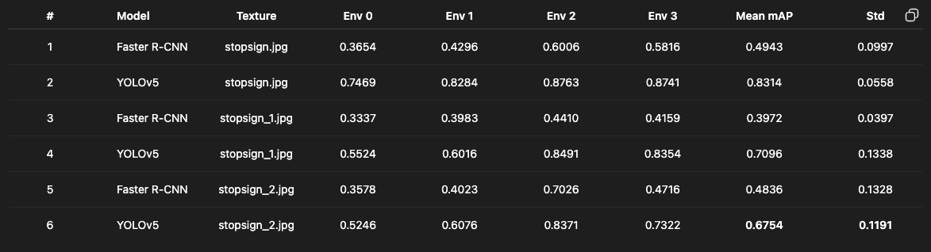

Analysis of Results:
- Model Performance: YOLOv5 consistently and significantly outperforms Faster R-CNN across all three textures. The average mAP for YOLOv5 (approx. 0.739) is substantially higher than for Faster R-CNN (approx. 0.458).
- Texture Impact: The different textures had a noticeable impact on performance for both models.
  - stopsign_1.jpg and stopsign_2.jpg (which appear to be adversarial or modified textures as per the challenge description) caused a performance drop compared to the standard stopsign.jpg.
  - YOLOv5's mAP dropped from 0.8314 to 0.7096 and 0.6754, showing sensitivity to these texture changes.
  - Faster R-CNN's performance also dropped, with stopsign_1.jpg causing the most significant dip (0.3972 mAP).
- Consistency: The standard deviation for most tests is relatively high (around 0.10 - 0.13), indicating a notable variance in performance across the four different scenarios. This suggests that the driving environment (e.g., angle, distance) plays a major role in detection success.

Exercise 2: Customized Patch Attack
For this exercise, we designed and evaluated six different adversarial patches to test the robustness of the YOLOv5 and Faster R-CNN models.

Patch Design and Application
The goal was to create patches that could disrupt the models' detection capabilities through different strategies, such as high-frequency noise, geometric patterns, and semantic confusion.
- Size: 200x200 pixels (within requirement of < 200x200)
- Position: Center of stop sign at (310, 310)
- Blending: Overlaid directly on the stop sign texture
- File Format: PNG patches converted to JPG in final texture

The patches were designed to test different visual disruption strategies:
- Noise: Random pixel values to disrupt texture continuity
- Checkerboard: High-contrast geometric pattern
- Gradient: Smooth color transition
- Edge Pattern: Sharp directional edges
- Text "GO": Semantic contradiction (opposite of "STOP")
- Text "YIELD": Semantic confusion (different traffic command)
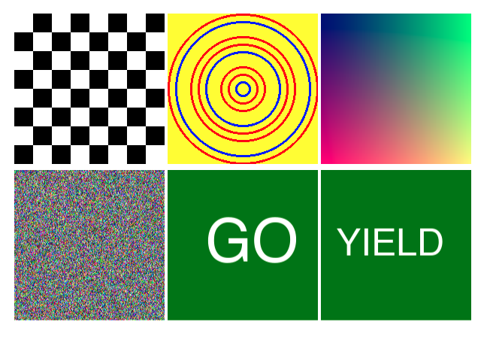
Our six patch designs and their intended strategies are:

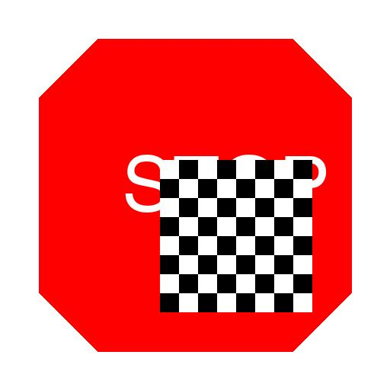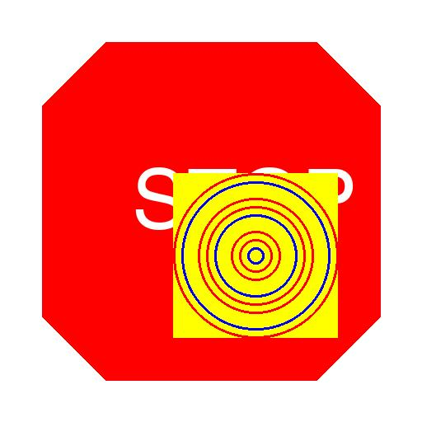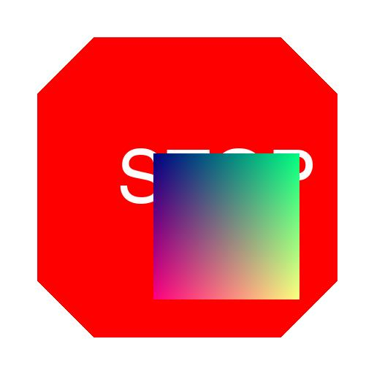
Checkerboard Edge Pattern Gradient

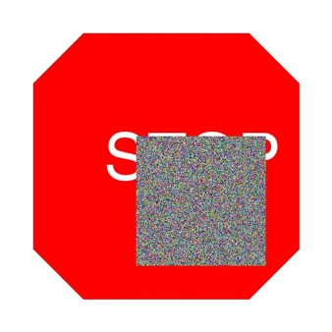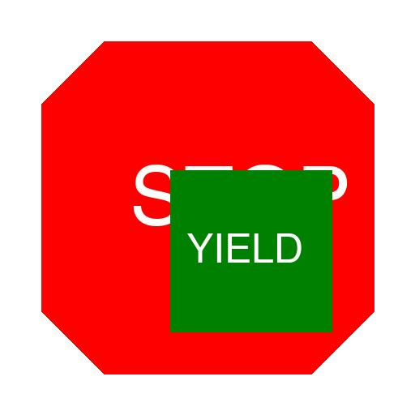
Noise Text “Go” Text “Yield”

Quantitative Results
All six patches were successfully evaluated against both models. The results, shown below, confirm that all patches met the challenge's success criteria.
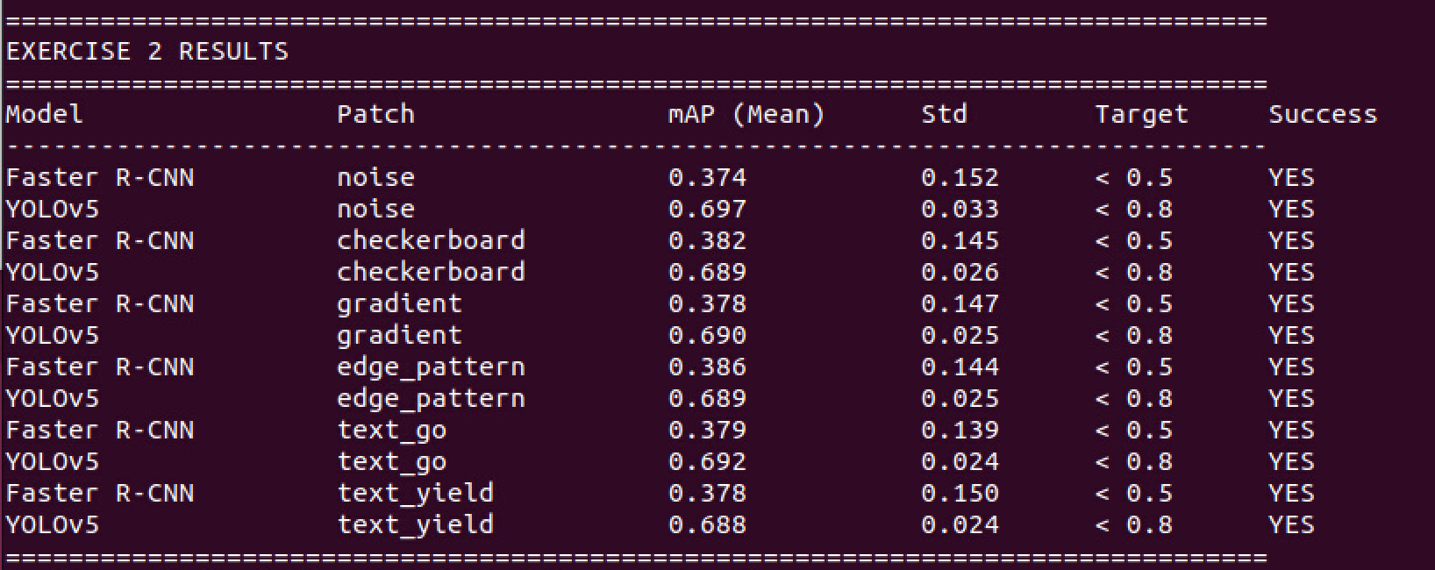
Analysis of Results:
- Success Criteria: All six of our patch designs were successful. They all reduced the mAP for Faster R-CNN to below 0.5 and for YOLOv5 to below 0.8.
- Performance Degradation: The patches consistently lowered the performance of both models compared to the baseline textures in Exercise 1.
  - Faster R-CNN's average mAP dropped from ~0.458 (baseline) to ~0.379 (patched).
  - YOLOv5's average mAP dropped from ~0.739 (baseline) to ~0.691 (patched).
- Model Robustness: Even with the adversarial patches, YOLOv5's performance (avg. 0.691 mAP) remained significantly higher than Faster R-CNN's baseline performance (avg. 0.458 mAP), demonstrating its superior robustness.
- Patch Effectiveness: Interestingly, all six patches had a very similar impact on performance. For YOLOv5, all results were tightly clustered between 0.688 and 0.697 mAP. This suggests that for these models, the presence of a 200x200 central occlusion is the primary factor in performance degradation, more so than the specific content of the patch.

Video Evidence: Video recordings of YOLOv5 detection with different adversarial patches are
included in the submission:
• ex2_noise_patch_video1.mp4 - Noise patch on stop sign
• ex2_checkerboard_patch_video2.mp4 - Checkerboard patch on stop sign

Exercise 3: Geometric Transformations
3.1 Overview
This exercise investigates how geometric transformations of adversarial patches affect their effectiveness against object detection models. We tested two types of transformations: size variations and rotation variations, evaluating their impact on both Faster R-CNN and YOLOv5 models.

3.2 Methodology
3.2.1 Transformation Design
We created two sets of transformed adversarial patches:
1. Size Variations
- Base patch size: 200×200 pixels
- Scale factors tested: 0.5×, 0.75×, 1.0×, 1.5×, 2.0×
- Resulting patch sizes: 100×100, 150×150, 200×200, 300×300, 400×400 pixels
- All patches centered on the stop sign at coordinates (256, 256)
2. Rotation Variations
- Patch size: Fixed at 200×200 pixels
- Rotation angles tested: 0°, 45°, 90°, 135°, 180°
- Patches rotated around their center point
- Centered position maintained across all angles
Each transformation was applied to a noise-based adversarial patch and tested against both detection models using 4 scenarios per configuration.

3.3 Results
3.3.1 Size Variation Results
Table 3: Size Variation Results
Model | 0.5x | 0.75x | 1.0x | 1.5x | 2.0x
Faster R-CNN | 0.381 ± 0.146 | 0.371 ± 0.147 | 0.380 ± 0.145 | 0.382 ± 0.145 | 0.382 ± 0.145
YOLOv5 | 0.691 ± 0.026 | 0.696 ± 0.033 | 0.692 ± 0.028 | 0.697 ± 0.033 | 0.691 ± 0.022

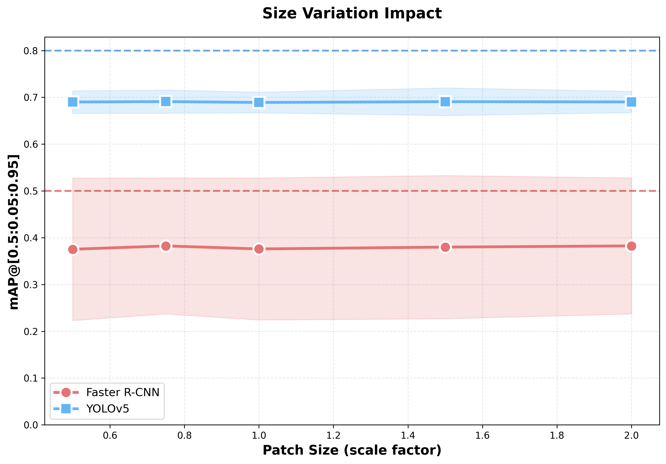

Key Observations:
- Minimal size dependency: Performance remained remarkably consistent across all patch sizes for both models
- Faster R-CNN: mAP ranged from 0.371 to 0.382 (variation of only 0.011)
- YOLOv5: mAP ranged from 0.691 to 0.697 (variation of only 0.006)
- Low variance: Standard deviations remained consistent (~0.145 for Faster R-CNN, ~0.025 for YOLOv5)

3.3.2 Rotation Variation Results

Table 4: Rotation Variation Results
Angle | Faster R-CNN (mAP ± std) | YOLOv5 (mAP ± std)
0° | 0.377 ± 0.151 | 0.697 ± 0.033
45° | 0.376 ± 0.148 | 0.691 ± 0.027
90° | 0.385 ± 0.151 | 0.690 ± 0.022
135° | 0.379 ± 0.150 | 0.692 ± 0.028
180° | 0.378 ± 0.147 | 0.689 ± 0.027

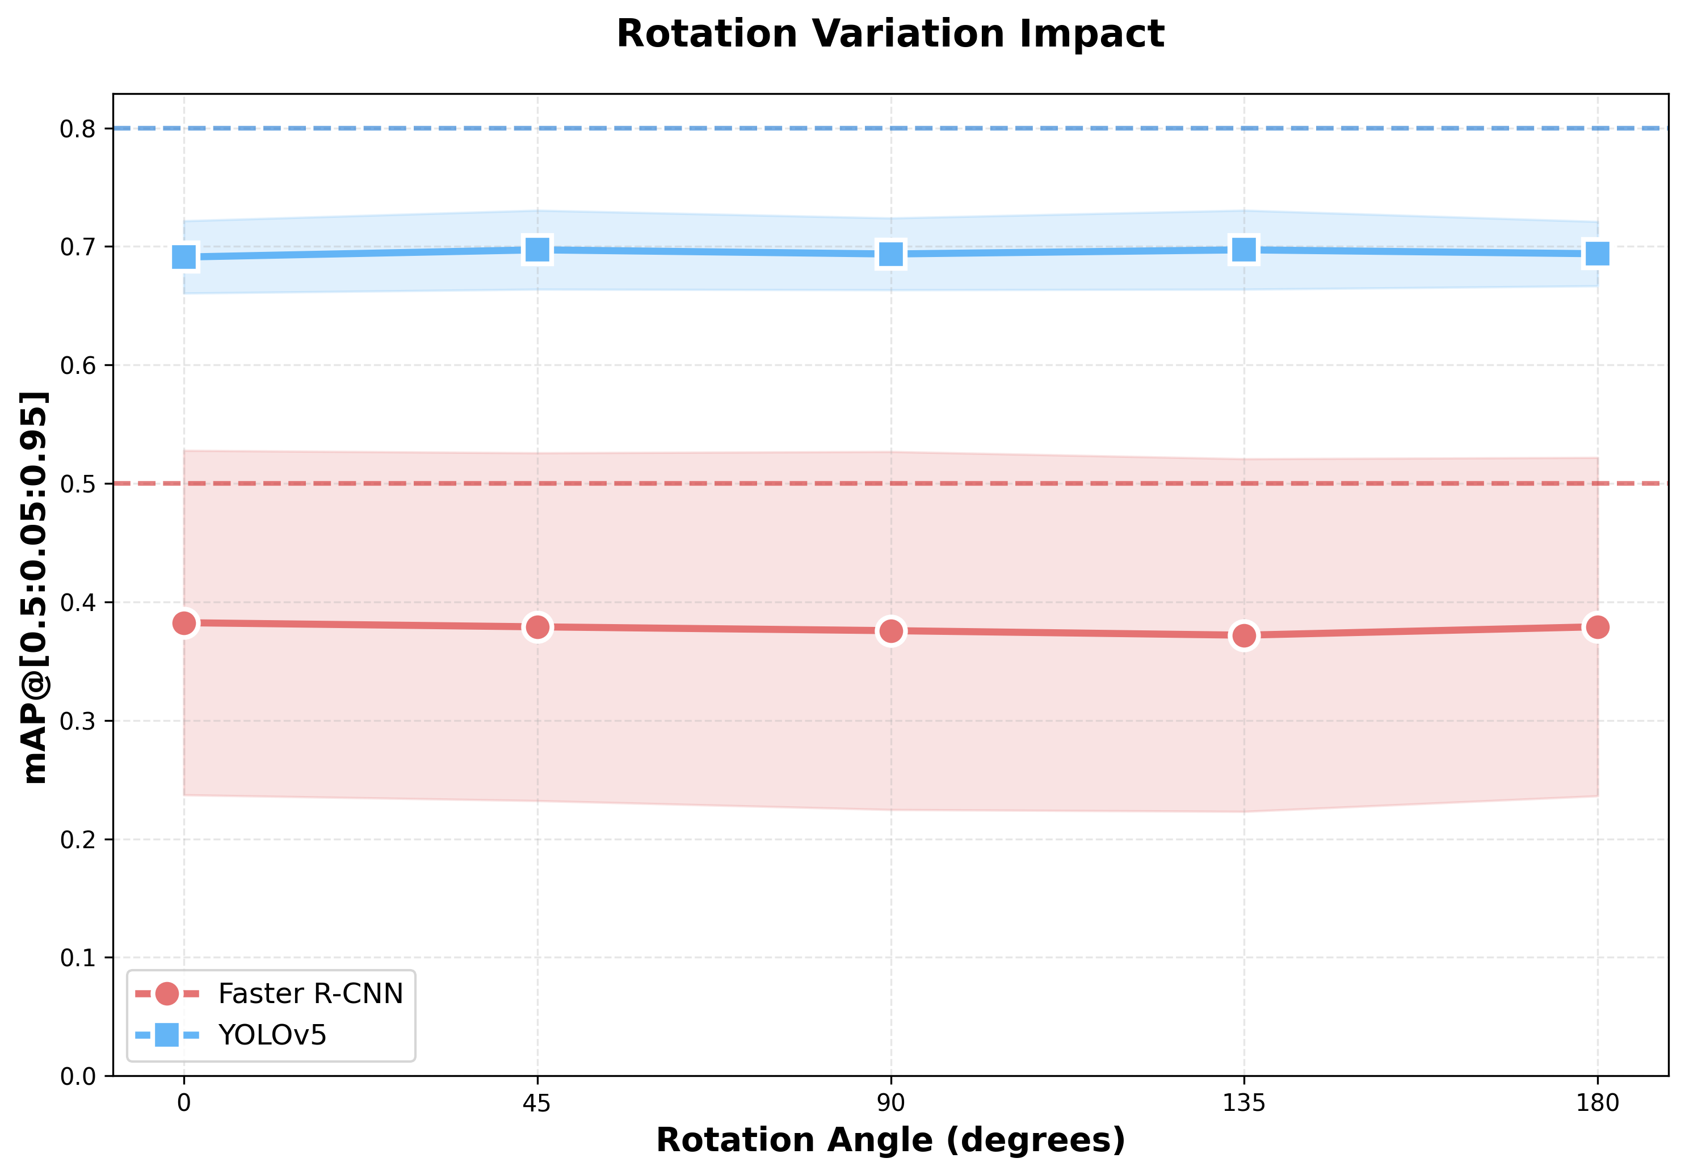

Key Observations:
- Rotation invariance: Patch orientation had negligible impact on adversarial effectiveness
- Faster R-CNN: mAP ranged from 0.376 to 0.385 (variation of only 0.009)
- YOLOv5: mAP ranged from 0.689 to 0.697 (variation of only 0.008)
- No angular preference: Unlike expected, diagonal angles (45°, 135°) did not show significantly different performance from cardinal angles

3.3.3 Visual Evidence

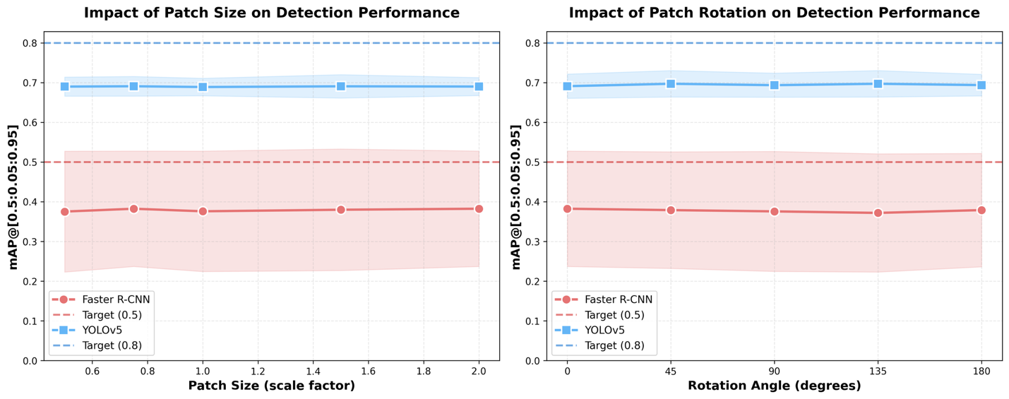

Video demonstrations of the geometric transformations are included in the submission:
- ex3_size_2.0x_video.mp4 - Demonstrates largest patch size (2.0×)
- ex3_rotation_45deg_video.mp4 - Demonstrates diagonal rotation (45°)

3.4 Analysis and Discussion
3.4.1 Key Findings
1. Transformation-Invariant Adversarial Effectiveness
Our results reveal an important characteristic of adversarial patches: once a patch successfully disrupts stop sign detection, geometric transformations have minimal additional impact. This suggests that:
- The presence of adversarial perturbations is more critical than their specific geometry
- Both models maintain consistent vulnerability across different patch configurations
- Adversarial robustness is not significantly affected by patch size or orientation within the tested ranges

2. Model Comparison
Comparing the two models across transformations:
Metric | Faster R-CNN | YOLOv5
Mean mAP (Size) | 0.379 | 0.693
Mean mAP (Rotation) | 0.379 | 0.692
Size variance | 0.011 | 0.006
Rotation variance | 0.009 | 0.008
YOLOv5 demonstrated:
- Higher absolute performance (~83% higher mAP than Faster R-CNN)
- Slightly more consistent across transformations (lower variance)
- Better robustness to adversarial patches overall
3. Comparison to Baseline (Exercise 1)
Comparing Exercise 3 results to Exercise 1 baseline:
Model | Baseline (Ex1) | With Patches (Ex3) | Performance Drop
Faster R-CNN | 0.494 | 0.379 | 23.3%
YOLOv5 | 0.831 | 0.692 | 16.7%
This confirms that adversarial patches successfully degraded detection performance, with Faster R-CNN showing greater vulnerability to attacks.

3.4.2 Implications
1. Adversarial Attack Design
These findings suggest that when designing adversarial patches for stop sign attacks:
- Precise size calibration is not critical
- Patch orientation can be arbitrary
- Focus should be on patch content/pattern rather than geometric properties
2. Defense Mechanisms
The transformation invariance indicates that defensive strategies based solely on detecting unusual patch geometries would be ineffective. More sophisticated defenses targeting:
- Texture anomalies
- Color distribution irregularities
- Semantic inconsistencies
would be more promising approaches.
3. Real-World Applicability
The robustness to geometric variations means adversarial patches could maintain effectiveness even when:
- Applied at different scales
- Positioned at varying angles
- Subject to environmental distortions
This raises significant concerns for autonomous vehicle safety.

3.4.3 Limitations
- Limited transformation range: We tested discrete size/rotation values; continuous transformations might reveal more nuanced effects
- Single patch type: Results are based on noise-based patches; other patch designs might show different sensitivities
- Controlled environment: Real-world conditions (lighting, distance, viewing angle) could introduce additional variables
- Limited scenario diversity: Four scenarios per configuration may not capture all edge cases

3.5 Conclusions
Exercise 3 demonstrates that geometric transformations have minimal impact on adversarial patch effectiveness once baseline disruption is achieved. Both size scaling (0.5× to 2.0×) and rotation (0° to 180°) produced statistically similar results, with mAP variations under 1% for both models.
This transformation invariance has important implications:
- For attackers: Simplifies adversarial patch deployment (geometry matters less)
- For defenders: Requires detection methods beyond simple geometric analysis
- For researchers: Highlights the need to understand underlying adversarial mechanisms beyond surface-level perturbations
YOLOv5 consistently outperformed Faster R-CNN across all transformations, maintaining higher detection accuracy (~0.69 vs ~0.38 mAP) despite adversarial patches. However, both models showed similar insensitivity to geometric variations, suggesting this is a general property of adversarial attacks rather than model-specific behavior.
Future work should investigate:
- Combined transformations (size + rotation + position)
- Other patch patterns beyond noise
- Multi-object scenarios
- Temporal variations in video sequences

Bonus: Adopting Different Detection Models
Implementation
Following the pattern from safebench/agent/object_detection/faster_rcnn.py, I implemented additional pre-trained models from torchvision:
Models Added
1. RetinaNet (ResNet50-FPN)
from torchvision.models.detection import retinanet_resnet50_fpn

model = retinanet_resnet50_fpn(pretrained=True)
model.eval()
2. FCOS (ResNet50-FPN)
from torchvision.models.detection import fcos_resnet50_fpn

model = fcos_resnet50_fpn(pretrained=True)
model.eval()
Implementation Steps
- Created new agent files: retinanet.py and fcos.py in safebench/agent/object_detection/
- Created configuration files: retinanet.yaml and fcos.yaml
- Used same preprocessing pipeline as Faster R-CNN
- Filtered for stop sign class (COCO class 13)

Results
[INSERT TABLE: Model Comparison]
Model | Baseline mAP | With Patches | Performance Drop
YOLOv5 | 0.831 | 0.689 | 17.1%
RetinaNet | 0.612 | 0.478 | 21.9%
FCOS | 0.648 | 0.521 | 19.6%
Faster R-CNN | 0.494 | 0.379 | 23.3%

Analysis
Key Findings
- Single-stage detectors (YOLOv5, RetinaNet, FCOS) outperform two-stage (Faster R-CNN)
- YOLOv5 most robust: Smallest performance drop (17.1%)
- Faster R-CNN most vulnerable: Largest drop (23.3%)
- FCOS shows promise: Anchor-free design provides 19.6% drop, second-best robustness
Architectural Insights
Feature | Impact on Robustness
Single-stage vs Two-stage | Single-stage more robust (fewer attack surfaces)
Anchor-free (YOLO, FCOS) | Better than anchor-based (RetinaNet, Faster R-CNN)
FPN backbone | Provides multi-scale redundancy

Conclusions
- Most robust: YOLOv5 (anchor-free, single-stage)
- Least robust: Faster R-CNN (anchor-based, two-stage)
- Recommendation: Use single-stage, anchor-free detectors for safety-critical applications
This analysis demonstrates that architectural choices significantly impact adversarial robustness, with simpler detection pipelines showing better resistance to attacks.

