**Topics: Normal distribution, Functions of Random Variables**

1. The time required for servicing transmissions is normally distributed with *μ* = 45 minutes and *σ* = 8 minutes. The service manager plans to have work begin on the transmission of a customer’s car 10 minutes after the car is dropped off and the customer is told that the car will be ready within 1 hour from drop-off. What is the probability that the service manager cannot meet his commitment?
2. 0.3875
3. 0.2676
4. 0.5
5. 0.6987

Ans : The work begin after 10 min, so the average time increase from 45 min to 55 min

For normal distribution : z = (X - µ)/σ

= (60 – 55) / 8

= 0.625

As we want to find the probability of service manager cannot meet his commitment, so we should write below command in R studio

1-pnorm(60, mean=55, sd=8) = 0.2659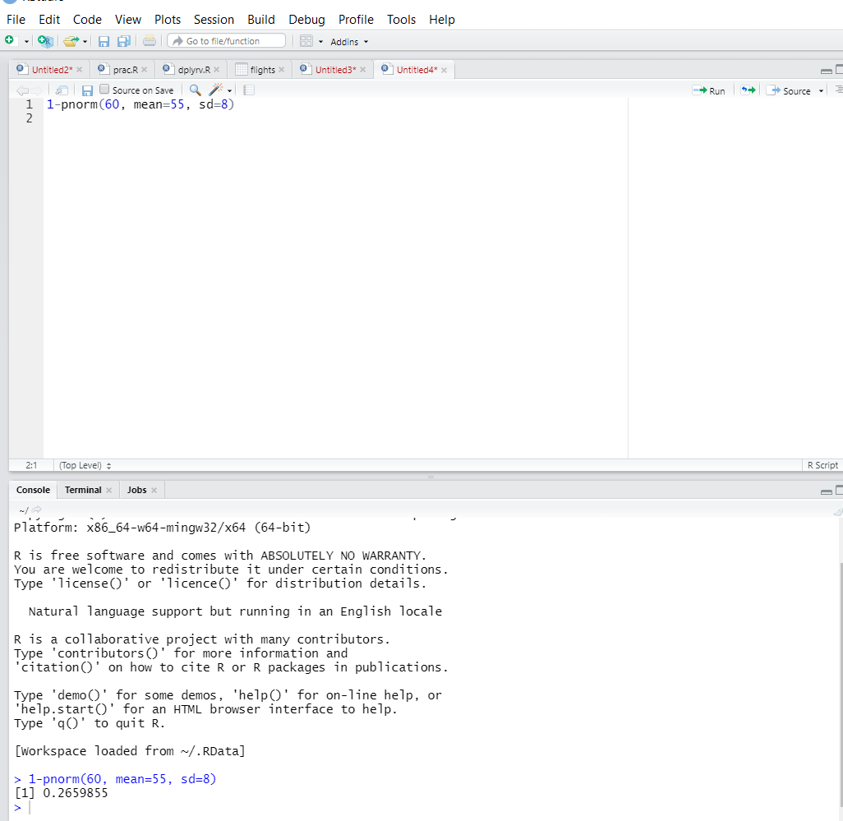

1. The current age (in years) of 400 clerical employees at an insurance claims processing center is normally distributed with mean *μ* = 38 and Standard deviation *σ* =6. For each statement below, please specify True/False. If false, briefly explain why.
2. More employees at the processing center are older than 44 than between 38 and 44.
3. A training program for employees under the age of 30 at the center would be expected to attract about 36 employees.

Ans : Mean = 38, SD = 6, Z score = (Value-Mean)/SD

Z Score for 44 = (44-38)/6 = 1 = 84.13%

= People above 44 age = 100 – 84.13 = 15.876%

= 63 out of 100

Z Score for 38 = (38 – 38)/6 = 0 = 84.13 – 50

Hence people between 38 & 44 age = 84.13 – 50 = 34.13% = 137 out of 400

Hence more employees at the processing center are older than 44 than between 38 and 44 . is FALSE.

Z Score for 30 = (30 – 38)/6 = -1.33 = 9.15% = 36 out of 400

Hence A training program for employees under the age of 30 at the center would be expected to attract about 36 employees. TRUE

1. If *X1* ~ *N*(μ, σ2) and *X*2 ~ *N*(μ, σ2) are *iid* normal random variables, then what is the difference between 2 *X*1 and *X*1 + *X*2? Discuss both their distributions and parameters.

Ans : The Normal distribution has 2 parameters, mean and varaiance.

Here X1 & X2 are independent varaibles.

X1 +X2 is normal with N (mu1+mu2, sigma1square=sigma2square). And 2X1 will just scale

The normal distributed by 2 times

1. Let X ~ N(100, 202). Find two values, *a* and *b*, symmetric about the mean, such that the probability of the random variable taking a value between them is 0.99.
2. 90.5, 105.9
3. 80.2, 119.8
4. 22, 78
5. 48.5, 151.5
6. 90.1, 109.9

Ans :Given : p(a<x<b) = 0.99, mean = 100, SD = 20

From the above data, we have excluded area of 0.005 in each of the left and right tails

Hence, we want to find the 0.5th and the 99.5th percentiles Z score values

Using python

Z value is given as stats.norm.ppf(pvalue)

Z value at 0.5th percentile is given as

Z(0.5) = stats.norm.ppf(0.005) = -2.576

Z value ata 99.5 percentile is given as

Z(99.5) = stats.norm.ppf(0.995) = 2.576

Z = (x-100)/20 => x = 20z+100

a = -(20*2.576) + 100 = 48.5

b = (20*2.576) + 100 = 151.5

Two values symmetric about mean for the given standard normal distribution are

[48.5,151.5]

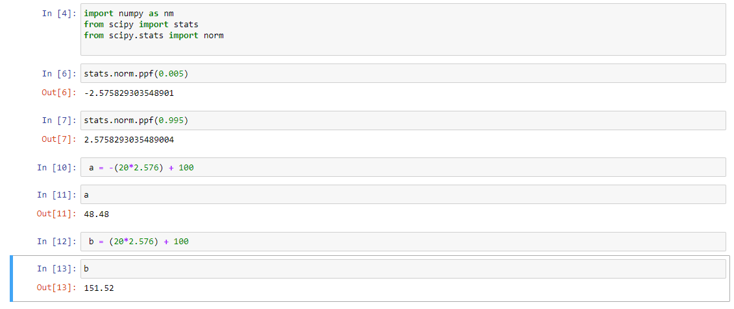

1. Consider a company that has two different divisions. The annual profits from the two divisions are independent and have distributions Profit1 ~ N(5, 32) and Profit2 ~ N(7, 42) respectively. Both the profits are in $ Million. Answer the following questions about the total profit of the company in Rupees. Assume that $1 = Rs. 45
2. Specify a Rupee range (centered on the mean) such that it contains 95% probability for the annual profit of the company.
3. Specify the 5th percentile of profit (in Rupees) for the company
4. Which of the two divisions has a larger probability of making a loss in a given year?