VISVESVARAYA TECHNOLOGICAL UNIVERSITY
“JNANA SANGAMA”, BELAGAVI-590018


A MINI PROJECT REPORT ON
RAILWAY BOOKING SYSTEM
Submitted in partial fulfillment of the requirements
For the award of degree of
Bachelor of Engineering
In
Computer Science and Engineering
By
PRAJWAL KULKARNI
(1KS19CS070)

Under guidance of
Mr. Kumar K
Asst. Prof, Dept. Of CSE
Dr. Dayananda R B
Prof, Dept. Of CSE

K.S.INSTITUTE OF TECHNOLOGY
#14, Raghuvanahalli, Kanakapura Main Road, Bengaluru-560109



CERTIFICATE

This is to certify that mini project work entitled “RAILWAY BOOKING SYSTEM” carried out by Mr. PRAJWAL KULKARNI bearing USN 1KS19CS070 bonafide student of K.S. Institute of Technology in the partial fulfilment for the award of the Bachelor of Engineering in Computer Science & Engineering of the Visvesvaraya Technological University, Belagavi, during the year 2021-22. It is certified that all corrections/suggestions indicated for Internal Assessment have been incorporated in the report deposited in the departmental library. The mini project report has been approved as it satisfies the academic requirements in respect of Mini Project work prescribed for the said degree for the 5th semester.

Dr. Rekha. B. Venkatapur
Prof & HOD, CS & E Department
Dr. Dilip Kumar
Principal/Director, KSIT

Name of the Examiner
Signature with date
1.
2.
I

ACKNOWLEDGEMENT

I take this opportunity to thank one and all involved in building this project. Firstly I would like to thank the college for providing us an opportunity to work on the project.

I would also like to thank the management of K. S. Institute of Technology for providing all the resources required for the project.

I wish to acknowledge my sincere gratitude to our beloved Principal, Dr. Dilip Kumar for his encouragement and providing all facilities for the accomplishment of this project.

This project would not have been possible without the support of our beloved Prof & HOD, Dr. Rekha.B.Venkatapur, Dept. of CSE.

I am also highly grateful to my project guides, Mr. Kumar K and Dr. Dayananda R B, Dept. of CSE who have been very generous in assisting and supporting, to do this Project “RAILWAY BOOKING SYSTEM”.

I also would like to thank all other teaching and non-teaching staff members who have extended their support and co-operation while bringing up this project

PRAJWAL KULKARNI
(1KS19CS070)

II

ABSTRACT

“RAILWAY BOOKING SYSTEM” is a simple web application used to book train tickets, it has a simple and extremely user friendly UI, where users can book tickets, view their existing tickets, view all train information, etc. Once a ticket is booked users will also receive an email with their ticket attached to it. Users can also cancel any ticket at any time.

III

CONTENTS

1. INTRODUCTION  - Overview  - Problem Statement  - Database Management System  - SQL  - HTML/CSS  - Flask | 1 – 3  1  1  1  2  2  3
2. REQUIREMENTS SPECIFICATION  - Software Requirements  - Hardware Requirements | 4  4  4
3. DETAILED DESIGN  - System Design  - Entity Relationship Diagram  - Relational Schema | 5 – 8  5  5  7
4. IMPLEMENTATION  - Module and their Roles | 9 - 10  9

IV

5. TESTING  - Software Testing  - Module Testing and Integration | 11  11  11
6. SNAPSHOTS  - Sign-in  - Sign-up  - Home  - All Trains Info  - View Tickets  - Book Ticket  - Available Trains  - Add Passengers  - Payment  - Mail  - Ticket PDF | 12 – 17  12  12  13  13  14  14  15  15  16  16  17
7. CONCLUSION | 18
8. REFERENCES | 19

V
RAILWAY BOOKING SYSTEM

CHAPTER 1
INTRODUCTION
Overview:
“RAILWAY BOOKING SYSTEM” is a simple web application used to book train tickets, it has a simple and extremely user friendly UI, where users can book tickets, view their existing tickets, view all train information, etc. Once a ticket is booked users will also receive an email with their ticket attached to it. Users can also cancel any ticket at any time.

Problem Statement:
The main aim of this web app is to simplify the train booking experience. Without any complicated procedures.

Database Management System:
A database management system (DBMS) is system software for creating and managing databases. The DBMS provides users and programmers with a systematic way to create, retrieve, update and manage data. The DBMS essentially serves as an interface between the database and end users application programs, ensuring that data is consistently organized and remains easily accessible.

Dept. of CSE, KSIT | 2021 - 2022 | 1
RAILWAY BOOKING SYSTEM

The DBMS manages three important things: the data, the database engine that allows data to be accessed, locked and modified, and the database schema, which defines the database’s logical structure. These three foundational elements help to provide concurrency, security, data integrity and uniform administration procedures. Typical database administration tasks supported by the DBMS include change management, performance monitoring/tuning and backup and recovery. Many database management systems are also responsible for automated rollbacks, restarts and recovery as well as the logging and auditing of activity.

SQL:
SQL is a standard language for storing, manipulating and retrieving data in databases.
Originally based upon relational algebra and tuple relational calculus, SQL consists of a data definition language, data manipulation language, and data control language. The scope of SQL includes data insert, query, update and delete, schema creation and modification, and data access control.
SQL became a standard of the American National Standards Institute (ANSI) in 1986, and of the International Organization for Standardization (ISO) in 1987. Since then, the standard has been revised to include a larger set of features. Despite the existence of such standards, most SQL code is not completely portable among different database systems without adjustments.

HTML:
HTML is a markup language used for structuring and presenting content on the web and the fifth and current major version of the HTML standard.

Dept. of CSE, KSIT | 2021 - 2022 | 2
RAILWAY BOOKING SYSTEM

HTML5 includes detailed processing models to encourage more interoperable implementations, it extends, improves and rationalizes the markup available for documents, and introduces markup and application programming interfaces (APIs) for complex web applications.

CSS:
Cascading Style Sheets (CSS) is a style sheet language used for describing the presentation of a document written in a language such as HTML, CSS is a cornerstone technology of the World Wide Web alongside HTML and JavaScript.

Flask:
To connect the database to the front-end we use Flask, a Python web framework which also acts as back-end in this project.
Flask is a micro web framework written in Python. It is classified as a micro-framework because it does not require particular tools or libraries. It has no database abstraction layer, form validation, or any other components where pre-existing third-party libraries provide common functions. However, Flask supports extensions that can add application features as if they were implemented in Flask itself. Extensions exist for object-relational mappers, form validation, upload handling, various open authentication technologies and several common framework related tools.

Dept. of CSE, KSIT | 2021 - 2022 | 3
RAILWAY BOOKING SYSTEM

CHAPTER 2

REQUIREMENTS SPECIFICATION
A computerized way of handling information about property and users details is efficient, organized and time saving, compared to a manual way of doing so. This is done through a database driven web application whose requirements are mentioned in this section.

Software Requirements:
- Database Requirements -
  - MySQL Server
  - MySQL Shell
  - MySQL workbench
- HTML and CSS
- Flask
- mysql-connector-python
- Operating System – Windows / Ubutu
- Python
- Server Deployment – Local Server

Hardware Requirements:
- RAM – 2GB or above
- Processor – Pentium IV or above
- Hard disk – 3 GB or more

Dept. of CSE, KSIT | 2021 - 2022 | 4
RAILWAY BOOKING SYSTEM

CHAPTER 3

DETAILED DESIGN
System Design:
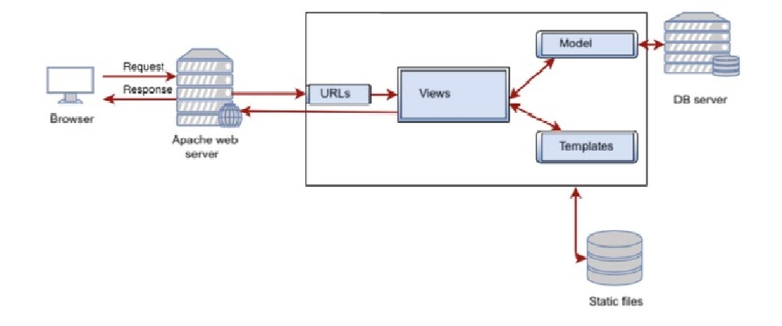
Three-tier Client / Server database architecture is commonly used architecture for web applications. Intermediate layer called Application server or Web Server stores the web connectivity software and the business logic (constraints) part of application used to access the right amount of data from the database server. This layer acts like medium for sending partially processed data between the database server and the client. Database architecture focuses on the design, development, implementation and maintenance of computer programs that store and organize information for businesses, agencies and institutions.

Entity Relationship Diagram:
An entity–relationship model is usually the result of systematic analysis to define and describe what is important to processes in an area of a business.
An E-R model does not define the business processes; it only presents a business data schema in graphical form. It is usually drawn in a graphical form as boxes (entities) that are connected by lines (relationships) which express the associations and dependencies between entities.

Dept. of CSE, KSIT | 2021 - 2022 | 5
RAILWAY BOOKING SYSTEM

An ER model is typically implemented as a database. In a simple relational database implementation, each row of a table represents one instance of an entity type, and each field in a table represents an attribute type. In a relational database a relationship between entities is implemented by storing the primary key of one entity as a pointer or “foreign key” in the table of another entity.

There is a tradition for ER/data models to be built at two or three levels of abstraction. Note that the conceptual-logical-physical hierarchy below is used in other kinds of specification, and is different from the three schema approach to software engineering.

The below figure is the enhanced ER diagram of railway booking system:
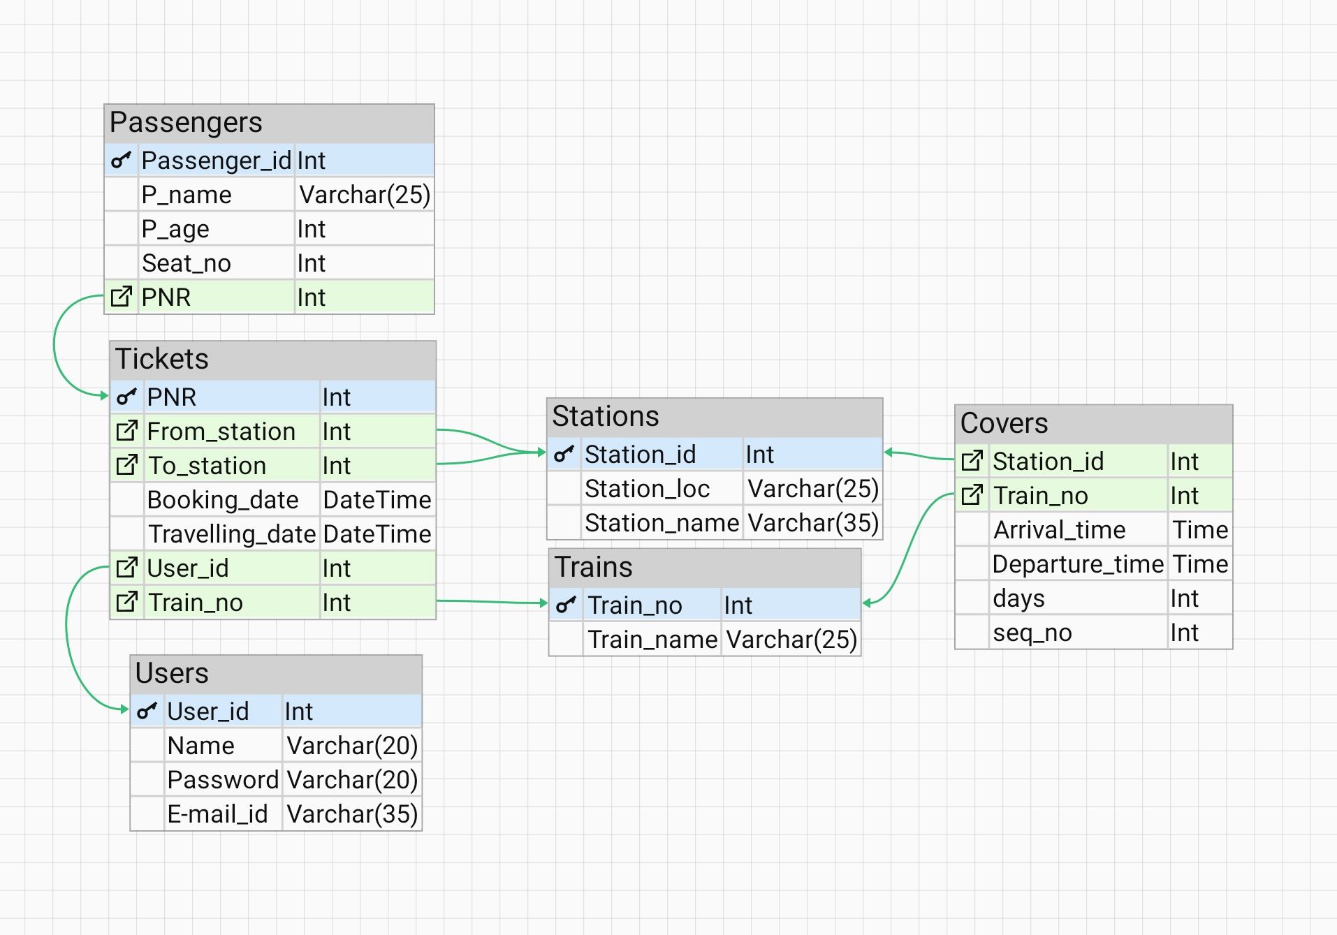

Dept. of CSE, KSIT | 2021 – 2022 | 6
RAILWAY BOOKING SYSTEM

The below figure is the ER diagram of railway booking system:

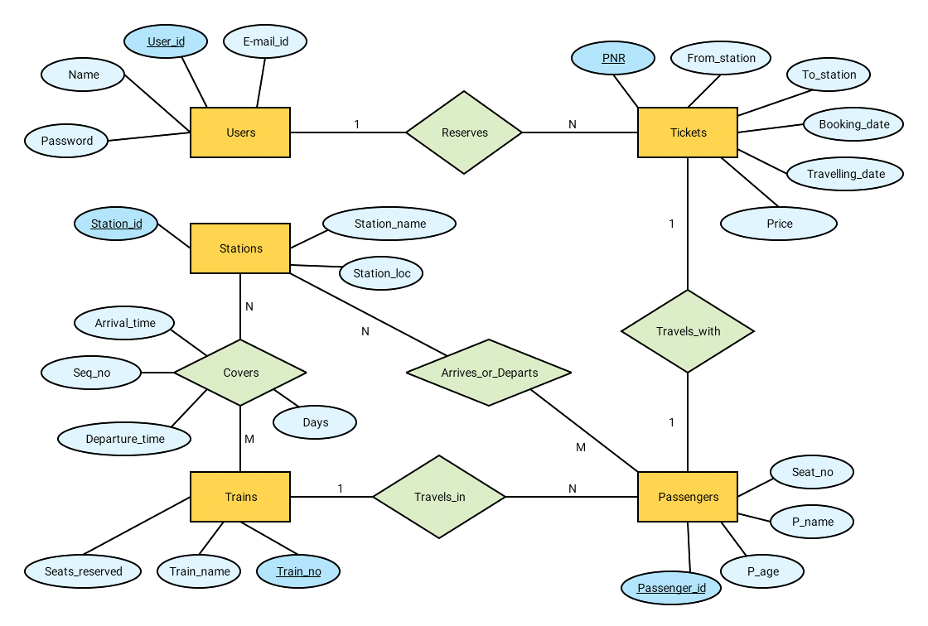
Relational Schema:
The term "schema" refers to the organization of data as a blueprint of how the database is constructed. The formal definition of a database schema is a set of formulas called integrity constraints imposed on a database. A relational schema shows references among fields in the database. When a primary key is referenced in another table in the database, it is called a foreign key. This is denoted by an arrow with the head pointing at the referenced key attribute. A schema diagram helps organize values in the database. The following diagram shows the schema diagram for the database.

Dept. of CSE, KSIT | 2021 - 2022 | 7
RAILWAY BOOKING SYSTEM

USERS:
user_id | Name | Password | E-mail_id

TRAINS:
Train_no | Train_name

STATIONS:
Station_id | Station_location | Station_name

COVERS:
Station_id | Train_no | Arrival_time | Departure_time | Days | Seq_no

TICKETS:
PNR | From | To | Booking_date | Travel_date | User_id | Train_no

PASSENGERS:
Passenger_id | Passenger_name | Passenger_age | Seat_no | PNR

Dept. of CSE, KSIT | 2021 - 2022 | 8
RAILWAY BOOKING SYSTEM

CHAPTER 4

IMPLEMENTATION

Module and their Roles:

Login:
The user will be able to login with his username and password to login into his account. Once he’s logged in he’ll be viewing the home page, which contains links to book ticket, view tickets and view all train information.

Sign-up:
The user can register his/her account by providing an username, password and E-mail ID, once registered he can head back to login page to login into his account.

Home:
The user when login into his/her account, he’ll be viewing the home page which contains links to book ticket, view tickets, view all train information and navigation which also contains all these links along with sign-out option.

All trains info:
Here user will be able to view all train details, like, train number, train name, all the stations it covers, the arrival and departure time at each station.

Dept. of CSE, KSIT | 2021 - 2022 | 9
RAILWAY BOOKING SYSTEM

View Tickets:
When user enters this page, he/she can see all the tickets he/she has booked so far, it contains all the information about the travel. The user can also cancel the ticket if wants to.

Book Ticket:
When user enters this page, he/she can book a new ticket, it contains a form, with source, destination and travel date as fields. Then by clicking submit it will take to next step.

Available Trains:
When user enters this page, he/she can view all the trains for given source and destination, with it’s arrival, departure and reaching time, he/she can select any one train among all the available ones.

Add Passengers:
When user is done selecting the train, user can add passengers, with maximum of 6 passengers per ticket and at least 1 passenger. It will be asking passenger’s name and age.

Payment:
After adding the passengers, user can make the payment either in form of Debit/Credit card or UPI. In Debit/Credit card payment, user will be fill prompted to enter card details and in UPI user will be asked to enter VPA (Virtual Payment Address) or user can also scan the QR code to make the payment.

Mail:
Once payment is done, ticket will be booked, and a confrontational mail will be sent to E-mail ID provided. The mail will be attached with the PDF format of the ticket.

Dept. of CSE, KSIT | 2021 - 2022 | 10
RAILWAY BOOKING SYSTEM

CHAPTER 5

TESTING

Software Testing
Testing is the process used to help identify correctness, completeness, security and quality of developed software. This includes executing a program with the intent of finding errors. It is important to distinguish between faults and failures. Software testing can provide objective, independent information about the quality of software and risk of its failure to users or sponsors. It can be conducted as soon as executable software (even if partially complete) exists.

Module Testing and Integration
Module testing is a process of testing the individual subprograms, subroutines, classes, or procedures in a program. Instead of testing whole software program at once, module testing recommend testing the smaller building blocks of the program. It is largely white box oriented. The objective of doing Module testing is not to demonstrate proper functioning of the module but to demonstrate the presence of an error in the module. Module testing allows implementing of parallelism into the testing process by giving the opportunity to test multiple modules simultaneously. The final integrated system too has been tested for various test cases such as duplicate entries and type mismatch.

Dept. of CSE, KSIT | 2021 - 2022 | 11
RAILWAY BOOKING SYSTEM

CHAPTER 6

SNAPSHOTS

Sign-in:
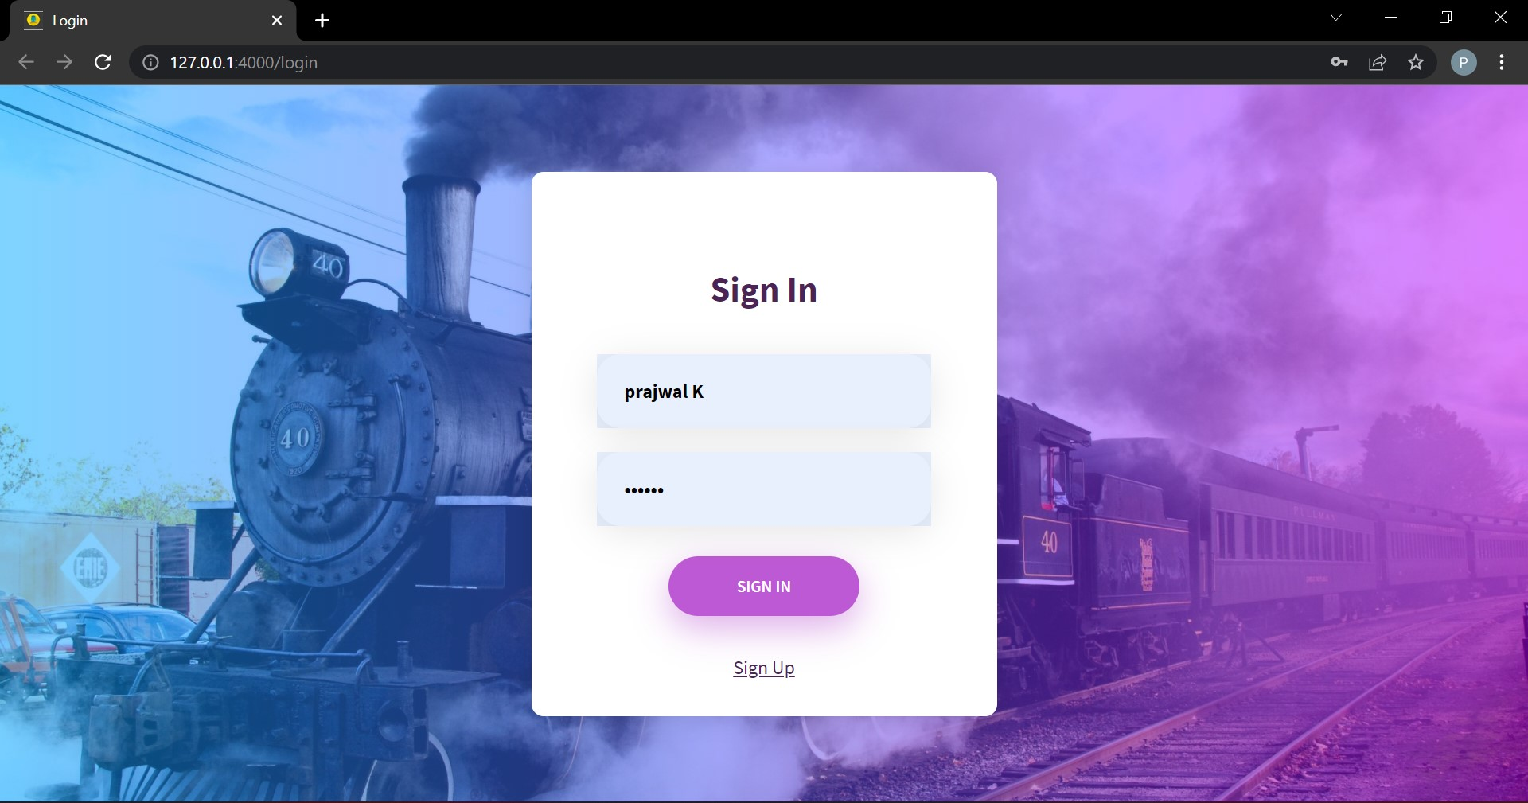
Sign-up:
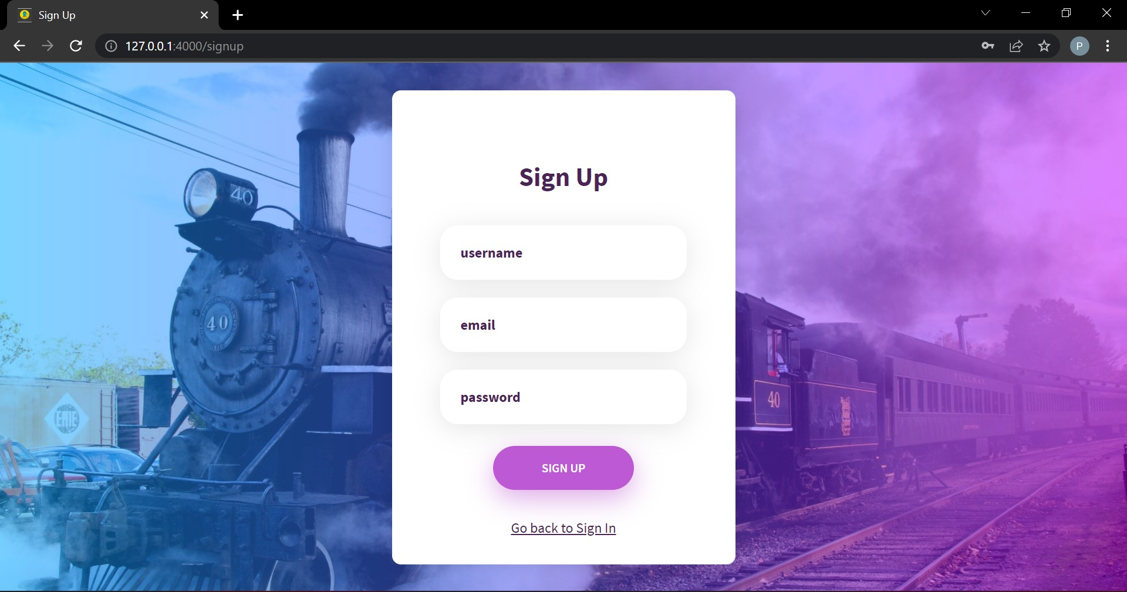
Dept. of CSE, KSIT | 2021 - 2022 | 12
RAILWAY BOOKING SYSTEM

Home:
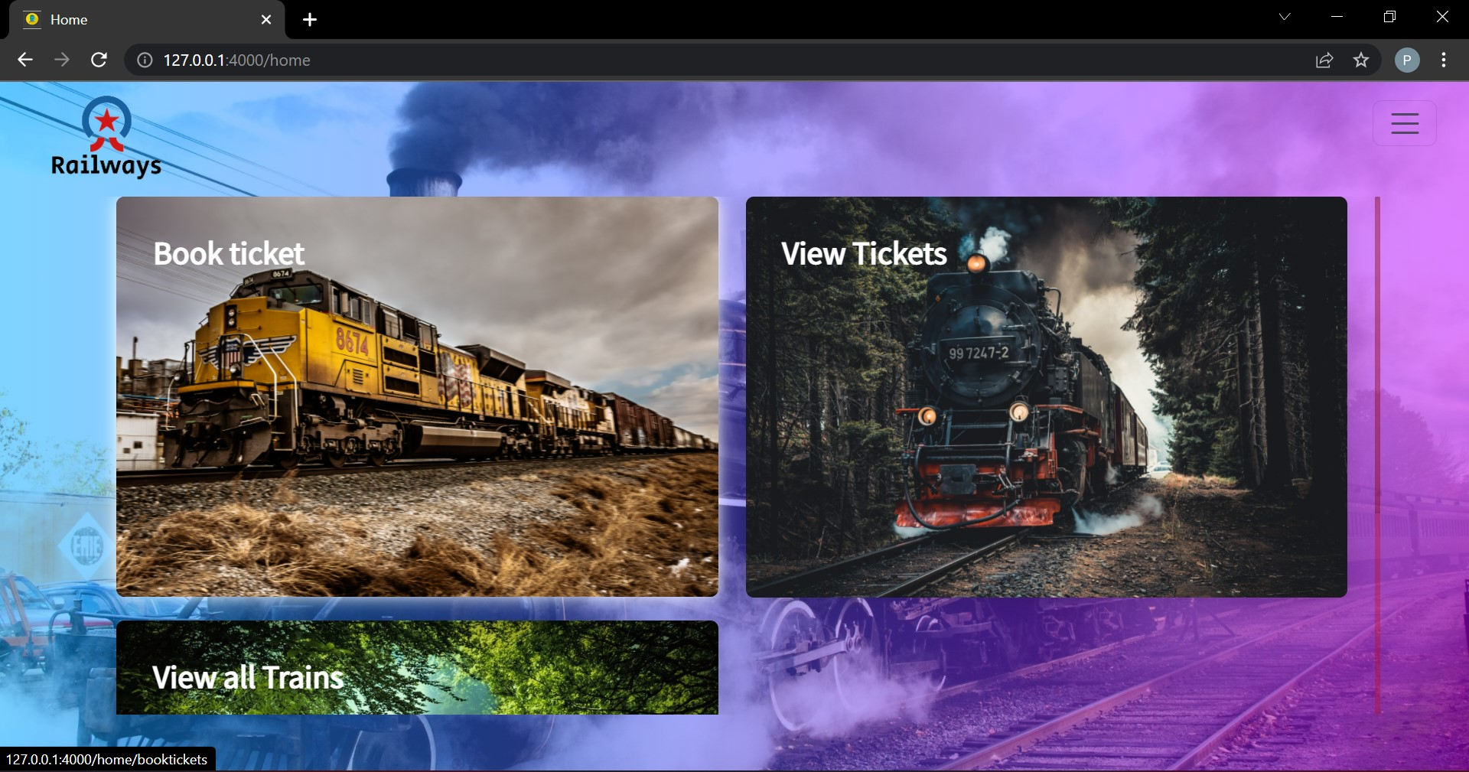
All Train Info:
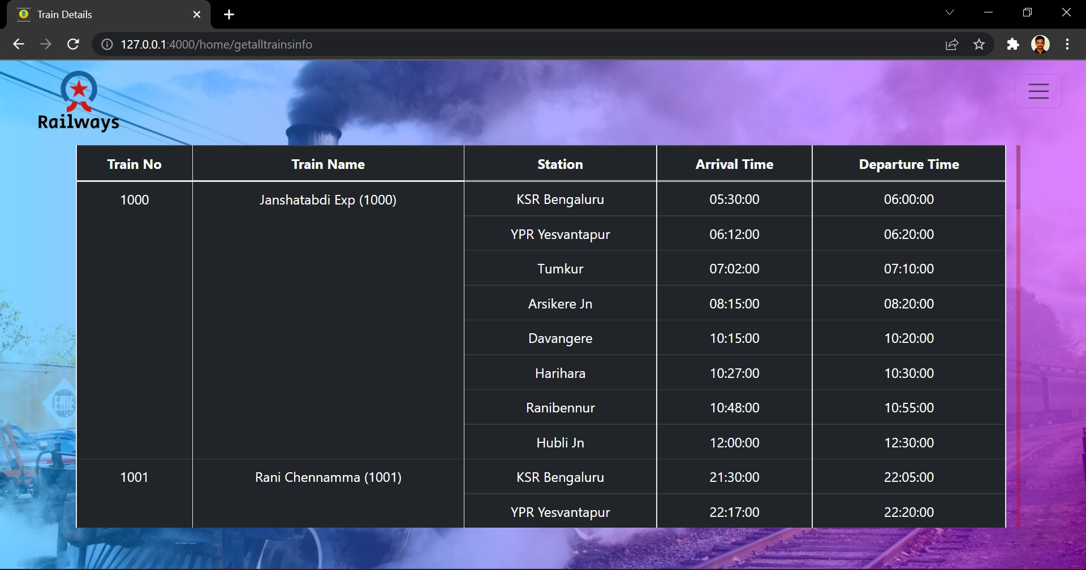

Dept. of CSE, KSIT | 2021 - 2022 | 13
RAILWAY BOOKING SYSTEM

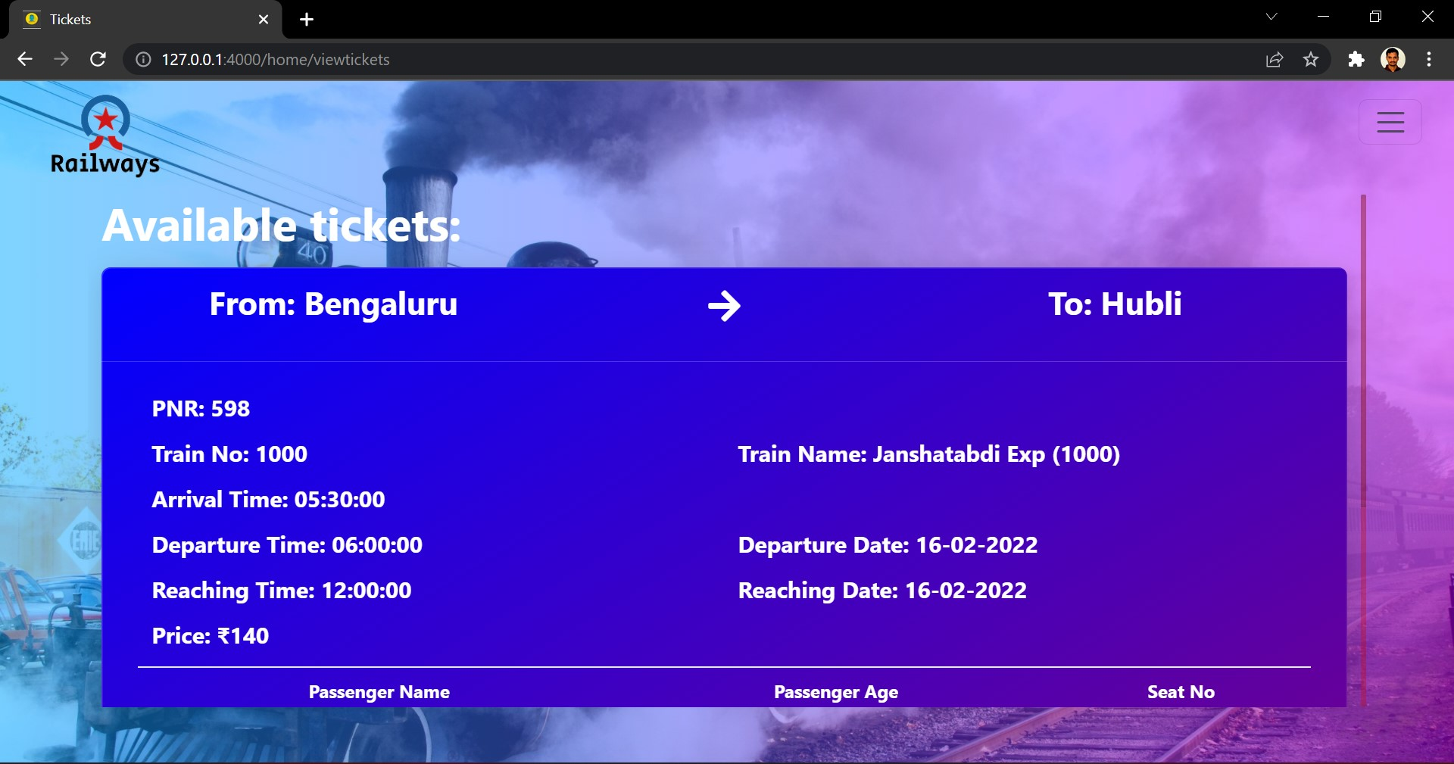
View Tickets:

Book Ticket:
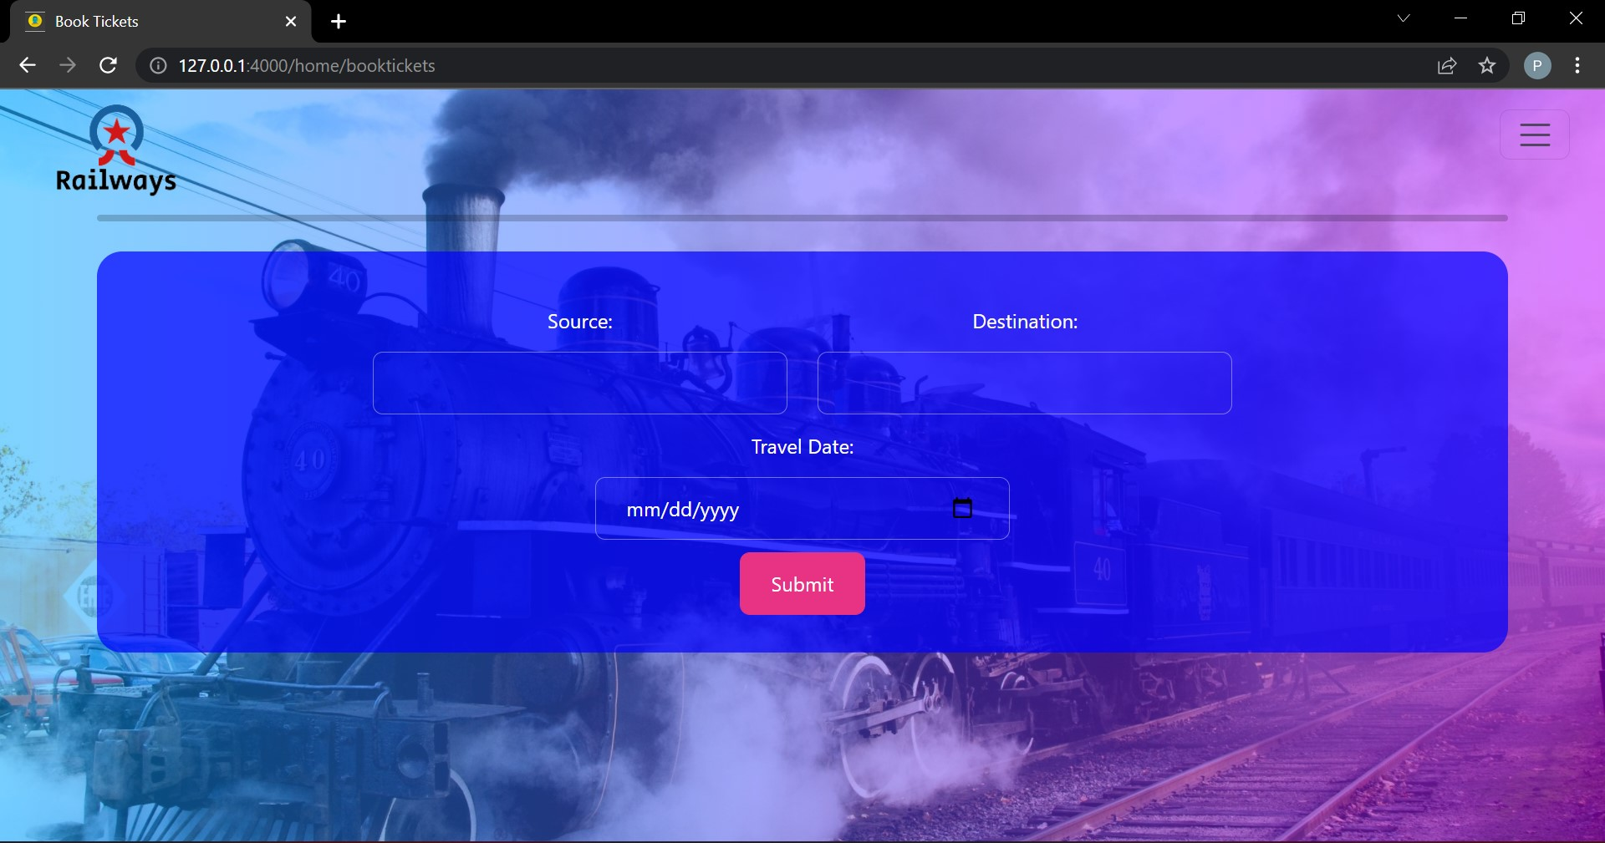

Dept. of CSE, KSIT | 2021 - 2022 | 14
RAILWAY BOOKING SYSTEM

Available Trains:
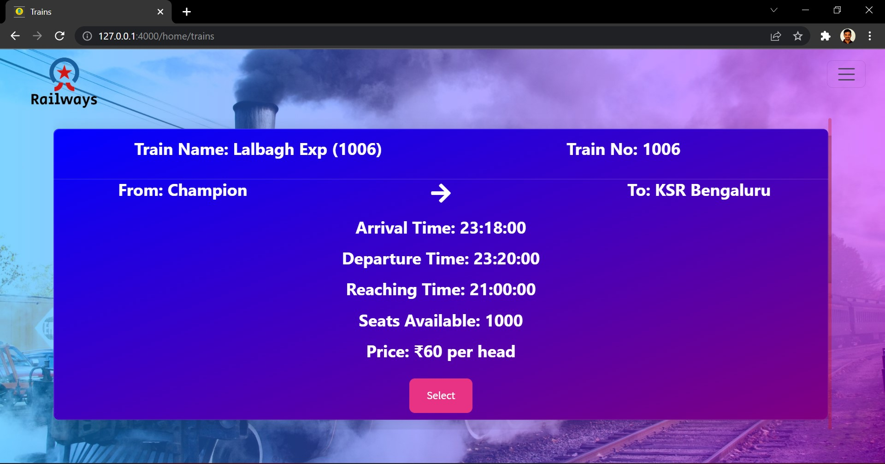
Add Passengers:
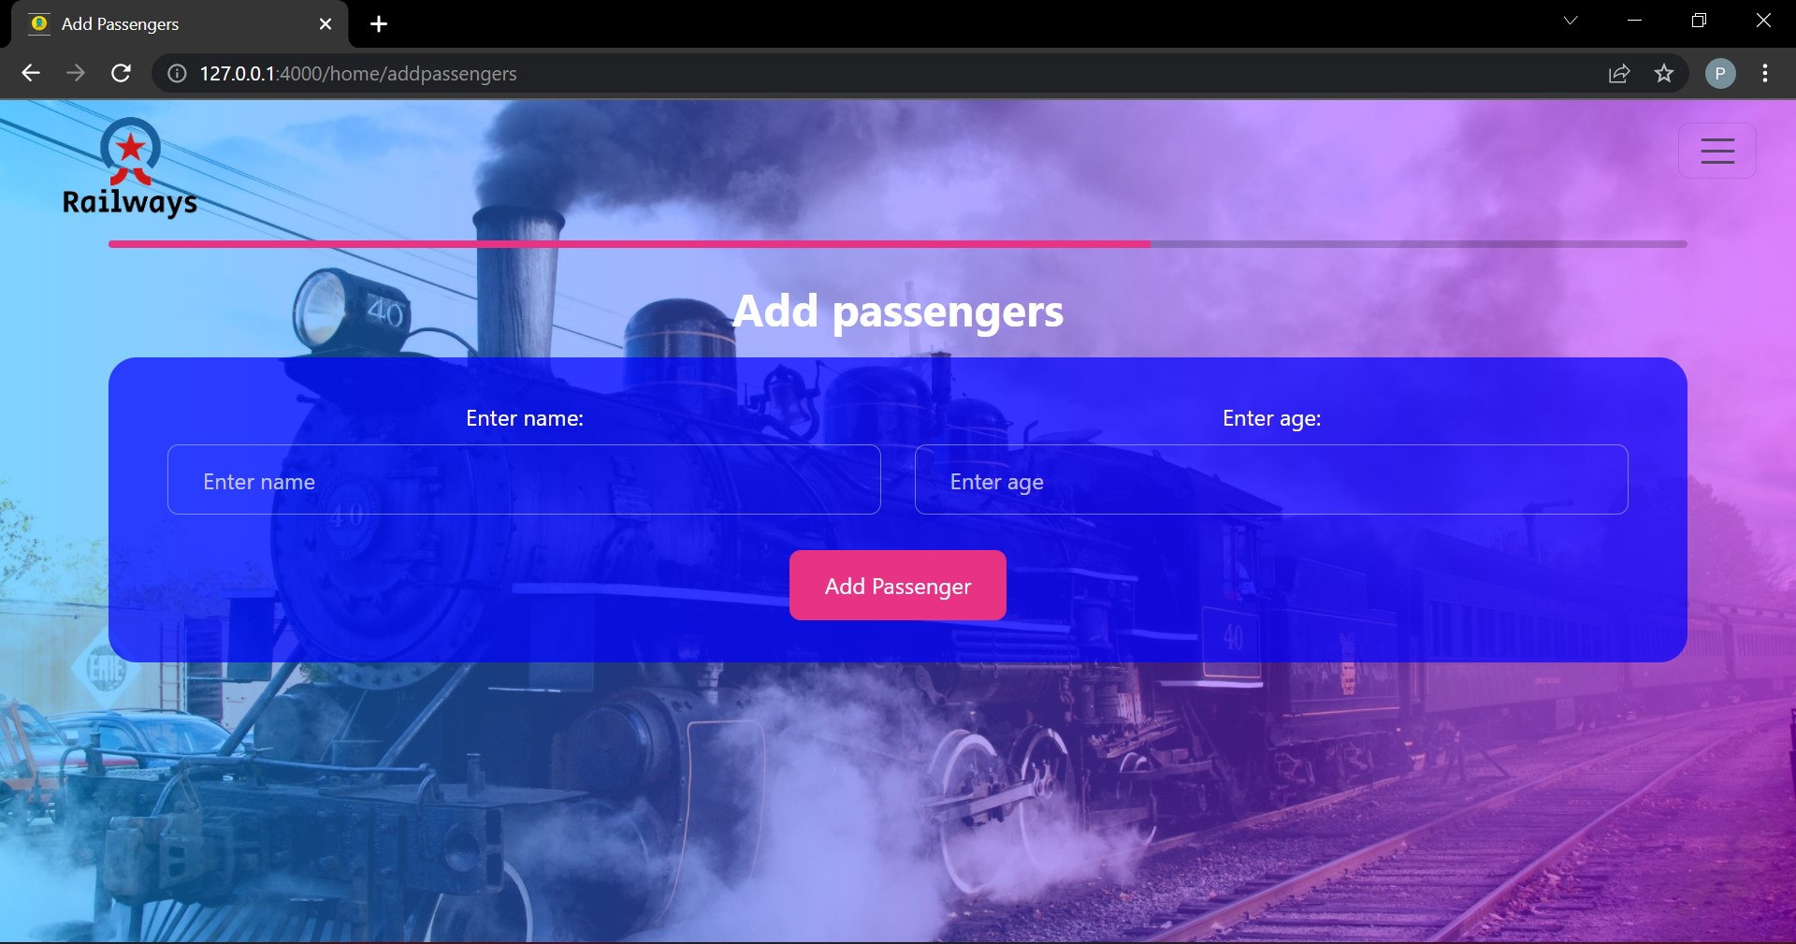
Dept. of CSE, KSIT | 2021 - 2022 | 15
RAILWAY BOOKING SYSTEM

Payment:
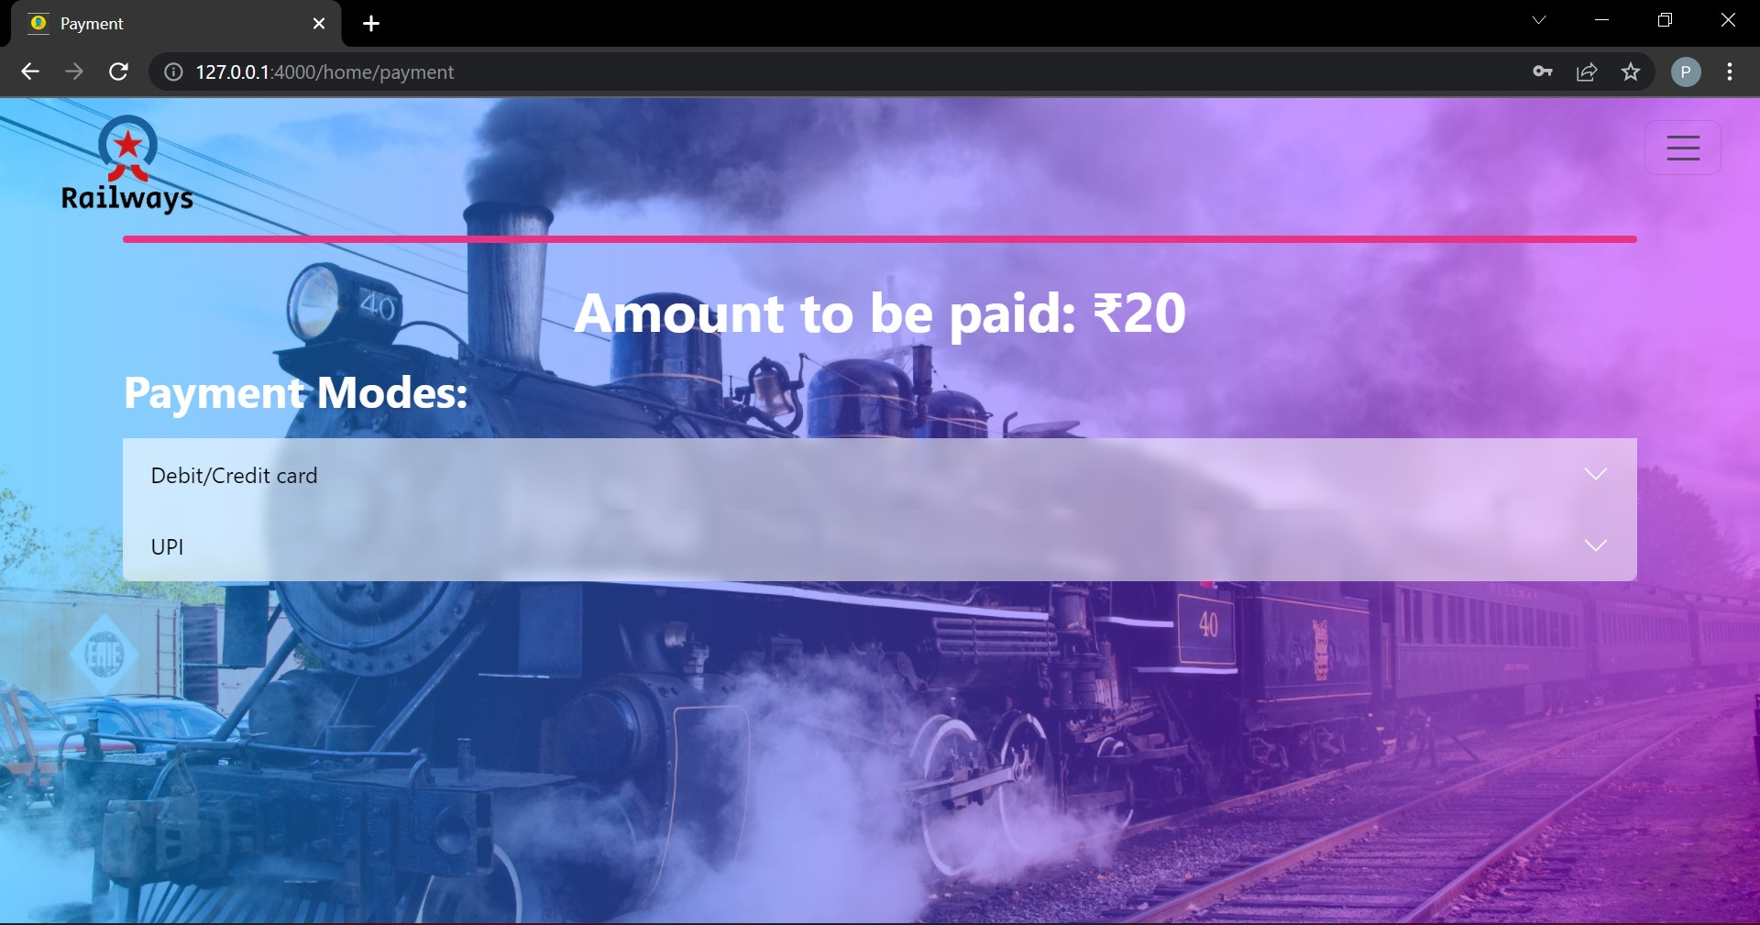
Mail:
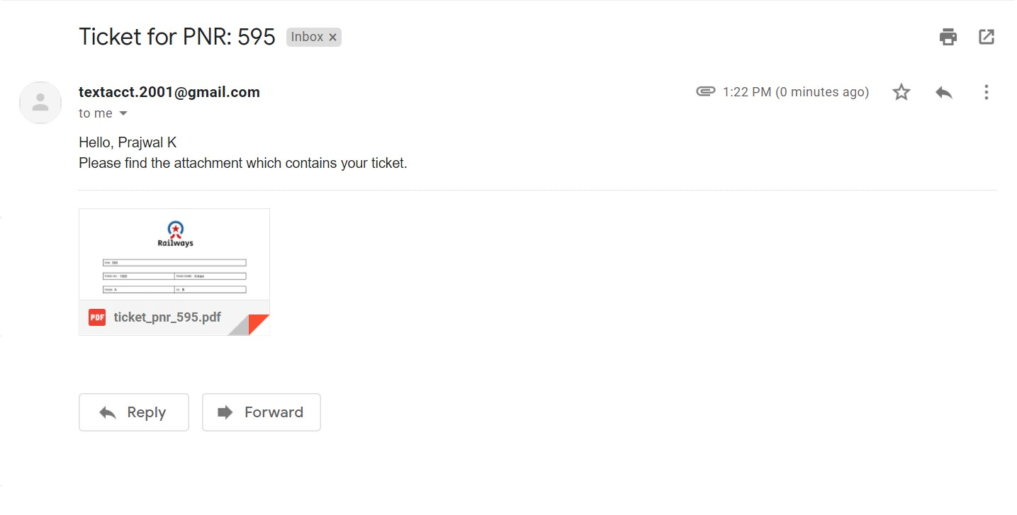

Dept. of CSE, KSIT | 2021 - 2022 | 16
RAILWAY BOOKING SYSTEM

Ticket PDF:
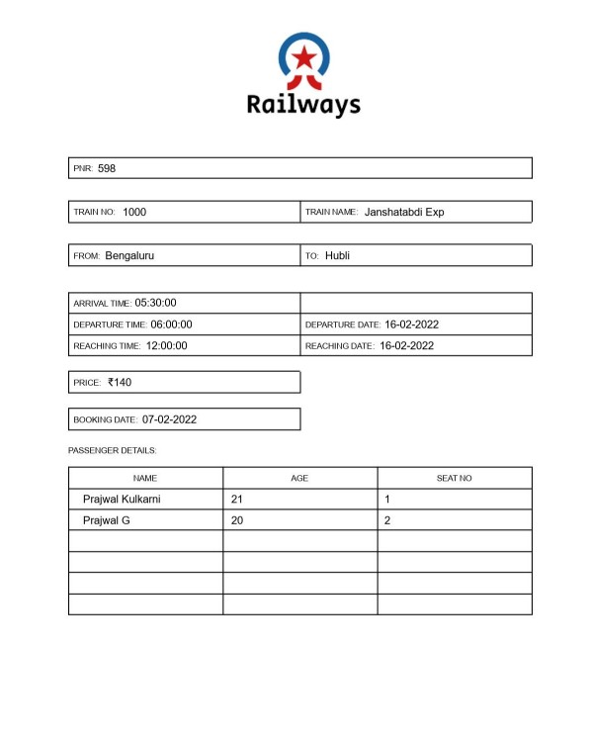

Dept. of CSE, KSIT | 2021 - 2022 | 17
RAILWAY BOOKING SYSTEM

CHAPTER 7

CONCLUSION

The railway booking system provides a easy and clean website to manage booking, viewing and canceling tickets. It allows simplified ways to control database. And also the ability to view the data that is being added and modified. It is also very secure as the password will be encrypted.

This project was developed using HTML5, CSS, Flask and MySQL.

The goals achieved by this project are:
- Centralized database
- Easier adding, modifying and deleting of data.
- Efficient management of tickets.
- Ability to securely manage data in one place.

Dept. of CSE, KSIT | 2021 - 2022 | 18
RAILWAY BOOKING SYSTEM

CHAPTER 8

REFERENCES

- Ramakrishnan, R., & Gehrke, J. (2011). Database Management systems. Boston: McGraw-Hill.
- Database systems concepts. Estados Unidos: McGraw-Hill Companies, Inc.

Flask Web Development: Developing Web Applications with Python 2nd Edition
- https://www.w3schools.com
- https://www.geeksforgeeks.com

Dept. of CSE, KSIT | 2021 - 2022 | 19

