VISVESVARAYA TECHNOLOGICAL UNIVERSITY
“JNANA SANGAMA”, BELAGAVI-590018
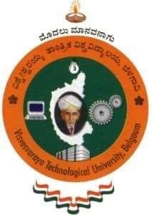
A MINI PROJECT REPORT ON
RAILWAY BOOKING SYSTEM
Submitted in partial fulfillment of the requirements
For the award of degree of
Bachelor of Engineering
In
Computer Science and Engineering
By
PRAJWAL G
[1KS19CS069]

Under guidance of
Mr. KUMAR K
Asst. Prof, Dept. Of CSE

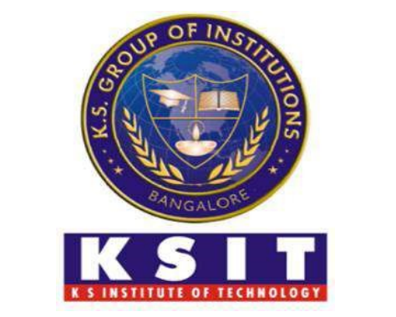
Department of Computer Science & Engineering
K.S.INSTITUTE OF TECHNOLOGY
#14, Raghuvanahalli, Kanakapura Main Road, Bengaluru-560109
2021-22

K.S.INSTITUTE OF TECHNOLOGY
#14, Raghuvanahalli, Kanakapura Main Road, Bengaluru-560109

Department of Computer Science & Engineering
CERTIFICATE

This is to certify that mini project work entitled “RAILWAY BOOKING SYSTEM” carried out by Mr. PRAJWAL G bearing USN 1KS19CS069 bonafide student of K.S. Institute of Technology in the partial fulfilment for the award of the Bachelor of Engineering in Computer Science & Engineering of the Visvesvaraya Technological University, Belagavi, during the year 2021-22. It is certified that all corrections/suggestions indicated for Internal Assessment have been incorporated in the report deposited in the departmental library. The mini project report has been approved as it satisfies the academic requirements in respect of Mini Project work prescribed for the said degree for the 5th semester.

Dr. Rekha B. Venkatapur  Prof & HOD, CS & E Department | Dr. Dilip Kumar  Principal/Director, KSIT

Mr. Kumar K
Asst. Prof, Dept. Of CSE

Name of the Examiner | Signature with Date
1.
2.

