AIM1 Unit Test QB
- PEAS representation for an Agent (Unit-1)
- Confusion Matrix, Precision, Recall Bias and Variance, overfitting, underfitting
- A* Algorithm
- Bayesian Belief Network
- Activation functions Unit=3
- Informed and Uninformed search algorithms (Unit-2)
- resolution in propositional logic with example. (Unit-1)
- Intelligent Agent Architecture (Unit-1)
- First Order Predicate Logic? example. (Unit-1)
- Hill Climbing algorithm (Unit-2)
- Best-First Search (Unit-2)
- Perceptron algorithm, Adaline Algorithm (Sums)
- SVM

Unit=1

- Agent’s Classification (Architecture of intelligent agents) (Unit-1)
- Simple reflex agent
- Model based reflex agents
- Goal based agents
- Utility based agents
- Learning agents

- PEAS representation for an agent (Unit-1)
- Performance measure
- Environment
- Actuator
- Sensor

- First Order Predicate Logic? example. (Unit-1)
  - Objects
  - Relation
  - Function

- Application Of AI
- Gaming
- Natural language processing
- Expert system
- Vision system
- Speech recognition
- Handwriting Recognition
- Intelligent robots

- resolution in propositional logic with example. (Unit-1)
- Atomic Propositions
- Compound Proposition
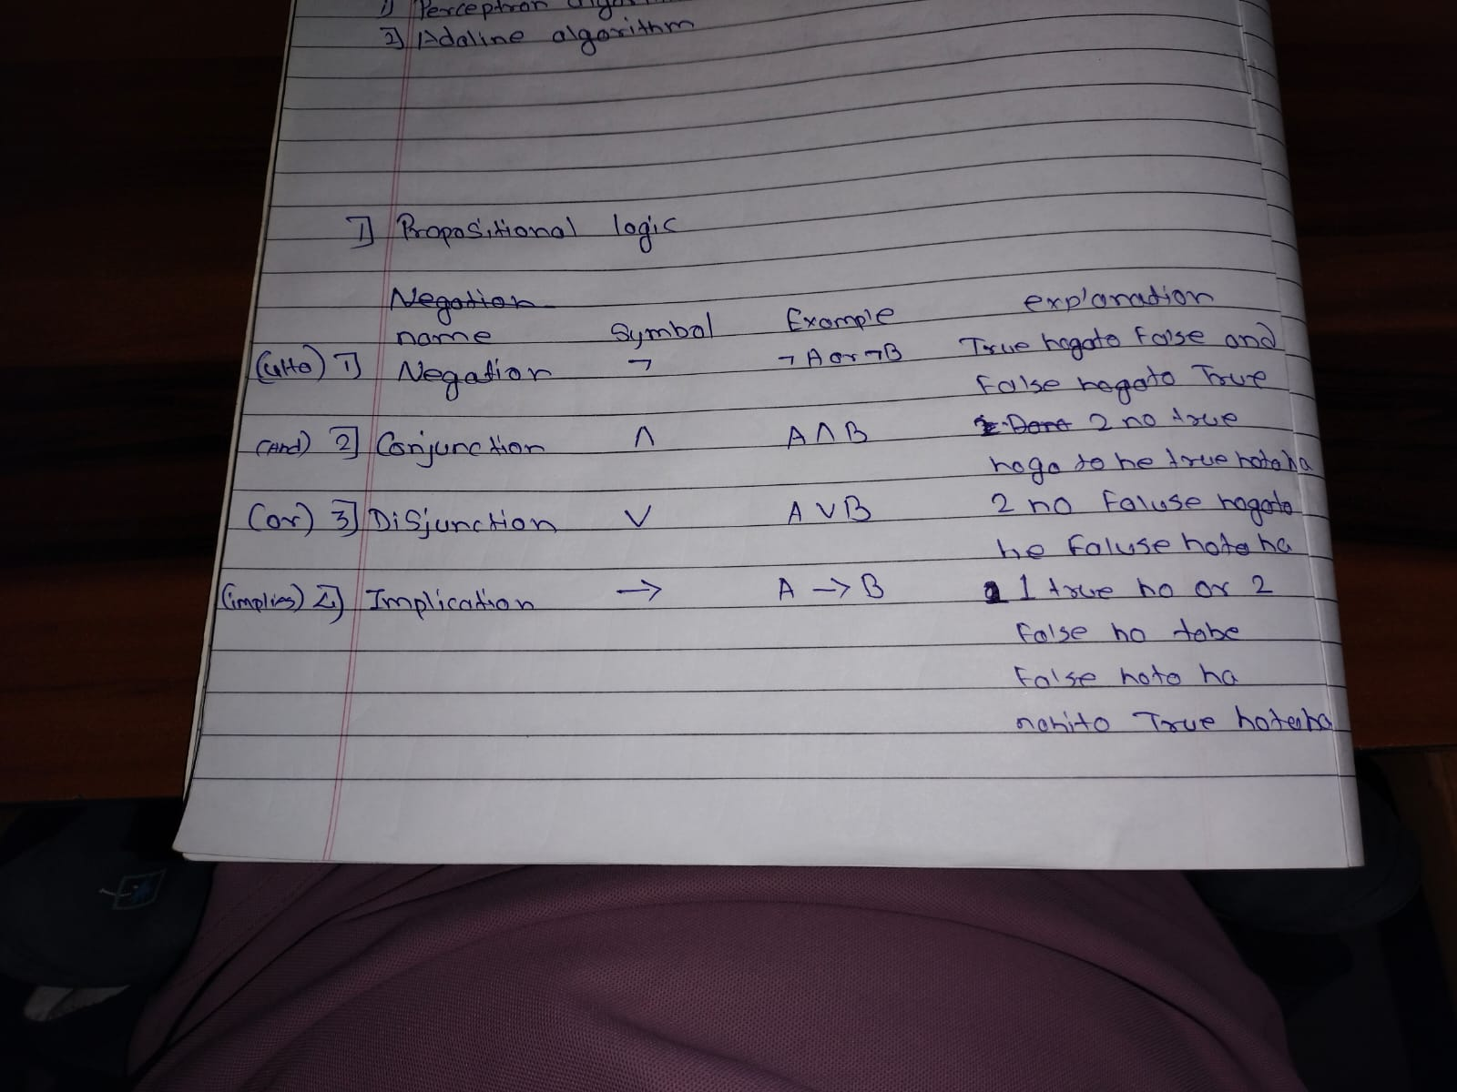

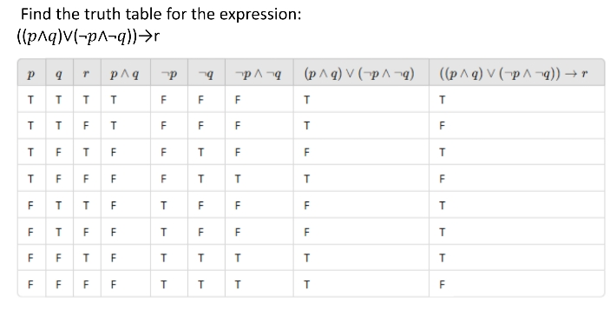

- Different task domains of AI
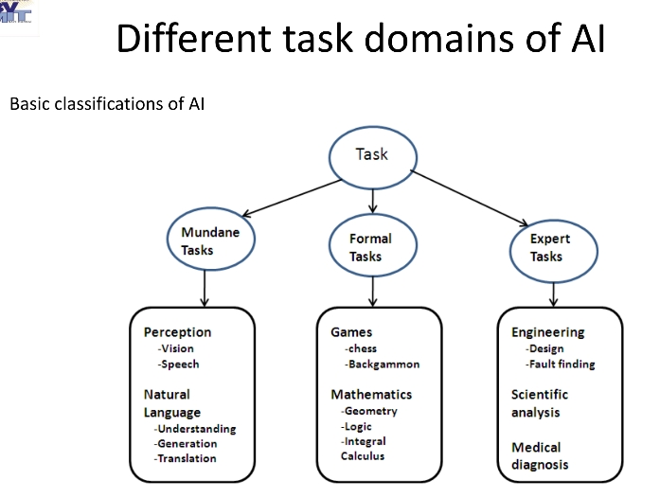

- Desirable properties of an agent
- Autonomy
- Reactivity
- Proactivity
- Ability to set goals
- Persistence

- Agent terminology
- Performance measure of agent
- Behavior of Agent
- Percept
- Percept Sequence
- Agent Function

Unit=3

- Activation Functions
- Identify function
- Binary step function
- Bipolar step function
- Binary Sigmoidal function
- Bipolar sigmoidal function
- Ramp function

- Types of gradient descent
- Batch gradient descent
- Stochastic gradient descent
- Mini-batch gradient descent

- Multi-layer artificial neural net
- Input
- Input vector
- Input Layer
- Hidden layer

- Supervised learning network
- Perceptron networks
- Single Layer Perceptron Networks
- Multi-Layer Perceptron Networks
- Adaline linear network

Unit -4
- Basic steps using in machine learning
- Collection date
- Training a model
- Evaluating the model
- Improving the performance

- Type of machine learning algorithms
- Supervisd
- Unsupervised
- Reinforcement

- Cross validation
- Leave-one-out Cross validation
- K-Fold Cross validation
- Stratified Cross validation
- Time series Cross validation

Unit -2

- Hill Climbing Algorithms

Hill climbing follows these steps:
  - Initial State: Start with any random solution.
(Shuruaat kisi bhi random answer se karo.)
  - Neighboring States: Make small changes in the current solution to create new solutions.
(Current answer me chote changes karo.)
  - Move to Neighbor: If the new solution is better, move to that solution.
(Agar naya answer better hai to usko choose karo.)
  - Termination: Keep repeating until no better solution is found.
(Jab aur better answer na mile, process stop ho jata hai.)

Types of Hill Climbing in Artificial Intelligence
  - Simple Hill Climbing Algorithm
  - Steepest-Ascent Hill Climbing
  - Stochastic Hill Climbing

Hill climbing algorithm simple example
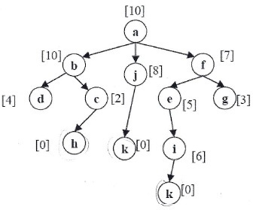

- BFS (Breadth First Search)
BFS is a searching algorithm used to visit nodes level by level.

Simple Points
- Start from the first node.
- Visit all nearby nodes first.
- Then visit the next level nodes.
- BFS uses a Queue (FIFO).
- It is used to find the shortest path in graphs.

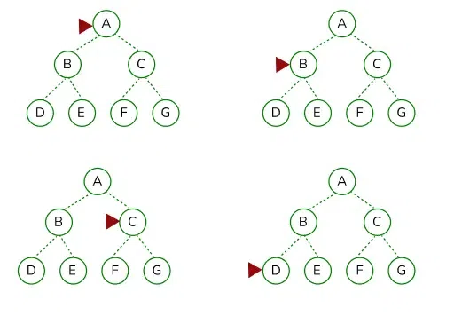
Example:

Output: A → B → C → D → E → F → G

- Alpha-Beta Pruning in Adversarial Search Algorithms

- Start from the root node.
- Evaluate moves for MAX and MIN players.
- Update Alpha and Beta values.
- If a branch cannot give a better result, skip that branch.
- Continue until the best move is found.

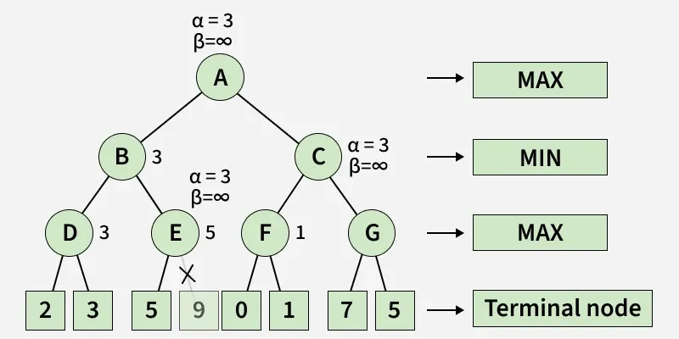

- DFS (Depth First Search) Algorithm

Steps of DFS
- Start from the root node.
- Visit the node.
- Go to an unvisited adjacent node.
- Continue until no unvisited node is left.
- Backtrack and visit remaining nodes.

Example:
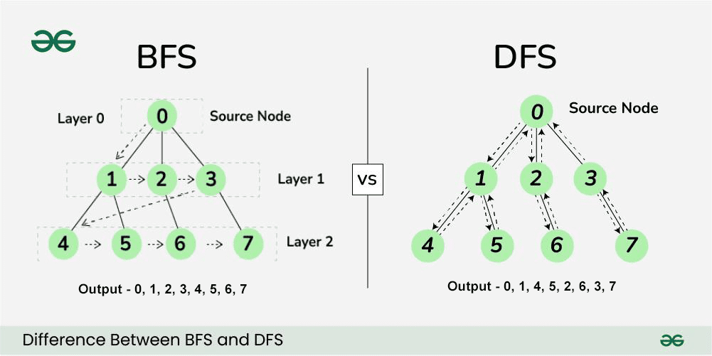

- Hill Climbing algorithm (Unit-2)

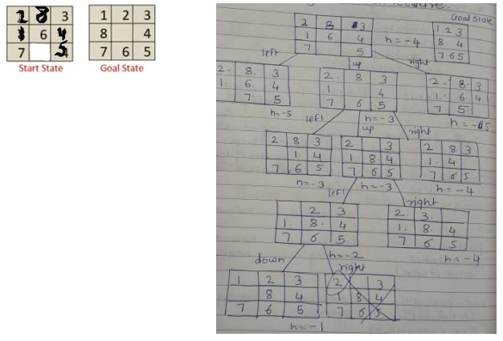



- A* Search Algorithm

A* (A-Star) Search Algorithm is an informed search algorithm used to find the shortest path between nodes. It uses both path cost and heuristic value to find the best solution.

Working
- Start from the initial node.
- Calculate f(n) value.
- Choose node with lowest f(n).
- Expand the selected node.
- Repeat until goal node is reached.

Formula: $f(n)=g(n)+h(n)$

- A* Algorithm (Example)
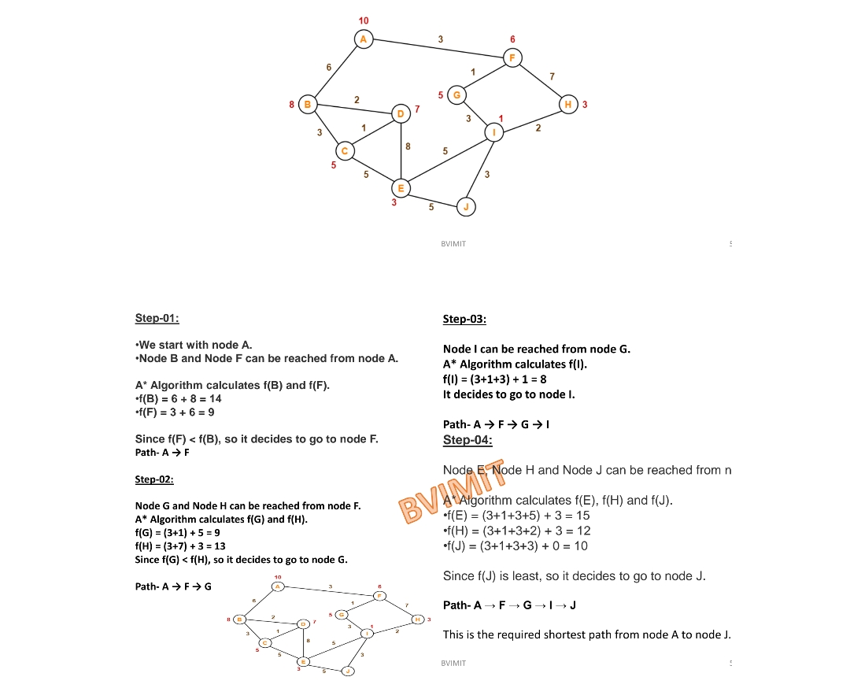

- A* Algorithm (8 puzzle problem)
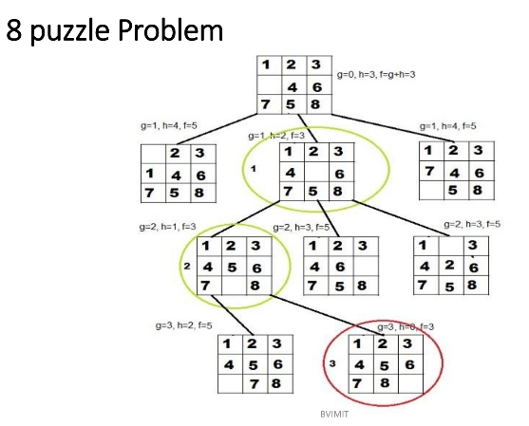

Unit = 5
  - Components of Bayesian Belief Network
1. Nodes
2. Directed Edges (Arrows)
3. Conditional Probability Table (CPT)
4. Parent Nodes
5. Child Nodes
6. Probabilistic Inference

Unit-6

    - SVM (support vector machine)
