NIST COLLEGENATIONAL INSTITUTE OF SCIENCE AND TECHNOLOGYTribhuvan UniversityInstitute of Science and Technology



REPORT ON POSSIBILITIES OF TOURISM INDUSTRY IN NEPAL

Submitted toDepartment of Computer Science and Information TechnologyNIST College

In partial fulfillment of the requirements for the Bachelor’s Degree in Computer Scienceand Information Technology

Submitted by  
Nishant Halwai (5163/071)  
February, 2019

**NIST College  
NATIONAL INSTITUTE OF SCIENCE TECHNOLOGY  
Tribhuvan University**

**STUDENT’S DECLARATION**

I hereby declare that project report entitled **“**POSSIBILITIES OF TOURISM INDUSTRY IN NEPAL**”**submitted in partial fulfillment of the requirement for **Bachelor Degree in Computer Science and Information Technology** of Tribhuvan University, is my original work and not submitted for the award of any other degree, diploma, fellowship, or any other similar title or prize.

…………………………….

Nishant Halwai (5163/071)

NIST College

Banepa, Kavrepalanchok

# 

# 

**NIST College  
NATIONAL INSTITUTE OF SCIENCE TECHNOLOGY  
Tribhuvan University**

**SUPERVISOR’S RECOMENDATION**

I hereby recommend that this internship work under my supervision by Shakti Nepalientitled “POSSIBILITIES OF TOURISM INDUSTRY IN NEPAL” in the partial fulfillment of the requirements for the degree of B.Sc. in Computer Science and Information Technology be processed for the evaluation.

…………………………………

Mr. UmeshDahal

Lecturer, NIST College

Department of CSIT

Banepa, Kavrepalanchok

**NIST College  
NATIONAL INSTITUTE OF SCIENCE TECHNOLOGY  
Tribhuvan University**

**LETTER OF APPROVAL**

This is to certify that this project prepared by Nishant Halwai entitled “POSSIBILITIES OF TOURISM INDUSTRY IN NEPAL” in partial fulfillment of the requirements for the degree of B.Sc. in Computer Science and Information Technology has been well studied. In our opinion it is satisfactory in the scope and quality as a project for the required degree.

……………………… .…………………..

Campus Chief Supervisor

Chet BahadurBista Mr. UmeshDahal

NIST College Lecturer, NIST College

…………………… ………………………

External Internal

# ACKNOWLEDGEMENT

The completion of this project entitled “POSSIBILITIES OF TOURISM INDUSTRY IN NEPAL” couldn’t have been possible without the participation and assistance of so many people whose name may not all be enumerated. Their contributions are sincerely appreciated and gratefully acknowledged. However I would like to express my deep appreciation particularly to the following:

Department of Science and Technology, Tribhuvan University for providing us an opportunity to work and research by including the internship as a part of syllabus.

Mr. UmeshDahal – Coordinator and supervisor for creating a virtuous academic and sociable environment to foster this project. Therefore, I would like to express my innermost thanks to him for providing me with all the crucial advices, guidelines and resources for the accomplishment of this project.

Mr. Dhan Prasad Dahal – Mentor for his guidance and knowledge throughout my internship duration.

External as well as my internal examiner for their valuable suggestions and our classmates and colleagues for their useful compliments and view for our project.

To all relatives, friends, and others who in one way or another shared their support either morally, financially or physically, thank you.

**Shakti Nepali(S.N. 5163/071)**

# ABSTRACT

This report provides detailed information about the possibilities of tourism industry in Nepal.The report that I have created is done on the basis of different information that I have collected from different sources.

Tourism

Table of Contents

ACKNOWLEDGEMENT v

ABSTRACT vi

LIST OF FIGURES ix

LIST OF TABLES x

LIST OF ABBREVIATIONS xi

CHAPTER 1: INTRODUCTION 1

1.1 Introduction 1

1.1.1 Introduction of Project 1

1.1.2 Scope of the Project 1

1.1.3 Limitation of the Project 2

1.1.4 Introduction of Organization 2

1.1.5 Organization Hierarchy 3

1.1.6 Duration of Internship 4

1.2 Problem Statement 4

1.3 Objectives 5

1.4 Responsibilities assigned 5

1.5 Motivation 5

1.6 Report Organization 6

CHAPTER 2: LITERATURE REVIEW 8

2.1 Study of Existing System 8

2.1.1 MeroJob 8

2.1.2 JobsNepal 8

CHAPTER 3: SYSTEM ANALYSIS 9

3.1 Requirement Collection 9

3.2 System Requirements 9

3.2.1 Functional Requirement 9

3.2.2 Non-functional Requirement 11

3.3 Feasibility Study 11

3.3.1 Technical feasibility 11

3.3.2 Economic feasibility 12

3.3.2 Operational feasibility 12

3.3.2 Schedule feasibility 12

3.4 Data Model of the System 13

3.5 Process Model of the System 13

CHAPTER 4: SYSTEM DESIGN 15

4.1 Architectural Design 15

4.2 Database Design 16

4.3 Process Design 17

4.3.1 Sequence Diagram 17

4.3.2 Activity Diagram 18

CHAPTER 5: IMPLEMENTATION 19

5.1 Implementation Tools 19

5.1.1 Tools Used 19

5.1.2 Backend 19

5.1.2 Database 19

5.2 Development Methodology 20

CHAPTER 6: TESTING 27

6.1 Unit Testing 27

6.2 System Testing 29

CHAPTER 7: CONCLUSION 30

7.1 Conclusion 30

7.2 Lesson learnt 31

REFERENCES 31

APPENDIX 32

# LIST OF FIGURES

Figure 1.1 Organizational Structure of E-Prabidhi Pvt.Ltd……………….………………3

Figure 1.2 Report organization of Rojgar……...……………………………………….…7

Figure 3.1 Usecase diagram of Rojgar ………………………….………….……………10

Figure 3.2 ER diagram of Rojgar……………………………….….……………...……..13

Figure 3.3 Class Diagram of Rojgar……………………………..…………...…………..13

Figure 4.1 System Architecture of Rojgar……………………………………...….……..15

Figure 4.2 Schema diagram of Rojgar………………………………………...…….……16

Figure 4.3 Sequence diagram of Rojgar………………………………………….....……17

Figure 4.4 Activity diagram of Rojgar…………………………………………...………18

Figure 5.2 Iterative Model…………..…………………………………………...…….…21

# LIST OF TABLES

Table 1.1: Contact Detail …………………………………………………………………2

Table 1.2: Internship Duration ……………………….……………………….…………..4

Table 5.1: Tools used for ROJGAR…………………………………………..………….19

Table6.1: Test case for Post Job………………………….………….………..………….28

Table6.2: Test case for CRUD operation...………………….………………...…………28

Table6.3: Test case for URL mapping ………………………….……………...………..29

Table6.4: Test case for Browser Compatibility ……………………………….…………30

# LIST OF ABBREVIATIONS

**Short Name Full Name**

ER Entity Relationship

IT Information Technology

Ltd. Limited

Pvt. Private

PMA Php My Admin

PHP Hypertext Preprocessor

NIST National Institute of Science and Technology

SDLC Software Development Life Cycle

SQL Structured Query Language

URL Uniform Resource Locator

# CHAPTER 1: INTRODUCTION

## **Introduction**

### **1.1.1 Introduction of Touris**

Well these days, online jobs portal are playing a major role in employment sector. They are the simplest ‘Keys’ that has made a huge difference in building employment as well as making employment easier. Through Online Job Portal, finding and providing job has become not just quicker but even more effective, that too for both the employer and job seekers. The online jobs portal have made it easier for the unemployed and the employed to get exciting opportunities. These portals provide the best available options so that people can grab their dream job from different sectors in the market.

Rojgar is a web based application that provides easy medium to find best candidate of the vacant job position for the organizations and means to let themselves provide their candidacy for any job by uploading the set of information including personal details, education, projects done, and other related information. Basically, the system provides means to create user-profile to a person seeking a job or for the one who is willing to offer the job. The only difference is that the job seeker provides the information about themselves mentioning all the necessary information and the job provider (or the company itself) reviews the details of the user to hire the one who meet all the requirements of the vacant job post holder. If the company meets believes that any of the job seeker is capable to be the member of their company, he/she gets called with the help of contact information attached by the jobseeker. This way the system provides two dimensional system for solving the task of job placement and job searching using the web.

### **1.1.2 Scope of the Project**

Today there are numerous organizations that need a huge amount of the employees every year. In such case, posting the vacancy and letting candidates apply for the post manually is somehow time consuming and tedious. In such case the Rojgarprovides easy way of making appointment of employees for the companies.

Following are the major scopes of the online job provider:

* Business organizations can hire employees easily online.
* People can put every information to show their interest for a job.
* A friendly user interface is provided to facilitate different services.

### **1.1.3 Limitation of the Project**

* No means of interaction between job seeker and job provider within system.
* Both job provider and job seeker have similar account type.

### **1.1.4 Introduction of Organization**

E-Prabidhi Pvt. Ltd. is a software development company based in Nepal actively working as a web development company. It is a Kathmandu-based leading software development company is in operation since 2010. Our core proficiency lies in designing, developing and deploying software solutions as well as integrated mobile solutions for small, medium and large enterprises. We offer simple, secure, transparent and result-driven business solutions to fulfill your business requirements. Along with technology solutions, we are here to provide a long-term strategic bond with our clients by offering further business consultations and solutions.

Contact Details

Table 1.1 Contact Detail

|  |  |
| --- | --- |
| Location | KamaladiPutalisadak-31, Kathmandu |
| Opening Hours | Mon-Fri: 9 AM - 6 PM |
| Telephone | 01-4240005 |
| Email | info@eprabidhi.com |
| Website | http://www.eprabidhi.com |

### **1.1.5 Organization Hierarchy**

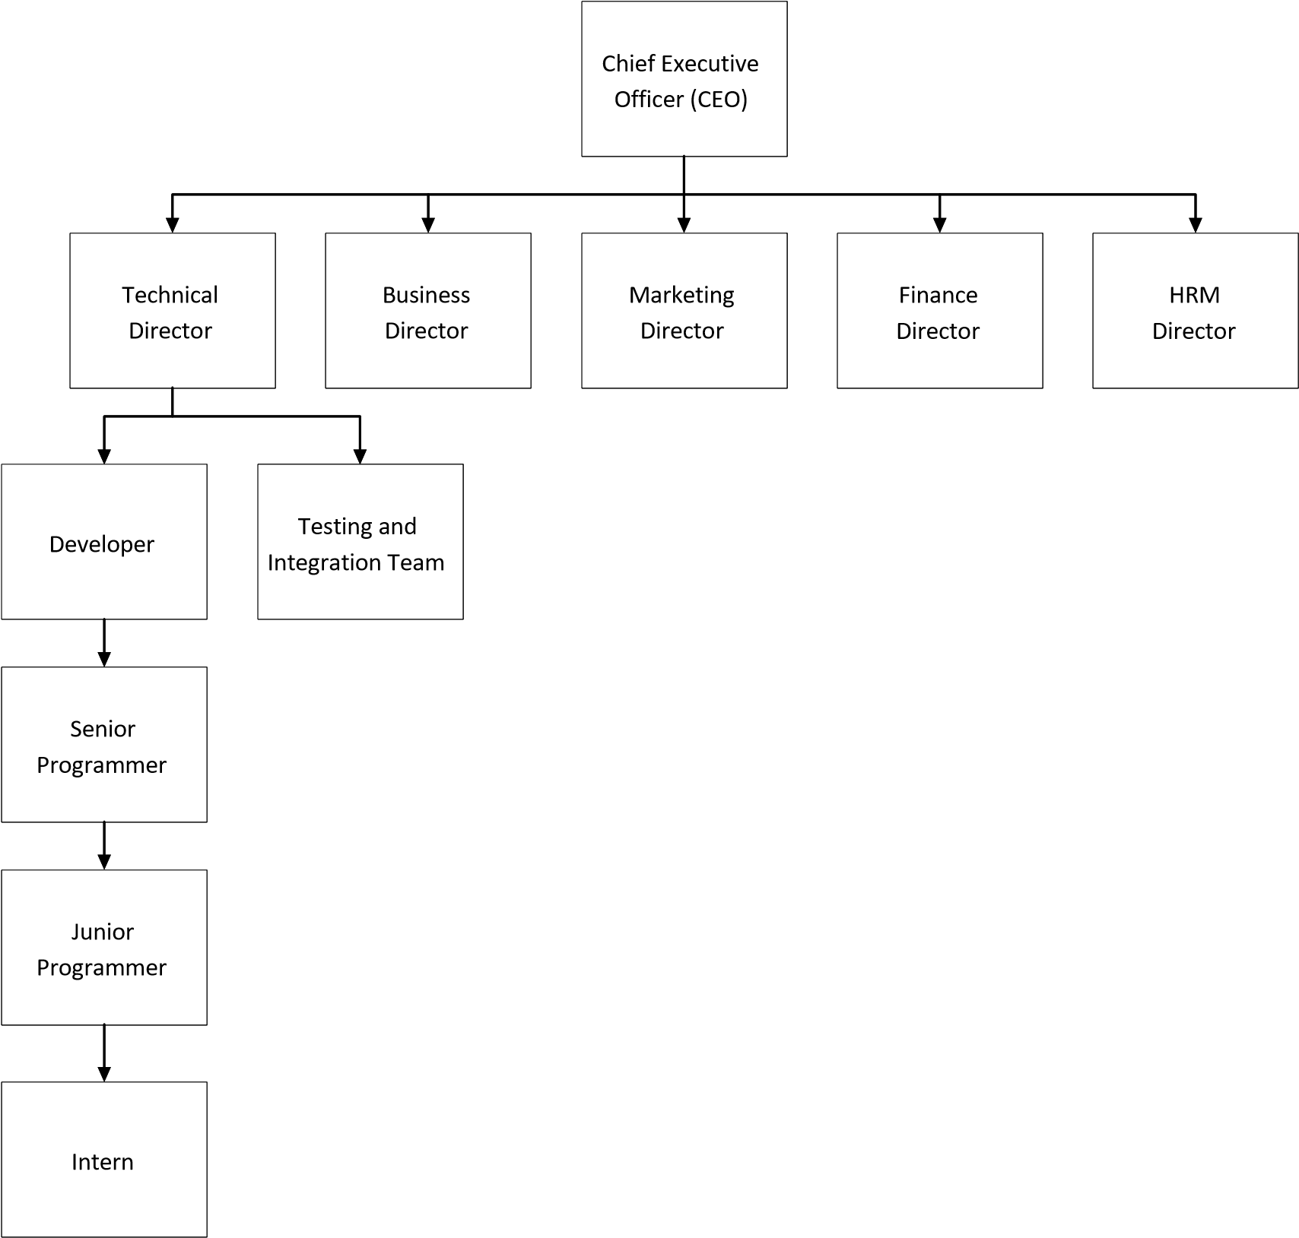

Figure 1.1: Organizational Structure of E-Prabidhi Pvt. Ltd

### **1.1.6 Duration of Internship**

I worked for a total of 3 months as an intern at E-Prabidhi Pvt. Ltd. The details of my internship period in the organization are summarized in the following table:

Table 1.2: Internship Duration

|  |  |
| --- | --- |
| Start Date | November |
| Total Duration | 3 Months (12 weeks) |
| Office Hour | 11:00 A.M – 3:00 P.M |
| Working Hour | 4 Hours per Day |
| Working Days | 5 Days a Week except Saturday |
| Position | Intern – PHP Developer |
| Supervisor | Mr. Dhan Prasad Dahal |

## **1.2 Problem Statement**

Traditionally, the task of finding a job, applying for it and attending the interview was really difficult because the job seeker needs to find the best possible job position, collect the document and related information and apply online in some cases, otherwise he/she must visit organization for the further procedure. Also companies needs to review documents and resume of the candidate manually and choose for the interview. Following were the main problems with manual recruitment of the employees:

* Difficult for the job seekers while applying for the post as they need to visit the office.
* Reviewing the full paper based documents manually is tedious task for companies.

With this system, job seekers can create their profile and upload the resume, and related documents specifying their skills, education, qualities and interests. With this set of information, job providers or companies reviews them online and call the qualified candidate with the contact information available. This way the task of employee selection and even recruitment task is simplified by the help of system developed.

## **Objectives**

The primary objective of the project is to create a secure, user-friendly web system for solving the job searching and employee hiring problem. Further the specific objectives of the project includes following:

* To create user profile for each user who can store their information online.
* To inherit searching algorithm so that job provider can sort the specific skilled individual.

## **1.4 Responsibilities assigned**

The primary task of an intern is to complete the task given to them within deadline. As an intern myself, I was given a various task to be completed for the designation of the project assigned to me. For my project Rojgar, as a backend developer, following tasks were assigned to me:

* To create various models of the project on Jobs and Payment.
* To create the models of the project that reflect the actual database composition of the system.
* To create Post Job,Add Company pages which is very important in this project and validate it as well.
* To create different CRUD pages where admin can delete the database data permanently like Manage Job Post,Show apply Jobs ,Manage Payment etc.

## **1.5 Motivation**

It is very important to select an organization that fulfills our objectives. As it is for our internship, it is necessary to select organization where there is learning environment because as in intern our first motive is to learn how the works are carried out in the real field.

The four year degree of BSc. CSIT allows us to attain knowledge on various aspects of Information Technology. At the same time the internship is the one of the major highlight of the program to expose the students to the professional world. Among the various criteria and sectors provided to us in internship prerequisite statement, software Development Company was chosen. Various organizations were shortlisted and approached out of which the organization with the best offer and environment was selected. E-PrabidhiPvt.Ltd which is located at Putalisadak-31, Kathmandu, IT Company that covers software development and I got selected there. The company helped me gain wide experience by getting me involved in their project.

## **1.6 Report Organization**

The report is separated into different chapters. Each chapter consists of various sub-chapters with the content. The preliminary section of the report consist of title page, letters, abstracts, acknowledgement, table of contents, list of figures and list of figures.

The first chapter contain the introduction and its sub-chapters. The second chapter consist of literature review, third chapter stores system analysis and its sub-chapters, third chapter stores system design and its sub-chapters and so on.

The report format of my project is diagrammatically represented as follows:

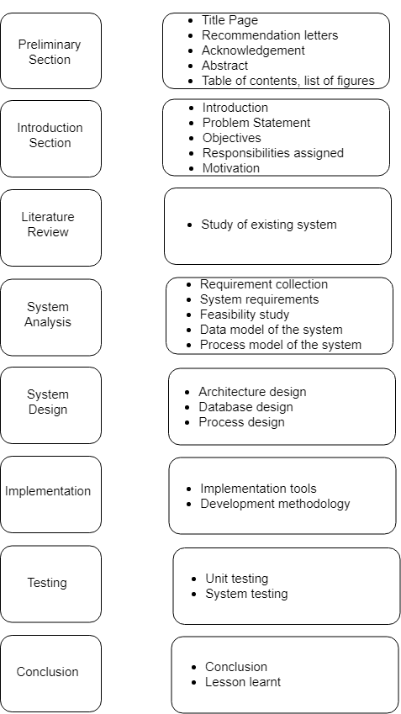

Fig 1.2 Report organization of Rojgar

# CHAPTER 2: LITERATURE REVIEW

**2.1 Study of Existing System**

Before developing the system various other similar systems were studied in order to ensure that the system for development is thoroughly understood. Some of the similar systems are summarized below:

**2.1.1 MeroJob**

From the web, to mobile, to social media tools and apps, we service companies of all sizes to find the right fit using most advanced technology in Nepal. Providing recruitment solutions to employers finding, fostering and preparing the right candidates in every possible ways with an effective tracking system and a dedicated team of customer service to both; the employers and the job seekers, has always been our primary goal.

The employer dashboard at merojob facilitates employers like you register your esteemed organization, post jobs and use the simplified short listing process to hire the best in few clicks with technology-guided tools. Customized platform provided to job seekers, on the other hand, let them register, search, apply and get jobs for free.

**2.1.2 JobsNepal**

JobsNepalthe largest locally focused employment website in the nation! Our mission is to lead the Internet employment industry in Nepal by providing innovative information, superior resume management software and a comprehensive selection of services.

It offers our services to the recruiting and job-seeking community in Nepal - and abroad, for those seeking Nepalese talent - entirely within a reasonable fee as we've introduced and are still refining our services.

It is our mission to bring the burgeoning Nepalese Internet and computing talent to bear on international Web development.

# CHAPTER 3: SYSTEM ANALYSIS

System analysis is the process of studying a procedure or business in order to identify its goals and purposes and create systems and procedures that will achieve them in an effective way.

## **3.1 Requirement Collection**

Requirement collection is the process of gathering and measuring information on targeted variables in an established systematic fashion. In case of my project, I was mainly focused on the backend development of the system and requirement is collected by someone else in organization. So, there is no any crucial activities in data collection phase.

## **3.2 System Requirements**

The requirements are the major part in the system development. These determine the structure, functionalities and operational constraints of the system. Requirements are hard to determine due to their dynamic and dependent in nature.

There are two different types of requirements:

### **3.2.1 Functional Requirement**

This section gives a functional requirement that applicable to the Online Job Portfolio system. Following are the main requirements that are of most need for the successful operation of the system:

* **User Registration**

Jobseekers registers themselves to be the member of the system.

* **Profile Creation**

After the registration, jobseekers create their profile by adding their personal information, education, skills, projects and other related information.

* **Company – Jobseeker Interaction**

The interaction between the jobseeker and the company seeking for employee is actually possible with the help of comment section and the actual contact information specified in the profile of user.

Functional requirement can be summarized by usecase diagram which is shown below:

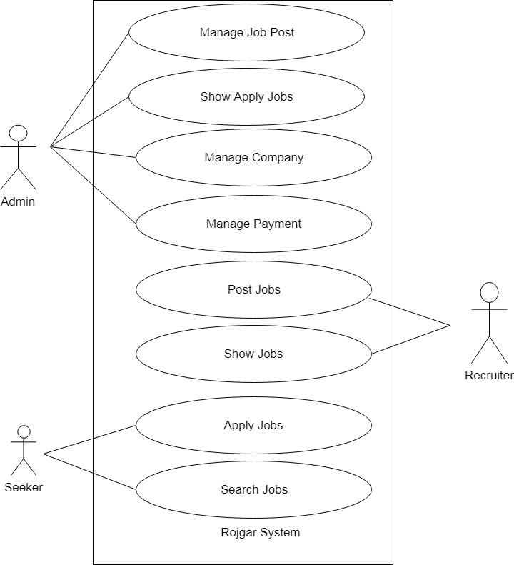

Fig 3.1: Usecase diagram of Rojgar

### **3.2.2 Non-functional Requirement**

* **Performance requirement:**

Some Performance requirements identified is listed below:

1. The system shall be able to maintain better response time, transaction rates and availability of resource.
2. The software shall support use of multiple users at a time.

* **Safety requirement:**

The database may get crashed at any certain time due to virus or operating system failure. Therefore, it is required to take the database backup.

* **Security requirement:**

Some of the factors that are identified to protect the software from accidental or malicious access, use, modification are as follows:

1. Restrict communications between some areas of the program.
2. Maintain security of user profile and data.

* **Modifiability**:

The users (jobseekers) must be able to modify their previously uploaded information.

## **3.3 Feasibility Study**

The following section deals about how the developed system (Rojgar) is feasible on given dimensions.

### **3.3.1 Technical feasibility**

The backend part of the system uses phpfor dynamic web page generation and to display the predicted output in the browser as well as to handle page requests. It supports Windows platform for its operation. All of the technology required by the application are available and can be accessed freely, hence it was determined technically feasible.

### **3.3.2 Economic feasibility**

Developing this application has very little economic cost. All the platform used to develop the application are open source and all the application software are freely available on internet hence this system is economically feasible.

### **3.3.2 Operational feasibility**

The application used 2-tier architecture. The server keeps the records of all users. The application can be accessed from anywhere with an internet connection. It is easy to use. Thus, it is determined to be operationally feasible.

### **3.3.2 Schedule feasibility**

The schedule feasibility of the project is ensured when the projects beets its deadline defined in the Gantt chart. If in case the estimated tasks of the overall project is completed within the defined schedule in chart, the project is said to be schedule feasible.

## **3.4 Data Model of the System**

* **ER diagram**

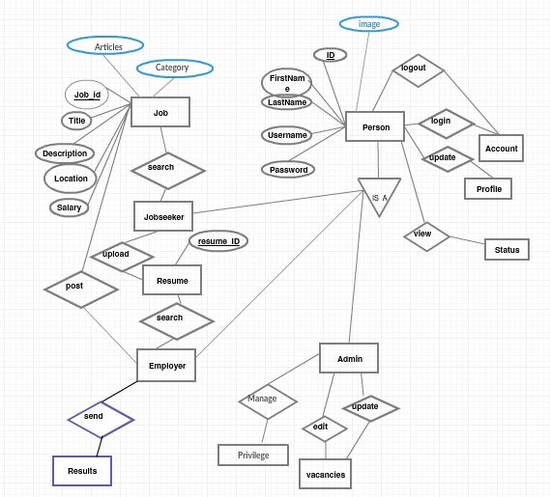

Fig 3.2 ER diagram of Rojgar

The diagram given above explains entity relationship diagram of our pojectRojgar. In this this system, there are many entities with associated attributes and relation between them. The entities used in the system are corresponding tables in the database with predefined attributes.

## **3.5 Process Model of the System**

* **Class Diagram**

The classes in a class diagram represent both the main objects and interactions in the application and the objects to be programmed. In the class diagram these classes are represented with boxes which contain 3 parts:

* The upper part holds the name of the class.
* The middle part contains the attributes of the class, and
* The bottom part gives the methods or operations the class can take.

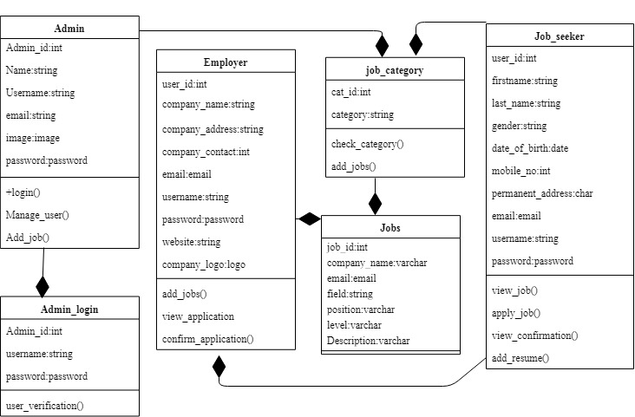

Fig 3.3 Class diagram of Rojgar

There are 6 classes in my project. Each class has corresponding table in database with a set of attributes and methods associated to it.

# CHAPTER 4: SYSTEM DESIGN

## **4.1 Architectural Design**

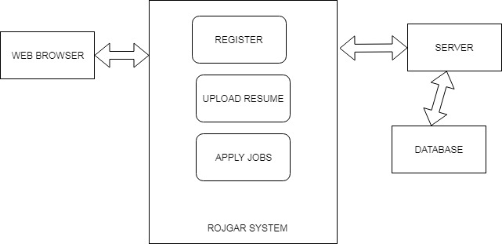

Fig 4.1 System Architecture of Rojgar

The architectural diagram of “Rojgar” is quite simple. It is a multitier architecture that consists the user interface that is interacted through web browser or presentation layer on the top tier. Similarly the middle tier consists of system modules and local server. Finally the bottom tier of the architecture consist of database interaction with the system.

## **4.2 Database Design**

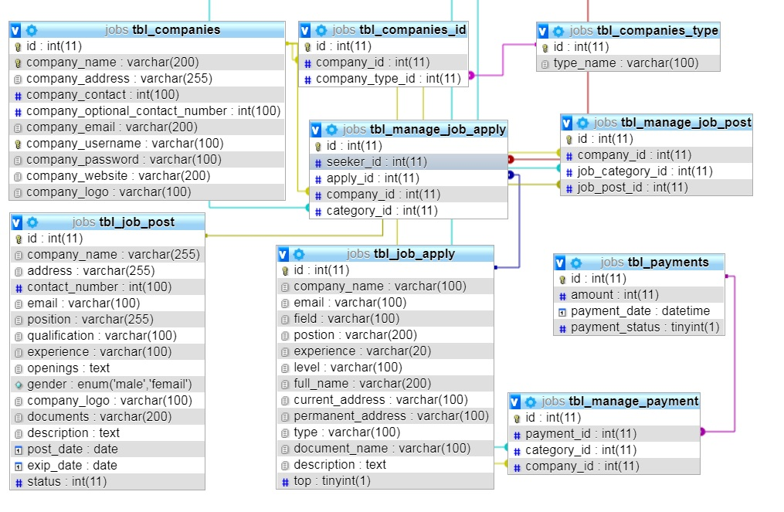

Fig 4.2 Schema diagram of Rojgar

## **4.3 Process Design**

### **4.3.1 Sequence Diagram**

i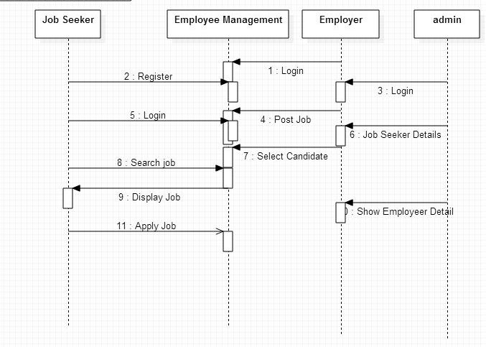

Fig 4.3 Sequence diagram of Rojgar

Figure above shows the overall process of the system through sequence of operations performed by the system users. Initially, User registers into the system and creates profile including necessary information about themselves. Then User or Job finder is able to login into the system. After login he/she either can modify information previously added or look for the response of companies. Companies or Job providers logins to the system in similar manner and contact the qualified personnel who they find deserving for the post.

### **4.3.2 Activity Diagram**

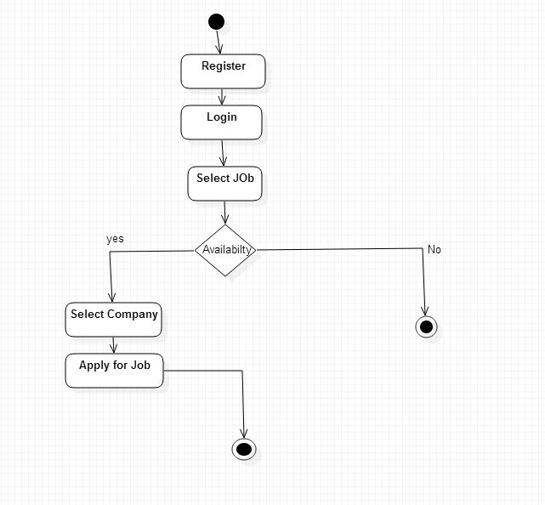

Fig 4.4 Activity diagram of Rojgar

The activity diagram of my project depicts different activities performed by the actor. The actor or user first logins to the system after registering. If the user is authenticated during login, he/she enters the dashboard page. There they can add different information about themselves. After successful user operation, the user logs out of the system. At this point the user session ends.

# CHAPTER 5: IMPLEMENTATION

## **5.1 Implementation Tools**

### **5.1.1 Tools Used**

Table 5.1: Tools used for Rojgar System

|  |  |
| --- | --- |
| **Tools name** | **Purpose** |
| **draw.io** | Analysis and designing |
| **Sublime text, PHP Storm** | Development |
| **Xampp server** | Local Server |
| **Microsoft Word** | Documentation |
| **Bitbucket** | Version controlling |

### **5.1.2 Backend**

* **PHP**: Hypertext Preprocessor (or simply PHP) is a server-side scripting language designed for Web development, but also used as a general-purpose programming language.

PHP in this project is used to create dynamic web pages that are generated from information accessed from a MySQL database. It is used to perform operations like read data from database, write data into database, modify the data, update the data, and moreover to display the data on the frontend (HTML Page).

### **5.1.2 Database**

* **Microsoft SQL Server** : In this project, PMA is used which is an excellent free, open source web-based database client that is used to interact more easily with MySQL. A raw view of the data, tables and fields stored in the MySQL database is accessed through PMA. It is used for performing maintenance operations on tables, backing up information, and editing things directly in the event.

## **5.2 Development Methodology**

Unlike the more traditional waterfall model, which focuses on a stringent step-by-step process of development stages, the iterative model is best thought of as a cyclical process. After an initial planning phase, a small handful of stages are repeated over and over, with each completion of the cycle incrementally improving and iterating on the software. Enhancements can quickly be recognized and implemented throughout each iteration, allowing the next iteration to be at least marginally better than the last.

**Planning & Requirements**: As with most any development project, the first step is go through an initial planning stage to map out the specification documents, establish software or hardware requirements, and generally prepare for the upcoming stages of the cycle.

**Analysis & Design**: Once planning is complete, an analysis is performed to nail down the appropriate business logic, database models, and the like that will be required at this stage in the project. The design stage also occurs here, establishing any technical requirements (languages, data layers, services, etc) that will be utilized in order to meet the needs of the analysis stage.

**Implementation**: With the planning and analysis out of the way, the actual implementation and coding process can now begin. All planning, specification, and design docs up to this point are coded and implemented into this initial iteration of the project.

**Testing:** Once this current build iteration has been coded and implemented, the next step is to go through a series of testing procedures to identify and locate any potential bugs or issues that have have cropped up.

**Evaluation**: Once all prior stages have been completed, it is time for a thorough evaluation of development up to this stage. This allows the entire team, as well as clients or other outside parties, to examine where the project is at, where it needs to be, what can or should change, and so on.

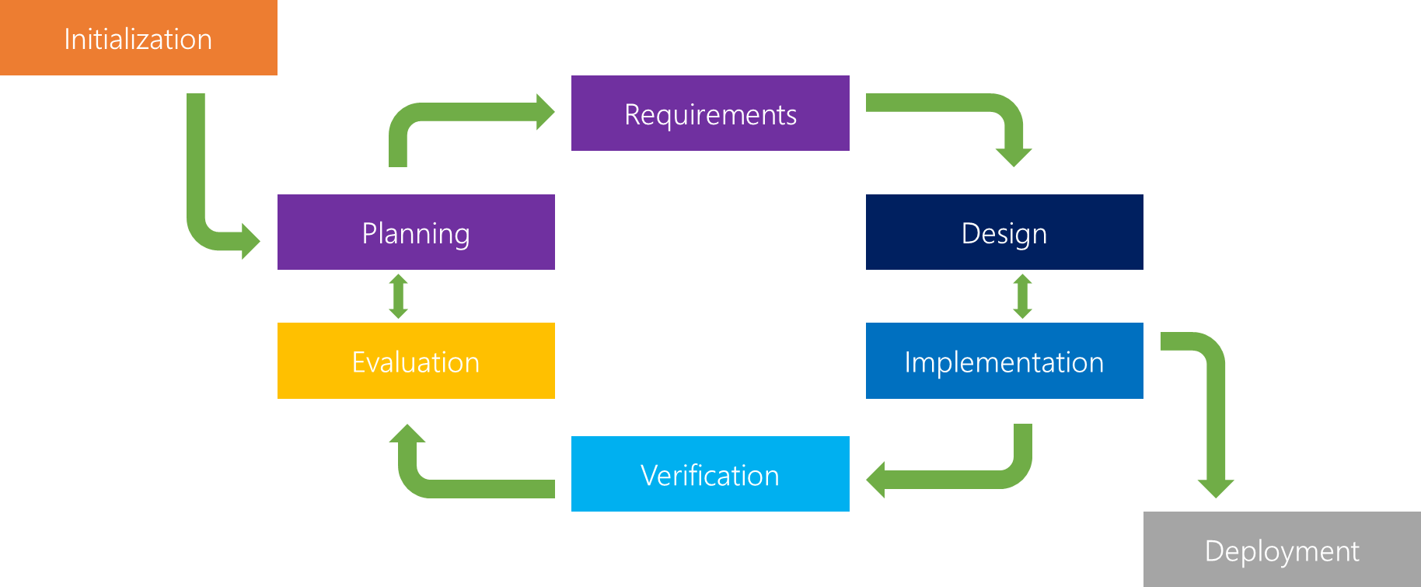

Figure 5.1: Iterative model

Rojgar is based on iterative model in the sense that, initial little requirements are studied and simple design is created. In first iteration of the model, the requirement about the project is collected and simple diagrammatical ER diagram is created. The created diagram is implemented to produce database table. So the first iteration of project development produced a database table structure of the system as per the ER diagram.

The backend development of the project ‘**Rojgar’** was carried out by performing the following tasks

At first the models of the project are designed. The model is the single definitive source of information about our data. It contains the fields and behavior of the data we are storing about. Each models maps to the single database table. It was done by creating model_name.php files in our application directory of the system.

For the creation of the tables like adding the Job details,User info,Payments etc we created the class of them inside models.php files as below:

<?php

$db = Database::Instance();

$jobCategory = $db->SelectAll('tbl_job_categories');

if (!empty($_POST)) {

$data['company_name'] = $_POST['company_name'];

$data['address'] = $_POST['address'];

$data['contact_number'] = $_POST['contact_number'];

$data['email'] = $_POST['email'];

$data['position'] = $_POST['position'];

$data['qualification'] = $_POST['qualification'];

$data['experience'] = $_POST['experience'];

$data['gender'] = md5($_POST['gender']);

$data['description'] = $_POST['description'];

$data['post_date'] = $_POST['post_date'];

$data['exip_date'] = $_POST['exip_date'];

$companyId = $_SESSION['company_id'];

$jobType = $_POST['job_type'];

// check payment status

$getPaymentResult=$db->Select("SELECT tbl_payments.*,tbl_job_categories.category_name,tbl_companies.* FROM tbl_payments

LEFT JOIN tbl_manage_payment on tbl_payments.id=tbl_payments.id

LEFT JOIN tbl_job_categories on tbl_manage_payment.category_id=tbl_job_categories.id

LEFT JOIN tbl_companies ON tbl_manage_payment.company_id=tbl_companies.id

WHERE tbl_companies.id='$companyId' and tbl_job_categories.id='$jobType'");

if (count($getPaymentResult) <= 0) {

$_SESSION['company_payment_id'] = $companyId;

$_SESSION['category_payment_id'] = $jobType;

redirect_to('@company-admin/payment');

}

//=========company logo========

$target_dir = page_path('public/images/company/');

$imageFileType=pathinfo($_FILES['company_logo']['name'], PATHINFO_EXTENSION);

$imageName = md5(microtime()) . '.' . $imageFileType;

$tpmName = $_FILES['company_logo']['tmp_name'];

if (move_uploaded_file($tpmName, $target_dir . $imageName)) {

$data['company_logo'] = $imageName;

}

//=========document logo========

$target_dir = page_path('public/images/document/');

$imageFileType = pathinfo($_FILES['documents']['name'], PATHINFO_EXTENSION);

$docName = md5(microtime()) . '.' . $imageFileType;

$tpmName = $_FILES['documents']['tmp_name'];

if (move_uploaded_file($tpmName, $target_dir . $docName)) {

$data['documents'] = $docName;

}

if ($lastInsertId = $db->Insert('tbl_job_post', $data)) {

if ($lastInsertId) {

$dbs = Database::Instance();

$cmpType['company_id'] = $companyId;

$cmpType['job_category_id'] = $jobType;

$cmpType['job_post_id'] = $lastInsertId;

$dbs->Insert('tbl_manage_job_post', $cmpType);

}

$_SESSION['success'] = 'data was successfully inserted';

redirect_to('@company-admin/show-post-jobs');

}

}

?>

After creating the models, the views for the models are created in views.php files. The views are php function that takes the web request and return the web response.

The views for post_job model was created as below:

<?php

$db = Database::Instance();

$criteria = $_SESSION['company_id'];

$jobsData=$db->Select("SELECT tbl_job_post.*,tbl_job_categories.category_name,tbl_companies.* FROM tbl_job_post

JOIN tbl_manage_job_post on tbl_manage_job_post.job_post_id=tbl_job_post.id

JOIN tbl_job_categories ON tbl_job_categories.id=tbl_manage_job_post.job_category_id

JOIN tbl_companies ON tbl_companies.id=tbl_manage_job_post.company_id

WHERE tbl_manage_job_post.company_id='$criteria'")

?>

<div id="page-wrapper">

<div class="row">

<div class="col-lg-12">

<h1 class="page-header">Dashboard</h1>

</div>

</div>

<div class="row">

<?= Messages(); ?>

<div class="col-md-12">

<table class="table">

<tr>

<th>S.n</th>

<th>Company Name</th>

<th>Download</th>

</tr>

<?php foreach ($jobsData as $key => $jobs): ?>

<tr>

<td><?= ++$key ?></td>

<td><?= $jobs->company_name ?></td>

<td>

<a href="<?= URL('public/images/document/'.$jobs->documents) ?>" download>

<i class="fa fa-file-pdf-o"></i>Download</a>

</td>

</tr>

<?php endforeach; ?>

# CHAPTER 6: TESTING

Testing is an integral part of SDLC which helps to determine whether the input given to the system provides a correct output or not. Testing involves the execution of a system component to evaluate one or more properties of interest. In general, these properties indicate the extent to which the component or system under test

* meets the requirements that guided its design and development,
* responds correctly to all kinds of inputs and is sufficiently usable,
* performs its functions within an acceptable time,
* can be installed and run in its intended environments

After the completion of specific modules and system, the testing of the system was performed to find out whether the requirements of the system are met or not. So the testing of my system helped to find out system flaws and errors. Following types of testing was performed to the system “Rojgar”.

## **6.1 Unit Testing**

In unit testing of Rojgar, each component and module of the system was tested and the outcome of the test was noted and reviewed to make changes to the system. Online Job Portfolio has various modules such as admin login and user registration. These modules were tested in unit testing.

**Test case 1**

Test case 1 deals with examining the parameters of the data during Post Job. Input given is the Recruiter information who has already an account and the Recruiter can Post the job after entering their account. This test checks to see if all the parameters during the job Post are set or not. If any data to be filled are left out, the system results in throwing error.

Table6.1 Test case for Post Job

|  |  |  |  |  |  |
| --- | --- | --- | --- | --- | --- |
| Test ID | Test Scenario | Input Data | Expected Result | Actual Result | Remark |
| 1 | For Post Job | All fields are filled | Post Successful | Post Successful | Test Passed |
| 2 | For Post Job | All fields are not filled | Please fill the for all fields | Post Unsuccessful | Test Passed |

**Test case 2**

Test case 2 deals with examining the parameters of the data during adding fo the Company ,Payment and delete them by admin. Input given is the information that is to be filled correctly without empty and the above steps has been done for the completion of this test.

Table 6. : Test case for CRUD operation

|  |  |  |  |  |  |
| --- | --- | --- | --- | --- | --- |
| **SN** | **Objective** | **Input** | **Expected Outcome** | **Original Outcome** | **Error Info** |
| 1 | To add Company | Empty name field | Data shouldn’t be saved | You need to fill the form correctly | Please Enter Company Name |
| 2 | To add Company | Non Empty name field and username | Data should be stored | Data has been saved successfully! | No error info |
| 3 | To add Payment | Empty name field | Data shouldn’t be saved | You need fill the form correctly | Please Enter all fields |
| 4 | To add Payment | Non-Empty name field | Data should be stored | Data has stored sucessfully |  |
| 5 | Delete company | Click delete | Specific data should be deleted | Data has been deleted |  |

**Test case 3**

Test case 3 deals with examining the URL mapping of certain application of the system. If the valid URL is passed to the address bar of a web browser, the browser must return the actual web application developed otherwise testing fails.

Table6.3 Test case for URL mapping

|  |  |  |  |  |  |
| --- | --- | --- | --- | --- | --- |
| Test ID | Test Scenario | Input Data | Expected Result | Actual Result | Remark |
| 1 | URL mapping test | Valid URL for a page: localhost://8000/login | Reach the login page | Reach the login page | Test Passed |
| 2 | URL mapping test | Invalid URL for a page:  Localhost://8000/loginn | Page not found | Page not found | Test Passed |

## **6.2 System Testing**

In this testing the functional requirement of the system were checked. This testing was done after the completion of the system and testing of each module of the system. After the system was developed the overall performance of the system should checked such as whether the developed supports the browser compatibility or not, and whether the overall requirement is met or not.

**Test case 1**

Test case 1 of the system testing deals with the browser compatibility, i.e. whether the developed complete system is fully supported in different web browsers or not.

Table6.4 Test case for Browser Compatibility

|  |  |  |  |  |  |
| --- | --- | --- | --- | --- | --- |
| Test ID | Test Scenario | Input Data | Expected Result | Actual Result | Remark |
| 1 | Testing browser compatibility for Chrome | Hit valid site’s URL | Reach the site on Chrome browser | As  expected | Test Passed |
| 2 | Testing browser compatibility for Firefox | Hit valid site’s URL | Reach the site on Chrome browser | As  expected | Test Passed |

# 

# 

# CHAPTER 7: CONCLUSION

## **7.1 Conclusion**

The internship program has been an excellent and rewarding experience for me. It has provided me with the opportunity to develop understanding of real world working environment as well as establish network contact with different personnel from the IT industry.

Rojgar is a web application. The key concept is to minimize the difficulty of process of employment selection and recruitment. It can observe that the information required can be obtained with ease and accuracy in the computerized system. The user with minimum knowledge about computer can be able to operate the system easily and get involve in creating account and uploading information. The companies seeking qualified employees contacts the jobseeker through the contact information provided.

## **7.2 Lesson learnt**

During the internship period I found that the internship was very beneficial as a part of development of career and the experience gained through this would be helpful and beneficial for the future opportunity. Besides developing a project other lessons are also learnt, and they are as follows:

* The importance of communication to co-ordinate the tasks, and how important it is to work in team and the way to work in team.
* How to bring ideas into the implementation and how to work within the time constraints.
* The process of gathering the information that is required to develop software.

# REFERENCES

Company info.(2019). E-prabridhiPvt.Ltd. Web site. Retrieved November 25,2018, from http://www.eprabidhi.com/

Development Model(July 19 2017). Iterative model website.Retrieved January 7,2018, from https://airbrake.io/blog/sdlc/iterative-model

JobsNepal. (2018). Retrieved January 17,2018, from https://www.jobsnepal.com/about-us/

Merojob. (2018). Retrieved January 17,2018, from https://merojob.com/about-us/

# APPENDIX

**Add Company**

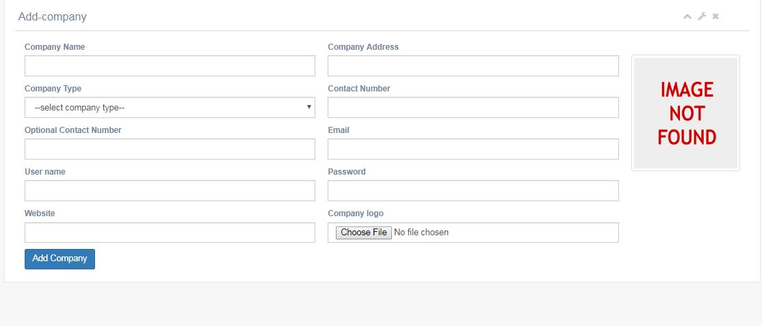

Fig 9.1: Add company

**Company type**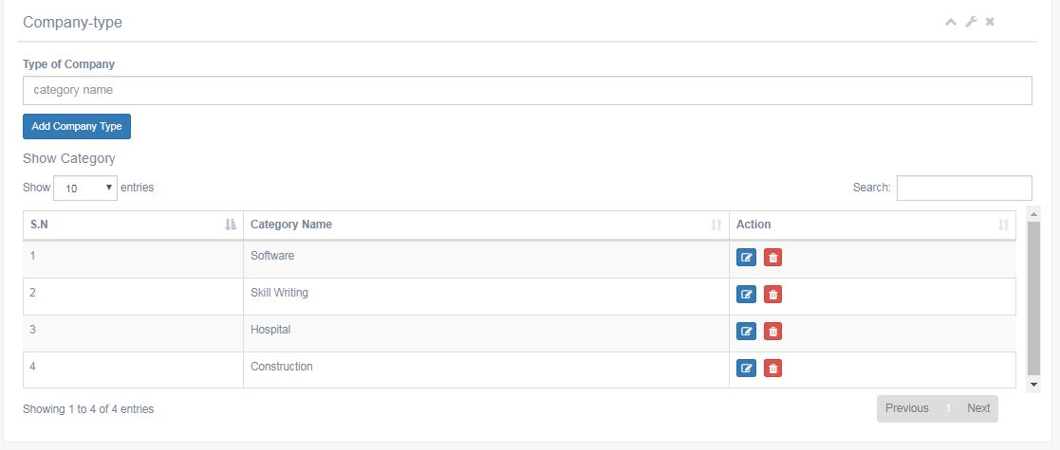

Fig 9.2: Company type

**Show company**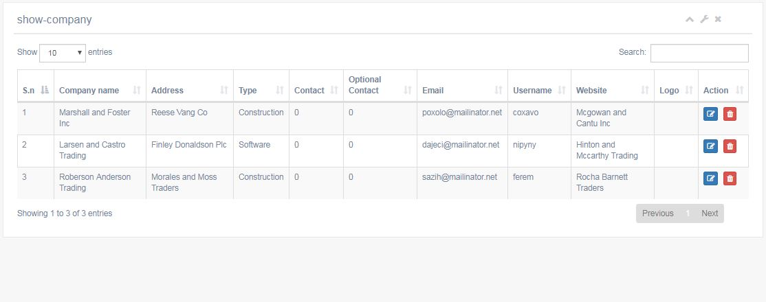

Fig 9.3: Show Company

**Post Job**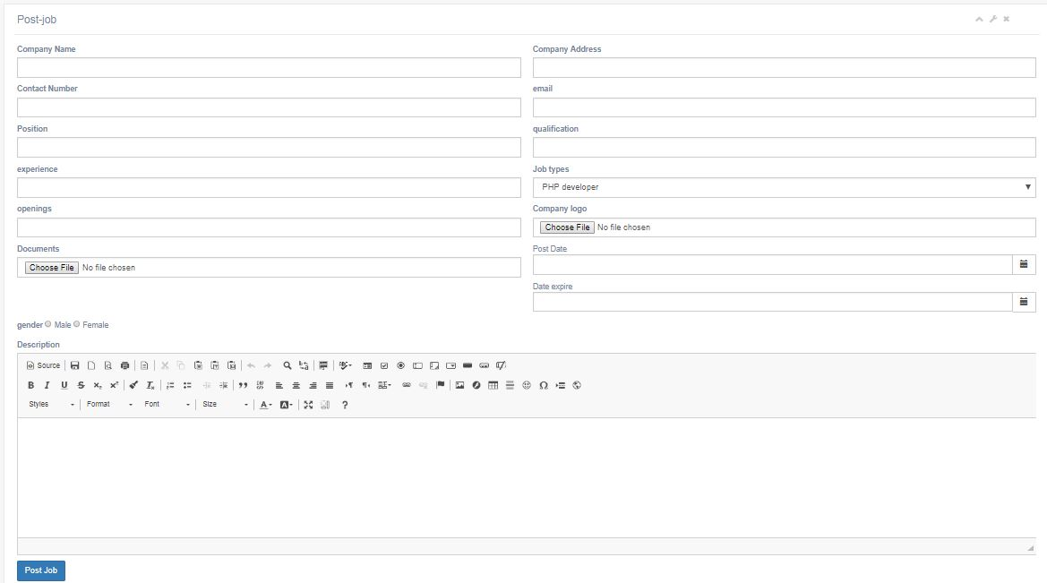

Fig 9.4:Post Job

**Show Post**

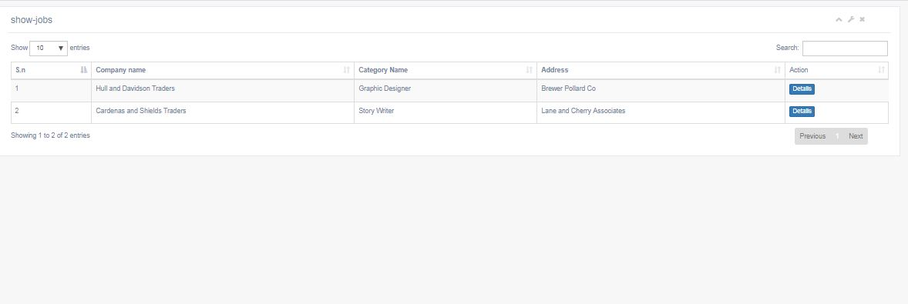

Fig 9.5:Show post