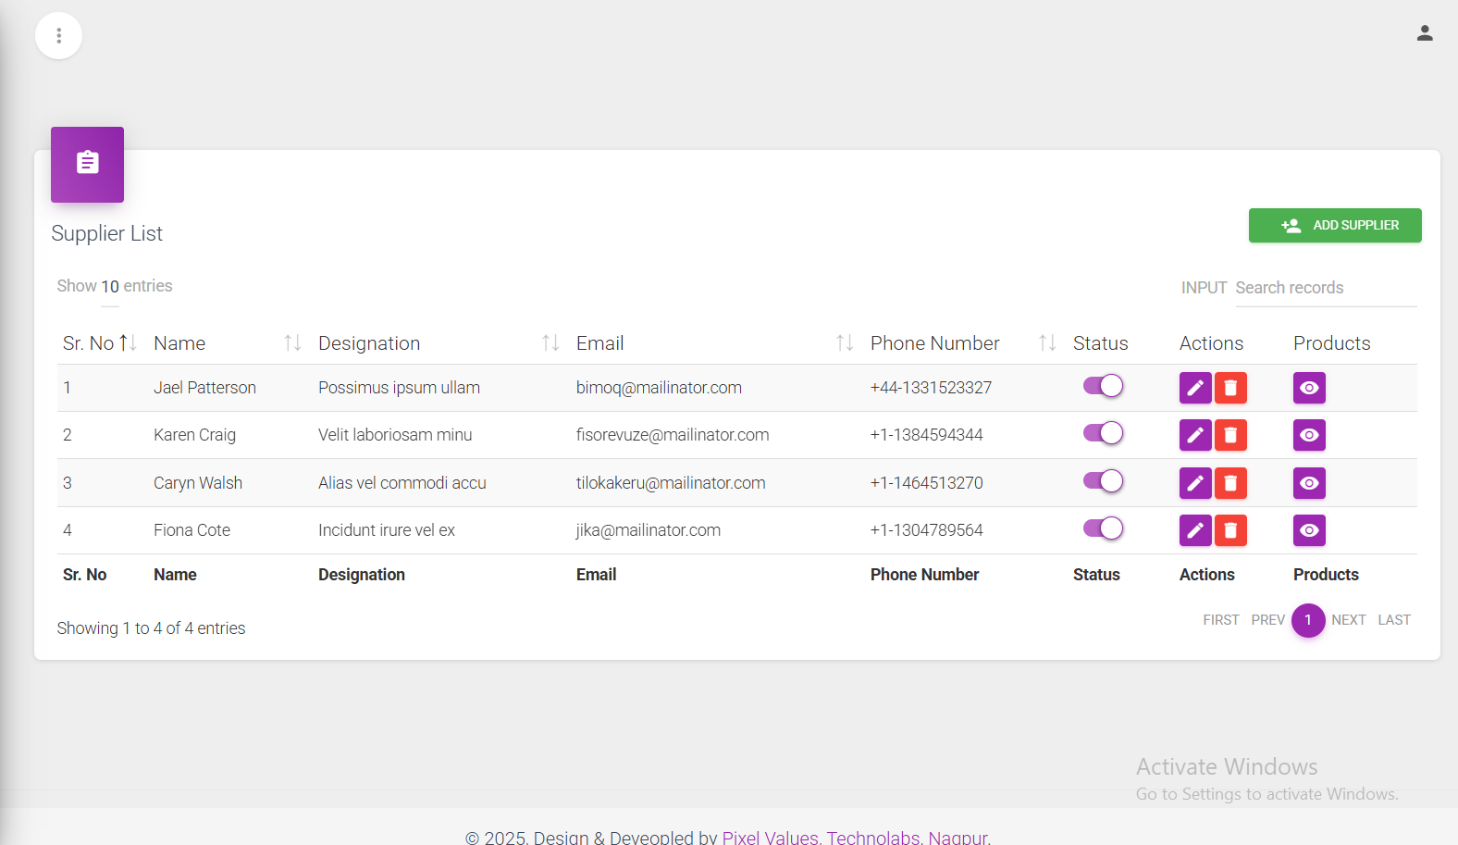

**Supplier Listed here**

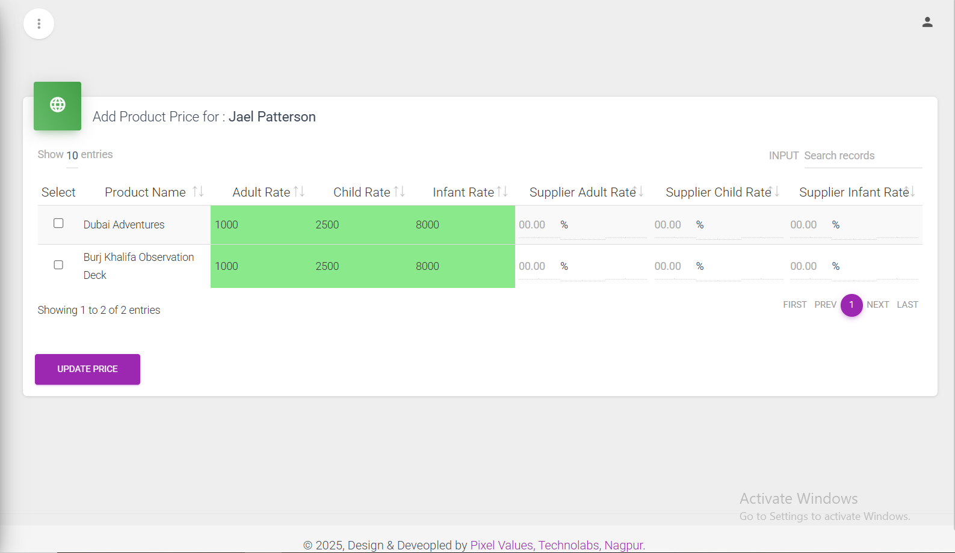

**Each Supplier having shown all products and as per his supplier has its own price to the product, by selecting checkbox and entering his values assign him that product with there price structure**

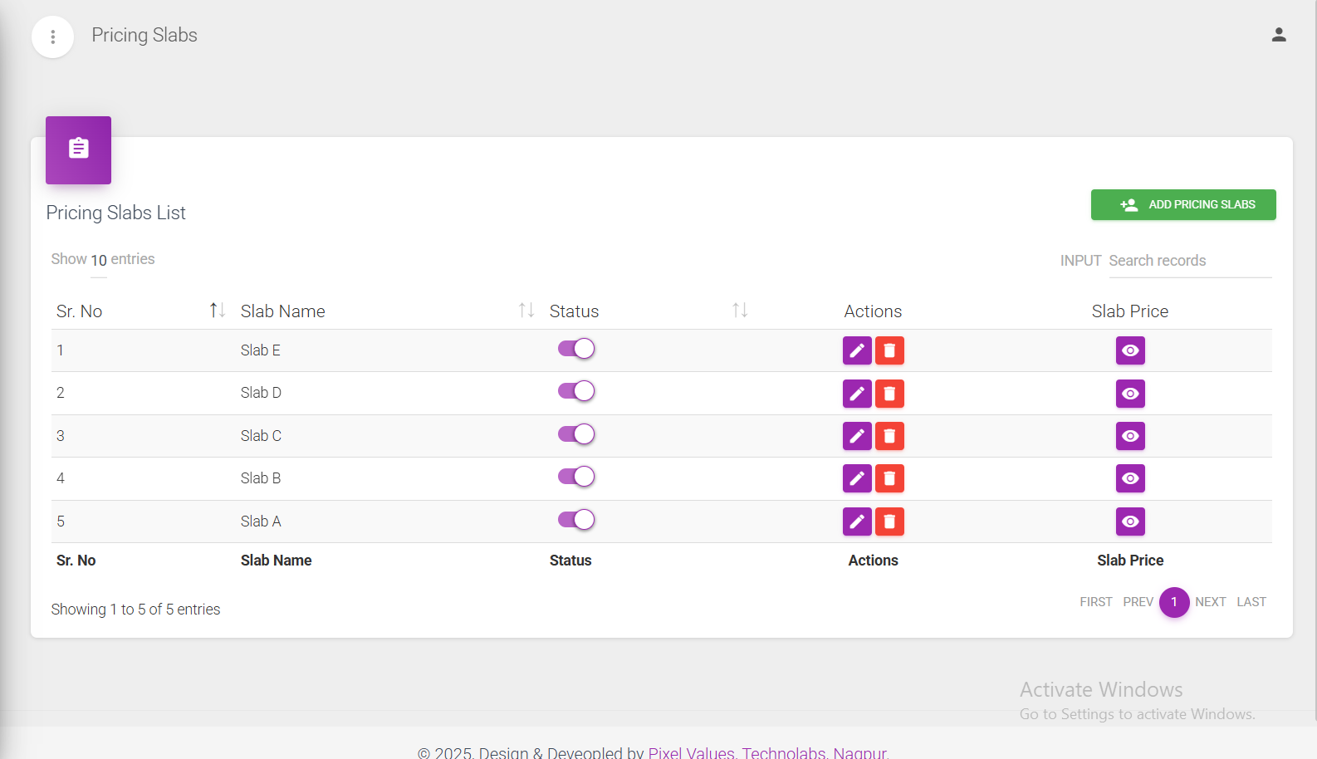

**Here is all pricing slabs are listed and on click of slab price ....... (next snap)**

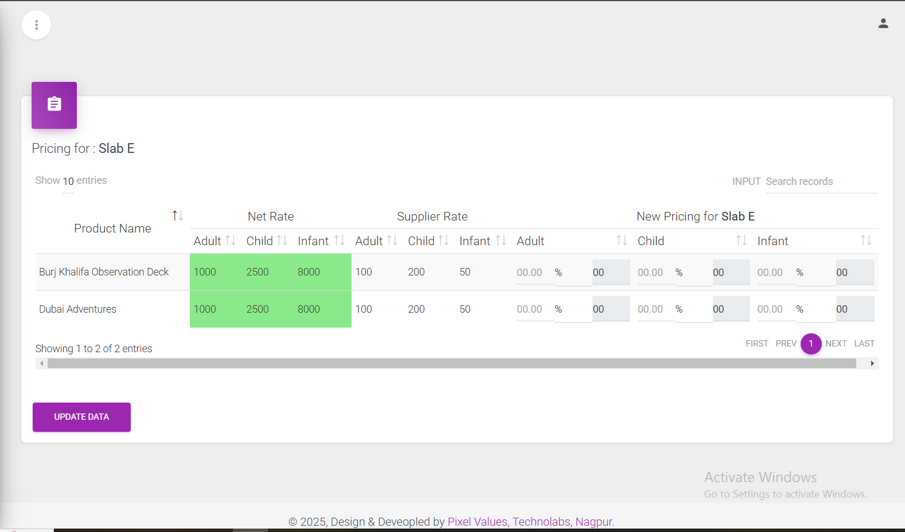**Here is showing product with minimum priced supplier, and then by entering the new values particular slab will be define**