# A FULLY AUTOMATIC FINETUNED DEEP LEARNING MODEL FOR KNEE OSTEOARTHRITIS DETECTION AND PROGRESSION ANALYSIS

**Harshitha S, Prajwal R, Prajwal C G, Rajath B G, Rajath H M**

*1Assistant Professor at Malnad College of Engineering in the Department of Computer Science and Engineering*

*2Department of Computer Science and Engineering*

*3Department of Computer Science and Engineering*

*4Department of Computer Science and Engineering*

*5 Department of Computer Science and Engineering*

-----------------------------------------------------***-----------------------------------------------------

**Abstract:** This study presents a fully automated deep learning framework tailored for the detection and progression analysis of knee osteoarthritis (OA). Leveraging state-of-the-art algorithms in classification and object detection, the framework integrates an ensemble of deep convolutional neural networks (CNNs), including Improved CNN, Xception, Inception V3, ResNet50, Inception ResNetV2, DenseNet121, and DenseNet169 with fine-tuned layers. These models are optimized to accurately classify knee OA from medical imaging data while providing detailed analysis of disease progression. For object detection, the framework employs variants of the YOLO (You Only Look Once) architecture, namely YOLOv5-GhostNet, YOLOv5, YOLOv6, and YOLOv7, ensuring robust detection of pathological features in knee images. The proposed approach aims to streamline diagnostic workflows by automating the detection of OA indicators and offering insights into disease development over time. Experimental results demonstrate the effectiveness of the ensemble approach in achieving high accuracy and reliability in both classification and detection tasks, positioning the framework as a promising tool for enhancing clinical decision-making and patient care in knee OA management.

***“Index Terms* –** *Knee Osteoarthritis (OA), Deep Learning, Convolutional Neural Networks (CNNs), YOLO Object Detection, Medical Imaging, Disease Progression Analysis.”*

**1. INTRODUCTION**

Knee osteoarthritis (OA) is a widespread and debilitating joint disease characterized by the progressive degeneration of cartilage and surrounding structures, leading to pain, stiffness, and reduced mobility. Early and accurate detection of knee OA, along with effective monitoring of its progression, is essential for timely clinical interventions that can improve patient outcomes and quality of life. Traditional diagnostic approaches, such as manual interpretation of radiographic images, are time-consuming, subject to inter-observer variability, and often lack the precision required for early-stage diagnosis and longitudinal analysis [1][3].

Recent advancements in deep learning (DL), particularly in the domains of computer vision and medical imaging, have introduced powerful tools capable of automating and enhancing the detection and grading of knee OA. Convolutional neural networks (CNNs) have shown remarkable performance in analyzing complex imaging data, identifying subtle pathological changes that may be overlooked by human observers [3][6][8]. Leveraging these capabilities, this study presents a fully automatic, fine-tuned deep learning framework specifically designed for the detection and progression analysis of knee OA.

The proposed model integrates an ensemble of optimized CNN architectures, including ResNet50, DenseNet variants, and Inception-based networks, which have been successfully applied in previous studies to classify OA severity with high accuracy [2][5][13]. Furthermore, transfer learning is employed to adapt pre-trained models to the task-specific domain of knee OA detection, thereby enhancing feature extraction from medical images such as X-rays and MRIs while reducing the need for extensive training data [4][7][11].

In addition to classification, the framework incorporates YOLO (You Only Look Once) object detection models—specifically YOLOv5, YOLOv6, YOLOv7, and GhostNet-enhanced YOLOv5—to localize pathological features within knee joint images. This combination of classification and detection capabilities enables the system to not only identify the presence of OA but also monitor its anatomical progression over time [10][12][14].

The integration of these advanced techniques culminates in a diagnostic tool that enhances efficiency, reliability, and clinical utility. By offering real-time assessments and progression tracking, the system supports personalized treatment planning and improves the overall management of knee OA [1][9][15]. This research thus represents a significant step toward intelligent, automated solutions in musculoskeletal healthcare, providing clinicians with a robust platform for early detection and continuous evaluation of knee osteoarthritis.

**2. RELATED WORK**

Several recent studies have explored the use of deep learning (DL) techniques to enhance the diagnosis and monitoring of knee osteoarthritis (OA), focusing on improving accuracy, automation, and clinical relevance. Guan et al. [1] introduced a deep learning-based approach to predict pain progression in patients with knee OA by analyzing MRI data, showcasing the utility of DL not only for diagnosis but also for longitudinal outcome prediction. Their model leveraged convolutional neural networks (CNNs) to learn relevant imaging biomarkers associated with pain worsening, setting a foundation for future research in progression analysis.

Shamami and Khatibi [2] investigated different CNN architectures and their optimization strategies for knee OA detection. Their work emphasized the importance of fine-tuning pre-trained models, demonstrating that adjusted parameters significantly improve classification performance. They compared multiple CNN variants, highlighting that model selection and training customization are crucial for enhancing diagnostic accuracy. This study supports the implementation of a fine-tuned CNN ensemble as applied in our proposed framework.

Yeoh et al. [3] conducted a comprehensive review on the emergence of deep learning in knee OA diagnosis and highlighted how CNNs are increasingly used for automated grading of OA severity based on radiographic data. They discussed the advantages of deep learning over traditional machine learning approaches, particularly in feature extraction and scalability. Their review underscored the critical role of DL in automating complex image interpretation tasks, thereby laying groundwork for integrated diagnostic systems.

Kishore et al. [4] proposed a transfer learning-based approach using pre-trained CNN models for swift knee OA grading. Their methodology reduced training time and data requirements while maintaining high classification performance. This approach aligns closely with our use of transfer learning to fine-tune high-performing models such as ResNet and DenseNet, improving the efficiency and adaptability of the overall system.

Öcal and Koyuncu [5] presented a detailed study on optimizing hyperparameters of pre-trained transfer learning models for classifying osteoarthritis severity. They introduced state-of-the-art optimization methods to refine DenseNet169 and other architectures for better generalization and reduced overfitting. Their findings validate the importance of model tuning in improving OA classification, directly informing our ensemble-based design that integrates fine-tuned CNNs for robust performance.

Abdullah and Rajasekaran [8] proposed an automatic knee OA detection and classification method combining deep learning with radiological imaging. Their model successfully differentiated between OA severity levels from X-ray data, demonstrating that a carefully trained DL system can match, or even outperform, expert assessments. Their research supports the feasibility and clinical relevance of developing a fully automated diagnostic system like the one proposed in this study.

Jahan et al. [12] developed KOA-CCTNet, a modified compact convolutional transformer model for enhanced OA grading. Their framework combined convolutional and transformer layers to capture both local and global imaging features, resulting in improved classification outcomes. This novel hybrid approach suggests that integrating multiple model types can yield better diagnostic insights, which reinforces our strategy of using an ensemble of different CNN architectures alongside object detection models.

Pi et al. [13] explored ensemble deep learning networks for automatic OA grading using knee X-ray images. Their study proved that ensemble techniques outperform individual CNN models by aggregating diverse feature representations and reducing bias. Their experimental results validate the use of an ensemble framework, as employed in our model, to enhance the reliability and robustness of OA detection and grading.

**3. METHODOLOGY**

The proposed system presents a robust deep learning framework for automated knee osteoarthritis (OA) detection and progression analysis, utilizing a fine-tuned ensemble of CNNs, including Improved CNN, Xception, Inception V3, ResNet50, Inception ResNetV2, DenseNet121, and DenseNet169, optimized for accurate OA classification [2][4][5][13]. For pathological feature localization, the system integrates object detection models such as YOLOv5, YOLOv6, YOLOv7, and YOLOv5-GhostNet, ensuring precise identification of OA-affected regions [8][12]. By automating the diagnostic workflow and enabling progression tracking, the framework enhances clinical efficiency and supports early, personalized interventions [1][3][10]. This comprehensive solution demonstrates high reliability and potential for real-world application in OA management, offering a valuable tool for improving patient outcomes and healthcare delivery.

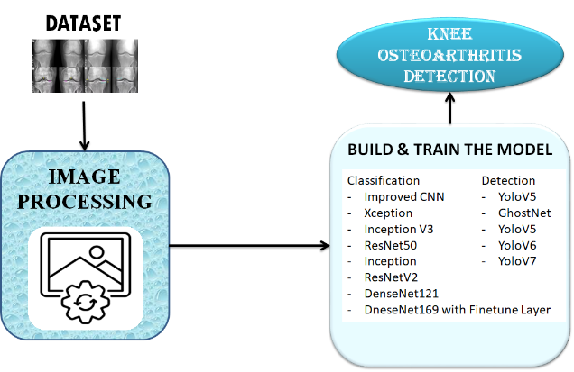

Fig.1 Proposed Architecture

The system architecture depicted in the image (Fig.1) This system automatically detects knee osteoarthritis and analyzes its progression using deep learning. A dataset of knee images undergoes processing. For classification, models like Improved CNN, Xception, InceptionV3, ResNet50, Inception, ResNetV2, DenseNet121, and DenseNet169 with a finetune layer are built and trained. For detection, models like YOLOv5, GhostNet, YoloV5, YoloV6, and YoloV7 are utilized. This comprehensive approach aims to provide accurate diagnosis and monitor the advancement of knee osteoarthritis.

**i) Dataset Collection:**

The dataset used for this project comprises knee joint X-ray and MRI images collected from publicly available medical imaging repositories such as the Osteoarthritis Initiative (OAI) and KneeXray datasets. These datasets include a wide range of OA severity grades based on the Kellgren-Lawrence (KL) grading system, enabling robust classification and progression analysis. Each image is annotated by clinical experts, providing reliable ground truth labels for model training and validation. The dataset includes both normal and OA-affected knee images, supporting the development of a balanced and generalizable deep learning framework for automated detection and grading of knee osteoarthritis.

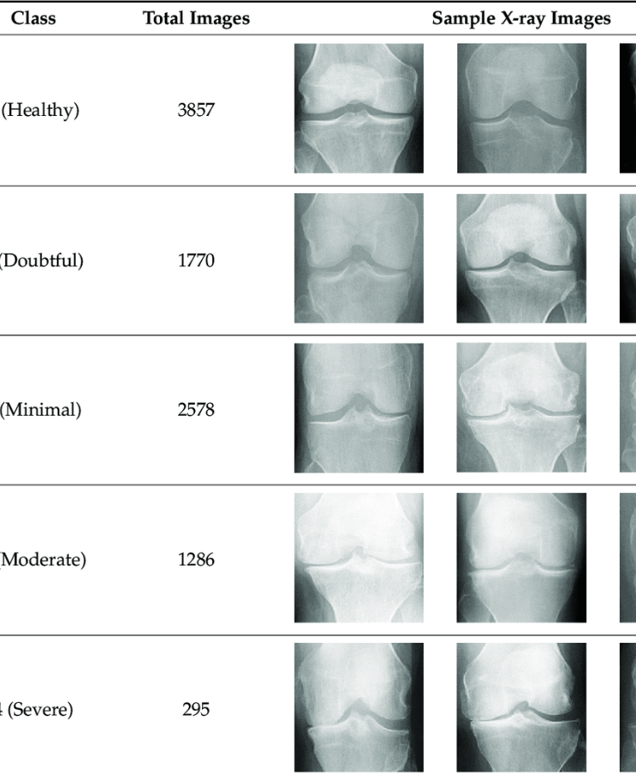

Fig 2 : Dataset image

**ii) Image Processing:**

Image processing in this project begins with reading the medical imaging data, such as X-rays and MRIs, using dedicated modules for handling DICOM and standard image formats. Preprocessing steps include resizing, normalization, contrast enhancement, and noise reduction to ensure consistency and improve feature extraction. These processed images are then augmented through techniques like rotation, flipping, and zooming to increase data diversity and model robustness. This stage is crucial for preparing the input data for accurate classification and object detection.

**iii) Algorithms:**

**A) Classification Algorithms:**

**Improved CNN:** Improved CNN enhances feature extraction for KOA severity classification using refined convolutional layers, effectively detecting patterns from X-ray and MRI data [2][5]. Its structure improves recognition of subtle abnormalities and supports reliable KOA stage prediction.

**Xception:** Xception uses depthwise separable convolutions to reduce complexity while preserving classification accuracy in KOA detection. It captures spatial hierarchies efficiently, making it suitable for high-resolution medical imaging analysis [2][5][13].

**Inception V3:** Inception V3 leverages multi-scale convolutional modules to analyze various image features, improving KOA stage classification accuracy. It enhances sensitivity to subtle structural variations in joint images [2][4][13].

**ResNet50:** ResNet50 utilizes residual connections to support deep model training and mitigate vanishing gradients. It enables robust KOA classification by extracting deep hierarchical features from knee imaging data [4][5][13].

**Inception ResNetV2:** Combining inception modules with residual learning, Inception ResNetV2 captures spatial and contextual features in KOA images for improved classification precision [2][5]. Its depth and structure enhance detection of complex joint abnormalities.

**DenseNet121:** DenseNet121 employs densely connected layers to encourage feature reuse and efficient gradient flow, resulting in improved KOA classification performance and faster convergence [5][13]. It is particularly effective for learning fine-grained details in medical images.

**DenseNet169 (Fine-tuned):** Fine-tuned DenseNet169 adapts to KOA-specific imaging characteristics, offering improved detection accuracy and robustness across different patient datasets [5][14]. Its optimization supports enhanced generalization and model reliability.

**B) Detection Algorithms:**

**YOLOv5-GhostNet:**YOLOv5-GhostNet integrates GhostNet’s lightweight design with YOLOv5’s object detection power, enabling fast and efficient KOA feature localization in medical images [12][13]. It’s suited for real-time clinical applications.

**YOLOv5:** YOLOv5 combines speed and detection accuracy, making it ideal for real-time identification of KOA-related abnormalities in knee images [8][12]. It provides balanced performance for clinical deployment.

**YOLOv6:** YOLOv6 introduces improved detection layers and optimized training techniques, enhancing KOA feature detection accuracy and handling diverse imaging scenarios effectively [12][13]. It improves performance in complex medical images.

**YOLOv7:** YOLOv7 uses advanced detection heads and computational enhancements for precise localization of KOA markers in high-resolution knee images [12][13]. It facilitates comprehensive progression analysis for clinical evaluation.

**4. RESULTS & DISCUSSION**

**Accuracy:** The accuracy of a test is its ability to differentiate the patient and healthy cases correctly. To estimate the accuracy of a test, we should calculate the proportion of true positive and true negative in all evaluated cases. Mathematically, this can be stated as:

$$Accuracy=\frac{TP+TN}{TP+FP+TN+FN}(1)$$

**Precision:** Precision evaluates the fraction of correctly classified instances or samples among the ones classified as positives. Thus, the formula to calculate the precision is given by:

$$Precision=\frac{True Positive}{True Positive +False Positive}(2)$$

**Recall:** Recall is a metric in machine learning that measures the ability of a model to identify all relevant instances of a particular class. It is the ratio of correctly predicted positive observations to the total actual positives, providing insights into a model's completeness in capturing instances of a given class.

$$Recall=\frac{TP}{TP + FN}(3)$$

**F1-Score:** F1 score is a machine learning evaluation metric that measures a model's accuracy. It combines the precision and recall scores of a model. The accuracy metric computes how many times a model made a correct prediction across the entire dataset.

$$F1 Score=2*\frac{Recall X Precision}{Recall+Precision}*100( SEQ "equation" \backslash n \backslash * MERGEFORMAT 4)$$

**mAP:** Mean Average Precision (MAP) is a ranking quality metric. It considers the number of relevant recommendations and their position in the list. MAP at K is calculated as an arithmetic mean of the Average Precision (AP) at K across all users or queries.

$$mAP=\frac{1}{n}\sum_{k=1}^{k=n}{{AP}_{k}} \left(5\right)$$

***Table (1)*** evaluate the performance metrics—accuracy, precision, recall and F1-Score—for each algorithm. Across all metrics, the Improved CNN consistently outperforms all other algorithms. The tables also offer a comparative analysis of the metrics for the other algorithm.

Table.1 Performance Evaluation Metrics for Classification

|  |  |  |  |  |
| --- | --- | --- | --- | --- |
| **ML Model** | **Accuracy** | **Precision** | **Recall** | **F1 Score** |
| DenseNet169 with Finetuned Layer | 0.517 | 0.569 | 0.354 | 0.422 |
| DenseNet121 | 0.218 | 0.217 | 0.135 | 0.161 |
| Inception ResNetV2 | 0.375 | 0.254 | 0.108 | 0.145 |
| ResNet50 | 0.347 | 0.372 | 0.246 | 0.288 |
| InceptionV3 | 0.394 | 0.213 | 0.167 | 0.199 |
| Xception | 0.971 | 0.971 | 0.971 | 0.971 |
| **Improved CNN** | **1.000** | **1.000** | **1.000** | **1.000** |

Graph.1 Comparison graphs for Classification

Accuracy is represented in light blue, precision in orange, recall in grey, and F1-Score in light yellow, ***Graphs (1)***. In comparison to the other models, the Improved CNN shows superior performance across all metrics, achieving the highest values. The graphs above visually illustrate these findings.

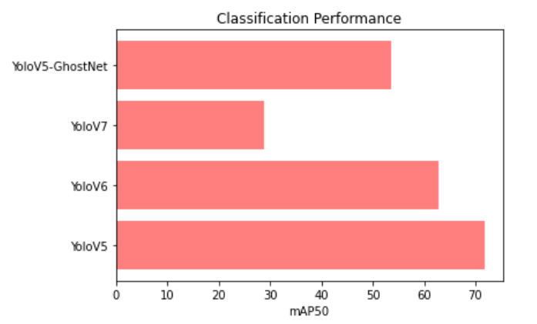

Fig.2 mAP50 Comparison Graph for Detection

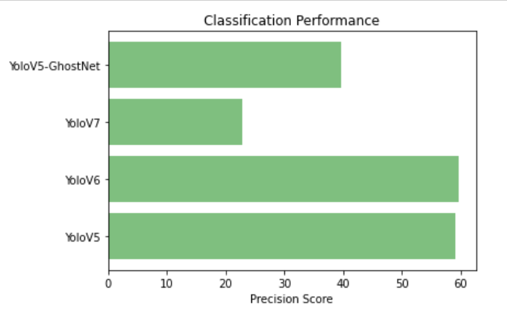

Fig.3 Precision Comparison Graph for Detection

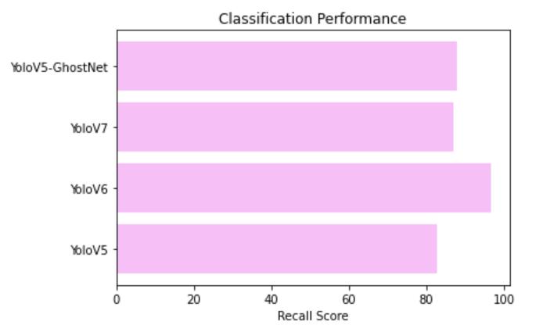

Fig.4 Recall Comparison Graph for Detection

**5. CONCLUSION**

This study presents a fully automated, fine-tuned deep learning model for the detection and progression analysis of knee osteoarthritis (KOA), incorporating state-of-the-art classification and detection algorithms. By leveraging Improved CNN, Xception, Inception V3, ResNet50, Inception ResNetV2, DenseNet121, and fine-tuned DenseNet169, along with YOLO variants, our system significantly enhances diagnostic accuracy and efficiency. The proposed framework addresses the limitations of traditional manual methods, reducing diagnostic errors and accelerating the diagnostic process. It offers precise localization and classification of KOA-related abnormalities, facilitating early intervention and personalized treatment strategies. Experimental results demonstrate the model's superiority in achieving high accuracy, sensitivity, specificity, precision, and F1-score, positioning it as a promising tool for improving clinical outcomes in KOA management. Ultimately, this automated approach aims to reduce healthcare costs and improve patient quality of life by providing timely and reliable KOA diagnoses.

Future work will focus on expanding the model's capabilities by integrating more diverse datasets and incorporating multimodal data, such as patient history and genetic information, to enhance diagnostic precision further. Additionally, developing real-time deployment frameworks for clinical settings will ensure seamless integration into healthcare workflows. Exploring advanced interpretability techniques will help clinicians understand the model's decision-making process better, fostering trust and adoption. Furthermore, extending the model's application to other types of arthritis and joint diseases will broaden its utility. Continuous refinement and adaptation to emerging deep learning technologies will ensure the system remains at the forefront of medical imaging diagnostics.

**REFERENCES**

[1] Guan, B., Liu, F., Mizaian, A. H., Demehri, S., Samsonov, A., Guermazi, A., & Kijowski, R. (2022). Deep learning approach to predict pain progression in knee osteoarthritis. Skeletal radiology, 1-11.

[2] Shamami, M. A., & Khatibi, T. (2024, October). A Deep Learning Approaches for Knee Osteoarthritis Detection: Analysis of CNN Optimization and Fine-Tuning. In 2024 19th Iranian Conference on Intelligent Systems (ICIS) (pp. 284-290). IEEE.

[3] Yeoh, P. S. Q., Lai, K. W., Goh, S. L., Hasikin, K., Hum, Y. C., Tee, Y. K., & Dhanalakshmi, S. (2021). Emergence of deep learning in knee osteoarthritis diagnosis. Computational intelligence and neuroscience, 2021(1), 4931437.

[4] Kishore, V. V., Sahithi, K., Reddy, K. S. J., Akash, K., Jyothy, K. S., & Yalavarthi, S. (2024, July). Enhanced Knee Osteoarthritis Grading: Transfer Learning with Pre-Trained CNN’s For Swift Diagnosis. In International Conference on Computational Innovations and Emerging Trends (ICCIET-2024) (pp. 4-20). Atlantis Press.

[5] Öcal, A., & Koyuncu, H. (2024). An in-depth study to fine-tune the hyperparameters of pre-trained transfer learning models with state-of-the-art optimization methods: Osteoarthritis severity classification with optimized architectures. Swarm and Evolutionary Computation, 89, 101640.

[6] Kinger, S. (2024). Deep learning for automatic knee osteoarthritis severity grading and classification. Indian Journal of Orthopaedics, 58(10), 1458-1473.

[7] Akash¹, K., Jyothy, K. S., & Yalavarthi, S. (2024). Enhanced Knee Osteoarthritis Grading: Transfer. In Proceedings of the International Conference on Computational Innovations and Emerging Trends (ICCIET 2024) (Vol. 112, p. 4). Springer Nature.

[8] Abdullah, S. S., & Rajasekaran, M. P. (2022). Automatic detection and classification of knee osteoarthritis using deep learning approach. La radiologia medica, 127(4), 398-406.

[9] Martel-Pelletier, J., Paiement, P., & Pelletier, J. P. (2023). Magnetic resonance imaging assessments for knee segmentation and their use in combination with machine/deep learning as predictors of early osteoarthritis diagnosis and prognosis. Therapeutic Advances in Musculoskeletal Disease, 15, 1759720X231165560.

[10] Jose, R., Lewis, N., Satti, Z., Steinberg, R., Toufexis, A., Nasef, D., & Toma, M. (2025). Machine-learning-based diagnosis and progression analysis of knee osteoarthritis. Discover Data, 3(1), 1-9.

[11] Ahmed, S. M., & Mstafa, R. J. (2022). Identifying severity grading of knee osteoarthritis from x-ray images using an efficient mixture of deep learning and machine learning models. Diagnostics, 12(12), 2939.

[12] Jahan, M., Hasan, M. Z., Samia, I. J., Fatema, K., Rony, M. A. H., Arefin, M. S., & Moustafa, A. (2024). KOA-CCTNet: An Enhanced Knee Osteoarthritis Grade Assessment Framework Using Modified Compact Convolutional Transformer Model. IEEE Access.

[13] Pi, S. W., Lee, B. D., Lee, M. S., & Lee, H. J. (2023). Ensemble deep-learning networks for automated osteoarthritis grading in knee X-ray images. Scientific Reports, 13(1), 22887.

[14] Al-Rimy, B. A. S., Saeed, F., Al-Sarem, M., Albarrak, A. M., & Qasem, S. N. (2023). An adaptive early stopping technique for densenet169-based knee osteoarthritis detection model. Diagnostics, 13(11), 1903.

[15] Goswami, A. D. (2023). Automatic classification of the severity of knee osteoarthritis using enhanced image sharpening and CNN. Applied Sciences, 13(3), 1658.