**Design and Build my Own EV Powertrain Prototype**

**Introduction:**

This project was developed as the capstone project for EV 201 - Design and Build Your Own EV Powertrain, a course offered by the Pupil First School e-learning platform. The model is designed to emulate the powertrain of an electric vehicle with simple design constraints.

**Overview:**

The model included a self-built motor, a motor controller, and a Battery Management System (BMS). Three IRFZ44N NMOS MOSFETs were used to turn on individual stator coils. The motor is a simple arrangement of three coils wound with 19 SWG wire over an MS bolt this setup formed the stator. Rotor is a two-pole permanent magnet type built using ball bearing and neodymium magnets. Motor controller and BMS controllers are Arduino NANO (ATmega328p) development boards.

BMS included provision to analyse four individual cells and was also equipped with over-temperature shutdown, under-voltage, and over-voltage cutoff protections. The I2C protocol was used to facilitate communication between modules, which mimicked a CAN bus-based system with some trade-offs.

**Motor controller circuit:**

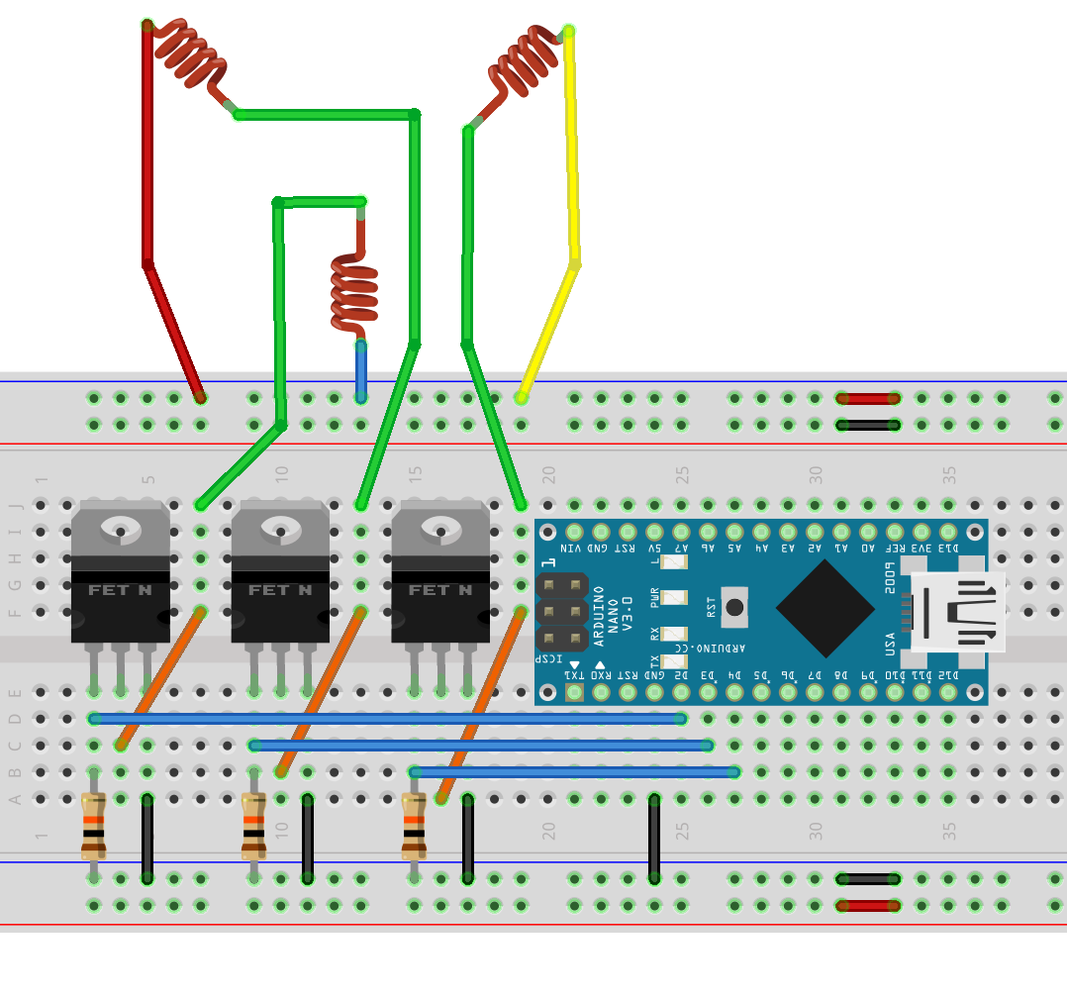

**Working:**

The motor controller algorithm adjusts the motor speed according to the information provided by BMS and to user inputs. A priority-centred system is utilized for decision-making to avoid conflict between system parameters. Motor speed is set to three various levels (low, medium, and high), which are decided by the battery temperature, battery voltage, and user input (in the same order as priority). Under critical conditions of very low battery voltages or very high battery temperatures, the motor is automatically shut down by the controller.

**Overview of the entire system:**

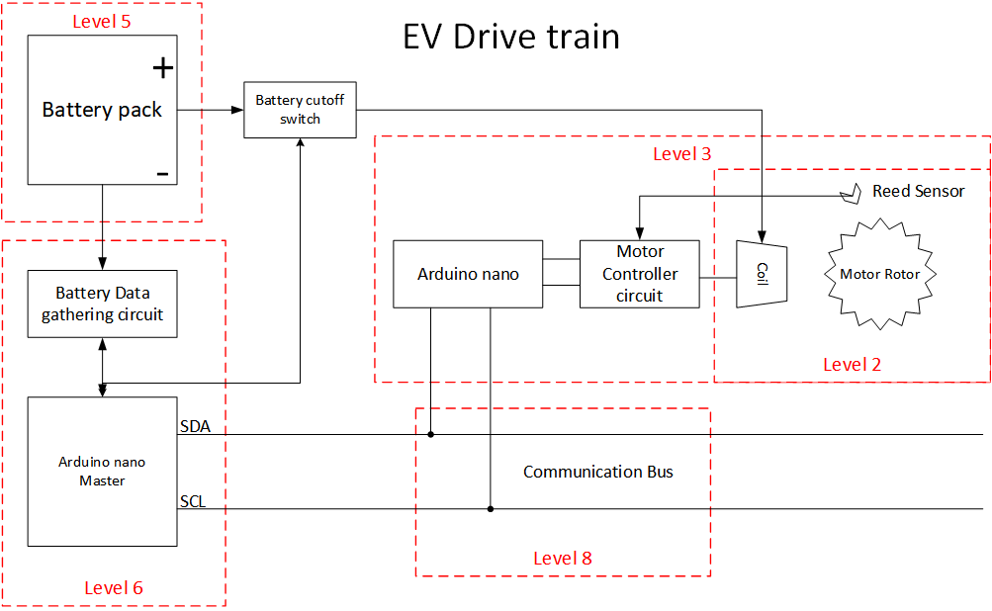

**Pros:** Simpler design and faster response of the system.

**Cons:** For the simplicity of the design, an open loop configuration is implemented, which is very different from an EV perspective. The motor controller is not equipped with any feedback mechanisms from the motor. This caused erratic initiation and stalling of the rotor.

**Skills**: Testing · Electronics · Electronic Engineering · Electrical Engineering · Power Electronics · Project Management · Time Management · Problem Solving · C (Programming Language) · Circuit Design