Lab2)

**Design:**

module mult_if(a, b, c, d, sel, z);

input a, b, c, d;

input [3:0] sel;

output z;

reg z;

always @(a or b or c or d or sel)

begin

z = 0;

if (sel[0]) z = a;

if (sel[1]) z = b;

if (sel[2]) z = c;

if (sel[3]) z = d;

end

endmodule

**Schematic**

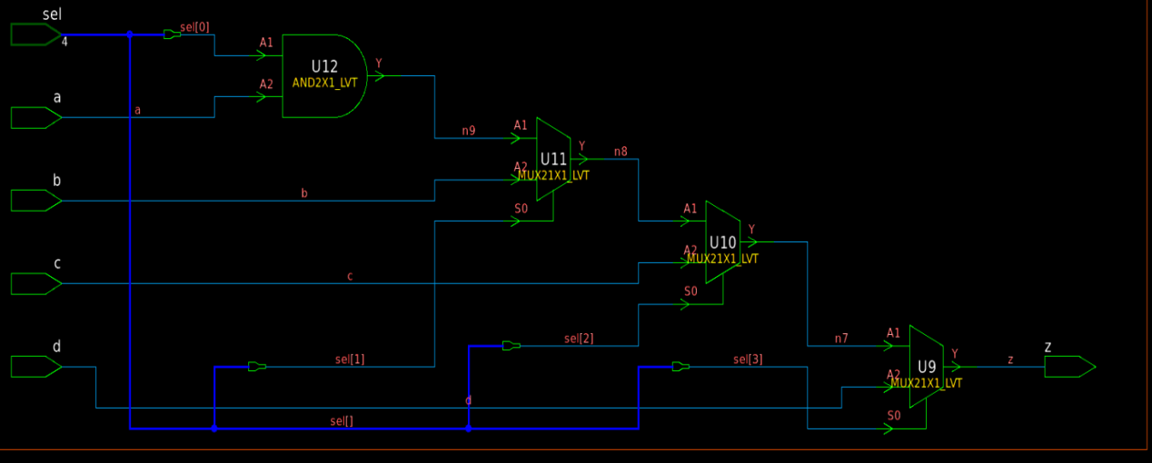

In the synthesized design of lab2, the inputs to the first SELECT_OP in the chain  
(sel[0] and a or 0) have the longest delay to the output z. The inputs  
to the last SELECT_OP in the chain (sel[3] and d) have the shortest  
delay to the output.

Lab3)

Design

module mult_if_improved(a, b_is_late, c, d, sel, z);

input a, b_is_late, c, d;

input [3:0] sel;

output z;

reg z, z1;

always @(a or b_is_late or c or d or sel)

begin

z1 = 0;

if (sel[0])

z1 = a;

if (sel[2])

z1 = c;

if (sel[3])

z1 = d;

if (sel[1] & ~(sel[2]|sel[3]))

z = b_is_late;

else

z = z1;

end

Endmodule

Schematic

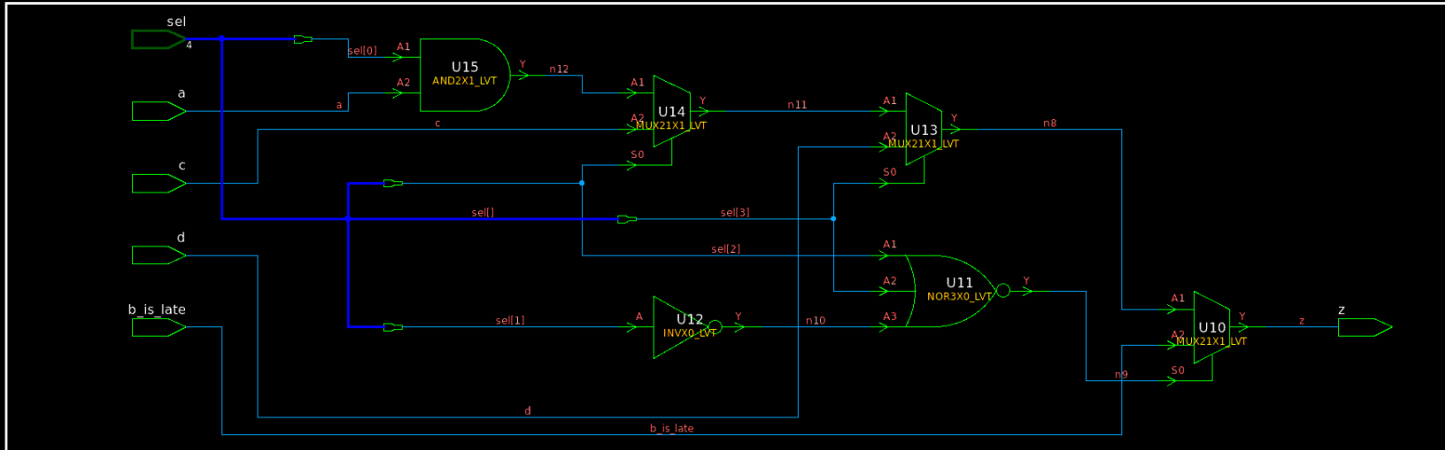

Lab4)

Design:

module single_if(a, b, c, d, sel, z);  
input a, b, c, d;  
input [3:0] sel;  
output z;  
reg z;  
always @(a or b or c or d or sel)  
begin  
z = 0;  
if (sel[3])  
z = d;  
else if (sel[2])  
z = c;  
else if (sel[1])  
z = b;  
else if(sel[0])  
z = a;  
end  
endmodule

schematic:

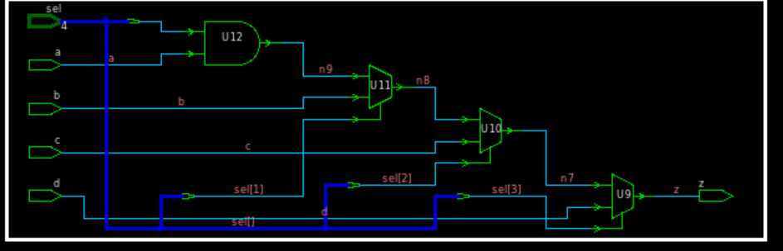

Lab 5)

Design:

module case1(a, b, c, d, sel, z);  
input a, b, c, d;  
input [3:0] sel;  
output z;  
reg z;  
always @(a or b or c or d or sel)  
begin  
casex (sel)  
4’b1xxx: z = d;  
4’bx1xx: z = c;  
4’bxx1x: z = b;  
4’bxxx1: z = a;  
default: z = 1’b0;  
endcase  
end  
endmodule

Schematic:

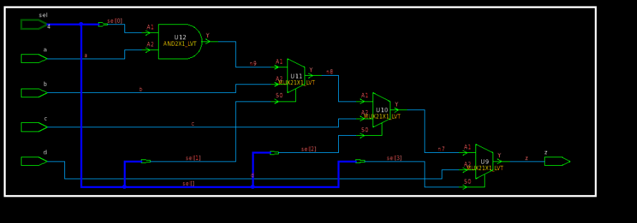

Lab 6)

Design:  
module case_in_if_01(A, DATA_is_late_arriving, C, sel, Z);  
input [8:1] A;  
input DATA_is_late_arriving;  
input [2:0] sel;  
input [5:1] C;  
output Z;  
reg Z;  
always @ (sel or C or A or DATA_is_late_arriving)  
begin  
if (C[1])  
Z = A[5];  
else if (C[2] == 1’b0)  
Z = A[4];  
else if (C[3])  
Z = A[1];  
else if (C[4])  
case (sel)  
3’b010: Z = A[8];  
3’b011: Z = DATA_is_late_arriving;  
3’b101: Z = A[7];  
3’b110: Z = A[6];  
default: Z = A[2];  
endcase  
else if (C[5] == 1’b0)  
Z = A[2];  
else  
Z = A[3];  
end  
endmodule

Schematic

