**DETECTION OF BRAIN TUMOR**

**This project is a Flask web application for detecting brain tumors from MRI images using a deep learning model built with PyTorch. Users can upload MRI images through the app, and the model will classify them as either tumor or non-tumor. The goal of this project is to provide an intuitive interface for medical professionals to quickly identify potential brain tumors.**

**LANGUAGE :** Machine Learning

**TOOLS :** ANACONDA NAVIGATOR

JUPYTER NOTEBOOK

**Create an app for detecting brain tumors with MRI images.**

**END TO END PROCESS:**

1. **Data Loading**: Load MRI images for training, validation, and testing.
2. **Data Preprocessing**: Apply normalization, resizing, and augmentation techniques.
3. **Model Building**: Build a Convolutional Neural Network (CNN) using PyTorch to classify the MRI images.
4. **Model Training:** Train the model on GPU (if available) to detect brain tumors.
5. **Flask Web Application**: Develop a Flask app for user interaction, allowing image uploads for tumor detection.
6. **Model Deployment**: Deploy the trained model within the Flask ap
7. **Prediction**: Provide real-time predictions through the Flask web app.

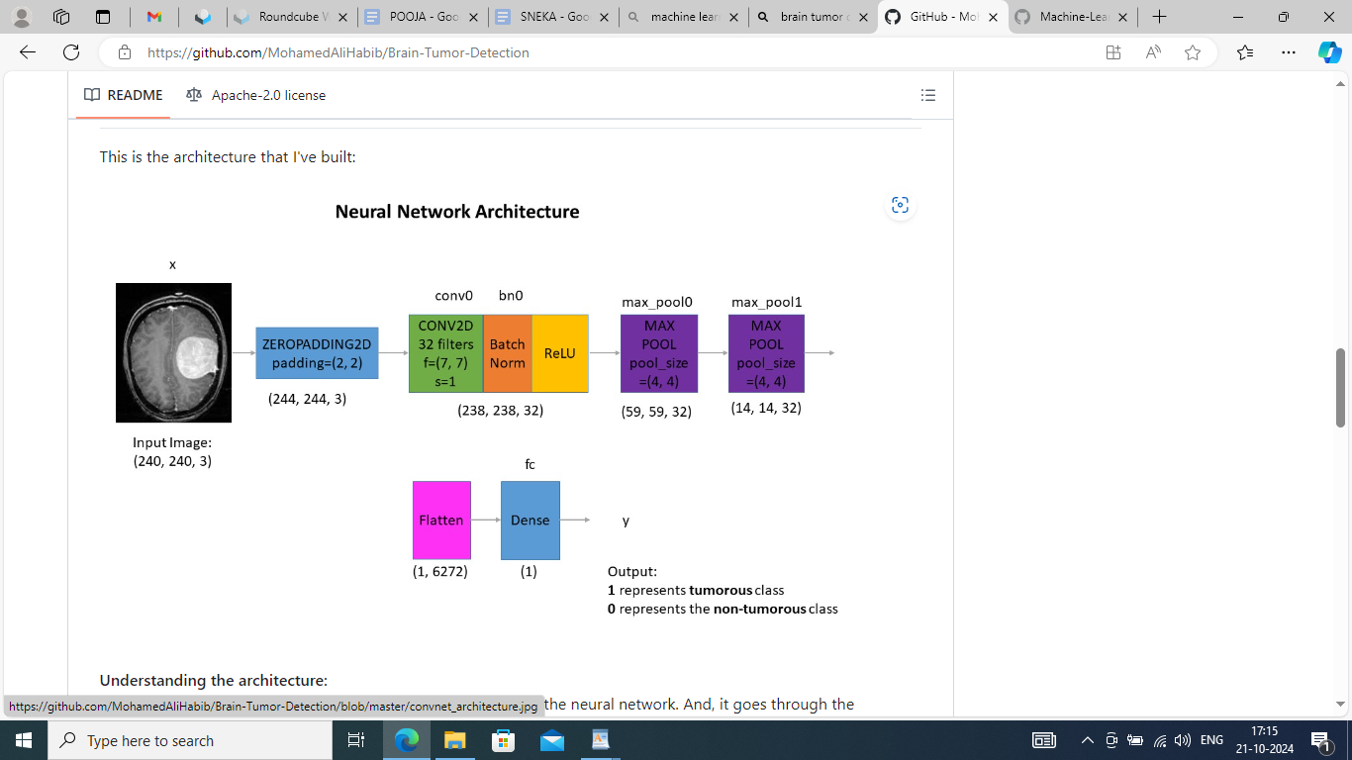

**MODULES:**

**HOME**

**PATIENT LOGIN**

**DOCTOR LOGIN**

**DETECTION PAGE**