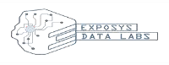Exposys Data Labs

Certificate of Internship

**TO WHOM IT MAY CONCERN**

This is to certify that **Mr. PRAJWAL B S** has completed internship programme on **“Web Developer”** from 09.02.2022 to 08.03.2022.

He took keen interest in the work assigned and successfully completed it. During the period of internship we found him to be punctual, hardworking and inquisitive.

We wish him luck and success in all his future endeavours.



**Y Vishnuvardhan**

Chief Director

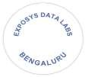[hr@exposysdata.com](mailto:hr@exposysdata.com) [www.exposysdata.com](http://www.exposysdata.com/)