



IBPS SO IT Officer Mains Memory Based 2023 Held on 28 January 2024
Q1. In indirect addressing mode, what does the address field of an instruction contain?
(a) The effective address of the operand directly
(b) The operand value itself
(c) The address of a memory location that stores the effective address (d) The address stored in the program counter
(e) The register number containing the operand
Ans.(c)
Q2. What will be the output of the following Java code snippet that calculates the length of a string without using the built-in length() method?
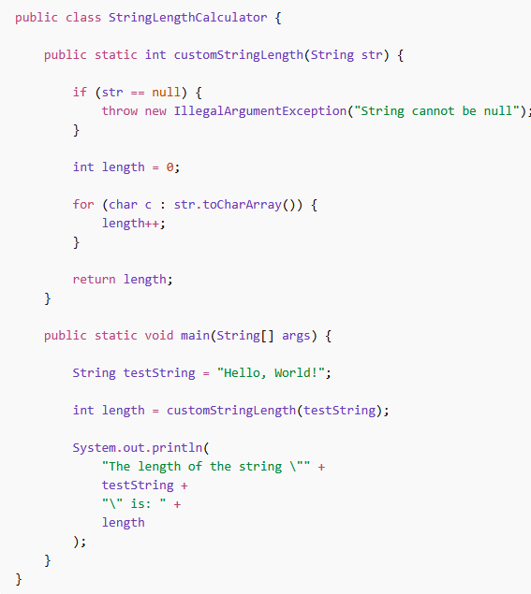
(a) The length of the string "Hello, World!" is: 13
(b) The length of the string "Hello, World!" is: 12
(c) Compilation Error
(d) Runtime Error: String cannot be null
(e) The length of the string "Hello, World!" is: 14
Ans.(a)
1







Q3. Which process is used to convert a grayscale image into a binary image, and which edge detection algorithm is well known for using gradient calculation along with non-maximum suppression and hysteresis thresholding?
(a) Thresholding, Laplacian
(b) Quantization, Sobel
(c) Sampling, Prewitt
(d) Thresholding, Canny
(e) Compression, Roberts
Ans.(d)
Q4. Which grayscale conversion approach generates a grayscale image by assigning equal importance to all three RGB components?
(a) Weighted luminance transformation
(b) Unweighted averaging of the RGB channels
(c) Edge-based grayscale transformation
(d) Alpha-transparency mapping
(e) Contrast-normalized grayscale encoding
Ans.(b)
Q5. Which of the following statements correctly describe the return values of the fork() system call in a Unix-like operating system?
(a) 0 to the child process and a positive value (child’s PID) to the parent process (b) 1 to the child process and 0 to the parent process
(c) A negative value if the fork fails
(d) Both (a) and (c)
(e) None of the above
Ans.(d)
Q6. Convert the hexadecimal number 1B0 into its binary equivalent. (a) 000110110000
(b) 001011100000
(c) 000101110000
(d) 000110101000
(e) 000100110000
Ans.(a)
Q7. Which of the following operators has the highest precedence in C++?
(a) Addition (+)
(b) Logical AND (&&)
(c) Multiplication (*)
(d) Function call operator (())
(e) Assignment (=)
Ans.(d)
2





Q8. What will be the output of the following C++ code snippet?
#include <iostream>
using namespace std;
int main() {
int a = 25, b = 14;
cout << a << " + " << b << " = " << a + b;
return 0;
}
(a) 14 + 12 = 25
(b) 14 - 0 = 14
(c) 25 + 14 = 39
(d) Compilation Error
(e) Syntax Error
Ans.(c)
Q9. Assuming each arithmetic and output operation takes constant time, what is the overall time complexity of the following code?
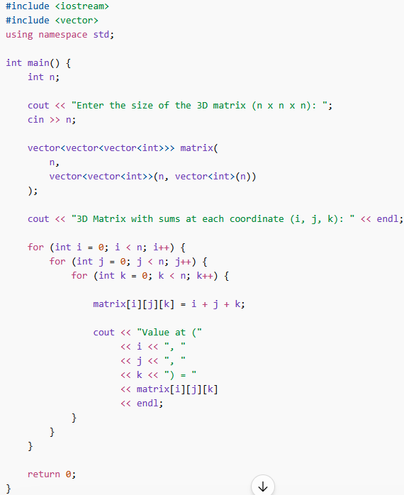
3





(a) O(n)
(b) O(n²)
(c) O(n³)
(d) O(n log n)
(e) O(log n)
Ans.(c)
Q10. Which TCP port is traditionally assigned as the standard default port for unencrypted SMTP communication between mail servers?
(a) 80
(b) 25
(c) 110
(d) 143
(e) 465
Ans.(b)
Q11. Which data structure is most commonly used to support Last-In-First-Out (LIFO) behavior required for UNDO and REDO operations in text editors?
(a) Queue
(b) Stack
(c) Linked List
(d) Heap
(e) Hash Table
Ans.(b)
Q12. What is the process of converting a grayscale or color image into a binary image containing only two possible pixel intensity values called?
(a) Binarization
(b) Image Enhancement
(c) Grayscale Conversion
(d) Quantization
(e) Segmentation
Ans.(a)
Q13. Which of the following statements is TRUE regarding the COCOMO?
(a) COCOMO completely ignores cost drivers such as hardware and personnel factors.
(b) COCOMO is mainly designed for managing Agile sprint backlogs and scrum cycles. (c) Intermediate COCOMO refines software effort estimation using cost drivers.
(d) COCOMO estimates software quality using normalization and dependency analysis only.
(e) COCOMO is primarily used for real-time packet scheduling in operating systems.
Ans.(c)
Q14. Which command in Linux is used to estimate and display the disk space usage of files and directories? (a) ls
4





(b) df
(c) du
(d) top
(e) mkdir
Ans.(c)
Q15. Which of the following statements is true regarding a Foreign Key in a relational database? (a) A foreign key uniquely identifies every record in a table.
(b) A foreign key is primarily used to sort records in ascending order.
(c) A foreign key establishes a relationship between two tables using referenced values. (d) A foreign key must always contain only unique values.
(e) A foreign key cannot contain duplicate or NULL values.
Ans.(c)
Q16. What is the maximum file size supported by the original Macintosh Hierarchical File System (HFS)? (a) 2 GB
(b) 4 GB
(c) 8 GB
(d) 16 GB
(e) 32 GB
Ans.(a)
Q17. Which of the following is primarily classified as a high-level scripting language rather than a low-level or system programming language?
(a) Assembly
(b) C
(c) Perl
(d) C++
(e) Machine Language
Ans.(c)
Q18. A software company is developing a banking application where all requirements are finalized before development begins, and client involvement after the requirement phase is minimal. The development process follows a strictly linear sequence in which each phase must be completed before the next phase starts.
Which software development model is most suitable for this project?
(a) Agile
(b) Waterfall
(c) Spiral
(d) V-Model
(e) Prototyping
Ans.(b)
Q19. What will be the output of the following C++ program?
5





#include <iostream>
#include <stack>
using namespace std;
void insertBottom(stack<int>& s, int x) {
if (s.empty()) {
s.push(x);
return;
}
int t = s.top();
s.pop();
insertBottom(s, x);
s.push(t);
}
void reverseStack(stack<int>& s) {
if (s.empty())
return;
int t = s.top();
s.pop();
reverseStack(s);
insertBottom(s, t);
}
void printStack(stack<int> s) {
while (!s.empty()) {
cout << s.top() << " ";
s.pop();
}
}
int main() {
stack<int> s;
s.push(34);
s.push(25);
s.push(58);
s.push(96);
s.push(12);
reverseStack(s);
cout << "Reversed Stack: ";
printStack(s);
return 0;
}
(a) Reversed Stack: 12 96 58 25 34
(b) Reversed Stack: 34 25 58 96 12
(c) Reversed Stack: 25 34 58 96 12
(d) Reversed Stack: 96 58 25 34 12
(e) Compilation Error
6





Ans.(b)
Q20. Consider the following processes, all arriving at time 0, with their respective burst times:
Process | Burst Time (ms)
P1 | 6
P2 | 8
P3 | 7
P4 | 3
Using Non-Preemptive Shortest Job First (SJF) scheduling, calculate the average waiting time. (a) 7.0 ms
(b) 5.5 ms
(c) 6.25 ms
(d) 5.0 ms
(e) 6.0 ms
Ans.(a)
Q21. If two attributes, P and Q, satisfy the functional dependencies P → Q and Q → P, then they exhibit: (a) Partial Dependency
(b) Full Functional Dependency
(c) Transitive Dependency
(d) Multivalued Dependency
(e) Mutual Functional Dependency
Ans.(e)
Q22. Which primary function of a hypervisor (Virtual Machine Manager) involves ensuring efficient distribution and management of CPU, memory, and storage resources among virtual machines?
(a) Virtual Machine Isolation
(b) Hardware Emulation
(c) Resource Allocation
(d) Network Virtualization
(e) Snapshot Management
Ans.(c)
Q23. In an operating system, where are newly submitted processes typically stored before they are admitted into main memory for execution?
(a) Job Pool
(b) Process Table
(c) Ready Queue
(d) Cache Memory
(e) Stack
Ans.(a)
Q24. Which SQL operator is used to filter rows by checking whether a value matches any value in a specified list?
7





(a) BETWEEN
(b) IN
(c) LIKE
(d) EXISTS
(e) DISTINCT
Ans.(b)
Q25. Which of the following statements regarding mutual exclusion in operating systems is false? (a) No two processes can execute in their critical sections simultaneously.
(b) Multiple processes can safely access a shared critical resource simultaneously without synchronization.
(c) Processes outside the critical section should not interfere with processes inside the critical section. (d) Mutual exclusion helps prevent race conditions during shared resource access.
(e) Only one process is allowed to access a critical resource at a time.
Ans.(b)
Q26. According to Fitts's Law, what factor significantly affects the time required to move a cursor to a target on the screen?
(a) The color of the target
(b) The size of the cursor
(c) The distance to the target and the size of the target (d) The screen resolution
(e) The type of input device used
Ans.(c)
Q27. Which of the following is the most fundamental benefit provided by inheritance in object-oriented programming?
(a) Faster execution of programs
(b) Enhanced code readability
(c) Increased code reusability
(d) Simplified debugging process
(e) Improved memory management
Ans.(c)
Q28. Which of the following best describes the function of the z-index property in CSS? (a) It determines the horizontal position of an element.
(b) It specifies the vertical position of an element.
(c) It controls the stacking order of elements along the z-axis. (d) It adjusts the opacity of an element.
(e) It sets the font size of an element.
Ans.(c)
Q29. Which of the following is an aggregate function in SQL? (a) CONCAT()
(b) AVG()
8





(c) SUBSTRING()
(d) LENGTH()
(e) NOW()
Ans.(b)
Q30. Which of the following statements regarding Super Key and Primary Key is incorrect? (a) Every primary key is a super key.
(b) A super key may contain additional attributes not required for unique identification. (c) A table can have multiple super keys.
(d) Every super key is selected as the primary key of a table.
(e) A primary key uniquely identifies each record in a table.
Ans.(d)
Q31. Which of the following is a valid use of the netsh command in Windows? (a) To modify network interface settings.
(b) To create a new directory.
(c) To open the Task Manager.
(d) To install a software application.
(e) To check the system temperature.
Ans.(a)
Q32. Consider the following Java code snippet:
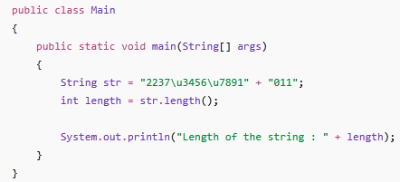
What will be the output of the program?
(a) Length of the string : 19
(b) Length of the string : 13
(c) Length of the string : 17
(d) Length of the string : 9
(e) Compilation Error
Ans.(d)
Q33. Which type of DDoS attack uses spoofed ICMP echo requests sent to broadcast addresses, causing multiple systems to flood the victim with ICMP reply packets?
(a) SYN Flood
(b) Ping of Death
9





(c) Smurf Attack
(d) DNS Amplification
(e) UDP Flood
Ans.(c)
Q34. Which of the following statements regarding the #define directive in C is incorrect? (a) #define can be used to create symbolic constants.
(b) #define can define function-like macros with parameters.
(c) Macros created using #define are expanded by the preprocessor before compilation. (d) #define can be used to create multi-line macros using the backslash () continuation character. (e) #define macros provide automatic type checking similar to C functions.
Ans.(e)
Q35. Which of the following commands in Linux is primarily used for network scanning and security auditing?
(a) netset
(b) tcpdump
(c) ifconfig
(d) nmap
(e) traceroute
Ans.(d)
Q36. In MongoDB, which feature is particularly useful for ensuring data availability and reliability in case of hardware failure or network issues?
(a) Sharding
(b) Indexing
(c) Replication
(d) Aggregation
(e) Caching
Ans.(c)
Q37. Identify the local link address from the following IPv6 addresses: (a) 2001:0db8:abcd:0012:0000:0000:0000:0001
(b) FE80:0000:0000:0000:0202:B3FF:FE1E:8329
(c) FF02:0000:0000:0000:0000:0000:0000:0001
(d) ::1
(e) 2001:4860:4860::8888
Ans.(b)
Q38. If set A has 4 elements and set B has 5 elements, then find the total number of elements in the Cartesian product A×B:
(a) 9
(b) 45
(c) 20
10





(d) 54
(e) None of the above
Ans.(c)
Q39. Salesforce CRM is an example of which cloud service model?
(a) Infrastructure as a Service (IaaS)
(b) Platform as a Service (PaaS)
(c) Software as a Service (SaaS)
(d) Database Management System (DBMS)
(e) None of the above
Ans.(c)
Q40. How is the salting technique used in hashing for enhanced security?
(a) It converts plain text into hashed text using the MD5 algorithm without adding any extra data. (b) It adds a random value to the input data before hashing to make each hash unique.
(c) It encrypts the hashed data using a symmetric encryption algorithm.
(d) It stores the hash directly without any modification or additional data.
(e) It compresses the hash to reduce storage space.
Ans.(b)
Q41. If you are unable to connect to a website despite having a working internet connection, which of the following is most likely the reason?
(a) DNS server is down or misconfigured
(b) The website’s IP address has changed recently
(c) Browser cache is not cleared
(d) Incorrect firewall settings
(e) Outdated operating system
Ans.(a)
Q42. What happens during a cache hit in a computer system?
(a) Data is transferred directly to the hard drive
(b) Data is fetched from main memory into the cache
(c) Requested data is retrieved directly from the cache memory (d) Data is permanently stored in the cache
(e) The cache memory is cleared
Ans.(c)
Q43. Which of the following Excel formulas performs a calculation only when cell A1 contains a value-type entry, and otherwise returns 0?
(a) =IF(CELL("contents",A1)="v",A1*2,0)
(b) =IF(CELL("format",A1)="v",A1*2,0)
(c) =IF(CELL("type",A1)="v",A1*2,0)
(d) =IF(CELL("address",A1)="v",A1*2,0)
(e) =IF(CELL("col",A1)="v",A1*2,0)
11





Ans.(c)
Q44. Which of the following is a condition that occurs in computer systems when the system spends more time in swapping data between RAM and the hard drive than executing actual tasks?
(a) Deadlock
(b) Thrashing
(c) Starvation
(d) Fragmentation
(e) Bottleneck
Ans.(b)
Q45. Under standard DBMS transaction theory used in basic SQL classification, which of the following commands is generally rollback-able before COMMIT?
(a) SELECT
(b) COMMIT
(c) DELETE
(d) CREATE
(e) ALTER
Ans.(c)
Q46. What is the tcpdump command in Linux used for? (a) To capture and analyze network packets.
(b) To display disk usage statistics.
(c) To monitor CPU and memory usage.
(d) To manage user accounts.
(e) To create and manage cron jobs.
Ans.(a)
Q47. In a relational database, which term represents a missing, unknown, or unavailable attribute value? (a) Empty table
(b) Derived value
(c) Null value
(d) Default value
(e) Zero value
Ans.(c)
Q48. Consider the following C code snippet:
12





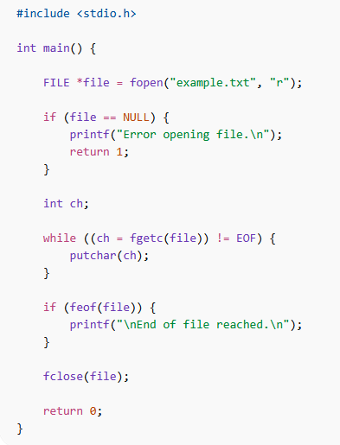
What is the purpose of the feof(file) function call in this program?
(a) To read the next character from the file stream
(b) To determine whether the end-of-file indicator for the file stream has been set (c) To close the file after all characters are read
(d) To move the file pointer to the beginning of the file
(e) To open the file in read mode
Ans.(b)
Q49. A Class B network with default mask /16 is subnetted using the mask /20. Assuming modern subnetting rules where subnet-zero is allowed, how many subnets are created?
(a) 8
(b) 16
(c) 32
(d) 64
(e) 256
Ans.(b)
13





Q50. Which feature of an L2 switch allows network administrators to segment a network into multiple broadcast domains, each behaving like a separate network?
(a) Spanning Tree Protocol (STP)
(b) Port Mirroring
(c) VLAN (Virtual Local Area Network)
(d) Link Aggregation
(e) QoS (Quality of Service)
Ans.(c)
Q51. Which of the following RF connectors is commonly used with coaxial cables for high-frequency signal transmission?
(a) BNC
(b) HDMI
(c) RJ45
(d) DVI
(e) PS/2
Ans.(a)
Q52. A repeater works at which of the following layers in the OSI model?
(a) Physical Layer
(b) Data Link Layer
(c) Network Layer
(d) Transport Layer
(e) Application Layer
Ans.(a)
Q53. Which statement correctly describes the functionality of the var_dump() function in PHP? (a) It assigns default values to one or more variables during execution.
(b) It dumps information about one or more variables, including their type and value. (c) It formats and logs error messages for debugging purposes.
(d) It creates a new variable and sets its data type automatically.
(e) It initializes arrays and objects for further processing.
Ans.(b)
Q54. Which of the following functions is not declared in <stdio.h>? (a) printf()
(b) scanf()
(c) fopen()
(d) sqrt()
(e) fprintf()
Ans.(d)
Q55. Which sorting algorithm has a worst-case time complexity of O(n2)? (a) Merge Sort
14





(b) Radix Sort
(c) Bubble Sort
(d) Heap Sort
(e) None of the above
Ans.(c)
Q56. What is the maximum number of elements present simultaneously in the operand stack while evaluating the postfix expression:
6 2 3 + - 3 8 2 / + *
(a) 1
(b) 2
(c) 3
(d) 4
(e) None of the above
Ans.(d)
Q57. Which of the following algorithms is not used for finding a Minimum Spanning Tree ?
(a) Kruskal's Algorithm
(b) Prim's Algorithm
(c) Boru vka's Algorithm
(d) Bellman-Ford Algorithm
(e) Reverse-Delete Algorithm
Ans.(d)
Q58. Which ACID property ensures that a transaction brings the database from one valid state to another, maintaining all predefined rules?
(a) Atomicity
(b) Consistency
(c) Isolation
(d) Durability
(e) None of the above
Ans.(b)
Q59. Which schema model is widely used in traditional data warehouse design for organizing fact tables and dimension tables?
(a) Star schema
(b) Mesh schema
(c) Hierarchical schema
(d) Graph schema
(e) None of the above
Ans.(a)
Q60. Which authorization framework is commonly used in modern web applications to enable token-based access and is often integrated into Single Sign-On (SSO) systems?
15







(a) Secure Sockets Layer
(b) Kerberos
(c) OAuth 2.0
(d) Lightweight Directory Access Protocol
(e) Transport Layer Security
Ans.(c)
16

