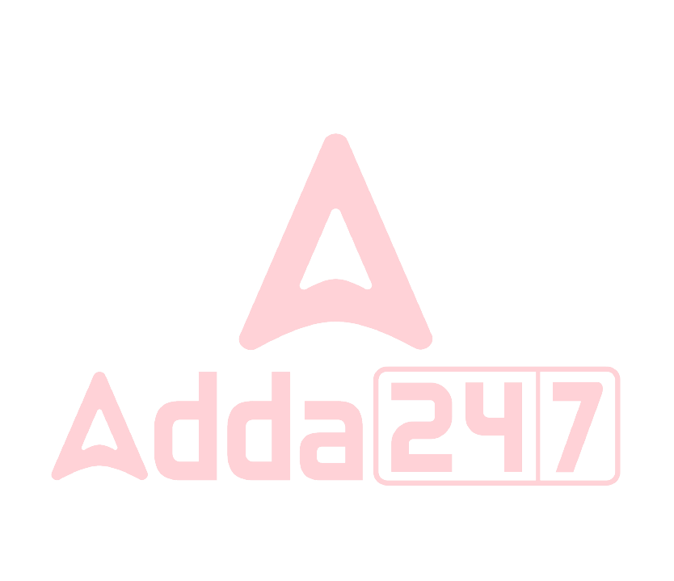

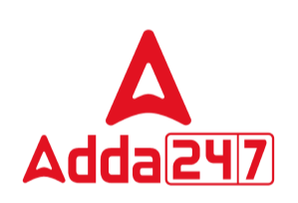



 | IBPS SO Prelims 2024 Memory Based Paper 09-Nov-2024-1st shift
Q1. | What is the underlying cause of a spark's occurrence?
Read the following passage and answer the following questions.
A spark is essentially an electric charge flying in the air between two points, one of which has a large quantity of surplus electrons while the other has too few. This difference in quantities of electrons can happen due to many reasons. Sometimes people have engineered it this way using chemicals: the simplest example is the battery that we use in everything from remote-controls to electric vehicles.
A point with a large number of surplus electrons is called the negative terminal (since electrons are negatively charged) and a point that is deficient of electrons is the positive terminal. This is why you see ‘+’ and ‘-’ signs marked on every battery. In most situations – and unlike some people – electrons are extremely equitable in nature and dislike this difference in their quantities. So, given an opportunity, they will travel from a place where they are more in number to a place where they are fewer in number. This is why current flows when we attach a wire between the two ends of a battery, and in the process we make our fans move, or bulbs light up, etc. However, if we don’t attach a wire and the electrons still want to move, what will they do?
If the gap between the surplus and the deficiency of electrons becomes too extreme, at some point, these electrons will lose all patience and decide to fly through the air, disrupting everything in between. This is not very dissimilar to human society. Sometimes, you might notice that something upsets people slowly over time, and then suddenly, there is a surprisingly large bit of unrest.
To be able to break out like this, electrons first need to break up air molecules mid-air, creating ions (charged atoms). In addition, many electrons inside the atoms are also pulled out, creating free electrons in the air. All this creates a region through which electrons can easily move – as if they have made a wire for themselves in thin air! And when they travel on this path, we see it as a spark.
Clouds are charged objects. When they move over large distances and collide with other clouds, they get more and more charged. At some point, this charge becomes too much for the clouds to hold, and breaks out as the lightning that we see (followed by the thunder that we hear).
(a) The flow of electrons, from a point with an excess of electrons to a point with a shortage of electrons.
(b) Chemical reactions within batteries
(c) Electromagnetic induction between two points
(d) Friction between materials generating static electricity
(e) Ionization of air molecules due to extreme temperature changes
Q2. How do electrons create a pathway for themselves in thin air without a physical wire?
Read the following passage and answer the following questions.
A spark is essentially an electric charge flying in the air between two points, one of which has a large quantity of surplus electrons while the other has too few. This difference in quantities of electrons can happen due to many reasons. Sometimes people have engineered it this way using chemicals: the simplest example is the battery that we use in everything from remote-controls to electric vehicles.
A point with a large number of surplus electrons is called the negative terminal (since electrons are negatively charged) and a point that is deficient of electrons is the positive terminal. This is why you see ‘+’ and ‘-’ signs marked on every battery. In most situations – and unlike some people – electrons are extremely equitable in nature and dislike this difference in their quantities. So, given an opportunity, they will travel from a place where they are more in number to a place where they are fewer in number. This is why current flows when we attach a wire between the two ends of a battery, and in the process we make our fans move, or bulbs light up, etc. However, if we don’t attach a wire and the electrons still want to move, what will they do?
If the gap between the surplus and the deficiency of electrons becomes too extreme, at some point, these electrons will lose all patience and decide to fly through the air, disrupting everything in between. This is not very dissimilar to human society. Sometimes, you might notice that something upsets people slowly over time, and then suddenly, there is a surprisingly large bit of unrest.
To be able to break out like this, electrons first need to break up air molecules mid-air, creating ions (charged atoms). In addition, many electrons inside the atoms are also pulled out, creating free electrons in the air. All this creates a region through which electrons can easily move – as if they have made a wire for themselves in thin air! And when they travel on this path, we see it as a spark.
1 | www.careerpower.in | Adda247 App 

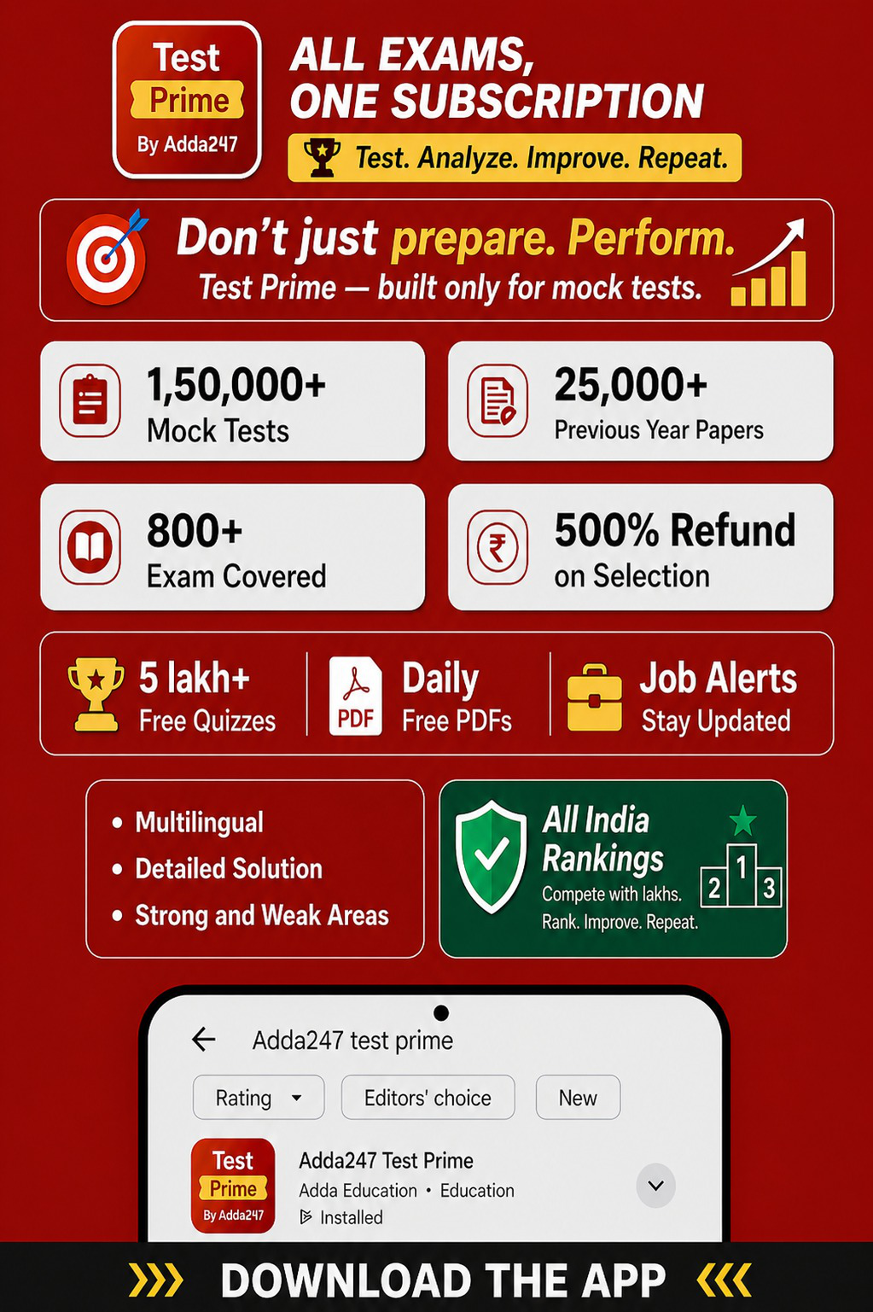







Clouds are charged objects. When they move over large distances and collide with other clouds, they get more and more charged. At some point, this charge becomes too much for the clouds to hold, and breaks out as the lightning that we see (followed by the thunder that we hear).
(a) They generate a magnetic field that guides their movement
(b) They create a temporary conductive path by breaking up air molecules and forming ions (c) They undergo a transformation into positively charged particles and repel each other (d) They induce a flow of electrons in nearby objects, connecting the two points
(e) They attract additional electrons from the surroundings to create a conducting channel
Q3.  Q4. | When does a spark occur in a battery?  Read the following passage and answer the following questions.  A spark is essentially an electric charge flying in the air between two points, one of which has a large quantity of surplus electrons while the other has too few. This difference in quantities of electrons can happen due to many reasons. Sometimes people have engineered it this way using chemicals: the simplest example is the battery that we use in everything from remote-controls to electric vehicles.  A point with a large number of surplus electrons is called the negative terminal (since electrons are negatively charged) and a point that is deficient of electrons is the positive terminal. This is why you see ‘+’ and ‘-’ signs marked on every battery. In most situations – and unlike some people – electrons are extremely equitable in nature and dislike this difference in their quantities. So, given an opportunity, they will travel from a place where they are more in number to a place where they are fewer in number. This is why current flows when we attach a wire between the two ends of a battery, and in the process we make our fans move, or bulbs light up, etc. However, if we don’t attach a wire and the electrons still want to move, what will they do?  If the gap between the surplus and the deficiency of electrons becomes too extreme, at some point, these electrons will lose all patience and decide to fly through the air, disrupting everything in between. This is not very dissimilar to human society. Sometimes, you might notice that something upsets people slowly over time, and then suddenly, there is a surprisingly large bit of unrest.  To be able to break out like this, electrons first need to break up air molecules mid-air, creating ions (charged atoms). In addition, many electrons inside the atoms are also pulled out, creating free electrons in the air. All this creates a region through which electrons can easily move – as if they have made a wire for themselves in thin air! And when they travel on this path, we see it as a spark.  Clouds are charged objects. When they move over large distances and collide with other clouds, they get more and more charged. At some point, this charge becomes too much for the clouds to hold, and breaks out as the lightning that we see (followed by the thunder that we hear).  (a) When the battery is fully charged  (b) When the battery is short-circuited  (c) When the battery is overheating  (d) When the battery is connected to a circuit  (e) When the battery is exposed to direct sunlight  What happens when the gap between electron surplus and deficiency becomes too extreme?  Read the following passage and answer the following questions.  A spark is essentially an electric charge flying in the air between two points, one of which has a large quantity of surplus electrons while the other has too few. This difference in quantities of electrons can happen due to many reasons. Sometimes people have engineered it this way using chemicals: the simplest example is the battery that we use in everything from remote-controls to electric vehicles.  A point with a large number of surplus electrons is called the negative terminal (since electrons are negatively charged) and a point that is deficient of electrons is the positive terminal. This is why you see ‘+’ and ‘-’ signs marked on every battery. In most situations – and unlike some people – electrons are extremely equitable in nature and dislike this difference in their quantities. So, given an opportunity, they will travel from a place where they are more in number to a place where they are fewer in number. This is why current flows when we attach a wire between the two ends of a battery, and in the process we make our fans move, or bulbs light up, etc. However, if we don’t attach a wire and the electrons still want to move, what will they do?  If the gap between the surplus and the deficiency of electrons becomes too extreme, at some point, these electrons will lose all patience and decide to fly through the air, disrupting everything in between. This is not very dissimilar to human society. Sometimes, you might notice that something upsets people slowly over time, and then suddenly, there is a surprisingly large bit of unrest.

2 | www.careerpower.in | Adda247 App 







To be able to break out like this, electrons first need to break up air molecules mid-air, creating ions (charged atoms). In addition, many electrons inside the atoms are also pulled out, creating free electrons in the air. All this creates a region through which electrons can easily move – as if they have made a wire for themselves in thin air! And when they travel on this path, we see it as a spark.
Clouds are charged objects. When they move over large distances and collide with other clouds, they get more and more charged. At some point, this charge becomes too much for the clouds to hold, and breaks out as the lightning that we see (followed by the thunder that we hear).
(a) Electrons convert into protons
(b) Electrons exhibit erratic movement but no spark is generated (c) Electrons lose patience and create a spark by flying through the air (d) Electrons stabilize their positions and remain stationary
(e) Electrons combine with other atoms to form a new substance
Q5.  Q6. | What is the similarity between a spark's occurrence and human society?  Read the following passage and answer the following questions.  A spark is essentially an electric charge flying in the air between two points, one of which has a large quantity of surplus electrons while the other has too few. This difference in quantities of electrons can happen due to many reasons. Sometimes people have engineered it this way using chemicals: the simplest example is the battery that we use in everything from remote-controls to electric vehicles.  A point with a large number of surplus electrons is called the negative terminal (since electrons are negatively charged) and a point that is deficient of electrons is the positive terminal. This is why you see ‘+’ and ‘-’ signs marked on every battery. In most situations – and unlike some people – electrons are extremely equitable in nature and dislike this difference in their quantities. So, given an opportunity, they will travel from a place where they are more in number to a place where they are fewer in number. This is why current flows when we attach a wire between the two ends of a battery, and in the process we make our fans move, or bulbs light up, etc. However, if we don’t attach a wire and the electrons still want to move, what will they do?  If the gap between the surplus and the deficiency of electrons becomes too extreme, at some point, these electrons will lose all patience and decide to fly through the air, disrupting everything in between. This is not very dissimilar to human society. Sometimes, you might notice that something upsets people slowly over time, and then suddenly, there is a surprisingly large bit of unrest.  To be able to break out like this, electrons first need to break up air molecules mid-air, creating ions (charged atoms). In addition, many electrons inside the atoms are also pulled out, creating free electrons in the air. All this creates a region through which electrons can easily move – as if they have made a wire for themselves in thin air! And when they travel on this path, we see it as a spark.  Clouds are charged objects. When they move over large distances and collide with other clouds, they get more and more charged. At some point, this charge becomes too much for the clouds to hold, and breaks out as the lightning that we see (followed by the thunder that we hear).  (a) Both are influenced by temperature changes  (b) Both rely on the presence of positive charges  (c) Both involve the movement of ions  (d) Both experience gradual unrest leading to sudden disturbances (e) Both require the presence of a physical wire for interaction  What enables electrons to move easily through the air when a spark occurs?  Read the following passage and answer the following questions.  A spark is essentially an electric charge flying in the air between two points, one of which has a large quantity of surplus electrons while the other has too few. This difference in quantities of electrons can happen due to many reasons. Sometimes people have engineered it this way using chemicals: the simplest example is the battery that we use in everything from remote-controls to electric vehicles.  A point with a large number of surplus electrons is called the negative terminal (since electrons are negatively charged) and a point that is deficient of electrons is the positive terminal. This is why you see ‘+’ and ‘-’ signs marked on every battery. In most situations – and unlike some people – electrons are extremely equitable in nature and dislike this difference in their quantities. So, given an opportunity, they will travel from a place where they are more in number to a place where they are fewer in number. This is why current flows when we attach a wire between the two ends of a battery, and in the process we make our fans move, or bulbs light up, etc. However, if we don’t attach a wire and the electrons still want to move, what will they do?

3 | www.careerpower.in | Adda247 App 







If the gap between the surplus and the deficiency of electrons becomes too extreme, at some point, these electrons will lose all patience and decide to fly through the air, disrupting everything in between. This is not very dissimilar to human society. Sometimes, you might notice that something upsets people slowly over time, and then suddenly, there is a surprisingly large bit of unrest.
To be able to break out like this, electrons first need to break up air molecules mid-air, creating ions (charged atoms). In addition, many electrons inside the atoms are also pulled out, creating free electrons in the air. All this creates a region through which electrons can easily move – as if they have made a wire for themselves in thin air! And when they travel on this path, we see it as a spark.
Clouds are charged objects. When they move over large distances and collide with other clouds, they get more and more charged. At some point, this charge becomes too much for the clouds to hold, and breaks out as the lightning that we see (followed by the thunder that we hear).
(a) The formation of a magnetic field around the electrons
(b) The polarization of nearby objects
(c) The conversion of electrons into photons
(d) The presence of conductive particles in the air
(e) The interaction with electromagnetic waves
Q7. What is a synonym for the word "equitable" as used in the passage?
Read the following passage and answer the following questions.
A spark is essentially an electric charge flying in the air between two points, one of which has a large quantity of surplus electrons while the other has too few. This difference in quantities of electrons can happen due to many reasons. Sometimes people have engineered it this way using chemicals: the simplest example is the battery that we use in everything from remote-controls to electric vehicles.
A point with a large number of surplus electrons is called the negative terminal (since electrons are negatively charged) and a point that is deficient of electrons is the positive terminal. This is why you see ‘+’ and ‘-’ signs marked on every battery. In most situations – and unlike some people – electrons are extremely equitable in nature and dislike this difference in their quantities. So, given an opportunity, they will travel from a place where they are more in number to a place where they are fewer in number. This is why current flows when we attach a wire between the two ends of a battery, and in the process we make our fans move, or bulbs light up, etc. However, if we don’t attach a wire and the electrons still want to move, what will they do?
If the gap between the surplus and the deficiency of electrons becomes too extreme, at some point, these electrons will lose all patience and decide to fly through the air, disrupting everything in between. This is not very dissimilar to human society. Sometimes, you might notice that something upsets people slowly over time, and then suddenly, there is a surprisingly large bit of unrest.
To be able to break out like this, electrons first need to break up air molecules mid-air, creating ions (charged atoms). In addition, many electrons inside the atoms are also pulled out, creating free electrons in the air. All this creates a region through which electrons can easily move – as if they have made a wire for themselves in thin air! And when they travel on this path, we see it as a spark.
Clouds are charged objects. When they move over large distances and collide with other clouds, they get more and more charged. At some point, this charge becomes too much for the clouds to hold, and breaks out as the lightning that we see (followed by the thunder that we hear).
(a) unfair
(b) just
(c) biased
(d) partial
(e) unequal
Q8. What is the antonym of the word "surplus" as used in the passage?
Read the following passage and answer the following questions.
A spark is essentially an electric charge flying in the air between two points, one of which has a large quantity of surplus electrons while the other has too few. This difference in quantities of electrons can happen due to many reasons. Sometimes people have engineered it this way using chemicals: the simplest example is the battery that we use in everything from remote-controls to electric vehicles.
4 | www.careerpower.in | Adda247 App 







A point with a large number of surplus electrons is called the negative terminal (since electrons are negatively charged) and a point that is deficient of electrons is the positive terminal. This is why you see ‘+’ and ‘-’ signs marked on every battery. In most situations – and unlike some people – electrons are extremely equitable in nature and dislike this difference in their quantities. So, given an opportunity, they will travel from a place where they are more in number to a place where they are fewer in number. This is why current flows when we attach a wire between the two ends of a battery, and in the process we make our fans move, or bulbs light up, etc. However, if we don’t attach a wire and the electrons still want to move, what will they do?
If the gap between the surplus and the deficiency of electrons becomes too extreme, at some point, these electrons will lose all patience and decide to fly through the air, disrupting everything in between. This is not very dissimilar to human society. Sometimes, you might notice that something upsets people slowly over time, and then suddenly, there is a surprisingly large bit of unrest.
To be able to break out like this, electrons first need to break up air molecules mid-air, creating ions (charged atoms). In addition, many electrons inside the atoms are also pulled out, creating free electrons in the air. All this creates a region through which electrons can easily move – as if they have made a wire for themselves in thin air! And when they travel on this path, we see it as a spark.
Clouds are charged objects. When they move over large distances and collide with other clouds, they get more and more charged. At some point, this charge becomes too much for the clouds to hold, and breaks out as the lightning that we see (followed by the thunder that we hear).
(a) deficiency
(b) excess
(c) abundance
(d) ample
(e) storage
Q9. . What is the antonym of the word "disrupting" as used in the passage?
Read the following passage and answer the following questions.
A spark is essentially an electric charge flying in the air between two points, one of which has a large quantity of surplus electrons while the other has too few. This difference in quantities of electrons can happen due to many reasons. Sometimes people have engineered it this way using chemicals: the simplest example is the battery that we use in everything from remote-controls to electric vehicles.
A point with a large number of surplus electrons is called the negative terminal (since electrons are negatively charged) and a point that is deficient of electrons is the positive terminal. This is why you see ‘+’ and ‘-’ signs marked on every battery. In most situations – and unlike some people – electrons are extremely equitable in nature and dislike this difference in their quantities. So, given an opportunity, they will travel from a place where they are more in number to a place where they are fewer in number. This is why current flows when we attach a wire between the two ends of a battery, and in the process we make our fans move, or bulbs light up, etc. However, if we don’t attach a wire and the electrons still want to move, what will they do?
If the gap between the surplus and the deficiency of electrons becomes too extreme, at some point, these electrons will lose all patience and decide to fly through the air, disrupting everything in between. This is not very dissimilar to human society. Sometimes, you might notice that something upsets people slowly over time, and then suddenly, there is a surprisingly large bit of unrest.
To be able to break out like this, electrons first need to break up air molecules mid-air, creating ions (charged atoms). In addition, many electrons inside the atoms are also pulled out, creating free electrons in the air. All this creates a region through which electrons can easily move – as if they have made a wire for themselves in thin air! And when they travel on this path, we see it as a spark.
Clouds are charged objects. When they move over large distances and collide with other clouds, they get more and more charged. At some point, this charge becomes too much for the clouds to hold, and breaks out as the lightning that we see (followed by the thunder that we hear).
(a) disturbing
(b) maintaining
(c) disorganizing
(d) upsetting
(e) interrupting
5 | www.careerpower.in | Adda247 App 







Q10. | Look after
(A) While her parents were away, Maria had to look after her younger siblings all weekend.
(B) The neighbors agreed to look after our cat while we were on vacation.
(C) He looked after his lost keys for an hour before finally finding them under the couch.
A word/phrase has been given in the question and used in the sentences below. Identify the statements where the word/phrase has been used in a contextually and grammatically correct manner.
(a) Both A & B
(b) All A, B, C
(c) Only C
(d) Both B & C
(e) Only A
Q11. Take down
(A) The police managed to take down the criminal without anyone getting hurt.
(B) She took down the old curtains and replaced them with new ones.
(C) I asked my assistant to take down everything discussed during the meeting.
A word/phrase has been given in the question and used in the sentences below. Identify the statements where the word/phrase has been used in a contextually and grammatically correct manner.
(a) Both A & B
(b) All A, B, C
(c) Only C
(d) Both B & C
(e) Only A
Q12. (I) Architects are incorporating passive cooling systems into new residential buildings.
(II) This reduces reliance on air conditioning and cuts energy use.
(A) Because passive cooling systems improve energy efficiency...
(B) Although traditional designs prioritized aesthetics over function...
(C) Since passive cooling has been banned in modern architecture...
Complete the sentence meaningfully using the best possible starter. Choose the option that most effectively conveys the sequence and impact described in the original sentences.
(a) Only A
(b) Both A and B
(c) Only C
(d) Both B and C
(e) All A, B, and C
Q13. The following question gives four sentences three of which definitively contain grammatical errors. Choose the sentence which is grammatically correct as the answer. If all four sentences have errors or all sentences are grammatically and contextually correct, choose “All are incorrect” as the answer.
(a) Due to the professor's parochial nature, he is often unwilling to entertain ideas other from his own.
(b) Upon spotting land, the stranded sailor initial felt joyous, only to realize that the island was a mirage.
(c) The greedy accountant will be apprehended at the airport before he could flee with the company’s profits.
(d) The packaging was intentionally deceptive, aiming to persuade consumers that the product was worth the price.
(e) All are incorrect
Q14. The following question gives four sentences three of which definitively contain grammatical errors. Choose the sentence which is grammatically correct as the answer. If all four sentences have errors or all sentences are grammatically and contextually correct, choose “All are incorrect” as the answer.
(a) If we fail to implement a cost containment plan, our company has incurred a loss of three million dollars this year.
(b) Given that the man has been unemployed since weeks, his agony will only cease when he secures a new job.
(c) Young children tend to become boisterous due to their abundance of energy and lack of social awareness. (d) Given that both his father and grandfather was surgeons, it appeared that Johnathan was destined to become a doctor as well.
(e) All are incorrect
6 | www.careerpower.in | Adda247 App 







Q15. | The following question gives four sentences three of which definitively contain grammatical errors. Choose the
sentence which is grammatically correct as the answer. If all four sentences have errors or all sentences are grammatically and contextually correct, choose “All are incorrect” as the answer.
(a) With the development of new farming machinery, life for those living in rural regions has changed dramatically. (b) Despite his hopes of remaining inconspicuous in the movie theatre, the famous actor was recognized by several of his fans.
(c) After having run a marathon the previous day, Kennedy woke up with her muscles tense and strained.
(d) Following their victory in the national championship, an uproar echoed throughout the arena.
(e) All are incorrect
Q16. The following question gives four sentences three of which definitively contain grammatical errors. Choose the sentence which is grammatically correct as the answer. If all four sentences have errors or all sentences are grammatically and contextually correct, choose “All are incorrect” as the answer.
(a) Due to his boss's finicky nature, she ensures that the carpets are cleaned at least twice a day.
(b) The paralyze soldier is going to receive the highest military award for displaying exceptional courage.
(c) The practice with sending handwritten letters seems to have become quite outdated today.
(d) In contrast to the actors outgoing public persona, he is actually a very shy individual in his personal life.
(e) All are incorrect
Q17. Which of the following will be the third statement of the rearrangement?
Five sentences are given in here. Rearrange these sentences in a meaningful order to answer the following questions.
(A) The country is also one of the world’s largest producers of modern bioenergy and has big ambitions to scale up its usage.
(B) In addition to that, India is pioneering a new model of economic development that could avoid the carbon-intensive approaches.
(C) Moreover, the International Energy Agency expects India to overtake China in the next few years to become the third largest ethanol market after the USA and Brazil.
(D) India’s economic growth has been among the highest in the world over the past two decades.
(E) For this, its renewable electricity is growing at a fast rate, with new capacity additions on track to double by 2026.
(a) A
(b) B
(c) C
(d) D
(e) E
Q18. Which of the following will be the last statement of the rearrangement?
Five sentences are given in here. Rearrange these sentences in a meaningful order to answer the following questions.
(A) The country is also one of the world’s largest producers of modern bioenergy and has big ambitions to scale up its usage.
(B) In addition to that, India is pioneering a new model of economic development that could avoid the carbon-intensive approaches.
(C) Moreover, the International Energy Agency expects India to overtake China in the next few years to become the third largest ethanol market after the USA and Brazil.
(D) India’s economic growth has been among the highest in the world over the past two decades.
(E) For this, its renewable electricity is growing at a fast rate, with new capacity additions on track to double by 2026.
(a) A
(b) B
(c) C
(d) D
(e) E
7 | www.careerpower.in | Adda247 App 







Q19. | Which of the following will be the first statement of the rearrangement?
Five sentences are given in here. Rearrange these sentences in a meaningful order to answer the following questions.
(A) The country is also one of the world’s largest producers of modern bioenergy and has big ambitions to scale up its usage.
(B) In addition to that, India is pioneering a new model of economic development that could avoid the carbon-intensive approaches.
(C) Moreover, the International Energy Agency expects India to overtake China in the next few years to become the third largest ethanol market after the USA and Brazil.
(D) India’s economic growth has been among the highest in the world over the past two decades.
(E) For this, its renewable electricity is growing at a fast rate, with new capacity additions on track to double by 2026.
(a) A
(b) B
(c) C
(d) D
(e) E
Q20. Which of the following will be the second statement of the rearrangement?
Five sentences are given in here. Rearrange these sentences in a meaningful order to answer the following questions.
(A) The country is also one of the world’s largest producers of modern bioenergy and has big ambitions to scale up its usage.
(B) In addition to that, India is pioneering a new model of economic development that could avoid the carbon-intensive approaches.
(C) Moreover, the International Energy Agency expects India to overtake China in the next few years to become the third largest ethanol market after the USA and Brazil.
(D) India’s economic growth has been among the highest in the world over the past two decades.
(E) For this, its renewable electricity is growing at a fast rate, with new capacity additions on track to double by 2026.
(a) A
(b) B
(c) C
(d) D
(e) E
Q21. . Which of the following will be the fourth statement of the rearrangement?
Five sentences are given in here. Rearrange these sentences in a meaningful order to answer the following questions.
(A) The country is also one of the world’s largest producers of modern bioenergy and has big ambitions to scale up its usage.
(B) In addition to that, India is pioneering a new model of economic development that could avoid the carbon-intensive approaches.
(C) Moreover, the International Energy Agency expects India to overtake China in the next few years to become the third largest ethanol market after the USA and Brazil.
(D) India’s economic growth has been among the highest in the world over the past two decades.
(E) For this, its renewable electricity is growing at a fast rate, with new capacity additions on track to double by 2026.
(a) A
(b) B
(c) C
(d) D
(e) E
8 | www.careerpower.in | Adda247 App 







Q22. | If a product or service is for good quality, it means that it is of a high standard.
In the following question, a sentence is given with a part in bold. The given phrase in the bold may contain an error. One of the following options can replace the incorrect phrase. The correct phrase that is to be replaced will be your answer. If the sentence is correct as it is, then select option ‘No replacement needed’ as the correct answer.
(a) If products or services are for
(b) If a product or service are of
(c) If a product or service are for
(d) If a product or service is of
(e) No replacement needed
Q23. Sally stared at the lounging figures, something imperious in its expression.
In the following question, a sentence is given with a part in bold. The given phrase in the bold may contain an error. One of the following options can replace the incorrect phrase. The correct phrase that is to be replaced will be your answer. If the sentence is correct as it is, then select option ‘No replacement needed’ as the correct answer.
(a) something imperiously in its expression
(b) something imperious in its expressions
(c) something imperious in her expression
(d) something imperious in it’s expression
(e) No replacement needed
Q24. The new revelations by the news outlet add to the services increasingly problematic reputation.
In the following question, a sentence is given with a part in bold. The given phrase in the bold may contain an error. One of the following options can replace the incorrect phrase. The correct phrase that is to be replaced will be your answer. If the sentence is correct as it is, then select option ‘No replacement needed’ as the correct answer.
(a) adding to the services increasingly
(b) add to the service’s increasingly
(c) add to the service increasingly
(d) add for the services increasingly
(e) No replacement needed
Q25. Each of the students have to submit his/her assignments by tomorrow.
In the following question, a sentence is given with a part in bold. The given phrase in the bold may contain an error. One of the following options can replace the incorrect phrase. The correct phrase that is to be replaced will be your answer. If the sentence is correct as it is, then select option ‘No improvement required’ as the correct answer.
(a) Each of the student had
(b) Each of the students has
(c) Each of the students had
(d) Each of the student has
(e) No improvement required
Q26. The dog wagged it's tail excitedly as it chased the ball in the park.
In the following question, a sentence is given with a part in bold. The given phrase in the bold may contain an error. One of the following options can replace the incorrect phrase. The correct phrase that is to be replaced will be your answer. If the sentence is correct as it is, then select option ‘No improvement required’ as the correct answer.
(a) its excitedly as it chase
(b) it is tail excitedly as it chased
(c) its tail excitedly as it chased
(d) its tail excitedly as it chases
(e) No improvement required
9 | www.careerpower.in | Adda247 App 







Q27. | COLUMN I
(A) When asked to give a review of the unappetizing diner
(B) The cleaning efficiency of the washing machine decreases
(C) The inhabitants of the village knew each other
COLUMN II
(D) but the newest driver’s efficiency is being questioned after receiving several speeding citations.
(E) and instantly became suspicious of the stranger walking down the street.
(F) the only word she could think of to describe the fish was ‘unsavory’.
In the question below, two columns are given, each containing three phrases/sentences. Choose the option that will connect the phrases to form meaningful and correct sentences.
(a) Only A-E
(b) Only C-F and B-D
(c) Only B-E and C-F
(d) Only A-F and C-E
(e) Only A-E and B-F
Q28. COLUMN I
(A) The truly generous give more of their possessions to those in need (B) The president gave a nationwide address to the people of his nation (C) Someone that is full of conceit tends to look down on others
COLUMN II
(D) their favorite food or toy than any adult would in a similar situation.
(E) following a horrific terrorist attack on the capital.
(F) and think of themselves as superior to everyone.
In the question below, two columns are given, each containing three phrases/sentences. Choose the option that will connect the phrases to form meaningful and correct sentences.
(a) Only A-E
(b) Only C-D
(c) Only B-E and C-F
(d) Only A-F and B-D
(e) Only A-E, B-F and C-D
Q29. COLUMN I
(A) The company broke the law when it decided to disperse
(B) Avoid the temptation of sweet snacks
(C) Realistically speaking, chopping wood is just a very low-tech means COLUMN II
(D) and munch on fruit and veggies instead
(E) its hazardous waste into the ocean.
(F) out of the building and head to their buses
In the question below, two columns are given, each containing three phrases/sentences. Choose the option that will connect the phrases to form meaningful and correct sentences.
(a) Only A-F
(b) Only C-D
(c) Only B-E and C-F
(d) Only A-E and B-D
(e) Only A-E, B-F and C-D
Q30. COLUMN I
(A)The students thought it would be advantageous
(B) If the city council rejects the company’s proposal
(C) Vacationers on a cruise ship watched the pod of dolphins
10 | www.careerpower.in | Adda247 App 







COLUMN II
(D)is close to the side of the pool prior to the Sea world Show.
(E) knowing that they needed to work together
(F) the biggest factory in our town will be closed
In the question below, two columns are given, each containing three phrases/sentences. Choose the option that will connect the phrases to form meaningful and correct sentences.
(a) Only C-D
(b) Only B-F
(c) Only B-E and C-F
(d) Only A-F and B-D
(e) Only A-E, B-F and C-D
Q31. Which of the following accurately describes the primary objective of monetary policy as executed by central banks?
Read the following passage and answer the given questions.
Monetary policy refers to the actions taken by a central bank to control the money supply and interest rates in an economy to achieve specific goals, such as price stability, and economic growth. Central banks use various tools to implement monetary policy, including open market operations, reserve requirements, and discount rates.
One key tool of monetary policy is open market operations, whereby the central bank buys or sells government securities in the open market. When the central bank buys securities, it injects money into the banking system, increasing the money supply and lowering interest rates. Conversely, when it sells securities, it withdraws money from the banking system, reducing the money supply and raising interest rates.
Another tool is reserve requirements, which mandate the amount of reserves banks must hold against their deposits. By adjusting reserve requirements, central banks can influence the amount of money banks can lend out, thereby affecting the money supply and interest rates.
Additionally, central banks set the discount rate, which is the interest rate at which banks can borrow funds directly from the central bank. By raising or lowering the discount rate, central banks can influence the cost of borrowing for banks, thus impacting the overall level of lending and economic activity.
Monetary policy decisions have significant implications for various __________________of the economy. Lowering interest rates, for example, can stimulate borrowing and investment, leading to increased consumer spending and economic growth. However, it can also lead to inflation if the economy overheats. Conversely, raising interest rates can help control inflation but may also slow down economic activity and increase unemployment. Understanding the intricacies of monetary policy and its implications is crucial for policymakers, businesses, and individuals alike, as it directly influences the overall health and stability of the economy.
(a) Maximizing government revenue through taxation and fiscal policies.
(b) Balancing international trade deficits to promote economic stability.
(c) Attaining price stability, full employment, and economic growth.
(d) Fostering income equality through wealth redistribution strategies.
(e) Ensuring financial market liquidity to facilitate smooth transactions.
Q32. How do open market operations influence the money supply, and consequently, interest rates? Read the following passage and answer the given questions.
Monetary policy refers to the actions taken by a central bank to control the money supply and interest rates in an economy to achieve specific goals, such as price stability, and economic growth. Central banks use various tools to implement monetary policy, including open market operations, reserve requirements, and discount rates.
One key tool of monetary policy is open market operations, whereby the central bank buys or sells government securities in the open market. When the central bank buys securities, it injects money into the banking system, increasing the money supply and lowering interest rates. Conversely, when it sells securities, it withdraws money from the banking system, reducing the money supply and raising interest rates.
Another tool is reserve requirements, which mandate the amount of reserves banks must hold against their deposits. By adjusting reserve requirements, central banks can influence the amount of money banks can lend out, thereby affecting the money supply and interest rates.
11 | www.careerpower.in | Adda247 App 







Additionally, central banks set the discount rate, which is the interest rate at which banks can borrow funds directly from the central bank. By raising or lowering the discount rate, central banks can influence the cost of borrowing for banks, thus impacting the overall level of lending and economic activity.
Monetary policy decisions have significant implications for various __________________of the economy. Lowering interest rates, for example, can stimulate borrowing and investment, leading to increased consumer spending and economic growth. However, it can also lead to inflation if the economy overheats. Conversely, raising interest rates can help control inflation but may also slow down economic activity and increase unemployment. Understanding the intricacies of monetary policy and its implications is crucial for policymakers, businesses, and individuals alike, as it directly influences the overall health and stability of the economy.
(a) By directly controlling the exchange rates of the national currency.
(b) By regulating the flow of foreign investments into the domestic market.
(c) By trading government securities to influence money supply and interest rates.
(d) By imposing restrictions on international capital movements.
(e) By setting caps on interest rates for consumer loans.
Q33.  Q34. | In the context of monetary policy, what role do reserve requirements play in the banking system?  Read the following passage and answer the given questions.  Monetary policy refers to the actions taken by a central bank to control the money supply and interest rates in an economy to achieve specific goals, such as price stability, and economic growth. Central banks use various tools to implement monetary policy, including open market operations, reserve requirements, and discount rates.  One key tool of monetary policy is open market operations, whereby the central bank buys or sells government securities in the open market. When the central bank buys securities, it injects money into the banking system, increasing the money supply and lowering interest rates. Conversely, when it sells securities, it withdraws money from the banking system, reducing the money supply and raising interest rates.  Another tool is reserve requirements, which mandate the amount of reserves banks must hold against their deposits. By adjusting reserve requirements, central banks can influence the amount of money banks can lend out, thereby affecting the money supply and interest rates.  Additionally, central banks set the discount rate, which is the interest rate at which banks can borrow funds directly from the central bank. By raising or lowering the discount rate, central banks can influence the cost of borrowing for banks, thus impacting the overall level of lending and economic activity.  Monetary policy decisions have significant implications for various __________________of the economy. Lowering interest rates, for example, can stimulate borrowing and investment, leading to increased consumer spending and economic growth. However, it can also lead to inflation if the economy overheats. Conversely, raising interest rates can help control inflation but may also slow down economic activity and increase unemployment. Understanding the intricacies of monetary policy and its implications is crucial for policymakers, businesses, and individuals alike, as it directly influences the overall health and stability of the economy.  (a) Determining the amount of foreign currency reserves banks must maintain.  (b) Regulating the liquidity of banks by mandating a portion of deposits to be retained.  (c) Setting limits on the amount of interest banks can charge on loans.  (d) Facilitating interbank lending by providing collateralized funds.  (e) Enforcing regulations on the types of assets banks can invest in.  Why is it important for central banks to strike a balance between stimulating economic activity and maintaining price stability?  Read the following passage and answer the given questions.  Monetary policy refers to the actions taken by a central bank to control the money supply and interest rates in an economy to achieve specific goals, such as price stability, and economic growth. Central banks use various tools to implement monetary policy, including open market operations, reserve requirements, and discount rates.  One key tool of monetary policy is open market operations, whereby the central bank buys or sells government securities in the open market. When the central bank buys securities, it injects money into the banking system, increasing the money supply and lowering interest rates. Conversely, when it sells securities, it withdraws money from the banking system, reducing the money supply and raising interest rates.  Another tool is reserve requirements, which mandate the amount of reserves banks must hold against their deposits. By adjusting reserve requirements, central banks can influence the amount of money banks can lend out, thereby affecting the money supply and interest rates.

12 | www.careerpower.in | Adda247 App 







Additionally, central banks set the discount rate, which is the interest rate at which banks can borrow funds directly from the central bank. By raising or lowering the discount rate, central banks can influence the cost of borrowing for banks, thus impacting the overall level of lending and economic activity.
Monetary policy decisions have significant implications for various __________________of the economy. Lowering interest rates, for example, can stimulate borrowing and investment, leading to increased consumer spending and economic growth. However, it can also lead to inflation if the economy overheats. Conversely, raising interest rates can help control inflation but may also slow down economic activity and increase unemployment. Understanding the intricacies of monetary policy and its implications is crucial for policymakers, businesses, and individuals alike, as it directly influences the overall health and stability of the economy.
(a) To ensure the profitability of commercial banks in the long term.
(b) To prevent fluctuations in the value of the national currency in international markets.
(c) To avoid excessive inflation or deflation that could destabilize the economy.
(d) To minimize income disparities and promote social cohesion within society.
(e) To maximize government revenue through taxation.
Q35. Which statement regarding open market operations, as described in the passage, is incorrect? Read the following passage and answer the given questions.
Monetary policy refers to the actions taken by a central bank to control the money supply and interest rates in an economy to achieve specific goals, such as price stability, and economic growth. Central banks use various tools to implement monetary policy, including open market operations, reserve requirements, and discount rates.
One key tool of monetary policy is open market operations, whereby the central bank buys or sells government securities in the open market. When the central bank buys securities, it injects money into the banking system, increasing the money supply and lowering interest rates. Conversely, when it sells securities, it withdraws money from the banking system, reducing the money supply and raising interest rates.
Another tool is reserve requirements, which mandate the amount of reserves banks must hold against their deposits. By adjusting reserve requirements, central banks can influence the amount of money banks can lend out, thereby affecting the money supply and interest rates.
Additionally, central banks set the discount rate, which is the interest rate at which banks can borrow funds directly from the central bank. By raising or lowering the discount rate, central banks can influence the cost of borrowing for banks, thus impacting the overall level of lending and economic activity.
Monetary policy decisions have significant implications for various __________________of the economy. Lowering interest rates, for example, can stimulate borrowing and investment, leading to increased consumer spending and economic growth. However, it can also lead to inflation if the economy overheats. Conversely, raising interest rates can help control inflation but may also slow down economic activity and increase unemployment. Understanding the intricacies of monetary policy and its implications is crucial for policymakers, businesses, and individuals alike, as it directly influences the overall health and stability of the economy.
(a) Open market operations involve the direct buying or selling of government securities.
(b) Selling government securities does eventually lower interest rates.
(c) Reserve requirements dictate the amount of reserves banks must maintain against deposits.
(d) Open market operations do not influence the money supply in the economy.
(e) All are correct.
Q36. Which of the following words is a synonym of 'mandate'?
Read the following passage and answer the given questions.
Monetary policy refers to the actions taken by a central bank to control the money supply and interest rates in an economy to achieve specific goals, such as price stability, and economic growth. Central banks use various tools to implement monetary policy, including open market operations, reserve requirements, and discount rates.
One key tool of monetary policy is open market operations, whereby the central bank buys or sells government securities in the open market. When the central bank buys securities, it injects money into the banking system, increasing the money supply and lowering interest rates. Conversely, when it sells securities, it withdraws money from the banking system, reducing the money supply and raising interest rates.
13 | www.careerpower.in | Adda247 App 







Another tool is reserve requirements, which mandate the amount of reserves banks must hold against their deposits. By adjusting reserve requirements, central banks can influence the amount of money banks can lend out, thereby affecting the money supply and interest rates.
Additionally, central banks set the discount rate, which is the interest rate at which banks can borrow funds directly from the central bank. By raising or lowering the discount rate, central banks can influence the cost of borrowing for banks, thus impacting the overall level of lending and economic activity.
Monetary policy decisions have significant implications for various __________________of the economy. Lowering interest rates, for example, can stimulate borrowing and investment, leading to increased consumer spending and economic growth. However, it can also lead to inflation if the economy overheats. Conversely, raising interest rates can help control inflation but may also slow down economic activity and increase unemployment. Understanding the intricacies of monetary policy and its implications is crucial for policymakers, businesses, and individuals alike, as it directly influences the overall health and stability of the economy.
(a) prohibit
(b) compel
(c) relinquish
(d) obscure
(e) audacious
Q37.  Q38. | Which of the following words is an antonym of 'inject'?  Read the following passage and answer the given questions.  Monetary policy refers to the actions taken by a central bank to control the money supply and interest rates in an economy to achieve specific goals, such as price stability, and economic growth. Central banks use various tools to implement monetary policy, including open market operations, reserve requirements, and discount rates.  One key tool of monetary policy is open market operations, whereby the central bank buys or sells government securities in the open market. When the central bank buys securities, it injects money into the banking system, increasing the money supply and lowering interest rates. Conversely, when it sells securities, it withdraws money from the banking system, reducing the money supply and raising interest rates.  Another tool is reserve requirements, which mandate the amount of reserves banks must hold against their deposits. By adjusting reserve requirements, central banks can influence the amount of money banks can lend out, thereby affecting the money supply and interest rates.  Additionally, central banks set the discount rate, which is the interest rate at which banks can borrow funds directly from the central bank. By raising or lowering the discount rate, central banks can influence the cost of borrowing for banks, thus impacting the overall level of lending and economic activity.  Monetary policy decisions have significant implications for various __________________of the economy. Lowering interest rates, for example, can stimulate borrowing and investment, leading to increased consumer spending and economic growth. However, it can also lead to inflation if the economy overheats. Conversely, raising interest rates can help control inflation but may also slow down economic activity and increase unemployment. Understanding the intricacies of monetary policy and its implications is crucial for policymakers, businesses, and individuals alike, as it directly influences the overall health and stability of the economy.  (a) extract  (b) administer  (c) infuse  (d) imbue  (e) inoculate  . Which of the following is the most suitable word for the given blank?  Read the following passage and answer the given questions.  Monetary policy refers to the actions taken by a central bank to control the money supply and interest rates in an economy to achieve specific goals, such as price stability, and economic growth. Central banks use various tools to implement monetary policy, including open market operations, reserve requirements, and discount rates.  One key tool of monetary policy is open market operations, whereby the central bank buys or sells government securities in the open market. When the central bank buys securities, it injects money into the banking system, increasing the money supply and lowering interest rates. Conversely, when it sells securities, it withdraws money from the banking system, reducing the money supply and raising interest rates.

14 | www.careerpower.in | Adda247 App 







Another tool is reserve requirements, which mandate the amount of reserves banks must hold against their deposits. By adjusting reserve requirements, central banks can influence the amount of money banks can lend out, thereby affecting the money supply and interest rates.
Additionally, central banks set the discount rate, which is the interest rate at which banks can borrow funds directly from the central bank. By raising or lowering the discount rate, central banks can influence the cost of borrowing for banks, thus impacting the overall level of lending and economic activity.
Monetary policy decisions have significant implications for various __________________of the economy. Lowering interest rates, for example, can stimulate borrowing and investment, leading to increased consumer spending and economic growth. However, it can also lead to inflation if the economy overheats. Conversely, raising interest rates can help control inflation but may also slow down economic activity and increase unemployment. Understanding the intricacies of monetary policy and its implications is crucial for policymakers, businesses, and individuals alike, as it directly influences the overall health and stability of the economy.
(a) invoke
(b) profound
(c) devastate
(d) riddle
(e) aspects
Q39.  Q40.  Q41.  Q42. | China’s industrial output has ___________15% from 40% since the __________ began.  In the following questions a sentence is given with two blanks. The sentence is then provided with five options which consist of the words that can fill the given blanks. Choose that option as the correct answer which can fill the given blanks in the exact order as given in the option.  (a) elite, extortion  (b) abysmal, fiasco  (c) dropped, crisis  (d) feline, hallmark  (e) none of these  The COVID-19 pandemic is first and ____________ human tragedy, _________ more than 120,000 and killing more than 4,200 people.  In the following questions a sentence is given with two blanks. The sentence is then provided with five options which consist of the words that can fill the given blanks. Choose that option as the correct answer which can fill the given blanks in the exact order as given in the option.  (a) apex, aptly  (b) curb, deteriorating  (c) benign, evolving  (d) foremost, infecting  (e) debut, exotic  The growing ___________ of the climate crisis shows the _________ need for immediate measures to drastically cut emissions now.  In the following questions a sentence is given with two blanks. The sentence is then provided with five options which consist of the words that can fill the given blanks. Choose that option as the correct answer which can fill the given blanks in the exact order as given in the option.  (a) apathy, haphazard  (b) haste, generosity  (c) urgency, dire  (d) fragile, dissenting  (e) none of these  Emissions _________ caused by economic downturns tend to be __________.  In the following questions a sentence is given with two blanks. The sentence is then provided with five options which consist of the words that can fill the given blanks. Choose that option as the correct answer which can fill the given blanks in the exact order as given in the option.  (a) hassle, inferred  (b) impairment, niche  (c) reductions, temporary  (d) violations, revamp  (e) implications, offence

15 | www.careerpower.in | Adda247 App 







Q43. | More than 5 million people _______ already die ___________ each year due to air pollution.
In the following questions a sentence is given with two blanks. The sentence is then provided with five options which consist of the words that can fill the given blanks. Choose that option as the correct answer which can fill the given blanks in the exact order as given in the option.
(a) detest, proximity
(b) obscure, alien
(c) ungainly, astutely
(d) worldwide, prematurely
(e) universally, triumph
Q44. In this ________________of crisis, there is a need to pay ________________to the safety and security of life and property. In the following questions a sentence is given with two blanks. The sentence is then provided with five options which consist of the words that can fill the given blanks. Choose that option as the correct answer which can fill the given blanks in the exact order as given in the option.
(a) series, heed
(b) wither, charges
(c) environment, ransom
(d) situation, attention
(e) era, hardwork
Q45. Despite facing numerous_______________, the team of dedicated researchers persevered with unwavering ___________________ collaborating data to unravel the complexities of the scientific phenomenon.
In the following questions a sentence is given with two blanks. The sentence is then provided with five options which consist of the words that can fill the given blanks. Choose that option as the correct answer which can fill the given blanks in the exact order as given in the option.
(a) resurrected, defunction
(b) obstacles, determination
(c) vibrant, insufficient
(d) anteriorly, reparation
(e) primitive, gelation
Q46. The company's marketing demographics (A) includes advertising (B) specific strategy (C) and using digital platforms for targeting (D).
In each of the questions given below, four words have been highlighted. These four words may or may not have been placed in their correct positions. The sentence is then followed by options with the correct combination of words that should replace each other in order to make the sentence grammatically and contextually correct. Find the correct combination of the words that should replace each other.
(a) A-B
(b) A-B & C-D
(c) C-D
(d) A-C & B-D
(e) No replacement required
Q47. The environmental crisis requires (A) urgent action and future (B) among governments in order to preserve (C) our planet for cooperation (D) generations.
In each of the questions given below, four words have been highlighted. These four words may or may not have been placed in their correct positions. The sentence is then followed by options with the correct combination of words that should replace each other in order to make the sentence grammatically and contextually correct. Find the correct combination of the words that should replace each other.
(a) A-C
(b) B-D
(c) A-B & C-D
(d) A-D & B-C
(e) No replacement required
16 | www.careerpower.in | Adda247 App 







Q48. | The healthcare system needs to safety (A) patient's prioritize (B) and provide treatment (C) and affordable efficient (D) options.
In each of the questions given below, four words have been highlighted. These four words may or may not have been placed in their correct positions. The sentence is then followed by options with the correct combination of words that should replace each other in order to make the sentence grammatically and contextually correct. Find the correct combination of the words that should replace each other.
(a) A-D
(b) B-C
(c) A-B &C-D
(d) A-C & B-D
(e) No replacement required
Q49. | The new educational curriculum skills (A) on developing critical (B) thinking and problem-solving focuses (C) among students (D).
In each of the questions given below, four words have been highlighted. These four words may or may not have been placed in their correct positions. The sentence is then followed by options with the correct combination of words that should replace each other in order to make the sentence grammatically and contextually correct. Find the correct combination of the words that should replace each other.
(a) A-C
(b) B-C
(c) C-D
(d) A-C & B-D
(e) No replacement required
Q50. The novel depths (A) a fascinating story with explores (B) characters that relatable (C) the provides (D) of human emotion.
In each of the questions given below, four words have been highlighted. These four words may or may not have been placed in their correct positions. The sentence is then followed by options with the correct combination of words that should replace each other in order to make the sentence grammatically and contextually correct. Find the correct combination of the words that should replace each other.
(a) A-C
(b) B-D
(c) A-B & C-D
(d) A-D & B-C
(e) No replacement required
Q51. Who among the following sits immediate left of the one who sits fourth to the right of the person who likes Kiwi? Study the following information carefully and answer the questions given below.
Nine persons – A, B, C, D, E, F, G, H and I – are seated in a single row facing north. Each person likes a different fruit- Apple, Mango, Plum, Cherry, Pear, Grapes, Orange, Kiwi and Guava. All the information provided is not necessarily in the given order.
B sits sixth to the right of the person who likes Plum. Three persons sit between the one who likes Plum and F. F sits immediate right of the person who likes Apple. The one who likes Cherry sits fourth to the left of the person who likes Apple. The person who likes Guava sits exactly between the person who likes Cherry and H. The person who likes Guava sits immediate right of person who likes Kiwi. One person sits between the person who likes Kiwi and G who doesn’t like Apple. As many persons sit to the right of G as to the left of the person who likes Strawberry. The one who likes Strawberry is an immediate neighbor of the person who likes Pear. Two persons sit between the person who likes Pear and E. The person who sits immediate right of E likes Grapes. More than three persons sit between the person who likes Grapes and Mango. C sits second to the right of the person who likes Mango and exactly between D and A. I and D are not immediate neighbours.
(a) The person who likes Pear
(b) The person who likes Grapes
(c) The person who likes Guava
(d) The person who likes Strawberry
(e) None of these
17 | www.careerpower.in | Adda247 App 







Q52. | Which among the following combinations is/are correct?
Study the following information carefully and answer the questions given below.
Nine persons – A, B, C, D, E, F, G, H and I – are seated in a single row facing north. Each person likes a different fruit- Apple, Mango, Plum, Cherry, Pear, Grapes, Orange, Kiwi and Guava. All the information provided is not necessarily in the given order.
B sits sixth to the right of the person who likes Plum. Three persons sit between the one who likes Plum and F. F sits immediate right of the person who likes Apple. The one who likes Cherry sits fourth to the left of the person who likes Apple. The person who likes Guava sits exactly between the person who likes Cherry and H. The person who likes Guava sits immediate right of person who likes Kiwi. One person sits between the person who likes Kiwi and G who doesn’t like Apple. As many persons sit to the right of G as to the left of the person who likes Strawberry. The one who likes Strawberry is an immediate neighbor of the person who likes Pear. Two persons sit between the person who likes Pear and E. The person who sits immediate right of E likes Grapes. More than three persons sit between the person who likes Grapes and Mango. C sits second to the right of the person who likes Mango and exactly between D and A. I and D are not immediate neighbours.
(a) F - Mango
(b) H - Apple
(c) C - Cherry
(d) I - Kiwi
(e) None of these
Q53. What is the position of the person who likes Pear with respect to I?
Study the following information carefully and answer the questions given below.
Nine persons – A, B, C, D, E, F, G, H and I – are seated in a single row facing north. Each person likes a different fruit- Apple, Mango, Plum, Cherry, Pear, Grapes, Orange, Kiwi and Guava. All the information provided is not necessarily in the given order.
B sits sixth to the right of the person who likes Plum. Three persons sit between the one who likes Plum and F. F sits immediate right of the person who likes Apple. The one who likes Cherry sits fourth to the left of the person who likes Apple. The person who likes Guava sits exactly between the person who likes Cherry and H. The person who likes Guava sits immediate right of person who likes Kiwi. One person sits between the person who likes Kiwi and G who doesn’t like Apple. As many persons sit to the right of G as to the left of the person who likes Strawberry. The one who likes Strawberry is an immediate neighbor of the person who likes Pear. Two persons sit between the person who likes Pear and E. The person who sits immediate right of E likes Grapes. More than three persons sit between the person who likes Grapes and Mango. C sits second to the right of the person who likes Mango and exactly between D and A. I and D are not immediate neighbours.
(a) Fourth to the right
(b) Immediate left
(c) Fifth to the right
(d) Third to the left
(e) Fifth to the left
Q54. Four of the following five are alike in a certain way and form a group. Who among the following does not belong to the group?
Study the following information carefully and answer the questions given below.
Nine persons – A, B, C, D, E, F, G, H and I – are seated in a single row facing north. Each person likes a different fruit- Apple, Mango, Plum, Cherry, Pear, Grapes, Orange, Kiwi and Guava. All the information provided is not necessarily in the given order.
B sits sixth to the right of the person who likes Plum. Three persons sit between the one who likes Plum and F. F sits immediate right of the person who likes Apple. The one who likes Cherry sits fourth to the left of the person who likes Apple. The person who likes Guava sits exactly between the person who likes Cherry and H. The person who likes Guava sits immediate right of person who likes Kiwi. One person sits between the person who likes Kiwi and G who doesn’t like Apple. As many persons sit to the right of G as to the left of the person who likes Strawberry. The one who likes Strawberry is an immediate neighbor of the person who likes Pear. Two persons sit between the person who likes Pear and E.
18 | www.careerpower.in | Adda247 App 







The person who sits immediate right of E likes Grapes. More than three persons sit between the person who likes Grapes and Mango. C sits second to the right of the person who likes Mango and exactly between D and A. I and D are not immediate neighbours.
(a) The one who likes Plum
(b) G
(c) The one who likes Apple
(d) B
(e) The one who likes Strawberry
Q55. . How many persons sit between the person who likes Strawberry and D?
Study the following information carefully and answer the questions given below.
Nine persons – A, B, C, D, E, F, G, H and I – are seated in a single row facing north. Each person likes a different fruit- Apple, Mango, Plum, Cherry, Pear, Grapes, Orange, Kiwi and Guava. All the information provided is not necessarily in the given order.
B sits sixth to the right of the person who likes Plum. Three persons sit between the one who likes Plum and F. F sits immediate right of the person who likes Apple. The one who likes Cherry sits fourth to the left of the person who likes Apple. The person who likes Guava sits exactly between the person who likes Cherry and H. The person who likes Guava sits immediate right of person who likes Kiwi. One person sits between the person who likes Kiwi and G who doesn’t like Apple. As many persons sit to the right of G as to the left of the person who likes Strawberry. The one who likes Strawberry is an immediate neighbor of the person who likes Pear. Two persons sit between the person who likes Pear and E. The person who sits immediate right of E likes Grapes. More than three persons sit between the person who likes Grapes and Mango. C sits second to the right of the person who likes Mango and exactly between D and A. I and D are not immediate neighbours.
(a) Five
(b) Four
(c) Six
(d) Eight
(e) Three
Q56. How many pair of letters are in the word ‘ BEAUTIFY’, each of which have as many letters between them as in the English alphabet (both forward and backward direction).
(a) Two
(b) Three
(c) Four
(d) One
(e) More than four
Q57. Statement:
Only a few March is July.
Only July is June.
Only a few April is July.
Conclusions:
In this question below, some statements are given following by five conclusions as five options. You have to take the given statements to be true even if they seem to be at variance with commonly known facts. Read the statements carefully and decide which of the conclusion definitely follows from the given statement, disregarding commonly known facts.
(a) All March being July is a possibility.
(b) No April is March.
(c) No March being June is a possibility.
(d) All April being June is a possibility.
(e) Some July is not March.
19 | www.careerpower.in | Adda247 App 







Q58. | Statement:
Only a few Yellow is Blue.
Only a few Red is Green.
All Blue is Red.
Conclusions:
In this question below, some statements are given following by five conclusions as five options. You have to take the given statements to be true even if they seem to be at variance with commonly known facts. Read the statements carefully and decide which of the conclusion definitely follows from the given statement, disregarding commonly known facts.
(a) Some Yellow is not Red.
(b) No Blue is Green.
(c) All Yellow is Red.
(d) Some Blue is not Green is a possibility.
(e) No Yellow is Green.
Q59. Statement:
Some Light is not White.
Only a few Light is Color.
Only White is Prism.
Conclusions:
In this question below, some statements are given following by five conclusions as five options. You have to take the given statements to be true even if they seem to be at variance with commonly known facts. Read the statements carefully and decide which of the conclusion definitely follows from the given statement, disregarding commonly known facts.
(a) Some Light is not Prism is a possibility.
(b) All Light being Color is a possibility.
(c) Some Prism is Light.
(d) All White is Light.
(e) All Prism is not color.
Q60. Statement:
Only Box is Bottle.
Only a few Mobile is Box.
No Box is Device.
Conclusions:
In this question below, some statements are given following by five conclusions as five options. You have to take the given statements to be true even if they seem to be at variance with commonly known facts. Read the statements carefully and decide which of the conclusion definitely follows from the given statement, disregarding commonly known facts.
(a) Some Device being Bottle is a possibility.
(b) Some Mobile is Bottle.
(c) Some Box is not Mobile.
(d) No Mobile is Device.
(e) All Bottle being Mobile is a possibility.
Q61. Who among the following likes Apricot?
Study the following information carefully and answer the questions given below:
Fourteen persons sit in two parallel rows, where A, B, C, D, E, F and G sit in row 1 and face south and H, I, J, K, L, M and N sit in row 2 and face north. Each person in row 1 faces a person in row 2 and vice versa. Each of them like a different fruit which are Papaya, Apple, Grapes, Cherry, Mango, Orange, Guava, Litchi, Kiwi, Banana, Plum, Apricot, Watermelon and Berry but not necessarily in the same order.
20 | www.careerpower.in | Adda247 App 







C sits third to the left of the one who likes apple. Three persons sit between the one who likes apple and the one who likes watermelon. L faces the one who likes watermelon. The one who likes guava sits third to the left of L. Only two persons sit between the one who likes guava and the one who likes papaya who sits second to the left of the person who faces E. Three persons sit between E and F who faces the one who sits second to the right of the one who likes cherry. The one who likes cherry sits exactly between I and N. The one who likes mango sits second to the left of I. A faces the one who likes mango. As many persons sit to the left of A as to the right of H. M sits next to H and faces the one who sits second to the right of the one who likes plum. D and K face each other but none of them sits at the extreme end. The one who likes kiwi sits to the right of the one who likes berry but not in the same row as G. The one who likes litchi is the only neighbour of the one who likes Apricot. The one who likes grapes doesn’t sit next to E.
(a) A
(b) E
(c) I
(d) M
(e) G
Q62. How many persons sit between J and the one who likes Kiwi?
Study the following information carefully and answer the questions given below:
Fourteen persons sit in two parallel rows, where A, B, C, D, E, F and G sit in row 1 and face south and H, I, J, K, L, M and N sit in row 2 and face north. Each person in row 1 faces a person in row 2 and vice versa. Each of them like a different fruit which are Papaya, Apple, Grapes, Cherry, Mango, Orange, Guava, Litchi, Kiwi, Banana, Plum, Apricot, Watermelon and Berry but not necessarily in the same order.
C sits third to the left of the one who likes apple. Three persons sit between the one who likes apple and the one who likes watermelon. L faces the one who likes watermelon. The one who likes guava sits third to the left of L. Only two persons sit between the one who likes guava and the one who likes papaya who sits second to the left of the person who faces E. Three persons sit between E and F who faces the one who sits second to the right of the one who likes cherry. The one who likes cherry sits exactly between I and N. The one who likes mango sits second to the left of I. A faces the one who likes mango. As many persons sit to the left of A as to the right of H. M sits next to H and faces the one who sits second to the right of the one who likes plum. D and K face each other but none of them sits at the extreme end. The one who likes kiwi sits to the right of the one who likes berry but not in the same row as G. The one who likes litchi is the only neighbour of the one who likes Apricot. The one who likes grapes doesn’t sit next to E.
(a) Three
(b) Two
(c) Four
(d) None
(e) One
Q63. Which among the following combination is not correct?
Study the following information carefully and answer the questions given below:
Fourteen persons sit in two parallel rows, where A, B, C, D, E, F and G sit in row 1 and face south and H, I, J, K, L, M and N sit in row 2 and face north. Each person in row 1 faces a person in row 2 and vice versa. Each of them like a different fruit which are Papaya, Apple, Grapes, Cherry, Mango, Orange, Guava, Litchi, Kiwi, Banana, Plum, Apricot, Watermelon and Berry but not necessarily in the same order.
C sits third to the left of the one who likes apple. Three persons sit between the one who likes apple and the one who likes watermelon. L faces the one who likes watermelon. The one who likes guava sits third to the left of L. Only two persons sit between the one who likes guava and the one who likes papaya who sits second to the left of the person who faces E. Three persons sit between E and F who faces the one who sits second to the right of the one who likes cherry. The one who likes cherry sits exactly between I and N. The one who likes mango sits second to the left of I. A faces the one who likes mango. As many persons sit to the left of A as to the right of H. M sits next to H and faces the one who sits second to the right of the one who likes plum. D and K face each other but none of them sits at the extreme end.
21 | www.careerpower.in | Adda247 App 







The one who likes kiwi sits to the right of the one who likes berry but not in the same row as G. The one who likes litchi is the only neighbour of the one who likes Apricot. The one who likes grapes doesn’t sit next to E.
(a) F- Watermelon
(b) N-Kiwi
(c) I-Guava
(d) H- Papaya
(e) A- Litchi
Q64. Four of the following five are alike in a certain way and thus form a group. Find the one which doesn’t belong to group?
Study the following information carefully and answer the questions given below:
Fourteen persons sit in two parallel rows, where A, B, C, D, E, F and G sit in row 1 and face south and H, I, J, K, L, M and N sit in row 2 and face north. Each person in row 1 faces a person in row 2 and vice versa. Each of them like a different fruit which are Papaya, Apple, Grapes, Cherry, Mango, Orange, Guava, Litchi, Kiwi, Banana, Plum, Apricot, Watermelon and Berry but not necessarily in the same order.
C sits third to the left of the one who likes apple. Three persons sit between the one who likes apple and the one who likes watermelon. L faces the one who likes watermelon. The one who likes guava sits third to the left of L. Only two persons sit between the one who likes guava and the one who likes papaya who sits second to the left of the person who faces E. Three persons sit between E and F who faces the one who sits second to the right of the one who likes cherry. The one who likes cherry sits exactly between I and N. The one who likes mango sits second to the left of I. A faces the one who likes mango. As many persons sit to the left of A as to the right of H. M sits next to H and faces the one who sits second to the right of the one who likes plum. D and K face each other but none of them sits at the extreme end. The one who likes kiwi sits to the right of the one who likes berry but not in the same row as G. The one who likes litchi is the only neighbour of the one who likes Apricot. The one who likes grapes doesn’t sit next to E.
(a) The one who likes Apricot
(b) The one who likes Cherry
(c) L
(d) F
(e) The one who likes Papaya
Q65. Which among the following statement is true?
Study the following information carefully and answer the questions given below:
Fourteen persons sit in two parallel rows, where A, B, C, D, E, F and G sit in row 1 and face south and H, I, J, K, L, M and N sit in row 2 and face north. Each person in row 1 faces a person in row 2 and vice versa. Each of them like a different fruit which are Papaya, Apple, Grapes, Cherry, Mango, Orange, Guava, Litchi, Kiwi, Banana, Plum, Apricot, Watermelon and Berry but not necessarily in the same order.
C sits third to the left of the one who likes apple. Three persons sit between the one who likes apple and the one who likes watermelon. L faces the one who likes watermelon. The one who likes guava sits third to the left of L. Only two persons sit between the one who likes guava and the one who likes papaya who sits second to the left of the person who faces E. Three persons sit between E and F who faces the one who sits second to the right of the one who likes cherry. The one who likes cherry sits exactly between I and N. The one who likes mango sits second to the left of I. A faces the one who likes mango. As many persons sit to the left of A as to the right of H. M sits next to H and faces the one who sits second to the right of the one who likes plum. D and K face each other but none of them sits at the extreme end. The one who likes kiwi sits to the right of the one who likes berry but not in the same row as G. The one who likes litchi is the only neighbour of the one who likes Apricot. The one who likes grapes doesn’t sit next to E.
(a) I sits exactly between H and K
(b) N doesn’t like kiwi
(c) D likes orange
(d) A sits to the right of the one who likes watermelon
(e) None is true
22 | www.careerpower.in | Adda247 App 







Q66.  Q67.  Q68. | What is the position of the element "Chair" in Step VI?  A word and number arrangement machine, when given an input line of numbers and words, rearranges them following a particular rule in each step. The following is an illustration of an input and its rearrangement.  Input: 45 Close 67 Grip 39 Knife 86 Dove 32 Village 90 Ring  Step I: Village 45 Close 67 Grip 39 Knife 86 Dove 32 Ring 90  Step II: Ring Village 45 Close 67 Grip 39 Knife Dove 32 90 86  Step III: Knife Ring Village 45 Close Grip 39 Dove 32 90 86 67  Step IV: Grip Knife Ring Village Close 39 Dove 32 90 86 67 45  Step V: Dove Grip Knife Ring Village Close 32 90 86 67 45 39  Step VI: Close Dove Grip Knife Ring Village 90 86 67 45 39 32  Step VI is the last step of the rearrangement. As per the rules followed in the above steps, find out in each of the following questions the appropriate steps for the given input.  Input: 52 Chair 78 Flowers 41 Umbrella 90 Box 48 Table 65 Shelf (a) Ninth from left  (b) Third from the left  (c) Tenth from the right  (d) Eleventh from the right  (e) None of these  Which among the following element is fifth to the right of Flowers in Step V?  A word and number arrangement machine, when given an input line of numbers and words, rearranges them following a particular rule in each step. The following is an illustration of an input and its rearrangement.  Input: 45 Close 67 Grip 39 Knife 86 Dove 32 Village 90 Ring  Step I: Village 45 Close 67 Grip 39 Knife 86 Dove 32 Ring 90  Step II: Ring Village 45 Close 67 Grip 39 Knife Dove 32 90 86  Step III: Knife Ring Village 45 Close Grip 39 Dove 32 90 86 67  Step IV: Grip Knife Ring Village Close 39 Dove 32 90 86 67 45  Step V: Dove Grip Knife Ring Village Close 32 90 86 67 45 39  Step VI: Close Dove Grip Knife Ring Village 90 86 67 45 39 32  Step VI is the last step of the rearrangement. As per the rules followed in the above steps, find out in each of the following questions the appropriate steps for the given input.  Input: 52 Chair 78 Flowers 41 Umbrella 90 Box 48 Table 65 Shelf (a) Box  (b) 41  (c) 48  (d) 90  (e) Umbrella  What is the sum of third and fifth number from the left end in Step III?  A word and number arrangement machine, when given an input line of numbers and words, rearranges them following a particular rule in each step. The following is an illustration of an input and its rearrangement.  Input: 45 Close 67 Grip 39 Knife 86 Dove 32 Village 90 Ring  Step I: Village 45 Close 67 Grip 39 Knife 86 Dove 32 Ring 90  Step II: Ring Village 45 Close 67 Grip 39 Knife Dove 32 90 86  Step III: Knife Ring Village 45 Close Grip 39 Dove 32 90 86 67  Step IV: Grip Knife Ring Village Close 39 Dove 32 90 86 67 45  Step V: Dove Grip Knife Ring Village Close 32 90 86 67 45 39  Step VI: Close Dove Grip Knife Ring Village 90 86 67 45 39 32  Step VI is the last step of the rearrangement. As per the rules followed in the above steps, find out in each of the following questions the appropriate steps for the given input.  Input: 52 Chair 78 Flowers 41 Umbrella 90 Box 48 Table 65 Shelf (a) 130  (b) 125  (c) 126  (d) 120  (e) None of these

23 | www.careerpower.in | Adda247 App 







Q69. | . Which element is second to the left of seventh element from the right end in Step II?
A word and number arrangement machine, when given an input line of numbers and words, rearranges them following a particular rule in each step. The following is an illustration of an input and its rearrangement.
Input: 45 Close 67 Grip 39 Knife 86 Dove 32 Village 90 Ring
Step I: Village 45 Close 67 Grip 39 Knife 86 Dove 32 Ring 90
Step II: Ring Village 45 Close 67 Grip 39 Knife Dove 32 90 86
Step III: Knife Ring Village 45 Close Grip 39 Dove 32 90 86 67
Step IV: Grip Knife Ring Village Close 39 Dove 32 90 86 67 45
Step V: Dove Grip Knife Ring Village Close 32 90 86 67 45 39
Step VI: Close Dove Grip Knife Ring Village 90 86 67 45 39 32
Step VI is the last step of the rearrangement. As per the rules followed in the above steps, find out in each of the following questions the appropriate steps for the given input.
Input: 52 Chair 78 Flowers 41 Umbrella 90 Box 48 Table 65 Shelf (a) 52
(b) Chair
(c) Flowers
(d) Umbrella
(e) None of these
Q70. If the first, fourth, fifth and eighth letters of the word “ MYSTIQUE” are combined to form a meaningful word, what will be the third letter from the right end of the word formed? If more than one such word can be formed, mark the answer as X and if no such word can be formed, mark the answer as Y.
(a) M
(b) E
(c) T
(d) X
(e) Y
Q71. From which among the following city R belongs and like which fruit?
Study the following information carefully and answer the questions given below:
Eight persons – P, Q, R, S, T, U, V and W – are from three different cities – Goa, Kerala, and Jammu. At least two persons and not more than three persons are from the same city, and each of them likes a different fruit among Mango, Apple, Orange, Banana, Grapes, Guava, Pineapple and Papaya but not necessarily in the same order. U is from the city different from W. Q and the person who likes Papaya are from the same city but both of them are not from Kerala. Q and W are from different cities. W is not from Goa. The person who likes papaya is not from the same city as U who is from the same city as the person who likes Mango. V likes Apple. T and Q are from the different cities. T is not from Kerala and doesn’t like Mango. P is from Goa. V is from the same city as W. S is from the city different from T who likes Pineapple. S doesn’t like Mango. The person who likes Pineapple and the person who likes Grapes are from same city. W doesn’t like Grapes. S and the person who likes Orange are from same city. Q doesn’t like Orange. W doesn’t like Banana. The person who likes Banana is not from Jammu. S is not from Kerala.
(a) Goa, Mango
(b) Kerala, Orange
(c) Goa, Orange
(d) Jammu, Mango
(e) Kerala, Mango
Q72. Which among the following fruit does P like?
Study the following information carefully and answer the questions given below:
Eight persons – P, Q, R, S, T, U, V and W – are from three different cities – Goa, Kerala, and Jammu. At least two persons and not more than three persons are from the same city, and each of them likes a different fruit among Mango, Apple, Orange, Banana, Grapes, Guava, Pineapple and Papaya but not necessarily in the same order.
24 | www.careerpower.in | Adda247 App 







U is from the city different from W. Q and the person who likes Papaya are from the same city but both of them are not from Kerala. Q and W are from different cities. W is not from Goa. The person who likes papaya is not from the same city as U who is from the same city as the person who likes Mango. V likes Apple. T and Q are from the different cities. T is not from Kerala and doesn’t like Mango. P is from Goa. V is from the same city as W. S is from the city different from T who likes Pineapple. S doesn’t like Mango. The person who likes Pineapple and the person who likes Grapes are from same city. W doesn’t like Grapes. S and the person who likes Orange are from same city. Q doesn’t like Orange. W doesn’t like Banana. The person who likes Banana is not from Jammu. S is not from Kerala.
(a) Guava
(b) Orange
(c) Mango
(d) Papaya
(e) Grapes
Q73. Which among the following statement is true?
I. S doesn’t like Papaya.
II. W is from Kerela and likes Guava.
III. Q and R is from same city.
Study the following information carefully and answer the questions given below:
Eight persons – P, Q, R, S, T, U, V and W – are from three different cities – Goa, Kerala, and Jammu. At least two persons and not more than three persons are from the same city, and each of them likes a different fruit among Mango, Apple, Orange, Banana, Grapes, Guava, Pineapple and Papaya but not necessarily in the same order. U is from the city different from W. Q and the person who likes Papaya are from the same city but both of them are not from Kerala. Q and W are from different cities. W is not from Goa. The person who likes papaya is not from the same city as U who is from the same city as the person who likes Mango. V likes Apple. T and Q are from the different cities. T is not from Kerala and doesn’t like Mango. P is from Goa. V is from the same city as W. S is from the city different from T who likes Pineapple. S doesn’t like Mango. The person who likes Pineapple and the person who likes Grapes are from same city. W doesn’t like Grapes. S and the person who likes Orange are from same city. Q doesn’t like Orange. W doesn’t like Banana. The person who likes Banana is not from Jammu. S is not from Kerala.
(a) Only I
(b) Only II
(c) Both I and II
(d) Only III
(e) Both I and III
Q74. Which of the following combination are correctly matched?
Study the following information carefully and answer the questions given below:
Eight persons – P, Q, R, S, T, U, V and W – are from three different cities – Goa, Kerala, and Jammu. At least two persons and not more than three persons are from the same city, and each of them likes a different fruit among Mango, Apple, Orange, Banana, Grapes, Guava, Pineapple and Papaya but not necessarily in the same order. U is from the city different from W. Q and the person who likes Papaya are from the same city but both of them are not from Kerala. Q and W are from different cities. W is not from Goa. The person who likes papaya is not from the same city as U who is from the same city as the person who likes Mango. V likes Apple. T and Q are from the different cities. T is not from Kerala and doesn’t like Mango. P is from Goa. V is from the same city as W. S is from the city different from T who likes Pineapple. S doesn’t like Mango. The person who likes Pineapple and the person who likes Grapes are from same city. W doesn’t like Grapes. S and the person who likes Orange are from same city. Q doesn’t like Orange. W doesn’t like Banana. The person who likes Banana is not from Jammu. S is not from Kerala.
(a) U - Grapes, Goa
(b) Q - Jammu, Guava
(c) R- Mango, Kerela
(d) T – Pineapple, Goa
(e) S - Papaya, Goa
25 | www.careerpower.in | Adda247 App 







Q75. | . If P is related to S and in the same way U is related to T then V is related to who among the following?
Study the following information carefully and answer the questions given below:
Eight persons – P, Q, R, S, T, U, V and W – are from three different cities – Goa, Kerala, and Jammu. At least two persons and not more than three persons are from the same city, and each of them likes a different fruit among Mango, Apple, Orange, Banana, Grapes, Guava, Pineapple and Papaya but not necessarily in the same order. U is from the city different from W. Q and the person who likes Papaya are from the same city but both of them are not from Kerala. Q and W are from different cities. W is not from Goa. The person who likes papaya is not from the same city as U who is from the same city as the person who likes Mango. V likes Apple. T and Q are from the different cities. T is not from Kerala and doesn’t like Mango. P is from Goa. V is from the same city as W. S is from the city different from T who likes Pineapple. S doesn’t like Mango. The person who likes Pineapple and the person who likes Grapes are from same city. W doesn’t like Grapes. S and the person who likes Orange are from same city. Q doesn’t like Orange. W doesn’t like Banana. The person who likes Banana is not from Jammu. S is not from Kerala.
(a) S
(b) R
(c) W
(d) Q
(e) U
Q76. Statement: The rise of artificial intelligence (AI) is transforming industries by automating tasks and improving efficiency. While it creates new opportunities, it also raises concerns about job displacement and ethical usage. Addressing these challenges will be key to harnessing AI’s full potential for societal benefit.
Conclusions:
I. AI will completely replace human jobs in all industries.
II. Ethical considerations are important to ensure responsible AI usage.
III. Industries adopting AI will likely see improvements in productivity.
IV. Job displacement is inevitable as AI adoption increases.
Which of the conclusions logically follow?
(a) Only I and IV
(b) Only II and III
(c) Only III and IV
(d) Only II, III, and IV
(e) Only I and II
Q77. Which of the following conclusion is drawn from the statement?
Read the given information carefully and answer the related questions:
Statement: The increasing use of renewable energy sources like solar and wind is seen as a solution to the global energy crisis. These sources are sustainable and reduce dependence on fossil fuels, which contribute to climate change. However, the transition faces challenges such as high initial investment costs and the intermittent nature of energy production. Governments and private sectors must collaborate to develop efficient storage systems and infrastructure to support this shift.
(a) Transitioning to renewable energy is impossible due to the high initial investment costs.
(b) The global energy crisis can be addressed by adopting renewable energy sources supported by efficient infrastructure.
(c) Fossil fuels are the only reliable energy source for long-term sustainability.
(d) Renewable energy sources like solar and wind can operate independently without any additional investments. (e) The intermittent nature of renewable energy makes it an unreliable solution to the global energy crisis.
Q78. . Which of the following Inference can be drawn from the statement?
I. Collaboration between governments and private sectors is crucial to successfully transition to renewable energy.
II. Renewable energy sources completely eliminate the need for fossil fuels immediately after implementation. III. The high initial investment costs and intermittent energy production are barriers to adopting renewable energy on a large scale.
26 | www.careerpower.in | Adda247 App 







Read the given information carefully and answer the related questions:
Statement: The increasing use of renewable energy sources like solar and wind is seen as a solution to the global energy crisis. These sources are sustainable and reduce dependence on fossil fuels, which contribute to climate change. However, the transition faces challenges such as high initial investment costs and the intermittent nature of energy production. Governments and private sectors must collaborate to develop efficient storage systems and infrastructure to support this shift.
(a) Only I
(b) Only II
(c) Only I and III
(d) Only III
(e) Only II and III
Q79.  Q80.  Q81.  Q82. | Statement: Online education platforms have seen a significant rise in enrollment, driven by the flexibility and accessibility they offer. However, concerns remain about the effectiveness of virtual learning compared to traditional classroom settings.  Assumptions:  I. The flexibility and accessibility of online education platforms attract more learners.  II. Traditional classroom settings are universally considered more effective than online learning.  III. The rise in enrollment indicates that online education is becoming the preferred mode of learning for all subjects.  Which of the following assumptions logically follow from the given statement?  (a) Only I  (b) Only II  (c) Only I and III  (d) Only I and II  (e) All I, II and III  Six persons- A, B, C, D, E and F were born in the month of January on different dates in the same year. A was born on the date which is multiple of 4 and 5. B was born 10 days after A. D was born on the date which is multiple of 7. C was born 6 days before D but not on an even numbered date. No one was born on 1 and 31 January. F was born on prime numbered date but after C. E was born on 18 January. When was D born?  (a) 14 January  (b) 7 January  (c) 21 January  (d) 28 January  (e) None of these  Statements: W< E ≤ R= T > U; H ≥ K= L≥ R< V  Conclusions: I: T>V II: E≤H  In this question, the relationship between different elements is shown in the statements. The statements are followed by conclusions. Study the conclusions based on the given statements and select the appropriate answer:  (a) If only conclusion I is true.  (b) If only conclusion II is true.  (c) If either conclusion I or II is true.  (d) If neither conclusion I nor II follows.  (e) If both conclusions I and II follow.  Statements: W> R ≥ Y = I ≤ P ; A ≤ S >Y ≤ F = G  Conclusions: I: W>G II: S≤P  In this question, the relationship between different elements is shown in the statements. The statements are followed by conclusions. Study the conclusions based on the given statements and select the appropriate answer:  (a) If only conclusion I is true.  (b) If only conclusion II is true.  (c) If either conclusion I or II is true.  (d) If neither conclusion I nor II follows.  (e) If both conclusions I and II follow.

27 | www.careerpower.in | Adda247 App 







Q83. | Fill in the blank with the appropriate symbols respectively as given below to make the statement A>G and U<N
definitely true.
A=S > D ≥ F ___ G ≤ H < U ≤ T < P___ L = N > V
(a) ≥, >
(b) >, >
(c) <, =
(d) ≥, ≤
(e) None of these
Q84. Fill in the blank with the appropriate symbols respectively as given below to make the statement Y>W and B > X definitely false.
Q < W≤ E = R ≤ T ___Y ≥ Z ≥ X < C___ V < B = N
(a) >, =
(b) <, ≤
(c) >,>
(d) =, <
(e) None of these
Q85. Eight books– A, B, C, D, E, F, G and H are kept one above another, but not necessarily in the same order. Which among them is kept immediately above book D?
Statement I: Only one book is kept above C and only three books are kept between C and G which is immediately below F.
Statement II: Only two books are kept between B and E which is immediately above F. As many books are kept above B as below A.
The question below consists of a question and two statements numbered I and II given below it. You have to decide whether the data provided in the statements are sufficient to answer the question. Read both the statements and answer the following questions:
(a) If the data given in statement I alone are sufficient to answer the question, while the data in statement II alone are not sufficient to answer the question.
(b) If the data given in statement II alone are sufficient to answer the question, while the data in statement I alone are not sufficient to answer the question.
(c) If the data given either in statement I alone or in statement II alone are sufficient to answer the question. (d) If the data given in both statements I and II together are not sufficient to answer the question.
(e) If the data given in both statements I and II together are necessary to answer the question.
Q86. Cup is in which direction with respect to cooler?
Statement I: Table is 5m east of Cup and 4m south of TV, which is 3m east of AC. Cooler is 5m south of AC. Statement II: Cooler is south-west of TV, which is 5m west of Hanger. Hanger is 4m north of Switch board, which is north-east of Cup.
The question below consists of a question and two statements numbered I and II given below it. You have to decide whether the data provided in the statements are sufficient to answer the question. Read both the statements and answer the following questions:
(a) If the data given in statement I alone are sufficient to answer the question, while the data in statement II alone are not sufficient to answer the question.
(b) If the data given in statement II alone are sufficient to answer the question, while the data in statement I alone are not sufficient to answer the question.
(c) If the data given either in statement I alone or in statement II alone are sufficient to answer the question. (d) If the data given in both statements I and II together are not sufficient to answer the question.
(e) If the data given in both statements I and II together are necessary to answer the question.
Q87. Seven persons – I, J, K, L, M, N and O are standing in a linear row facing south, but not necessarily in the same order. Who among them stands second from the left end?
Statement I: Only two persons stand between I and K where neither of them stands at the end. L stands to the immediate left of N. As many persons stand to the left of I as to the right of L. N doesn’t stand at the
extreme end.
28 | www.careerpower.in | Adda247 App 







Statement II: K stands second to the left of J. Only three persons stand between J and O who does not stand at the end. The number of persons stand to the left of M is one less than the right of K. K doesn’t stand adjacent to M.
The question below consists of a question and two statements numbered I and II given below it. You have to decide whether the data provided in the statements are sufficient to answer the question. Read both the statements and answer the following questions:
(a) If the data given in statement I alone are sufficient to answer the question, while the data in statement II alone are not sufficient to answer the question.
(b) If the data given in statement II alone are sufficient to answer the question, while the data in statement I alone are not sufficient to answer the question.
(c) If the data given either in statement I alone or in statement II alone are sufficient to answer the question. (d) If the data given in both statements I and II together are not sufficient to answer the question.
(e) If the data given in both statements I and II together are necessary to answer the question.
Q88.  Q89.  Q90. | Six children – U, V, W, X, Y and Z have different number of kites with them. Who among them has the second highest number of kites?  Statement I: V has more kites than Y who has less kites than W. Z has more kites than W but less kites than V. Statement II: Y has more kites than V. Only three children have less kites than V. Z has more kites than V but not more than Y.  The question below consists of a question and two statements numbered I and II given below it. You have to decide whether the data provided in the statements are sufficient to answer the question. Read both the statements and answer the following questions:  (a) If the data given in statement I alone are sufficient to answer the question, while the data in statement II alone are not sufficient to answer the question.  (b) If the data given in statement II alone are sufficient to answer the question, while the data in statement I alone are not sufficient to answer the question.  (c) If the data given either in statement I alone or in statement II alone are sufficient to answer the question. (d) If the data given in both statements I and II together are not sufficient to answer the question.  (e) If the data given in both statements I and II together are necessary to answer the question.  Which of the following can logically be inferred as a potential effect of the cause ‘Governments are actively promoting the adoption of electric vehicles (EVs)’?  Read the given information carefully and answer the related questions:  Statement: Global adoption of electric vehicles (EVs) is accelerating as governments push for lower carbon emissions. Major automakers are transitioning to EV production, spurred by advancements in battery technology and increasing consumer demand. However, the transition poses challenges, including inadequate charging infrastructure and the high cost of production. Overcoming these hurdles will be crucial to achieving sustainable transportation goals.  (a) Automakers will abandon traditional vehicles entirely.  (b) Charging infrastructure will expand to meet demand.  (c) Battery technology will stagnate due to lack of investment.  (d) Consumer demand for EVs will decrease due to higher costs.  (e) Governments will ban non-EV production globally.  Which of the following course of action would logically help address the challenge that the adoption of electric vehicles (EVs) faces challenges such as inadequate charging infrastructure and high production costs?  Read the given information carefully and answer the related questions:  Statement: Global adoption of electric vehicles (EVs) is accelerating as governments push for lower carbon emissions. Major automakers are transitioning to EV production, spurred by advancements in battery technology and increasing consumer demand. However, the transition poses challenges, including inadequate charging infrastructure and the high cost of production. Overcoming these hurdles will be crucial to achieving sustainable transportation goals.  (a) Governments should introduce subsidies for EV manufacturers to lower production costs.  (b) Automakers should shift their focus to hybrid vehicles instead of fully electric ones.  (c) Companies should stop developing EVs until charging infrastructure is fully developed.  (d) Consumers should be discouraged from purchasing EVs until prices drop significantly.  (e) Governments should impose penalties on traditional vehicle manufacturers to fund EV development.

29 | www.careerpower.in | Adda247 App 







Q91. | Four of the following five are alike in a certain way and thus form a group. Find the one which doesn’t belong to
group?
Study the following information carefully and answer the questions given below:
W is the mother-in-law of X. T is the brother-in-law of X who does not have a sibling. Z is the father-in-law of Y who is the spouse of T. V is the grandson of W but not the child of U. Z has only two children. Y is the aunt of S. S and V have opposite genders. U is sister-in-law of Y.
(a) Z
(b) X
(c) T
(d) V
(e) S
Q92. How Z is related to V?
Study the following information carefully and answer the questions given below:
W is the mother-in-law of X. T is the brother-in-law of X who does not have a sibling. Z is the father-in-law of Y who is the spouse of T. V is the grandson of W but not the child of U. Z has only two children. Y is the aunt of S. S and V have opposite genders. U is sister-in-law of Y.
(a) Father
(b) Grand father
(c) Uncle
(d) Nephew
(e) None of these
Q93. . What is the ratio of male to female respectively?
Study the following information carefully and answer the questions given below:
W is the mother-in-law of X. T is the brother-in-law of X who does not have a sibling. Z is the father-in-law of Y who is the spouse of T. V is the grandson of W but not the child of U. Z has only two children. Y is the aunt of S. S and V have opposite genders. U is sister-in-law of Y.
(a) 5:3
(b) 3:5
(c) 1:1
(d) 3:1
(e) 1:3
Q94. Find the odd one out.
(a) ACF
(b) DFI
(c) KMP
(d) UVX
(e) SUX
Q95. If in the given number “ 246859317” the digits at the odd position are increased by 1 then the digits are arranged in ascending order from left to right then what is the product of the 4th digits from both the ends in the new number thus formed?
(a) 24
(b) 42
(c) 28
(d) 12
(e) 18
Q96. R goes to which country?
Study the following information carefully and answer the questions given below:
Eight persons- P, Q, R, S, T, U, V and W go to different countries- Egypt, Canada, US, Chile, Germany, Armenia, Croatia and France for vacation but not necessarily in the same order.
30 | www.careerpower.in | Adda247 App 







P goes to the country which name starts with a vowel. T doesn’t go to France and Germany. Q and W doesn’t go to France and Canada. R, V and U doesn’t go to Armenia, Croatia and France. Q, W and T doesn’t go to Armenia and US. T, U and V doesn’t go to Canada. W goes to Germany. U and Q doesn’t go to US and Chile.
(a) US
(b) Canada
(c) France
(d) Croatia
(e) None of these
Q97. T goes to which country?
Study the following information carefully and answer the questions given below:
Eight persons- P, Q, R, S, T, U, V and W go to different countries- Egypt, Canada, US, Chile, Germany, Armenia, Croatia and France for vacation but not necessarily in the same order.
P goes to the country which name starts with a vowel. T doesn’t go to France and Germany. Q and W doesn’t go to France and Canada. R, V and U doesn’t go to Armenia, Croatia and France. Q, W and T doesn’t go to Armenia and US. T, U and V doesn’t go to Canada. W goes to Germany. U and Q doesn’t go to US and Chile.
(a) Egypt
(b) Either Egypt or Chile
(c) US
(d) Chile
(e) None of these
Q98. Which among the following combination is not correct?
Study the following information carefully and answer the questions given below:
Eight persons- P, Q, R, S, T, U, V and W go to different countries- Egypt, Canada, US, Chile, Germany, Armenia, Croatia and France for vacation but not necessarily in the same order.
P goes to the country which name starts with a vowel. T doesn’t go to France and Germany. Q and W doesn’t go to France and Canada. R, V and U doesn’t go to Armenia, Croatia and France. Q, W and T doesn’t go to Armenia and US. T, U and V doesn’t go to Canada. W goes to Germany. U and Q doesn’t go to US and Chile.
(a) V- US
(b) R-Canada
(c) S- France
(d) U-Armenia
(e) All are correct
Q99. Who among the following goes to Egypt?
Study the following information carefully and answer the questions given below:
Eight persons- P, Q, R, S, T, U, V and W go to different countries- Egypt, Canada, US, Chile, Germany, Armenia, Croatia and France for vacation but not necessarily in the same order.
P goes to the country which name starts with a vowel. T doesn’t go to France and Germany. Q and W doesn’t go to France and Canada. R, V and U doesn’t go to Armenia, Croatia and France. Q, W and T doesn’t go to Armenia and US. T, U and V doesn’t go to Canada. W goes to Germany. U and Q doesn’t go to US and Chile.
(a) T
(b) W
(c) U
(d) Q
(e) P
Q100. Q goes to which country?
Study the following information carefully and answer the questions given below:
Eight persons- P, Q, R, S, T, U, V and W go to different countries- Egypt, Canada, US, Chile, Germany, Armenia, Croatia and France for vacation but not necessarily in the same order.
31 | www.careerpower.in | Adda247 App 

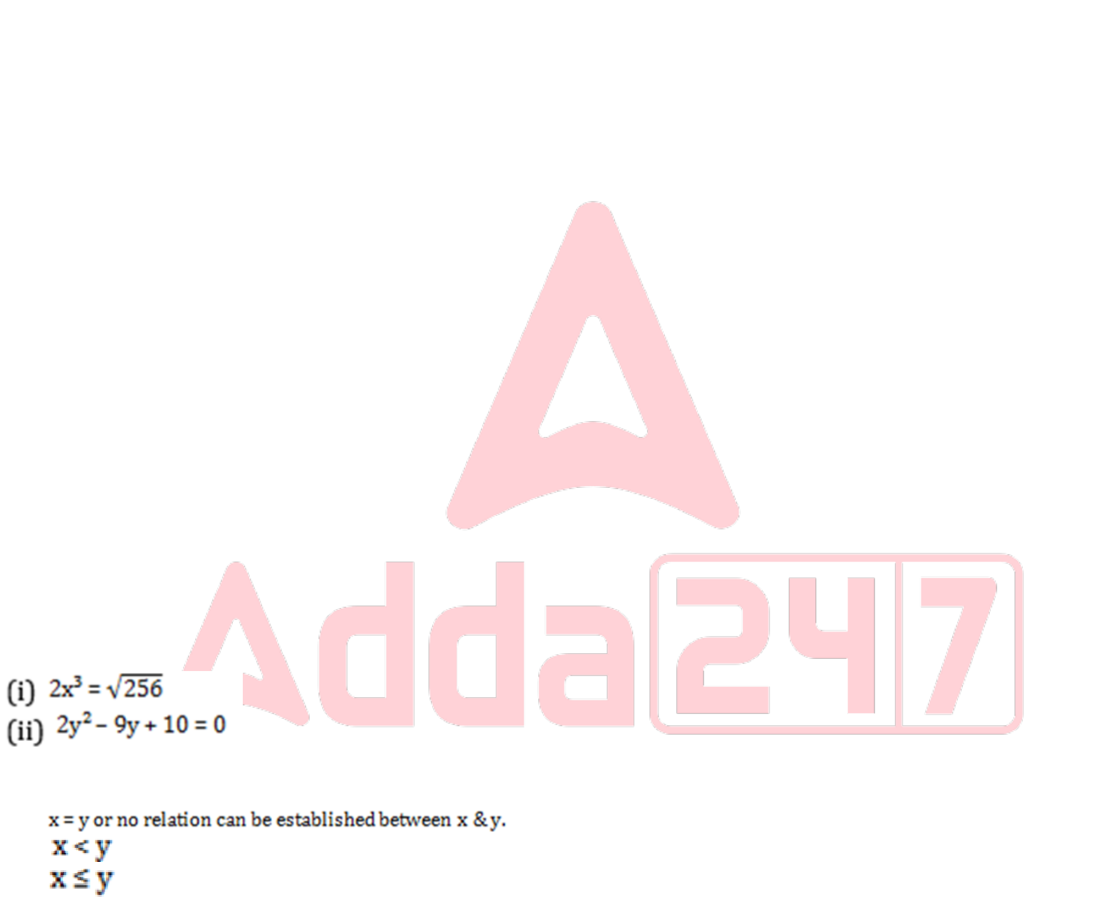





P goes to the country which name starts with a vowel. T doesn’t go to France and Germany. Q and W doesn’t go to France and Canada. R, V and U doesn’t go to Armenia, Croatia and France. Q, W and T doesn’t go to Armenia and US. T, U and V doesn’t go to Canada. W goes to Germany. U and Q doesn’t go to US and Chile.
(a) US
(b) Chile
(c) Germany
(d) Either US or Chile
(e) Croatia
Q101. I. x² - 7x + 12 = 0
II. y² - 8y + 12 = 0
In the following two equations questions numbered (I) and (II) are given. You have to solve both equations and Give answer.
(a) If x > y
(b) If x ≥ y
(c) If y > x
(d) If y ≥ x
(e) If x = y or no relation can be established
Q102. I. x2 = 81
II. (y-9)2 = 0
In the following two equations questions numbered (I) and (II) are given. You have to solve both equations and Give answer.
(a) If x > y
(b) If x ≥ y
(c) If y > x
(d) If y ≥ x
(e) If x = y or no relation can be established
Q103. I. x2-7x-18=0
II. y2-19y+90=0
In each question two equations numbered (I) and (II) are given. Student should solve both the equations and mark appropriate answer.
(a) x ≤ y
(b) x = y or no relation can be established
(c) x > y
(d) x ≥ y
(e) x < y
Q104. | In each of these questions, two equations (i) and (ii) are given, you have to solve both the equations and give answer accordingly.  (a)
(b)
(c)
(d)
(e)
Q105. I. x² – 15x + 56 = 0
II. y = ∛512
In each question two equations numbered (I) and (II) are given. Student should solve both the equations and mark appropriate answer.
(a) If x=y or no relation can be established
(b) If x>y
(c) If x<y
(d) If x>=y
(e) If x<=y
32 | www.careerpower.in | Adda247 App 

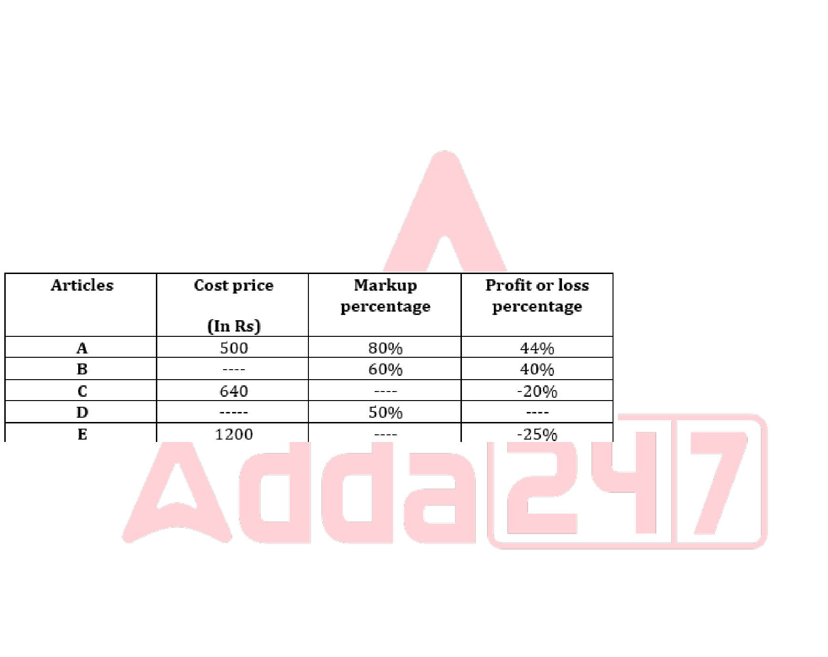





Q106. The ratio of the discount percentage on article A to the markup percentage on article E is 4:5. Find the difference between the discount allowed on article E and the profit earned on article A (in Rs).
Read the following table carefully and answer the questions given below. The table shows the cost price, markup percentage, and profit or loss percentage of five different articles.
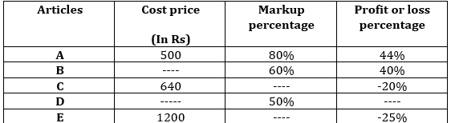
Note: (i) The negative percentage shows the loss suffered on the article.
(ii) Few values are missing in the table. A candidate is expected to calculate the missing value, if it is required to answer the given question on the basis of the given data.
(a) 180
(b) 220
(c) 380
(d) 420
(e) 540
Q107. If the average selling price of articles C, D, and E is Rs 830 2/3 and the profit percentage of article D is one-third of the markup percentage of article B, then find which of the following option is correct about the article D. Read the following table carefully and answer the questions given below. The table shows the cost price, markup percentage, and profit or loss percentage of five different articles.
Note: (i) The negative percentage shows the loss suffered on the article.
(ii) Few values are missing in the table. A candidate is expected to calculate the missing value, if it is required to answer the given question on the basis of the given data.
(a) The profit earned on the article D is Rs 180
(b) Discount allowed on the article D is 20%
(c) Both (a) & (b)
(d) Both (a) & (e)
(e) The cost price of the article D is more than that of article E.
Q108. If the discount allowed on the article C is 36% and the marked price of the article C is 33.33% less than that of article B, then find the selling price of the article B (in Rs).
Read the following table carefully and answer the questions given below. The table shows the cost price, markup percentage, and profit or loss percentage of five different articles.

Note: (i) The negative percentage shows the loss suffered on the article.
33 | www.careerpower.in | Adda247 App 

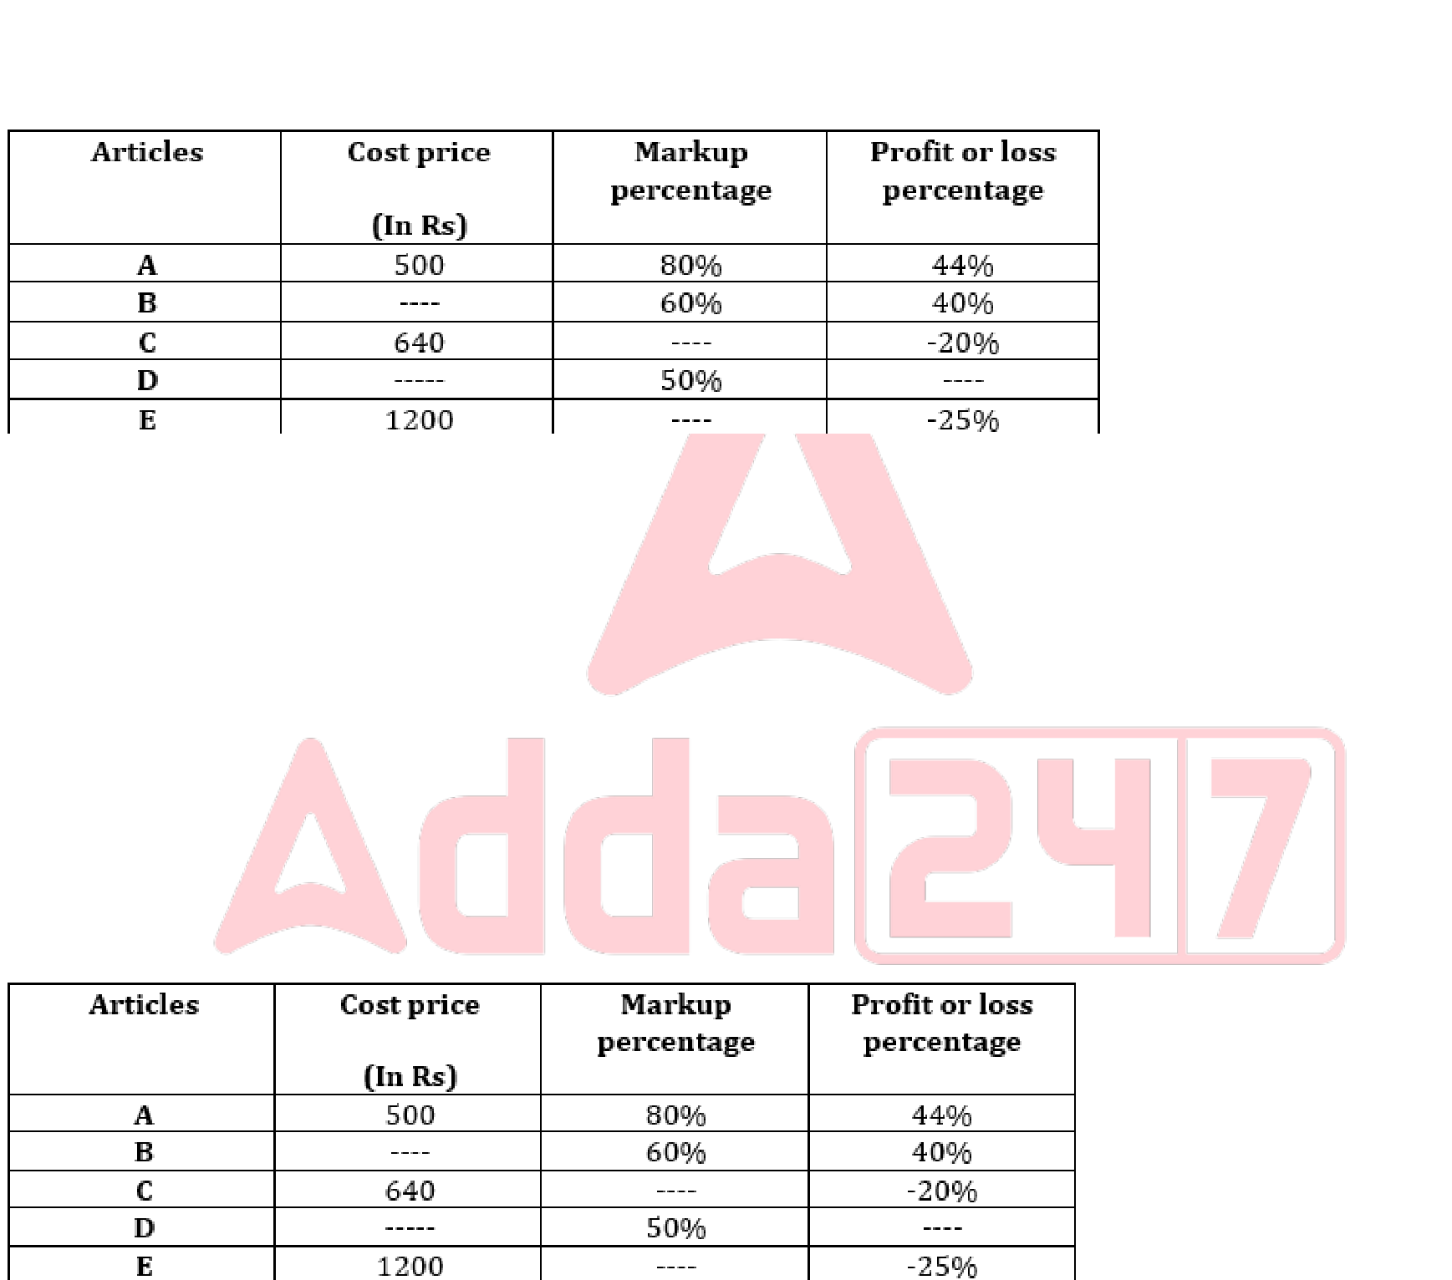





(ii) Few values are missing in the table. A candidate is expected to calculate the missing value, if it is required to answer the given question on the basis of the given data.
(a) 840
(b) 950
(c) 1470
(d) 1120
(e) 1050
Q109. Find which of the following statement/s is /are incorrect.
I. The discount percentage on the article A is more than 25%
II. The difference between the selling price of the article C and E more than the half of the selling price of the article A.
III. The loss suffered on the article C is equal to two-third of loss suffered article C.
Read the following table carefully and answer the questions given below. The table shows the cost price, markup percentage, and profit or loss percentage of five different articles.
Note: (i) The negative percentage shows the loss suffered on the article.
(ii) Few values are missing in the table. A candidate is expected to calculate the missing value, if it is required to answer the given question on the basis of the given data.
(a) All I, II & III
(b) Only I
(c) Both I & II
(d) Both I & III
(e) Only II
Q110. . The cost price of article D is 80% of that of article A, and the discount allowed on article D is 10%. If the profit % on article D is equal to the markup percentage of article E, then find the discount percentage of article E. Read the following table carefully and answer the questions given below. The table shows the cost price, markup percentage, and profit or loss percentage of five different articles.
Note: (i) The negative percentage shows the loss suffered on the article.
(ii) Few values are missing in the table. A candidate is expected to calculate the missing value, if it is required to answer the given question on the basis of the given data.
(a) 66.23%
(b) 44.44%
(c) 33.83%
(d) 52.67%
(e) 30.33%
34 | www.careerpower.in | Adda247 App 

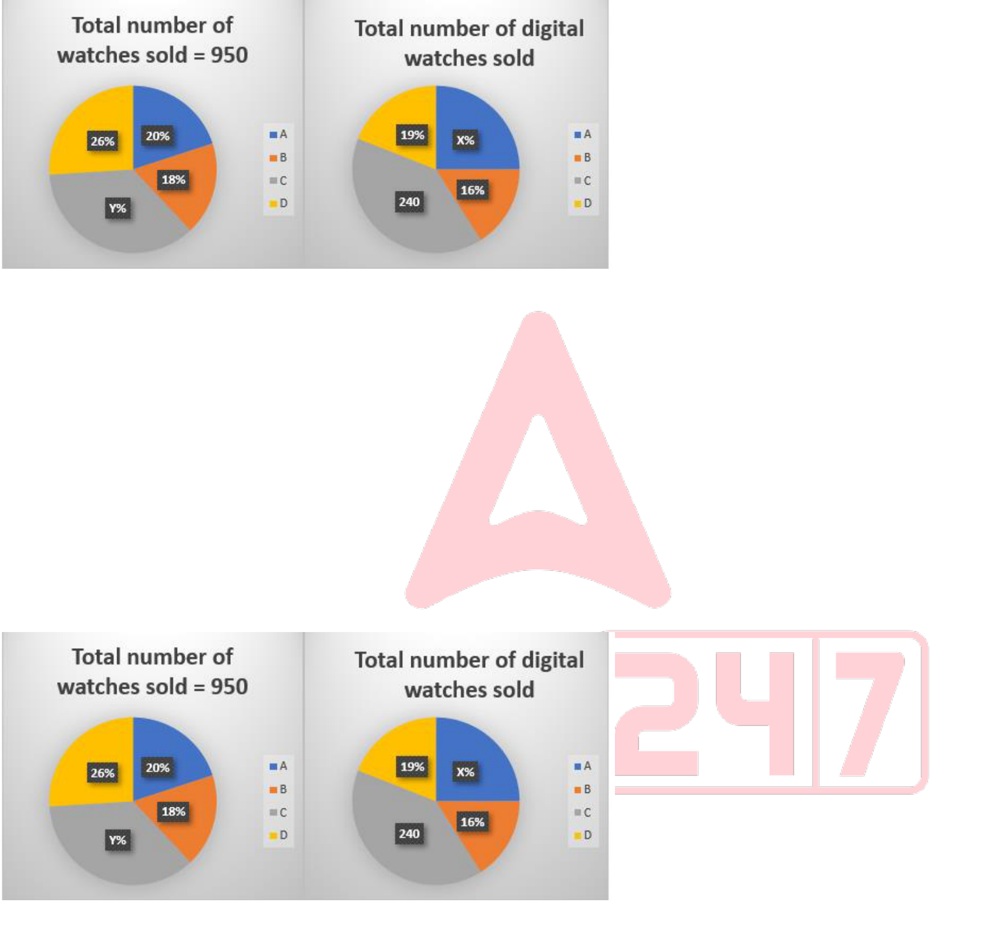





Q111. Find the difference between the total analog watches sold by A and B together and the total digital watches sold by C.
Read the following pie charts carefully and answer the questions given below. Pie chart I shows the percentage distribution of the total number of watches sold and pie chart II shows the percentage or number of the total digital watches sold by four different shops.
Note: (i) Total watches sold = Digital watches sold + Analog watches sold (ii) X+11 = Y
(a) 140
(b) 125
(c) 105
(d) 115
(e) 150
Q112. Find the ratio of the total analog watches sold by C to the total digital watches sold by B.
Read the following pie charts carefully and answer the questions given below. Pie chart I shows the percentage distribution of the total number of watches sold and pie chart II shows the percentage or number of the total digital watches sold by four different shops.
Note: (i) Total watches sold = Digital watches sold + Analog watches sold (ii) X+11 = Y
(a) 19:11
(b) 11:19
(c) 16:17
(d) 17:16
(e) 19: 17
Q113. If the price of each digital and analog watch sold by D is Rs (Y+4) and Rs Z and the total revenue generated by D by selling all the watches is Rs 11210, then find Z.
Read the following pie charts carefully and answer the questions given below. Pie chart I shows the percentage distribution of the total number of watches sold and pie chart II shows the percentage or number of the total digital watches sold by four different shops.
Note: (i) Total watches sold = Digital watches sold + Analog watches sold
35 | www.careerpower.in | Adda247 App 

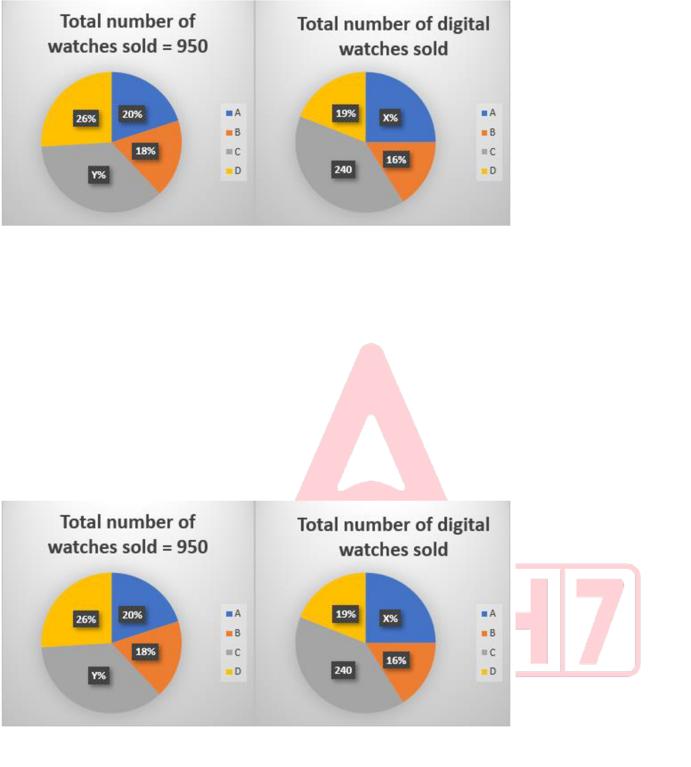





(ii) X+11 = Y
(a) 80
(b) 66
(c) 24
(d) 45
(e) 50
Q114. If the total analog watches sold by E is 4X and the total digital watches sold by B is Y/9 less than that of E, then the total watches sold by E is what percentage of the total analog watches sold by A, B, C and D?
Read the following pie charts carefully and answer the questions given below. Pie chart I shows the percentage distribution of the total number of watches sold and pie chart II shows the percentage or number of the total digital watches sold by four different shops.
Note: (i) Total watches sold = Digital watches sold + Analog watches sold (ii) X+11 = Y
(a) 57%
(b) 44%
(c) 32%
(d) 49%
(e) 63%
Q115. Total analog watches sold by C and D together is what percentage more or less than the total digital watches sold by A (approx.)?
Read the following pie charts carefully and answer the questions given below. Pie chart I shows the percentage distribution of the total number of watches sold and pie chart II shows the percentage or number of the total digital watches sold by four different shops.
Note: (i) Total watches sold = Digital watches sold + Analog watches sold (ii) X+11 = Y
36 | www.careerpower.in | Adda247 App 







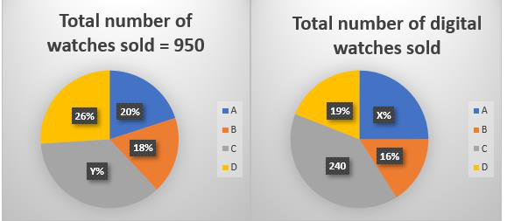
(a) 39.75%
(b) 42.5%
(c) 56.67%
(d) 66.33%
(e) None of these
Q116. Quantity I: A container has 60 liters of a mixture of milk and water in the ratio 3:2. 20 liters of this mixture is replaced with pure water. If the mixture is sold for Rs 20 per liter and cost of pure milk is Rs 35 per liter then find the profit (in Rs)
Quantity II: A shopkeeper has two varieties(A & B) of tea worth ₹200/kg and ₹300/kg. He mixes variety A & B in the ratio 2:3 respectively. Find the price(in Rs) per kg of the resulting mixture.
In the given question, two quantities are given, one as ‘Quantity I’ and another as ‘Quantity II’. You have to determine relationship between two quantities and choose the appropriate option. (Compare only numeric values)
(a) Quantity I > Quantity II
(b) Quantity I < Quantity II
(c) Quantity I ≥ Quantity II
(d) Quantity I ≤ Quantity II
(e) Quantity I = Quantity II or no relation
Q117. What is the ratio of the total number of students in section A of class Q to section B of class R? Read the data carefully and answer the following questions.
There are three classes: P, Q, and R in a school. Each class has two sections – A and B.
For classes P and R, the ratio of students in section A to section B is 5:3. In class Q, half of the total students are in section A. The average number of students in classes P and R together is 144. The total number of students in class Q is 40 more than in class P.
The total number of students in class P is 32 less than in class R.
Note: Total students in any class = students in section A + students in section B.
(a) 7:5
(b) 7:8
(c) 9:10
(d) 21:25
(e) 3:4
Q118. The total number of students in section B of class P is what percent of the total number of students in section B of class R?
Read the data carefully and answer the following questions.
There are three classes: P, Q, and R in a school. Each class has two sections – A and B.
For classes P and R, the ratio of students in section A to section B is 5:3. In class Q, half of the total students are in section A. The average number of students in classes P and R together is 144. The total number of students in class Q is 40 more than in class P.
37 | www.careerpower.in | Adda247 App 







The total number of students in class P is 32 less than in class R.
Note: Total students in any class = students in section A + students in section B.
(a) 40%
(b) 80%
(c) 60%
(d) 75%
(e) 57%
Q119. If the total number of students in classes P, Q, R, and S is 712, then what is the difference between the number of students in section A of class P and the total number of students in class S?
Read the data carefully and answer the following questions.
There are three classes: P, Q, and R in a school. Each class has two sections – A and B.
For classes P and R, the ratio of students in section A to section B is 5:3. In class Q, half of the total students are in section A. The average number of students in classes P and R together is 144. The total number of students in class Q is 40 more than in class P.
The total number of students in class P is 32 less than in class R.
Note: Total students in any class = students in section A + students in section B.
(a) 156
(b) 176
(c) 196
(d) 186
(e) 166
Q120. What is the average number of students in section A of class Q and section B of class R?
Read the data carefully and answer the following questions.
There are three classes: P, Q, and R in a school. Each class has two sections – A and B.
For classes P and R, the ratio of students in section A to section B is 5:3. In class Q, half of the total students are in section A. The average number of students in classes P and R together is 144. The total number of students in class Q is 40 more than in class P.
The total number of students in class P is 32 less than in class R.
Note: Total students in any class = students in section A + students in section B.
(a) 72
(b) 40
(c) 64
(d) 66
(e) 70
Q121. What is the difference between the total number of students in section B and section A across all classes P, Q, and R?
Read the data carefully and answer the following questions.
There are three classes: P, Q, and R in a school. Each class has two sections – A and B.
For classes P and R, the ratio of students in section A to section B is 5:3. In class Q, half of the total students are in section A. The average number of students in classes P and R together is 144. The total number of students in class Q is 40 more than in class P.
The total number of students in class P is 32 less than in class R.
Note: Total students in any class = students in section A + students in section B.
(a) 60
(b) 96
(c) 108
(d) 72
(e) 84
38 | www.careerpower.in | Adda247 App 







Q122. 29, 31, 33, 42, 69, 150, 393
Find the wrong term in the following number series.
(a) 42
(b) 33
(c) 29
(d) 31
(e) 69
Q123. 8, 30, 140, 690, ?, 17190
Find the missing number in the following number series.
(a) 3450
(b) 3430
(c) 3460
(d) 3440
(e) 3480
Q124. 108, 216, 162, 40.5, 202.5, 33.75, 236.25
In the question a number series is given and only one number is wrong. Find out the wrong number.
(a) 216
(b) 108
(c) 162
(d) 40.5
(e) 236.25
Q125. 10, 27, 83, 169, 509, 1021
Find the wrong term in the following number series.
(a) 10
(b) 27
(c) 83
(d) 169
(e) 509
Q126. 2000, 400, 160, 96, 76.8, 90, 92.16
In each of these questions a number series is given. In each series only one number is wrong. Find out the wrong number.
(a) 400
(b) 2000
(c) 90
(d) 160
(e) 96
Q127. Set A is a set of three consecutive prime numbers. Set B is a set of two consecutive odd numbers. The sum of largest number of set A and B is 62, while different between largest number of set A and B is 24. (Where largest number of set A > than largest number of set B)
Quantity I: Difference between smallest number of set A and set B.
Quantity II. 20
In the given questions, two quantities are given, one as ‘Quantity I’ and another as ‘Quantity II’. You have to determine relationship between numerical value of these two quantities and choose the appropriate option.
(a) Quantity I > Quantity II
(b) Quantity I < Quantity II
(c) Quantity I ≥ Quantity II
(d) Quantity I ≤ Quantity II
(e) Quantity I = Quantity II or no relation
39 | www.careerpower.in | Adda247 App 







Q128. Quantity 1: The average weight of a group of 100 people is 30 kg. If ratio of boys to girls in the group is 3:2 and average weight of all boys of the group is 35 kg, then find average weight of all females of the group?
Quantity 2: 24
In the given question, two quantities are provided, one as 'Quantity 1' and another as 'Quantity 2'. You have to determine the relationship between the two quantities and choose the appropriate option (compare only numerical values).
(a) Quantity 1 > Quantity 2
(b) Quantity 1 ≥ Quantity 2
(c) Quantity 2 > Quantity 1
(d) Quantity 2 ≥ Quantity 1
(e) Quantity 1 = Quantity 2 or Relationship cannot be established
Q129. Quantity I: The average age of 10 men is 30 years. If 5 more men join the group, the new average becomes 28 years. Find the average age of the 5 new men.
Quantity II: The average score of 20 students in a test is 65. If the top 5 scorers have an average score of 80, then find the average score of the remaining 15 students.
In the given question, two quantities are given, one as ‘Quantity I’ and another as ‘Quantity II’. You have to determine relationship between two quantities and choose the appropriate option. (Compare only numeric values)
(a) Quantity I > Quantity II
(b) Quantity I < Quantity II
(c) Quantity I ≥ Quantity II
(d) Quantity I ≤ Quantity II
(e) Quantity I = Quantity II or no relation
Q130. A train is traveling at a speed of 90 km/h. The train completely crosses a platform in 30 seconds. It then overtakes a man running at 18 km/h in the same direction in 20 seconds. What is the length of the platform?
(a) 500 meters
(b) 600 meters
(c) 350 meters
(d) 650 meters
(e) 700 meters
Q131. A boat goes from point A to B upstream and returns to A through the same path. If the time of journey from A to B is twice that of the time taken to travel from B to A, then the ratio of the speed of the boat in still water to the speed of the current is
(a) 7:5
(b) 2:1
(c) 3:2
(d) 3:1
(e) 9:7
Q132. The speed of a car is 60% more than the speed of a bus, while bus can cover X km distance in six hours and car 𝟏
can cover X + 80 distance km in five hours. If car increased its speed by 𝟒th then find the time taken by car to cover (X+160) km distance (In hours).
(a) 6
(b) 5
(c) 8
(d) 7.5
(e) 4.5
Q133. The side of a cube is 8 cm more than the side of a square. If the area of the square is 1/9th of the lateral surface area of the cube, then find the volume of the cube?
(a) 1728 cm³
(b) 8000 cm³
(c) 13824 cm³
(d) 1331 cm³
(e) 2197 cm³
40 | www.careerpower.in | Adda247 App 







Q134. The average length of 20 wooden planks is 75 cm. When 4 new planks with lengths x, x+10, x + 20 and x+30 cm are added, the average length becomes 72 cm. Find the value of x.
(a) 42
(b) 44
(c) 45
(d) 43
(e) 46
Q135. The present age of A is 60% more than that of B and the present age of C is five years more than that of B. If the difference between the age of A and C after six years is 10, then find the age of A four year ago (in years).
(a) 36
(b) 24
(c) 30
(d) 6²
(e) Both (a) & (d)
Q136. The ratio of income of P to that of Q is 2:3 and the ratio of expenditure of P to that Q is 5:6. If the income of Q is increased by 50% and expenditure is same, then the saving of Q becomes Rs.12000. If saving of P is Rs.3000, then find the income of P.
(a) Rs.10500
(b) Rs.9500
(c) Rs.7000
(d) Rs.5000
(e) Rs.8000
Q137. There are four numbers, among which the smallest two numbers are in the ratio 5:7. The largest number is 2 more than the second-largest number. The average of the smallest and largest numbers is 22.5. Also, the average of four times the second smallest number and six times the second largest number is 126. Find the average of the four numbers.
(a) 21.5
(b) 22
(c) 22.5
(d) 23
(e) 23.5
Q138. A spends 10% of his monthly income on rent, 20% on grocery and he spends 10% of the remaining income on transport. If A saves remaining amount and his monthly saving is Rs. 5040, then find the monthly income (in Rs.) of A.
(a) 8000
(b) 9000
(c) 4000
(d) 5000
(e) 6000
Q139. Vessel X contains milk and water in the ratio of 5:4 respectively. 9 litres of mixture is removed and 20 litres of mixture from vessel Y which containing milk and water in the ratio 3: 2 respectively is mixed in the remaining mixture in vessel X. If the ratio of milk to water in the resultant mixture in vessel X is 4: 3, then find the quantity of mixture in vessel X initially?
(a) 120 liters
(b) 60 liters
(c) 45 liters
(d) 90 liters
(e) 80 liters
41 | www.careerpower.in | Adda247 App 







Q140. P, Q, and R can complete a piece of work in 24, 36, and 48 days respectively. They started working together, but after 8 days, P left. After another 2 days, Q also left and R continued working alone. Find the time taken by R to complete the remaining work.
(a) 48/5
(b) 26/3
(c) 60/13
(d) 3/4
(e) 4/3
Q141. A barrel contains 56 liters of kerosene. It has two taps. One tap (A) draws 500 ml every 6 minutes. After first 5 liters are drawn from the barrel, the second tap (B) also starts, it draws 1 liter in every 5 minutes. How many hours will be taken in all to empty the tank?
(a) 7 hours
(b) 3 hours
(c) 4 hours
(d) 11 hours
(e) 10.5 hours
Q142. A and B started a business with investments of Rs 8000 and Rs 12000. After four months, A withdrew two-fifths of his investment, and B added Rs 2000 more. If at the end of the year, the profit share of A is Rs 11000, then find the total profit (in Rs).
(a) 42500
(b) 36000
(c) 47800
(d) 49000
(e) 41000
Q143. B is x more than C and A is x more than B. If A = 1000. If average of A and C is 960, then what is the value of x? (a) 60
(b) 80
(c) 120
(d) 40
(e) 30
Q144. The cost price of the article is 33.33% less than the selling price of the article. If the marked price of the article is 120% more than the cost price of the article and the discount given on the article is Rs 490, then find the markup price of the article (in Rs).
(a) 450
(b) 840
(c) 750
(d) 980
(e) 660
Q145. Total number of employees working in A is what percentage of average number of female employees working in B and D? The line graph shows the total employees (male + female) and total male employees working in five different companies.
42 | www.careerpower.in | Adda247 App 

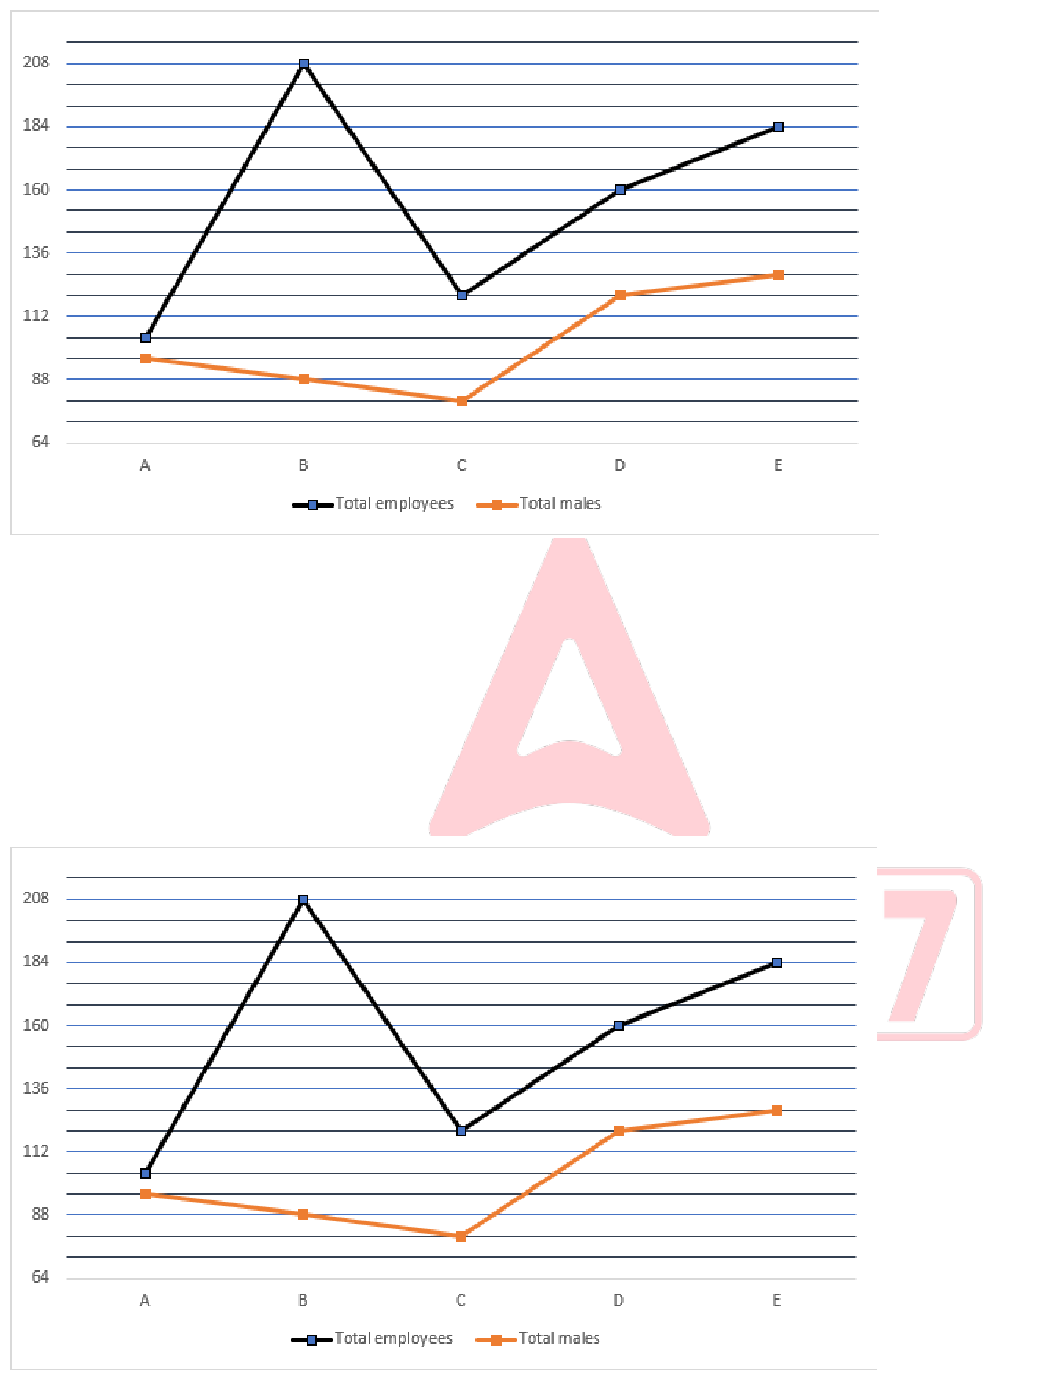





Read the information and answer the following questions.
(a) 130
(b) 120
(c) 140
(d) 110
(e) 105
Q146. Find the ratio of the total female employees working in B and C together and the total male employees working in D and A.
The line graph shows the total employees (male + female) and total male employees working in five different companies. Read the information and answer the following questions.
(a) 25:8
(b) 12:17
(c) 31:14
(d) 20:27
(e) 1:11
43 | www.careerpower.in | Adda247 App 

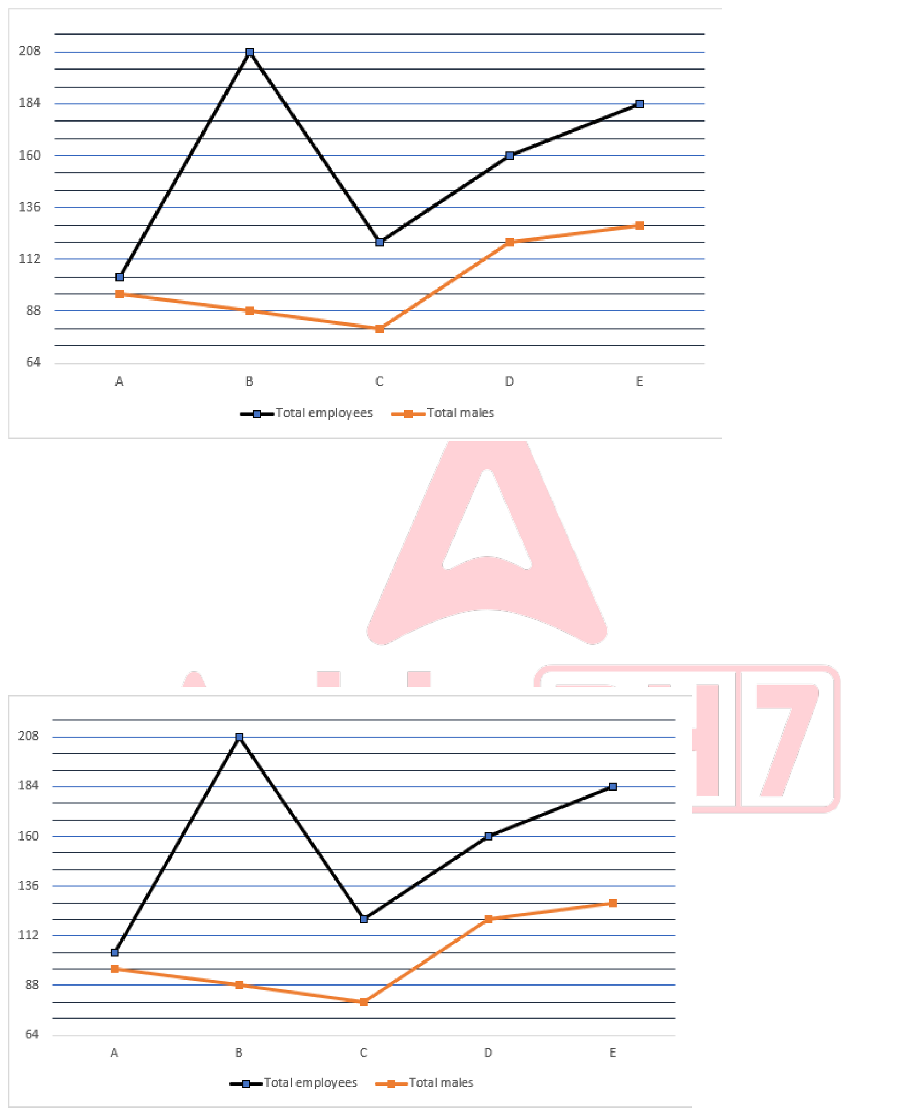





Q147. Find the difference between the maximum number of female employees and the minimum number of male employees working in the given companies.
The line graph shows the total employees (male + female) and total male employees working in five different companies. Read the information and answer the following questions.
(a) 30
(b) 20
(c) 40
(d) 10
(e) 5
Q148. The ratio of total employees working in F to E is 2:1 and the male employees are 1/3 of females in F. Find the difference between the female employees working in F and A. The line graph shows the total employees (male + female) and total male employees working in five different companies. Read the information and answer the following questions.
(a) 322
(b) 200
(c) 234
(d) 222
(e) 268
44 | www.careerpower.in | Adda247 App 



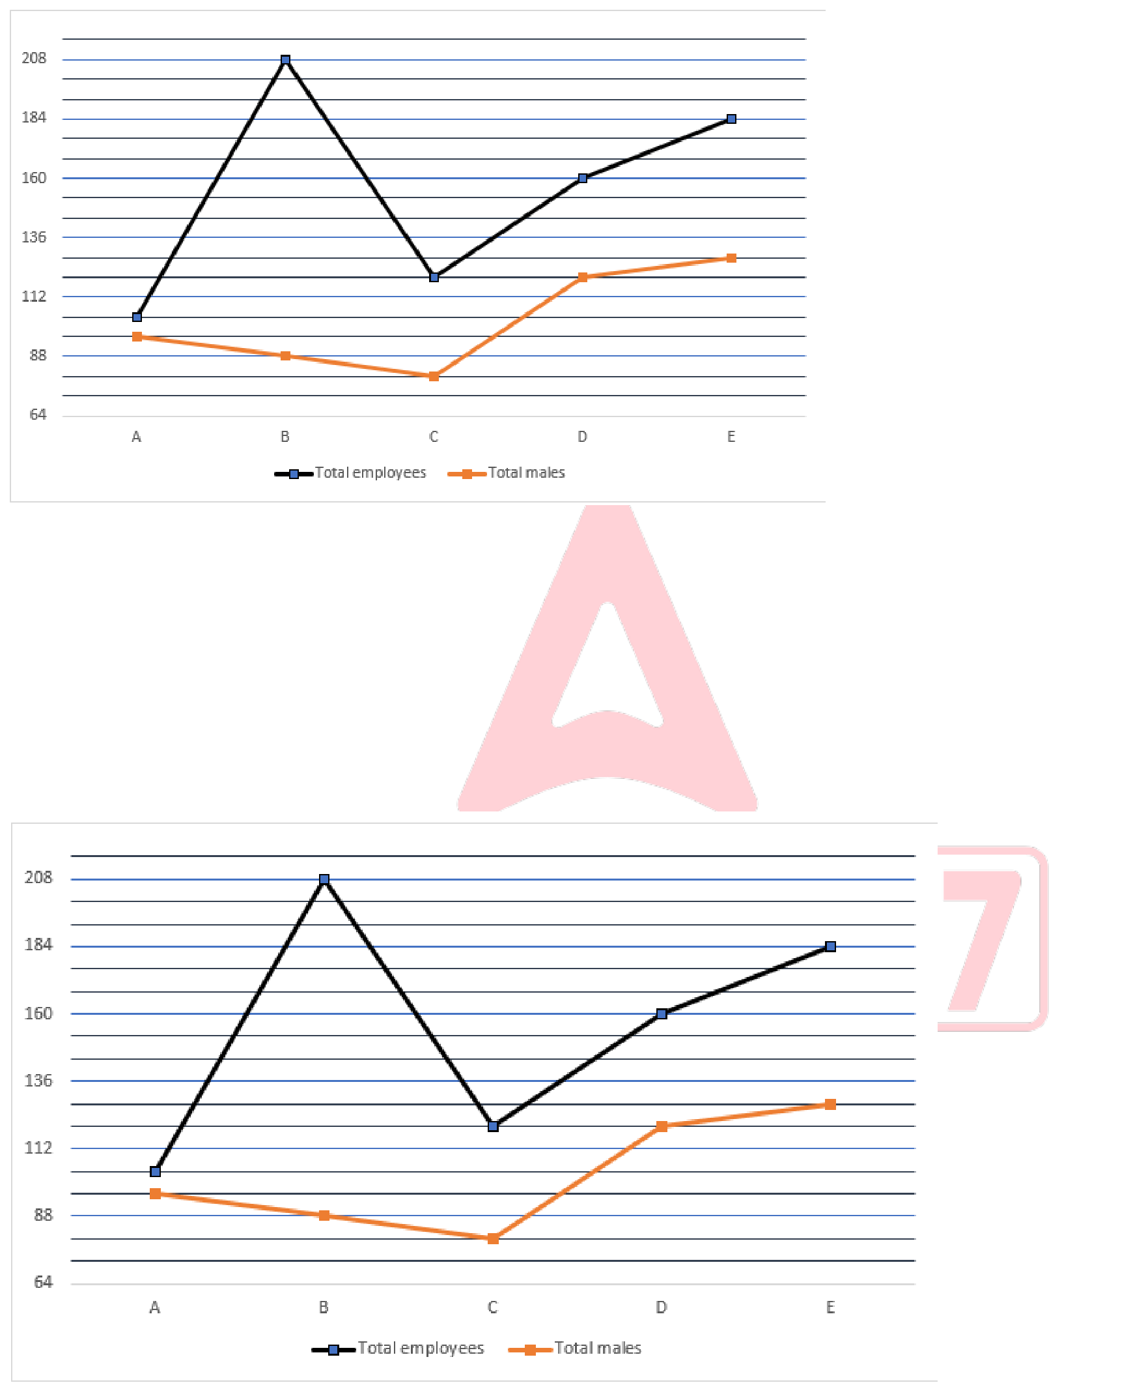





Q149. 20% of employees working in D are interns and the ratio of males to females interns are 1:3. Find the number of male employees who are not interns. The line graph shows the total employees (male + female) and total male employees working in five different companies. Read the information and answer the following questions.
(a) 112
(b) 110
(c) 41
(d) 221
(e) 211
Q150. Total number of female employees working in E and D is what percent more or less than total employees working in A (approx.).
The line graph shows the total employees (male + female) and total male employees working in five different companies. Read the information and answer the following questions.
(a) 8
(b) 20
(c) 40
(d) 90
(e) 33
45 | www.careerpower.in | Adda247 App 

