



1). The CMM Level at which measurable goals for quality and productivity are established in
a)Level 1
b)Level 3
c)Level 5
d)Level 4
e)Level 2
2). When you will visit websites spyware may be substantially downloaded. This is called a
a)logic bomb
b)drive – by download
c)Virus
d)drive – in download
e)spyot
3). Malicious software is known as
a)disasterware
b)badware
c)illegalware
d)malware
e)maliciousware
4). A data structure where elements can be added or removed at either end but not in the middle is called a)requeue
b)queues
c)dequeue
d)linked lists
e)stacks
5). Which of the following are placeholders for literal value in a SQL query being sent to the database a)reduction and resolution variables
b)resolution variables
c)reduction variables
d)assimilation variables
e)bind variables

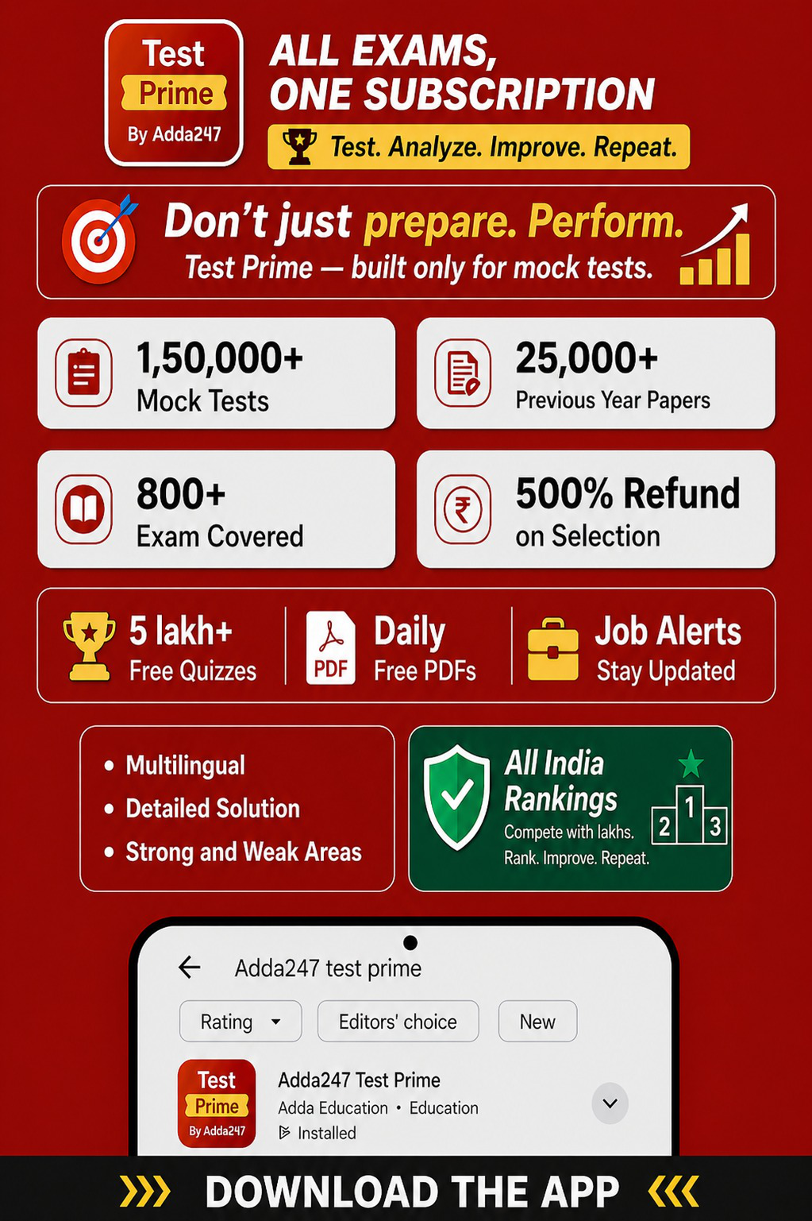





6). In TPS systems, an output that signifies that a specific transaction has taken place is called a (n) a)detail report
b)action document
c)inception report
d)exception report
e)Summary report
7). ________ is the process whereby media files such as a video start playing as they are downloading a)Streaming
b)Pushing
c)Dragging
d)Flashing
e)Pulling
8). Which of the following statements about Stacks is incorrect?
a)New nodes can only be added to the top of the stack
b)Stacks can be implemented using linked lists
c)Stacks are first – in, first – out data structures
d)The last node (at the bottom) of a stack has a null(0) link
e)stacks are very useful
9). The UML designation for a public class member is
a)the symbol @
b)the symbol #
c)the minus symbol (-)
d)The plus symbol (+)
e)The word public
10). what type of join is needed when you wish to include rows that do not have matching values?
a)Equi - join
b)Indefinite join
c)Intermediate join
d)Natural join
e)Outer join
Answers:
1). d) 2). b) 3). d) 4). c) 5). e) 6). b) 7). a) 8). c) 9). d) 10). e) 11). A home page is





a)the web page that identifies a website
b)a webpage you eventually reach by clicking a series of hyperlinks
c)a webpage created by an individual home user, as opposed to the one created by a corporation
d)the last page of the website
e)the web page you like to visit the most
12). A network covering a large geographic area is usually referred to as a(n)
a)huge area network
b)wide area network
c)internetwork
d)local area network
e)intranet
13). Frame relay
a)does not use error correction routines
b)is used by facsimile machines
c)uses error – correction routines
d)does not work weel on the internet
e)is an outdated technology
14). The design tool used to illustrate the logic of a new computer software logic diagram that uses symbols to represent program elements is called a (n)
a)data logic chart
b)data flow diagram
c)software logic diagram
d)system flow chart
e)entry relationship illustration
15). A web facility that helps to find sites with the information and / or services that is desired is
a)a hyperlink
b)the top inner domain
c)a search engine
d)a network access point
e)a blog
16). When new data are to be inserted into a data structure but there is not available space ; this situation is usually called





a)underflow
b)overflow
c)Houseful
d)saturated
e)empty
17). A _____________ is an acrylic diagraph, which has only node with in – degree 0, and other nodes have in degree 1.
a)Dis – joint tree
b)Direction oriented tree
c)Directed tree
d)Diagonalised tree
e)Undirected tree
18). Which of the following are true of XML ?
a)XML is too complicated.
b)XML is difficult to learn
c)XML is a set of tags designed to tell browsers how to display text on a webpage d)XML is a set of rules for creating tags to describe data
e)XML is a set of tags designed to tell browsers how to display images on a webpage 19). Which of the following forms does not describe parallel ATA devices?
a)SCSI
b)IOE and DOE
c)IOE
d)DOE
e)ATA
20). _____________ maps domain name to their IP addresses.
a)Wi - Fi
b)DNS
c)HTML
d)XML
e)Java
Answers:
11). a) 12). b) 13). a)14). d) 15). c) 16). b) 17). c) 18). d) 19). a) 20). b)





21). Every host computer on the internet has a (n)
a)similar IP address
b)unique 10 – digit number
c)common name and number
d)unique IP address
e)Unique 15 – digit number
22). Which of the following are five built – in functions provided by SQL?
a)SUM, AVG, MIN, MAX, NAME
b)MIN, MAX, MULT, DIV, NAME
c)SUM, AVG, MULT, DIV, MIN
d)SUM, AVG, MIN, MAX, MULT
e)COUNT, SUM, AVG, MAX, MIN
23). Common Gateway Interface (CGI) is which of the following?
a)An interface that accepts and returns data that may be written in SQL
b)A small program that executes within other application and is stored on the server
c)A small program that executes within other application and is stored on the client
d)A small program that executes within other application and is stored on the client or the server e)An interface that accepts and returns data that may be written in any language that produces executable file
24). Which of the following wildcard masks is most useful for matching all IP packets in subnet 10.1.128.0, mask 255.255.255.0?
a)0.0.0.0
b)0.0.0.255
c)0.0.0240
d)0.0.0.31
e)0.0.15.0
25). Which of the following is not a testable Web App security element?
a)Encryption
b)Authentication and Encryption
c)Firewalls
d)Authentication
e)Penetration
26). _________ are two Important technologies for developing the Semantic web





a)XML and RDF
b)XML and HTML
c)RDF and HTML
d)Wi-Fi and RDF
e)Wi-Fi and XML
27). In what kind of storage, we can easily insert, delete, concatenate and reaarange substrings?
a)Stack
b)Linked list
c)Dedicated list
d)Queue
e)Array
28). Web Pages can be created using
a)only Web authoring software
b)only macromedia Dreamweaver
c)any Word processor
d)only Microsoft products
e)only Microsoft Front Page
29). Which of the following techniques provides redundancy by using two disks and two controllers?
a)Disk striping
b)Disk striping with parity
c)Drive mirroring
d)Drive mirroring and disk striping
e)Drive duplexing
30). _________ is the term for the use of deception to get someone’s sensitive information a)Identity theft
b)Personal engineering
c)Spoofing
d)Social engineering
e)Hacking
Answers:
21). d) 22). e) 23). e) 24). b) 25). e) 26). a) 27). b) 28). c) 29). e) 30). d)
31). In addition to an internet connection, which of the following is needed to?





a)Telnet client
b)Scanner
c)Mail client
d)HP client
e)Web browser
32). A DBMS performs several important functions that guarantee the integrity and consistency of the data in the database. Which of the following is not one of those functions?
a)Data integrity management
b)Data reports
c)Security and storage management
d)Data storage management
e)Security management
33). A procedural program stores __________ in a collection of variables and a set of _______ performs operations on it.
a)parameters ; arguments
b)data ; functions
c)assets ; actions
d)strings ; operators
e)numbers ; arguments
34). Which of the following is the phase of SDLC in which the identified requirements are incorporated into the new system’s design
a)Maintenance
b)Physical Layout
c)Requirement design
d)Systems design
e)System blueprint
35). What does DLCI stand for?
a)Data Link Circuit Identifier
b)Data Link Connection interrupt
c)Data Link Connection Indicator
d)Data Link Circuit Indicator
e)Data Link Connection Identifier
36). What standard Java Package is used to move the cursors?





a)Javax swing
b)java cio
c)java lo
d)java facio
e)java awt event
37). A communications medium where data are transformed into lights pulses is
a)coaxial cable
b)optical fibre
c)satellite
d)twisted – pair cable
e)Copper cable
38). __________ is a standard for security that is inclined at the network or packet processing layer of network communications, as opposed to the application layer.
a)Passive FTP
b)TCP
c)SSL
d)S – HTTP
e)IPsec
39). Locking may cause which of the following problems?
a)Deadlock
b)Versioning
c)Versioning and Deadlock
d)Erroneous updates
e)Erroneous updates and deadlock
40). Which of the following is not a WebApp Interface mechanism ?
a)Links
b)Cookies
c)Browser
d)Cookies and Links
e)Forms
Answers:
31). e) 32). b) 33). b) 34). c) 35). e) 36). e) 37). b) 38). e) 39). a) 40). c)





41). _________ is one of the older and slowest methods an intruder might use to scan a network to determine which of a range of IP addresses map to live hosts.
a)Ping sweep
b)Phreaking
c)Smurfing
d)War driving
e)Brute force cracking
42). which of the following is used to create and delete views and relations within tables?
a)SQL Data Identification Language
b)SQL Data Identification and Manipulation Language c)SQL Data Relational Language
d)SQL Data Definition Language
e)SQL Data Manipulation Language
43). Criminal hacking is called
a)cracking
b)a virus
c)a trojan horse
d)a worm
e)blasting
44). Backword recovery is which of the following?
a)Where the before – images are applied to the database
b)Where the after – images and a = before – images are applied to the database.
c)Where the after – images are applied to the database
d)Continuing without any recovery
e)Switching to an existing copy of the database
45). ________ is the integration of economic, social, cultural and ecological facets of life, enabled by information technologies.
a)Business environment
b)Neutralisation
c)Nationalisation
d)Regionalisation
e)Globalisation







46). ________ is the process and tools used by managers and executives with the support of the project team to manage employee resistance.
a)Resistance management
b)Change management
c)Detailing management
d)Probing management
e)Blasting management
47). A cross life – cycle activity of system development is
a)data modeling
b)fact finding
c)prototyping
d)data flow diagram modeling
e)object modeling
48). The result of a SQL SELECT statement is a(n)
a)report
b)file
c)page
d)table
e)form
49). Web App performance tests are designed to
a)assess Web App usability
b)test network performance
c)test network connectivity
d)evaluate page loading times
e)simulate real – world loading situations
50). A CASE SQL statement is which of the following?
a)A way to establish a data definition in SQL or establish a loop in SQL b)A way to establish an IF – THEN – ELSE in SQL
c)A way to establish a loop in SQL
d)A way to establish a data definition in SQL
e)Establish a loop in SQL and establish an IF – THEN – ELSE in SQL Answers:
41). a) 42). d) 43). a) 44). a) 45). e) 46). a) 47). b) 48). d) 49). e) 50). b)

