**AIM: To write a C program to implement the hill cipher substitution techniques.**

**DESCRIPTION:** Each letter is represented by a number = 1... Z = 25, is used, but this is not an essential feature of the cipher. To encrypt a message, each block of n letters is multiplied by an invertible decrypt the message, each block is multiplied by the inverse of the matrix used for encryption. The matrix used for encryption is the cipher randomly from the set of invertible

**EXAMPLE:**

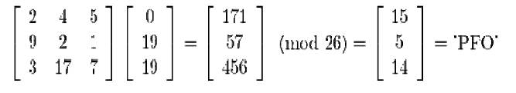

**ALGORITHM:**

STEP-1: Read the plain text and key from the user.

STEP-2: Split the plain text into groups of

STEP-3: Arrange the keyword in a 3*3 matrix.

STEP-4: Multiply the two matrices to obtain the cipher text of length three.

STEP-5: Combine all these groups to get the complete cipher text.

**PROGRAM: (Hill Cipher)**

#include<stdio.h>

#include<conio.h>

#include<string.h>

int main(){

unsigned int a[3][3]={{6,24,1},{13,16,10},{20,17,15}};

unsigned int b[3][3]={{8,5,10},{21,8,21},{21,12,8}};

int i,j, t=0;

unsigned int c[20],d[20];

char msg[20];

clrscr();

printf("Enter plain text

scanf("%s",msg);

for(i=0;i<strlen(msg);i++)

{ c[i]=msg[i]-65;

printf("%d ",c[i]);

}

for(i=0;i<3;i++)

{ t=0;

for(j=0;j<3;j++)

{

t=t+(a[i][j]*c[j]);

}

d[i]=t%26;

}

printf("\nEncrypted Cipher Text :");

for(i=0;i<3;i++)

printf(" %c",d[i]+65);

for(i=0;i<3;i++)

{

t=0;

for(j=0;j<3;j++)

{

t=t+(b[i][j]*d[j]);

}

c[i]=t%26;

}

printf("\nDecrypted Cipher Text :");

for(i=0;i<3;i++)

printf(" %c",c[i]+65);

getch();

return 0;

}

**OUTPUT:**

