
IAASB Stakeholder Survey
May 2021
Responses due: August 5, 2021


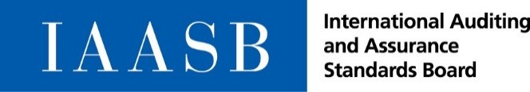
International Auditing and Assurance Standards Board
IAASB Survey Consultation—The IAASB’s Work Plan for 2022‒2023
About the IAASB
The objective of the IAASB is to serve the public interest by setting high-quality auditing, assurance, and other related standards and by facilitating the convergence of international and national auditing and assurance standards, thereby enhancing the quality and consistency of practice throughout the world and strengthening public confidence in the global auditing and assurance profession.
The IAASB develops auditing and assurance standards and guidance for use by all professional accountants under a shared standard-setting process involving the Public Interest Oversight Board, which oversees the activities of the IAASB, and the IAASB Consultative Advisory Group, which provides public interest input into the development of the standards and guidance. The structures and processes that support the operations of the IAASB are facilitated by the International Federation of Accountants (IFAC).

For copyright, trademark, and permissions information, please see below.
NOTE
This version of the survey (in Word) is being provided to assist organizations that may need to consult internally or to help facilitate any outreach activities that respondents may wish to undertake in preparing their response to the IAASB Survey.
Survey responses will only be accepted via the online tool at the following link: https://survey.alchemer.com/s3/6289516/IAASB-Work-Plan-Survey.
We encourage stakeholders to further distribute the link to the online survey to their members or constituents within their jurisdictions.
Background
Due process requires us to consult on the development of the IAASB Work Plan. The IAASB’s Due Process and Working Procedures outline the process to be followed to develop the strategies and work plans.
In developing our Strategy for 2020‒2023 (the Strategy) and Work Plan for 2020‒2021 (current Work Plan), we undertook extensive public consultation, including an initial survey in May 2018, to improve our understanding of stakeholder needs. Respondents to the public consultation agreed with our focus for the 2020–2023 strategy period, including the three strategic objectives to guide our work as well as the individual topics identified for our current Work Plan.
Our strategic objectives direct the activities we commit to in pursuit of our goals. Our work plans set out the specific actions we will undertake. During this strategy period, we have continued to monitor internal and external developments, and evaluated how these developments impact our approach to delivery of our current Work Plan. As we continue to interact with our stakeholders there has been ongoing support for our current work, albeit with a continued call for more urgency and for us to progress our standard-setting activities in a timely manner.
Our strategic objectives continue to remain relevant, but we have adapted our current Work Plan as needed, with changes made with the public interest in mind. Because of the reduced Board plenary time and increased burdens on those impacted by our standards resulting from the COVID-19 pandemic, we have adjusted some of the project timelines.
Our focus is on the completion of the current set of projects that respond to public interest needs. In moving to our Work Plan for 2022–2023, we believe that, absent a significant change in the external environment or a strong stakeholder view otherwise, the Board’s current projects and initiatives should continue, albeit that some may have been re-prioritized. Representatives of our Consultative Advisory Group expressed support for this approach at their March 2021 meeting.
Objective of this Survey Consultation
The objective of this consultation is to obtain stakeholder views on the topics that will be included in the Work Plan for 2022‒2023 as well as on possible new topics we will start as capacity opens up (see Section II of this consultation).
Feedback to this consultation will assist the Board in evaluating its priorities and allocating its resources in the best way possible, given the volunteer nature of the Board and capacity considerations.

Section I – Respondent Information
Question 1
We would like to know to which stakeholder group you belong, i.e., from which perspective are you providing feedback?
- Monitoring Group member
- Investor, analyst or a user of financial or other reporting
- Those Charged with Governance
- Preparer of financial or other reporting
- Regulator or oversight authority
- National Standard Setter
- Accounting firm
- Public sector organization
- Professional Accountancy Organization or other professional organization
- Academic
- Individual
Question 2
Please provide the following information about your organization (if applicable) and other contact information:
- Your organization's name (or leave blank if you are completing the survey in your personal capacity)
- Your name and job title/role
- Your email address
Question 3
Please indicate the geographical profile which best represents your situation, i.e., from which geographical perspective are you providing feedback?
- Global
- Asia Pacific
- Europe
- Middle East and Africa
- North America
- South America

Section II – Work Plan for 2022‒2023
Strategic Objectives
Our Strategy includes the following three strategic objectives:
    - Increase the Emphasis on Emerging Issues to Ensure that Our International Standards Provide a Foundation for High-Quality Audit, Assurance and Related Services Engagements
    - Innovate Our Ways of Working to Strengthen and Broaden Our Agility, Capabilities, and Capacity to Do the Right Work at the Right Time
    - Maintain and Deepen Our Relationships with Our Stakeholders to Achieve Globally Relevant, Progressive and Operable Standards
These strategic objectives drive our decisions about what to include in our work plans, including our Work Plan for 2022–2023. Decisions made about any new topics to pursue for 2022 – 2023 will be consistent with these strategic objectives.
Context for the Work Plan for 2022‒2023
During 2020 and 2021, in addition to completing our Quality Management projects, we have commenced work on a number of significant projects as set out in the Detailed Work Plan Table. This current Detailed Work Plan Table reflects recent adaptations in timetables.
Among other activities and projects in 2021, we plan to complete our revision of ISA 600 (i.e., group audits) in December 2021. Given the significance of this project, activities around the implementation of the revised standard will continue into 2022.
In considering our Work Plan for 2022–2023, the standard-setting projects and initiatives currently underway at the start of 2022 must, in our view, first be completed before commencing new work:
Project | Targeted Timeline
Audits of Less Complex Entities – Addressing Complexity, Understandability, Scalability and Proportionality through Developing a Separate Standard and Other Related Actions | - Development of a Separate Standard  - Finalization of standard: December 2022.  - Complexity, Understandability, Scalability and Proportionality Workstream  - Development of drafting principles and guidelines for the ISAs more broadly in 2021: further activities in relation to this still to be determined.
Audit Evidence (Revision of ISA 500) | Exposure draft (ED): September 2022.  Finalization of standard: Second half 2023.
Fraud (Revision of ISA 240) | ED: March 2023.  Finalization of standard: Second half 2024.
Going Concern⁵ (Revisions of ISA 570 (Revised)) | ED: March 2023  Completion of project: First half 2024.
Implications for IAASB Standards of International Ethics Standards Board for Accountants’ (IESBA) Project, Definitions of Listed Entity and Public Interest Entity⁵ | Any standard-setting activities, as necessary, will likely continue into 2022.
The estimated targeted timing above assumes a ‘normal’ progression for a project but may change as each of the projects progresses. It also takes into account that we will return to an in-person format for Board meetings and Task Force meetings in Q1 2022, which is also subject to change as the pandemic continues (e.g., the implications for international travel and the in-person convening of groups).
In addition to our standard-setting projects, there are several ongoing workstreams that will require Board plenary time during 2022 and 2023, for example in relation to:
- Technology, including our focused efforts on disruptive technologies;
- Professional Skepticism;
- Coordination with IESBA and the work that they undertake in 2022 and 2023; and
- Development of future strategy and work plans.
Our staff regularly undertakes detailed planning activities in relation to the Board’s work so that the progression of projects can be regularly updated and planning for new projects can be commenced before capacity opens. Based on the table above, we will likely have four to five substantial standard-setting projects being progressed in 2022 and 2023. To progress and complete these projects, as well as accounting for Board plenary time, and Staff resources, it is estimated that most of these substantial projects will continue well into 2022 and 2023. Accordingly, it is unlikely that any significant new standard-setting projects or initiatives can commence until later in 2023 without modifying the current Work Plan and planned timelines.
Question 4
Do you agree with our view that the Board’s standard-setting projects currently underway (i.e., Audits of Less Complex Entities, Audit Evidence, Fraud, Going Concern and Implications for IAASB Standards of IESBA’s project on the Definitions of Listed Entity and Public Interest Entity) at the commencement of 2022 should remain public interest priorities and therefore be completed?
- Yes / No
- If no, which projects should not be continued and why not?
Determining New Projects for the Work Plan for 2022–2023
As explained, and excluding an urgent need for action that would require us to change our focus, it is likely that one, or possibly two, new topics could be pursued later in 2023. This section explains how we will select the next topic(s).
Framework for Activities
We established a Framework for Activities (the Framework) as part of our Strategy. The Framework is aimed at articulating how we organize our efforts to deliver on our committed actions. Since the issuance of the Strategy, we further developed the Framework and recently published it.
The “Information Gathering and Research Activities” component of the Framework helps us identify those topics that need to be prioritized. This component categorizes all possible topics that we identified as relating to our standards into three ‘categories’—Category A, Category B and Category C (further described in the diagram below). We use this approach as a type of ‘filtering’ process to help us to focus our activities on selecting topics and scoping projects, or other actions, that effectively address the issues and challenges that have been identified.
We identify and collect all feasible topics or issues for future consideration in ‘Category A,’ which helps us to identify those areas that may require our focus (e.g., from inspection findings, consultations, post-implementation review, outreach, etc.). Topics or issues are included in ‘Category A’ when they relate to our International Standards and there is a public interest need or benefit in pursuing the topic because, for example:
- There are new practices or behaviors related to practitioners using our standards.
- Inconsistencies in the standards have arisen (such as when new or revised standards are developed).
- The standards have become less relevant (e.g., when there have been environmental changes or technology has advanced).
We identify these new possible topics through various ways, including through our work plan consultations.
The following criteria (as set out in the Framework) are considered to move a topic from ‘Category A’ to ‘Category B’:
- Action on the topic is in the public interest;
- Alignment with the Board’s remit for standard-setting or other focused activities;
- The prevalence of the issue globally;
- Board action is necessary to maintain or enhance quality of engagements; and
- There is an urgency for the issue to be addressed.
It is important that we also consider the feasibility of undertaking the work in terms of Board plenary time and volunteer capacity, and Staff resources (or others) to undertake the work.
Based on the outcome of the research and information gathering work undertaken, we will determine whether a topic in Category B moves to Category C, with further work undertaken to determine the scope of a possible project or other action as needed.
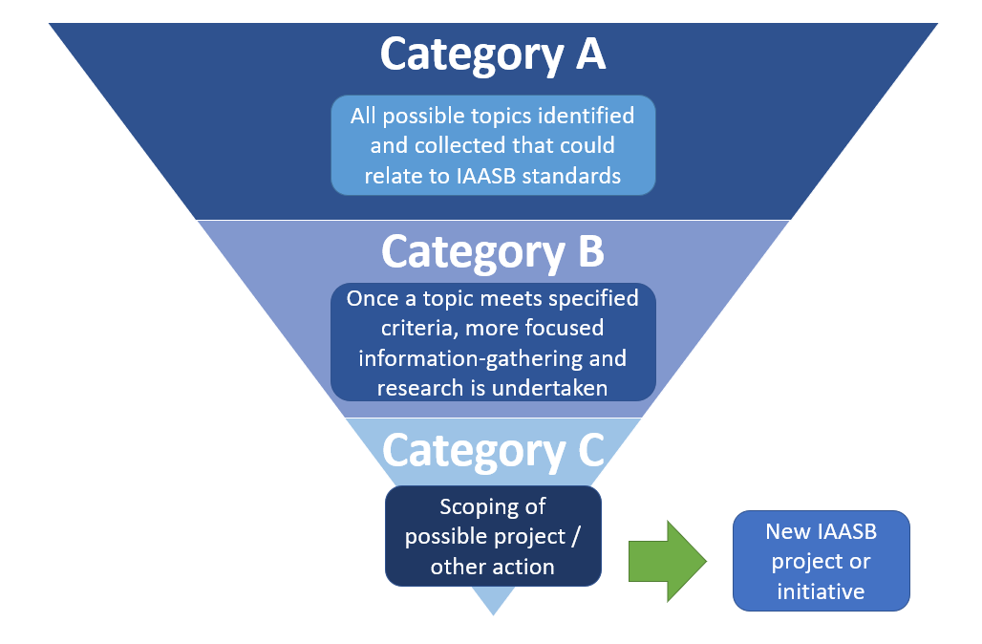
The diagram below illustrates the movement between categories and provides context as to the nature of activities within each category. It is not intended to be a linear process, or with a particular timing within a specific category as that will depend on the nature and urgency of the topic that has been identified, and how much work is needed to proceed through each category.
Determining Possible New Topics for the Work Plan for 2022–2023
On the basis that work will commence on one or two new topics at a minimum in 2023, we would like stakeholder views about what topic(s) we should consider for future standard-setting or other IAASB activities.
To facilitate an understanding of the likely next possible topic(s), we have applied the criteria to move from ‘Category A’ to ‘Category B’ to the topics and issues already identified in ‘Category A.’ Based on our review of the topics included in Category A and an initial assessment of the criteria, we have identified eight leading candidate topics to move to Category B. The eight topics that we believe could be our next possible topic(s) are described in the table below. As we are at a very early stage, it would be difficult to describe the exact actions in relation to each topic, but we believe that our attention is warranted to possibly undertake more focused information gathering and research activities to determine if a project or other action is needed, and what that would be.
We also note that the list is preliminary and would welcome stakeholder input on whether we should consider other topics as leading priorities. In identifying other topics, we encourage respondents to explain why those topics should be considered.
Topic | Description
Possible Standard-Setting Relating to Audits/Reviews – Substantial Revision or Narrow Scope Project (i.e., Targeted Changes)
Responding to Assessed Risks | Revising and modernizing ISA 330, The Auditor’s Responses to Assessed Risks to enhance the coherence of the suite of ISAs and make the standard more relevant for today’s environment and current practice. A project to revise ISA 330 would likely require a substantial revision of the standard.
Analytical Procedures | Revising ISA 520, Analytical Procedures to enhance the relevance of the standard for today’s environment (e.g., taking into account the impact of technology on how analytical procedures are planned and performed), to address regulatory concerns, enhance the coherence of the suite of ISAs and address other challenges identified with the standard. Activities to scope a project on ISA 520 would determine whether it would be a substantial revision of the standard or more limited in scope, or whether the development of non-authoritative guidance is needed.
Audit Sampling | Revising ISA 530, Audit Sampling to enhance the relevance of the standard for today’s environment (e.g., for consistency in practice), respond to regulatory concerns and address other challenges identified with the standard. Activities to scope a project on ISA 530 would determine whether it would be a substantial revision of the standard or more limited in scope, or whether the development of non-authoritative guidance is needed.
Using the Work of an Auditor’s Expert | Revising ISA 620, Using the Work of an Auditor’s Expert to enhance the relevance of the standard for today’s environment (e.g., new practice and behaviors regarding using experts), respond to regulatory input and address other matters of clarity needed. Activities to scope a project on ISA 620 would determine whether it would be a substantial revision of the standard or more limited in scope.
Review of Interim Financial Information | Revising International Standard on Review Engagements (ISRE) 2410, Review of Interim Financial Information Performed by the Independent Auditor of the Entity for the Clarity format for coherence with other IAASB standards, enhance clarity and address other challenges identified related to the standard. A project to revise ISRE 2410 would likely require a substantial revision of the standard.
Joint Audits | As joint audits are becoming more prevalent globally there is an increasing need for guidance about how joint audit engagements should be undertaken; clarifying practice in this area will contribute to consistency in auditor procedures. Initially, we could explore whether it is feasible to develop a pronouncement or non-authoritative materials that would have global relevance due to the differing nature of such engagements in those jurisdictions where joint audits are mandated or permitted, to determine an appropriate way forward.
Other Assurance
Assurance for XBRL | The increasing use of eXtensible Business Reporting Language (XBRL) in digital financial reporting, for example by the European Union and the Securities and Exchange Commission in the United States, will likely drive the need for assurance in this area in the near future. We could explore the development of an assurance standard for assurance engagements on financial information reported in a digital format that would meet global needs.
Assurance for Climate Change Disclosures | Climate change disclosures continue to evolve globally, as does the need for assurance. We could explore the development of an assurance standard or non-authoritative guidance for assurance engagements on climate change disclosures that would meet global needs.
There are two broad areas that have not been included in the list of eight topics within the table above:
- Technology ─ Technology as a subject is pervasive across our standards. We will consider any impacts of technology and relevant changes needed in individual projects. We also have our ongoing workstream related to technology (including our focused efforts on disruptive technologies) (see the ‘Context for the Work Plan for 2022‒2023’ section).
- Assurance on non-financial information ─ In addition to the “Assurance for Climate Change Disclosures” as included in the table above, we are aware of current global developments to establish a coherent set of sustainability reporting standards. We will continue to closely monitor developments within the broader area of non-financial information reporting, and will take action as appropriate, if and when needed. We are prepared to act to enhance our standards, frameworks and guidance to support progress in this area at the right time. More detail about our recent work relating to this area, including our recently approved Non-Authoritative Guidance on Extended External Reporting (EER) Assurance Engagements, can be found on our EER webpage.
Narrow Scope Amendments
In addition to the topics in the table above, we would like to hear whether there are specific topics or “pain points” that the IAASB could address through narrow scope amendments. Our Framework allows for narrow scope maintenance of our standards achieved through a limited number of targeted changes, to either a single standard or across multiple standards (i.e., a “narrow scope maintenance project”). These types of projects are undertaken, for example, when there is an urgent need to address an issue or when a standard-setting response is indicated (rather than non-authoritative material) but does not require a full scope revision on one or more standards. Before commencing work on such a project, we would still consider our overall priorities and capacity to undertake the work.
Question 5
Please rank the relative importance of the eight topics in the table above to yourself or your organization (with 1 being the highest priority).
- List with 8 topics – you can only select a topic once by assigning a number (from 1 to 8) to each topic.
- Please provide your rationale and views on the needs and interests that would be served by undertaking such work, why certain topics are relatively more important to you or your organization and any other relevant information to the IAASB)?
Question 6
Are there any other topics that are more important than the eight topics in the table above that should be prioritized ahead of these? If so, please explain what the topic is, what topic(s) should it be prioritized ahead of, and why (including your views on the needs and interests that would be served by undertaking such work)?
Question 7
Are there any specific topics or issues related to a targeted requirement(s) or issue(s) that could be a candidate for the narrow scope maintenance of our standards (other than what you have already addressed)? If so, please explain what the topic or issue is, which standard it relates to, why this is limited in scope, and why this should be prioritized?

The structures and processes that support the operations of the IAASB are facilitated by the International Federation of Accountants® or IFAC®.
The IAASB and IFAC do not accept responsibility for loss caused to any person who acts or refrains from acting in reliance on the material in this publication, whether such loss is caused by negligence or otherwise.
International Standards on Auditing, International Standards on Assurance Engagements, International Standards on Review Engagements, International Standards on Related Services, International Standards on Quality Control, International Auditing Practice Notes, Exposure Drafts, Consultation Papers, and other IAASB publications are published by, and copyright of, IFAC.
Copyright © May 2021 by IFAC. All rights reserved. Permission is granted to make copies of this work to achieve maximum exposure and feedback provided that each copy bears the following credit line: “Copyright © May 2021 by the International Federation of Accountants® or IFAC®. All rights reserved. Used with permission of IFAC. Permission is granted to make copies of this work to achieve maximum exposure and feedback.”
The ‘International Auditing and Assurance Standards Board’, ‘International Standards on Auditing’, ‘International Standards on Assurance Engagements’, ‘International Standards on Review Engagements’, ‘International Standards on Related Services’, ‘International Standards on Quality Management’, ‘International Standards on Quality Control’, ‘International Auditing Practice Notes’, ‘IAASB’, ‘ISA’, ‘ISAE’, ‘ISRE’, ‘ISRS’, ‘ISQM’, ‘ISQC’, ‘IAPN’, and IAASB logo are trademarks of IFAC, or registered trademarks and service marks of IFAC in the US and other countries.
For copyright, trademark, and permissions information, please go to permissions or contact permissions@ifac.org.

International Standard on Auditing (ISA) 600, Special Considerations—Audits of Group Financial Statements (Including the Work of Component Auditors)
The targeted projects in the table do not take account of any changes that may result from the implementation of the Monitoring Group reforms, which are scheduled to begin in the 2022–2023 period. These changes will affect Board members (and their capacity) and Staff (and its capacity).
These projects are described in more detail on our project pages.
ISA 500, Audit Evidence
These projects are still in the information gathering stage, and the nature and extent of changes to be made, and other activities (if necessary), still have to be determined by the Board. Depending on the agreed project activities, the targeted timing for these projects may significantly change.
ISA 240, The Auditor’s Responsibilities Relating to Fraud in an Audit of Financial Statements
ISA 570 (Revised), Going Concern
This project is described in more detail on our project page.
This project is described in more detail on our project page.
We currently have eight full-time technical staff, directly working on the standard-setting projects (excluding the Technical Director), with one open position, as well as a Staff Fellow (until September 2021). Consultants (currently two) are used as the need arises. If staff resources evolve as the Monitoring Group recommendations are adopted, changes will be made to the Board’s agenda as Board plenary time allows.

