Project Submission by Prajwal Mahajan

The project problem statement includes an application that can ingest any kind of document types such as pdf, doc, csv, txt, imges etc and understand the user’s query and give answer based on the document provided.

I have build an application in Antigravity tool, the entire application is based on python3 language with component such as streamlit to makes user experience easy to use and the application backed by the gemini llm model gemini 3 flash preview. For the embedding sake it uses the offline model called as MiniLM L6 V2 sentence transfomer that run locally and manage to capture the semantic meaning. For the vector store I have used the FAISS and for storing the local information about the user i have used sqlite db.

1. System Architecture :

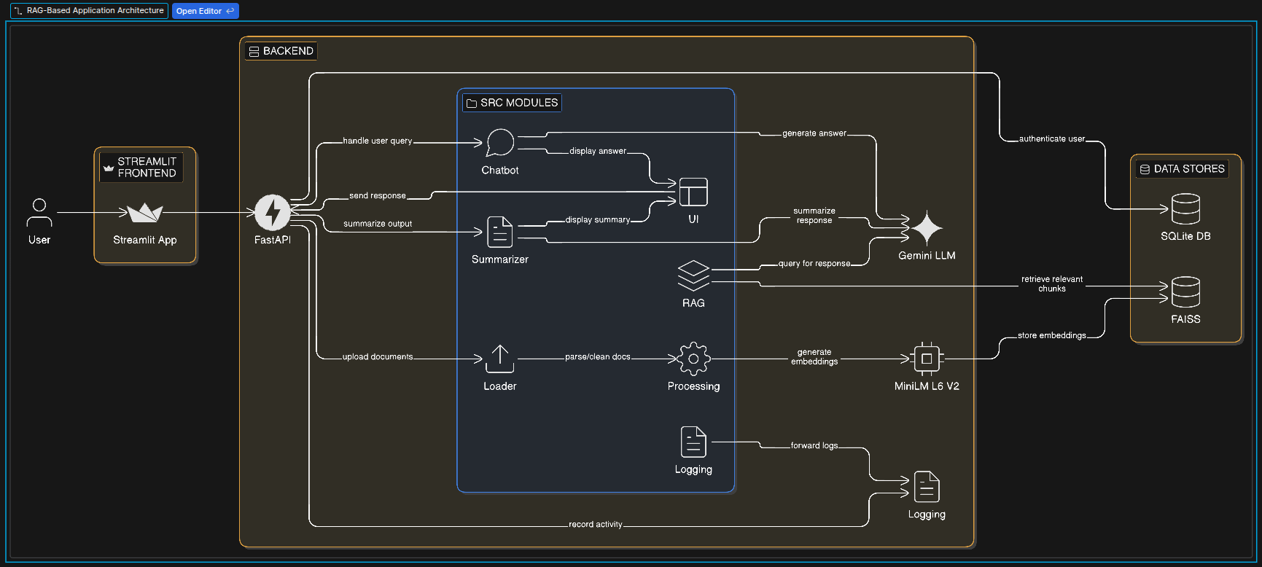

2. Directory of the project :

.streamlit/
└── config.toml

.env/
├── bin/
├── etc/
├── include/
├── lib/
└── share/

backend/
└── main.py

logging/
└── chat_logs.csv

src/
├── chatbot/
│ ├── conversation_chain.py
│ ├── history_manager.py
│ └── memory.py
├── loader/
│ ├── csv_loader.py
│ ├── ... (pdf, docx, excel, etc.)
│ └── web_loader.py
├── logging/
│ └── logger.py
├── processing/
│ ├── embedding.py
│ ├── splitter.py
│ └── vector_store.py
├── rag/
│ ├── gemini_llm.py
│ ├── qa_chain.py
│ └── retriever.py
├── summarizer/
│ ├── summarizer.py
│ └── summary_styles.py
└── ui/
├── chat.py
├── login.py
├── sidebar.py
└── styles.py

user_data/
└── [User specific data]

vector db/
└── [Vector database files]

3. Screen shot of the project in Antigravity

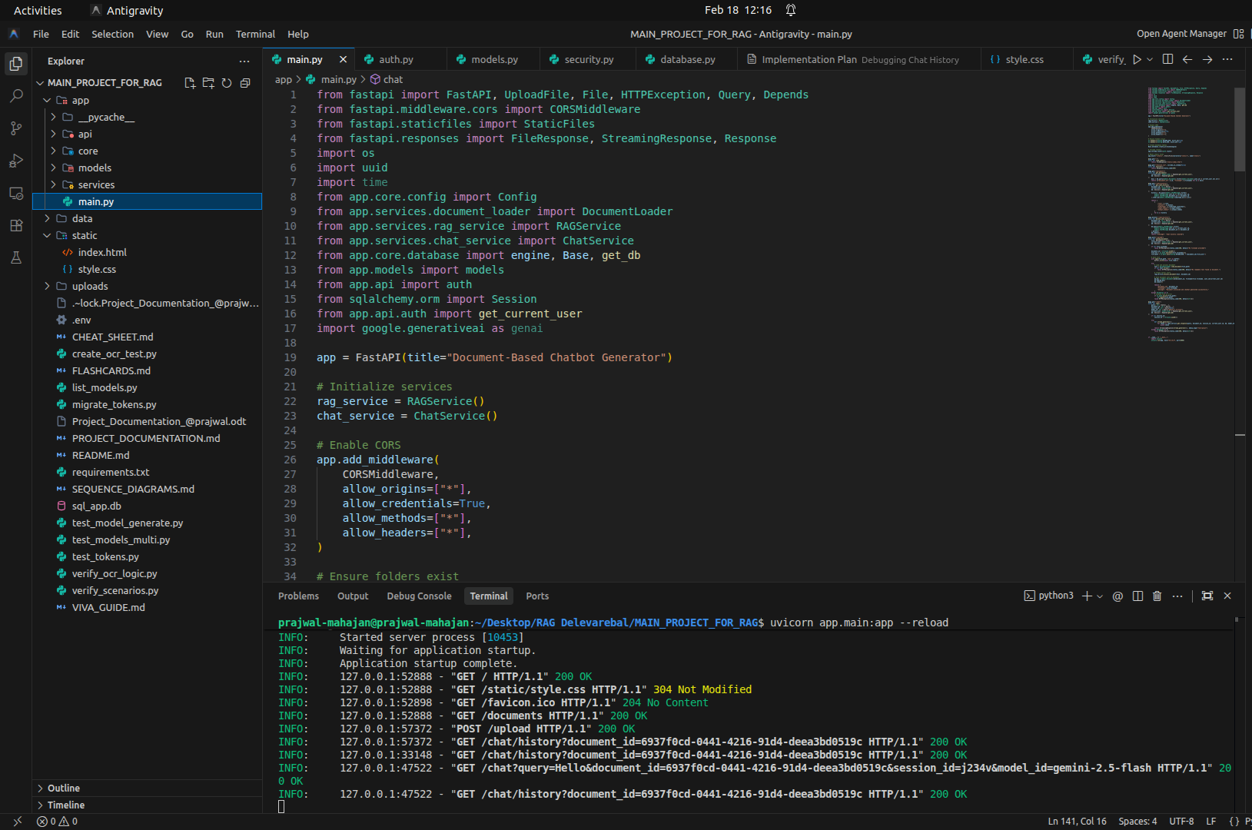

4. Running Code in terminal

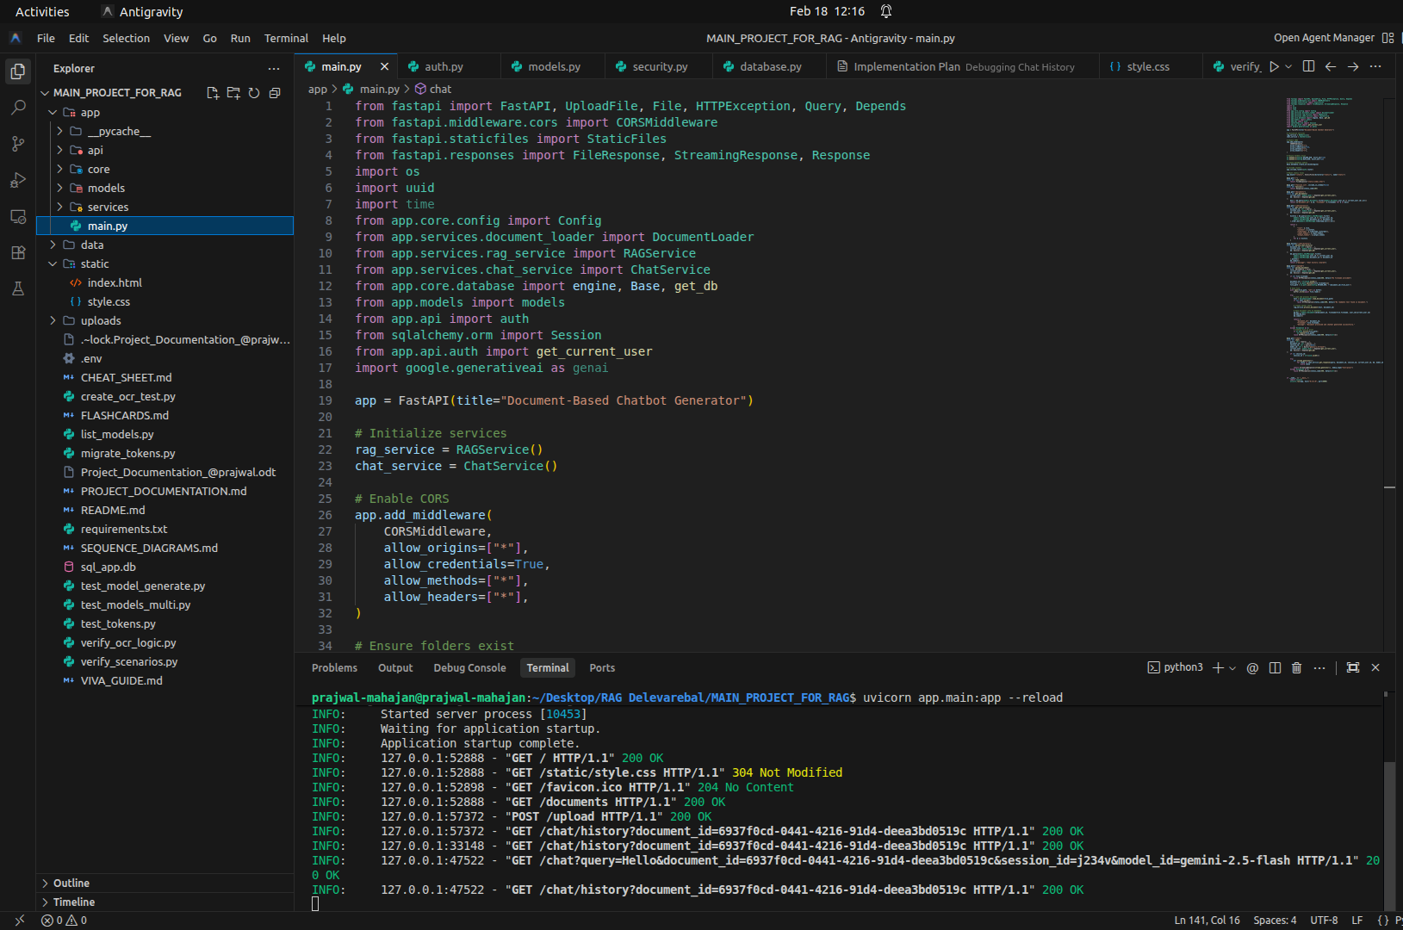
5. Login UI

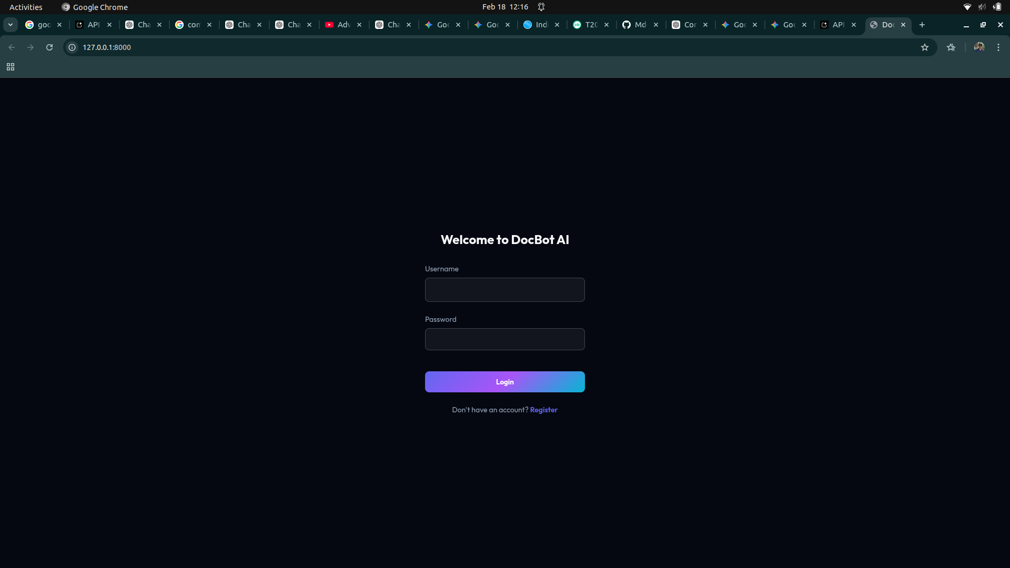

6. User Credentials

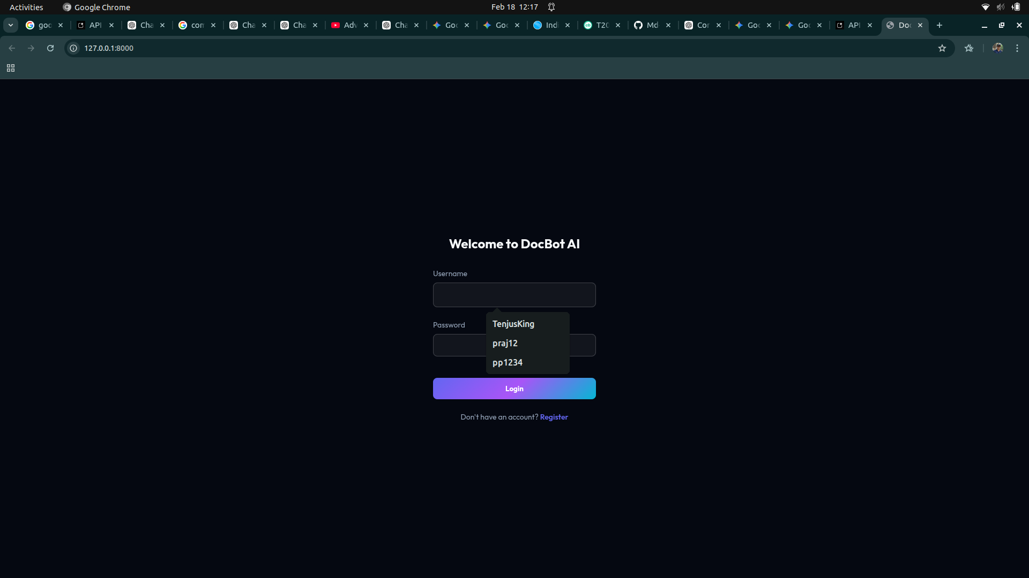

7. Document Management

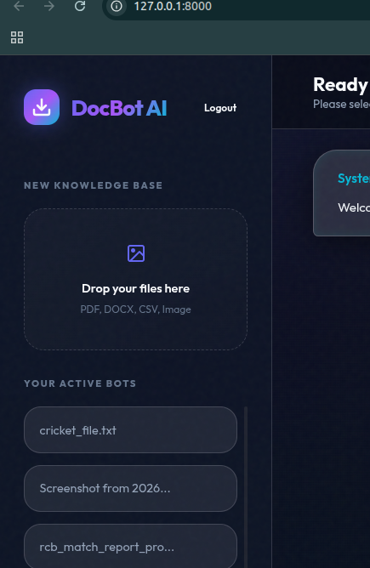

8. Chat Workspace

