Royal Challengers Bangalore vs Chennai Super Kings
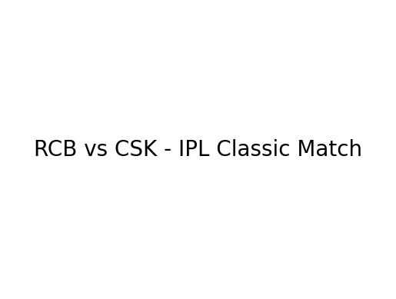

Match Overview
This document presents a detailed report of a thrilling Indian Premier League (IPL) encounter between Royal Challengers Bangalore (RCB) and Chennai Super Kings (CSK). The match was played in front of a packed stadium with high expectations from fans. RCB, led by Virat Kohli, showcased aggressive intent and strong teamwork throughout the game. The contest featured explosive batting, strategic bowling changes, and intense moments that kept spectators engaged until the final overs.

RCB Batting Performance
RCB started strongly with an attacking opening partnership. Virat Kohli anchored the innings with a composed half-century while the middle order accelerated the scoring rate during the death overs. Glenn Maxwell contributed quick boundaries that shifted momentum toward RCB. Smart strike rotation and calculated risks helped RCB post a competitive total.

RCB Batting Scorecard
Batsman | Runs | Balls | Strike Rate
Virat Kohli | 72 | 48 | 150.0
Faf du Plessis | 38 | 22 | 172.7
Glenn Maxwell | 41 | 24 | 170.8
Dinesh Karthik | 26* | 12 | 216.6
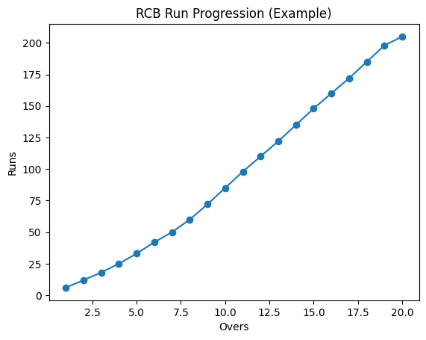

Bowling Performance
RCB bowlers executed disciplined plans while defending the total. Mohammed Siraj provided early breakthroughs, while spinners controlled the middle overs. Harshal Patel delivered crucial death overs, restricting CSK’s scoring opportunities and ensuring pressure remained on the chasing side.

RCB Bowling Figures
Bowler | Overs | Runs | Wickets
Mohammed Siraj | 4 | 28 | 2
Harshal Patel | 4 | 32 | 3
Wanindu Hasaranga | 4 | 24 | 2

Match Result & Fan Reaction
RCB successfully defended the total and secured a memorable victory. The crowd erupted in celebration as players congratulated each other. The match highlighted RCB’s balanced squad and strong execution under pressure. Fans across social media praised the performance, making it one of the most talked-about matches of the season.


