

**DON**

**BOSCO**

**INSTITUTE**

**OF**

**TECHNOLOGY**

Kumbalgodu,

Mysuru

Road,

Bengaluru

–

560074

**Department of INFORMATION SCIENCE &**

**ENGINEERING**

**SUBMITTED**

**BY**

**IV**

**SEMESTER**

**/**

**BE**

**Under the G**

**uidance of**

**Dr Rajashekar Patil M**

**P**

**rofessor**

**D**

**ept**

**. of ISE, DBIT**

**[**

**As**

**per**

**Choice**

**Based**

**Credit**

**System**

**(**

**CBCS**

**)**

**Scheme]**

**LAB**

**MANUAL**

**for**

**the**

**subject**

**Design**

**And**

**Analysis**

**of**

**Algorithm**

**Laboratory**

**(21**

**CS**

**42)**

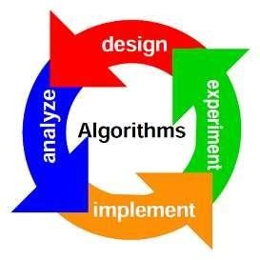

**(1DB21IS102)**

a

**PRAJWAL**