INTRODUCTION

1.1 Background
Education is one of the most critical pillars of societal development. Academic performance reflects not just intellectual ability but also the influence of social, familial, and environmental factors. In today's data-rich environment, educational institutions collect vast amounts of student data, yet most schools still rely on traditional, manual processes to evaluate student performance — processes that are slow, subjective, and prone to error.

Machine Learning offers a powerful alternative by enabling predictive analytics on student data. By learning patterns from historical records, ML models can identify at-risk students much earlier than conventional methods, allowing educators to implement targeted interventions before failure occurs.
1.2 Problem Definition
Educational institutions face significant challenges in proactively identifying students who are at risk of academic failure. The absence of an intelligent early warning system means that teachers often discover struggling students only after the damage is done — after examinations have been failed and attendance thresholds crossed. Manual assessment lacks scalability, consistency, and personalisation.
1.3 Proposed Solution
This project proposes an end-to-end intelligent web-based system that leverages five supervised ML algorithms to predict student pass/fail outcomes. The system is built on a Flask backend, uses a ColumnTransformer pipeline for feature preprocessing, and selects the best model automatically via cross-validation. It also provides SHAP-based explanations for every prediction, making the AI decision transparent and interpretable.
1.4 Scope of the Project
- Predict whether a student will Pass or Fail based on 30+ features.
- Support bulk prediction (CSV/Excel upload) and individual (manual entry) modes.
- Auto-generate 10 visualisation charts per prediction session.
- Provide personalised, actionable improvement tips for each student.
- Allow export of prediction results as downloadable CSV reports.
- Deliver SHAP explainability for transparent AI-driven decisions.
HARDWARE / SOFTWARE REQUIREMENTS

4.1 Hardware Requirements
Component | Specification
Processor | Intel Core i3 / AMD Ryzen 3 or higher
RAM | Minimum 4 GB (8 GB Recommended)
Storage | Minimum 10 GB free disk space
Operating System | Windows 10/11, Ubuntu 20.04+ or macOS
Internet Connection | Required for initial package installation

4.2 Software Requirements
Software / Library | Version | Purpose
Python | 3.8+ | Core programming language
Flask | 2.x | Web framework for server & routing
scikit-learn | 1.x | ML pipeline: LR, SVM, Random Forest
XGBoost | 1.7+ | Gradient boosted tree classifier
SHAP | 0.41+ | Model explainability & feature attribution
Pandas | 1.5+ | Data manipulation and ingestion
NumPy | 1.23+ | Numerical array operations
Matplotlib | 3.6+ | Chart and visualisation generation
Joblib | 1.2+ | Model serialisation (model.pkl)
Jinja2 | 3.x | HTML template rendering (via Flask)
Bootstrap | 5.x | Responsive front-end UI framework
VS Code / PyCharm | Any | Recommended IDE for development

RESOURCES METHODOLOGY

5.1 Dataset
The project uses the Student Performance Dataset originally published by Paulo Cortez and Alice M.G. Silva (University of Minho, 2008). The dataset contains records of 395 secondary school students from two Portuguese schools and includes 30+ demographic, academic, and social attributes. The target column 'passed' indicates whether a student passed (yes) or failed (no) the academic year.

5.2 Feature Categories
Academic Features: school, studytime, failures, schoolsup, famsup, paid, activities, higher, absences
Personal Features: sex, age, address, famsize, Pstatus, Medu, Fedu, guardian, nursery, internet
Social Features: romantic, traveltime, freetime, goout, Dalc (weekday alcohol), Walc (weekend alcohol), health, Mjob, Fjob, reason

5.3 System Development Methodology
The project follows a structured CRISP-DM (Cross Industry Standard Process for Data Mining) methodology combined with Agile iterative development cycles:
Step 1 – Data Collection: The student performance CSV dataset is loaded via Pandas. Users can also upload custom CSV/Excel files through the web interface.
Step 2 – Data Preprocessing: A ColumnTransformer pipeline applies OneHotEncoding to all categorical features (school, sex, address, etc.) and passes through numerical columns unchanged. Class imbalance between pass/fail is handled through balanced class weights.
Step 3 – Model Training: Five ML algorithms are trained: Logistic Regression, SVM (linear kernel), SVM (RBF kernel), Random Forest Classifier, and XGBoost. Each model is evaluated using StratifiedKFold cross-validation (5-fold) to select the best.
The system trains and compares five supervised Machine Learning classification algorithms. The best model is automatically selected using Stratified K-Fold cross-validation (k=5). Below is a concise explanation of each algorithm:
1. Logistic Regression
Logistic Regression is a statistical linear model used for binary classification. It estimates the probability that a given input belongs to a class (Pass/Fail) using the sigmoid function: σ(z) = 1 / (1 + e⁻ᶻ), where z = wᵀx + b.
Type: Linear, Discriminative classifier
Strength: Fast, interpretable, works well on linearly separable data
Limitation: Cannot capture non-linear feature interactions
Use Here: Baseline model; provides coefficient-based feature importance
2. Support Vector Machine – Linear Kernel (SVM Linear)
SVM finds the optimal hyperplane that maximally separates the two classes (Pass/Fail) by maximising the margin between the nearest data points of each class (support vectors). The linear kernel computes: K(xᵢ, xⱼ) = xᵢ · xⱼ.
Type: Discriminative, margin-based linear classifier
Strength: Effective in high-dimensional spaces with fewer samples
Limitation: Poor performance on complex, non-linearly distributed data
Use Here: Evaluated as a linear alternative to Logistic Regression
3. Support Vector Machine – RBF Kernel (SVM RBF) ★ Best Model
The RBF (Radial Basis Function) kernel maps input data into an infinite-dimensional space, enabling SVM to learn non-linear boundaries. Kernel function: K(xᵢ, xⱼ) = exp(−γ‖xᵢ − xⱼ‖²). This model achieved the highest cross-validated accuracy (70.1%) and F1-Score (0.765) in this project.
Type: Non-linear kernel-based discriminative classifier
Strength: Handles non-linear relationships; robust to overfitting
Limitation: Slower training on large datasets; sensitive to γ and C
Use Here: Best performing model — selected automatically by CV
4. Random Forest Classifier
Random Forest is an ensemble method that builds multiple decision trees on random subsets of data (bagging) and averages their predictions. Each tree is trained on a bootstrap sample and uses a random subset of features at each split, reducing variance and preventing overfitting.
Type: Ensemble, bagging-based non-linear classifier
Strength: Handles mixed feature types; high recall; robust to noise
Limitation: Less interpretable; can overfit on noisy small datasets
Use Here: Provides feature importance scores for SHAP explainability
5. XGBoost (Extreme Gradient Boosting)
XGBoost is an optimised gradient boosting algorithm that builds trees sequentially, with each new tree correcting the errors of the previous one. It minimises a regularised objective: L(θ) = Σ l(yᵢ, ŷᵢ) + Ω(f), where Ω penalises model complexity to prevent overfitting. XGBoost is known for speed and top competition performance.
Type: Ensemble, boosting-based non-linear classifier
Strength: High accuracy, built-in regularization, handles missing values
Limitation: More hyperparameters to tune; slower than single models
Use Here: Delivers high recall; supports SHAP TreeExplainer for explanations
Summary Comparison Table
Algorithm | CV Accuracy | Precision | Recall | F1-Score
Logistic Regression | 64.8% | 0.714 | 0.660 | 0.686
SVM (Linear kernel) | 65.3% | 0.723 | 0.641 | 0.680
SVM (RBF kernel) ★ | 70.1% | 0.710 | 0.830 | 0.765
Random Forest | 68.6% | 0.680 | 0.924 | 0.784
XGBoost | 67.8% | 0.714 | 0.849 | 0.775

Step 4 – Model Evaluation: Models are evaluated on accuracy, precision, recall, and F1-score. The best model is saved as model.pkl using Joblib. Metrics are stored in algo_metrics.json and displayed in the web interface.
Step 5 – Prediction & Explanation: The selected model predicts Pass/Fail with a probability score for each student. SHAP (SHapley Additive exPlanations) values explain which features contributed most to each prediction, making the AI decision transparent and interpretable.
Step 6 – Visualisation & Reporting: 10 charts are auto-generated: predicted counts bar chart, study time vs performance, absence distribution histogram, past failure analysis, Pearson correlation heatmap, raw and normalised confusion matrices, algorithm comparison chart, feature importance chart, and SHAP summary plot. Results are exported as a downloadable CSV report.
Step 7 – Web Interface (Flask App): The Flask application provides three functional tabs: (1) Upload Dataset for bulk predictions, (2) Manual Entry for individual student analysis, and (3) Default Dataset for demonstration purposes. The Bootstrap 5 UI is fully responsive.

DFD AND ER Diagram
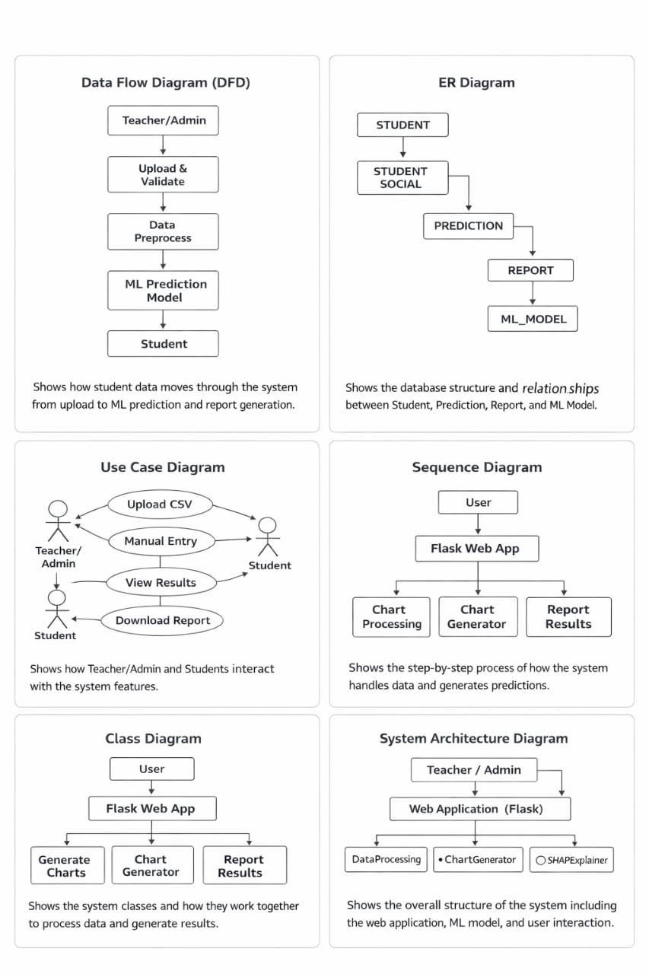

CONCLUSION

This project successfully demonstrates the application of Machine Learning in the domain of education — specifically in predicting student academic performance. By training five different classification algorithms on real student data and automatically selecting the best-performing model, the system provides a robust, data-driven solution to the problem of early student failure detection.

The integration of SHAP explainability ensures that predictions are not just accurate but also interpretable, allowing educators to understand exactly why a student is predicted to pass or fail. The personalised improvement tips generated for each student make the system actionable — not merely predictive.

The Flask-based web application provides an intuitive, responsive interface suitable for deployment in real educational environments. The system supports three modes of use — bulk file upload, individual student manual entry, and default dataset analysis — making it flexible for a variety of institutional needs.

In summary, the Intelligent Student Performance Prediction System achieves its core objectives:
- Accurate Pass/Fail prediction using ML with up to 70.1% cross-validated accuracy.
- Automatic best-model selection using StratifiedKFold cross-validation.
- Transparent, explainable AI via SHAP feature attribution.
- 10 automated visualisation charts for comprehensive data analysis.
- Personalised, actionable improvement tips per student.
- Downloadable prediction reports and a clean responsive web interface.

This system holds significant potential to transform how schools monitor and support student progress, moving from reactive to proactive academic management.

FUTURE ENHANCEMENT

While the current system provides a comprehensive ML-based prediction platform, several enhancements can further improve its capabilities, scalability, and reach:

1. Deep Learning Integration: Incorporating LSTM (Long Short-Term Memory) networks or multi-layer neural networks can capture more complex temporal patterns in student performance data, especially when tracking progress across multiple academic terms or years.
2. Cloud-Based Deployment: Deploying the application on cloud platforms such as AWS, Google Cloud, or Heroku with a CI/CD pipeline will allow real-time access, automatic scaling, and improved availability for institutions with large student populations.
3. Mobile Application: Developing a companion mobile application using React Native or Flutter will allow teachers, students, and parents to access predictions, reports, and alerts conveniently from their smartphones.
4. Automated Alert & Notification System: Implementing an automated email and SMS alert system that notifies teachers and parents when a student is predicted to be at high risk of failure will enable faster, more timely interventions.
5. Role-Based Access Control (RBAC): Adding JWT-based authentication and role-specific dashboards for Administrators, Teachers, and Students will improve security and personalise the experience for each stakeholder group.
6. Multi-Subject & Multi-Grade Support: Extending the system to handle predictions across multiple subjects (Mathematics, Science, Language) and multiple grade levels will significantly broaden its applicability in real educational institutions.
7. Real-Time Data Integration: Integrating with Learning Management Systems (LMS) such as Moodle or Canvas via REST APIs to automatically pull live student attendance and grade data will make the system fully automated and reduce manual data entry.
8. Advanced Explainability: Adding LIME (Local Interpretable Model-Agnostic Explanations) alongside SHAP, and generating natural language explanation summaries for each prediction, will further improve accessibility for non-technical stakeholders.
9. Data Analytics Dashboard: Building an interactive analytics dashboard with drill-down filters for class, subject, term, and demographic groups will provide administrators with powerful institutional-level insights for data-driven policy decisions.

These future enhancements will transform the current system from a standalone prediction tool into a comprehensive, institution-wide intelligent academic monitoring and support platform — driving better educational outcomes at scale.

