MECHINAGAR POLYTECHNIC INSTITUTE

MECHINAGAR-10,DHULABARI

DEPARTMENT OF INFORMAION

TECHNOLOGY

PROPOSAL ON

INVENTORY MANAGEMENT SYSTEM

SUBMITTED BY: SUBMITTED TO:

Miru Limbu Arjun Tiwari

Prajwal Neupane

Rajkumar Shahi

Santosh Dhakal

ABSTRACT:

This project is aimed at developing a web based application named Inventory Management System for managing the inventory system of specific organization. The Inventory Management System (IMS) refers to the system and processes to manage the stock of organization with the involvement of Technology system. This system can be used to store the details of the inventory, purchase goods, stock maintenance, update the inventory based on the sales details, generate sales and inventory report daily or weekly based. This project is categorize individual aspects for the sales and inventory management system. In this system we are solving different problem affecting to direct sales management and purchase management. Inventory Management System is important to ensure quality control in businesses that handle transactions resolving around consumer goods. Without proper inventory control, a large retail store may run out of stock on an important item. A good inventory management system will alert the wholesaler when it is time to record. Inventory Management System is also on important means of automatically tracking large shipment. An automated Inventory Management System helps to minimize the errors while recording the stock.

**Table of Contents**

INTRODUCTION 1

OBJECTIVES 1

LITERATURE REVIEW 2

METHODOLOGY 2

1. Requirement Analysis 2
2. System Design: 2
3. Database Design 2
4. Software Development 2
5. Testing 3
6. Maintenance & Support 3

FEATURES 3

TOOLS AND TECHNIQUES 3

Programming Languages 3

Frameworks 4

Database Management System (DBMS): 4

Version Control Systems 4

HTML (Hypertext Markup Language): 5

CSS (Cascading Style Sheet): 5

JavaScript 5

Web Server: 6

EXPECTED OUTCOMES 6

ER DIAGRAM 7

BUDGET 8

CONCLUSION 8

REFERENCES 9

# INTRODUCTION:

The inventory management system at a warehouse is a set of techniques, methods, and technologies for managing and controlling inventories. It can be used and utilized in a wide range of ways, from simple to complex. It focuses on the needs and scale of the company, as well as the capabilities and utility of the management software. Inventory management system software is a necessary and valuable tool for all firms that deal with inventory. It regulates the movement of stock in and out, keeps track of inventory levels for all items and stock, provides access to sales data and analytics, and helps businesses specify specific safety stock requirements .Inventory management is, in a way, the lifeblood of a company; it is what generates sales, which drives profitability. The advantages of a sophisticated and effective inventory management system can be enormous. The way a company maintains its inventory can have a big impact on its overall success.

# OBJECTIVES:

* To develop an application that deals with the day to day requirement of any production organization
* To develop the easy management of the inventory
* To handle the inventory details like sales details, purchase details and balance stock details
* To provide competitive advantage to the organization.
* To provide details information about the stock balance.
* To make the stock manageable and simplify the use of inventory in the organization.

# LITERATURE REVIEW:

Products are considered as the business resources for the organization. This includes managing the product with appropriate way to review any time as per the requirement. Therefore it is important to have a computer based IMS which has the ability to generate reports, maintain the balance of the stock, details about the purchase and sales in the organization. Before developing this application we came up with 2 Inventory Management System existing in the market, which helps to give the knowledge for the development of our project. These application software are only used by the large organization but so we came up with the application which can be used by the small company for the management of their stock in the production houses. After analyzing the other inventory management system we decided to include some of common and key features that should be included in every inventory management system. So we decided to include those things that help the small organization in a way or other.

METHODOLOGY:

Developing an Inventory Management System requires careful planning and implementation. Here is a general methodology that can be followed for creating an Inventory Management System:

1. Requirement Analysis: We collected a number of requirements for project from our primitive research, website visits, and interview to the concerned personnel and their experiences regarding the concepts of its development.
2. System Design: Create a high-level design of the Inventory Management System. This includes defining the system architecture, data model, user interface design, and the overall system flow.
3. Database Design: Designing the database structure that will store information about goods, purchase, transactions, and other relevant data. Identify the necessary tables, relationships, and attributes.
4. Software Development: To implement the Inventory Management System based on the design and requirements. We choose PHP as programming language and Laravel as framework.
5. Testing: Testing the Inventory Management System to identify and fix any bugs or issues.
6. Deployment: Once the functional and nonfunctional testing is done; the product is deployed in the customer environment or released into the market
7. Maintenance & Support: Once the Inventory Management System is deployed, monitoring its performance, security, and reliability is done till the lifetime of Software.

# Problem in existing project:

The manual system used Previous is entirely a paper based system.

This manual system is time-consuming, more prone to errors and less efficient.

Some of the disadvantages of the current manual system are:

* + Less User-Friendly
  + Risk for human errors
  + Time consuming
  + Difficulty to maintain large volume of data
  + Paperwork trail

FEATURES:

* + Customer Management: Efficiently track customer profiles, orders, and interactions for personalized service and satisfaction.
  + Product Catalog: It maintains a large catalog of products with essential details for accurate inventory management sales.
  + Order Management: Smooth order processing, tracking, and ensuring delivery on time and customer satisfaction.
  + Shipment Tracking: It Monitor shipment status and provides real-time updates to customers, optimizing products and delivery.
  + Supplier Management: It Manages supplier relationships and performance metrics for reliable procurement of goods and quality assurance.
  + Warehouse Management: It Optimizes warehouse layout and inventory handling processes for efficient storage and movement of goods**.**

# TOOLS AND TECHNIQUES:

Inventory Management System can utilize various tools and techniques to enhance their functionality and efficiency. Here are some common tools and techniques used in Inventory Management System.

## Programming Languages:

Programming languages play a crucial role in building the system's functionality. Common languages used for inventory management systems include:

* + PHP is a widely - used server-side scripting language specifically designed for web development. It is known for its simplicity, flexibility, and extensive community support.
  + It is known for its simplicity, flexibility, and extensive community support.
  + PHP is capable of embedding within HTML code, making it easy to create dynamic web pages.

## Frameworks:

Frameworks provide a foundation for developing a inventory management system, offering pre-built components, libraries, and tools. Here we use Laravel framework for designing inventory management system application.

Laravel: - A PHP framework known for its elegant syntax and robust features.

* + Laravel is an open-source PHP web application framework known for its elegance, simplicity, and modern features.
  + It follows the Model-View-Controller (MVC) architectural pattern, which separates the application's logic, presentation, and data layers.
  + Laravel offers a wide range of built-in features, including routing, caching, session management, and authentication.

## Database Management System (DBMS):

DBMS is used to store and manage the inventory system's data. Popular DBMS choices Include:

* + MySQL: An open-source relational database management system (RDBMS).
  + MySQL follows the SQL (Structured Query Language) standard, providing a powerful and flexible language for managing databases.
  + It supports features such as transactions, stored procedures, triggers, and views, allowing complex database operations and data manipulation.
  + MySQL is compatible with various operating systems, including Windows, Linux, and mac OS, making it highly accessible.

## Version Control Systems:

Version controls systems help manage the source code and collaboration among developers. Examples include:

Git: A widely used distributed version control system for tracking changes in code.

* + Git is a distributed version control system designed for managing source code and tracking changes in files.
  + It allows multiple developers to work on the same project simultaneously and provides mechanisms for collaboration and code integration.
  + Git stores project data as a series of snapshots, making it fast and efficient to track changes and revert to previous versions.

## HTML (Hypertext Markup Language):

HTML is the standard markup language used for creating the structure and content of web pages. In the context of a Inventory Management System, HTML is used to define the various elements and components of the system's user interface, such as buttons, forms, tables, and text. It allows developers to structure the web pages and organize the content in a logical and hierarchical manner.

## CSS (Cascading Style Sheet):

CSS is a style sheet language used for describing the presentation and visual appearance of a web page. It works in conjunction with HTML to control the layout, colors, fonts, and other visual aspects of the Inventory Management System's user interface. CSS enables developers to apply consistent styles and create an attractive and user-friendly design across all the pages of the system.

## JavaScript:

JavaScript is a high-level programming language that adds interactivity and dynamic behavior to web pages. In the context of a Inventory Management System, JavaScript is used to implement client-side functionalities, such as form validation, data manipulation, and user interactions. It enables developers to create responsive and interactive features, enhancing the user experience of the system.

Web Server:

A web server stores and delivers the content for a website – such as text, images, video, and application data – to clients that request it. The most common type of client is a web browser, which requests data from your website when a user clicks on a link or downloads a document on a page displayed in the browser.

.Nginx: Nginx is popular web server software that is used to serve web content efficiently and handle HTTP requests. In the context of a Inventory Management System, Nginx can be used as the web server to host the system's web application. It provides high performance, scalability, and load balancing capabilities, ensuring that the system can handle a large number of concurrent users and deliver content quickly and reliably.

# EXPECTED OUTCOMES:

The final outcome of the Inventory Management System includes:

* + Better Inventory Accuracy: With solid inventory management, you know what’s in stock and order only the amount of inventory you need to meet demand.
  + Reduced Risk of Overselling : Inventory management helps track what’s in stock and what’s on backorder, so you don’t oversell products.
  + Cost Savings: Stock costs money until it sells. Carrying costs include storage handling and transportation fees, insurance and employee salaries. Inventory is also at risk of theft, loss from natural disasters.
  + More Productivity: Good inventory management solutions save time that could be spent on other activities.
  + Increased Profits: A better understanding of both availability and demand leads to higher inventory turnover, which leads to greater profits.
  + Enhanced Security and Privacy: It provides access controls, data encryption, and safeguards against unauthorized access or data breaches, maintaining the

confidentiality and integrity of sensitive data.

# ER DIAGRAM:

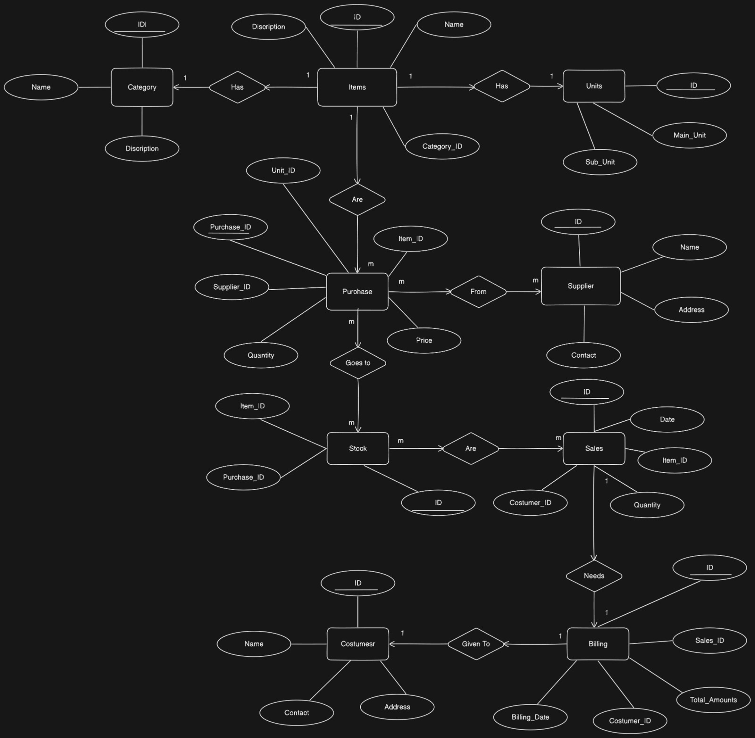

# OUR PROPOSED TEAM:

|  |  |  |
| --- | --- | --- |
| **Name** | **Role** | **Responsibilities** |
| Miru Limbu | Full Stack Developer | Handling both frontend and backend tasks, integrating the entire development process |
| Santosh Dhakal | Backend Developer | Managing server-side logic, databases and application  Architecture. |
| Prajwal Neupane | Frontend Developer | Implementing visual elements, user interface and ensuring responsive design. |
| Rajkumar Shahi | UI/UX Designer | Designing user interfaces and optimizing user experience. |

BUDGET:

The breakdown of fund required for entire project is given in below table.

|  |  |  |
| --- | --- | --- |
| S.N | Details | Amount |
| 1. | Laptop | N/a |
| 2. | Required Software | 5,000 |
| 3. | Portable devices (Pen drives, CD etc.) | 2,000 |
| 4. | Developing Cost | 33,000 |
| 5. | Paper Work Cost | 1,000 |
| 6. | Miscellaneous | 4,000 |
|  | Total Cost | 45,000 |

# 

# CONCLUSION:

This paper describes an Inventory Management System that stores sales data for a certain desktop application. It's a simple desktop application that links to the actual distribution center, allowing information to be refreshed and confirmed in the store. It's a secure application that prevents data from being spoiled in the stores. It also provides sales information on a daily, weekly, monthly and annually basis. This system makes inventory management a breeze. Increased income and profitability, a better employee climate, and an overall boost in customer satisfaction will be noticed as a result of the inventory management system.

REFERENCES:

[1] The Department of Education. (2016). Retrieved October 22 , 2016, from http://education.umbc.edu/

[2] Apple Inc, A. (2016). 21.5-inch iMac. Retrieved October 23, 2016, from [http://www.apple.com/shop/buymac/imac?product=MK142LL/A&step=config#](http://www.apple.com/shop/buymac/imac?product=MK142LL/A&step=config)

[3] Amazon. (2016). Barcode Scanner. Retrieved October 23, 2016, , from <https://www.amazon.com/TEEMI-TM2D-09-Handheld-Automatic-barcode/dp/B019DU8PTU>

[4] Amazon. (1996). Zebra LP 2844 label Barcode USPS printer LP2844. Retrieved October 23, 2016, , from Amazon.com: Electronics, <https://www.amazon.com/Zebra-Label-Barcode-PrinterLP2844/dp/B001COX8MA>

[5] Oracle. (2016). Oracle E-Business Suite Applications Global Price List. Retrieved October 24, 2016, from http://www.oracle.com/us/corporate/pricing/applications-price-list-070574.pdf [6] PayScale. (2016). Information technology (IT) consultant salary. Retrieved October 24, 2016, from <http://www.payscale.com/research/US/Job=Information_Technology_(IT)_Consultant/Salary>

[7] Training, I.-L. (2014, July 15). School asset tracking case study: Gananda CSD. Retrieved November 15, 2016, Retrieved from <http://www.waspbarcode.com/case-studies/assettracking/gananda-school-district>

[8] 7475, copo. (2013, February 18). Mainuddin Bhuiyan. Retrieved November 15, 2016, from <http://www.slideshare.net/copo7475/inventory-management-system-16598132>

[9] Scanco. (2013, August 30). Top Five benefits of a good inventory management strategy. Retrieved November 15, 2016, from http://www.scanco.com/top-five-benefits-of-a-goodinventory-management-strategy/