Railway Reservation System

Submitted as Mini Project for Special Topics: Programming with C++ Semester III

**BACHELOR OF TECHNOLOGY**

in

Computer Science and Engineering

Student Name 1:Prajwal R P

SRN:PES1201701703

Student Name2:Ganesha K S

SRN:PES1201701731

Under Guidance of

Prof. Jamuna S Murthy

BE (CSE), M.Tech (SSE)

Assistant Professor

**Aug 2018- Dec 2018**

**Department of Computer Science and Engineering**

**PES UNIVERSITY**

Outer Ring Rd, Banashankari 3rd Stage, Banashankari, Bengaluru, Karnataka 560085

[www.pes.edu](http://www.pes.edu)

Introduction

This project is a simple console application built without the use of graphics. Named railway reservation system project in C++, this program features two modes, password protection and some basic file handling operations to add and display train inquiry and reservation records. This project is complete and totally-error free, and I have presented the source code in a very understandable manner.

The source for railway reservation system project in C++ is over 700 lines, so I haven’t included the code in this post. You can directly download the source code of this project from the link below. Also, the description provided here contains general features and header files related to this project — it can be used as project synopsis.

Description

1. **Administrator mode**: There are two modes in this project – the administrator mode and the user mode. For the first time you have to create Users from the Admin mode. Once users are created, you can use the same user again and again, and they will be stored in separate files.

The operations related to both these modes are quite similar in this railway reservation system project in C++. In Admin mode, you can create detail database, add details, display details, perform user management functions and display passenger details.

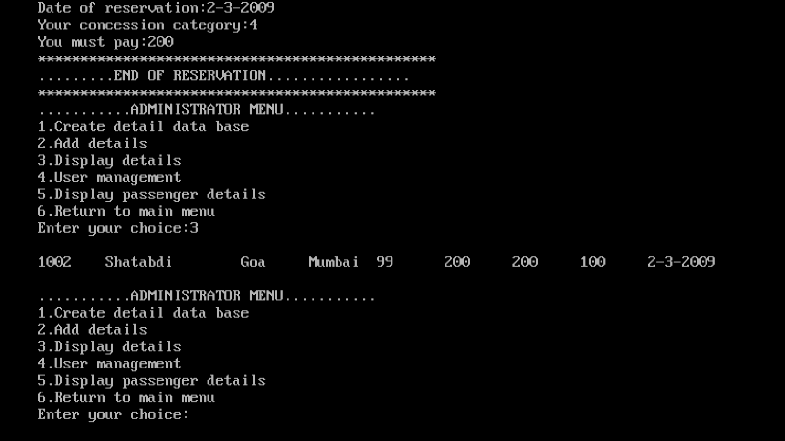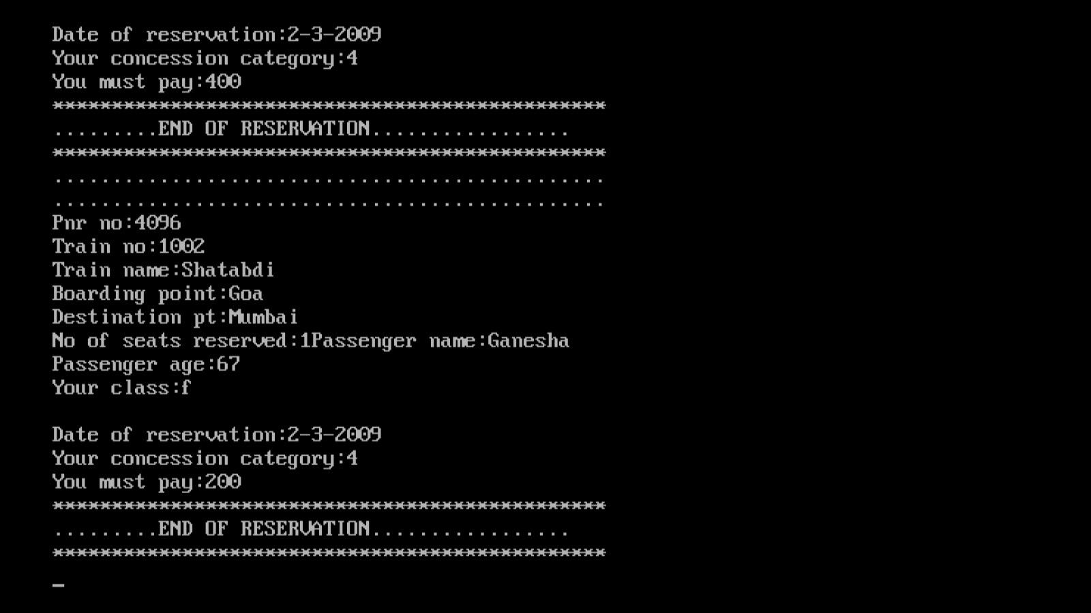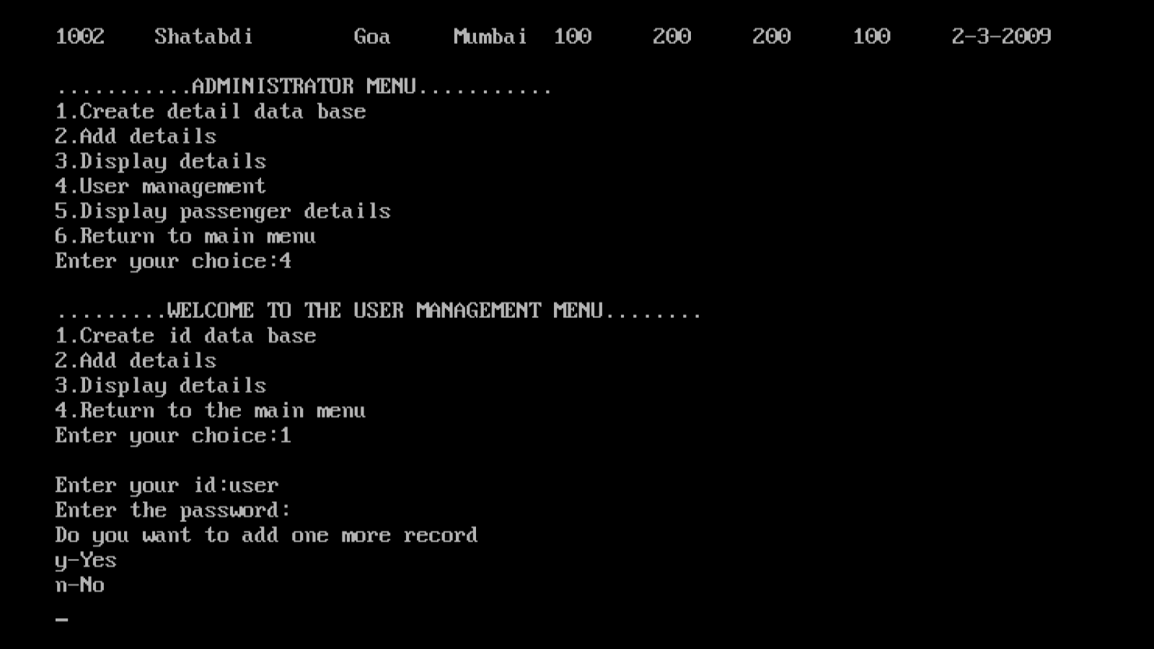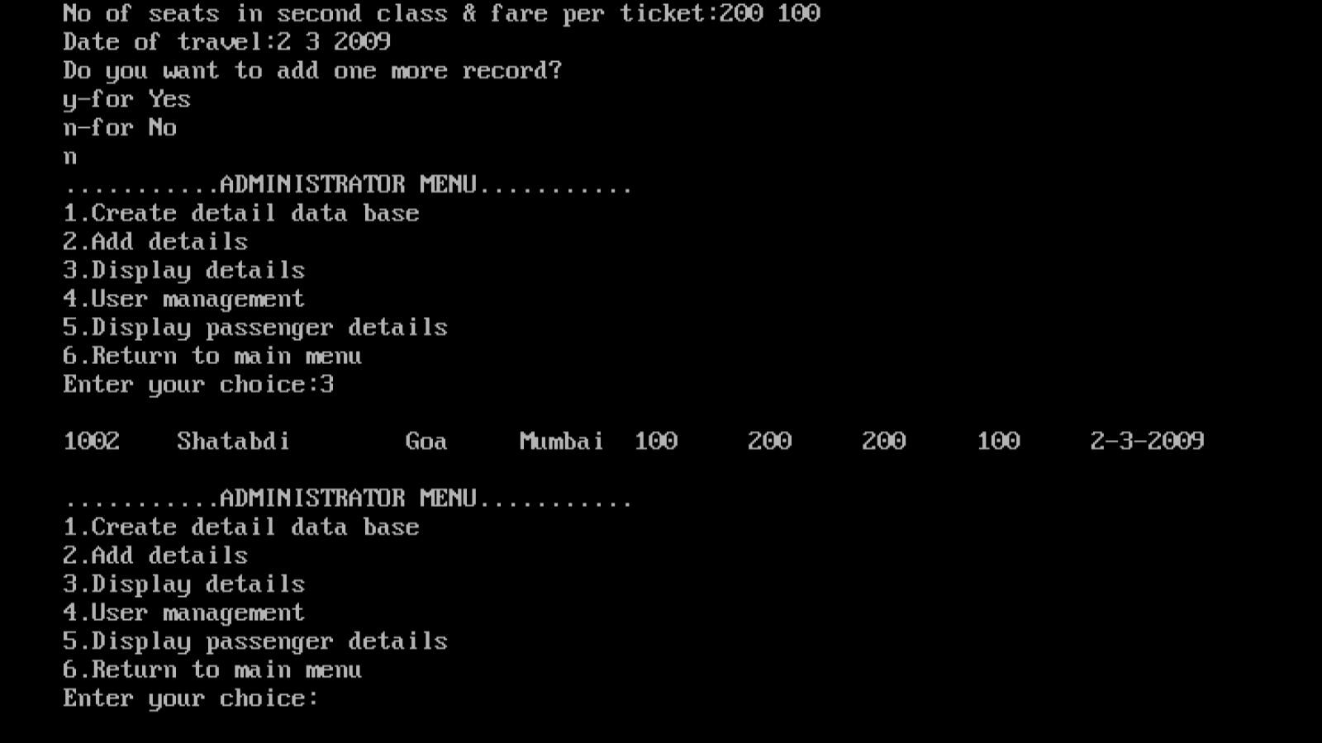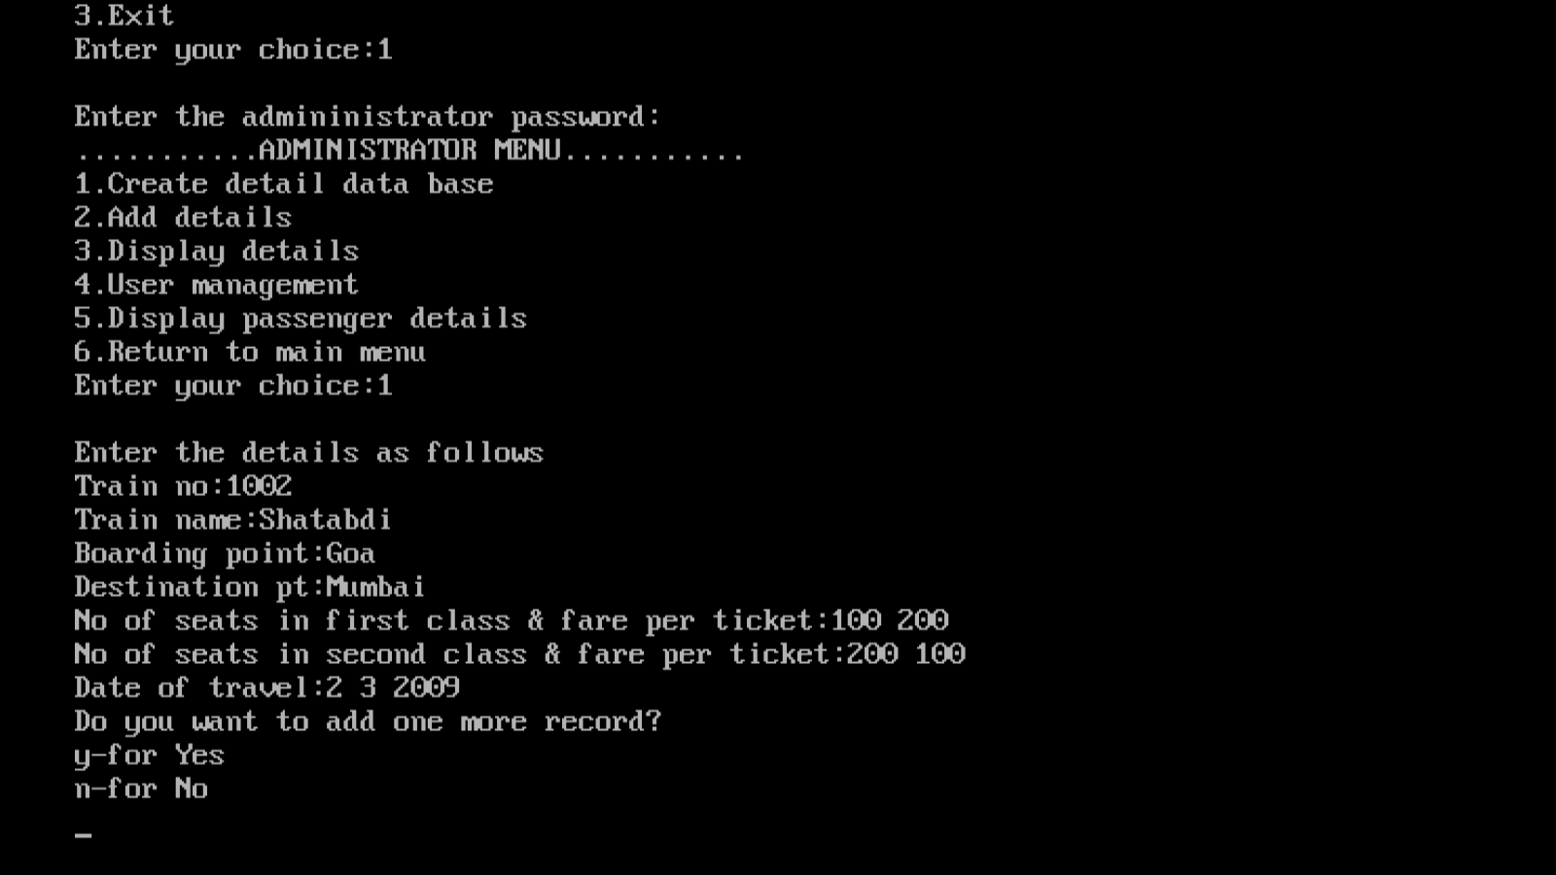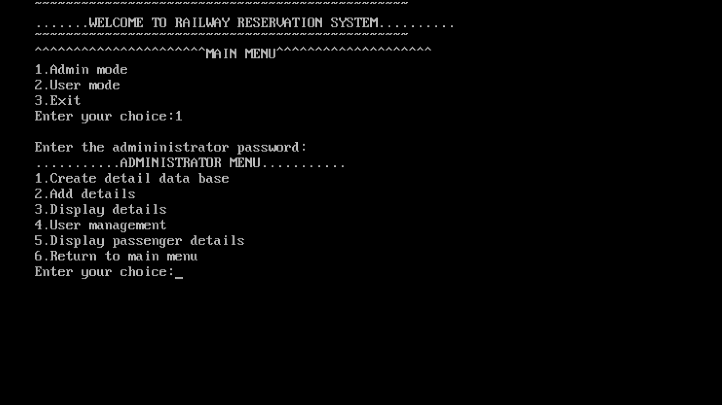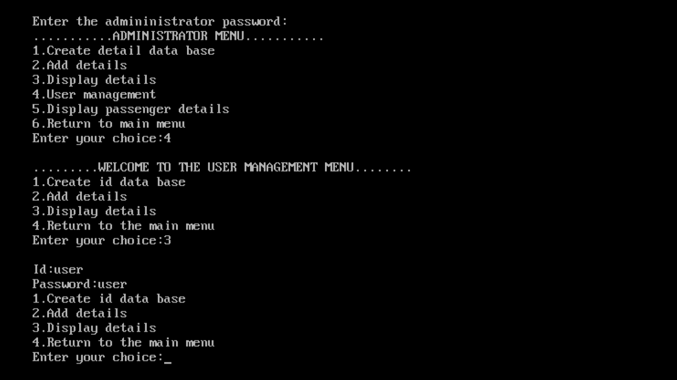

2. **User mode**: As aforementioned, at first you need to go to the administrator mode and create users. After that, you can use these users as you wish, and the information related to them will be recorded in separate files. In the user mode, you can create id database, add details and display details.

3. Train and Reservation details: In this railway reservation system project in C++, users can get both the train details and the train reservation details. The details to be provided for train are train no., train name, boarding point, destination point, no. of seats in first class and fare per ticket, no. of seats in second class and fare per ticket and date of travel.

And, in case of reservation details, the information to be provided are train no., train name, boarding point, destination point, no. of seats required, seat class specification, date of reservation, passenger category and amount to be paid. According to the no. of seats, additional information – passenger name and passenger age are to be provided. The passenger category is divided as: military, senior

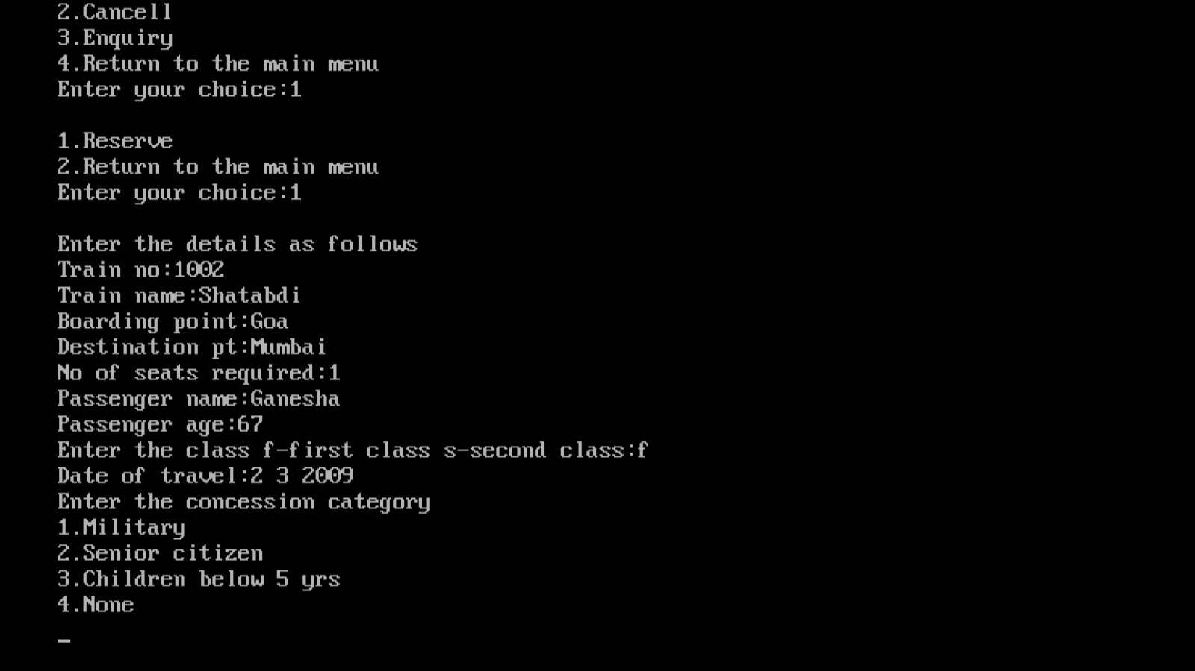4. Cancel reservation: It is somewhat similar to the feature mentioned above. This feature requires the date of cancellation in this railway reservation system project in C++. Then cancellation details can be displayed; the details here include train no., train name, boarding point, destination point, passenger class, no. of seats to be cancelled, passenger name and age, date of cancellation and the amount to be collected back.

5. Password: This railway reservation system project in C++ requires the administrator password to access the admin mode. The password is “pass”. If you enter the wrong password, it displays the message – “You are not permitted to login.”

