Collection Service Testing after version upgrade

- Payment Controller
- Payment Search - http://localhost:8280/collection-services/payments/_search?tenantId=pg.citya&mobileNumber=7645325127
Payload - curl --location 'http://localhost:8280/collection-services/payments/_search?tenantId=pg.citya&mobileNumber=7645325127' \
--header 'Content-Type: application/json' \
--data-raw '{
"RequestInfo": {
"apiId": "Rainmaker",
"authToken": "dummy-token",
"userInfo": {
"id": 243,
"uuid": "f8672e56-71e7-4863-b75d-9f3f37d5f742",
"userName": "9999009999",
"name": "Shivank",
"mobileNumber": "9999009999",
"emailId": "shivank@gmail.com",
"locale": "en_IN",
"type": "CITIZEN",
"roles": [
{
"name": "Citizen",
"code": "CITIZEN",
"tenantId": "pg"
}
],
"active": true,
"tenantId": "pg"
}
}
}'

Response:
{
"ResponseInfo": {
"apiId": "Rainmaker",
"ver": null,
"ts": null,
"resMsgId": "uief87324",
"msgId": null,
"status": "200 OK"
},
"Payments": [
{
"id": "34a2dd8f-9186-4a52-8cc0-89f5313c9ecc",
"tenantId": "pg.citya",
"totalDue": 1500,
"totalAmountPaid": 1500,
"transactionNumber": "citya2024311178",
"transactionDate": 1751016630034,
"paymentMode": "CASH",
"instrumentDate": 1751016630034,
"instrumentNumber": null,
"instrumentStatus": "APPROVED",
"ifscCode": null,
"auditDetails": {
"createdBy": "832",
"createdTime": 1751016629969,
"lastModifiedBy": "832",
"lastModifiedTime": 1751016629969
},
"additionalDetails": {
"manualReceiptDate": 1751016629649,
"manualReceiptNumber": "MIG-1751016629-SV-1013-002255",
"manualInstrumentType": "CASH",
"manualCollectionCenter": "MigrationScript"
},
"paymentDetails": [
{
"paymentId": null,
"id": "e6f29f82-3e79-44e1-9926-c640c9897a14",
"tenantId": "pg.citya",
"totalDue": 1500,
"totalAmountPaid": 1500,
"receiptNumber": "SV/1013/2025-26/002016",
"manualReceiptNumber": null,
"manualReceiptDate": 0,
"receiptDate": 1751016629969,
"receiptType": "BILLBASED",
"businessService": "sv-services",
"billId": "66cd2e6e-a160-41d8-ba82-1fafad2eb6de",
"bill": {
"id": "66cd2e6e-a160-41d8-ba82-1fafad2eb6de",
"mobileNumber": null,
"paidBy": null,
"payerName": null,
"payerAddress": null,
"payerEmail": null,
"payerId": null,
"status": "ACTIVE",
"reasonForCancellation": null,
"isCancelled": null,
"additionalDetails": null,
"billDetails": [
{
"billDescription": null,
"displayMessage": null,
"callBackForApportioning": null,
"cancellationRemarks": null,
"id": "b35ec071-f1bf-4e46-a846-a5dc23664292",
"tenantId": "pg.citya",
"demandId": "7ad41c06-844a-40cb-9be5-200fc93689aa",
"billId": "66cd2e6e-a160-41d8-ba82-1fafad2eb6de",
"amount": 1500,
"amountPaid": 1500,
"fromPeriod": 1751016629230,
"toPeriod": 1782552629230,
"additionalDetails": null,
"channel": null,
"voucherHeader": null,
"boundary": null,
"manualReceiptNumber": null,
"manualReceiptDate": null,
"billAccountDetails": [
{
"id": "8ce24980-cdad-4bcc-8f93-13220c5a32de",
"tenantId": "pg.citya",
"billDetailId": "b35ec071-f1bf-4e46-a846-a5dc23664292",
"demandDetailId": "8734b161-8568-4681-bac3-a20a42e32026",
"order": 0,
"amount": 1500,
"adjustedAmount": 1500,
"isActualDemand": null,
"taxHeadCode": "SV_STREET_VENDING_REGISTRATION_FEE",
"additionalDetails": null,
"purpose": null,
"auditDetails": null
}
],
"collectionType": null,
"auditDetails": null,
"expiryDate": 1751048999780
}
],
"tenantId": "pg.citya",
"auditDetails": {
"createdBy": "7f4fd980-628e-4266-a992-40fa629e2f05",
"createdTime": 1751016629780,
"lastModifiedBy": "7f4fd980-628e-4266-a992-40fa629e2f05",
"lastModifiedTime": 1751016629780
},
"collectionModesNotAllowed": [
"DD"
],
"partPaymentAllowed": false,
"isAdvanceAllowed": false,
"minimumAmountToBePaid": null,
"businessService": "sv-services",
"totalAmount": 1500,
"consumerCode": "SV-1013-002255",
"billNumber": "BILL-013582",
"billDate": 1751016629780,
"amountPaid": null
},
"additionalDetails": null,
"auditDetails": {
"createdBy": "832",
"createdTime": 1751016629969,
"lastModifiedBy": "832",
"lastModifiedTime": 1751016629969
}
}
],
"paidBy": "OWNER",
"mobileNumber": "9728765418",
"payerName": "Atul",
"payerAddress": null,
"payerEmail": null,
"payerId": "9cedd0a1-de9b-484b-8b62-0fe8e30c1978",
"paymentStatus": "NEW",
"fileStoreId": null
}
]
}
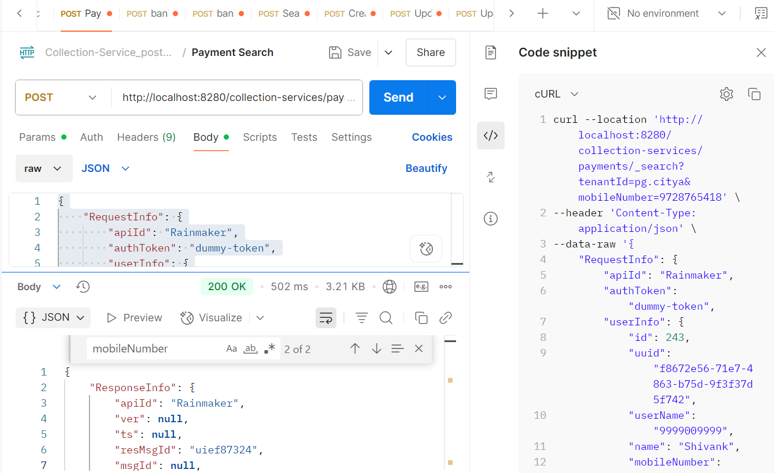
From env via port forward:
Response:
{
"ResponseInfo": {
"apiId": "Rainmaker",
"ver": null,
"ts": null,
"resMsgId": "uief87324",
"msgId": null,
"status": "200 OK"
},
"Payments": [
{
"id": "34a2dd8f-9186-4a52-8cc0-89f5313c9ecc",
"tenantId": "pg.citya",
"totalDue": 1500,
"totalAmountPaid": 1500,
"transactionNumber": "citya2024311178",
"transactionDate": 1751016630034,
"paymentMode": "CASH",
"instrumentDate": 1751016630034,
"instrumentNumber": null,
"instrumentStatus": "APPROVED",
"ifscCode": null,
"auditDetails": {
"createdBy": "832",
"createdTime": 1751016629969,
"lastModifiedBy": "832",
"lastModifiedTime": 1751016629969
},
"additionalDetails": {
"manualReceiptDate": 1751016629649,
"manualReceiptNumber": "MIG-1751016629-SV-1013-002255",
"manualInstrumentType": "CASH",
"manualCollectionCenter": "MigrationScript"
},
"paymentDetails": [
{
"paymentId": null,
"id": "e6f29f82-3e79-44e1-9926-c640c9897a14",
"tenantId": "pg.citya",
"totalDue": 1500,
"totalAmountPaid": 1500,
"receiptNumber": "SV/1013/2025-26/002016",
"manualReceiptNumber": null,
"manualReceiptDate": 0,
"receiptDate": 1751016629969,
"receiptType": "BILLBASED",
"businessService": "sv-services",
"billId": "66cd2e6e-a160-41d8-ba82-1fafad2eb6de",
"bill": {
"id": "66cd2e6e-a160-41d8-ba82-1fafad2eb6de",
"mobileNumber": null,
"paidBy": null,
"payerName": null,
"payerAddress": null,
"payerEmail": null,
"payerId": null,
"status": "ACTIVE",
"reasonForCancellation": null,
"isCancelled": null,
"additionalDetails": null,
"billDetails": [
{
"billDescription": null,
"displayMessage": null,
"callBackForApportioning": null,
"cancellationRemarks": null,
"id": "b35ec071-f1bf-4e46-a846-a5dc23664292",
"tenantId": "pg.citya",
"demandId": "7ad41c06-844a-40cb-9be5-200fc93689aa",
"billId": "66cd2e6e-a160-41d8-ba82-1fafad2eb6de",
"amount": 1500,
"amountPaid": 1500,
"fromPeriod": 1751016629230,
"toPeriod": 1782552629230,
"additionalDetails": null,
"channel": null,
"voucherHeader": null,
"boundary": null,
"manualReceiptNumber": null,
"manualReceiptDate": null,
"billAccountDetails": [
{
"id": "8ce24980-cdad-4bcc-8f93-13220c5a32de",
"tenantId": "pg.citya",
"billDetailId": "b35ec071-f1bf-4e46-a846-a5dc23664292",
"demandDetailId": "8734b161-8568-4681-bac3-a20a42e32026",
"order": 0,
"amount": 1500,
"adjustedAmount": 1500,
"isActualDemand": null,
"taxHeadCode": "SV_STREET_VENDING_REGISTRATION_FEE",
"additionalDetails": null,
"purpose": null,
"auditDetails": null
}
],
"collectionType": null,
"auditDetails": null,
"expiryDate": 1751048999780
}
],
"tenantId": "pg.citya",
"auditDetails": {
"createdBy": "7f4fd980-628e-4266-a992-40fa629e2f05",
"createdTime": 1751016629780,
"lastModifiedBy": "7f4fd980-628e-4266-a992-40fa629e2f05",
"lastModifiedTime": 1751016629780
},
"collectionModesNotAllowed": [
"DD"
],
"partPaymentAllowed": false,
"isAdvanceAllowed": false,
"minimumAmountToBePaid": null,
"businessService": "sv-services",
"totalAmount": 1500,
"consumerCode": "SV-1013-002255",
"billNumber": "BILL-013582",
"billDate": 1751016629780,
"amountPaid": null
},
"additionalDetails": null,
"auditDetails": {
"createdBy": "832",
"createdTime": 1751016629969,
"lastModifiedBy": "832",
"lastModifiedTime": 1751016629969
}
}
],
"paidBy": "OWNER",
"mobileNumber": "9728765418",
"payerName": "Atul",
"payerAddress": null,
"payerEmail": null,
"payerId": "9cedd0a1-de9b-484b-8b62-0fe8e30c1978",
"paymentStatus": "NEW",
"fileStoreId": null
}
]
}

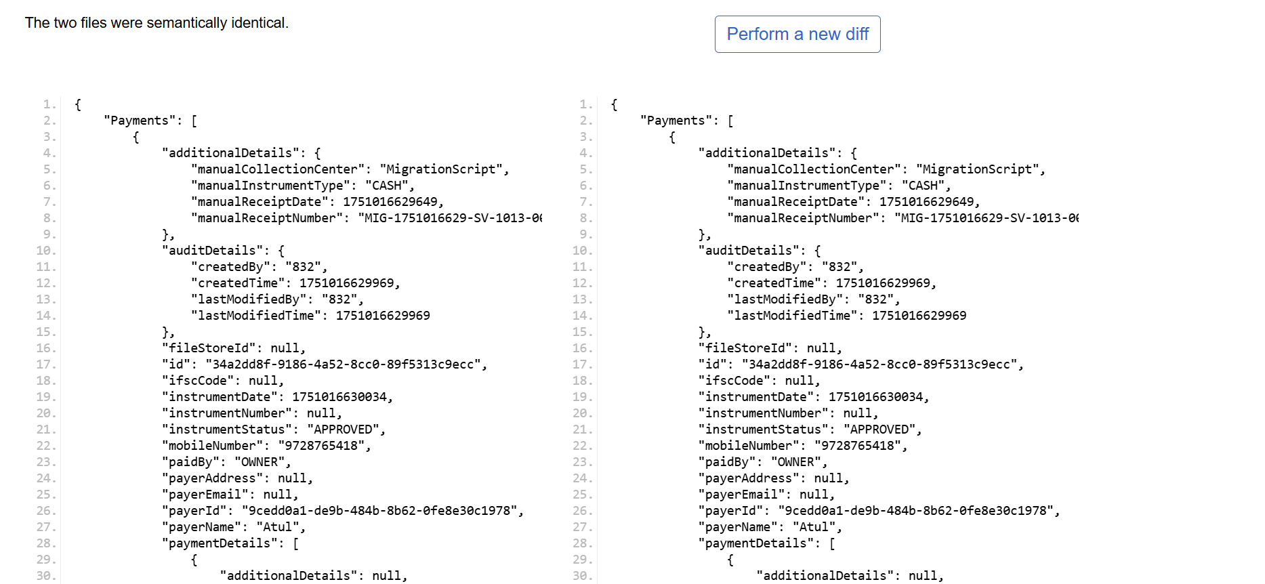

Payment Create: http://localhost:8280/collection-services/payments/_create

Request Payload:
curl -X POST "http://localhost:8280/collection-services/payments/_create" \
-H "Content-Type: application/json" \
-d '{
"RequestInfo": {
"apiId": "Rainmaker",
"msgId": "1751347293277|en_IN",
"authToken": null,
"correlationId": "22c9e877-c666-4293-a3d2-6b2cbdfbb4ce",
"userInfo": {
"id": 1001,
"userName": "TLEMP",
"name": "Atul",
"type": "EMPLOYEE",
"mobileNumber": "7809234712",
"emailId": null,
"roles": [
{
"name": "TL doc verifier",
"code": "TL_DOC_VERIFIER",
"tenantId": "pg.citya"
},
{
"name": "TL Admin",
"code": "TL_ADMIN",
"tenantId": "pg.citya"
},
{
"name": "TL Creator",
"code": "TL_CREATOR",
"tenantId": "pg.citya"
},
{
"name": "TL Approver",
"code": "TL_APPROVER",
"tenantId": "pg.citya"
},
{
"name": "TL Field Inspector",
"code": "TL_FIELD_INSPECTOR",
"tenantId": "pg.citya"
},
{
"name": "TL Counter Employee",
"code": "TL_CEMP",
"tenantId": "pg.citya"
}
],
"tenantId": "pg.citya",
"uuid": "fd7421c7-b444-442c-a63d-d87e8a58a21e"
}
},
"Payment": {
"tenantId": "pg.citya",
"totalAmountPaid": 350,
"paymentMode": "CASH",
"paidBy": "OWNER",
"mobileNumber": "9848475757",
"payerName": "sourabh",
"payerId": "18b6844b-cf23-4d36-a672-55027f71f261",
"paymentStatus": "NEW",
"paymentDetails": [
{
"tenantId": "pg.citya",
"totalAmountPaid": 350,
"businessService": "TL",
"billId": "c70fcb8f-2a1a-4232-ab70-a8a6789aa607"
}
]
}
}'
Response from local:
{
"ResponseInfo": {
"apiId": "Rainmaker",
"ver": null,
"ts": null,
"resMsgId": "uief87324",
"msgId": "1751347293277|en_IN",
"status": "200 OK"
},
"Payments": [
{
"id": "b627b5dc-6df9-4cc7-8e94-d187c210156b",
"tenantId": "pg.citya",
"totalDue": 350,
"totalAmountPaid": 350,
"transactionNumber": "citya2451834161",
"transactionDate": 1751348549489,
"paymentMode": "CASH",
"instrumentDate": 1751348549489,
"instrumentNumber": null,
"instrumentStatus": "APPROVED",
"ifscCode": null,
"auditDetails": {
"createdBy": "1001",
"createdTime": 1751348549252,
"lastModifiedBy": "1001",
"lastModifiedTime": 1751348549252
},
"additionalDetails": null,
"paymentDetails": [
{
"paymentId": null,
"id": "114c9d81-5e4f-487e-9129-2350bb41c0bf",
"tenantId": "pg.citya",
"totalDue": 350,
"totalAmountPaid": 350,
"receiptNumber": "07/2025-26/000081",
"manualReceiptNumber": null,
"manualReceiptDate": null,
"receiptDate": 1751348549253,
"receiptType": "BILLBASED",
"businessService": "TL",
"billId": "c70fcb8f-2a1a-4232-ab70-a8a6789aa607",
"bill": {
"id": "c70fcb8f-2a1a-4232-ab70-a8a6789aa607",
"mobileNumber": "8474857362",
"paidBy": "OWNER",
"payerName": "sourabh",
"payerAddress": null,
"payerEmail": null,
"payerId": null,
"status": "PAID",
"reasonForCancellation": null,
"isCancelled": null,
"additionalDetails": null,
"billDetails": [
{
"billDescription": null,
"displayMessage": null,
"callBackForApportioning": null,
"cancellationRemarks": null,
"id": "cefdb0c3-185c-4369-ba5e-04221a5581a9",
"tenantId": "pg.citya",
"demandId": "e428f539-a771-4e17-aa72-d2dc699221d4",
"billId": "c70fcb8f-2a1a-4232-ab70-a8a6789aa607",
"amount": 350,
"amountPaid": 350,
"fromPeriod": 1743465565000,
"toPeriod": 1774976013000,
"additionalDetails": {
"calculationDescription": [
"77c3a328-d692-45fe-9e7a-2cf9c80b9d6e|0|bc4cda12-dab3-4e6e-8218-6888835c4550"
]
},
"channel": null,
"voucherHeader": null,
"boundary": null,
"manualReceiptNumber": null,
"manualReceiptDate": null,
"billAccountDetails": [
{
"id": "2a427e85-9ef1-46bc-863e-ea59781209bd",
"tenantId": "pg.citya",
"billDetailId": "cefdb0c3-185c-4369-ba5e-04221a5581a9",
"demandDetailId": "27182595-59a1-45a4-84a1-d15c2bd70196",
"order": 2,
"amount": 350,
"adjustedAmount": 350,
"isActualDemand": null,
"taxHeadCode": "TL_TAX",
"additionalDetails": null,
"purpose": null,
"auditDetails": null
}
],
"collectionType": null,
"auditDetails": null,
"expiryDate": 1751394599526
}
],
"tenantId": "pg.citya",
"auditDetails": {
"createdBy": "fd7421c7-b444-442c-a63d-d87e8a58a21e",
"createdTime": 1751347275527,
"lastModifiedBy": "fd7421c7-b444-442c-a63d-d87e8a58a21e",
"lastModifiedTime": 1751347275527
},
"collectionModesNotAllowed": [
"DD",
"OFFLINE_NEFT",
"OFFLINE_RTGS",
"POSTAL_ORDER"
],
"partPaymentAllowed": false,
"isAdvanceAllowed": false,
"minimumAmountToBePaid": null,
"businessService": "TL",
"totalAmount": 350,
"consumerCode": "APP-000224",
"billNumber": "BILL-013746",
"billDate": 1751347275527,
"amountPaid": 350
},
"additionalDetails": null,
"auditDetails": {
"createdBy": "1001",
"createdTime": 1751348549252,
"lastModifiedBy": "1001",
"lastModifiedTime": 1751348549252
}
}
],
"paidBy": "OWNER",
"mobileNumber": "9848475757",
"payerName": "sourabh",
"payerAddress": null,
"payerEmail": null,
"payerId": "18b6844b-cf23-4d36-a672-55027f71f261",
"paymentStatus": "NEW",
"fileStoreId": null
}
]
}
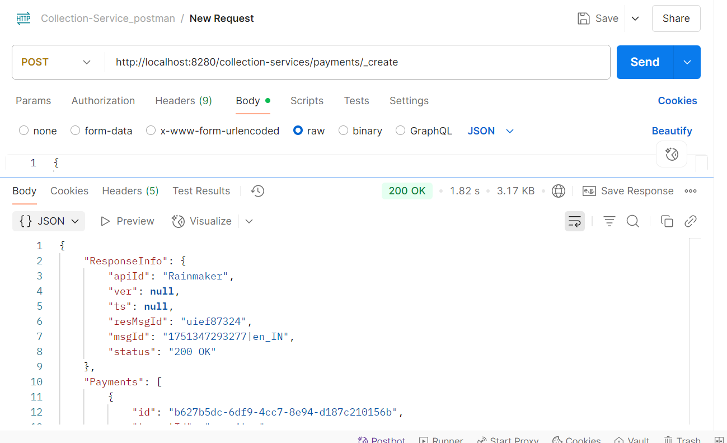

Response from Env:
{
"ResponseInfo": {
"apiId": "Rainmaker",
"ver": null,
"ts": null,
"resMsgId": "uief87324",
"msgId": "1751347293277|en_IN",
"status": "200 OK"
},
"Payments": [
{
"id": "227287ee-5c7e-4b56-9754-5096cfc1c6ad",
"tenantId": "pg.citya",
"totalDue": 350,
"totalAmountPaid": 350,
"transactionNumber": "citya1301162218",
"transactionDate": 1751349012559,
"paymentMode": "CASH",
"instrumentDate": 1751349012559,
"instrumentNumber": null,
"instrumentStatus": "APPROVED",
"ifscCode": null,
"auditDetails": {
"createdBy": "1001",
"createdTime": 1751349012479,
"lastModifiedBy": "1001",
"lastModifiedTime": 1751349012479
},
"additionalDetails": null,
"paymentDetails": [
{
"paymentId": null,
"id": "8d2b19da-20f4-48f9-8c74-07f74a92e0c9",
"tenantId": "pg.citya",
"totalDue": 350,
"totalAmountPaid": 350,
"receiptNumber": "TL/1013/2025-26/002172",
"manualReceiptNumber": null,
"manualReceiptDate": null,
"receiptDate": 1751349012479,
"receiptType": "BILLBASED",
"businessService": "TL",
"billId": "c70fcb8f-2a1a-4232-ab70-a8a6789aa607",
"bill": {
"id": "c70fcb8f-2a1a-4232-ab70-a8a6789aa607",
"mobileNumber": "8474857362",
"paidBy": "OWNER",
"payerName": "sourabh",
"payerAddress": null,
"payerEmail": null,
"payerId": null,
"status": "PAID",
"reasonForCancellation": null,
"isCancelled": null,
"additionalDetails": null,
"billDetails": [
{
"billDescription": null,
"displayMessage": null,
"callBackForApportioning": null,
"cancellationRemarks": null,
"id": "cefdb0c3-185c-4369-ba5e-04221a5581a9",
"tenantId": "pg.citya",
"demandId": "e428f539-a771-4e17-aa72-d2dc699221d4",
"billId": "c70fcb8f-2a1a-4232-ab70-a8a6789aa607",
"amount": 350,
"amountPaid": 350,
"fromPeriod": 1743465565000,
"toPeriod": 1774976013000,
"additionalDetails": {
"calculationDescription": [
"77c3a328-d692-45fe-9e7a-2cf9c80b9d6e|0|bc4cda12-dab3-4e6e-8218-6888835c4550"
]
},
"channel": null,
"voucherHeader": null,
"boundary": null,
"manualReceiptNumber": null,
"manualReceiptDate": null,
"billAccountDetails": [
{
"id": "2a427e85-9ef1-46bc-863e-ea59781209bd",
"tenantId": "pg.citya",
"billDetailId": "cefdb0c3-185c-4369-ba5e-04221a5581a9",
"demandDetailId": "27182595-59a1-45a4-84a1-d15c2bd70196",
"order": 2,
"amount": 350,
"adjustedAmount": 350,
"isActualDemand": null,
"taxHeadCode": "TL_TAX",
"additionalDetails": null,
"purpose": null,
"auditDetails": null
}
],
"collectionType": null,
"auditDetails": null,
"expiryDate": 1751394599526
}
],
"tenantId": "pg.citya",
"auditDetails": {
"createdBy": "fd7421c7-b444-442c-a63d-d87e8a58a21e",
"createdTime": 1751347275527,
"lastModifiedBy": "fd7421c7-b444-442c-a63d-d87e8a58a21e",
"lastModifiedTime": 1751347275527
},
"collectionModesNotAllowed": [
"DD",
"OFFLINE_NEFT",
"OFFLINE_RTGS",
"POSTAL_ORDER"
],
"partPaymentAllowed": false,
"isAdvanceAllowed": false,
"minimumAmountToBePaid": null,
"businessService": "TL",
"totalAmount": 350,
"consumerCode": "APP-000224",
"billNumber": "BILL-013746",
"billDate": 1751347275527,
"amountPaid": 350
},
"additionalDetails": null,
"auditDetails": {
"createdBy": "1001",
"createdTime": 1751349012479,
"lastModifiedBy": "1001",
"lastModifiedTime": 1751349012479
}
}
],
"paidBy": "OWNER",
"mobileNumber": "9848475757",
"payerName": "sourabh",
"payerAddress": null,
"payerEmail": null,
"payerId": "18b6844b-cf23-4d36-a672-55027f71f261",
"paymentStatus": "NEW",
"fileStoreId": null
}
]
}
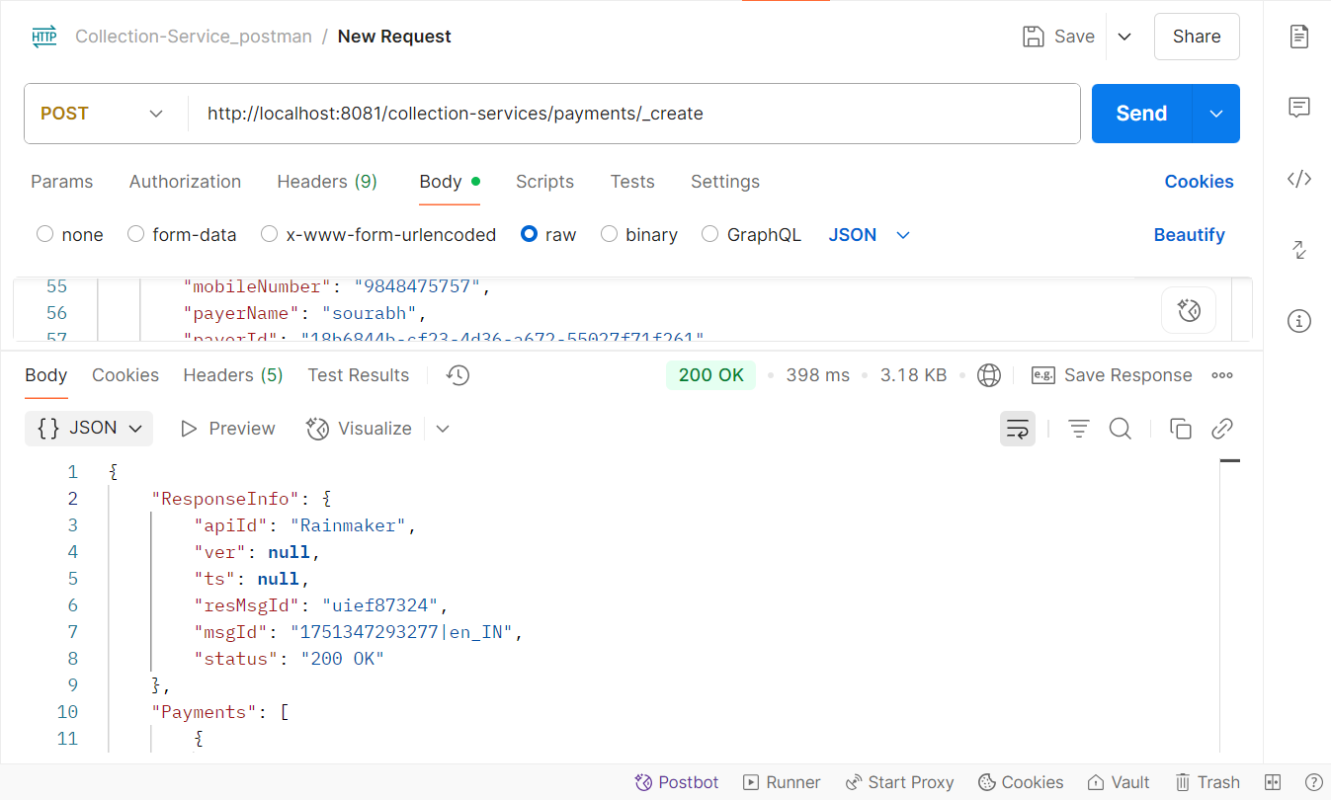
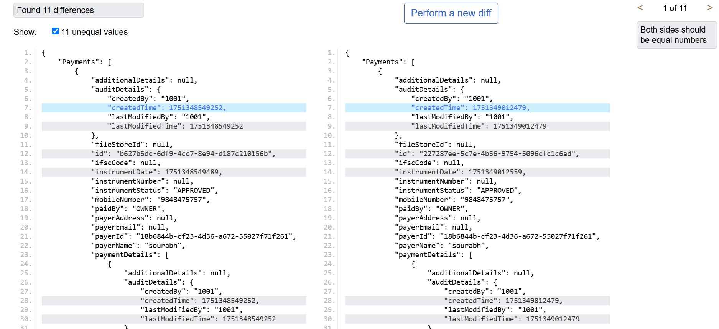

Payment Validate: http://localhost:8280/collection-services/payments/_validate
Request Payload:
curl --location 'http://localhost:8280/collection-services/payments/_validate' \
--header 'Content-Type: application/json' \
--data-raw '{
"RequestInfo": {
"apiId": "Rainmaker",
"msgId": "1751434355993|en_IN",
"authToken": null,
"correlationId": "04c85b84-a8f2-42c7-9ba4-1e57f21cb115",
"userInfo": {
"id": 811,
"userName": "8010012414",
"name": "OWNER",
"type": "CITIZEN",
"mobileNumber": "8010012414",
"emailId": "cghvjbnk@gmail.com",
"roles": [
{
"name": "Citizen",
"code": "CITIZEN",
"tenantId": "pg"
}
],
"tenantId": "pg",
"uuid": "f789d679-352d-4aec-8198-4d61af1e0566"
}
},
"Payment": {
"tenantId": "pg.citya",
"totalAmountPaid": 3540.0,
"paymentMode": "CASH",
"paidBy": "OWNER",
"mobileNumber": "8010012414",
"payerName": "OWNER",
"payerId": "f789d679-352d-4aec-8198-4d61af1e0566",
"paymentStatus": "DEPOSITED",
"paymentDetails": [
{
"tenantId": "pg.citya",
"totalAmountPaid": 3540.0,
"businessService": "adv-services",
"billId": "21915a63-0f04-4f08-a3bf-a9af06ab9ef5"
}
]
}
}'

Response from local:
{
"ResponseInfo": {
"apiId": "Rainmaker",
"ver": null,
"ts": null,
"resMsgId": "uief87324",
"msgId": "1751434355993|en_IN",
"status": "200 OK"
},
"Payments": [
{
"id": "4582cafb-60a1-4bf3-ad18-5757d4f6c074",
"tenantId": "pg.citya",
"totalDue": 3540.00,
"totalAmountPaid": 3540.0,
"transactionNumber": null,
"transactionDate": null,
"paymentMode": "CASH",
"instrumentDate": null,
"instrumentNumber": null,
"instrumentStatus": null,
"ifscCode": null,
"auditDetails": {
"createdBy": "811",
"createdTime": 1751435420236,
"lastModifiedBy": "811",
"lastModifiedTime": 1751435420236
},
"additionalDetails": null,
"paymentDetails": [
{
"paymentId": null,
"id": "819f5adc-1a94-482e-9e6d-71cd8e590348",
"tenantId": "pg.citya",
"totalDue": 3540.00,
"totalAmountPaid": 3540.0,
"receiptNumber": null,
"manualReceiptNumber": null,
"manualReceiptDate": null,
"receiptDate": 1751435420236,
"receiptType": "BILLBASED",
"businessService": "adv-services",
"billId": "21915a63-0f04-4f08-a3bf-a9af06ab9ef5",
"bill": {
"id": "21915a63-0f04-4f08-a3bf-a9af06ab9ef5",
"mobileNumber": "8010012414",
"paidBy": "OWNER",
"payerName": "OWNER",
"payerAddress": null,
"payerEmail": null,
"payerId": null,
"status": "PAID",
"reasonForCancellation": null,
"isCancelled": null,
"additionalDetails": null,
"billDetails": [
{
"billDescription": null,
"displayMessage": null,
"callBackForApportioning": null,
"cancellationRemarks": null,
"id": "22392a8a-8c3c-4470-a5c9-dac916d0bdfd",
"tenantId": "pg.citya",
"demandId": "b12476a8-6997-4cec-8fcf-70edf52eb098",
"billId": "21915a63-0f04-4f08-a3bf-a9af06ab9ef5",
"amount": 3540.00,
"amountPaid": null,
"fromPeriod": 1751434329997,
"toPeriod": 1760380200000,
"additionalDetails": null,
"channel": null,
"voucherHeader": null,
"boundary": null,
"manualReceiptNumber": null,
"manualReceiptDate": null,
"billAccountDetails": [
{
"id": "95b8f6a6-3bac-4013-8110-1821b2b0154a",
"tenantId": "pg.citya",
"billDetailId": "22392a8a-8c3c-4470-a5c9-dac916d0bdfd",
"demandDetailId": "575e306f-fc84-4531-9f21-678ef72d04e8",
"order": 0,
"amount": 3000.00,
"adjustedAmount": 0.00,
"isActualDemand": null,
"taxHeadCode": "ADV_BOOKING_FEES",
"additionalDetails": null,
"purpose": null,
"auditDetails": null
},
{
"id": "fe11c1c5-09bf-408d-b11e-89a73fd57106",
"tenantId": "pg.citya",
"billDetailId": "22392a8a-8c3c-4470-a5c9-dac916d0bdfd",
"demandDetailId": "16141cc7-cbb2-4323-9a6e-83f82a7652ba",
"order": 0,
"amount": 270.00,
"adjustedAmount": 0.00,
"isActualDemand": null,
"taxHeadCode": "ADV_SGST",
"additionalDetails": null,
"purpose": null,
"auditDetails": null
},
{
"id": "925f021d-b9ec-4dd9-8e3d-dd8acfb029d5",
"tenantId": "pg.citya",
"billDetailId": "22392a8a-8c3c-4470-a5c9-dac916d0bdfd",
"demandDetailId": "faf81c2a-37ea-425b-8124-e9c57e99964a",
"order": 0,
"amount": 270.00,
"adjustedAmount": 0.00,
"isActualDemand": null,
"taxHeadCode": "ADV_CGST",
"additionalDetails": null,
"purpose": null,
"auditDetails": null
}
],
"collectionType": null,
"auditDetails": null,
"expiryDate": 1751480999692
}
],
"tenantId": "pg.citya",
"auditDetails": {
"createdBy": "f789d679-352d-4aec-8198-4d61af1e0566",
"createdTime": 1751434332692,
"lastModifiedBy": "f789d679-352d-4aec-8198-4d61af1e0566",
"lastModifiedTime": 1751434332692
},
"collectionModesNotAllowed": [
"DD"
],
"partPaymentAllowed": false,
"isAdvanceAllowed": false,
"minimumAmountToBePaid": null,
"businessService": "adv-services",
"totalAmount": 3540.00,
"consumerCode": "ADV-1013-000507",
"billNumber": "BILL-013761",
"billDate": 1751434332692,
"amountPaid": null
},
"additionalDetails": null,
"auditDetails": {
"createdBy": "811",
"createdTime": 1751435420236,
"lastModifiedBy": "811",
"lastModifiedTime": 1751435420236
}
}
],
"paidBy": "OWNER",
"mobileNumber": "8010012414",
"payerName": "OWNER",
"payerAddress": null,
"payerEmail": null,
"payerId": "f789d679-352d-4aec-8198-4d61af1e0566",
"paymentStatus": "DEPOSITED",
"fileStoreId": null
}
]
}
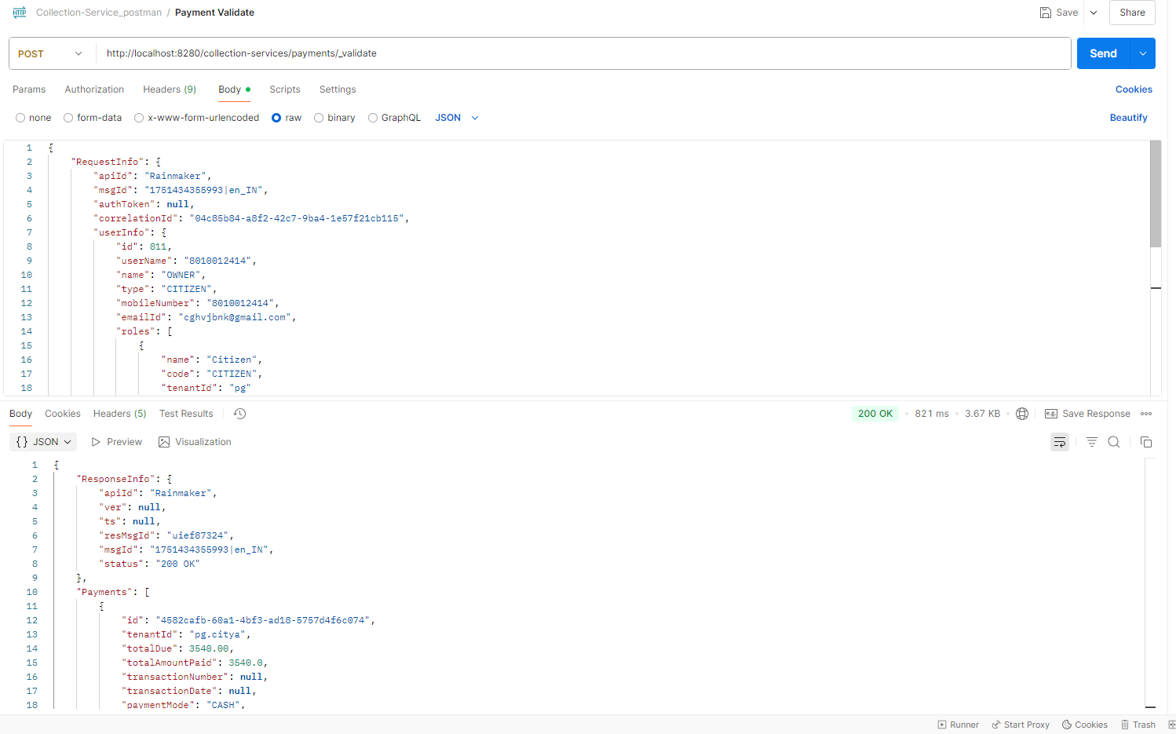
Response from env:
{
"ResponseInfo": {
"apiId": "Rainmaker",
"ver": null,
"ts": null,
"resMsgId": "uief87324",
"msgId": "1751434355993|en_IN",
"status": "200 OK"
},
"Payments": [
{
"id": "f7fb6ad9-388b-43a8-a02b-4d2534ca4356",
"tenantId": "pg.citya",
"totalDue": 3540.00,
"totalAmountPaid": 3540.0,
"transactionNumber": null,
"transactionDate": null,
"paymentMode": "CASH",
"instrumentDate": null,
"instrumentNumber": null,
"instrumentStatus": null,
"ifscCode": null,
"auditDetails": {
"createdBy": "811",
"createdTime": 1751435986348,
"lastModifiedBy": "811",
"lastModifiedTime": 1751435986348
},
"additionalDetails": null,
"paymentDetails": [
{
"paymentId": null,
"id": "eb53ead0-4a82-4e31-a90a-963fba5cb5b9",
"tenantId": "pg.citya",
"totalDue": 3540.00,
"totalAmountPaid": 3540.0,
"receiptNumber": null,
"manualReceiptNumber": null,
"manualReceiptDate": null,
"receiptDate": 1751435986348,
"receiptType": "BILLBASED",
"businessService": "adv-services",
"billId": "21915a63-0f04-4f08-a3bf-a9af06ab9ef5",
"bill": {
"id": "21915a63-0f04-4f08-a3bf-a9af06ab9ef5",
"mobileNumber": "8010012414",
"paidBy": "OWNER",
"payerName": "OWNER",
"payerAddress": null,
"payerEmail": null,
"payerId": null,
"status": "PAID",
"reasonForCancellation": null,
"isCancelled": null,
"additionalDetails": null,
"billDetails": [
{
"billDescription": null,
"displayMessage": null,
"callBackForApportioning": null,
"cancellationRemarks": null,
"id": "22392a8a-8c3c-4470-a5c9-dac916d0bdfd",
"tenantId": "pg.citya",
"demandId": "b12476a8-6997-4cec-8fcf-70edf52eb098",
"billId": "21915a63-0f04-4f08-a3bf-a9af06ab9ef5",
"amount": 3540.00,
"amountPaid": null,
"fromPeriod": 1751434329997,
"toPeriod": 1760380200000,
"additionalDetails": null,
"channel": null,
"voucherHeader": null,
"boundary": null,
"manualReceiptNumber": null,
"manualReceiptDate": null,
"billAccountDetails": [
{
"id": "95b8f6a6-3bac-4013-8110-1821b2b0154a",
"tenantId": "pg.citya",
"billDetailId": "22392a8a-8c3c-4470-a5c9-dac916d0bdfd",
"demandDetailId": "575e306f-fc84-4531-9f21-678ef72d04e8",
"order": 0,
"amount": 3000.00,
"adjustedAmount": 0.00,
"isActualDemand": null,
"taxHeadCode": "ADV_BOOKING_FEES",
"additionalDetails": null,
"purpose": null,
"auditDetails": null
},
{
"id": "fe11c1c5-09bf-408d-b11e-89a73fd57106",
"tenantId": "pg.citya",
"billDetailId": "22392a8a-8c3c-4470-a5c9-dac916d0bdfd",
"demandDetailId": "16141cc7-cbb2-4323-9a6e-83f82a7652ba",
"order": 0,
"amount": 270.00,
"adjustedAmount": 0.00,
"isActualDemand": null,
"taxHeadCode": "ADV_SGST",
"additionalDetails": null,
"purpose": null,
"auditDetails": null
},
{
"id": "925f021d-b9ec-4dd9-8e3d-dd8acfb029d5",
"tenantId": "pg.citya",
"billDetailId": "22392a8a-8c3c-4470-a5c9-dac916d0bdfd",
"demandDetailId": "faf81c2a-37ea-425b-8124-e9c57e99964a",
"order": 0,
"amount": 270.00,
"adjustedAmount": 0.00,
"isActualDemand": null,
"taxHeadCode": "ADV_CGST",
"additionalDetails": null,
"purpose": null,
"auditDetails": null
}
],
"collectionType": null,
"auditDetails": null,
"expiryDate": 1751480999692
}
],
"tenantId": "pg.citya",
"auditDetails": {
"createdBy": "f789d679-352d-4aec-8198-4d61af1e0566",
"createdTime": 1751434332692,
"lastModifiedBy": "f789d679-352d-4aec-8198-4d61af1e0566",
"lastModifiedTime": 1751434332692
},
"collectionModesNotAllowed": [
"DD"
],
"partPaymentAllowed": false,
"isAdvanceAllowed": false,
"minimumAmountToBePaid": null,
"businessService": "adv-services",
"totalAmount": 3540.00,
"consumerCode": "ADV-1013-000507",
"billNumber": "BILL-013761",
"billDate": 1751434332692,
"amountPaid": null
},
"additionalDetails": null,
"auditDetails": {
"createdBy": "811",
"createdTime": 1751435986348,
"lastModifiedBy": "811",
"lastModifiedTime": 1751435986348
}
}
],
"paidBy": "OWNER",
"mobileNumber": "8010012414",
"payerName": "OWNER",
"payerAddress": null,
"payerEmail": null,
"payerId": "f789d679-352d-4aec-8198-4d61af1e0566",
"paymentStatus": "DEPOSITED",
"fileStoreId": null
}
]
}
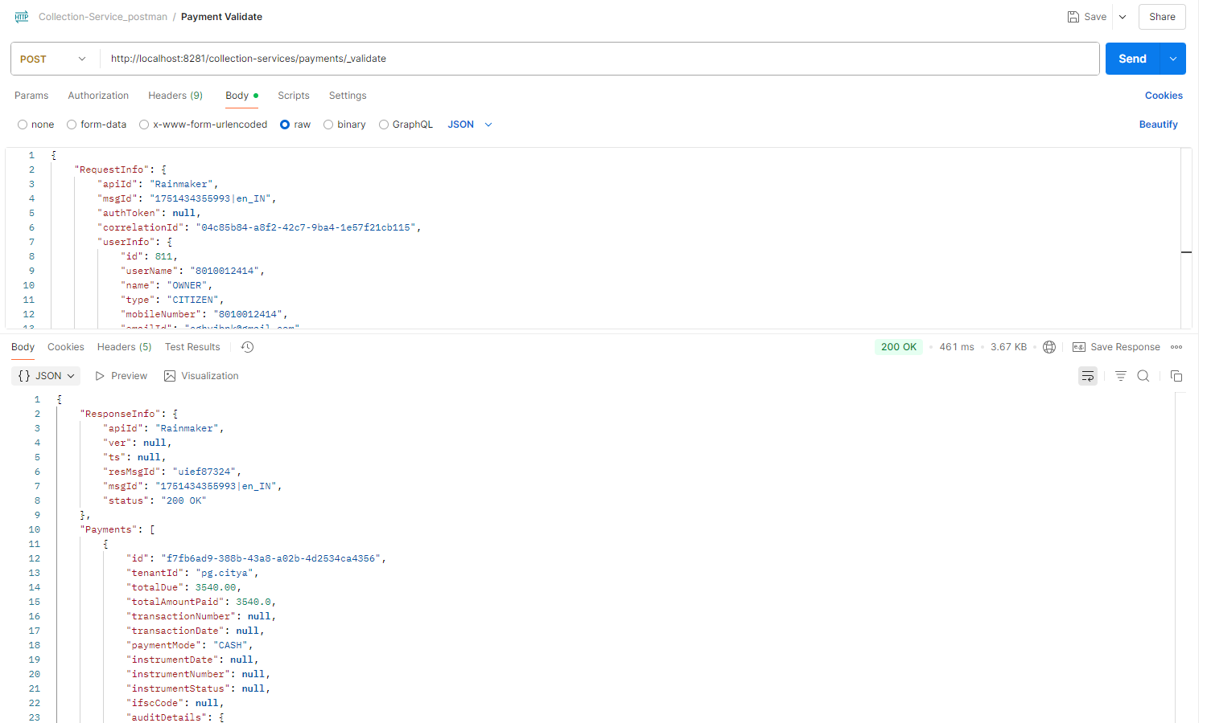
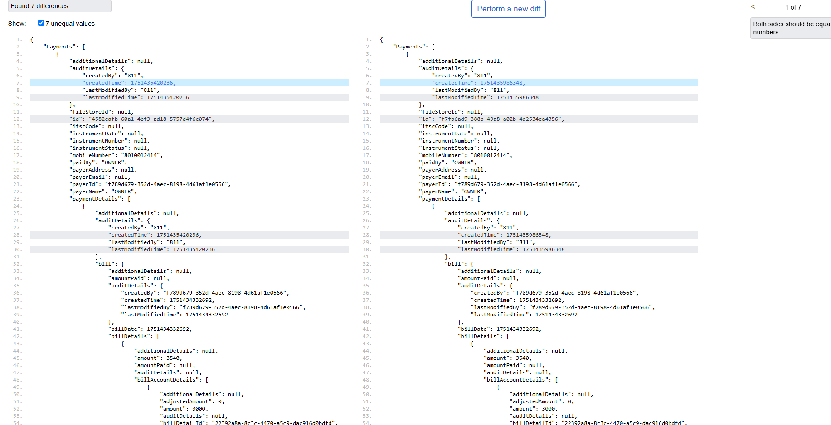
2 Remittance Controller

Remittance Search:
Request Payload: http://localhost:8280/collection-services/remittances/_search?tenantId=pg.citya
curl --location 'http://localhost:8280/collection-services/remittances/_search?tenantId=pg.citya' \
--header 'Content-Type: application/json' \
--data '{
"RequestInfo": {
"apiId": "Rainmaker",
"authToken": "dummy-token",
"userInfo": {
"id": 1,
"uuid": "test-uuid",
"userName": "testuser",
"tenantId": "pg.citya",
"type": "EMPLOYEE",
"roles": [
{
"name": "Finance Admin",
"code": "FIN_ADMIN",
"tenantId": "pg.citya"
}
]
}
}
}'

Response :
{
"ResponseInfo": {
"apiId": "Rainmaker",
"ver": null,
"ts": null,
"resMsgId": "uief87324",
"msgId": null,
"status": "200 OK"
},
"Remittance": [
{
"tenantId": "pg.citya",
"id": "f4b306ae01764ab384b3c5188fb55717",
"referenceNumber": "REF-001",
"referenceDate": 1719400000000,
"voucherHeader": null,
"function": null,
"fund": null,
"remarks": null,
"reasonForDelay": null,
"status": "APPROVED",
"bankaccount": "000000000001",
"auditDetails": {
"createdBy": "1",
"createdTime": 1751008018990,
"lastModifiedBy": "1",
"lastModifiedTime": 1751008018990
},
"remittanceReceipts": [
{
"tenantId": null,
"id": null,
"remittance": null,
"receipt": null
}
],
"remittanceDetails": [
{
"tenantId": "pg.citya",
"id": "4ea449e3f2d64d0e95f1331bc3158e88",
"remittance": "f4b306ae01764ab384b3c5188fb55717",
"chartOfAccount": "COA-001",
"creditAmount": 1000,
"debitAmount": 0
}
],
"remittanceInstruments": [
{
"tenantId": "pg.citya",
"id": "4059e8b802834953a982b25b70bc6fe3",
"remittance": "f4b306ae01764ab384b3c5188fb55717",
"instrument": "CHQ-123456",
"reconciled": false
}
]
}
]
}
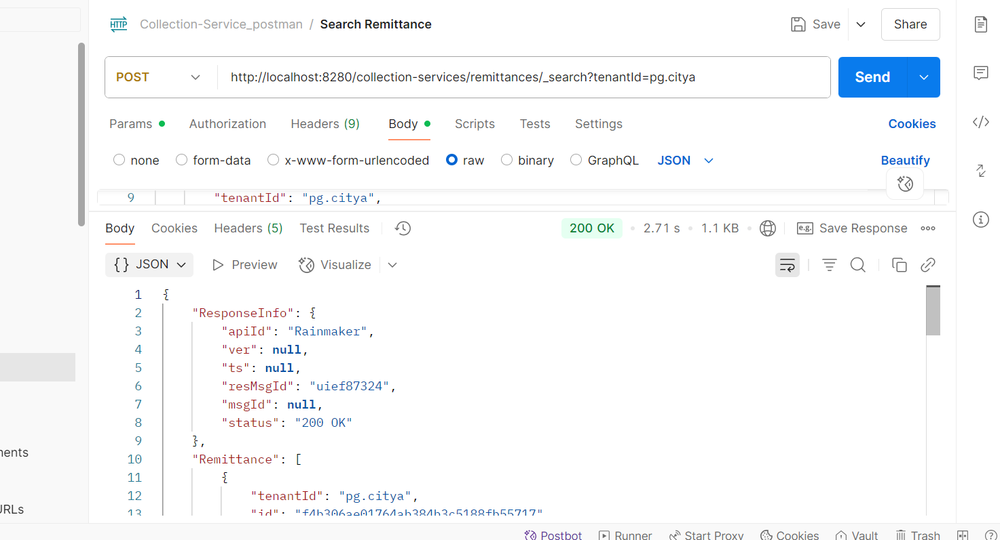

- Create Remittance : http://localhost:8280/collection-services/remittances/_create

Request Payload:
curl --location 'http://localhost:8280/collection-services/remittances/_create' \
--header 'Content-Type: application/json' \
--data '{
"RequestInfo": {
"apiId": "Rainmaker",
"authToken": "dummy-token",
"userInfo": {
"id": 1,
"uuid": "test-uuid",
"userName": "testuser",
"tenantId": "pg.citya",
"type": "EMPLOYEE",
"roles": [
{
"name": "Finance Admin",
"code": "FIN_ADMIN",
"tenantId": "pg.citya"
}
]
}
},
"Remittance": [
{
"tenantId": "pg.citya",
"referenceNumber": "REF-002",
"referenceDate": 1719400000000,
"status": "PENDING",
"bankaccount": "000000000002",
"remittanceDetails": [
{
"chartOfAccount": "COA-002",
"creditAmount": 1000.0,
"debitAmount": 0.0
}
],
"remittanceInstruments": [
{
"instrument": "CHQ-1234567"
}
]
}
]
}'
Response from local:
{
"ResponseInfo": {
"apiId": "Rainmaker",
"ver": null,
"ts": null,
"resMsgId": "uief87324",
"msgId": null,
"status": "200 OK"
},
"Remittance": [
{
"tenantId": "pg.citya",
"id": "5d2f9ee34bdb451b8e8d17c2d5de1108",
"referenceNumber": "REF-002",
"referenceDate": 1719400000000,
"voucherHeader": null,
"function": null,
"fund": null,
"remarks": null,
"reasonForDelay": null,
"status": "APPROVED",
"bankaccount": "000000000002",
"auditDetails": {
"createdBy": "1",
"createdTime": 1751138042606,
"lastModifiedBy": "1",
"lastModifiedTime": 1751138042606
},
"remittanceReceipts": [],
"remittanceDetails": [
{
"tenantId": "pg.citya",
"id": "9a14567e27ba4a64b8e1fa4c5960bbdd",
"remittance": "5d2f9ee34bdb451b8e8d17c2d5de1108",
"chartOfAccount": "COA-002",
"creditAmount": 1000,
"debitAmount": 0
}
],
"remittanceInstruments": [
{
"tenantId": "pg.citya",
"id": "59d49596e3d7482392e51ab12cab214f",
"remittance": "5d2f9ee34bdb451b8e8d17c2d5de1108",
"instrument": "CHQ-1234567",
"reconciled": null
}
]
}
]
}
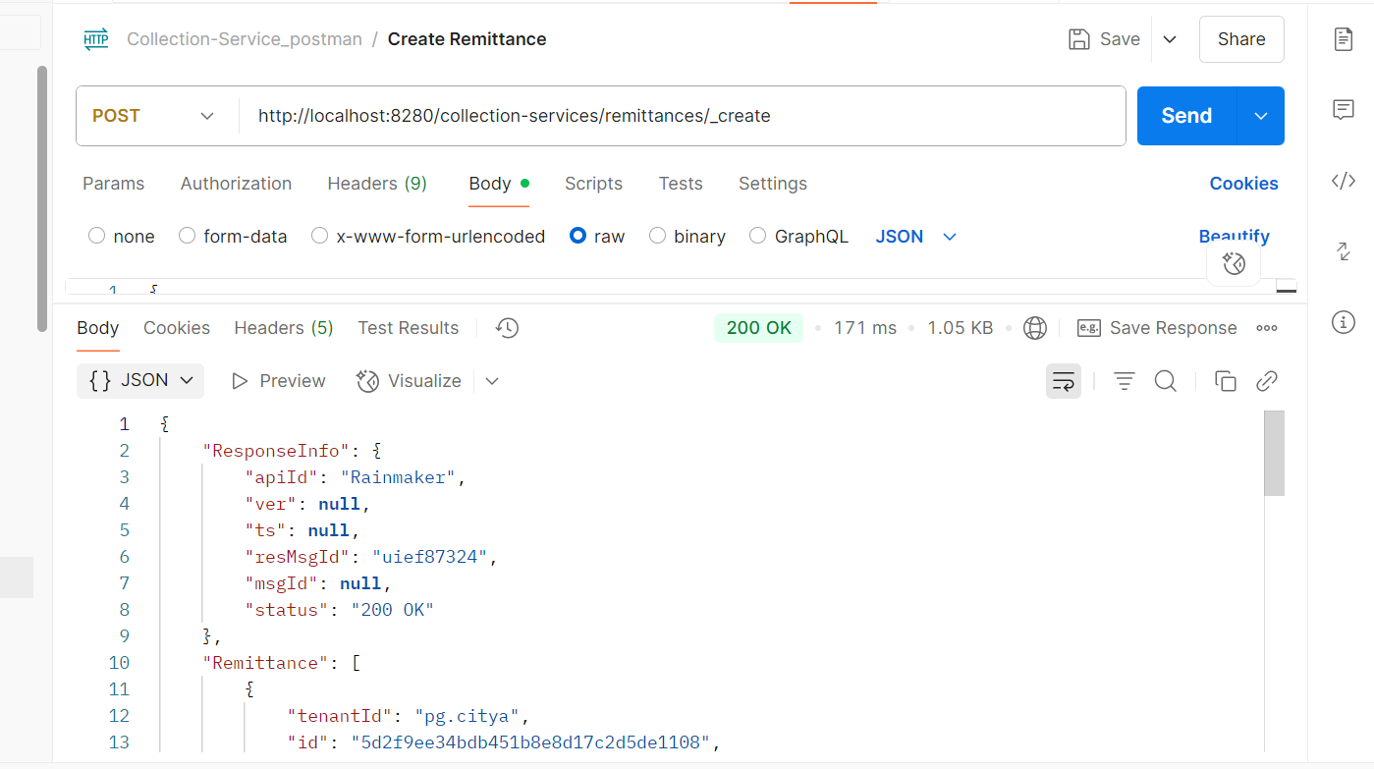
Response from environment:
{
"ResponseInfo": {
"apiId": "Rainmaker",
"ver": null,
"ts": null,
"resMsgId": "uief87324",
"msgId": null,
"status": "200 OK"
},
"Remittance": [
{
"tenantId": "pg.citya",
"id": "4b4b24594eea4c46b2bc6d15aa5e97fe",
"referenceNumber": "REF-002",
"referenceDate": 1719400000000,
"voucherHeader": null,
"function": null,
"fund": null,
"remarks": null,
"reasonForDelay": null,
"status": "APPROVED",
"bankaccount": "000000000002",
"auditDetails": {
"createdBy": "1",
"createdTime": 1751271212403,
"lastModifiedBy": "1",
"lastModifiedTime": 1751271212403
},
"remittanceReceipts": [],
"remittanceDetails": [
{
"tenantId": "pg.citya",
"id": "33e64b334bde41f0845222febaac3a99",
"remittance": "4b4b24594eea4c46b2bc6d15aa5e97fe",
"chartOfAccount": "COA-002",
"creditAmount": 1000,
"debitAmount": 0
}
],
"remittanceInstruments": [
{
"tenantId": "pg.citya",
"id": "d5c59c519cd54813b7ff08be0b72d1c8",
"remittance": "4b4b24594eea4c46b2bc6d15aa5e97fe",
"instrument": "CHQ-1234567",
"reconciled": null
}
]
}
]
}
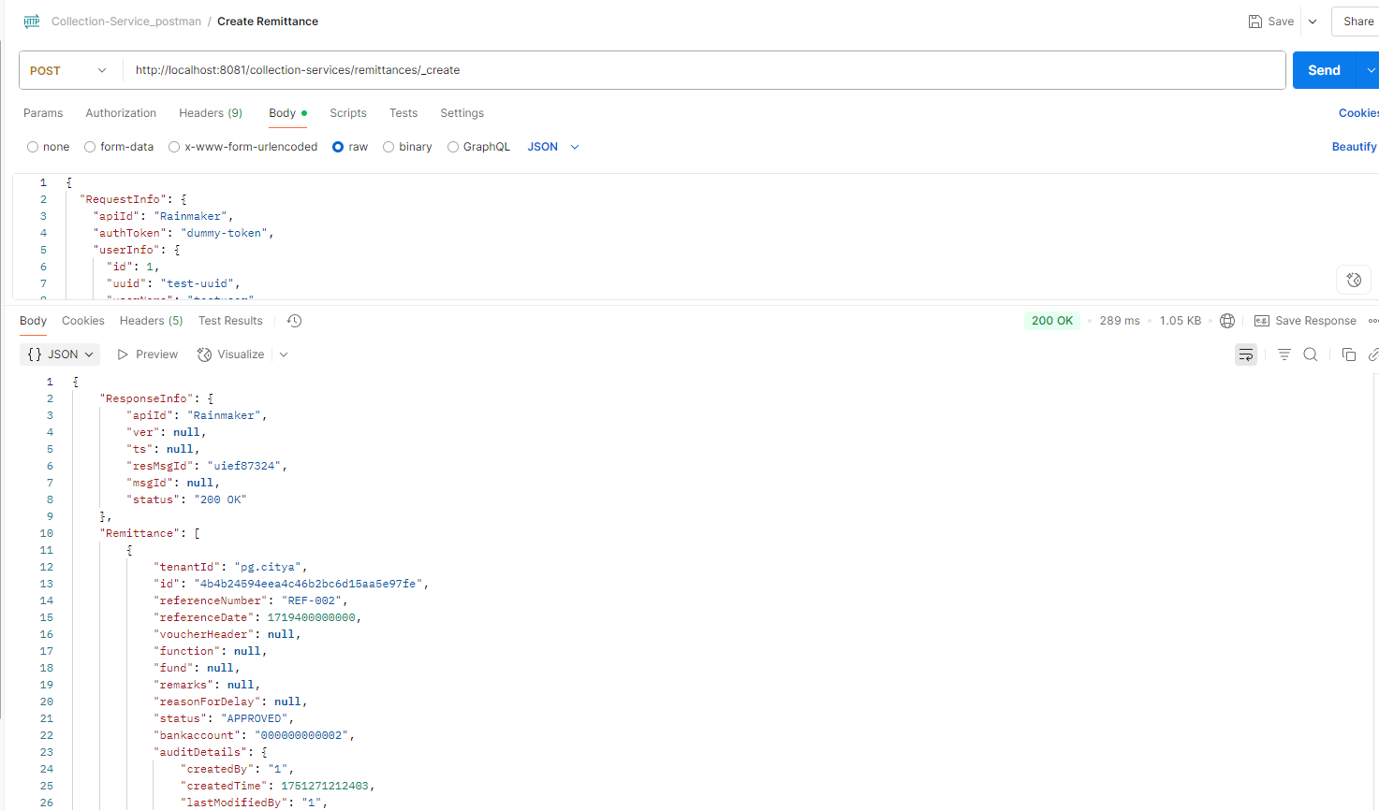

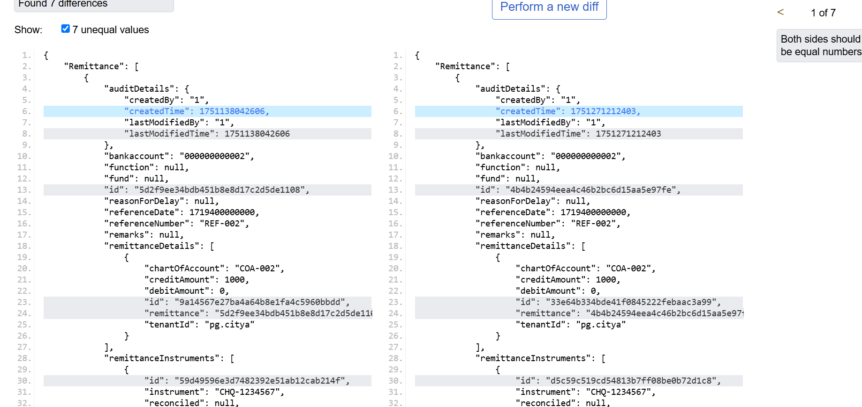
Update Remittance: http://localhost:8280/collection-services/remittances/_update
Request payload:
curl --location 'http://localhost:8280/collection-services/remittances/_update' \
--header 'Content-Type: application/json' \
--data '{
"RequestInfo": {
"apiId": "Rainmaker",
"authToken": "dummy-token",
"userInfo": {
"id": 1,
"uuid": "test-uuid",
"userName": "testuser",
"tenantId": "pg.citya",
"type": "EMPLOYEE",
"roles": [
{
"name": "Finance Admin",
"code": "FIN_ADMIN",
"tenantId": "pg.citya"
}
]
}
},
"Remittance": [
{
"tenantId": "pg.citya",
"id": "f4b306ae01764ab384b3c5188fb55717",
"referenceNumber": "REF-001",
"referenceDate": 1719400000000,
"voucherHeader": null,
"function": null,
"fund": null,
"remarks": "Updated remarks",
"reasonForDelay": null,
"status": "APPROVED",
"bankaccount": "000000000001",
"auditDetails": {
"createdBy": "1",
"createdTime": 1751008018990,
"lastModifiedBy": "1",
"lastModifiedTime": 1751008018990
},
"remittanceReceipts": [],
"remittanceDetails": [
{
"tenantId": "pg.citya",
"id": "4ea449e3f2d64d0e95f1331bc3158e88",
"remittance": "f4b306ae01764ab384b3c5188fb55717",
"chartOfAccount": "COA-001",
"creditAmount": 1000.0,
"debitAmount": 0.0
}
],
"remittanceInstruments": [
{
"tenantId": "pg.citya",
"id": "4059e8b802834953a982b25b70bc6fe3",
"remittance": "f4b306ae01764ab384b3c5188fb55717",
"instrument": "CHQ-123456",
"reconciled": null
}
]
}
]
}'
Response from local:
{
"ResponseInfo": {
"apiId": "Rainmaker",
"ver": null,
"ts": null,
"resMsgId": "uief87324",
"msgId": null,
"status": "200 OK"
},
"Remittance": [
{
"tenantId": "pg.citya",
"id": "f4b306ae01764ab384b3c5188fb55717",
"referenceNumber": "REF-001",
"referenceDate": 1719400000000,
"voucherHeader": null,
"function": null,
"fund": null,
"remarks": "Updated remarks",
"reasonForDelay": null,
"status": "APPROVED",
"bankaccount": "000000000001",
"auditDetails": {
"createdBy": "1",
"createdTime": 1751008018990,
"lastModifiedBy": "1",
"lastModifiedTime": 1751008018990
},
"remittanceReceipts": [],
"remittanceDetails": [
{
"tenantId": "pg.citya",
"id": "4ea449e3f2d64d0e95f1331bc3158e88",
"remittance": "f4b306ae01764ab384b3c5188fb55717",
"chartOfAccount": "COA-001",
"creditAmount": 1000,
"debitAmount": 0
}
],
"remittanceInstruments": [
{
"tenantId": "pg.citya",
"id": "4059e8b802834953a982b25b70bc6fe3",
"remittance": "f4b306ae01764ab384b3c5188fb55717",
"instrument": "CHQ-123456",
"reconciled": null
}
]
}
]
}
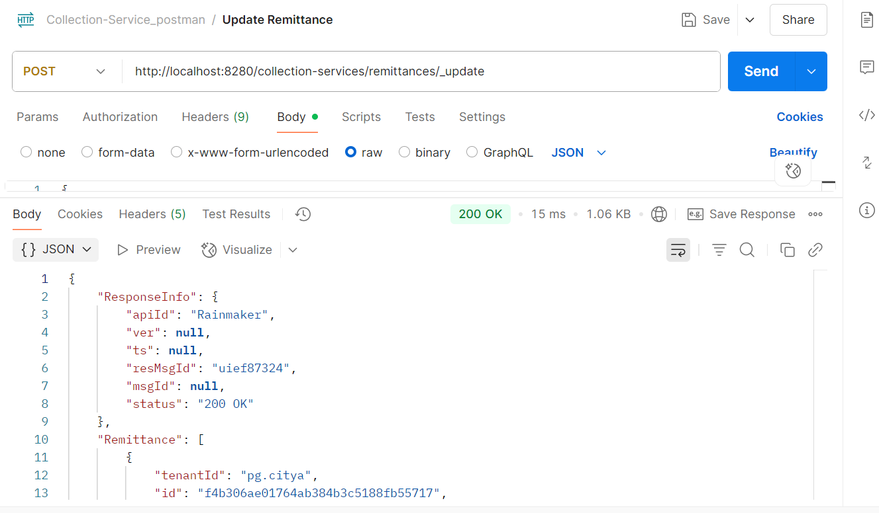

Response from Env:
{
"ResponseInfo": {
"apiId": "Rainmaker",
"ver": null,
"ts": null,
"resMsgId": "uief87324",
"msgId": null,
"status": "200 OK"
},
"Remittance": [
{
"tenantId": "pg.citya",
"id": "f4b306ae01764ab384b3c5188fb55717",
"referenceNumber": "REF-001",
"referenceDate": 1719400000000,
"voucherHeader": null,
"function": null,
"fund": null,
"remarks": "Updated remarks",
"reasonForDelay": null,
"status": "APPROVED",
"bankaccount": "000000000001",
"auditDetails": {
"createdBy": "1",
"createdTime": 1751008018990,
"lastModifiedBy": "1",
"lastModifiedTime": 1751008018990
},
"remittanceReceipts": [],
"remittanceDetails": [
{
"tenantId": "pg.citya",
"id": "4ea449e3f2d64d0e95f1331bc3158e88",
"remittance": "f4b306ae01764ab384b3c5188fb55717",
"chartOfAccount": "COA-001",
"creditAmount": 1000,
"debitAmount": 0
}
],
"remittanceInstruments": [
{
"tenantId": "pg.citya",
"id": "4059e8b802834953a982b25b70bc6fe3",
"remittance": "f4b306ae01764ab384b3c5188fb55717",
"instrument": "CHQ-123456",
"reconciled": null
}
]
}
]
}
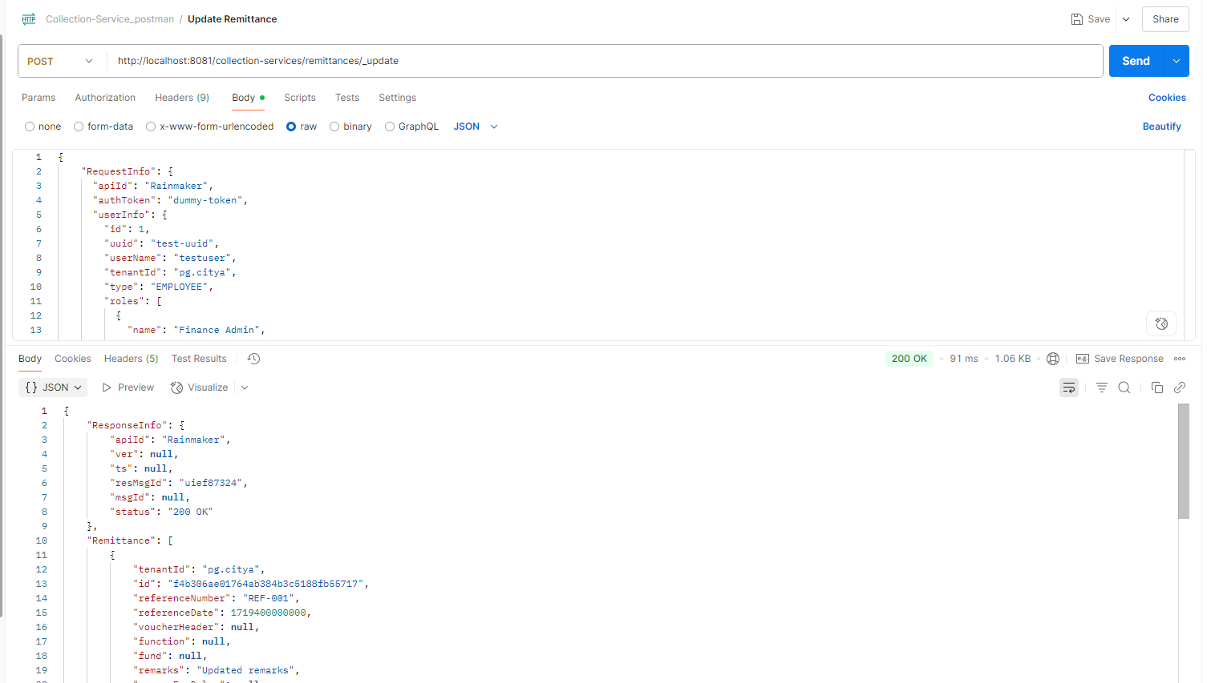

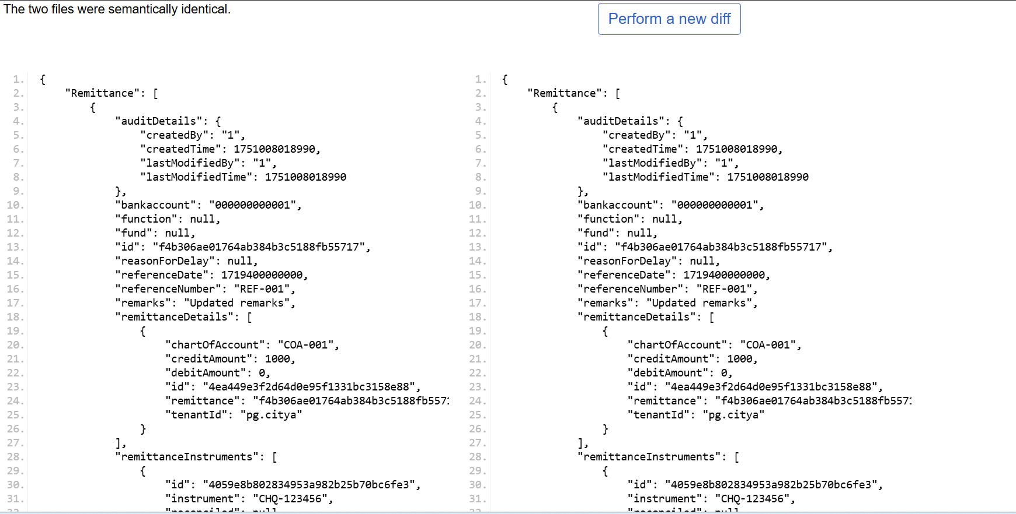

3 Bank Account Controller

- Create Bank Account

Request Payload:
curl --location 'http://localhost:8280/collection-services/bankAccountServiceMapping/_create' \
--header 'Content-Type: application/json' \
--data '{
"RequestInfo": {
"apiId": "Rainmaker",
"authToken": "dummy-token",
"userInfo": {
"id": 1,
"uuid": "test-uuid",
"userName": "testuser",
"tenantId": "pg.citya",
"type": "EMPLOYEE",
"roles": [
{
"name": "Finance Admin",
"code": "FIN_ADMIN",
"tenantId": "pg.citya"
}
]
}
},
"bankAccountServiceMapping": [
{
"tenantId": "pg.citya",
"bankAccount": "000000000002",
"bank": "Allahabad UP Gramin Bank",
"bankBranch": "001",
"businessDetails": "TL.RENEWAL"
}
]
}'
Response from local:
{
"BankAccountServiceMapping": [
{
"businessDetails": "TL.RENEWAL",
"bankAccount": "000000000002",
"bank": "Allahabad UP Gramin Bank",
"bankBranch": "001",
"tenantId": "pg.citya"
}
],
"ResponseInfo": {
"apiId": "Rainmaker",
"ver": null,
"ts": null,
"resMsgId": "uief87324",
"msgId": null,
"status": "200 OK"
}
}
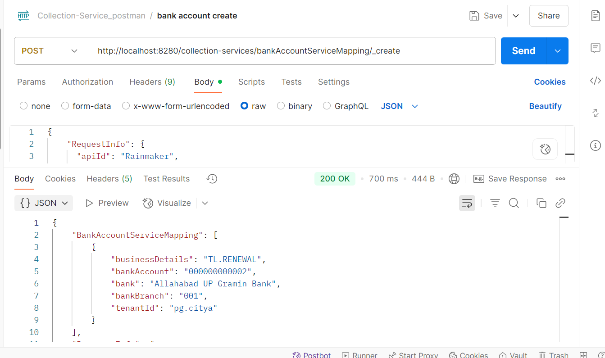
Response from env:
{
"BankAccountServiceMapping": [
{
"businessDetails": "TL.RENEWAL",
"bankAccount": "000000000002",
"bank": "Allahabad UP Gramin Bank",
"bankBranch": "001",
"tenantId": "pg.citya"
}
],
"ResponseInfo": {
"apiId": "Rainmaker",
"ver": null,
"ts": null,
"resMsgId": "uief87324",
"msgId": null,
"status": "200 OK"
}
}
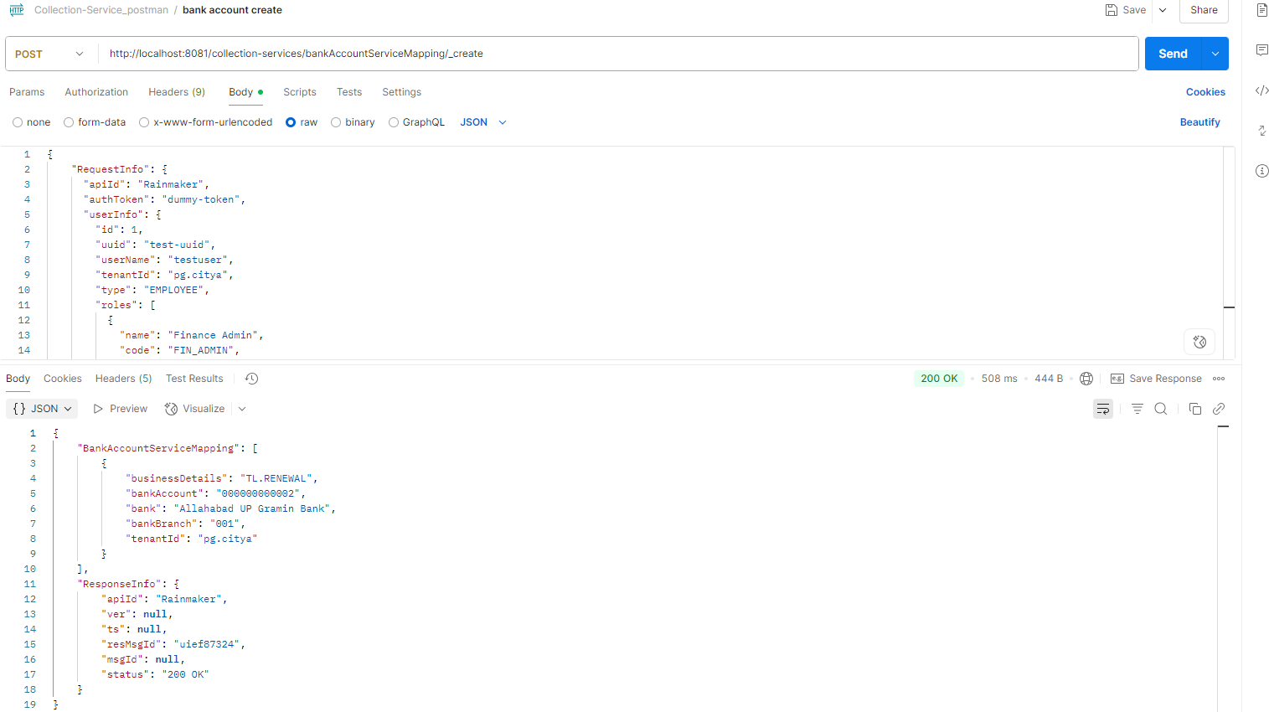

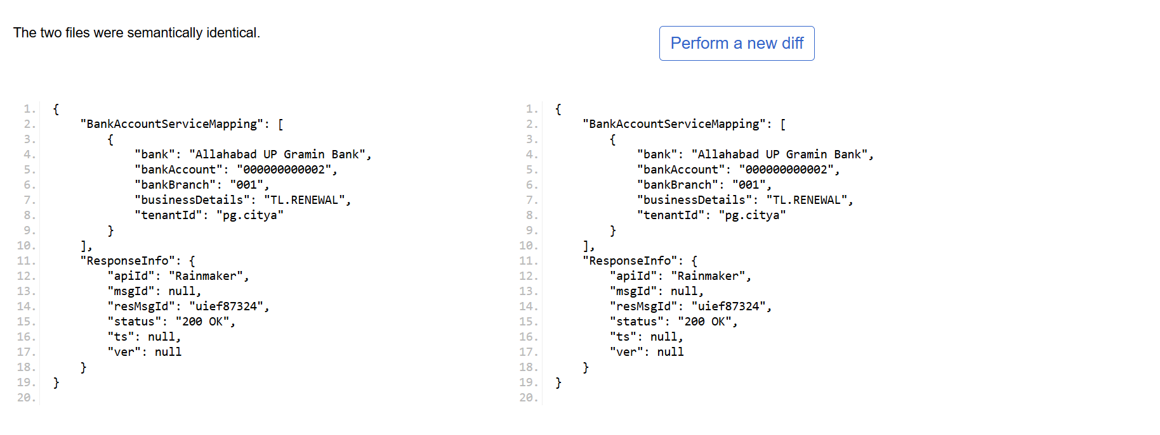
- Bank Account Search
Request Payload:
curl --location 'http://localhost:8081/collection-services/bankAccountServiceMapping/_search?tenantId=pg.citya' \
- --header 'Content-Type: application/json' \
- --data '{
- "RequestInfo": {
- "apiId": "Rainmaker",
- "authToken": "dummy-token",
- "userInfo": {
- "id": 1,
- "uuid": "test-uuid",
- "userName": "testuser",
- "tenantId": "pb.amritsar",
- "type": "EMPLOYEE",
- "roles": [
- {
- "name": "Finance Admin",
- "code": "FIN_ADMIN",
- "tenantId": "pb.amritsar"
- }
- ]
- }
- }
- }'
Response from local:
{
- "BankAccountServiceMapping": [
- {
- "businessDetails": "TL.RENEWAL",
- "bankAccount": "000000000001",
- "bank": "Allahabad UP Gramin Bank",
- "bankBranch": "001",
- "tenantId": "pg.citya"
- },
- {
- "businessDetails": "chb-services",
- "bankAccount": "1234567890123456",
- "bank": "kunal",
- "bankBranch": "069",
- "tenantId": "pg.citya"
- },
- {
- "businessDetails": "chb-services",
- "bankAccount": "844102001001VN",
- "bank": "STATE BANK OF INDIA",
- "bankBranch": "6305",
- "tenantId": "pg.citya"
- },
- {
- "businessDetails": "sv-services",
- "bankAccount": "844102001001VN",
- "bank": "STATE BANK OF INDIA",
- "bankBranch": "11959",
- "tenantId": "pg.citya"
- }
- ],
- "ResponseInfo": {
- "apiId": "Rainmaker",
- "ver": null,
- "ts": null,
- "resMsgId": "uief87324",
- "msgId": null,
- "status": "200 OK"
- }
- }
- 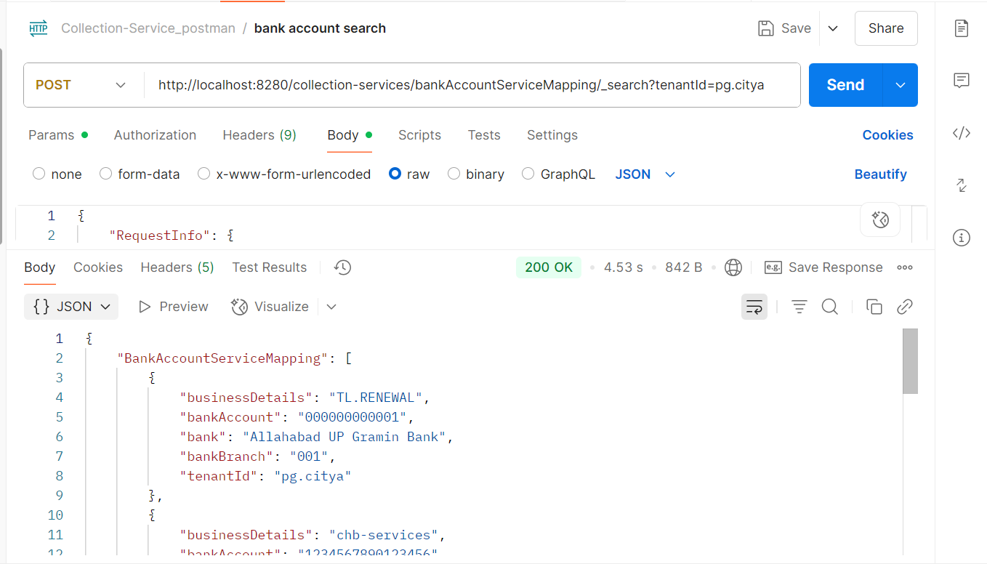
Response from env:
{
- "BankAccountServiceMapping": [
- {
- "businessDetails": "TL.RENEWAL",
- "bankAccount": "000000000001",
- "bank": "Allahabad UP Gramin Bank",
- "bankBranch": "001",
- "tenantId": "pg.citya"
- },
- {
- "businessDetails": "chb-services",
- "bankAccount": "1234567890123456",
- "bank": "kunal",
- "bankBranch": "069",
- "tenantId": "pg.citya"
- },
- {
- "businessDetails": "chb-services",
- "bankAccount": "844102001001VN",
- "bank": "STATE BANK OF INDIA",
- "bankBranch": "6305",
- "tenantId": "pg.citya"
- },
- {
- "businessDetails": "sv-services",
- "bankAccount": "844102001001VN",
- "bank": "STATE BANK OF INDIA",
- "bankBranch": "11959",
- "tenantId": "pg.citya"
- }
- ],
- "ResponseInfo": {
- "apiId": "Rainmaker",
- "ver": null,
- "ts": null,
- "resMsgId": "uief87324",
- "msgId": null,
- "status": "200 OK"
- }

- }

 