Egf Intrument Service Testing Evidence
Instrument Create
curl --location 'localhost:8480/egf-instrument/instruments/_create' \
--header 'Content-Type: application/json' \
--data '{
"requestInfo":{
"resMsgId":"placeholder",
"status":"200",
"apiId":null,
"ver":null,
"ts":1483212661000,
"key":null,
"authToken":"",
"userInfo":{
"id":1
}
},
"instruments":[
{
"id":"hello",
"transactionNumber":"transactionNumber",
"transactionDate":"23-08-2017",
"amount":100,
"payee":"payee",
"transactionType":"Credit",
"bank":{
"id":10,
"code":"10",
"name":"nameupdate",
"description":"descriptionupdate",
"active":true,
"type":"typeupdate",
"tenantId":"default"
},
"bankAccount":{
"id":"1",
"bankBranch":{
"id":"1",
"bank":{
"id":10000,
"code":"10",
"name":"neameupdate",
"description":"descriptionupdate",
"active":true,
"type":"typeupdate",
"tenantId":"default"
},
"code":"Rajesh",
"name":"Rajesh",
"active":true,
"micr":"Rajesh",
"tenantId":"default"
},
"chartOfAccount":{
"id":"1223",
"tenantId":"default"
},
"fund":{
"id":"1",
"tenantId":"default"
},
"accountNumber":"000000000001",
"accountType":"OTHER SCHEDULED BANKS",
"active":true,
"type":"RECEIPTS_PAYMENTS",
"tenantId":"default"
},
"instrumentType":{
"id":"f3ae954c-74b0-47d9-9c17-088362c31e35",
"name":"Online",
"active":"true",
"tenantId":"default"
},
"serialNo":"serialNo",
"tenantId":"default"
}
]
}'
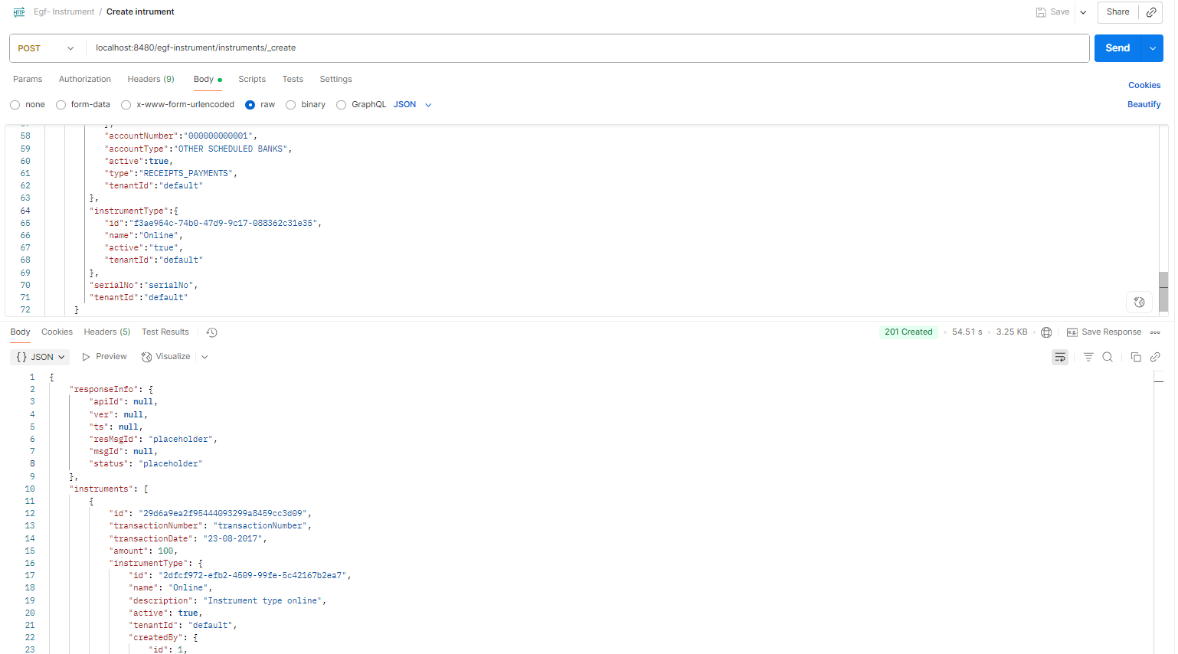

Instrument search
curl -X POST \
'http://localhost:8480/egf-instrument/instruments/_search?tenantId=default&pageSize=10&offset=0' \
-H 'Content-Type: application/json' \
-d '{
"RequestInfo": {
"apiId": "Rainmaker",
"ver": ".01",
"ts": "01-01-2017 12:00:00",
"action": "_search",
"did": "1",
"key": "",
"msgId": "20170310130900|en_IN",
"authToken": "your-auth-token-here",
"userInfo": {
"id": 1,
"userName": "admin",
"name": "Administrator",
"type": "EMPLOYEE",
"mobileNumber": "9999999999",
"emailId": "admin@egovernments.org",
"roles": [
{
"name": "Employee",
"code": "EMPLOYEE",
"tenantId": "default"
}
],
"tenantId": "default",
"uuid": "string"
}
}
}'

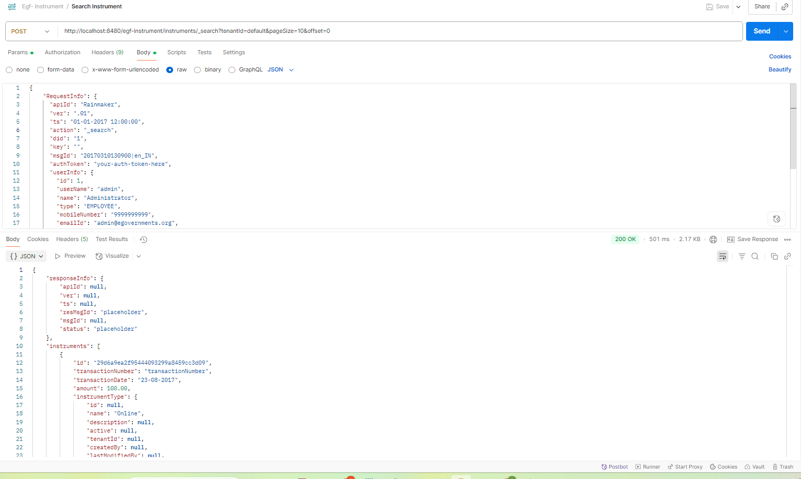

Instrument delete:
curl -X POST \
http://localhost:8480/egf-instrument/instruments/_delete \
-H 'Content-Type: application/json' \
-d '{
"RequestInfo": {
"apiId": "Rainmaker",
"ver": ".01",
"ts": "01-01-2017 12:00:00",
"action": "_delete",
"did": "1",
"key": "",
"msgId": "20170310130900|en_IN",
"authToken": "your-auth-token-here",
"userInfo": {
"id": 1,
"userName": "admin",
"name": "Administrator",
"type": "EMPLOYEE",
"mobileNumber": "9999999999",
"emailId": "admin@egovernments.org",
"roles": [
{
"name": "Employee",
"code": "EMPLOYEE",
"tenantId": "default"
}
],
"tenantId": "default",
"uuid": "string"
}
},
"instruments": [
{
"id": "29d6a9ea2f95444093299a8459cc3d09",
"tenantId": "default"
}
]
}'
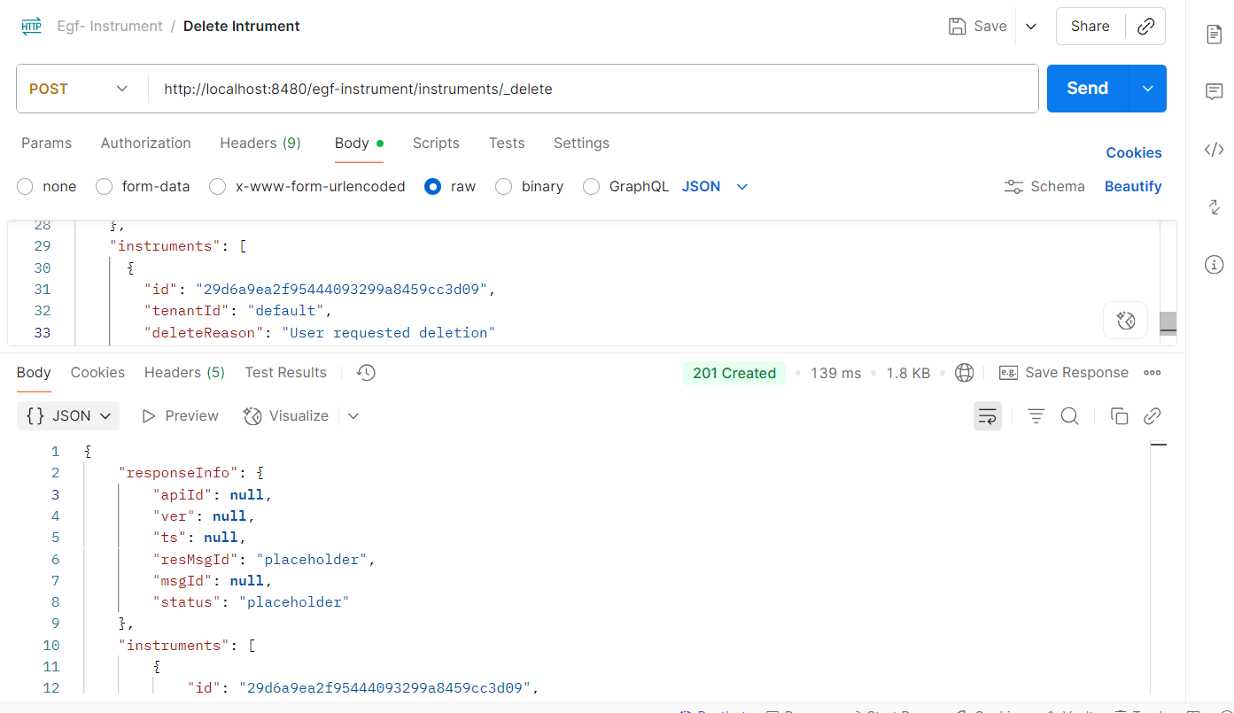

Instrument update:
curl --location 'http://localhost:8480/egf-instrument/instruments/_update' \
--header 'Content-Type: application/json' \
--data-raw '{
"RequestInfo": {
"apiId": "Rainmaker",
"ver": ".01",
"ts": "01-01-2017 12:00:00",
"action": "_update",
"did": "1",
"key": "",
"msgId": "20170310130900|en_IN",
"authToken": "your-auth-token-here",
"userInfo": {
"id": 1,
"userName": "admin",
"name": "Administrator",
"type": "EMPLOYEE",
"mobileNumber": "9999999999",
"emailId": "admin@egovernments.org",
"roles": [
{
"name": "Employee",
"code": "EMPLOYEE",
"tenantId": "default"
}
],
"tenantId": "default",
"uuid": "string"
}
},
"instruments": [
{
"id": "d6043e33bebf43e9bca8577638dbb0d4",
"transactionNumber": "updatedTransactionNumber",
"transactionDate": "25-08-2017",
"amount": 769,
"instrumentType": {
"id": "2dfcf972-efb2-4509-99fe-5c42167b2ea7",
"name": "Online",
"description": "Instrument type online",
"active": true,
"tenantId": "default"
},
"bank": {
"id": "10",
"code": "10",
"name": "nameupdate",
"description": "descriptionupdate",
"active": true,
"type": "typeupdate",
"tenantId": "default"
},
"branchName": "Updated Branch",
"bankAccount": {
"id": "1",
"bankBranch": {
"id": "1",
"bank": {
"id": "10000",
"code": "10",
"name": "neameupdate",
"description": "descriptionupdate",
"active": true,
"type": "typeupdate",
"tenantId": "default"
},
"code": "Rajesh",
"name": "Rajesh",
"address": null,
"address2": null,
"city": null,
"state": null,
"pincode": null,
"phone": null,
"fax": null,
"contactPerson": null,
"active": true,
"description": null,
"micr": "Rajesh",
"tenantId": "default"
},
"chartOfAccount": {
"id": "1223",
"glcode": null,
"name": null,
"accountCodePurpose": null,
"description": null,
"isActiveForPosting": null,
"parentId": null,
"type": null,
"classification": null,
"functionRequired": null,
"budgetCheckRequired": null,
"majorCode": null,
"isSubLedger": null,
"tenantId": "default"
},
"fund": {
"tenantId": "default",
"id": "1",
"name": null,
"code": null,
"identifier": null,
"level": null,
"parent": null,
"active": null
},
"accountNumber": "000000000001",
"accountType": "OTHER SCHEDULED BANKS",
"description": null,
"active": true,
"payTo": null,
"type": "RECEIPTS_PAYMENTS",
"tenantId": "default"
},
"financialStatus": null,
"remittanceVoucherId": null,
"transactionType": "Credit",
"payee": "Updated Payee",
"drawer": "Updated Drawer",
"serialNo": "updatedSerialNo",
"instrumentVouchers": [],
"tenantId": "default"
}
]
}'
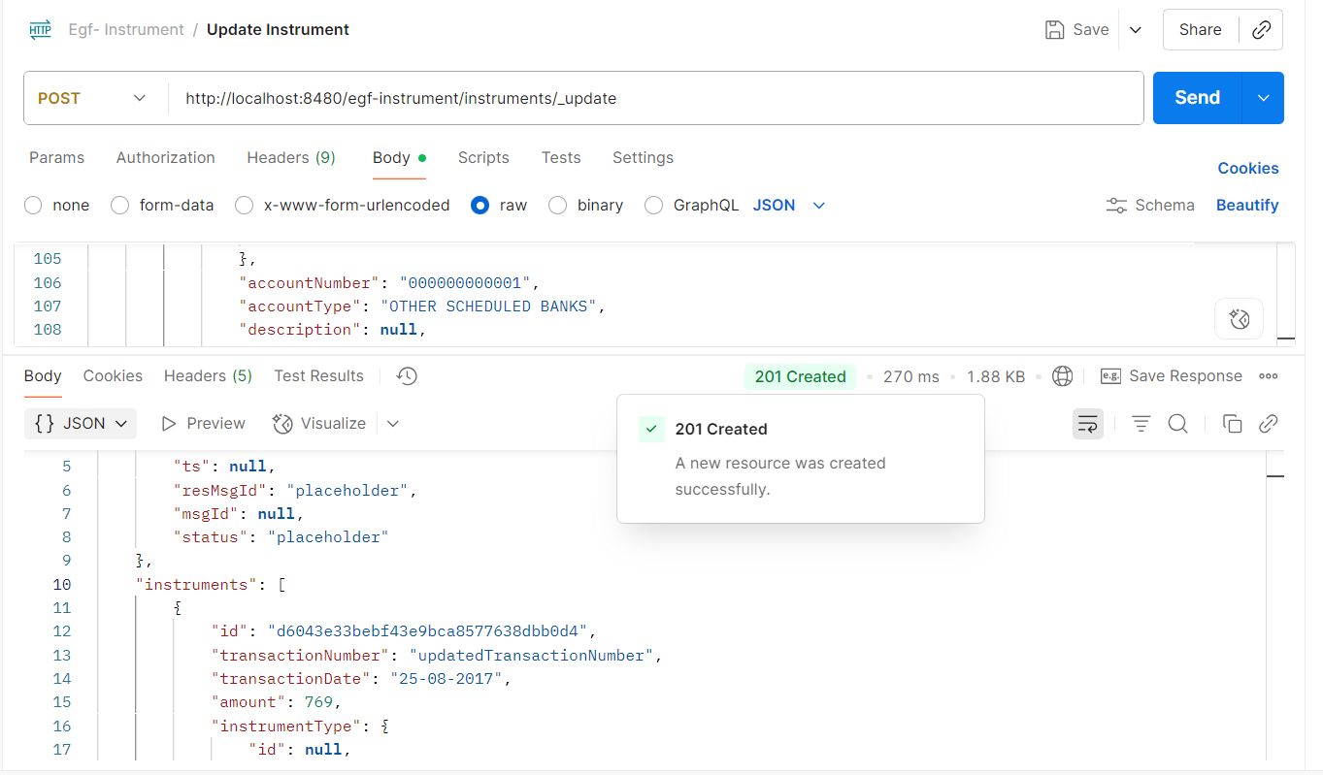

Deposit Instrument:
curl --location 'http://localhost:8480/egf-instrument/instruments/_deposit' \
--header 'Content-Type: application/json' \
--data-raw '{
"RequestInfo": {
"apiId": "Rainmaker",
"ver": ".01",
"ts": "01-01-2017 12:00:00",
"action": "_deposit",
"did": "1",
"key": "",
"msgId": "20170310130900|en_IN",
"authToken": "your-auth-token-here",
"userInfo": {
"id": 1,
"userName": "admin",
"name": "Administrator",
"type": "EMPLOYEE",
"mobileNumber": "9999999999",
"emailId": "admin@egovernments.org",
"roles": [
{
"name": "Employee",
"code": "EMPLOYEE",
"tenantId": "default"
}
],
"tenantId": "default",
"uuid": "string"
}
},
"instruments": [
{
"id": "d6043e33bebf43e9bca8577638dbb0d4",
"remittanceVoucherId": "REM001",
"tenantId": "default"
}
]
}'
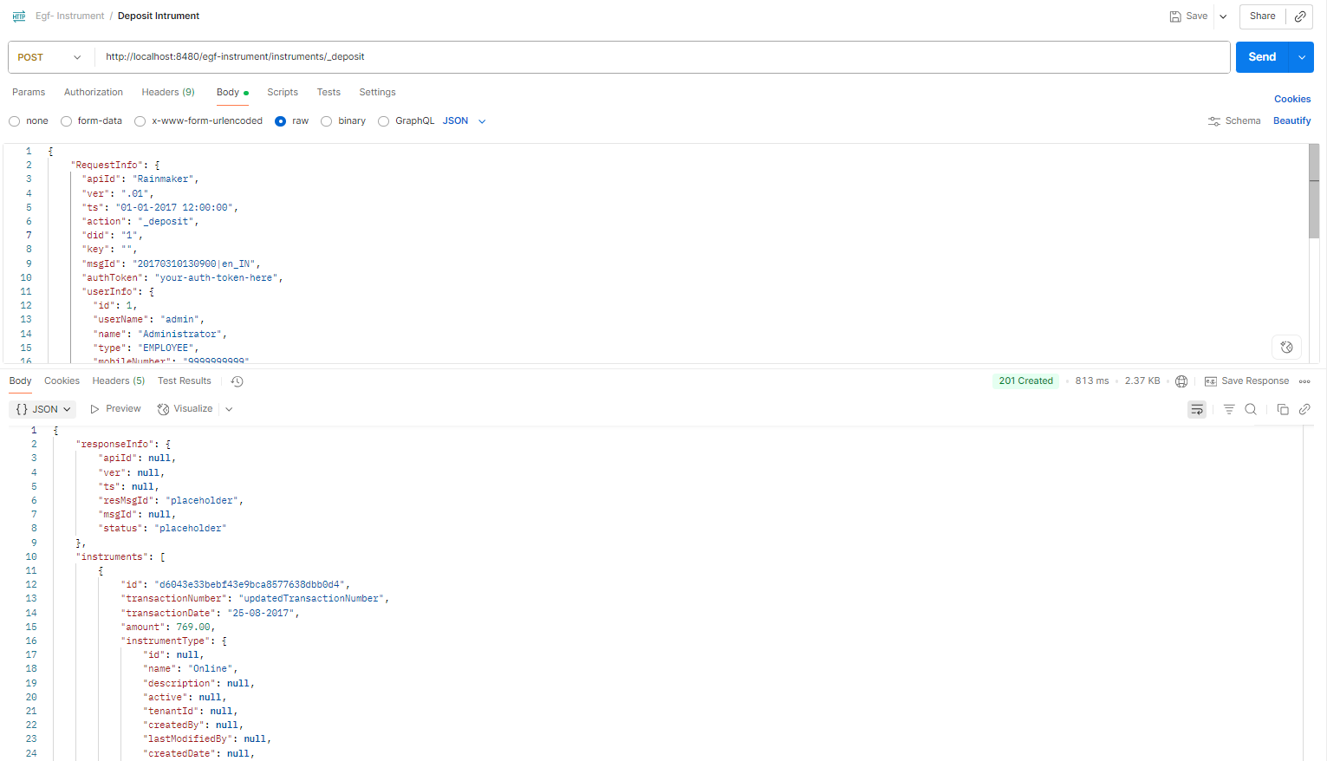

Dishonor instrument

curl --location 'http://localhost:8480/egf-instrument/instruments/_dishonor' \
--header 'Content-Type: application/json' \
--data-raw '{
"RequestInfo": {
"apiId": "Rainmaker",
"ver": ".01",
"ts": "01-01-2017 12:00:00",
"action": "_dishonor",
"did": "1",
"key": "",
"msgId": "20170310130900|en_IN",
"authToken": "your-auth-token-here",
"userInfo": {
"id": 1,
"userName": "admin",
"name": "Administrator",
"type": "EMPLOYEE",
"mobileNumber": "9999999999",
"emailId": "admin@egovernments.org",
"roles": [
{
"name": "Employee",
"code": "EMPLOYEE",
"tenantId": "default"
}
],
"tenantId": "default",
"uuid": "string"
}
},
"instruments": [
{
"id": "d6043e33bebf43e9bca8577638dbb0d4",
"tenantId": "default"
}
]
}'
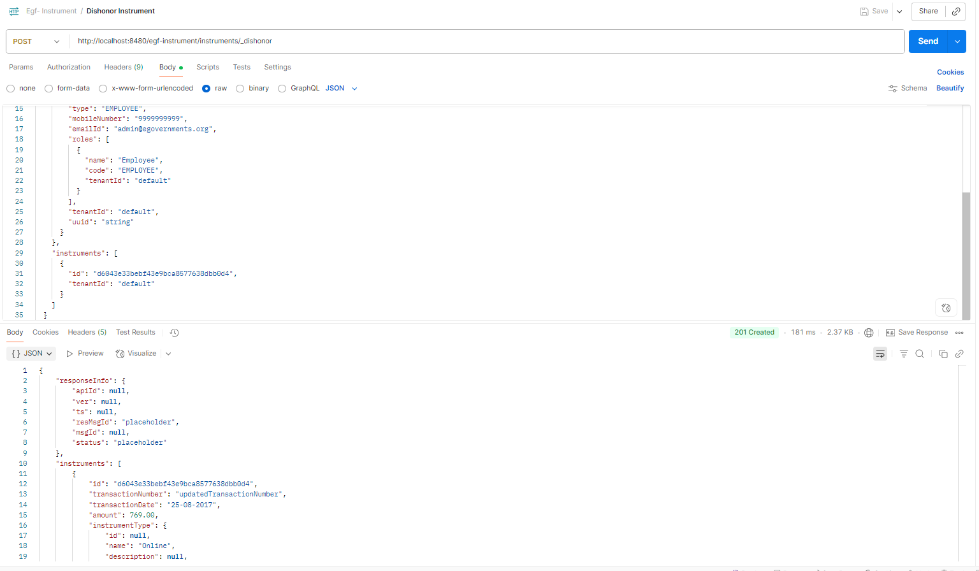

CreateInstrumentType
curl --location 'http://localhost:8480/egf-instrument/instrumenttypes/_create' \
--header 'Content-Type: application/json' \
--data-raw '{
"RequestInfo": {
"apiId": "Rainmaker",
"ver": ".01",
"ts": "01-01-2017 12:00:00",
"action": "_create",
"did": "1",
"key": "",
"msgId": "20170310130900|en_IN",
"authToken": "your-auth-token-here",
"userInfo": {
"id": 1,
"userName": "admin",
"name": "Administrator",
"type": "EMPLOYEE",
"mobileNumber": "9999999999",
"emailId": "admin@egovernments.org",
"roles": [
{
"name": "Employee",
"code": "EMPLOYEE",
"tenantId": "default"
}
],
"tenantId": "default",
"uuid": "string"
}
},
"instrumentTypes": [
{
"name": "UPI",
"description": "Unified Payments Interface",
"active": true,
"tenantId": "default"
}
]
}'
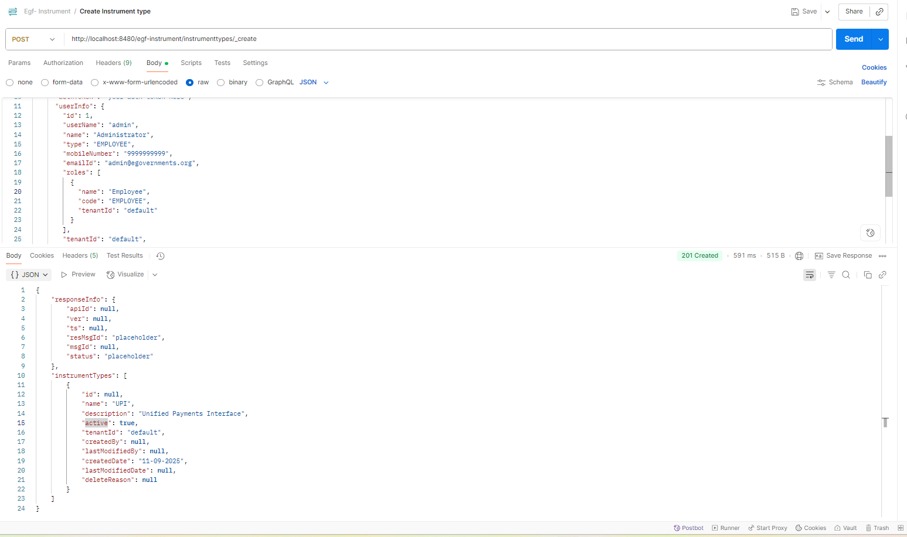

UpdateInstrumentType
curl --location 'http://localhost:8480/egf-instrument/instrumenttypes/_update' \
--header 'Content-Type: application/json' \
--data-raw '{
"RequestInfo": {
"apiId": "Rainmaker",
"ver": ".01",
"ts": "01-01-2017 12:00:00",
"action": "_update",
"did": "1",
"key": "",
"msgId": "20170310130900|en_IN",
"authToken": "your-auth-token-here",
"userInfo": {
"id": 1,
"userName": "admin",
"name": "Administrator",
"type": "EMPLOYEE",
"mobileNumber": "9999999999",
"emailId": "admin@egovernments.org",
"roles": [
{
"name": "Employee",
"code": "EMPLOYEE",
"tenantId": "default"
}
],
"tenantId": "default",
"uuid": "string"
}
},
"instrumentTypes": [
{
"id": "2dfcf972-efb2-4509-99fe-5c42167b2ea7",
"name": "UPI_Updated",
"description": "Updated Unified Payments Interface",
"active": true,
"tenantId": "default"
}
]
}'
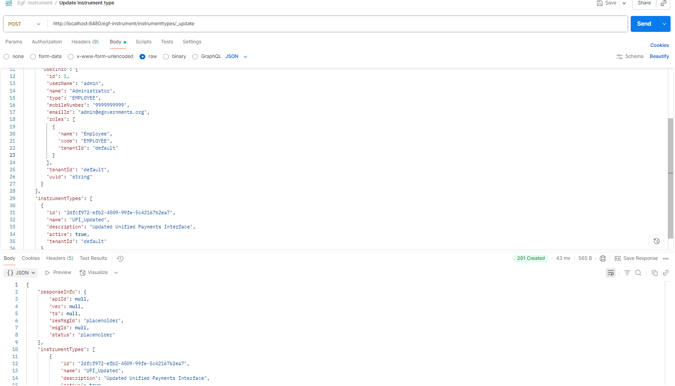

SearchInstrumentType:
curl --location 'http://localhost:8480/egf-instrument/instrumenttypes/_search?tenantId=default&pageSize=10&offset=0' \
--header 'Content-Type: application/json' \
--data-raw '{
"RequestInfo": {
"apiId": "Rainmaker",
"ver": ".01",
"ts": "01-01-2017 12:00:00",
"action": "_search",
"did": "1",
"key": "",
"msgId": "20170310130900|en_IN",
"authToken": "your-auth-token-here",
"userInfo": {
"id": 1,
"userName": "admin",
"name": "Administrator",
"type": "EMPLOYEE",
"mobileNumber": "9999999999",
"emailId": "admin@egovernments.org",
"roles": [
{
"name": "Employee",
"code": "EMPLOYEE",
"tenantId": "default"
}
],
"tenantId": "default",
"uuid": "string"
}
}
}'
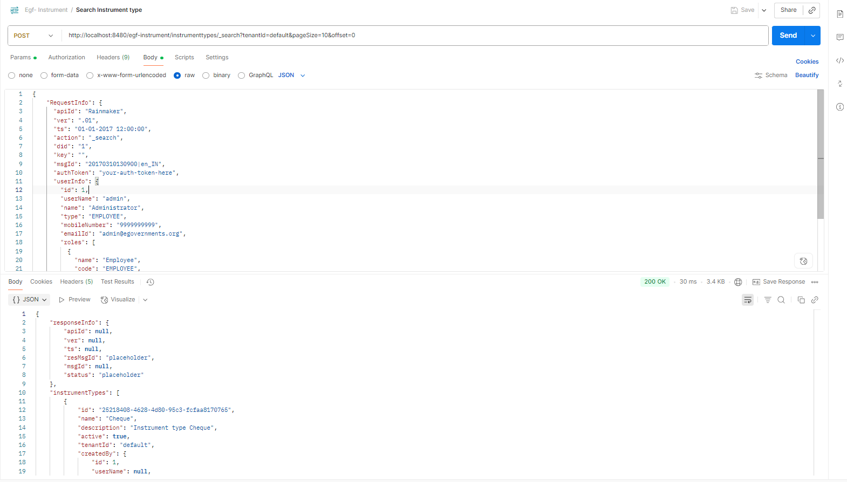

DeleteInstrumentType
curl --location 'http://localhost:8480/egf-instrument/instrumenttypes/_delete' \
--header 'Content-Type: application/json' \
--data-raw '{
"RequestInfo": {
"apiId": "Rainmaker",
"ver": ".01",
"ts": "01-01-2017 12:00:00",
"action": "_delete",
"did": "1",
"key": "",
"msgId": "20170310130900|en_IN",
"authToken": "your-auth-token-here",
"userInfo": {
"id": 1,
"userName": "admin",
"name": "Administrator",
"type": "EMPLOYEE",
"mobileNumber": "9999999999",
"emailId": "admin@egovernments.org",
"roles": [
{
"name": "Employee",
"code": "EMPLOYEE",
"tenantId": "default"
}
],
"tenantId": "default",
"uuid": "string"
}
},
"instrumentTypes": [
{
"id": "331703eaa04548b7984f237c94049cac",
"tenantId": "default"
}
]
}'

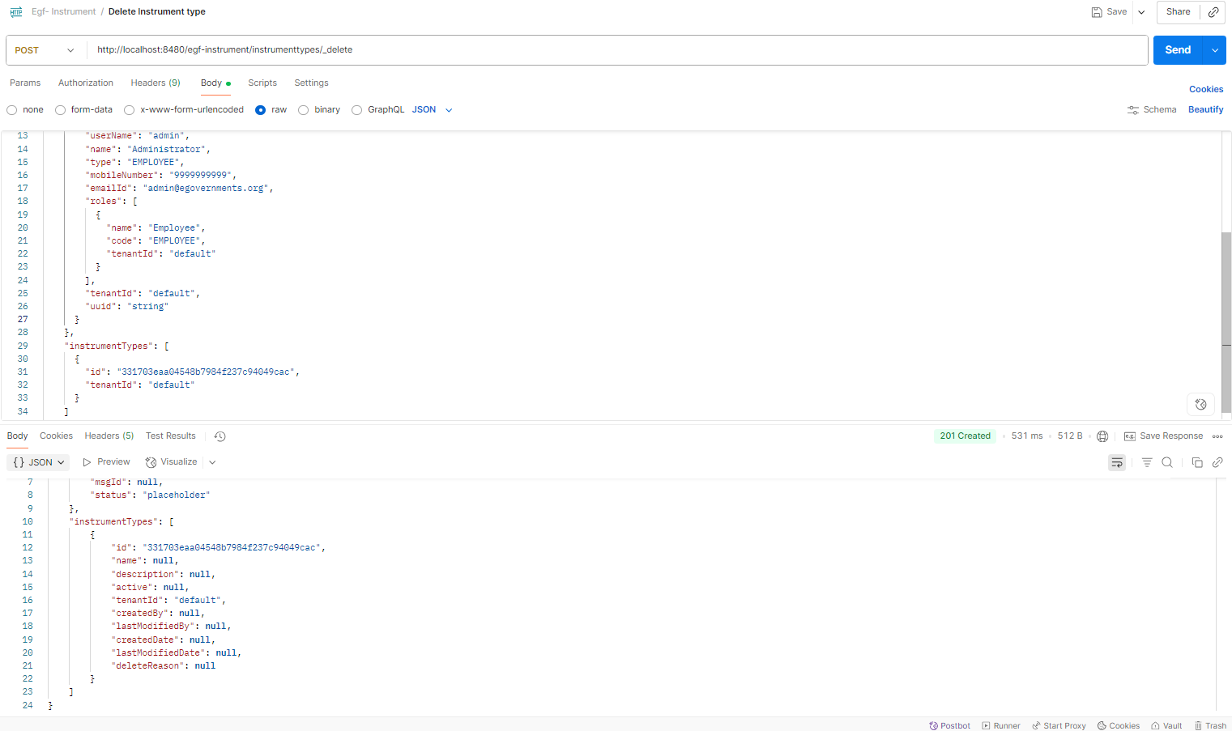

Create Instrument Account Code

curl --location 'http://localhost:8480/egf-instrument/instrumentaccountcodes/_create' \
--header 'Content-Type: application/json' \
--data-raw '{
"RequestInfo": {
"apiId": "Rainmaker",
"ver": ".01",
"ts": "01-01-2017 12:00:00",
"action": "_create",
"did": "1",
"key": "",
"msgId": "20170310130900|en_IN",
"authToken": "your-auth-token-here",
"userInfo": {
"id": 1,
"userName": "admin",
"name": "Administrator",
"type": "EMPLOYEE",
"mobileNumber": "9999999999",
"emailId": "admin@egovernments.org",
"roles": [
{
"name": "Employee",
"code": "EMPLOYEE",
"tenantId": "default"
}
],
"tenantId": "default",
"uuid": "string"
}
},
"instrumentAccountCodes": [
{
"instrumentType": {
"name": "DD"
},
"accountCode": {
"glcode": "11001"
},
"tenantId": "default"
}
]
}'
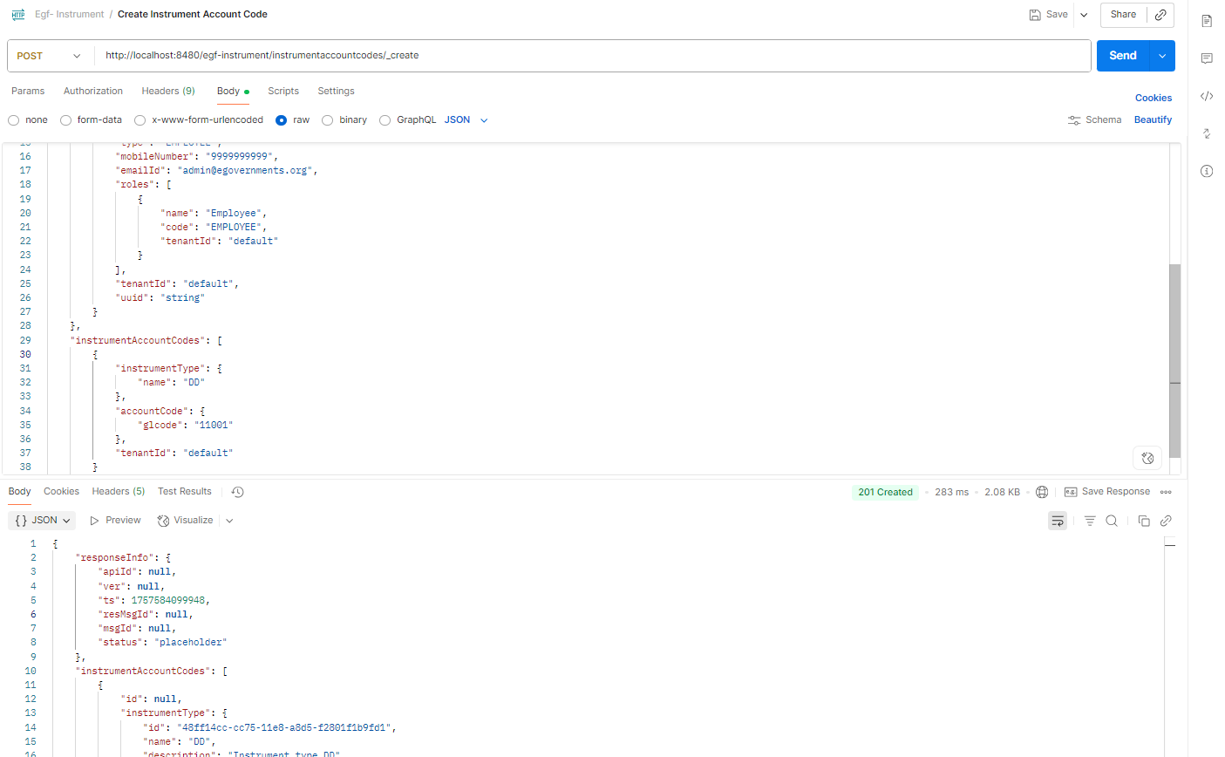
Update Instrument Account Code
curl --location 'http://localhost:8480/egf-instrument/instrumentaccountcodes/_update' \
--header 'Content-Type: application/json' \
--data-raw '{
"RequestInfo": {
"apiId": "Rainmaker",
"ver": ".01",
"ts": "01-01-2017 12:00:00",
"action": "_update",
"did": "1",
"key": "",
"msgId": "20170310130900|en_IN",
"authToken": "your-auth-token-here",
"userInfo": {
"id": 1,
"userName": "admin",
"name": "Administrator",
"type": "EMPLOYEE",
"mobileNumber": "9999999999",
"emailId": "admin@egovernments.org",
"roles": [
{
"name": "Employee",
"code": "EMPLOYEE",
"tenantId": "default"
}
],
"tenantId": "default",
"uuid": "string"
}
},
"instrumentAccountCodes": [
{
"id": "ef8e5365c10348659151405e3c4ad510",
"instrumentType": {
"id": "48ff14cc-cc75-11e8-a8d5-f2801f1b9fd1",
"name": "DD"
},
"accountCode": {
"glcode": "11001"
},
"tenantId": "default"
}
]
}'
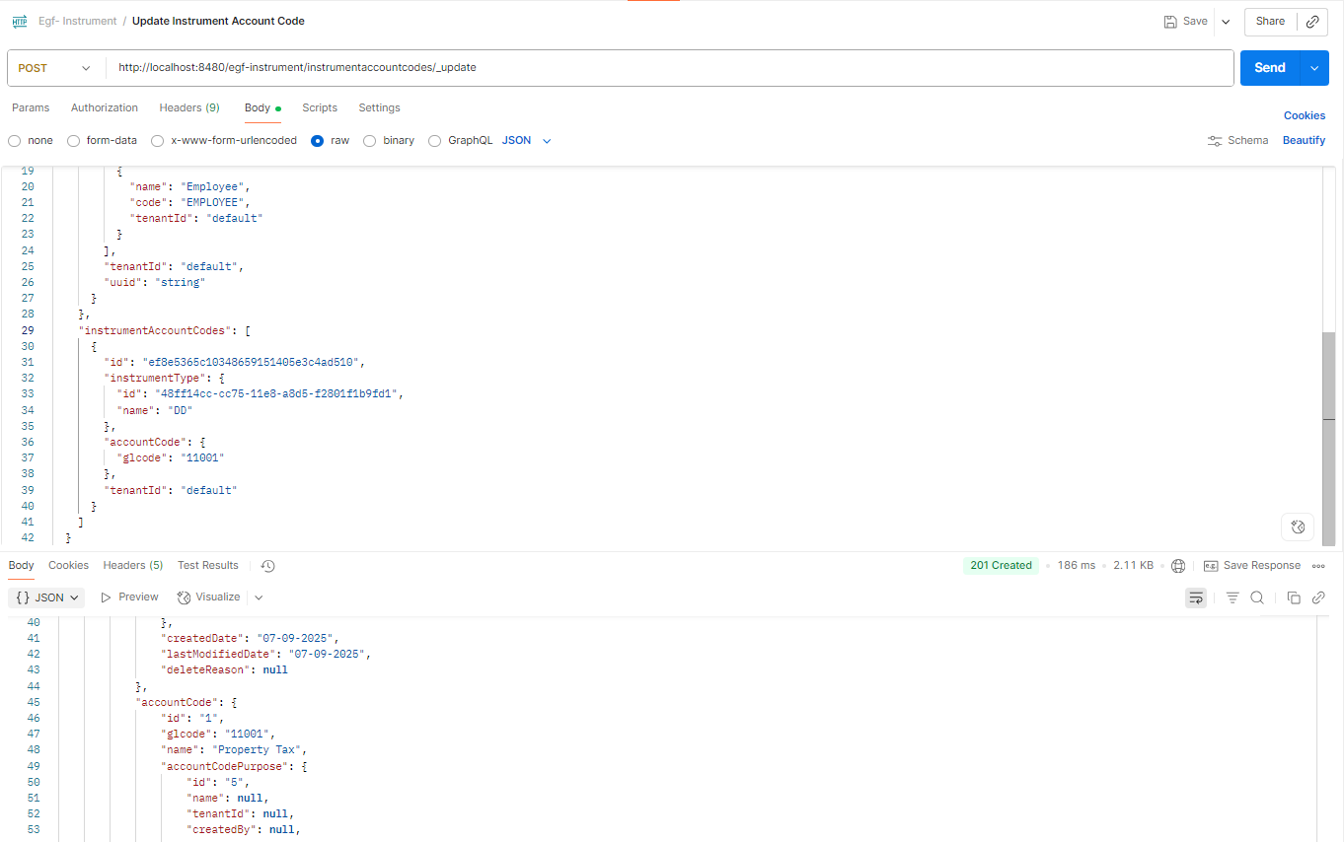
Search Instrument Account Code
curl --location 'http://localhost:8480/egf-instrument/instrumentaccountcodes/_search?tenantId=default' \
--header 'Content-Type: application/json' \
--data-raw '{
"RequestInfo": {
"apiId": "Rainmaker",
"ver": ".01",
"ts": "01-01-2017 12:00:00",
"action": "_search",
"did": "1",
"key": "",
"msgId": "20170310130900|en_IN",
"authToken": "your-auth-token-here",
"userInfo": {
"id": 1,
"userName": "admin",
"name": "Administrator",
"type": "EMPLOYEE",
"mobileNumber": "9999999999",
"emailId": "admin@egovernments.org",
"roles": [
{
"name": "Employee",
"code": "EMPLOYEE",
"tenantId": "default"
}
],
"tenantId": "default",
"uuid": "string"
}
}
}'
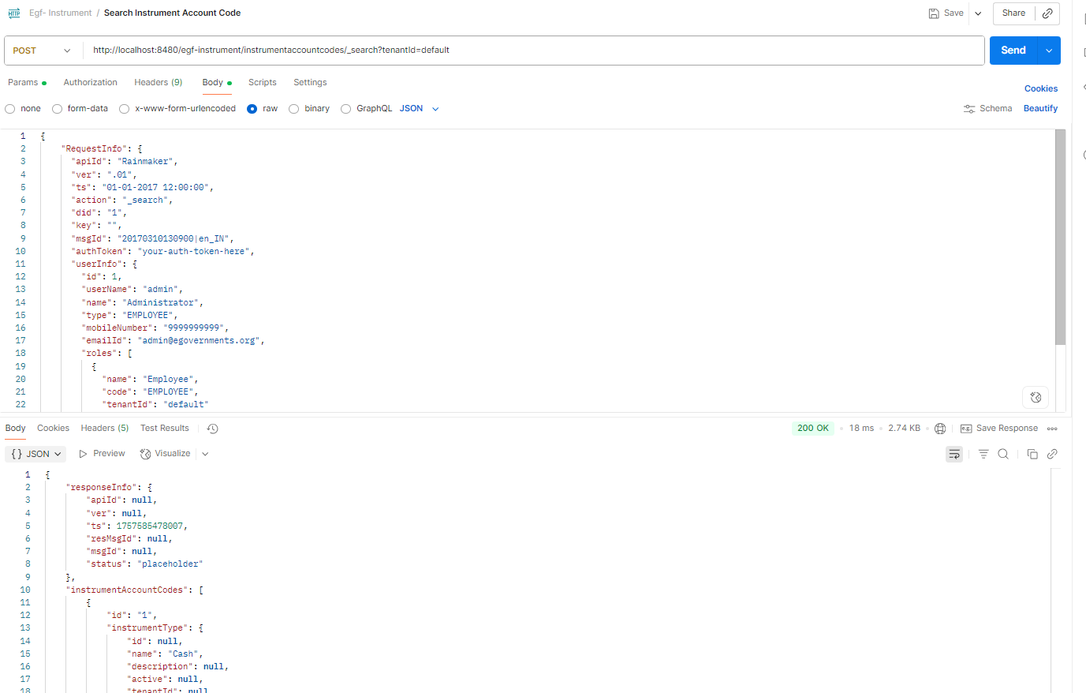

Delete Instrument Account Code
curl --location 'http://localhost:8480/egf-instrument/instrumentaccountcodes/_delete' \
--header 'Content-Type: application/json' \
--data-raw '{
"RequestInfo": {
"apiId": "Rainmaker",
"ver": ".01",
"ts": "01-01-2017 12:00:00",
"action": "_delete",
"did": "1",
"key": "",
"msgId": "20170310130900|en_IN",
"authToken": "your-auth-token-here",
"userInfo": {
"id": 1,
"userName": "admin",
"name": "Administrator",
"type": "EMPLOYEE",
"mobileNumber": "9999999999",
"emailId": "admin@egovernments.org",
"roles": [
{
"name": "Employee",
"code": "EMPLOYEE",
"tenantId": "default"
}
],
"tenantId": "default",
"uuid": "string"
}
},
"instrumentAccountCodes": [
{
"id": "ef8e5365c10348659151405e3c4ad510",
"instrumentType": {
"id": "48ff14cc-cc75-11e8-a8d5-f2801f1b9fd1",
"name": "DD"
},
"accountCode": {
"glcode": "11001"
},
"tenantId": "default"
}
]
}'
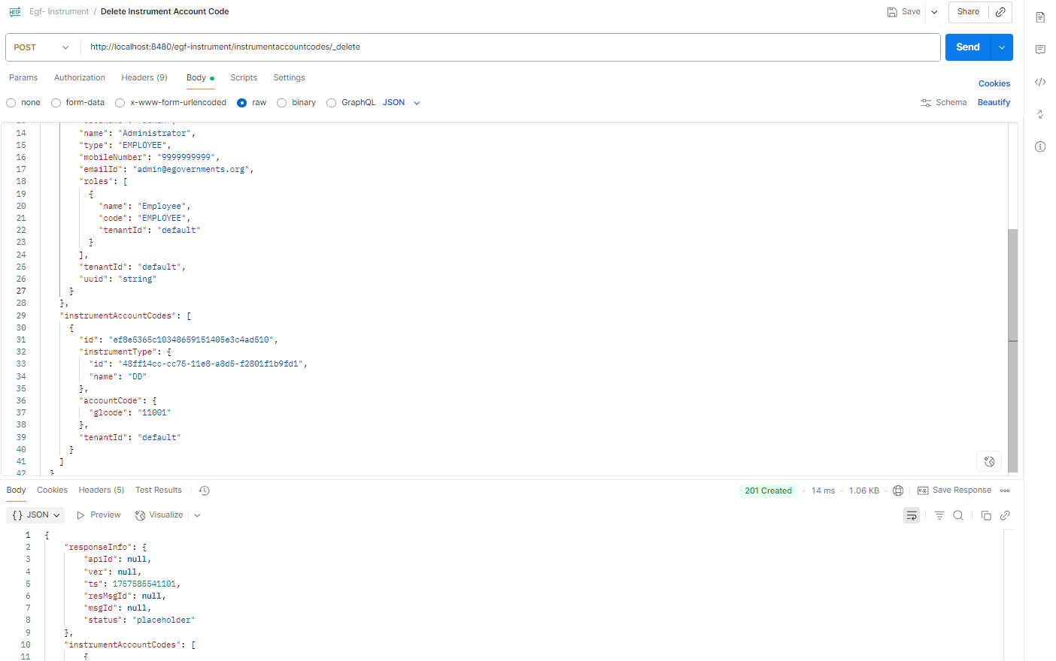

Create Surrender Reasons
curl --location 'http://localhost:8480/egf-instrument/surrenderreasons/_create' \
--header 'Content-Type: application/json' \
--data-raw '{
"RequestInfo": {
"apiId": "Rainmaker",
"ver": ".01",
"ts": "01-01-2017 12:00:00",
"action": "_create",
"did": "1",
"key": "",
"msgId": "20170310130900|en_IN",
"authToken": "your-auth-token-here",
"userInfo": {
"id": 1,
"userName": "admin",
"name": "Administrator",
"type": "EMPLOYEE",
"mobileNumber": "9999999999",
"emailId": "admin@egovernments.org",
"roles": [
{
"name": "Employee",
"code": "EMPLOYEE",
"tenantId": "default"
}
],
"tenantId": "default",
"uuid": "string"
}
},
"surrenderReasons": [
{
"name": "Damaged Cheque",
"description": "Cheque is physically damaged and cannot be processed",
"tenantId": "default"
}
]
}'
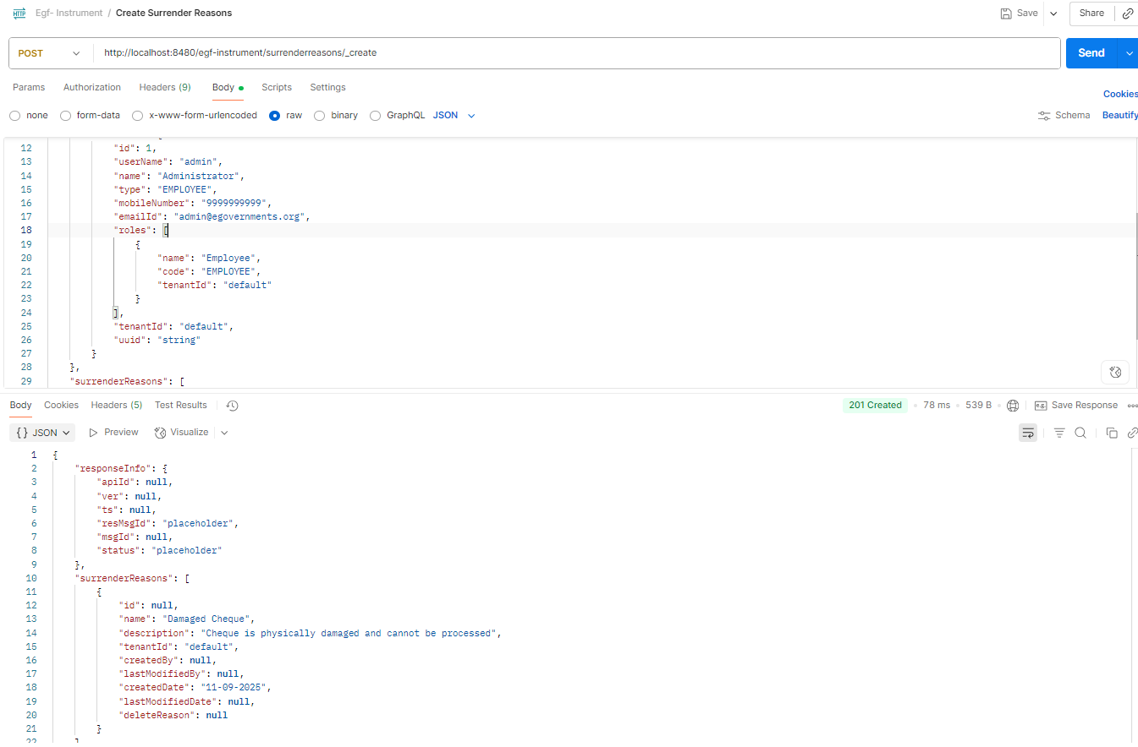

Update Surrender Reasons
curl --location 'http://localhost:8480/egf-instrument/surrenderreasons/_update' \
--header 'Content-Type: application/json' \
--data-raw '{
"RequestInfo": {
"apiId": "Rainmaker",
"ver": ".01",
"ts": "01-01-2017 12:00:00",
"action": "_update",
"did": "1",
"key": "",
"msgId": "20170310130900|en_IN",
"authToken": "your-auth-token-here",
"userInfo": {
"id": 1,
"userName": "admin",
"name": "Administrator",
"type": "EMPLOYEE",
"mobileNumber": "9999999999",
"emailId": "admin@egovernments.org",
"roles": [
{
"name": "Employee",
"code": "EMPLOYEE",
"tenantId": "default"
}
],
"tenantId": "default",
"uuid": "string"
}
},
"surrenderReasons": [
{
"id": "cf7651e5d15a4e6e9fa02e78551647d1",
"name": "Damaged Cheque Updated",
"description": "Updated description for damaged cheque that cannot be processed",
"tenantId": "default"
}
]
}'
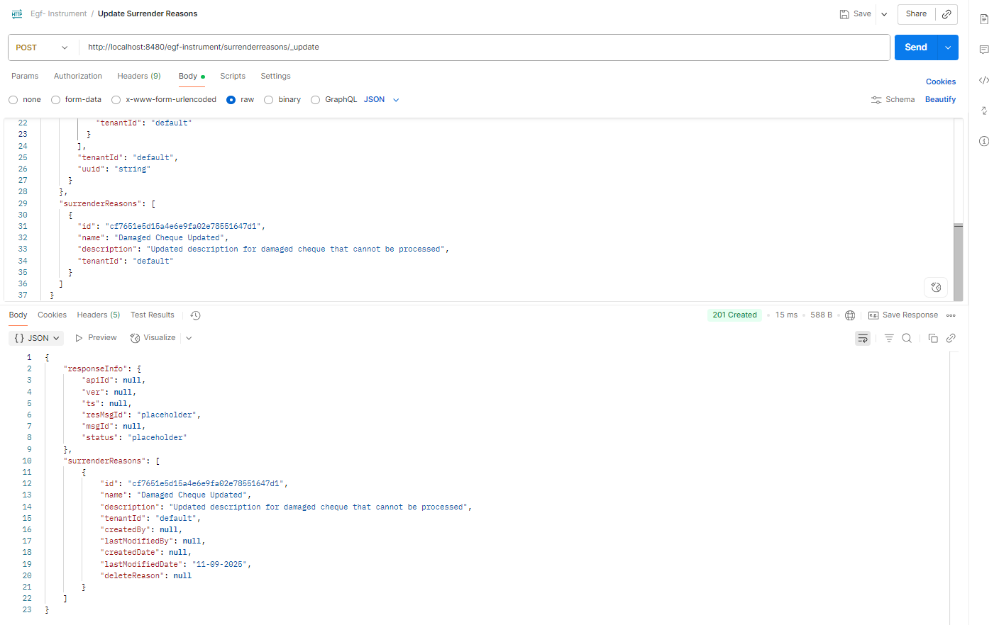
Search Surrender Reasons
curl --location 'http://localhost:8480/egf-instrument/surrenderreasons/_search?tenantId=default&pageSize=10&offset=0' \
--header 'Content-Type: application/json' \
--data-raw '{
"RequestInfo": {
"apiId": "Rainmaker",
"ver": ".01",
"ts": "01-01-2017 12:00:00",
"action": "_search",
"did": "1",
"key": "",
"msgId": "20170310130900|en_IN",
"authToken": "your-auth-token-here",
"userInfo": {
"id": 1,
"userName": "admin",
"name": "Administrator",
"type": "EMPLOYEE",
"mobileNumber": "9999999999",
"emailId": "admin@egovernments.org",
"roles": [
{
"name": "Employee",
"code": "EMPLOYEE",
"tenantId": "default"
}
],
"tenantId": "default",
"uuid": "string"
}
}
}'
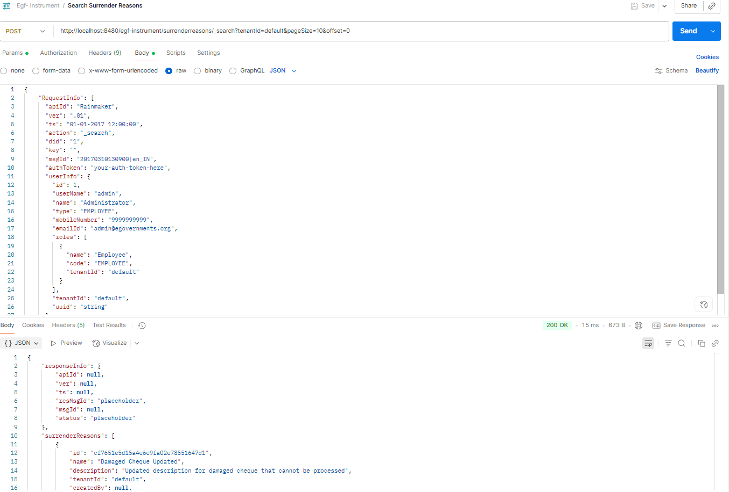
Delete Surrender Reasons
curl --location 'http://localhost:8480/egf-instrument/surrenderreasons/_delete' \
--header 'Content-Type: application/json' \
--data-raw '{
"RequestInfo": {
"apiId": "Rainmaker",
"ver": ".01",
"ts": "01-01-2017 12:00:00",
"action": "_delete",
"did": "1",
"key": "",
"msgId": "20170310130900|en_IN",
"authToken": "your-auth-token-here",
"userInfo": {
"id": 1,
"userName": "admin",
"name": "Administrator",
"type": "EMPLOYEE",
"mobileNumber": "9999999999",
"emailId": "admin@egovernments.org",
"roles": [
{
"name": "Employee",
"code": "EMPLOYEE",
"tenantId": "default"
}
],
"tenantId": "default",
"uuid": "string"
}
},
"surrenderReasons": [
{
"id": "cf7651e5d15a4e6e9fa02e78551647d1",
"tenantId": "default"
}
]
}'
