Overview
- Service Name: Apportion Service
- Upgrade Date: 25 July 2025
- Performed By: Parvesh Mishra NUDM Team

curl --location 'http://localhost:8280/egf-master/accountcodepurposes/_search?tenantId=pg.citya' \
--header 'Content-Type: application/json' \
--data '{
"requestInfo": {
"apiId": "string",
"ver": "string",
"ts": 0,
"action": "string",
"did": "string",
"key": "string",
"msgId": "string",
"authToken": "string",
"correlationId": "string",
"plainAccessRequest": {
"recordId": "string",
"plainRequestFields": [
"string"
]
},
"userInfo": {
"id": 0,
"userName": "string",
"name": "string",
"type": "string",
"mobileNumber": "string",
"emailId": "string",
"roles": [
{
"id": 0,
"name": "string",
"code": "string",
"tenantId": "string"
}
],
"tenantId": "string",
"uuid": "string"
}
},
"suppliers": [
{
"id": "string",
"code": "string",
"name": "string",
"address": "string",
"mobile": "string",
"email": "string",
"description": "string",
"active": true,
"panNo": "string",
"tinNo": "string",
"registationNo": "string",
"bankAccount": {
"id": "string",
"bankBranch": {
"id": "string",
"bank": {
"id": "string",
"code": "string",
"name": "string",
"description": "string",
"active": true,
"type": "string",
"tenantId": "string",
"createdBy": {
"id": 0,
"userName": "string",
"name": "string",
"type": "string",
"mobileNumber": "string",
"emailId": "string",
"roles": [
{
"id": 0,
"name": "string",
"code": "string",
"tenantId": "string"
}
],
"tenantId": "string",
"uuid": "string"
},
"lastModifiedBy": {
"id": 0,
"userName": "string",
"name": "string",
"type": "string",
"mobileNumber": "string",
"emailId": "string",
"roles": [
{
"id": 0,
"name": "string",
"code": "string",
"tenantId": "string"
}
],
"tenantId": "string",
"uuid": "string"
},
"createdDate": "2025-08-05T11:13:01.350Z",
"lastModifiedDate": "2025-08-05T11:13:01.350Z",
"deleteReason": "string"
},
"code": "string",
"name": "TeGRODNrWJlEb__WcbCZRnviu9QeMXFUb4ytbnxelWwiLd",
"address": "string",
"address2": "string",
"city": "string",
"state": "string",
"pincode": "string",
"phone": "string",
"fax": "string",
"contactPerson": "string",
"active": true,
"description": "string",
"micr": "string",
"tenantId": "string",
"createdBy": {
"id": 0,
"userName": "string",
"name": "string",
"type": "string",
"mobileNumber": "string",
"emailId": "string",
"roles": [
{
"id": 0,
"name": "string",
"code": "string",
"tenantId": "string"
}
],
"tenantId": "string",
"uuid": "string"
},
"lastModifiedBy": {
"id": 0,
"userName": "string",
"name": "string",
"type": "string",
"mobileNumber": "string",
"emailId": "string",
"roles": [
{
"id": 0,
"name": "string",
"code": "string",
"tenantId": "string"
}
],
"tenantId": "string",
"uuid": "string"
},
"createdDate": "2025-08-05T11:13:01.350Z",
"lastModifiedDate": "2025-08-05T11:13:01.350Z",
"deleteReason": "string"
},
"chartOfAccount": {
"id": "string",
"glcode": "string",
"name": "string",
"accountCodePurpose": {
"id": "string",
"name": "string",
"tenantId": "string",
"createdBy": {
"id": 0,
"userName": "string",
"name": "string",
"type": "string",
"mobileNumber": "string",
"emailId": "string",
"roles": [
{
"id": 0,
"name": "string",
"code": "string",
"tenantId": "string"
}
],
"tenantId": "string",
"uuid": "string"
},
"lastModifiedBy": {
"id": 0,
"userName": "string",
"name": "string",
"type": "string",
"mobileNumber": "string",
"emailId": "string",
"roles": [
{
"id": 0,
"name": "string",
"code": "string",
"tenantId": "string"
}
],
"tenantId": "string",
"uuid": "string"
},
"createdDate": "2025-08-05T11:13:01.350Z",
"lastModifiedDate": "2025-08-05T11:13:01.350Z",
"deleteReason": "string"
},
"description": "string",
"isActiveForPosting": true,
"parentId": "string",
"type": "string",
"classification": 0,
"functionRequired": true,
"budgetCheckRequired": true,
"majorCode": "string",
"isSubLedger": true,
"tenantId": "string",
"createdBy": {
"id": 0,
"userName": "string",
"name": "string",
"type": "string",
"mobileNumber": "string",
"emailId": "string",
"roles": [
{
"id": 0,
"name": "string",
"code": "string",
"tenantId": "string"
}
],
"tenantId": "string",
"uuid": "string"
},
"lastModifiedBy": {
"id": 0,
"userName": "string",
"name": "string",
"type": "string",
"mobileNumber": "string",
"emailId": "string",
"roles": [
{
"id": 0,
"name": "string",
"code": "string",
"tenantId": "string"
}
],
"tenantId": "string",
"uuid": "string"
},
"createdDate": "2025-08-05T11:13:01.350Z",
"lastModifiedDate": "2025-08-05T11:13:01.350Z",
"deleteReason": "string"
},
"fund": {
"tenantId": "string",
"createdBy": {
"id": 0,
"userName": "string",
"name": "string",
"type": "string",
"mobileNumber": "string",
"emailId": "string",
"roles": [
{
"id": 0,
"name": "string",
"code": "string",
"tenantId": "string"
}
],
"tenantId": "string",
"uuid": "string"
},
"lastModifiedBy": {
"id": 0,
"userName": "string",
"name": "string",
"type": "string",
"mobileNumber": "string",
"emailId": "string",
"roles": [
{
"id": 0,
"name": "string",
"code": "string",
"tenantId": "string"
}
],
"tenantId": "string",
"uuid": "string"
},
"createdDate": "2025-08-05T11:13:01.350Z",
"lastModifiedDate": "2025-08-05T11:13:01.350Z",
"deleteReason": "string",
"id": "string",
"name": "string",
"code": "string",
"identifier": "string",
"level": 0,
"parent": "string",
"active": true
},
"accountNumber": "string",
"accountType": "string",
"description": "string",
"active": true,
"payTo": "string",
"type": "RECEIPTS",
"tenantId": "string",
"createdBy": {
"id": 0,
"userName": "string",
"name": "string",
"type": "string",
"mobileNumber": "string",
"emailId": "string",
"roles": [
{
"id": 0,
"name": "string",
"code": "string",
"tenantId": "string"
}
],
"tenantId": "string",
"uuid": "string"
},
"lastModifiedBy": {
"id": 0,
"userName": "string",
"name": "string",
"type": "string",
"mobileNumber": "string",
"emailId": "string",
"roles": [
{
"id": 0,
"name": "string",
"code": "string",
"tenantId": "string"
}
],
"tenantId": "string",
"uuid": "string"
},
"createdDate": "2025-08-05T11:13:01.350Z",
"lastModifiedDate": "2025-08-05T11:13:01.350Z",
"deleteReason": "string"
},
"ifscCode": "string",
"bank": {
"id": "string",
"code": "string",
"name": "string",
"description": "string",
"active": true,
"type": "string",
"tenantId": "string",
"createdBy": {
"id": 0,
"userName": "string",
"name": "string",
"type": "string",
"mobileNumber": "string",
"emailId": "string",
"roles": [
{
"id": 0,
"name": "string",
"code": "string",
"tenantId": "string"
}
],
"tenantId": "string",
"uuid": "string"
},
"lastModifiedBy": {
"id": 0,
"userName": "string",
"name": "string",
"type": "string",
"mobileNumber": "string",
"emailId": "string",
"roles": [
{
"id": 0,
"name": "string",
"code": "string",
"tenantId": "string"
}
],
"tenantId": "string",
"uuid": "string"
},
"createdDate": "2025-08-05T11:13:01.350Z",
"lastModifiedDate": "2025-08-05T11:13:01.350Z",
"deleteReason": "string"
},
"tenantId": "string",
"createdBy": {
"id": 0,
"userName": "string",
"name": "string",
"type": "string",
"mobileNumber": "string",
"emailId": "string",
"roles": [
{
"id": 0,
"name": "string",
"code": "string",
"tenantId": "string"
}
],
"tenantId": "string",
"uuid": "string"
},
"lastModifiedBy": {
"id": 0,
"userName": "string",
"name": "string",
"type": "string",
"mobileNumber": "string",
"emailId": "string",
"roles": [
{
"id": 0,
"name": "string",
"code": "string",
"tenantId": "string"
}
],
"tenantId": "string",
"uuid": "string"
},
"createdDate": "2025-08-05T11:13:01.350Z",
"lastModifiedDate": "2025-08-05T11:13:01.350Z",
"deleteReason": "string"
}
]
}'

Note: localhost:8082 is locally & localhost:8090 is niuatt environment

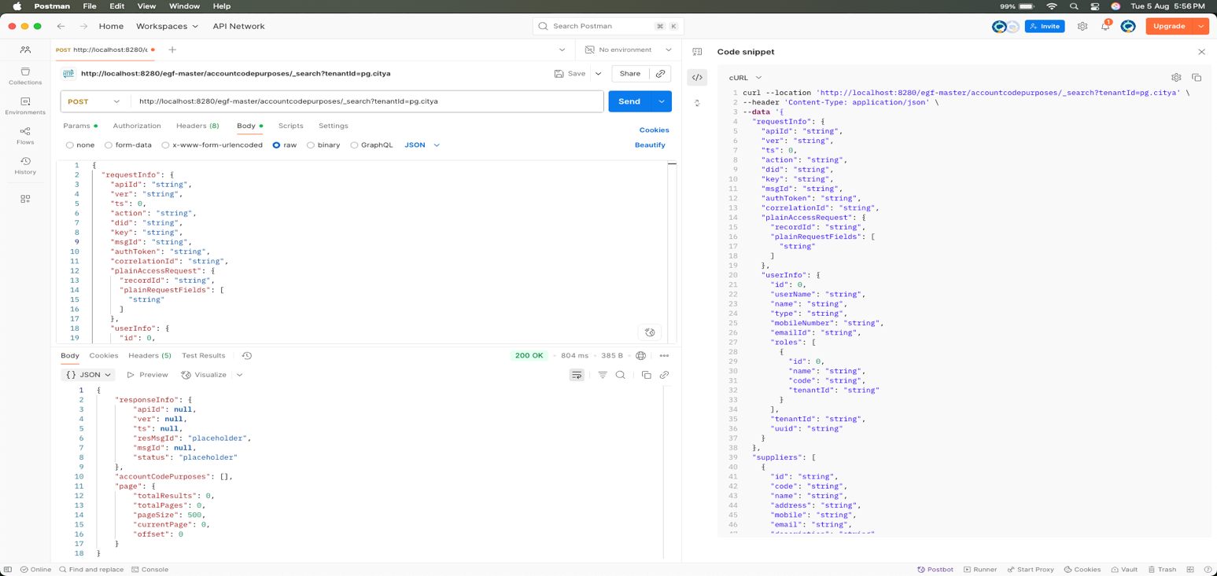

Response
{
"responseInfo": {
"apiId": null,
"ver": null,
"ts": null,
"resMsgId": "placeholder",
"msgId": null,
"status": "placeholder"
},
"accountCodePurposes": [],
"page": {
"totalResults": 0,
"totalPages": 0,
"pageSize": 500,
"currentPage": 0,
"offset": 0
}
}

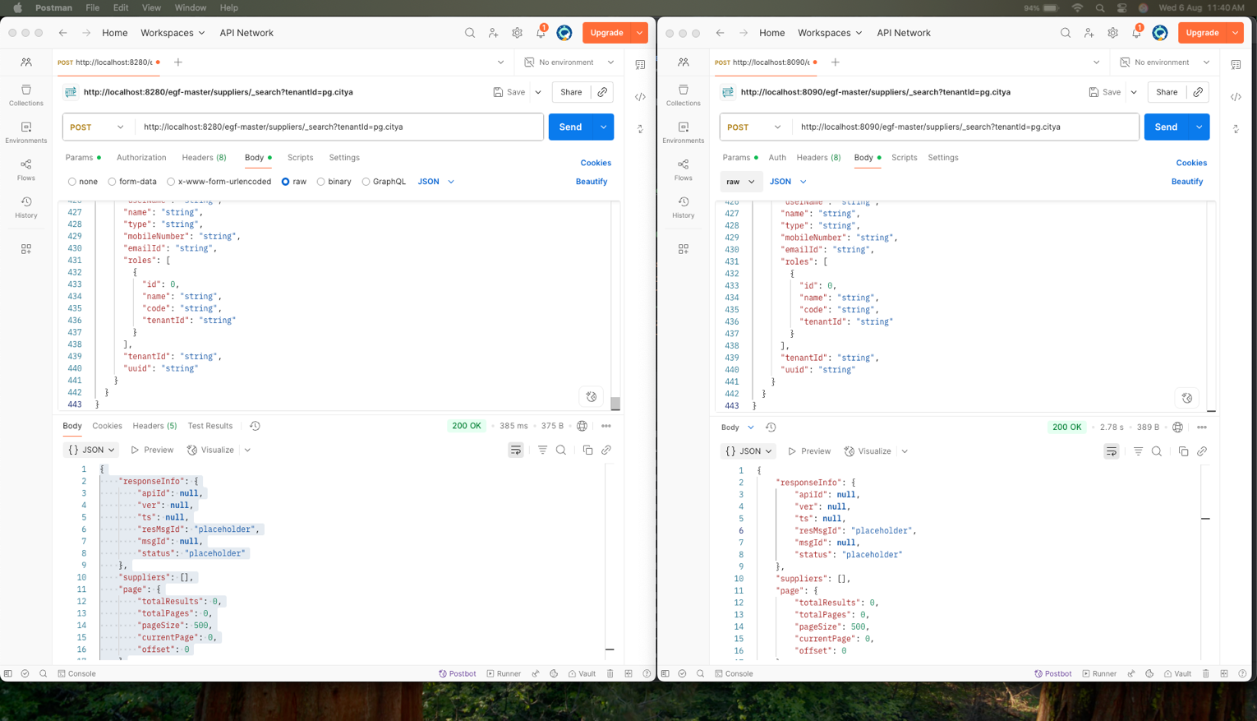

Response Compare

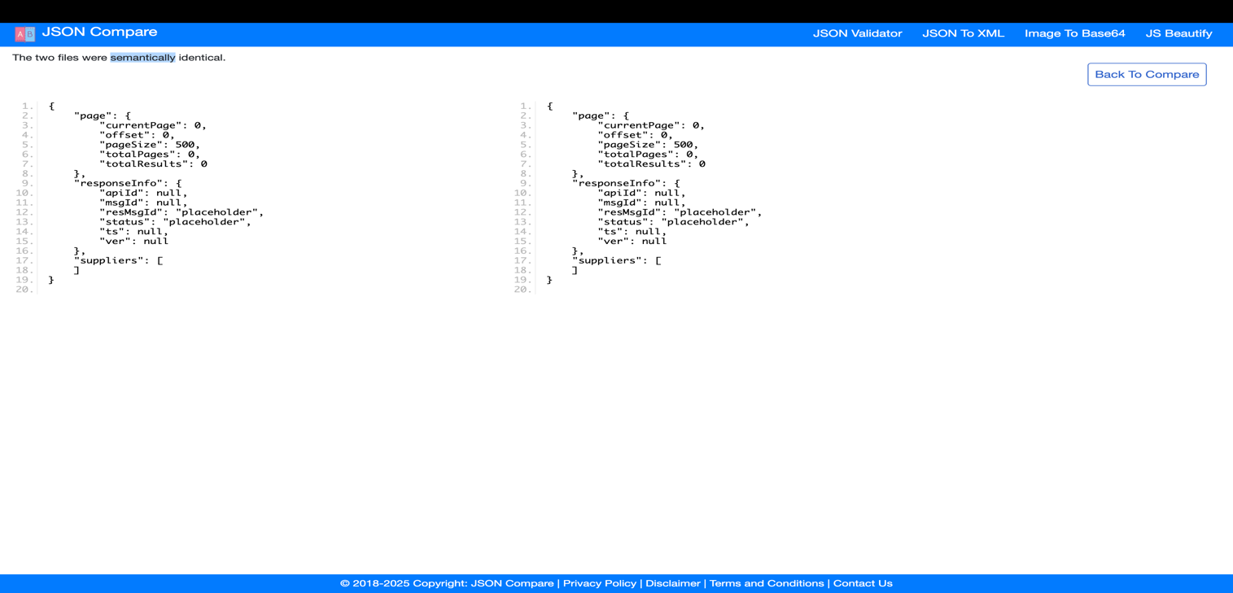

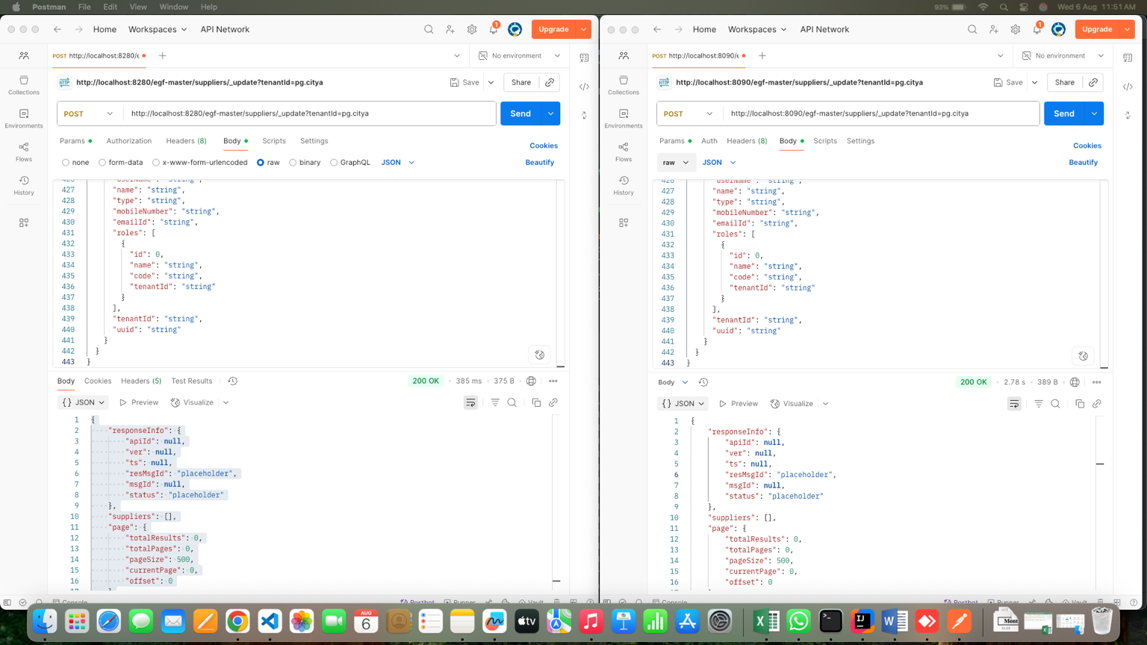

Response Compare

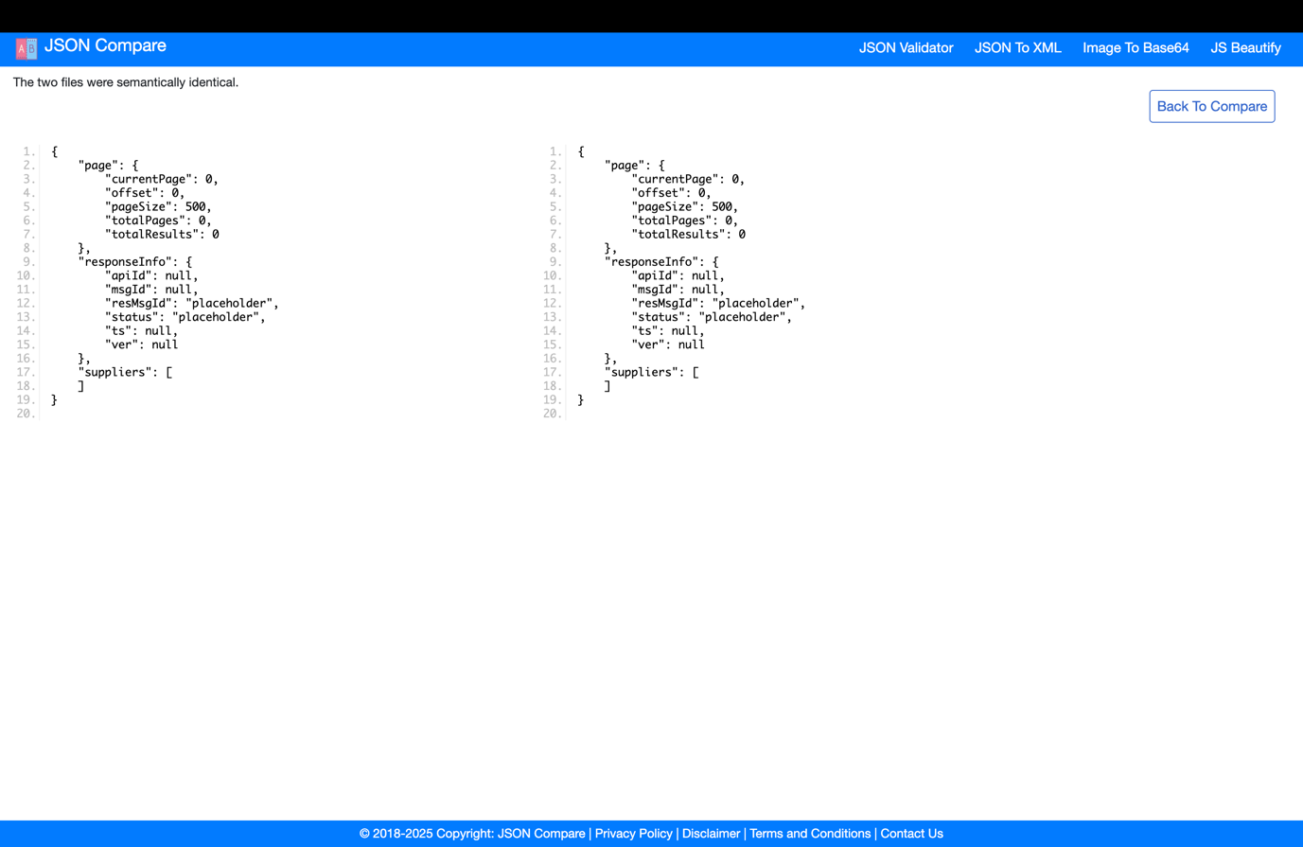

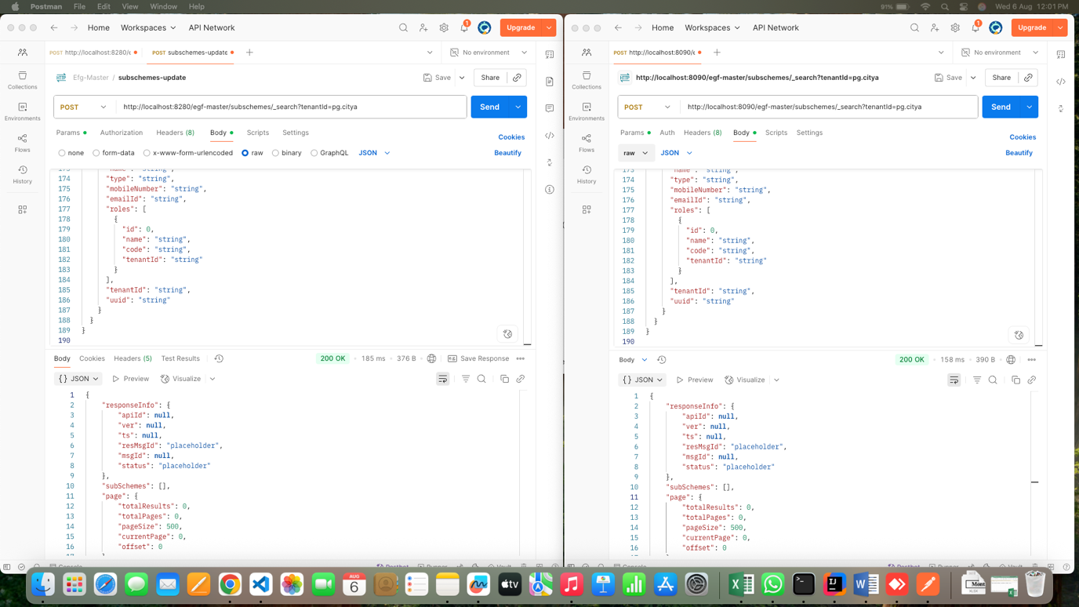

Respose Compare

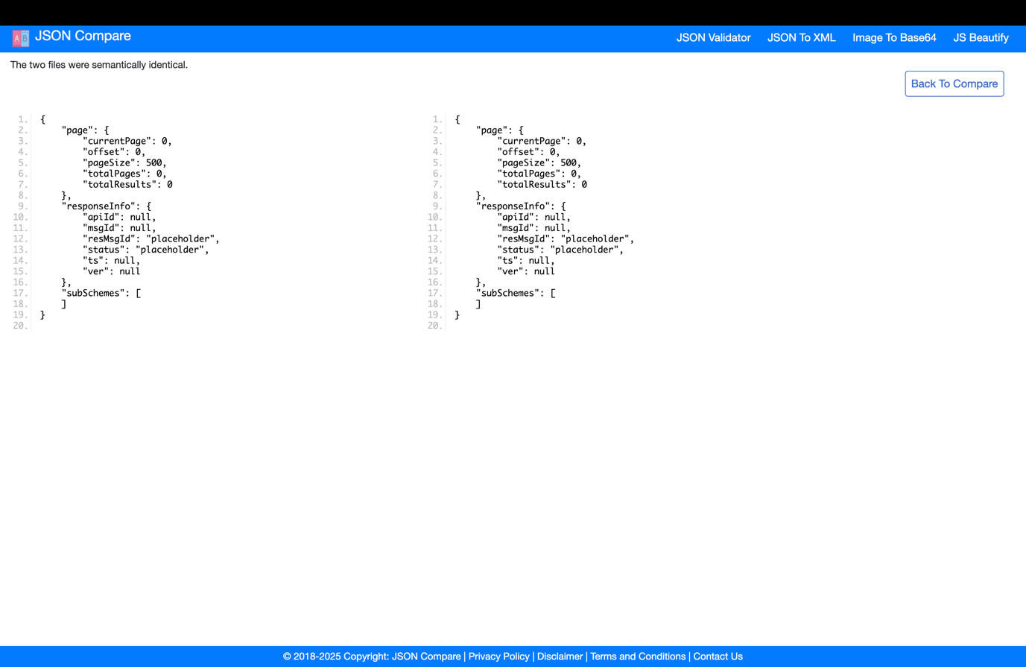

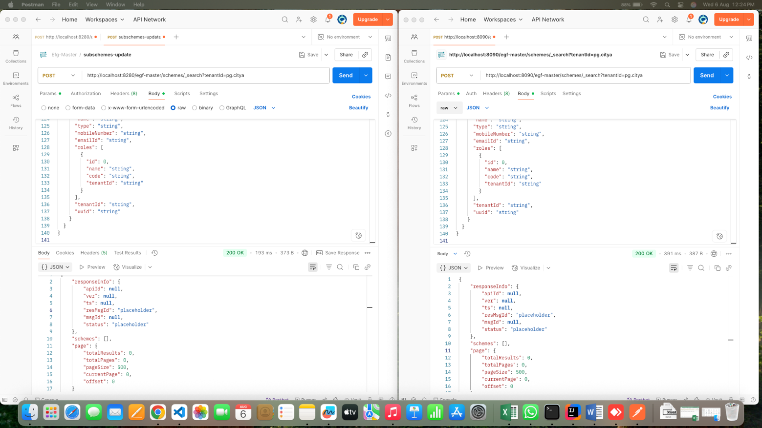

Response Compare

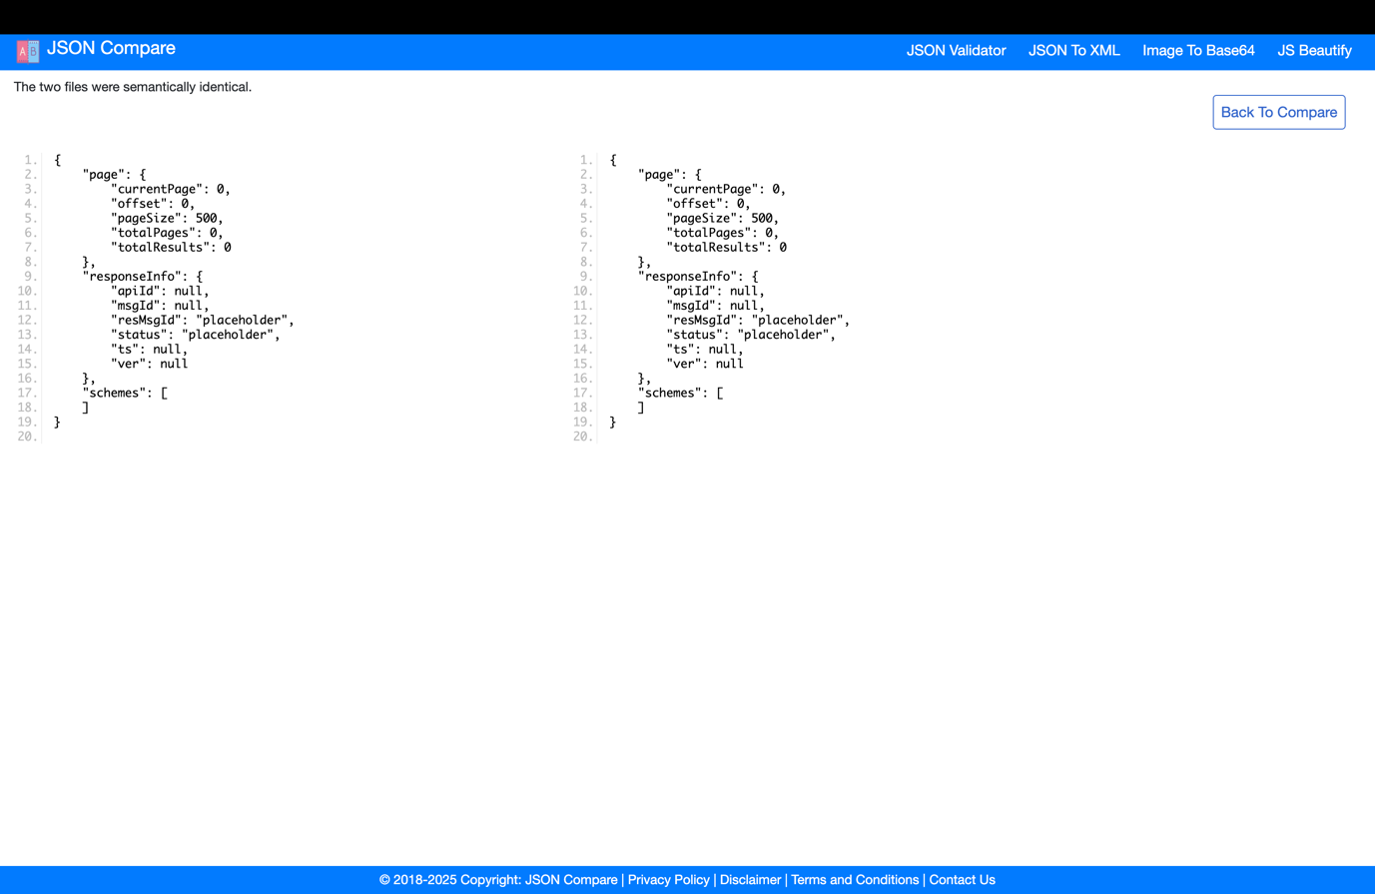

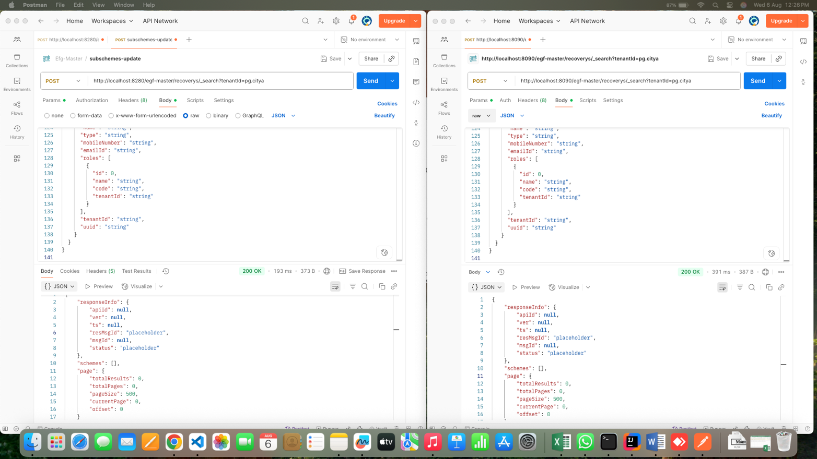

Response compare



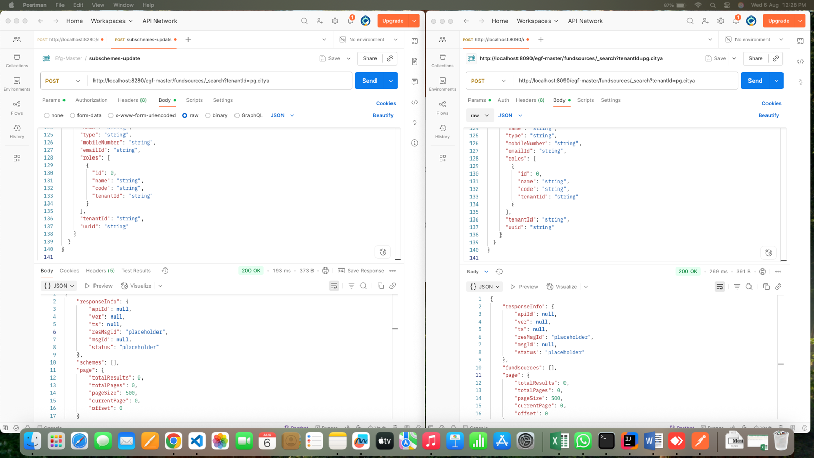

Response compare

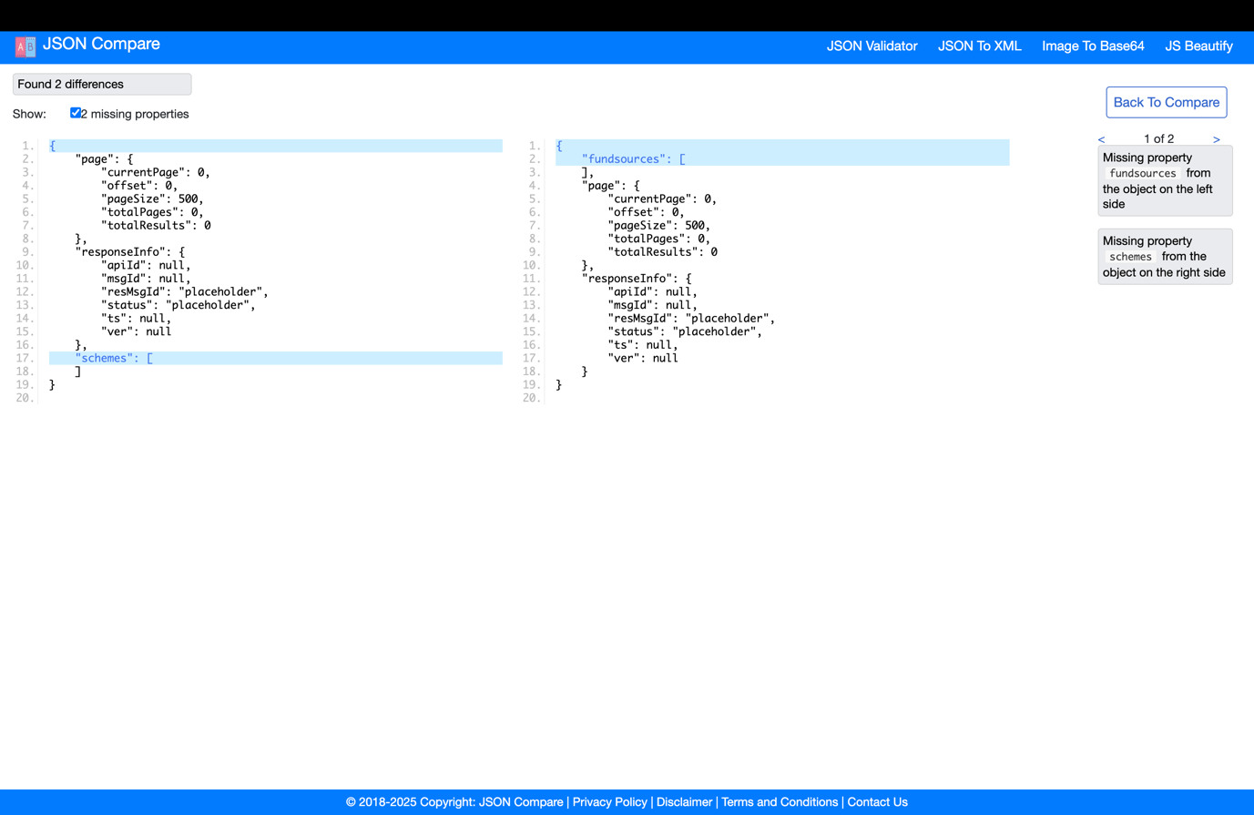

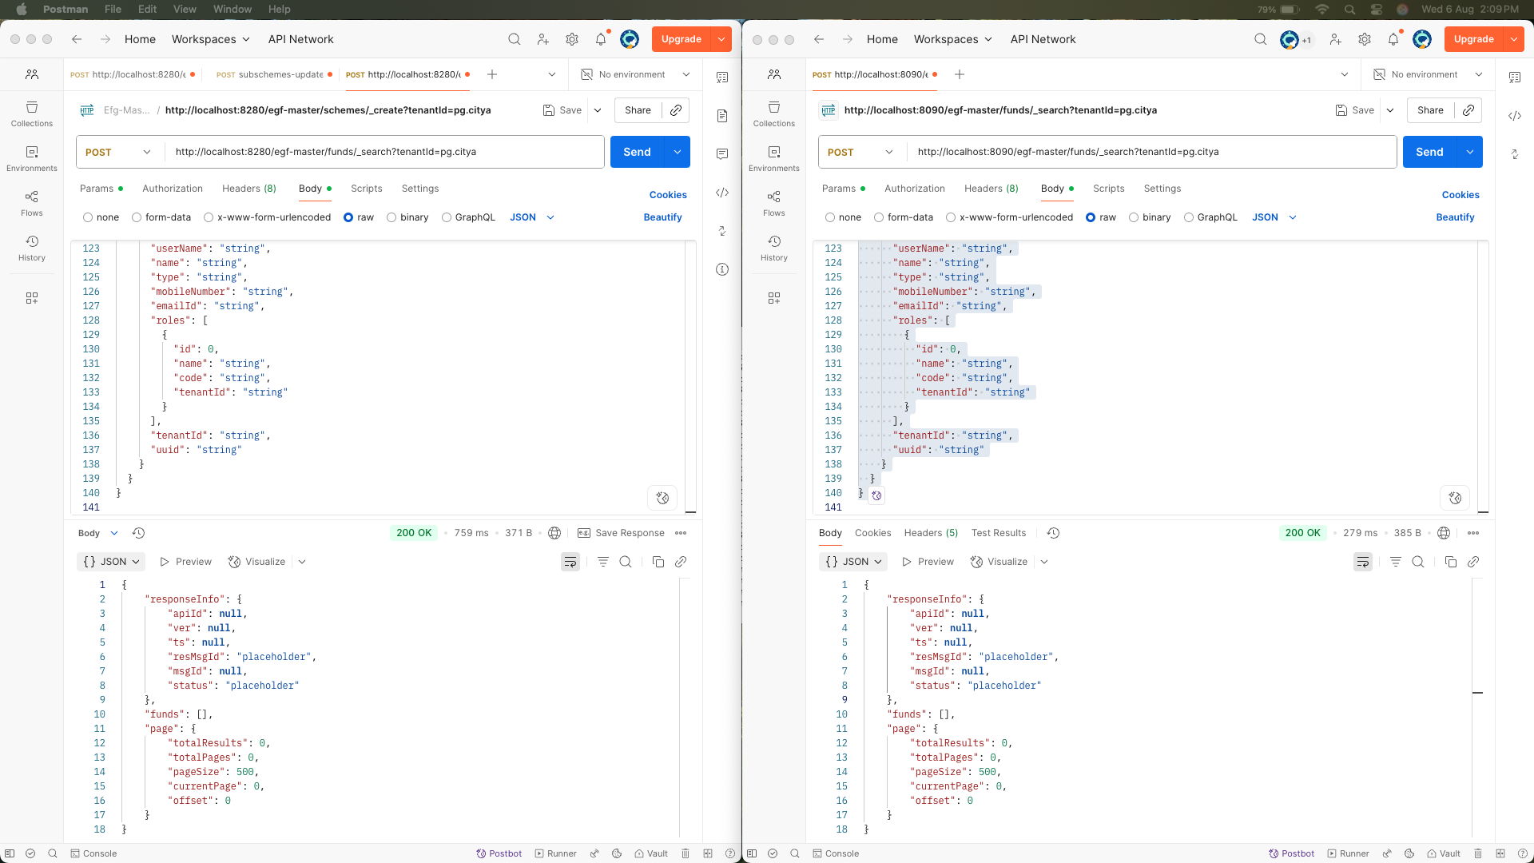

Response compare

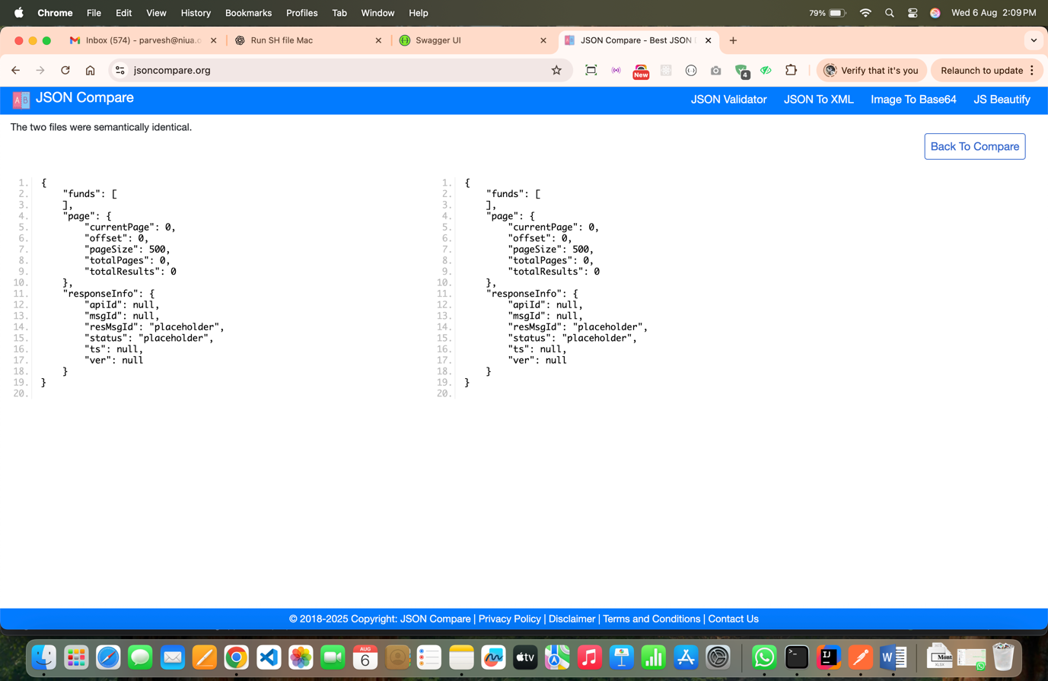

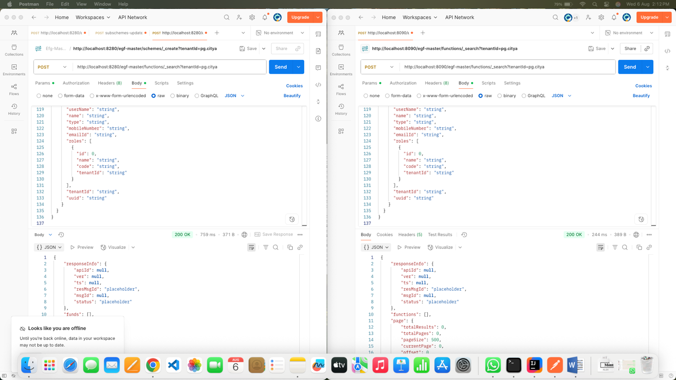

Response compare

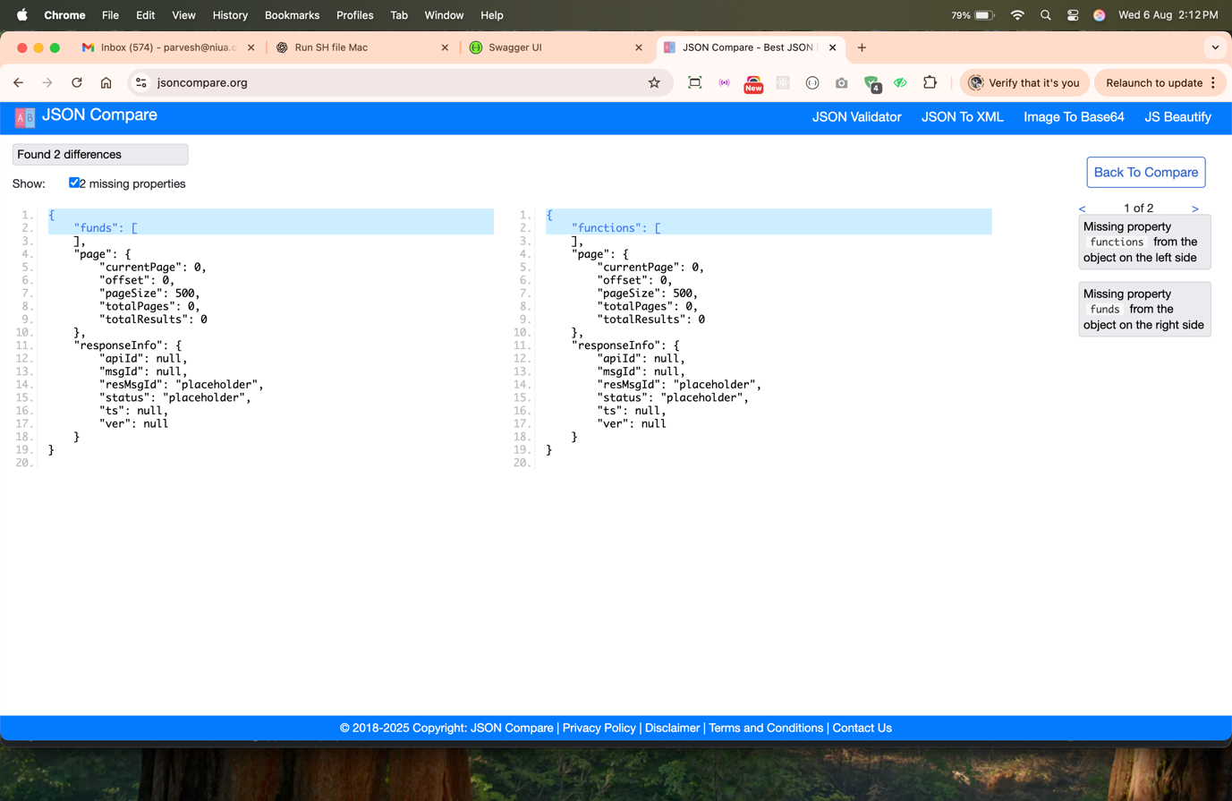

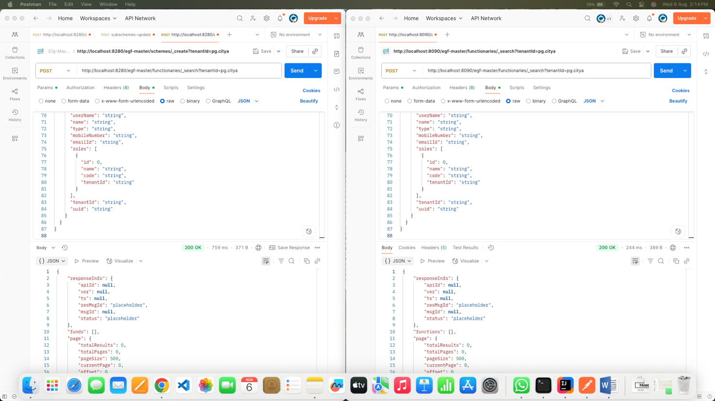

Response compare
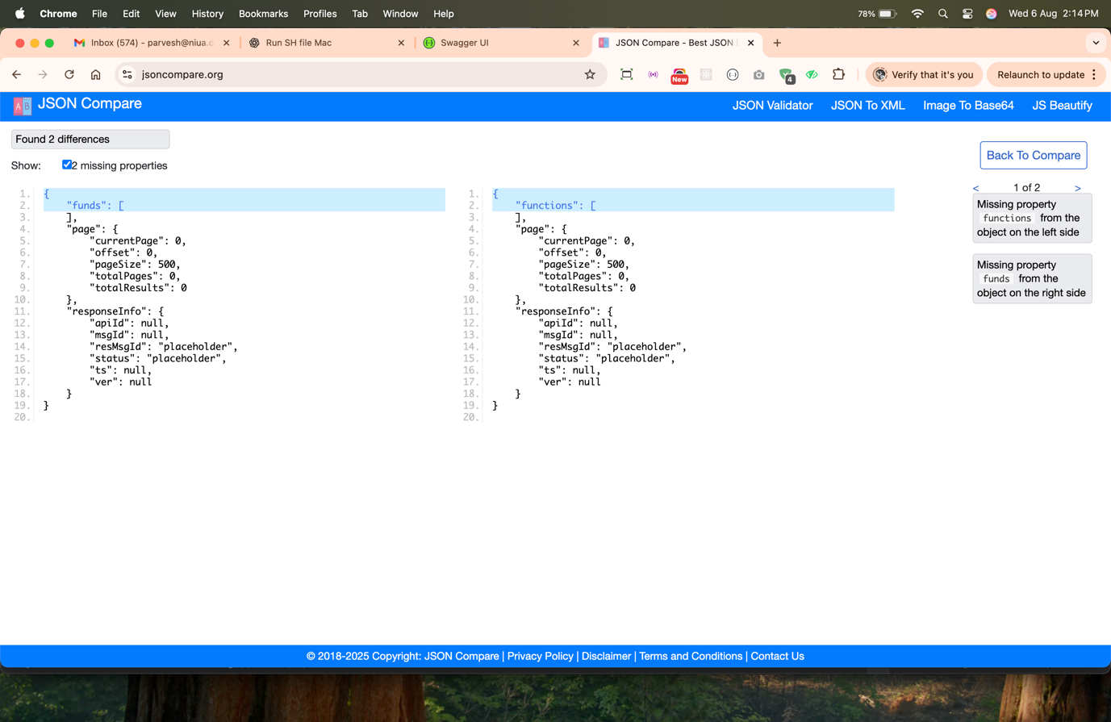

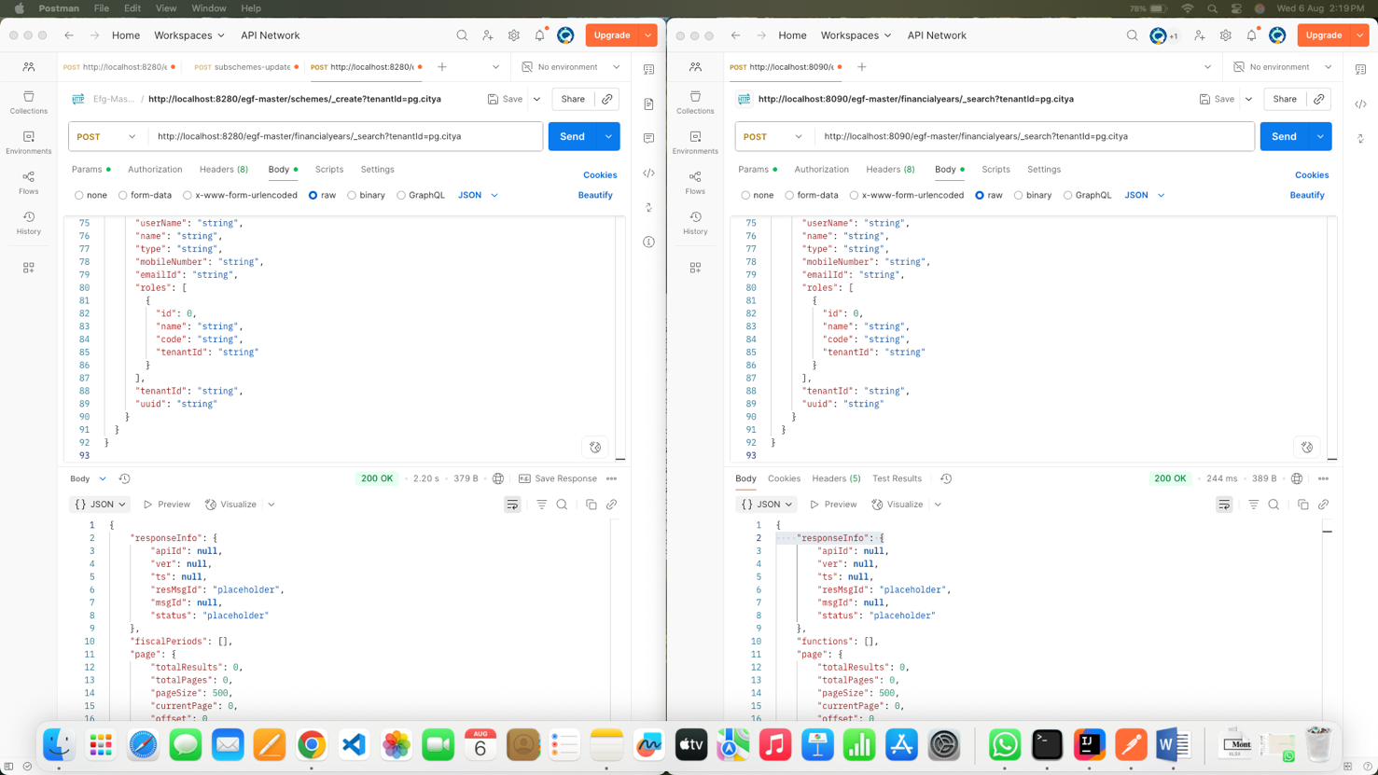

Response compare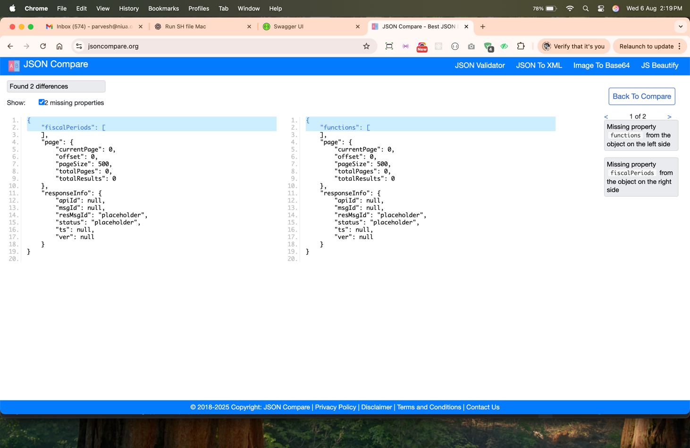

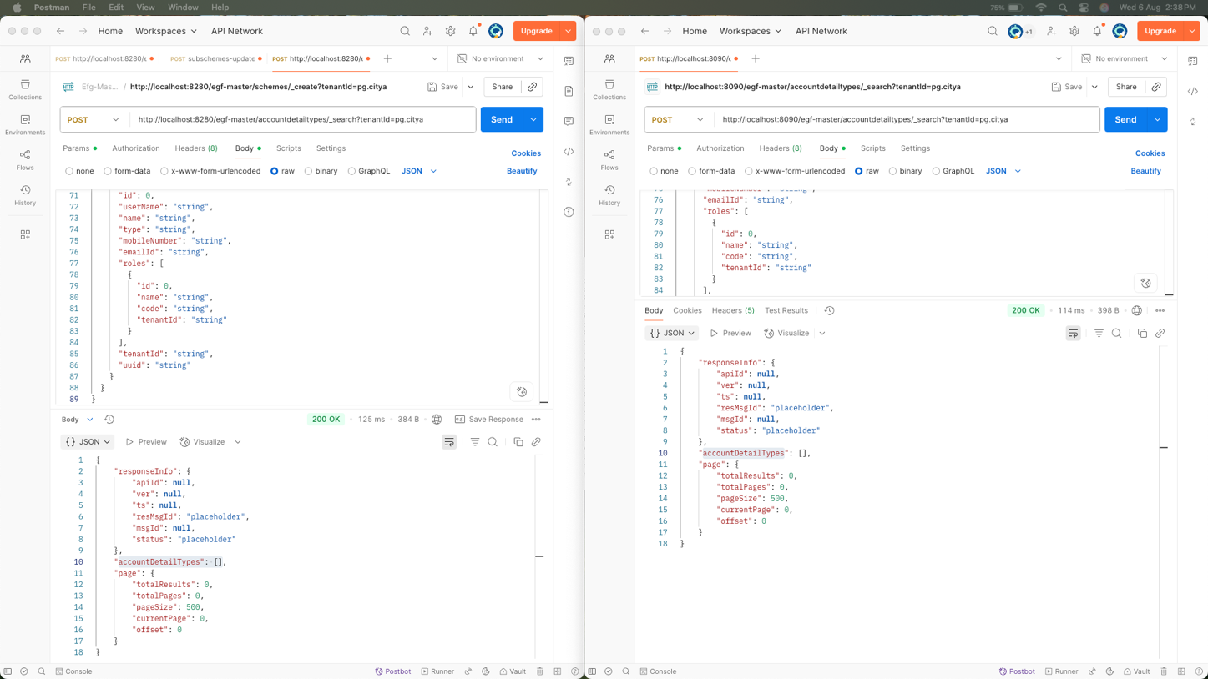

Response compare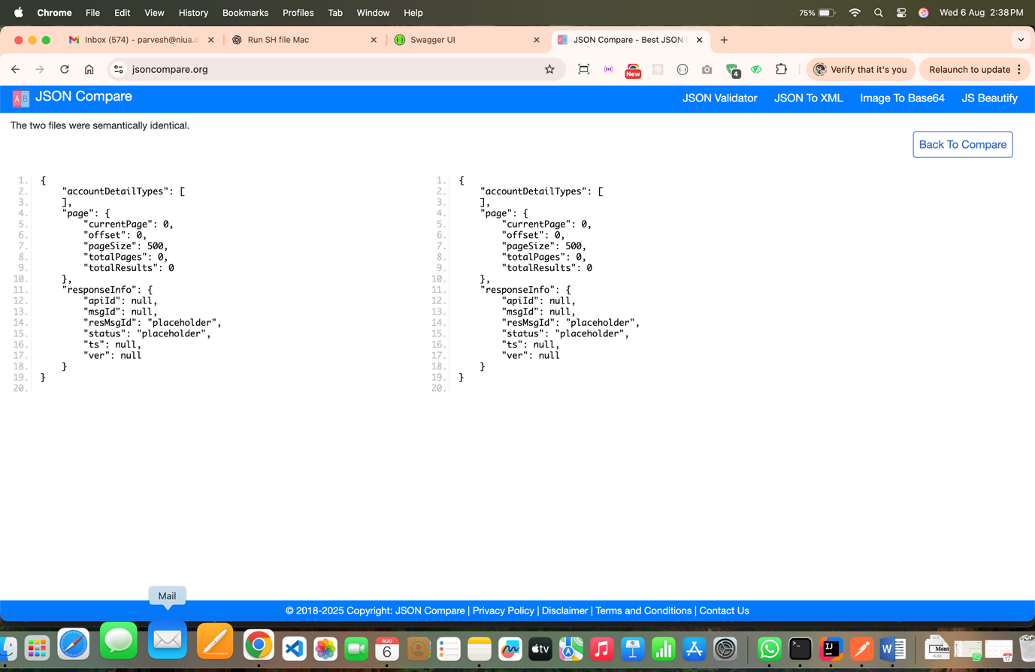

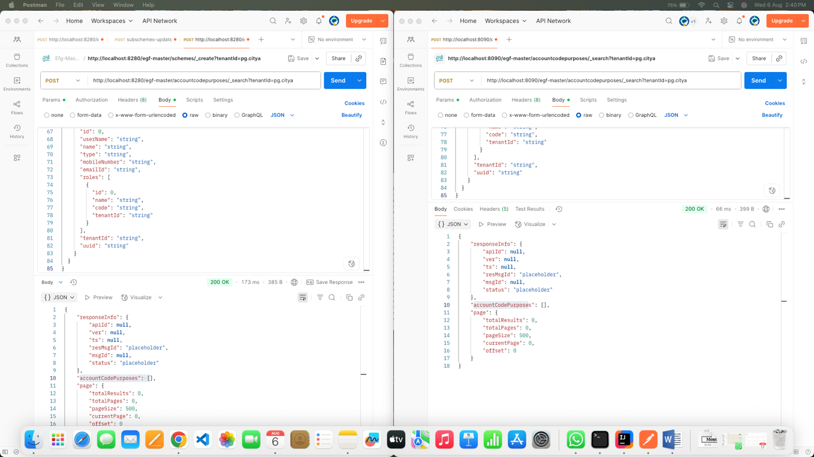

Response compare
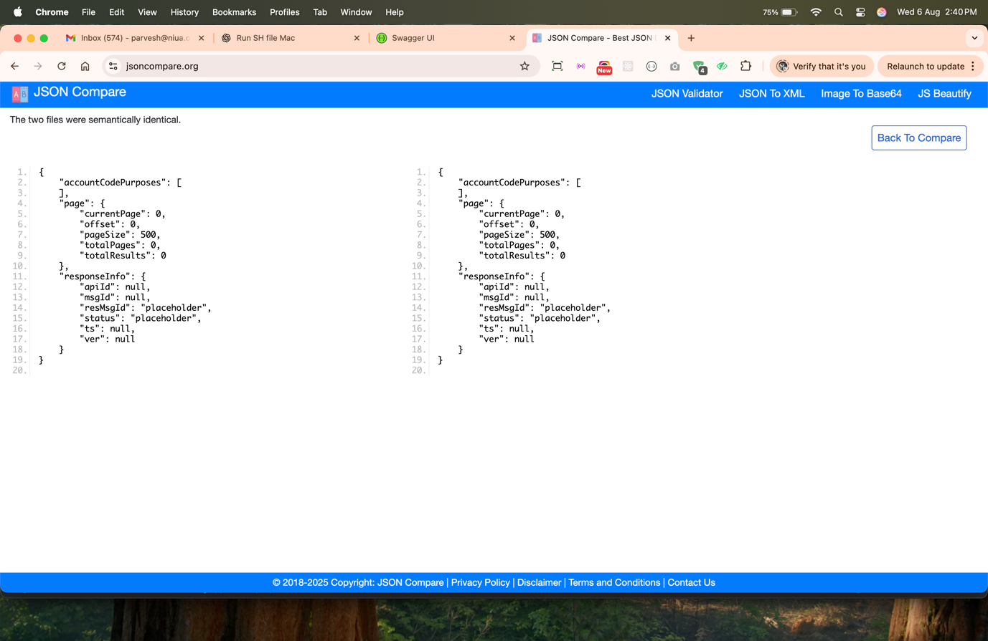

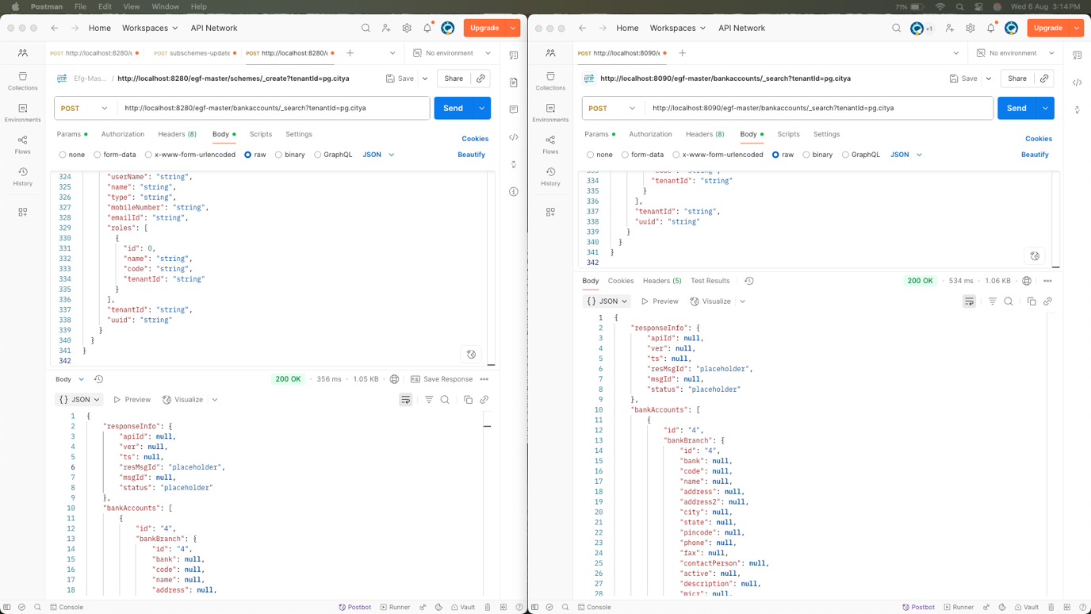

Response compare

