Overview
- Service Name: Apportion Service
- Upgrade Date: 25 July 2025
- Performed By: Parvesh Mishra NUDM Team

Supporting Evidence of Curl Request

curl --location 'http://localhost:8280/apportion-service/v2/bill/_apportion' \
--header 'Content-Type: application/json' \
--data '
{
"Bills": [
{
"additionalDetails": {
"array": true,
"bigDecimal": true,
"bigInteger": true,
"binary": true,
"boolean": true,
"containerNode": true,
"double": true,
"empty": true,
"float": true,
"floatingPointNumber": true,
"int": true,
"integralNumber": true,
"long": true,
"missingNode": true,
"nodeType": "ARRAY",
"null": true,
"number": true,
"object": true,
"pojo": true,
"short": true,
"textual": true,
"valueNode": true
},
"amountPaid": 0,
"auditDetails": {
"createdBy": "string",
"createdTime": 0,
"lastModifiedBy": "string",
"lastModifiedTime": 0
},
"billDate": 0,
"billDetails": [
{
"additionalDetails": {
"array": true,
"bigDecimal": true,
"bigInteger": true,
"binary": true,
"boolean": true,
"containerNode": true,
"double": true,
"empty": true,
"float": true,
"floatingPointNumber": true,
"int": true,
"integralNumber": true,
"long": true,
"missingNode": true,
"nodeType": "ARRAY",
"null": true,
"number": true,
"object": true,
"pojo": true,
"short": true,
"textual": true,
"valueNode": true
},
"amount": 0,
"amountPaid": 0,
"auditDetails": {
"createdBy": "string",
"createdTime": 0,
"lastModifiedBy": "string",
"lastModifiedTime": 0
},
"billAccountDetails": [
{
"additionalDetails": {
"array": true,
"bigDecimal": true,
"bigInteger": true,
"binary": true,
"boolean": true,
"containerNode": true,
"double": true,
"empty": true,
"float": true,
"floatingPointNumber": true,
"int": true,
"integralNumber": true,
"long": true,
"missingNode": true,
"nodeType": "ARRAY",
"null": true,
"number": true,
"object": true,
"pojo": true,
"short": true,
"textual": true,
"valueNode": true
},
"adjustedAmount": 0,
"amount": 0,
"auditDetails": {
"createdBy": "string",
"createdTime": 0,
"lastModifiedBy": "string",
"lastModifiedTime": 0
},
"billDetailId": "string",
"demandDetailId": "string",
"id": "string",
"isActualDemand": true,
"order": 0,
"purpose": "ARREAR",
"taxHeadCode": "string",
"tenantId": "string"
}
],
"billDescription": "string",
"billId": "string",
"boundary": "string",
"callBackForApportioning": true,
"cancellationRemarks": "string",
"channel": "string",
"collectedAmount": 0,
"demandId": "string",
"displayMessage": "string",
"expiryDate": 0,
"fromPeriod": 0,
"id": "string",
"manualReceiptDate": 0,
"manualReceiptNumber": "string",
"receiptDate": 0,
"receiptType": "string",
"tenantId": "string",
"toPeriod": 0,
"voucherHeader": "string"
}
],
"billNumber": "string",
"businessService": "string",
"collectionModesNotAllowed": [
"string"
],
"consumerCode": "string",
"id": "string",
"isAdvanceAllowed": true,
"isCancelled": true,
"minimumAmountToBePaid": 0,
"mobileNumber": "string",
"paidBy": "string",
"partPaymentAllowed": true,
"payerAddress": "string",
"payerEmail": "string",
"payerId": "string",
"payerName": "string",
"reasonForCancellation": "string",
"status": "ACTIVE",
"tenantId": "string",
"totalAmount": 0
}
],
"RequestInfo": {
"apiId": "Rainmaker",
"ver": ".01",
"ts": null,
"action": "_update",
"did": "1",
"key": "",
"msgId": "20170310130900|en_IN",
"authToken": "8ee8f02a-a4bf-41a9-9d62-f573041cfb19",
"correlationId": null,
"userInfo": {
"id": 73,
"userName": null,
"name": null,
"type": "EMPLOYEE",
"mobileNumber": null,
"emailId": null,
"roles": [
{
"id": 2,
"name": "Customer Support Representative",
"code": null,
"tenantId": null
}
],
"tenantId": "pg.citya",
"uuid": "uuid"
}
},
"tenantId": "pg.citya"
}'

Response:
{
"ResponseInfo": {
"apiId": "Rainmaker",
"ver": ".01",
"ts": null,
"resMsgId": "uief87324",
"msgId": "20170310130900|en_IN",
"status": "successful"
},
"tenantId": "pg.citya",
"Bills": [
{
"id": "string",
"mobileNumber": "string",
"paidBy": "string",
"payerName": "string",
"payerAddress": "string",
"payerEmail": "string",
"payerId": "string",
"status": "ACTIVE",
"reasonForCancellation": "string",
"isCancelled": true,
"additionalDetails": {
"array": true,
"bigDecimal": true,
"bigInteger": true,
"binary": true,
"boolean": true,
"containerNode": true,
"double": true,
"empty": true,
"float": true,
"floatingPointNumber": true,
"int": true,
"integralNumber": true,
"long": true,
"missingNode": true,
"nodeType": "ARRAY",
"null": true,
"number": true,
"object": true,
"pojo": true,
"short": true,
"textual": true,
"valueNode": true
},
"billDetails": [
{
"billDescription": "string",
"displayMessage": "string",
"callBackForApportioning": true,
"cancellationRemarks": "string",
"id": "string",
"tenantId": "string",
"demandId": "string",
"billId": "string",
"amount": 0,
"amountPaid": 0,
"fromPeriod": 0,
"toPeriod": 0,
"collectedAmount": 0,
"additionalDetails": {
"array": true,
"bigDecimal": true,
"bigInteger": true,
"binary": true,
"boolean": true,
"containerNode": true,
"double": true,
"empty": true,
"float": true,
"floatingPointNumber": true,
"int": true,
"integralNumber": true,
"long": true,
"missingNode": true,
"nodeType": "ARRAY",
"null": true,
"number": true,
"object": true,
"pojo": true,
"short": true,
"textual": true,
"valueNode": true
},
"receiptDate": 0,
"receiptType": "string",
"channel": "string",
"voucherHeader": "string",
"boundary": "string",
"manualReceiptNumber": "string",
"manualReceiptDate": 0,
"billAccountDetails": [
{
"id": "string",
"tenantId": "string",
"billDetailId": "string",
"demandDetailId": "string",
"order": 0,
"amount": 0,
"adjustedAmount": 0,
"isActualDemand": true,
"taxHeadCode": "string",
"additionalDetails": {
"array": true,
"bigDecimal": true,
"bigInteger": true,
"binary": true,
"boolean": true,
"containerNode": true,
"double": true,
"empty": true,
"float": true,
"floatingPointNumber": true,
"int": true,
"integralNumber": true,
"long": true,
"missingNode": true,
"nodeType": "ARRAY",
"null": true,
"number": true,
"object": true,
"pojo": true,
"short": true,
"textual": true,
"valueNode": true
},
"purpose": "ARREAR",
"auditDetails": {
"createdBy": "string",
"lastModifiedBy": "string",
"createdTime": 0,
"lastModifiedTime": 0
}
}
],
"auditDetails": {
"createdBy": "string",
"lastModifiedBy": "string",
"createdTime": 0,
"lastModifiedTime": 0
},
"expiryDate": 0
}
],
"tenantId": "string",
"auditDetails": {
"createdBy": "string",
"lastModifiedBy": "string",
"createdTime": 0,
"lastModifiedTime": 0
},
"collectionModesNotAllowed": [
"string"
],
"partPaymentAllowed": true,
"isAdvanceAllowed": true,
"minimumAmountToBePaid": 0,
"businessService": "string",
"totalAmount": 0,
"consumerCode": "string",
"billNumber": "string",
"billDate": 0,
"amountPaid": 0
}
]
}
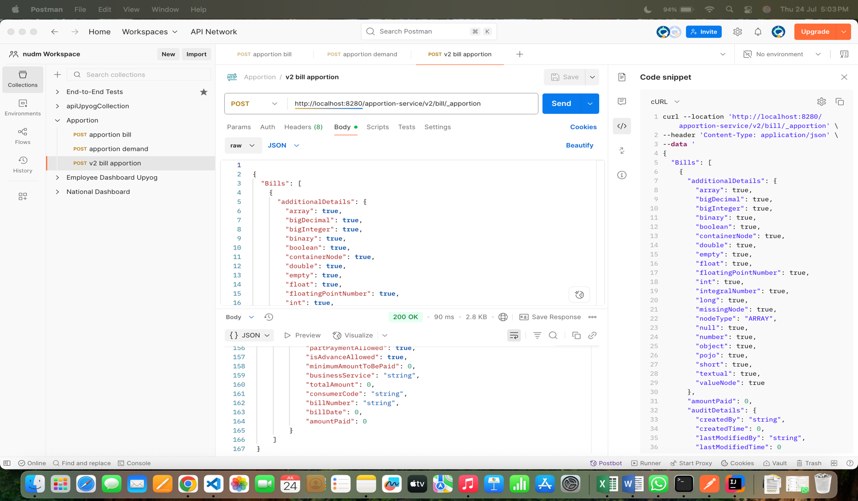

Note: localhost:8082 is locally & localhost:8090 is niuatt environment

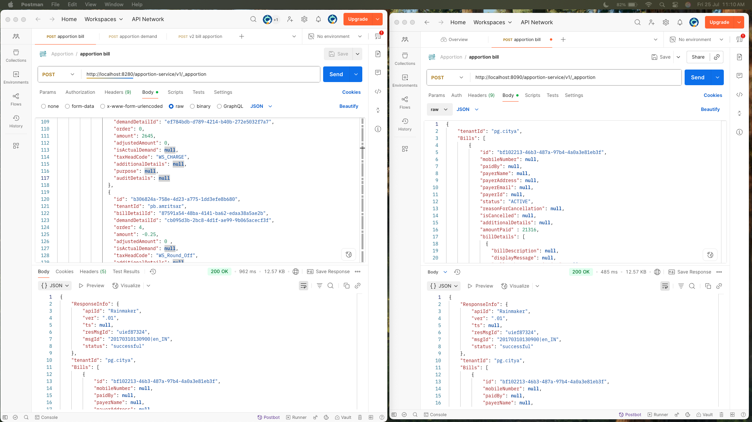

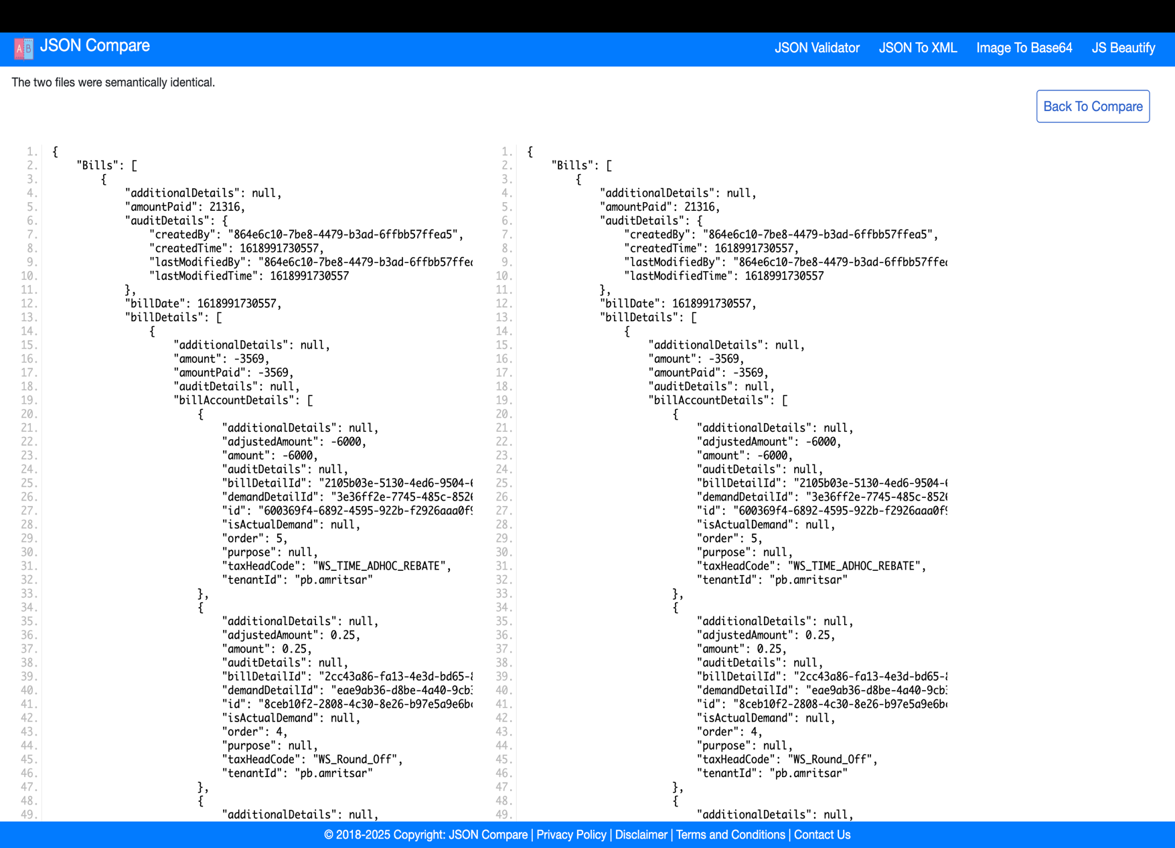
Response:

