Overview
- Service Name: Employee Dashboard
- Upgrade Date: 1 July 2025
- Performed By: Parvesh Mishra NUDM Team

Supporting Evidence of Curl Request
curl --location 'http://localhost:8089/employee-dashboard/_search?_=1751263784242' \
--header 'accept: application/json, text/plain, */*' \
--header 'accept-language: en-US,en;q=0.9,hi;q=0.8' \
--header 'content-type: application/json;charset=UTF-8' \
--header 'origin: https://niuatt.niua.in' \
--header 'priority: u=1, i' \
--header 'referer: https://niuatt.niua.in/digit-ui/employee' \
--header 'sec-ch-ua: "Not(A:Brand";v="99", "Google Chrome";v="133", "Chromium";v="133"' \
--header 'sec-ch-ua-mobile: ?0' \
--header 'sec-ch-ua-platform: "macOS"' \
--header 'sec-fetch-dest: empty' \
--header 'sec-fetch-mode: cors' \
--header 'sec-fetch-site: same-origin' \
--header 'user-agent: Mozilla/5.0 (Macintosh; Intel Mac OS X 10_15_7) AppleWebKit/537.36 (KHTML, like Gecko) Chrome/133.0.0.0 Safari/537.36' \
--data '{
"tenantId": "pg.citya",
"moduleName": "ALL",
"RequestInfo": {
"apiId": "Rainmaker",
"authToken": "1617a04d-2191-45dd-9c82-9564a17766f5",
"userInfo": {
"id": 902,
"uuid": "d1576567-a084-4c36-b49b-332d29c7561e",
"userName": "SV_EMP",
"name": "TVC Employee",
"mobileNumber": "9879879879",
"emailId": null,
"locale": null,
"type": "EMPLOYEE",
"roles": [
{
"name": "Dashboard Employee",
"code": "DASHBOARD_EMPLOYEE",
"tenantId": "pg.citya"
},
{
"name": "TVC Employee",
"code": "TVCEMPLOYEE",
"tenantId": "pg.citya"
},
{
"name": "SV CEMP ",
"code": "SVCEMP",
"tenantId": "pg.citya"
}
],
"active": true,
"tenantId": "pg.citya",
"permanentCity": null
},
"msgId": "1751263784242|en_IN",
"plainAccessRequest": {}
}
}'

Response
{
"responseInfo": {
"apiId": "Rainmaker",
"ver": null,
"ts": null,
"resMsgId": "Data Fetched Successfully",
"msgId": "1751263784242|en_IN",
"status": "SUCCESSFUL"
},
"employeeDashboard": {
"applicationReceived": 2426,
"applicationPending": 783,
"applicationApproved": 0,
"totalAmount": 6769037
}
}

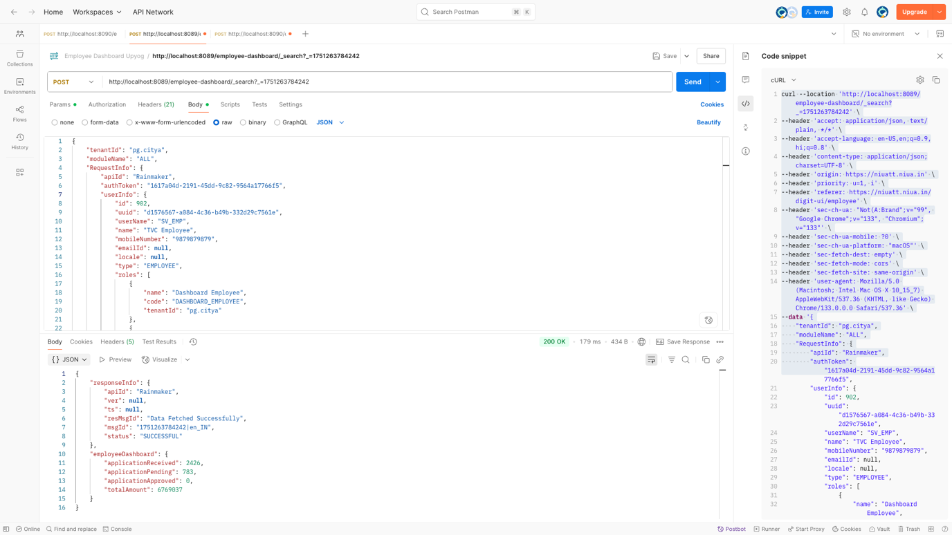

Supporting Evidence: Curl Comparison (Local vs. NIUA Environment)

Supporting Evidence for ALL SERVICES curl

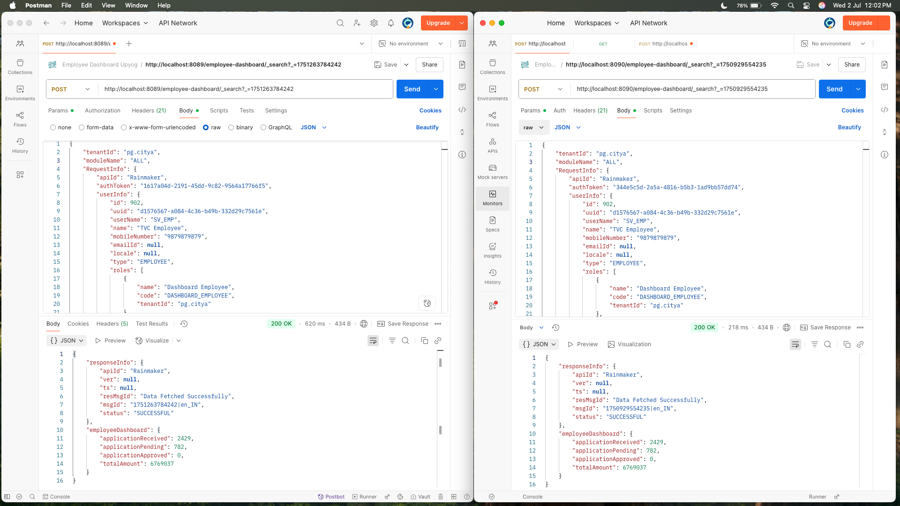

Note: localhost:8089 is locally & localhost:8090 is niuatt environment for All services

Response Difference of All services

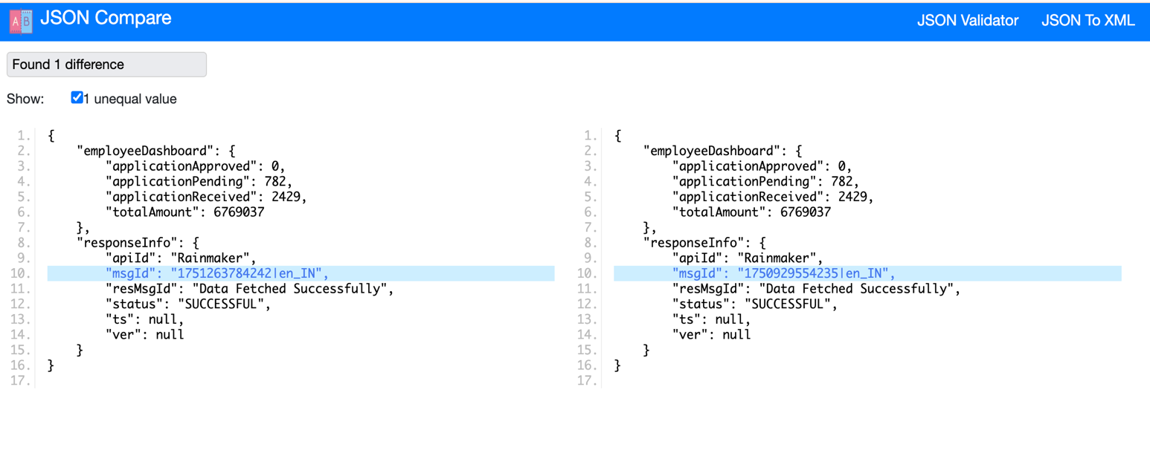

Supporting Evidence for OBPAS curl

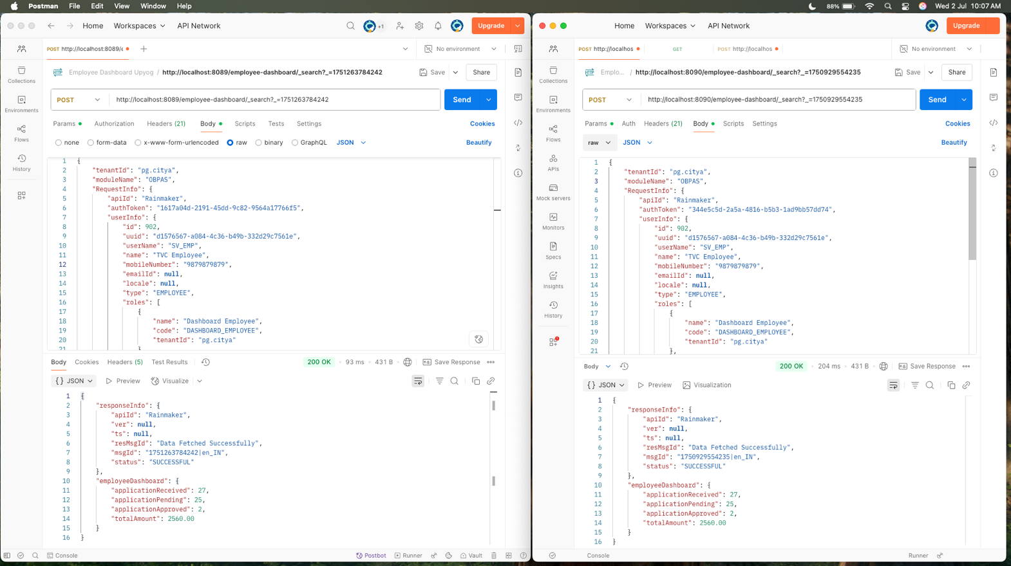

Response Difference of OBPAS

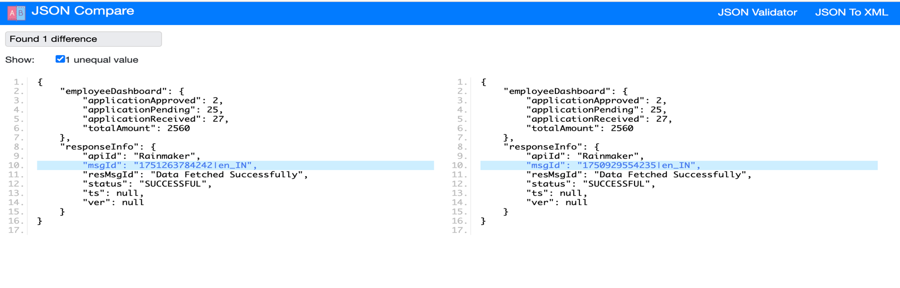

Supporting Evidence for ASSET curl

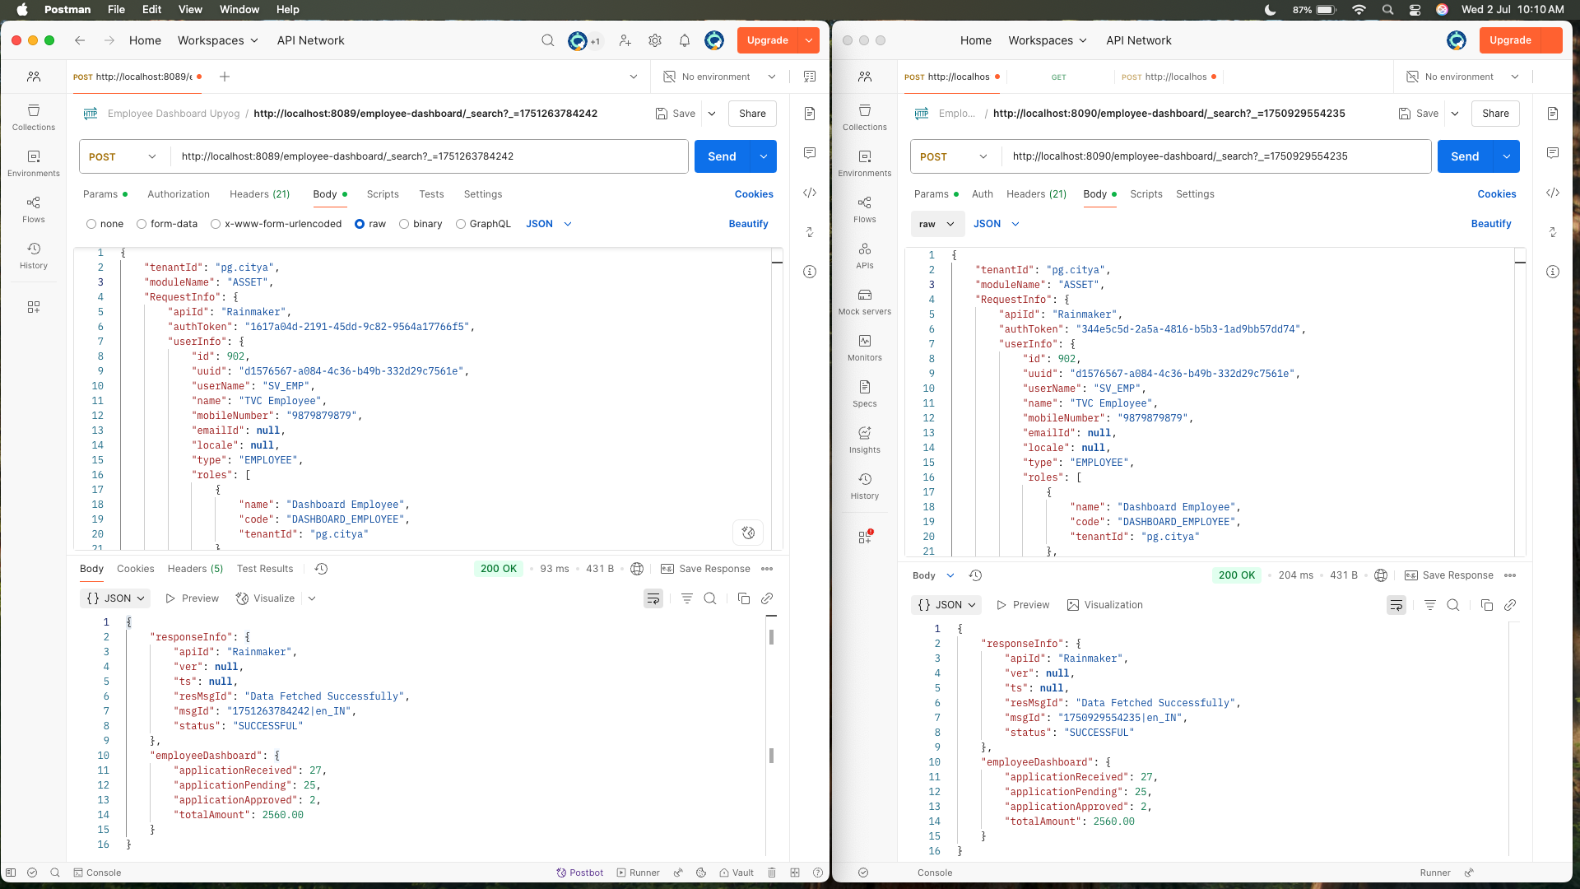

Response Difference of asset

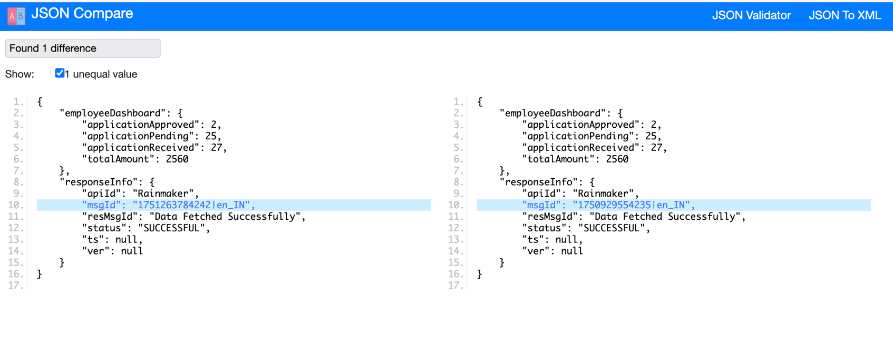

Supporting Evidence for FSM curl

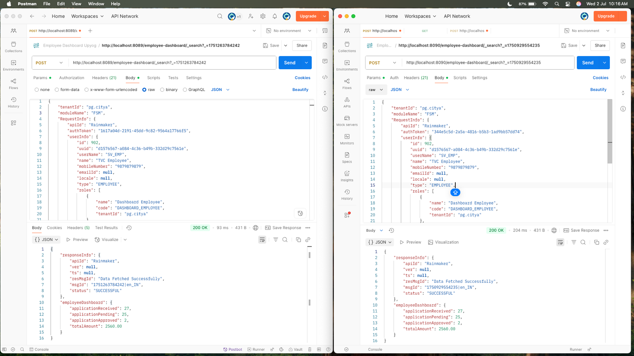

Response Difference of FSM

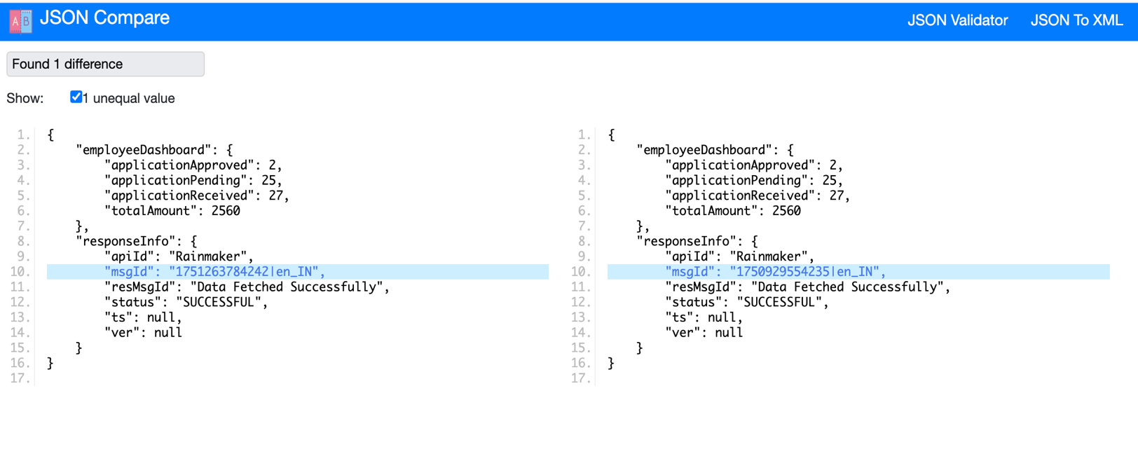

Supporting Evidence for PGR curl

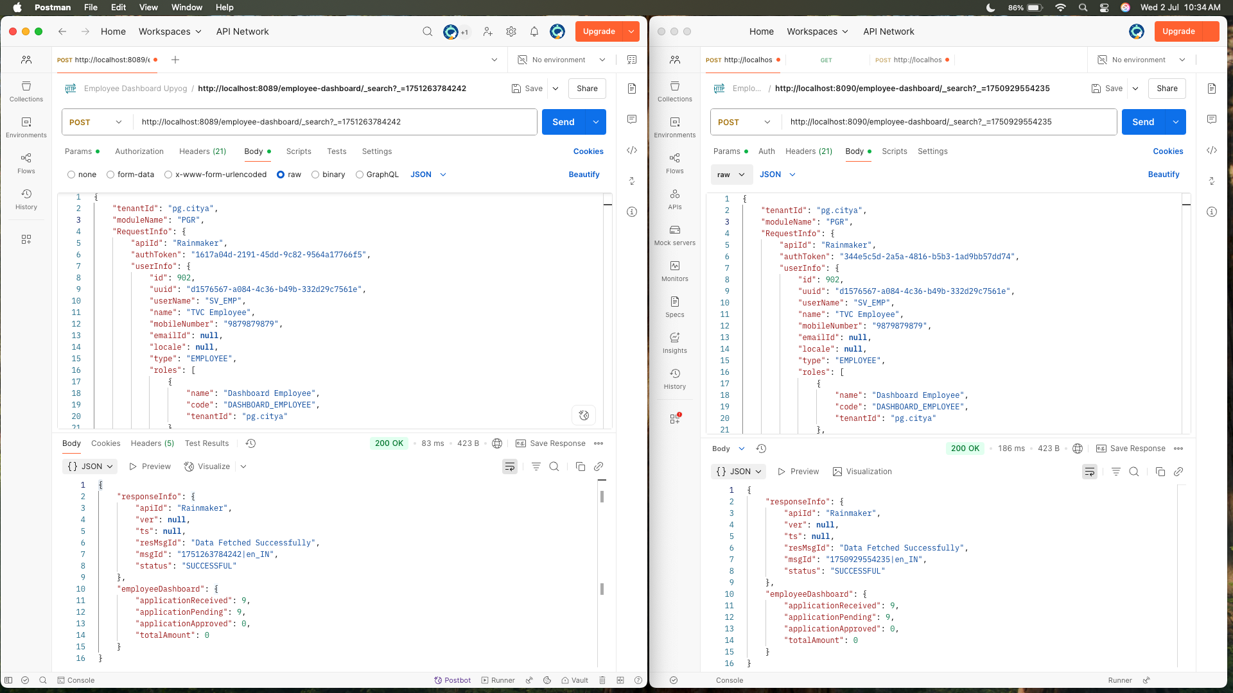

Response Difference of PGR

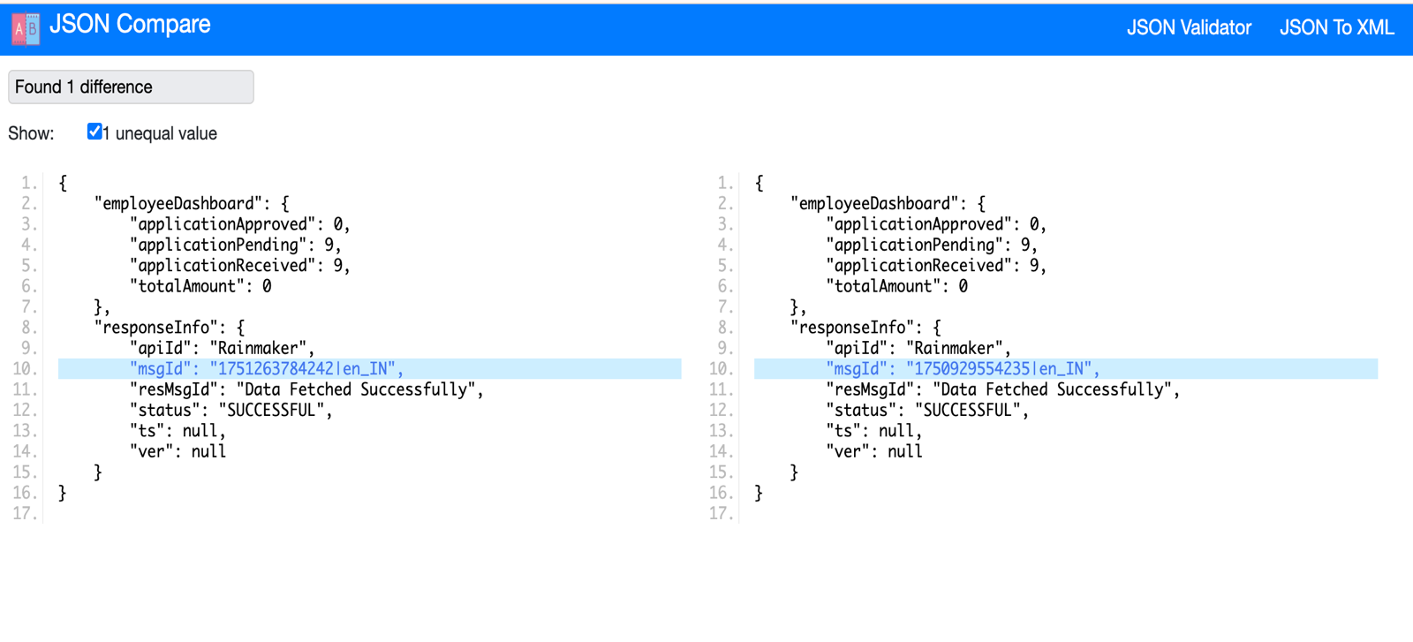

Supporting Evidence for CHB curl

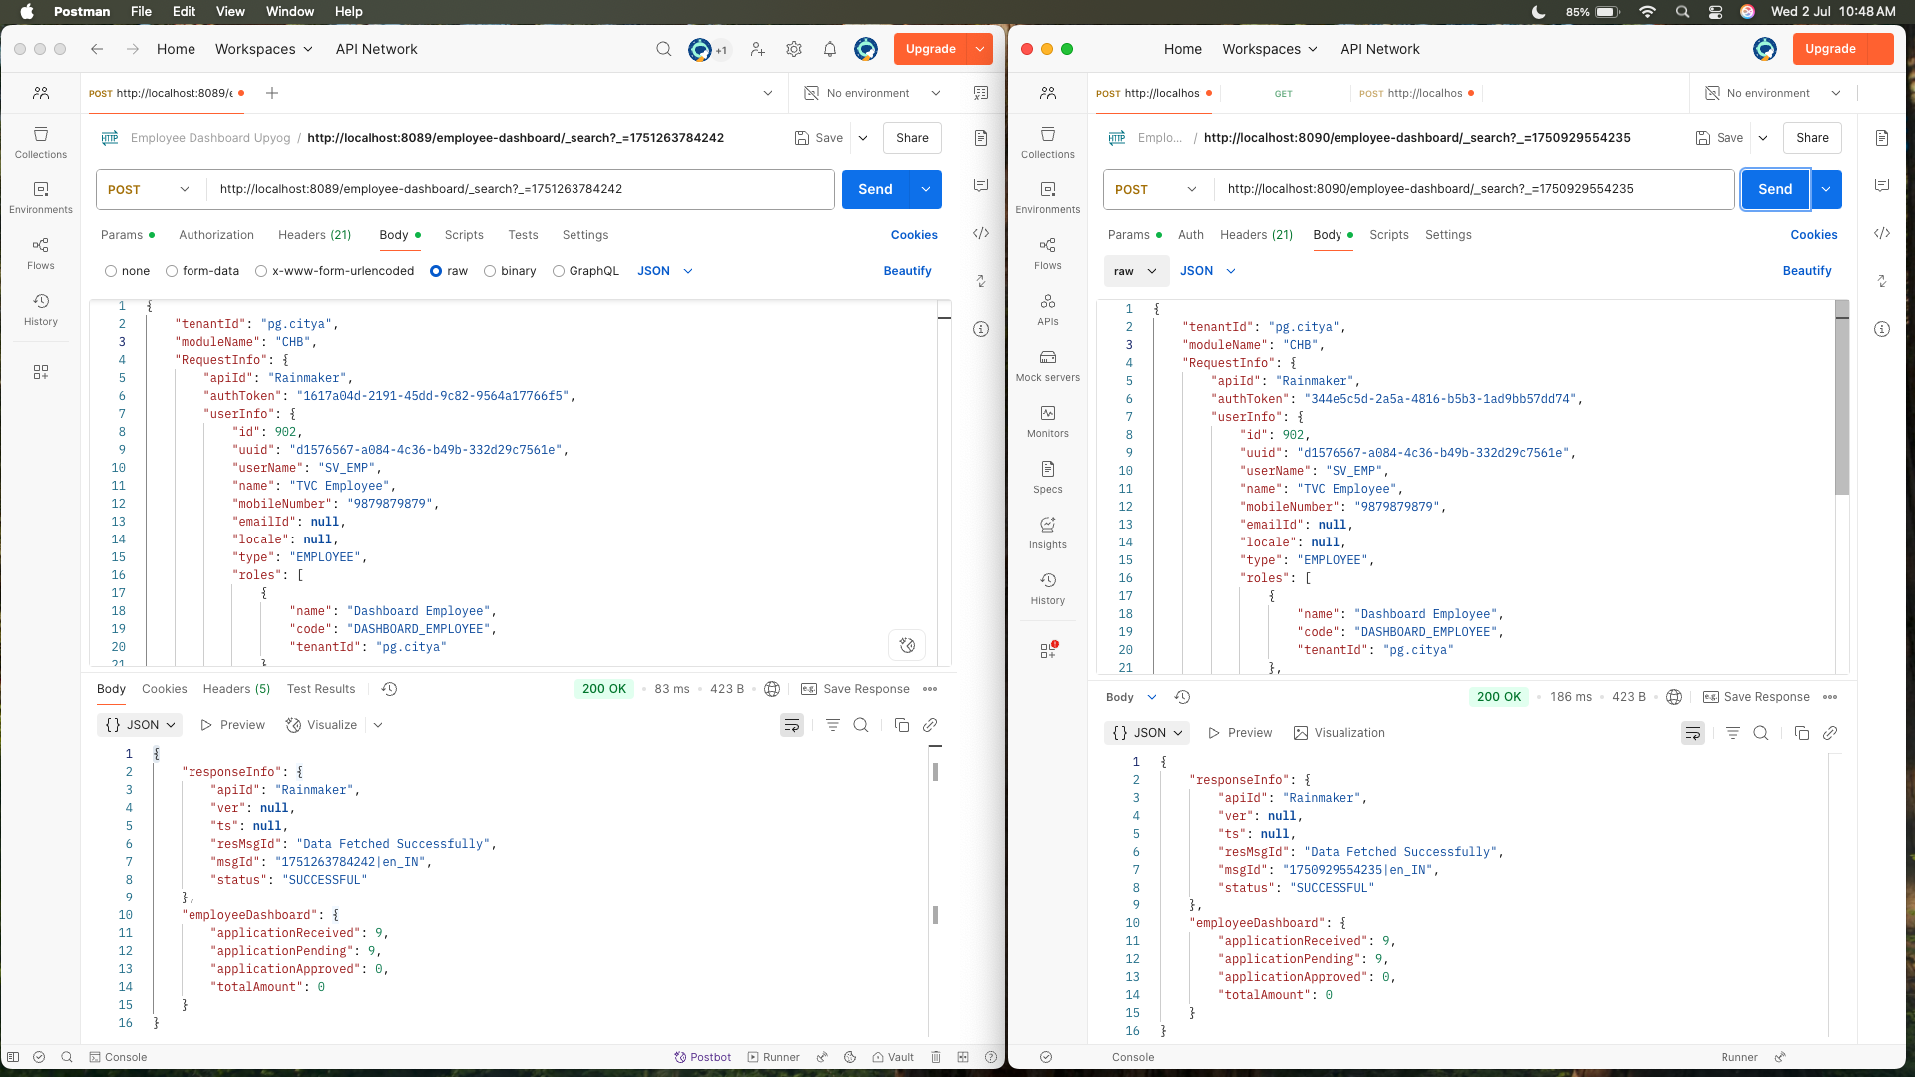

Response Difference of CHB

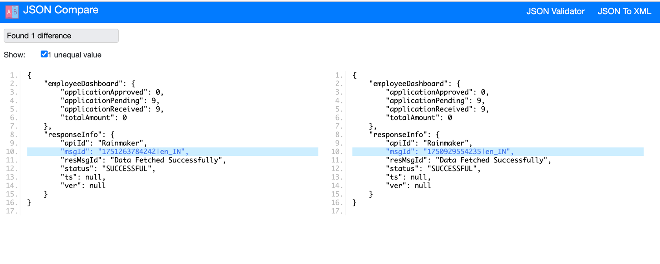

Supporting Evidence for PT curl

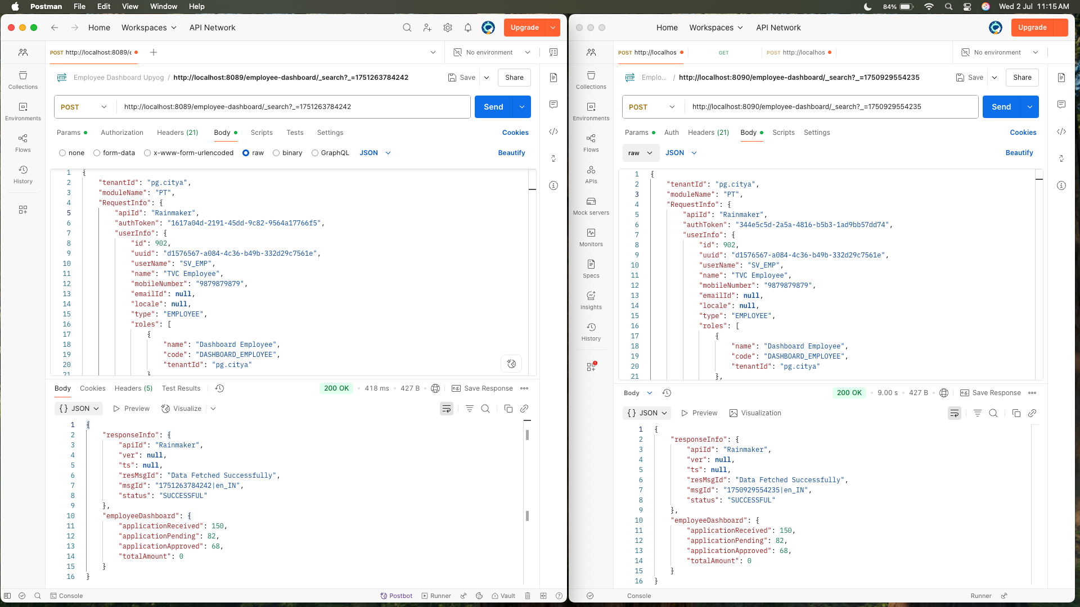

Response Difference of PT

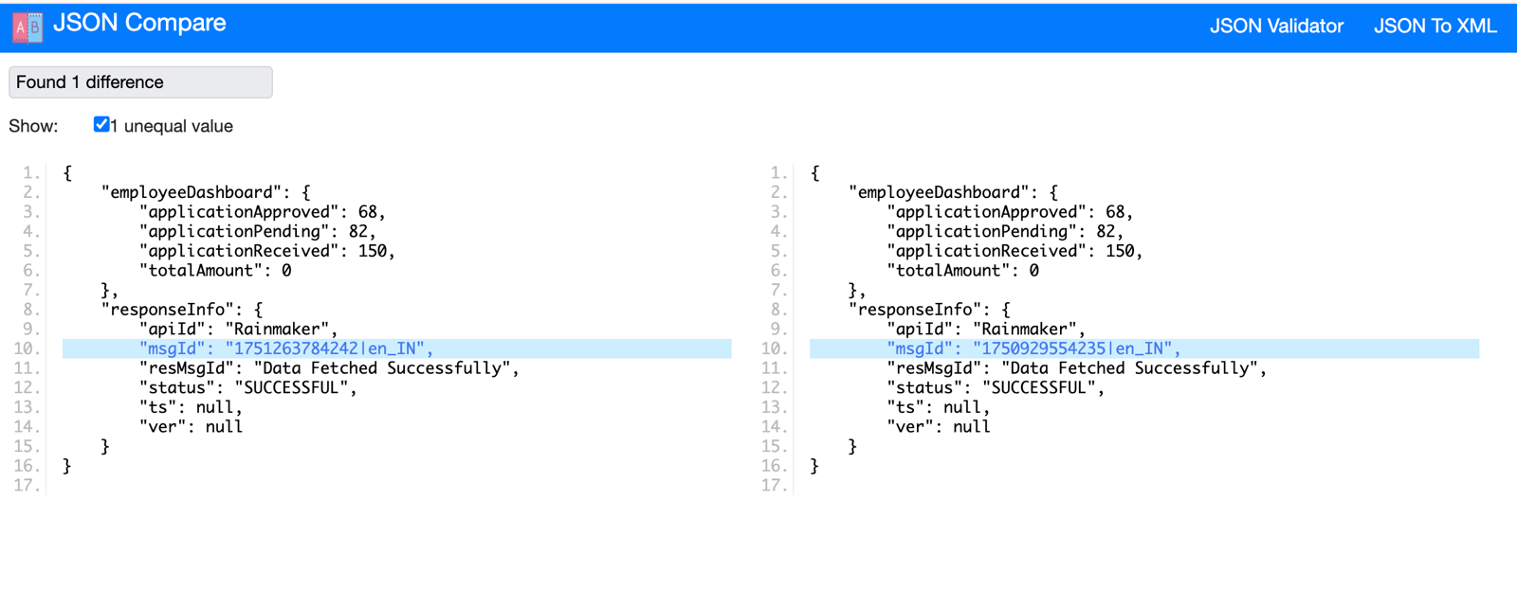

Supporting Evidence for SEWERAGE curl

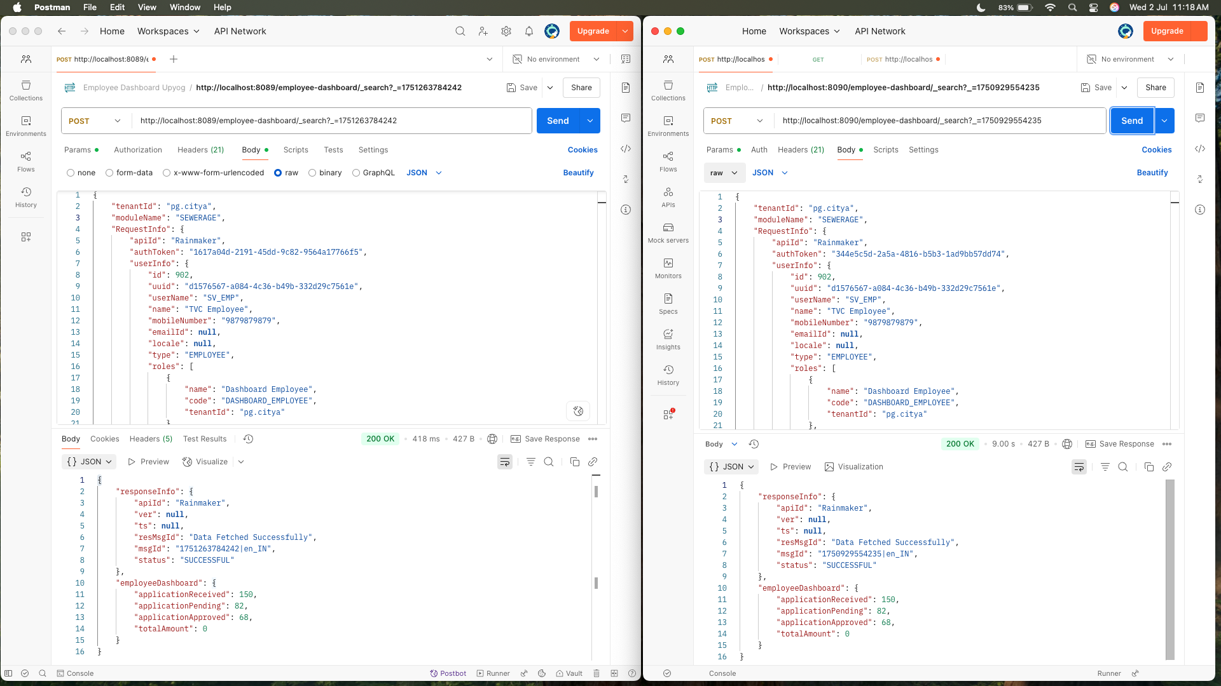

Response Difference of SEWERAGE



Supporting Evidence for PETSERVICES curl

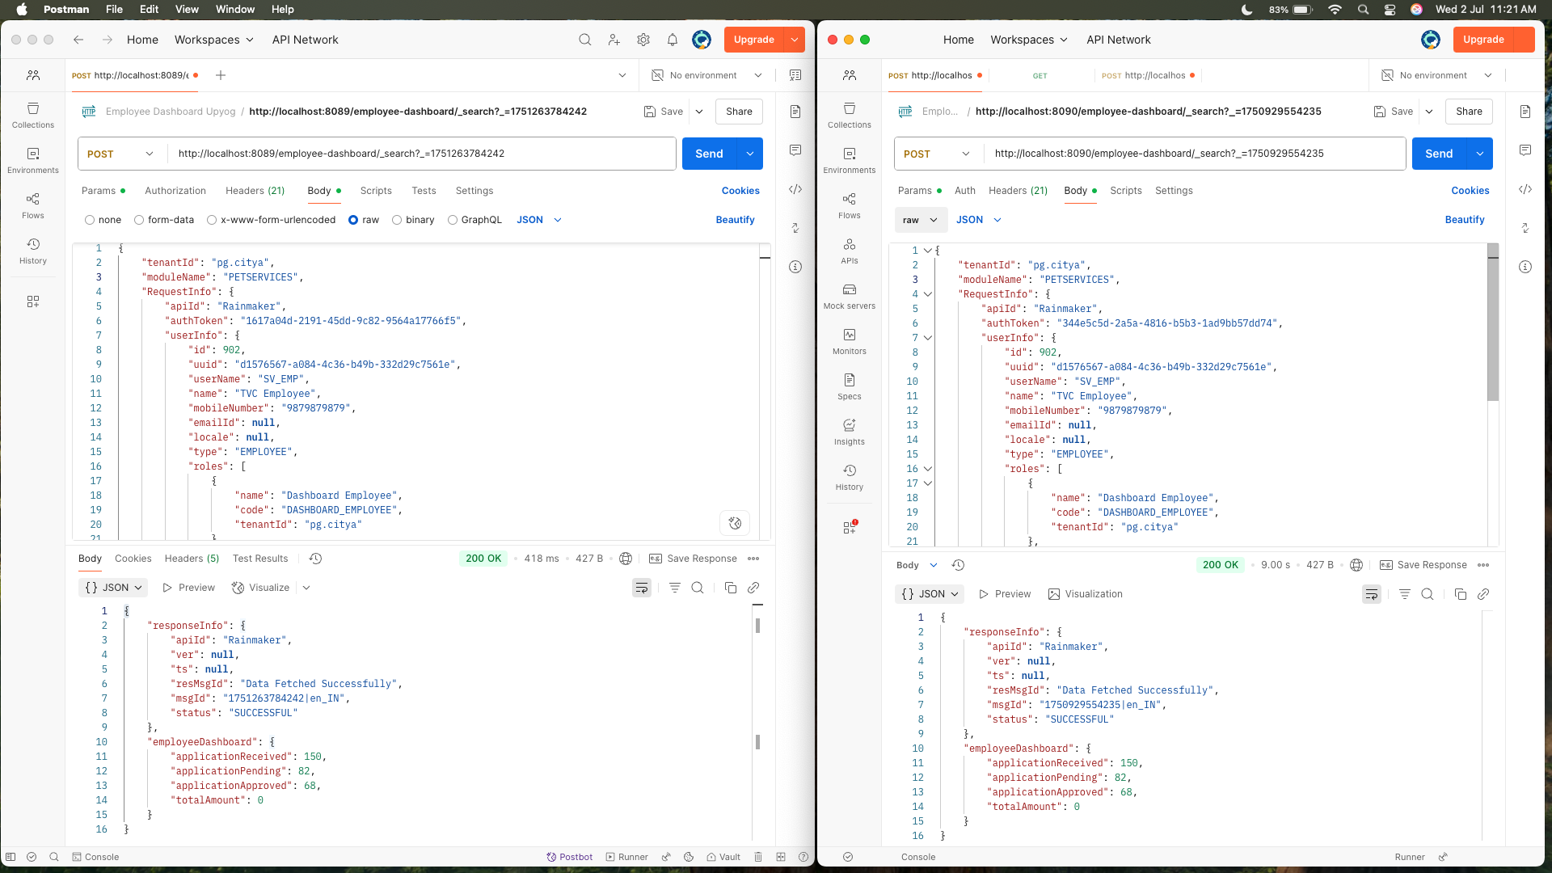

Response Difference of PETSERVICES

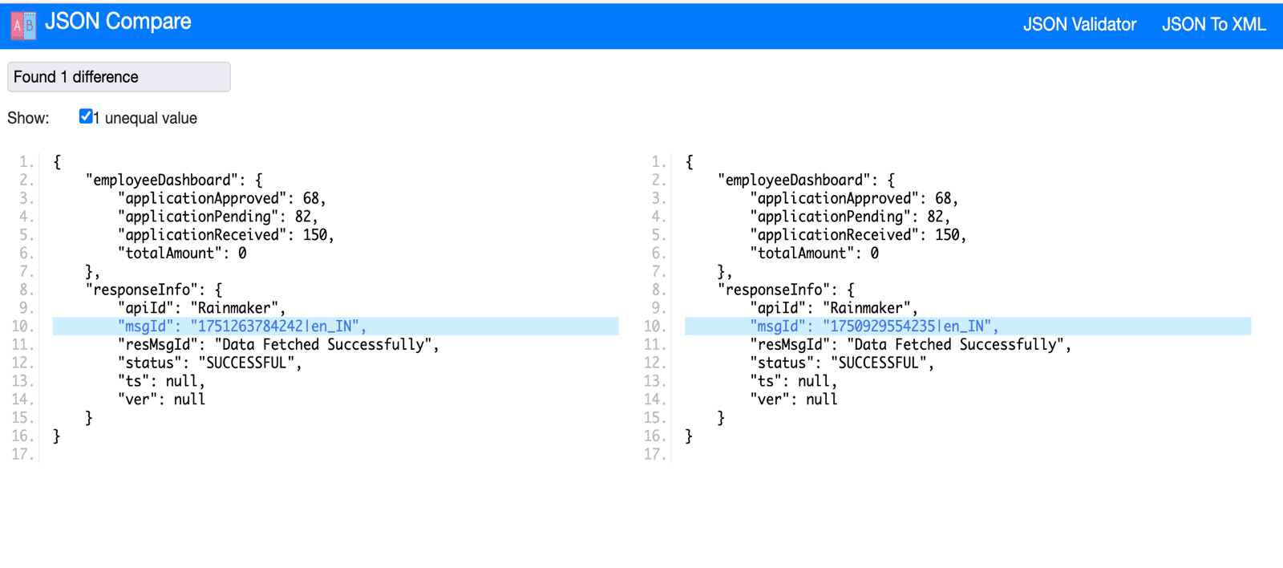

Supporting Evidence for TL curl

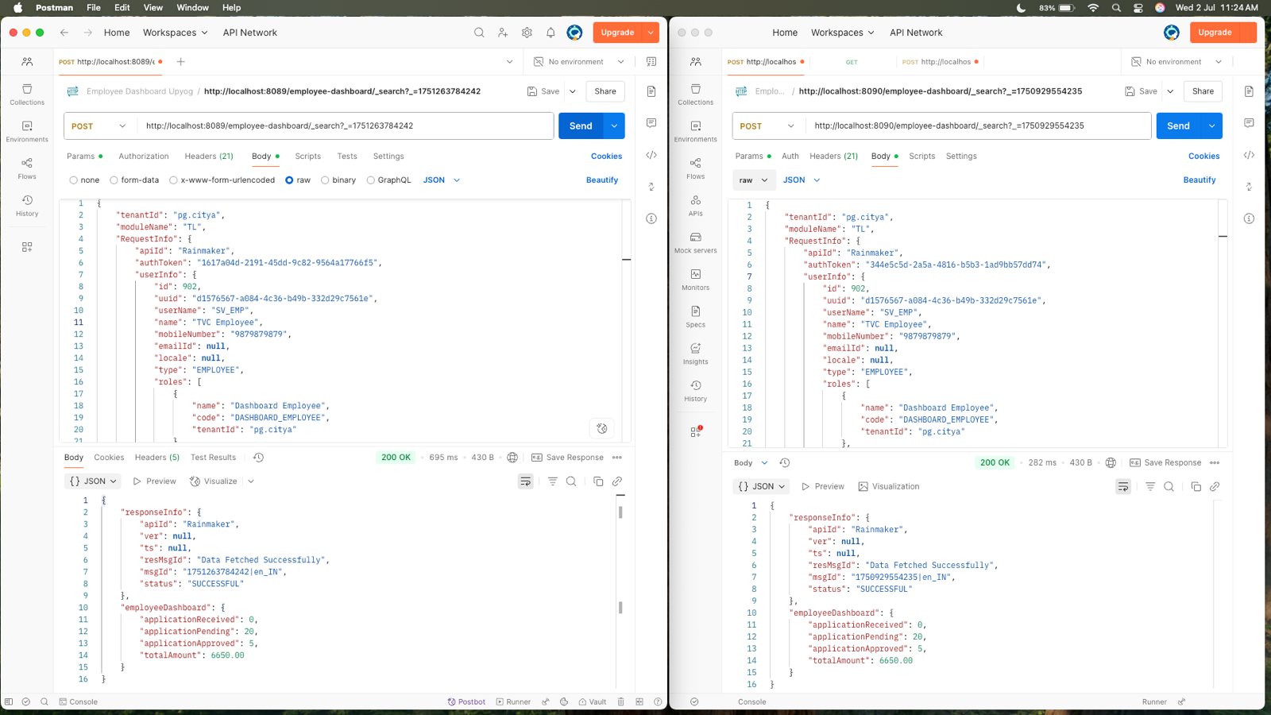

Response Difference of TL

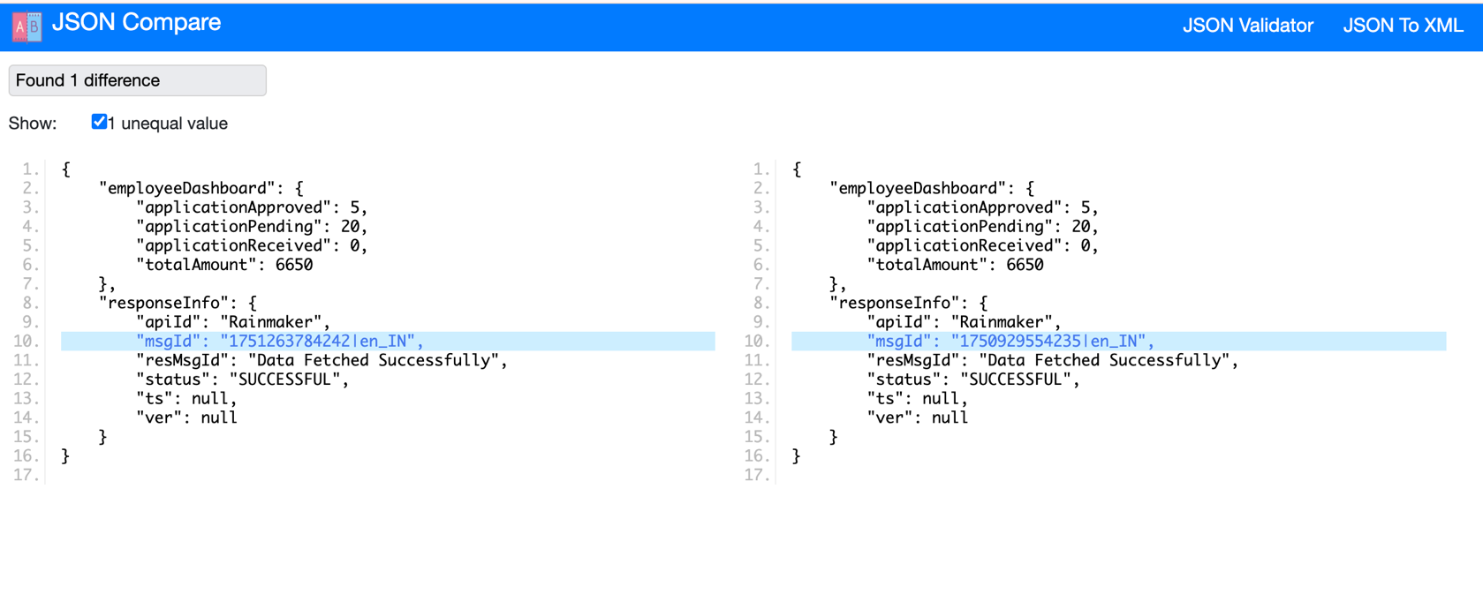

Supporting Evidence for WATER curl

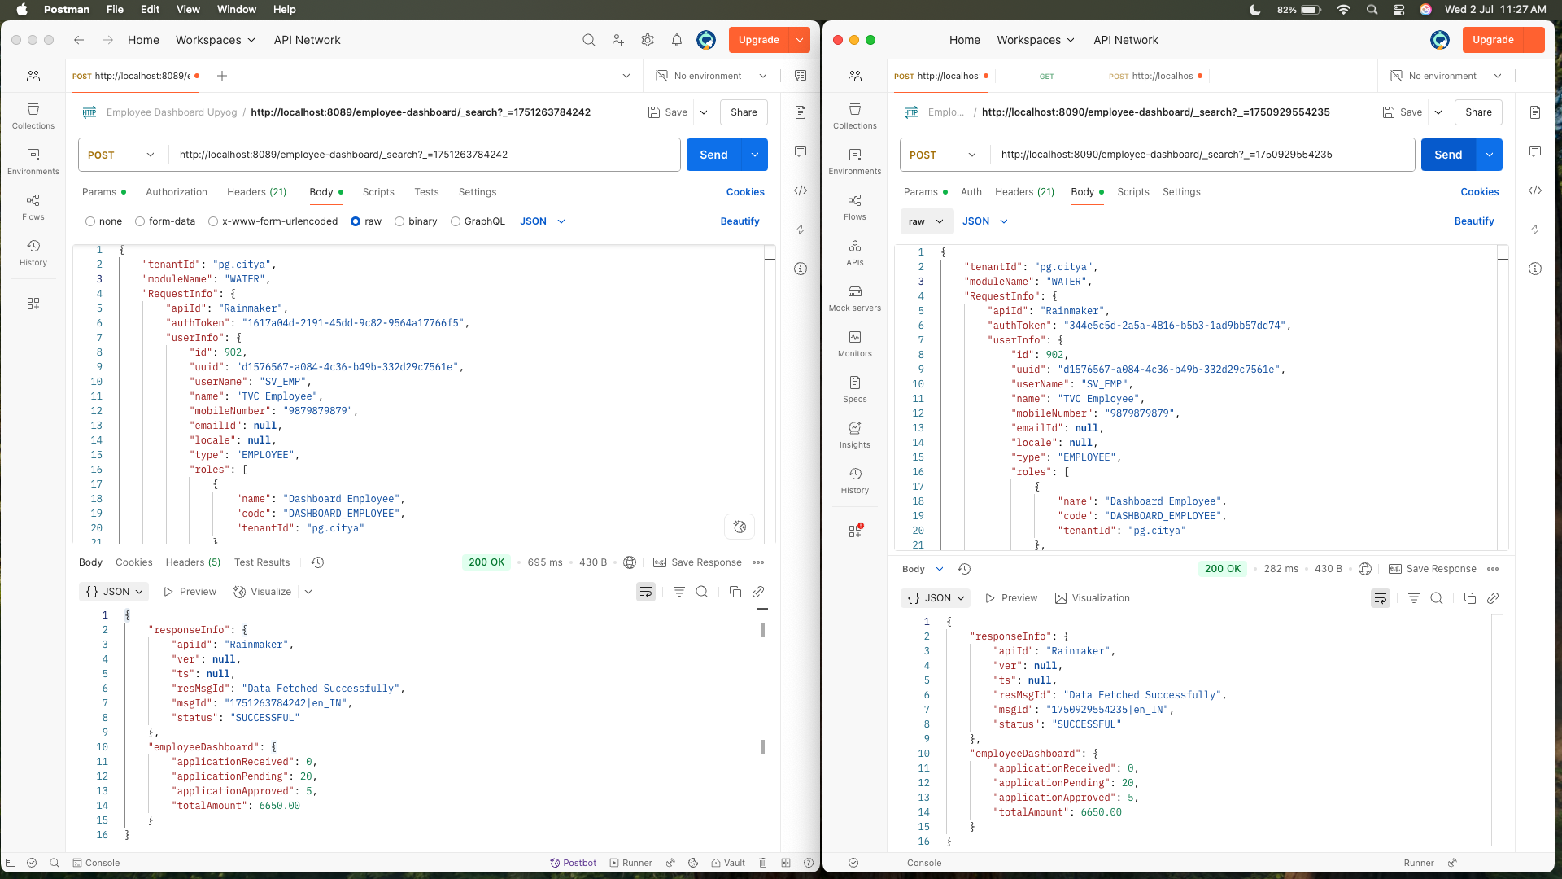

Response Difference of WATER

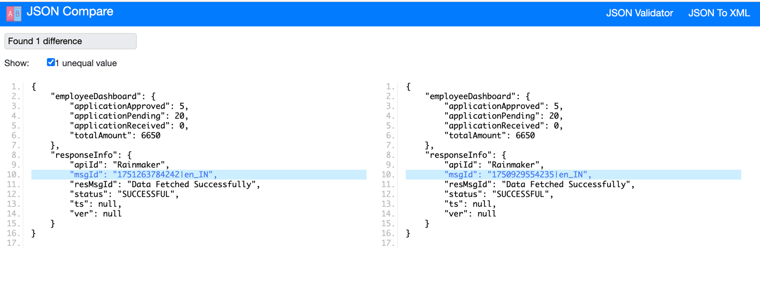

Supporting Evidence for EWASTE curl

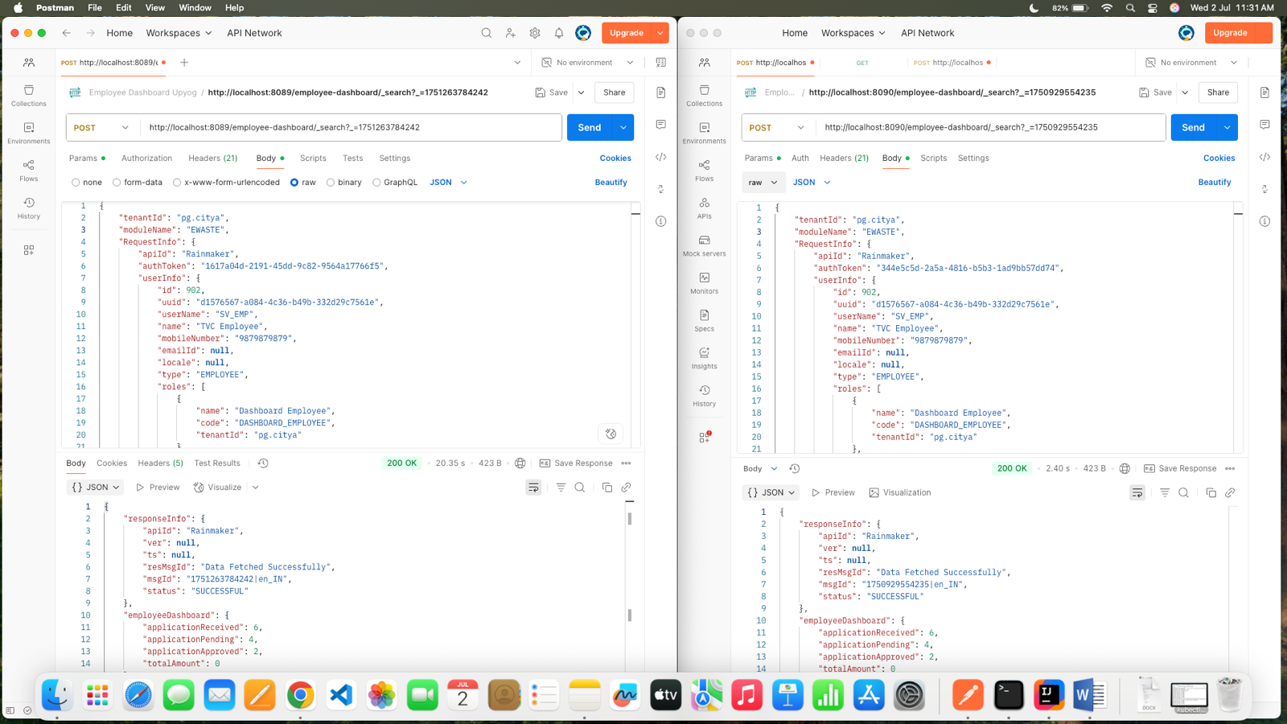

Response Difference of EWASTE

