Collection Service Testing after version upgrade
- Payment Controller
- Payment Search - http://localhost:8280/collection-services/payments/_search?tenantId=pg.citya&mobileNumber=7645325127
Payload - curl --location 'http://localhost:8280/collection-services/payments/_search?tenantId=pg.citya&mobileNumber=7645325127' \
--header 'Content-Type: application/json' \
--data-raw '{
"RequestInfo": {
"apiId": "Rainmaker",
"authToken": "dummy-token",
"userInfo": {
"id": 243,
"uuid": "f8672e56-71e7-4863-b75d-9f3f37d5f742",
"userName": "9999009999",
"name": "Shivank",
"mobileNumber": "9999009999",
"emailId": "shivank@gmail.com",
"locale": "en_IN",
"type": "CITIZEN",
"roles": [
{
"name": "Citizen",
"code": "CITIZEN",
"tenantId": "pg"
}
],
"active": true,
"tenantId": "pg"
}
}
}'

Response:
{
"ResponseInfo": {
"apiId": "Rainmaker",
"ver": null,
"ts": null,
"resMsgId": "uief87324",
"msgId": null,
"status": "200 OK"
},
"Payments": [
{
"id": "34a2dd8f-9186-4a52-8cc0-89f5313c9ecc",
"tenantId": "pg.citya",
"totalDue": 1500,
"totalAmountPaid": 1500,
"transactionNumber": "citya2024311178",
"transactionDate": 1751016630034,
"paymentMode": "CASH",
"instrumentDate": 1751016630034,
"instrumentNumber": null,
"instrumentStatus": "APPROVED",
"ifscCode": null,
"auditDetails": {
"createdBy": "832",
"createdTime": 1751016629969,
"lastModifiedBy": "832",
"lastModifiedTime": 1751016629969
},
"additionalDetails": {
"manualReceiptDate": 1751016629649,
"manualReceiptNumber": "MIG-1751016629-SV-1013-002255",
"manualInstrumentType": "CASH",
"manualCollectionCenter": "MigrationScript"
},
"paymentDetails": [
{
"paymentId": null,
"id": "e6f29f82-3e79-44e1-9926-c640c9897a14",
"tenantId": "pg.citya",
"totalDue": 1500,
"totalAmountPaid": 1500,
"receiptNumber": "SV/1013/2025-26/002016",
"manualReceiptNumber": null,
"manualReceiptDate": 0,
"receiptDate": 1751016629969,
"receiptType": "BILLBASED",
"businessService": "sv-services",
"billId": "66cd2e6e-a160-41d8-ba82-1fafad2eb6de",
"bill": {
"id": "66cd2e6e-a160-41d8-ba82-1fafad2eb6de",
"mobileNumber": null,
"paidBy": null,
"payerName": null,
"payerAddress": null,
"payerEmail": null,
"payerId": null,
"status": "ACTIVE",
"reasonForCancellation": null,
"isCancelled": null,
"additionalDetails": null,
"billDetails": [
{
"billDescription": null,
"displayMessage": null,
"callBackForApportioning": null,
"cancellationRemarks": null,
"id": "b35ec071-f1bf-4e46-a846-a5dc23664292",
"tenantId": "pg.citya",
"demandId": "7ad41c06-844a-40cb-9be5-200fc93689aa",
"billId": "66cd2e6e-a160-41d8-ba82-1fafad2eb6de",
"amount": 1500,
"amountPaid": 1500,
"fromPeriod": 1751016629230,
"toPeriod": 1782552629230,
"additionalDetails": null,
"channel": null,
"voucherHeader": null,
"boundary": null,
"manualReceiptNumber": null,
"manualReceiptDate": null,
"billAccountDetails": [
{
"id": "8ce24980-cdad-4bcc-8f93-13220c5a32de",
"tenantId": "pg.citya",
"billDetailId": "b35ec071-f1bf-4e46-a846-a5dc23664292",
"demandDetailId": "8734b161-8568-4681-bac3-a20a42e32026",
"order": 0,
"amount": 1500,
"adjustedAmount": 1500,
"isActualDemand": null,
"taxHeadCode": "SV_STREET_VENDING_REGISTRATION_FEE",
"additionalDetails": null,
"purpose": null,
"auditDetails": null
}
],
"collectionType": null,
"auditDetails": null,
"expiryDate": 1751048999780
}
],
"tenantId": "pg.citya",
"auditDetails": {
"createdBy": "7f4fd980-628e-4266-a992-40fa629e2f05",
"createdTime": 1751016629780,
"lastModifiedBy": "7f4fd980-628e-4266-a992-40fa629e2f05",
"lastModifiedTime": 1751016629780
},
"collectionModesNotAllowed": [
"DD"
],
"partPaymentAllowed": false,
"isAdvanceAllowed": false,
"minimumAmountToBePaid": null,
"businessService": "sv-services",
"totalAmount": 1500,
"consumerCode": "SV-1013-002255",
"billNumber": "BILL-013582",
"billDate": 1751016629780,
"amountPaid": null
},
"additionalDetails": null,
"auditDetails": {
"createdBy": "832",
"createdTime": 1751016629969,
"lastModifiedBy": "832",
"lastModifiedTime": 1751016629969
}
}
],
"paidBy": "OWNER",
"mobileNumber": "9728765418",
"payerName": "Atul",
"payerAddress": null,
"payerEmail": null,
"payerId": "9cedd0a1-de9b-484b-8b62-0fe8e30c1978",
"paymentStatus": "NEW",
"fileStoreId": null
}
]
}
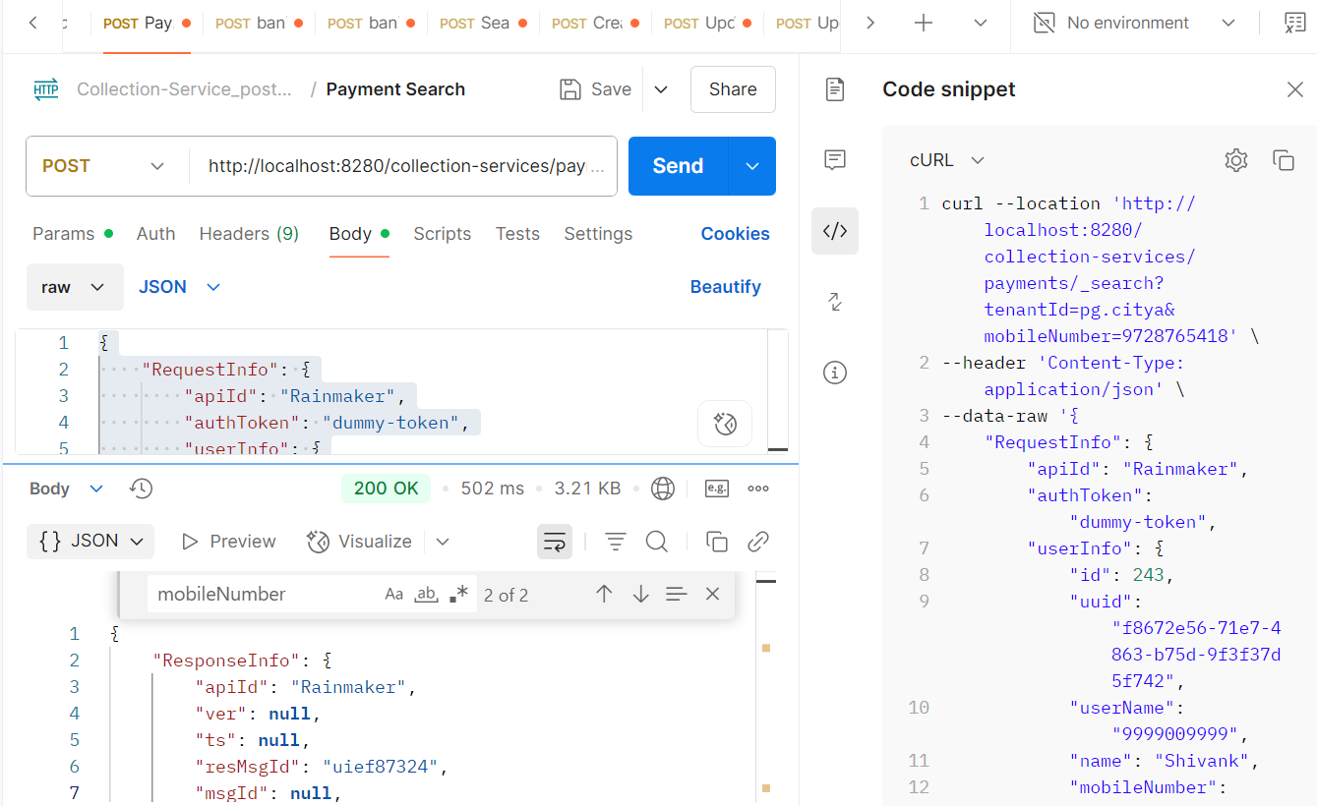
From env via port forward:
Response:
{
"ResponseInfo": {
"apiId": "Rainmaker",
"ver": null,
"ts": null,
"resMsgId": "uief87324",
"msgId": null,
"status": "200 OK"
},
"Payments": [
{
"id": "34a2dd8f-9186-4a52-8cc0-89f5313c9ecc",
"tenantId": "pg.citya",
"totalDue": 1500,
"totalAmountPaid": 1500,
"transactionNumber": "citya2024311178",
"transactionDate": 1751016630034,
"paymentMode": "CASH",
"instrumentDate": 1751016630034,
"instrumentNumber": null,
"instrumentStatus": "APPROVED",
"ifscCode": null,
"auditDetails": {
"createdBy": "832",
"createdTime": 1751016629969,
"lastModifiedBy": "832",
"lastModifiedTime": 1751016629969
},
"additionalDetails": {
"manualReceiptDate": 1751016629649,
"manualReceiptNumber": "MIG-1751016629-SV-1013-002255",
"manualInstrumentType": "CASH",
"manualCollectionCenter": "MigrationScript"
},
"paymentDetails": [
{
"paymentId": null,
"id": "e6f29f82-3e79-44e1-9926-c640c9897a14",
"tenantId": "pg.citya",
"totalDue": 1500,
"totalAmountPaid": 1500,
"receiptNumber": "SV/1013/2025-26/002016",
"manualReceiptNumber": null,
"manualReceiptDate": 0,
"receiptDate": 1751016629969,
"receiptType": "BILLBASED",
"businessService": "sv-services",
"billId": "66cd2e6e-a160-41d8-ba82-1fafad2eb6de",
"bill": {
"id": "66cd2e6e-a160-41d8-ba82-1fafad2eb6de",
"mobileNumber": null,
"paidBy": null,
"payerName": null,
"payerAddress": null,
"payerEmail": null,
"payerId": null,
"status": "ACTIVE",
"reasonForCancellation": null,
"isCancelled": null,
"additionalDetails": null,
"billDetails": [
{
"billDescription": null,
"displayMessage": null,
"callBackForApportioning": null,
"cancellationRemarks": null,
"id": "b35ec071-f1bf-4e46-a846-a5dc23664292",
"tenantId": "pg.citya",
"demandId": "7ad41c06-844a-40cb-9be5-200fc93689aa",
"billId": "66cd2e6e-a160-41d8-ba82-1fafad2eb6de",
"amount": 1500,
"amountPaid": 1500,
"fromPeriod": 1751016629230,
"toPeriod": 1782552629230,
"additionalDetails": null,
"channel": null,
"voucherHeader": null,
"boundary": null,
"manualReceiptNumber": null,
"manualReceiptDate": null,
"billAccountDetails": [
{
"id": "8ce24980-cdad-4bcc-8f93-13220c5a32de",
"tenantId": "pg.citya",
"billDetailId": "b35ec071-f1bf-4e46-a846-a5dc23664292",
"demandDetailId": "8734b161-8568-4681-bac3-a20a42e32026",
"order": 0,
"amount": 1500,
"adjustedAmount": 1500,
"isActualDemand": null,
"taxHeadCode": "SV_STREET_VENDING_REGISTRATION_FEE",
"additionalDetails": null,
"purpose": null,
"auditDetails": null
}
],
"collectionType": null,
"auditDetails": null,
"expiryDate": 1751048999780
}
],
"tenantId": "pg.citya",
"auditDetails": {
"createdBy": "7f4fd980-628e-4266-a992-40fa629e2f05",
"createdTime": 1751016629780,
"lastModifiedBy": "7f4fd980-628e-4266-a992-40fa629e2f05",
"lastModifiedTime": 1751016629780
},
"collectionModesNotAllowed": [
"DD"
],
"partPaymentAllowed": false,
"isAdvanceAllowed": false,
"minimumAmountToBePaid": null,
"businessService": "sv-services",
"totalAmount": 1500,
"consumerCode": "SV-1013-002255",
"billNumber": "BILL-013582",
"billDate": 1751016629780,
"amountPaid": null
},
"additionalDetails": null,
"auditDetails": {
"createdBy": "832",
"createdTime": 1751016629969,
"lastModifiedBy": "832",
"lastModifiedTime": 1751016629969
}
}
],
"paidBy": "OWNER",
"mobileNumber": "9728765418",
"payerName": "Atul",
"payerAddress": null,
"payerEmail": null,
"payerId": "9cedd0a1-de9b-484b-8b62-0fe8e30c1978",
"paymentStatus": "NEW",
"fileStoreId": null
}
]
}

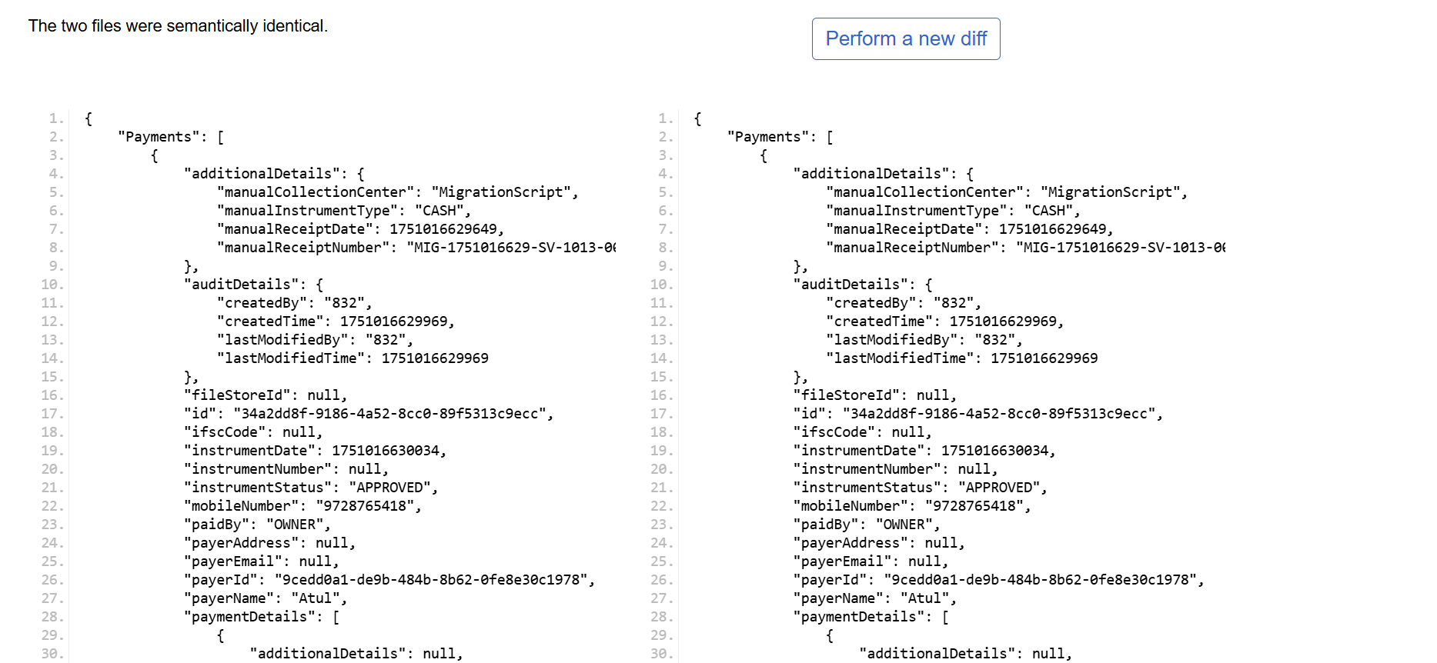

- Payment Create: http://localhost:8280/collection-services/payments/_create

2 Remittance Controller

Remittance Search:
Request Payload: http://localhost:8280/collection-services/remittances/_search?tenantId=pg.citya
curl --location 'http://localhost:8280/collection-services/remittances/_search?tenantId=pg.citya' \
--header 'Content-Type: application/json' \
--data '{
"RequestInfo": {
"apiId": "Rainmaker",
"authToken": "dummy-token",
"userInfo": {
"id": 1,
"uuid": "test-uuid",
"userName": "testuser",
"tenantId": "pg.citya",
"type": "EMPLOYEE",
"roles": [
{
"name": "Finance Admin",
"code": "FIN_ADMIN",
"tenantId": "pg.citya"
}
]
}
}
}'

Response :
{
"ResponseInfo": {
"apiId": "Rainmaker",
"ver": null,
"ts": null,
"resMsgId": "uief87324",
"msgId": null,
"status": "200 OK"
},
"Remittance": [
{
"tenantId": "pg.citya",
"id": "f4b306ae01764ab384b3c5188fb55717",
"referenceNumber": "REF-001",
"referenceDate": 1719400000000,
"voucherHeader": null,
"function": null,
"fund": null,
"remarks": null,
"reasonForDelay": null,
"status": "APPROVED",
"bankaccount": "000000000001",
"auditDetails": {
"createdBy": "1",
"createdTime": 1751008018990,
"lastModifiedBy": "1",
"lastModifiedTime": 1751008018990
},
"remittanceReceipts": [
{
"tenantId": null,
"id": null,
"remittance": null,
"receipt": null
}
],
"remittanceDetails": [
{
"tenantId": "pg.citya",
"id": "4ea449e3f2d64d0e95f1331bc3158e88",
"remittance": "f4b306ae01764ab384b3c5188fb55717",
"chartOfAccount": "COA-001",
"creditAmount": 1000,
"debitAmount": 0
}
],
"remittanceInstruments": [
{
"tenantId": "pg.citya",
"id": "4059e8b802834953a982b25b70bc6fe3",
"remittance": "f4b306ae01764ab384b3c5188fb55717",
"instrument": "CHQ-123456",
"reconciled": false
}
]
}
]
}
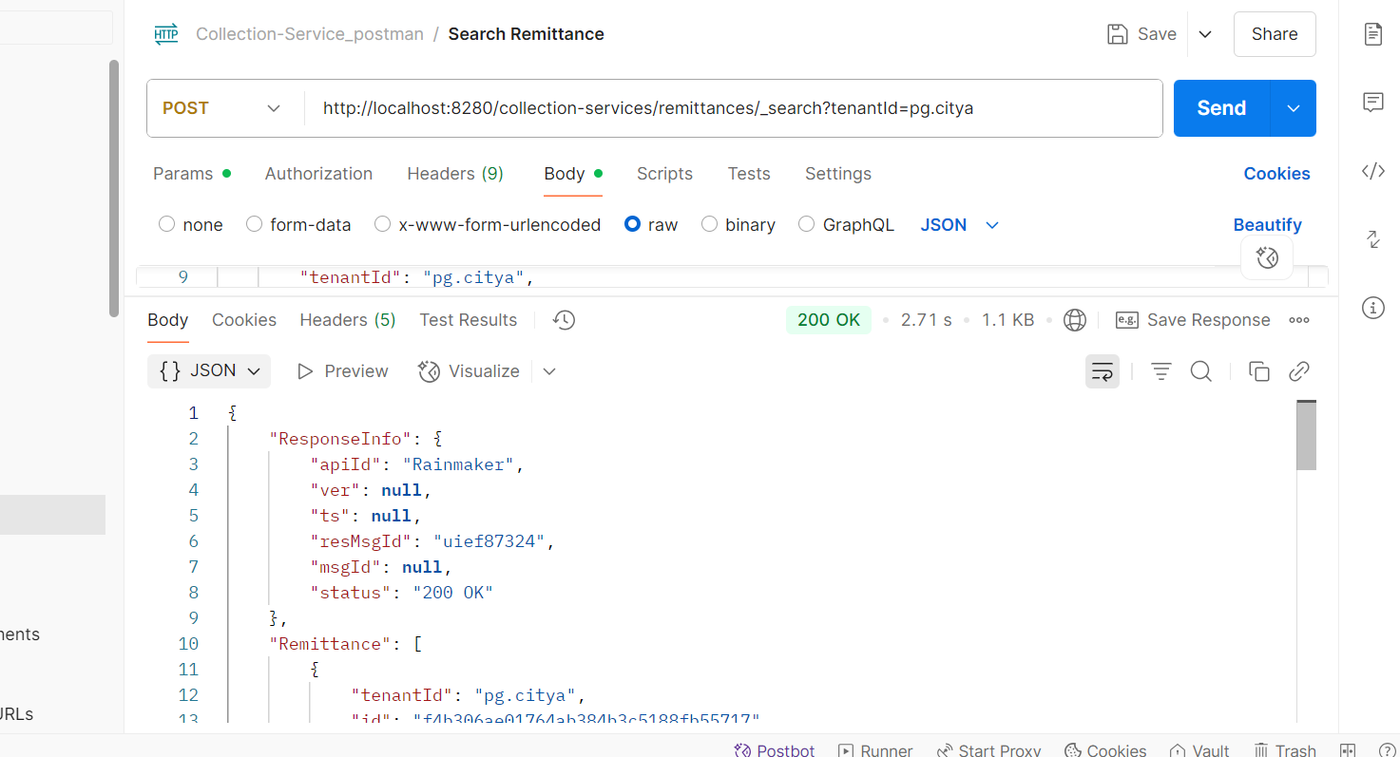

- Create Remittance : http://localhost:8280/collection-services/remittances/_create

Request Payload:
curl --location 'http://localhost:8280/collection-services/remittances/_create' \
--header 'Content-Type: application/json' \
--data '{
"RequestInfo": {
"apiId": "Rainmaker",
"authToken": "dummy-token",
"userInfo": {
"id": 1,
"uuid": "test-uuid",
"userName": "testuser",
"tenantId": "pg.citya",
"type": "EMPLOYEE",
"roles": [
{
"name": "Finance Admin",
"code": "FIN_ADMIN",
"tenantId": "pg.citya"
}
]
}
},
"Remittance": [
{
"tenantId": "pg.citya",
"referenceNumber": "REF-002",
"referenceDate": 1719400000000,
"status": "PENDING",
"bankaccount": "000000000002",
"remittanceDetails": [
{
"chartOfAccount": "COA-002",
"creditAmount": 1000.0,
"debitAmount": 0.0
}
],
"remittanceInstruments": [
{
"instrument": "CHQ-1234567"
}
]
}
]
}'
Response from local:
{
"ResponseInfo": {
"apiId": "Rainmaker",
"ver": null,
"ts": null,
"resMsgId": "uief87324",
"msgId": null,
"status": "200 OK"
},
"Remittance": [
{
"tenantId": "pg.citya",
"id": "5d2f9ee34bdb451b8e8d17c2d5de1108",
"referenceNumber": "REF-002",
"referenceDate": 1719400000000,
"voucherHeader": null,
"function": null,
"fund": null,
"remarks": null,
"reasonForDelay": null,
"status": "APPROVED",
"bankaccount": "000000000002",
"auditDetails": {
"createdBy": "1",
"createdTime": 1751138042606,
"lastModifiedBy": "1",
"lastModifiedTime": 1751138042606
},
"remittanceReceipts": [],
"remittanceDetails": [
{
"tenantId": "pg.citya",
"id": "9a14567e27ba4a64b8e1fa4c5960bbdd",
"remittance": "5d2f9ee34bdb451b8e8d17c2d5de1108",
"chartOfAccount": "COA-002",
"creditAmount": 1000,
"debitAmount": 0
}
],
"remittanceInstruments": [
{
"tenantId": "pg.citya",
"id": "59d49596e3d7482392e51ab12cab214f",
"remittance": "5d2f9ee34bdb451b8e8d17c2d5de1108",
"instrument": "CHQ-1234567",
"reconciled": null
}
]
}
]
}
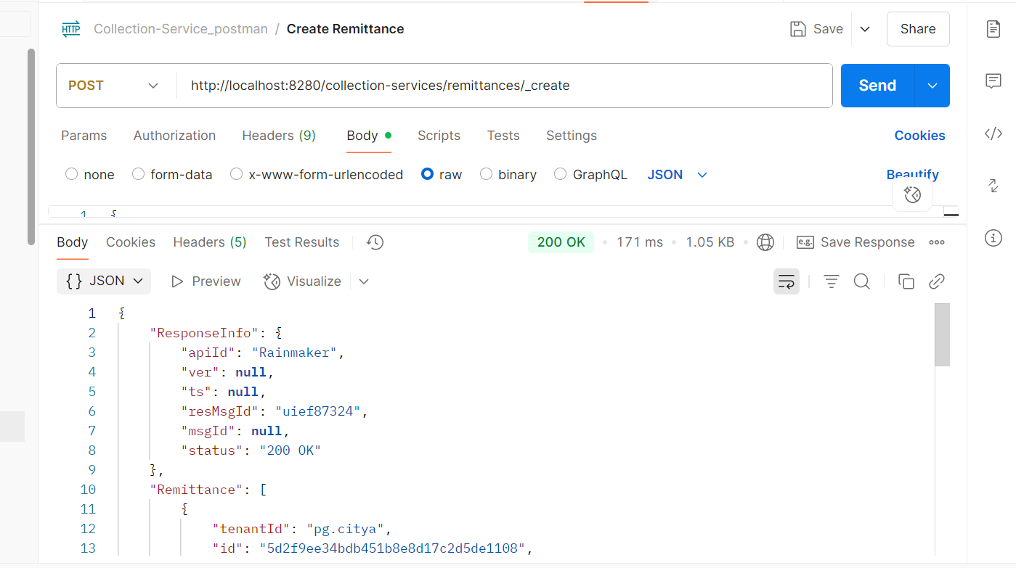
Response from environment:
{
"ResponseInfo": {
"apiId": "Rainmaker",
"ver": null,
"ts": null,
"resMsgId": "uief87324",
"msgId": null,
"status": "200 OK"
},
"Remittance": [
{
"tenantId": "pg.citya",
"id": "4b4b24594eea4c46b2bc6d15aa5e97fe",
"referenceNumber": "REF-002",
"referenceDate": 1719400000000,
"voucherHeader": null,
"function": null,
"fund": null,
"remarks": null,
"reasonForDelay": null,
"status": "APPROVED",
"bankaccount": "000000000002",
"auditDetails": {
"createdBy": "1",
"createdTime": 1751271212403,
"lastModifiedBy": "1",
"lastModifiedTime": 1751271212403
},
"remittanceReceipts": [],
"remittanceDetails": [
{
"tenantId": "pg.citya",
"id": "33e64b334bde41f0845222febaac3a99",
"remittance": "4b4b24594eea4c46b2bc6d15aa5e97fe",
"chartOfAccount": "COA-002",
"creditAmount": 1000,
"debitAmount": 0
}
],
"remittanceInstruments": [
{
"tenantId": "pg.citya",
"id": "d5c59c519cd54813b7ff08be0b72d1c8",
"remittance": "4b4b24594eea4c46b2bc6d15aa5e97fe",
"instrument": "CHQ-1234567",
"reconciled": null
}
]
}
]
}
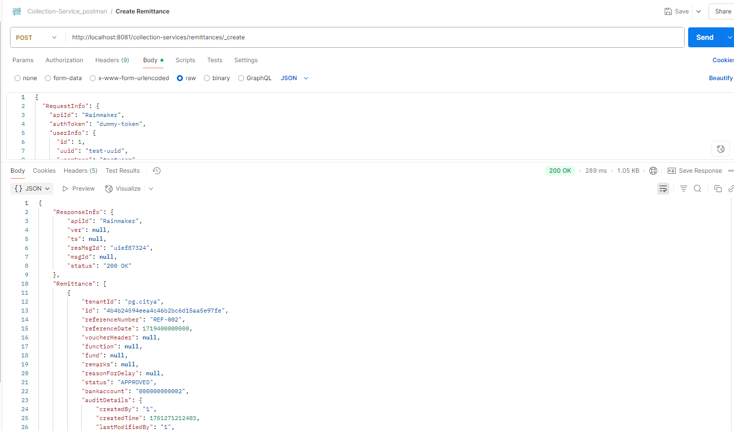

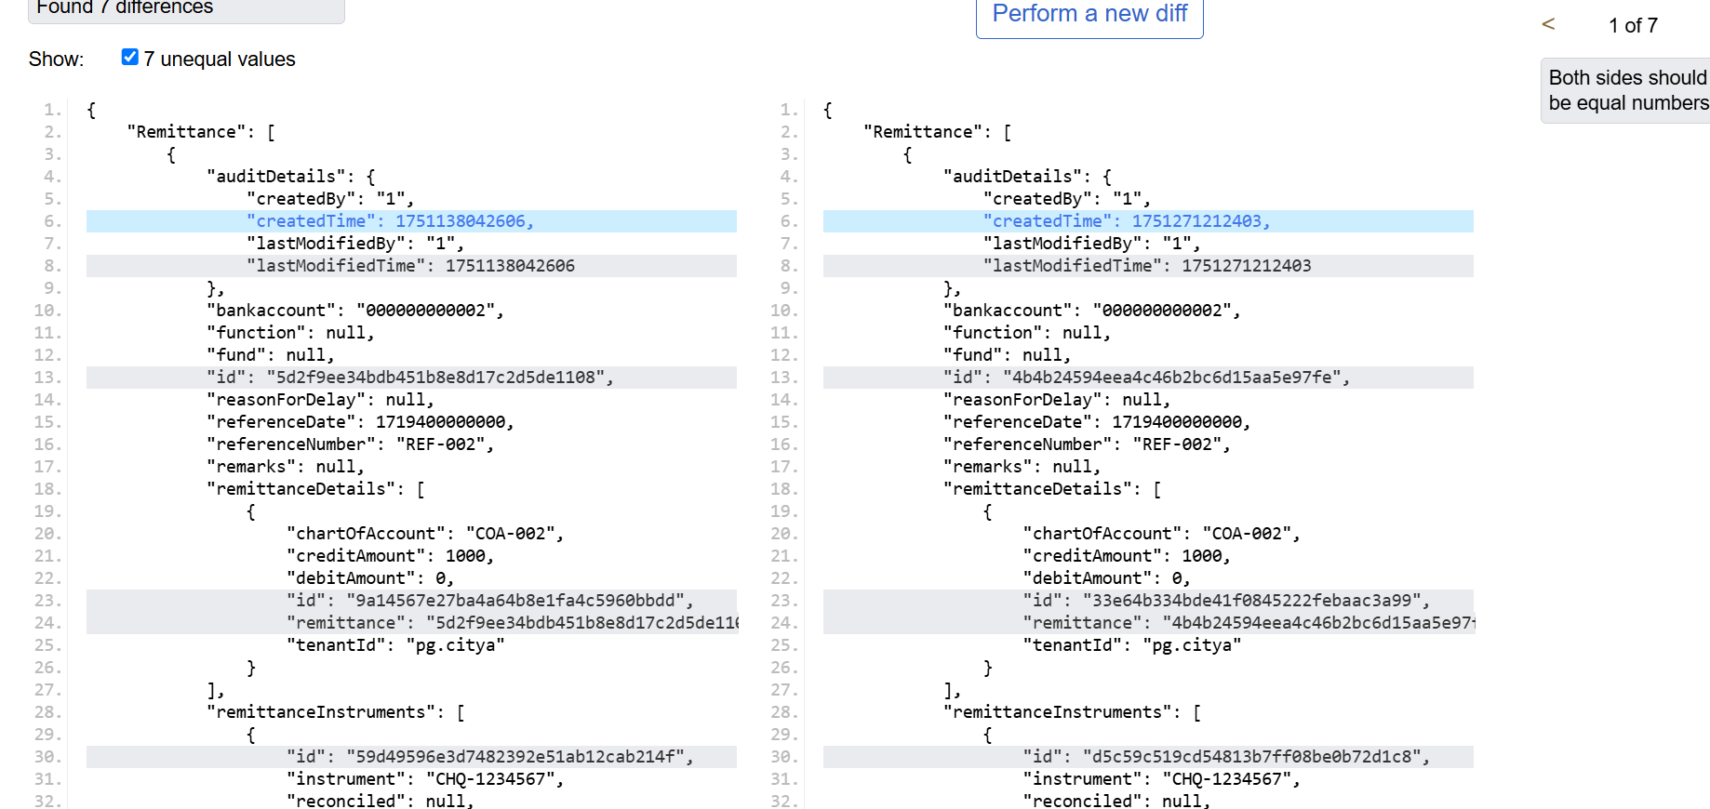
Update Remittance: http://localhost:8280/collection-services/remittances/_update
Request payload:
curl --location 'http://localhost:8280/collection-services/remittances/_update' \
--header 'Content-Type: application/json' \
--data '{
"RequestInfo": {
"apiId": "Rainmaker",
"authToken": "dummy-token",
"userInfo": {
"id": 1,
"uuid": "test-uuid",
"userName": "testuser",
"tenantId": "pg.citya",
"type": "EMPLOYEE",
"roles": [
{
"name": "Finance Admin",
"code": "FIN_ADMIN",
"tenantId": "pg.citya"
}
]
}
},
"Remittance": [
{
"tenantId": "pg.citya",
"id": "f4b306ae01764ab384b3c5188fb55717",
"referenceNumber": "REF-001",
"referenceDate": 1719400000000,
"voucherHeader": null,
"function": null,
"fund": null,
"remarks": "Updated remarks",
"reasonForDelay": null,
"status": "APPROVED",
"bankaccount": "000000000001",
"auditDetails": {
"createdBy": "1",
"createdTime": 1751008018990,
"lastModifiedBy": "1",
"lastModifiedTime": 1751008018990
},
"remittanceReceipts": [],
"remittanceDetails": [
{
"tenantId": "pg.citya",
"id": "4ea449e3f2d64d0e95f1331bc3158e88",
"remittance": "f4b306ae01764ab384b3c5188fb55717",
"chartOfAccount": "COA-001",
"creditAmount": 1000.0,
"debitAmount": 0.0
}
],
"remittanceInstruments": [
{
"tenantId": "pg.citya",
"id": "4059e8b802834953a982b25b70bc6fe3",
"remittance": "f4b306ae01764ab384b3c5188fb55717",
"instrument": "CHQ-123456",
"reconciled": null
}
]
}
]
}'
Response from local:
{
"ResponseInfo": {
"apiId": "Rainmaker",
"ver": null,
"ts": null,
"resMsgId": "uief87324",
"msgId": null,
"status": "200 OK"
},
"Remittance": [
{
"tenantId": "pg.citya",
"id": "f4b306ae01764ab384b3c5188fb55717",
"referenceNumber": "REF-001",
"referenceDate": 1719400000000,
"voucherHeader": null,
"function": null,
"fund": null,
"remarks": "Updated remarks",
"reasonForDelay": null,
"status": "APPROVED",
"bankaccount": "000000000001",
"auditDetails": {
"createdBy": "1",
"createdTime": 1751008018990,
"lastModifiedBy": "1",
"lastModifiedTime": 1751008018990
},
"remittanceReceipts": [],
"remittanceDetails": [
{
"tenantId": "pg.citya",
"id": "4ea449e3f2d64d0e95f1331bc3158e88",
"remittance": "f4b306ae01764ab384b3c5188fb55717",
"chartOfAccount": "COA-001",
"creditAmount": 1000,
"debitAmount": 0
}
],
"remittanceInstruments": [
{
"tenantId": "pg.citya",
"id": "4059e8b802834953a982b25b70bc6fe3",
"remittance": "f4b306ae01764ab384b3c5188fb55717",
"instrument": "CHQ-123456",
"reconciled": null
}
]
}
]
}
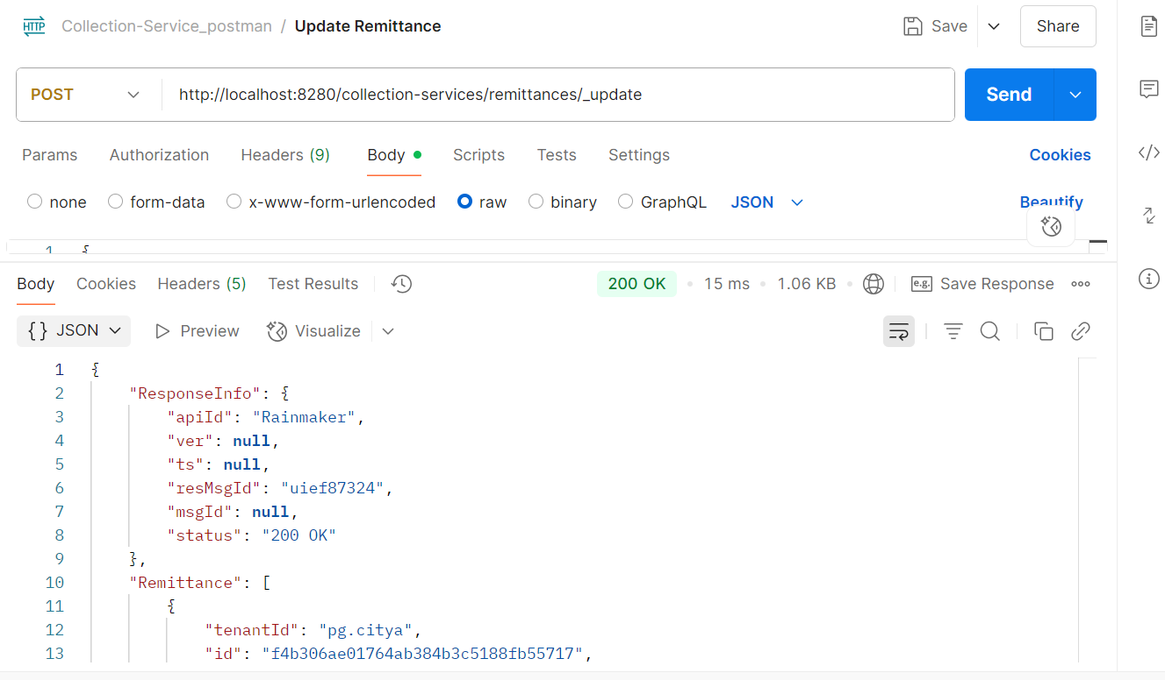

Response from Env:
{
"ResponseInfo": {
"apiId": "Rainmaker",
"ver": null,
"ts": null,
"resMsgId": "uief87324",
"msgId": null,
"status": "200 OK"
},
"Remittance": [
{
"tenantId": "pg.citya",
"id": "f4b306ae01764ab384b3c5188fb55717",
"referenceNumber": "REF-001",
"referenceDate": 1719400000000,
"voucherHeader": null,
"function": null,
"fund": null,
"remarks": "Updated remarks",
"reasonForDelay": null,
"status": "APPROVED",
"bankaccount": "000000000001",
"auditDetails": {
"createdBy": "1",
"createdTime": 1751008018990,
"lastModifiedBy": "1",
"lastModifiedTime": 1751008018990
},
"remittanceReceipts": [],
"remittanceDetails": [
{
"tenantId": "pg.citya",
"id": "4ea449e3f2d64d0e95f1331bc3158e88",
"remittance": "f4b306ae01764ab384b3c5188fb55717",
"chartOfAccount": "COA-001",
"creditAmount": 1000,
"debitAmount": 0
}
],
"remittanceInstruments": [
{
"tenantId": "pg.citya",
"id": "4059e8b802834953a982b25b70bc6fe3",
"remittance": "f4b306ae01764ab384b3c5188fb55717",
"instrument": "CHQ-123456",
"reconciled": null
}
]
}
]
}
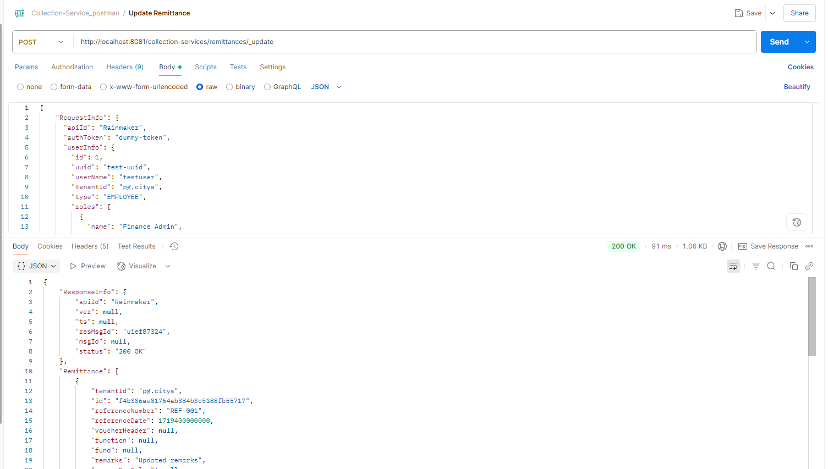

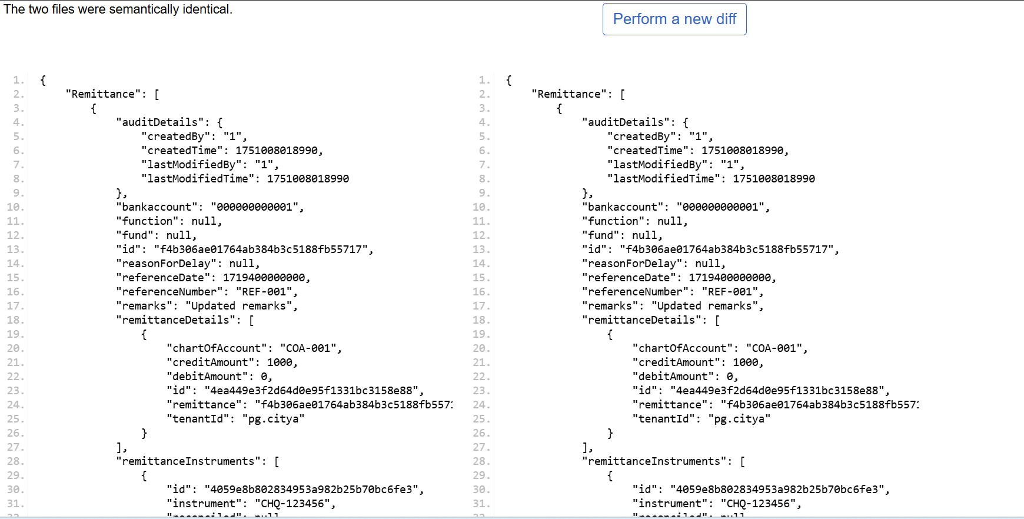

3 Bank Account Controller

- Create Bank Account

Request Payload:
curl --location 'http://localhost:8280/collection-services/bankAccountServiceMapping/_create' \
--header 'Content-Type: application/json' \
--data '{
"RequestInfo": {
"apiId": "Rainmaker",
"authToken": "dummy-token",
"userInfo": {
"id": 1,
"uuid": "test-uuid",
"userName": "testuser",
"tenantId": "pg.citya",
"type": "EMPLOYEE",
"roles": [
{
"name": "Finance Admin",
"code": "FIN_ADMIN",
"tenantId": "pg.citya"
}
]
}
},
"bankAccountServiceMapping": [
{
"tenantId": "pg.citya",
"bankAccount": "000000000002",
"bank": "Allahabad UP Gramin Bank",
"bankBranch": "001",
"businessDetails": "TL.RENEWAL"
}
]
}'
Response from local:
{
"BankAccountServiceMapping": [
{
"businessDetails": "TL.RENEWAL",
"bankAccount": "000000000002",
"bank": "Allahabad UP Gramin Bank",
"bankBranch": "001",
"tenantId": "pg.citya"
}
],
"ResponseInfo": {
"apiId": "Rainmaker",
"ver": null,
"ts": null,
"resMsgId": "uief87324",
"msgId": null,
"status": "200 OK"
}
}
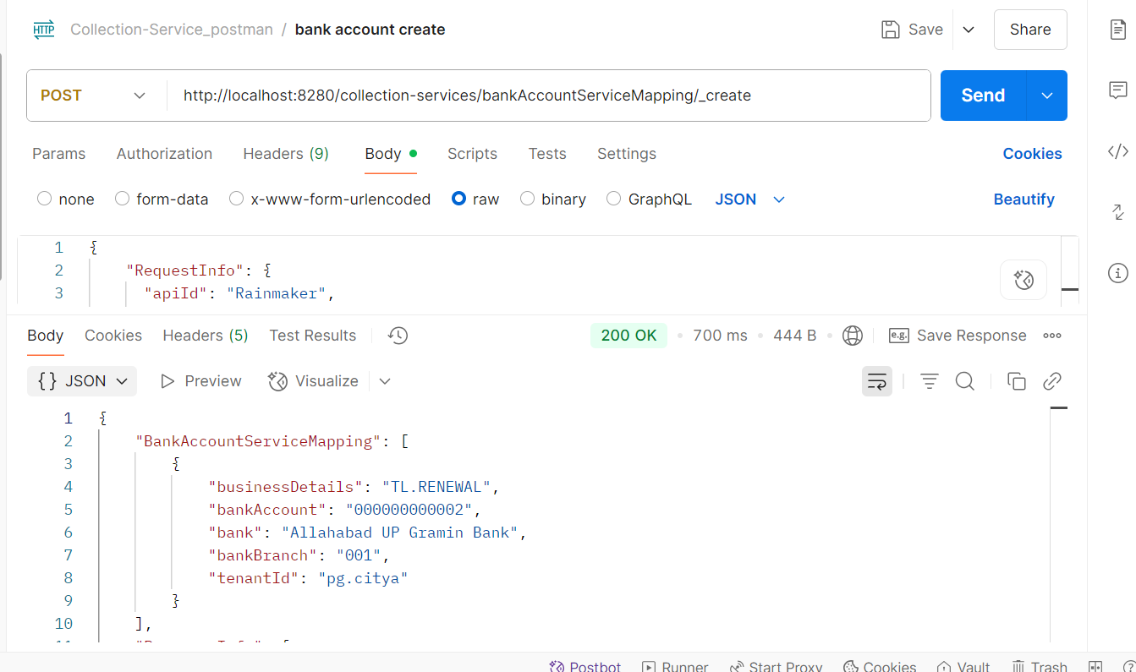
Response from env:
{
"BankAccountServiceMapping": [
{
"businessDetails": "TL.RENEWAL",
"bankAccount": "000000000002",
"bank": "Allahabad UP Gramin Bank",
"bankBranch": "001",
"tenantId": "pg.citya"
}
],
"ResponseInfo": {
"apiId": "Rainmaker",
"ver": null,
"ts": null,
"resMsgId": "uief87324",
"msgId": null,
"status": "200 OK"
}
}
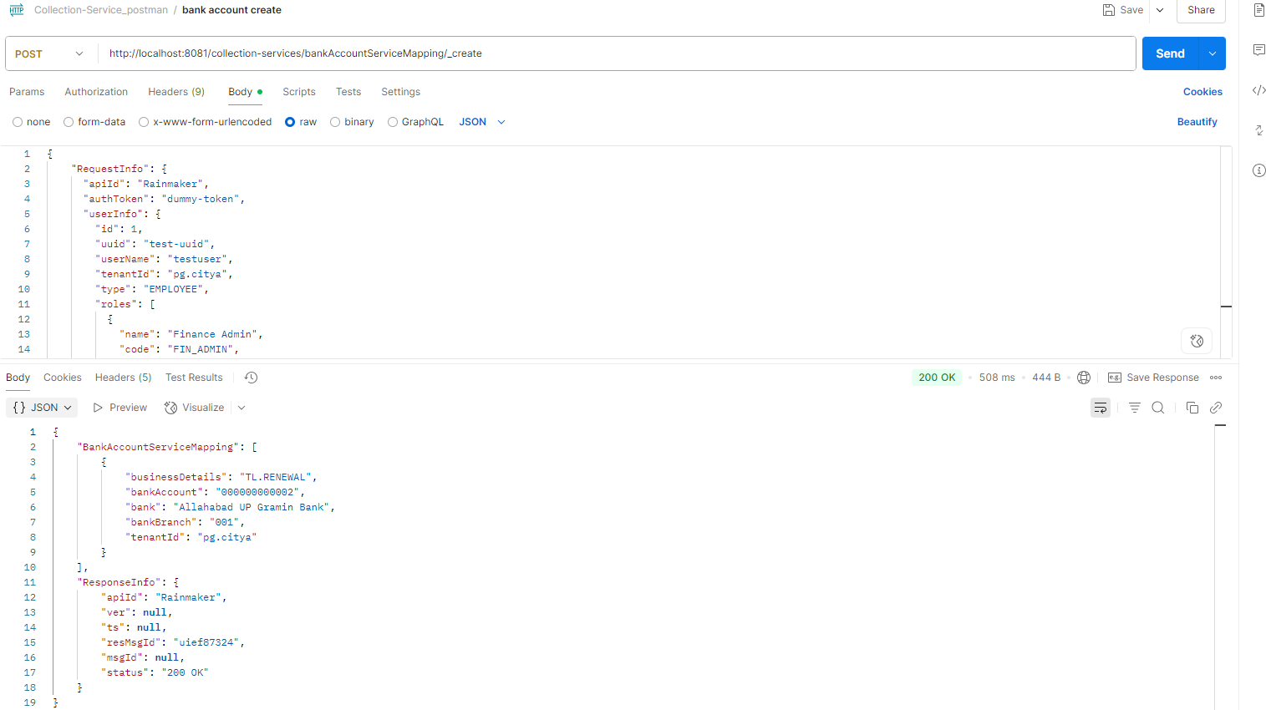

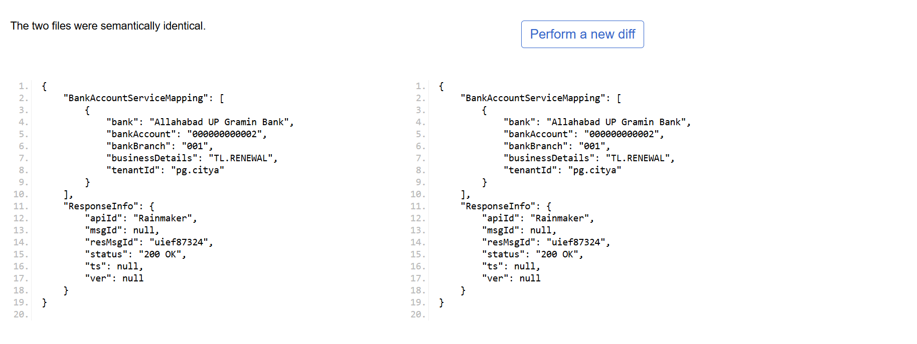
- Bank Account Search
Request Payload:
curl --location 'http://localhost:8081/collection-services/bankAccountServiceMapping/_search?tenantId=pg.citya' \
- --header 'Content-Type: application/json' \
- --data '{
- "RequestInfo": {
- "apiId": "Rainmaker",
- "authToken": "dummy-token",
- "userInfo": {
- "id": 1,
- "uuid": "test-uuid",
- "userName": "testuser",
- "tenantId": "pb.amritsar",
- "type": "EMPLOYEE",
- "roles": [
- {
- "name": "Finance Admin",
- "code": "FIN_ADMIN",
- "tenantId": "pb.amritsar"
- }
- ]
- }
- }
- }'
Response from local:
{
- "BankAccountServiceMapping": [
- {
- "businessDetails": "TL.RENEWAL",
- "bankAccount": "000000000001",
- "bank": "Allahabad UP Gramin Bank",
- "bankBranch": "001",
- "tenantId": "pg.citya"
- },
- {
- "businessDetails": "TL.RENEWAL",
- "bankAccount": "000000000002",
- "bank": "Allahabad UP Gramin Bank",
- "bankBranch": "001",
- "tenantId": "pg.citya"
- }
- ],
- "ResponseInfo": {
- "apiId": "Rainmaker",
- "ver": null,
- "ts": null,
- "resMsgId": "uief87324",
- "msgId": null,
- "status": "200 OK"
- }
- }
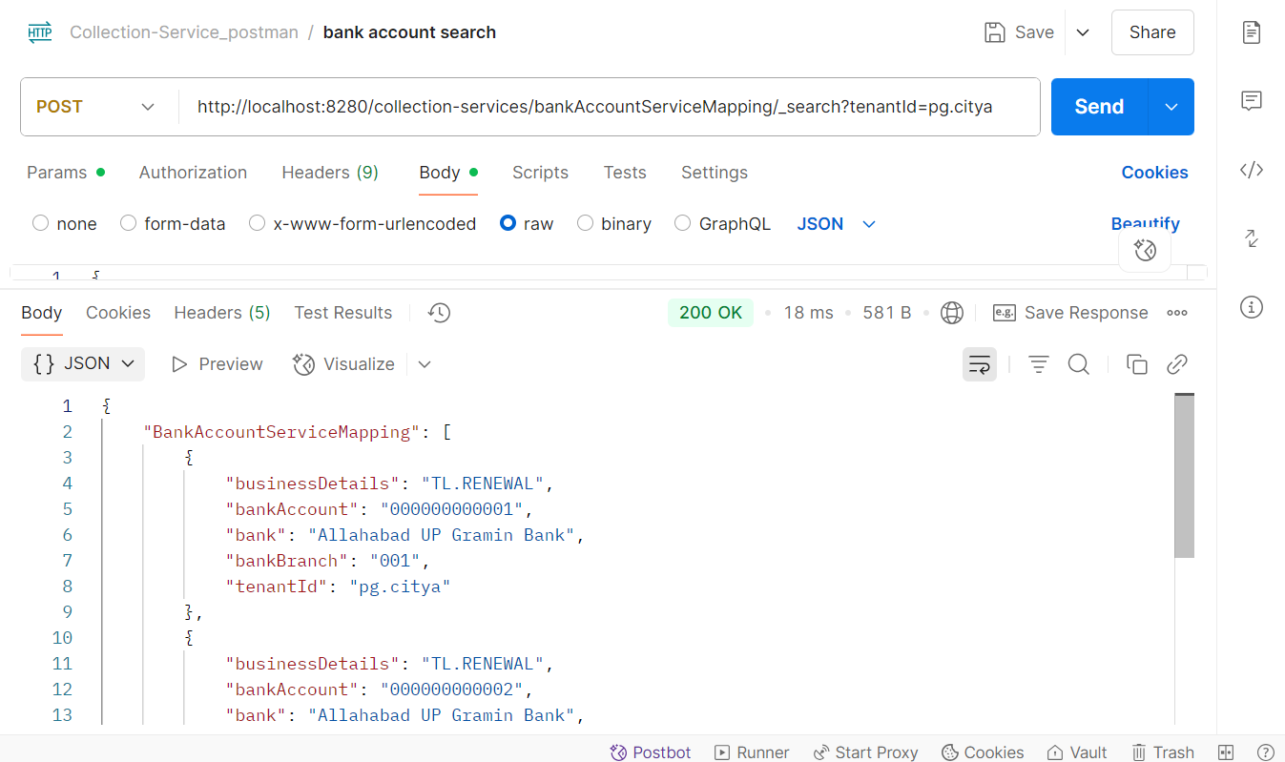
Response from env:
{
- "BankAccountServiceMapping": [
- {
- "businessDetails": "TL.RENEWAL",
- "bankAccount": "000000000001",
- "bank": "Allahabad UP Gramin Bank",
- "bankBranch": "001",
- "tenantId": "pg.citya"
- },
- {
- "businessDetails": "chb-services",
- "bankAccount": "1234567890123456",
- "bank": "kunal",
- "bankBranch": "069",
- "tenantId": "pg.citya"
- },
- {
- "businessDetails": "chb-services",
- "bankAccount": "844102001001VN",
- "bank": "STATE BANK OF INDIA",
- "bankBranch": "6305",
- "tenantId": "pg.citya"
- },
- {
- "businessDetails": "sv-services",
- "bankAccount": "844102001001VN",
- "bank": "STATE BANK OF INDIA",
- "bankBranch": "11959",
- "tenantId": "pg.citya"
- }
- ],
- "ResponseInfo": {
- "apiId": "Rainmaker",
- "ver": null,
- "ts": null,
- "resMsgId": "uief87324",
- "msgId": null,
- "status": "200 OK"
- }

- }
