SCREENSHOTS OF TO DO LIST APP

Compilation of code



Final Output

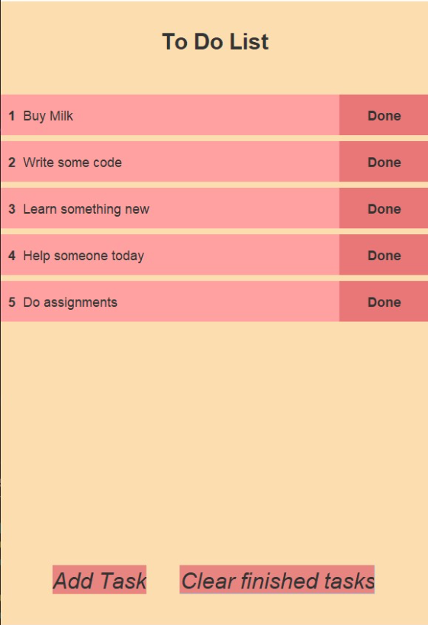

After the task is finished, you can mark them done.

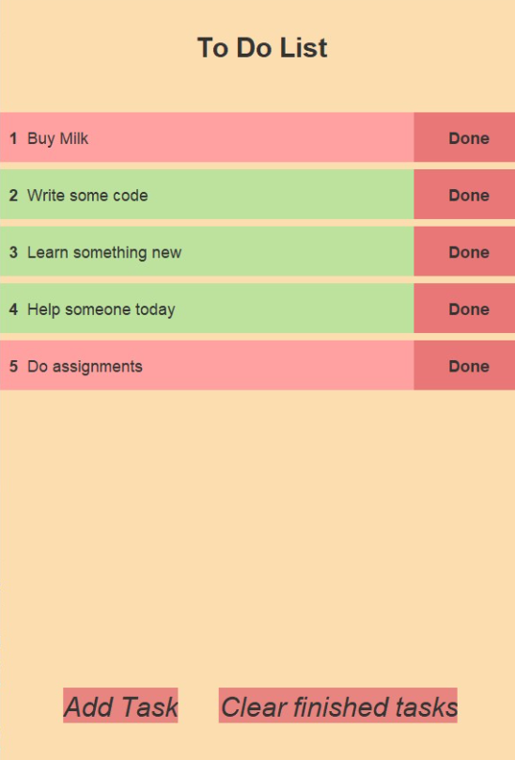

If you want to remove all the tasks you have marked as done just click on the clear finished tasks button and it will be removed.

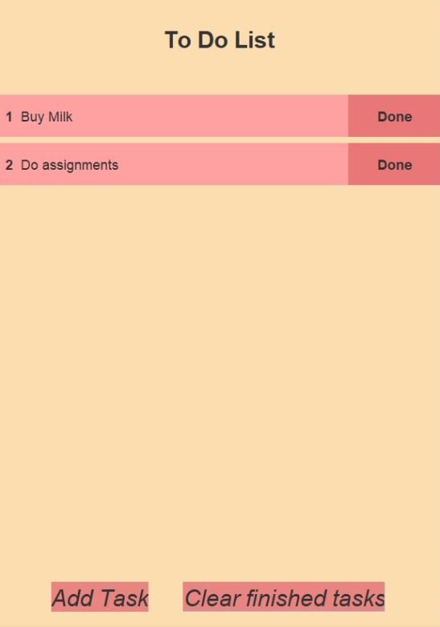

Databases Screenshots

On clicking add button

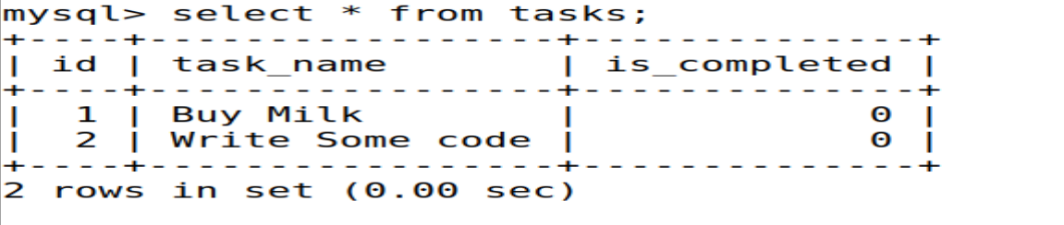

On clicking done for the task with id=1

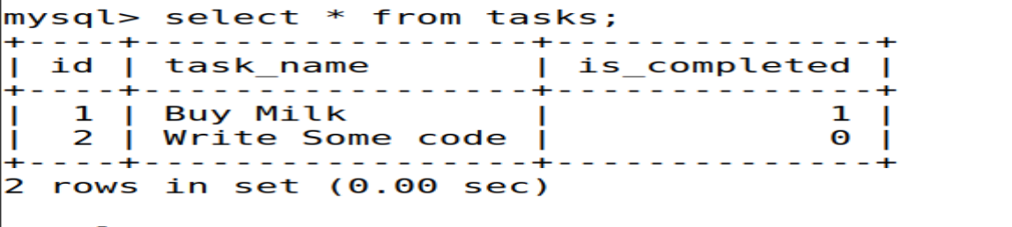

On clicking clear finished finished tasks

