**Problem definition**

~~“~~The robot should be user friendly,stable,easy to handle and available at affordable price.It should be able to draw any type of patterns on 5 sq.feet area,and it should work on rechargeable battery .It should be able to work on any kind of surface ~~”~~

**Use case diagram to represent the above system.**

Sand drawing machine

**User Machine**

**Functional Structure( System sub functions for each Usecase)**

|  |  |  |
| --- | --- | --- |
| **Usecase 1**  Entering the pattern | | **System**  1.Aceepting patterns  2.Displaying the amount of sand required for chosen pattern |
| **Usecase 2**  Control | | **System**   1. Movement of the machine   2.Opening and closing of valve |
| **Usecase 3**  Loading sand | **System**  1.Accepting the sand | |

**Task 2.4: Inputs, outputs of the system**

|  |  |
| --- | --- |
| **Inputs** | **Outputs** |
| **1.** Pattern | **1**. Displaying the amount of sand required |
| **2.** Sand | **2.** Drawing |
| **3.** Power | **3**. Movement of wheels |

**Black box model**

system

Pattern

Drawing

Electric power

Movement

Sand

Displaying the amount of sand required

**Glass box representation of the above system**

Display

Display pattern

Display the amount of sand required

Drawing the pattern

Adjusting the thickness of the sand

Opening the valve

w

Coordinating the movement

Indicates when the pattern is drawn

Indication

Indicates when the sand is empty

**Morphological chart:**

|  |  |  |  |  |
| --- | --- | --- | --- | --- |
| **Function** | **Mean1** | **Mean2** | **Mean3** | **Mean4** |
| 1.Input information | Touch screen | Keyboard | Voice command | Gesture control |
| 2. Control | Remote | Joystick | Voice command | Gesture control |
| 3. Movement | Four Wheels | Chain and sprocket | Belt | Two Wheels |
| 4.Indication of finish of sand | LED | Alarm | Display | _ |
| 5. Valve | Solenoid valve | Ball valve | Silder crank valve | Screw valve |

**Task 2.7: In the above table draw the selection path showing the concepts Draw the four conceptual models below.**

**Concept 1**

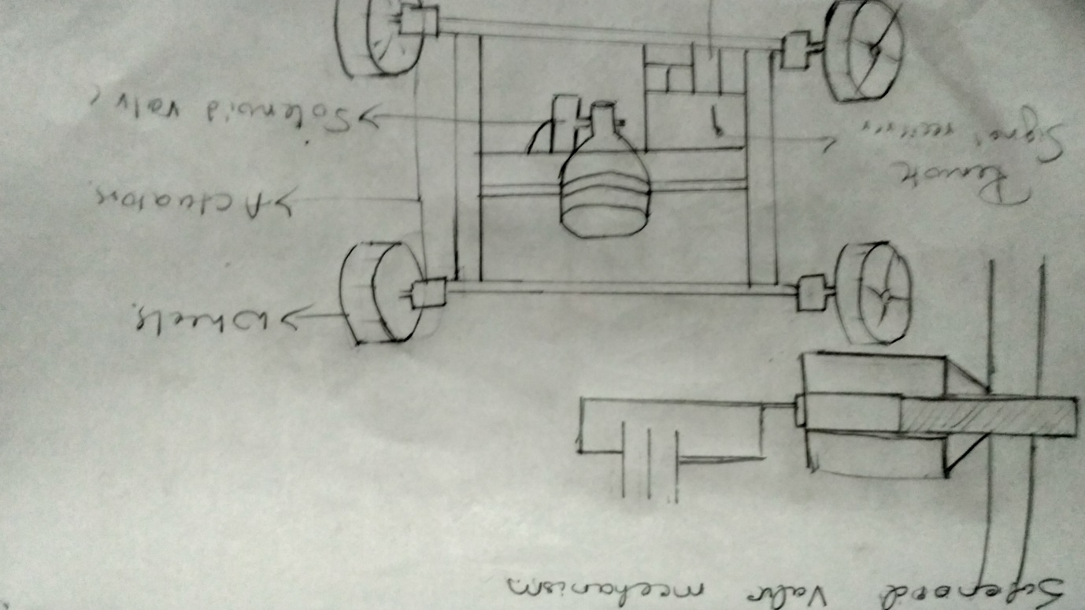

|  |  |
| --- | --- |
| Function | Selected means |
|  | Voice Command |
| 2 | Remote |
| 3 | Wheels |
| 4 | LED |
| 5 | Solenoid valve |

**Concept 2**

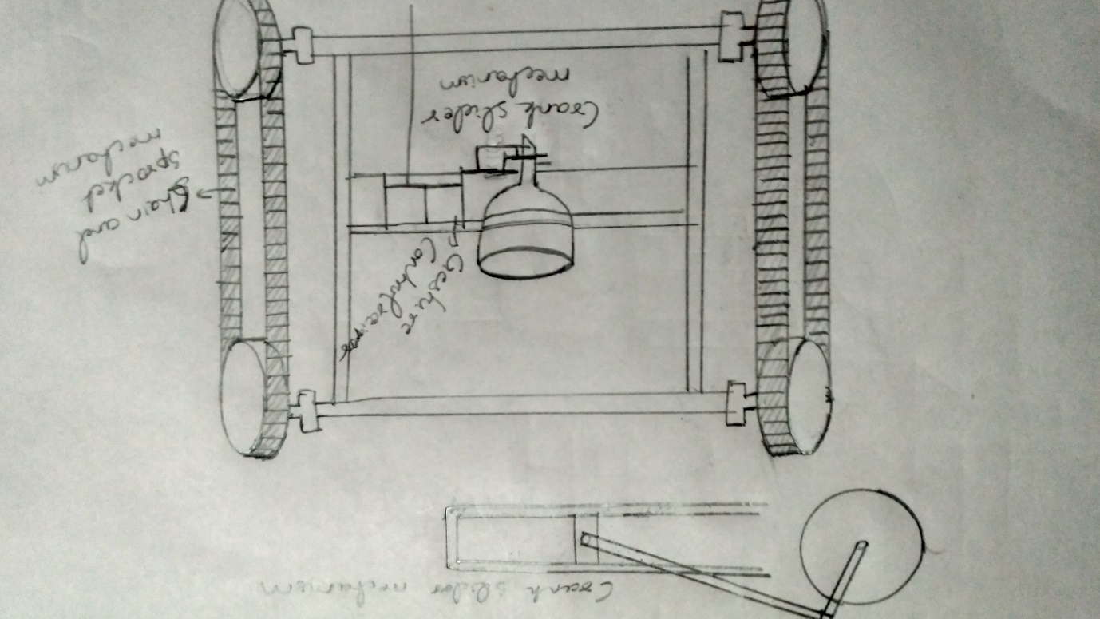

|  |  |
| --- | --- |
| Function | Selected means |
| 1 | Touchscreen |
| 2 | Gesture control |
| 3 | Chain and sprocket |
| 4 | Alarm |
| 5 | Crank slider valve |

**Concept3**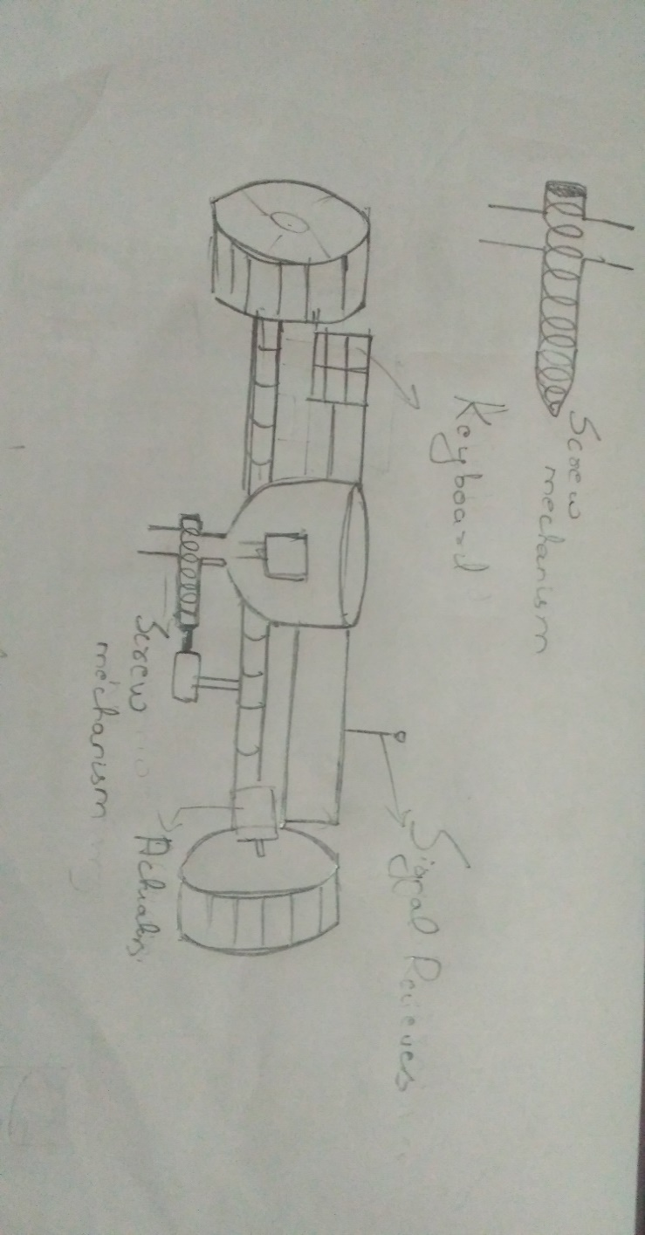

|  |  |
| --- | --- |
| Function | Selected mean |
| 1 | Keyboard |
| 2 | Voice command |
| 3 | Two wheels |
| 4 | LED |
| 5 | Screw valve |

**Concept 4**

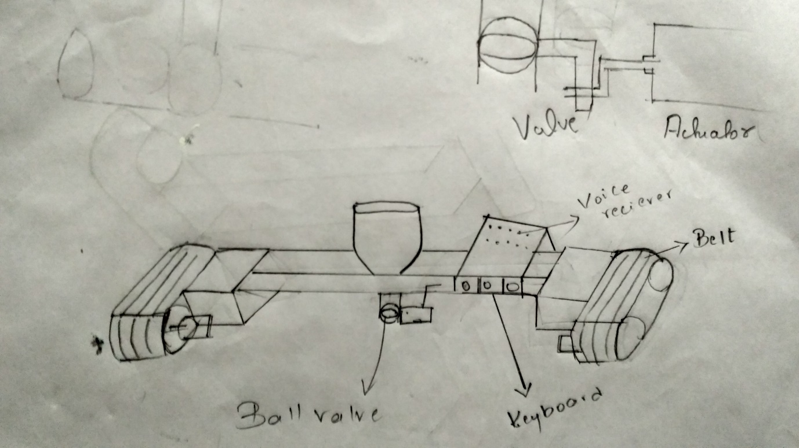

|  |  |
| --- | --- |
| Function | Means |
| 1 | Keyboard |
| 2 | Joystick |
| 3 | Belt |
| 4 | Alaram |
| 5 | Ball valve |