**PERTINENT INFORMATION GATHERING**

**PROBLEM:**Sand art is becoming famous day by day. A robot manufacturing industry is looking forward to showcase their product in an upcoming sand art exhibition by exhibiting a sand drawing robot.

**Prototype of sand drawing machine**

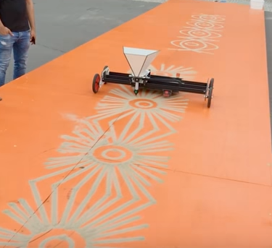

Fig 1.sand spray [1]

Youtube link: <https://youtu.be/5YbcwAlJzvI>

**Sand and spray chalk machine :**

The dosing device for the sand is completely reworked, the valve is now sitting down so the hardly still sand creek is there.

Sandspur thickness can be adjusted via replaceable nozzles made of POM.

Working area is Y 800mm X is limited only by the space (tested to 10m) or alternatively there are still 1500mm wide rails then Y goes to 1300mm.

Its quick change system work excellently.

consumption will be tackled with larger can (750 ml instead of 400 ml, which also fit into the receptacle) and a modified nozzle 0.3 instead of about 0.6 mm.

The machine runs for about 3h.

**Sand drawing robot**

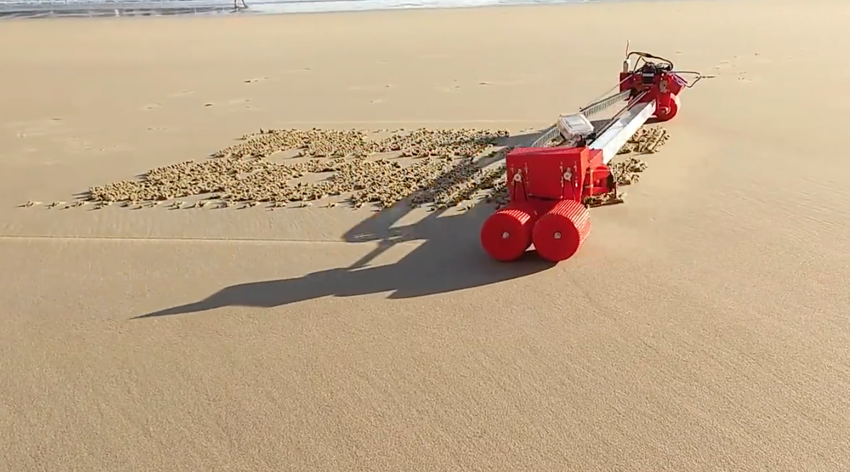

Fig 2.sand drawing robot [2]

Video link: <https://youtu.be/7T1esQgRwrM>

**Sand drawing robot**: The device takes the form of a gantry-style system that you might be familiar with from your CNC router or 3D printer. One axis is pulled back and forth with a belt drive and motor setup. The other axis, though, is different than a traditional CNC machine, as it moves across the beach using four wheels. Instead of spindle or extruder, the sliding portion simply has a hobby servo that pokes into the ground when needed, intermittently rending the sand.

The robot is effectively a long bar that acts kind of like a printer, rolling across the beach and spelling out messages by making a series of dashes in the sand. A mechanical unit slides across the main metal bar and when it gets to the spot where it needs to draw, a little notch drops down and makes a stripe in the sand.

**Kinetic sand drawing table**

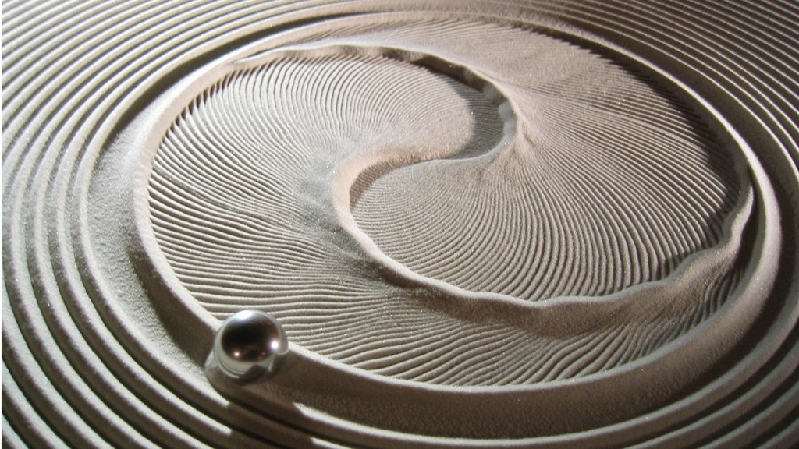

Fig 3.kinetc sand drawing machine

Video link: <https://youtu.be/qdseS4xLioo>

**Kinetic sand drawing table:** A sand is a functional piece of art . it is a complex electromagnetical device within a coffee table that draws patterns in the sand.

The table has a web based interface that allows a user to draw about 30 different types of patterns. Everything from spirals, snow flakes, text, clipart and mazes to fractals and strange attractors can be drawn . Everything is written in python making it easy to add new patterns. The software runs on raspberry Pi and Beaglebone and generates G code which is then sent to a tiny G controller.

Under the table is a two motor robot that moves a magnet which draws a steel ball through the sand. The motors are controlled by a small Raspberry Pi computer which plays a set of path files, much like a music playerplays an mp3 file.

 There is no on or off switch; the table calibrates itself when you plug it in and automatically starts playing a default playlist of trails. Shapiro says that buyers do have control over the playback, however, which lets you choose your favorite paths and how fast the ball moves.

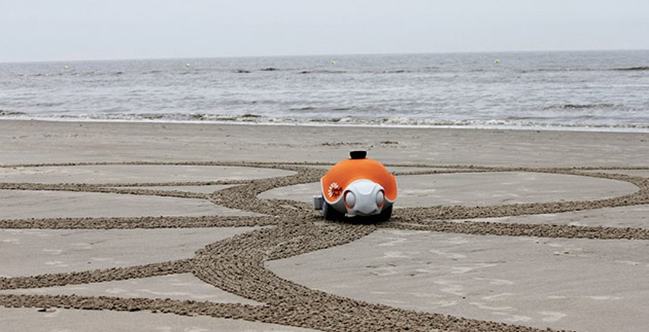

Fig 4.beach bot [4]

Video link: <https://youtu.be/eBRrQBPtdak>

**Beach bot:**This cute little robot looks like a turtle with a big orange shell and it is designed to do something fun at the beach. The Beach bot is designed to draw large scale art in the sand as it rolls around under its own power. The robot was designed by a team from ETH Zurich and the Zurich division of Disney Research.

The robot rolls around and draws in the sand using a rake attached under its body. The bot is able to control the pressure on that rake to make marks in the sand. The biggest challenge for the team was figuring out how to translate the pictures they want the robot to draw in the sand into something the robot could understand.

To do this the researchers developed an algorithm that can turn images into trajectories that the robot can work with. The algorithm isn’t perfect just yet, the team still has to tweak the Beachbot’s work manually when it works on a large project.

For the robot to work the team places four poles around a 10-meter square area to tell the turtle where to draw. A laser scanner built into Beachbot and it’s on board computer can detect the poles and recognize the area inside as the place to draw.

|  |  |
| --- | --- |
| **Electronical parts** | **Mechanical parts** |
| Arduino board | Wheels |
| Ategma 16 controller board | Gear belt |
| Servo motor | Metal chasis |
| DC motor | Nut bolts |
| Arduino CNC shield | Linear rod |
| Half-size breadboard | Bearings |
| Batteries | Tire metal spokes or metal rod from scanner |

**Mechanism/Principles:**

**Nozzle and flapper mechanism**

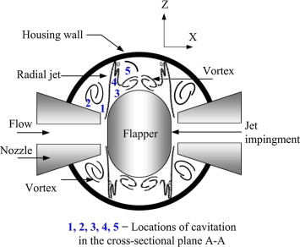

**Nozzle and flapper mechanism (For opening and closing of sand valve):** The nozzle and flapper mechanism is a displacement type detector which converts mechanical movement into a pressure signal, by covering the orifice of a nozzle with a flat plate called the flapper. This restricts the nozzle fluid flow and generates a pressure signal.

**Link of mechanical and electrical parts:**

1. <https://www.thingiverse.com/thing:2349232>
2. <https://www.instructables.com/id/Arduino-Drawing-Robot/>
3. <https://www.instructables.com/id/Engineering-Drawing-Robot/>

**Present solution for the problem**

**Sandscript - Automatic Sand Drawing Machines**

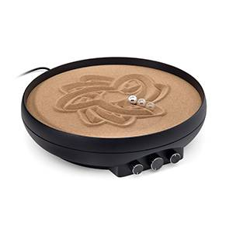

This device uses magnets to let you control a ball with three dials, tracing patterns in the sand. You can make symmetrical mandala patterns or randomized doodles on command. Set it and let it go or make tiny adjustments continuously. Sandscript comes with two steel balls; make your selection based on what level of detail suits your design aesthetic. And when you're ready to start over, just shake it like an Etch a Sketch, and your ephemeral designs will disappear into a blank canvas of sand.

**Product Specifications**

Sandscript - Automatic Sand Drawing Machine

Design mesmerizing sand drawings with your own magically magnetic zen garden

* Using the three knobs, make symmetrical mandala patterns or randomized doodles on command
* Choose ball based on how fine of a detail suits your aesthetic (larger ball makes thicker lines)
* Dimensions: 11 1/2" diameter
* Weight: 2 1/2 lbs.
* Includes Sandscript automatic sand drawing machine, 2 stainless steel balls, 1 package of sand, and AC power adapter

**DIY Project links:**

1. <https://www.theverge.com/2015/1/10/7522999/beach-robot-draws-the-future>
2. <https://www.youtube.com/watch?v=5YbcwAlJzvI>
3. <https://youtu.be/xM0PWjE5cdg>
4. <https://www.youtube.com/watch?v=qdseS4xLioo>
5. <https://youtu.be/3KZIA--rJWg>
6. <https://youtu.be/7T1esQgRwrM>
7. <https://The> awesomer.com/sand-drawing-robot/484457
8. <https://youtu.be/qdseS4xLioo>
9. <https://www.thisiscolossal.com/2015/06bruce-shapiros-mesmerizing-kinetic-sand-drawing-machines/>
10. <https://youtu.be/JSsjwXvqVt4>
11. <http://www.fubiz.net/en/2015/06/09/kinetic-sand-drawing-machine-2/>
12. <https://youtu.be/5YbcwaAlJzvl>
13. <http://openbuilds.com/biulds/cnc-sand-and-spraycalk-drawmaschine.4792/>

Reference:

[1]<https://openbuilds.com/builds/cnc-sand-and-spraycalk-drawmaschine.4792/>

[2]<https://blog.hackster.io/plot-messages-on-a-beautiful-beach-with-this-sand-drawing-robot-c0212e021f74>

[3]<https://www.kickstarter.com/projects/1199521315/sisyphus-the-kinetic-art-table>

[4] <https://www.slashgear.com/disney-beachbot-draws-in-the-sand-12363752/>